String For Your Supper

Key Concepts
1. Living things are dependent upon each other and upon their non-living environment.
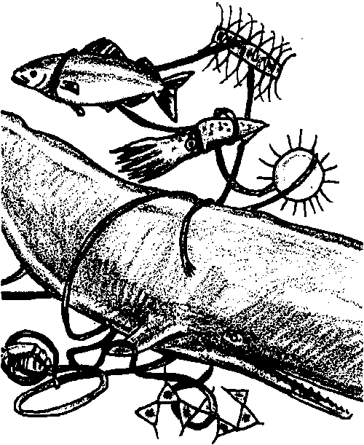
2. Organisms can be classified as producers, consumers, or decomposers, depending on how they obtain their food.
3. Food chains show the relationships of organisms in an ecological community based on the order of who eats whom. Food chains are crosslinked into food webs.
4. The major source of energy in most marine food webs is the sun.
5. The most stable communities are those with the greatest diversity. A stable community is one which is able to resist disruption.

Background

Food chains and webs trace energy flow in an ecosystem and are handy tools for describing how an ecosystem functions. A brief overview of food chains follows.

The major source of energy for life systems on our planet is sunlight, yet only green plants can use this energy directly. They capture the sun’s energy chemically in molecules of sugars that only green plants can make. Other organisms get energy by eating plants directly or indirectly. Their bodies use most of the energy for basic life processes and store some of it. When eaten by other organisms, the stored energy is utilized further.

The relationships of who eats whom (the path of energy transfer) are outlined as food chains.
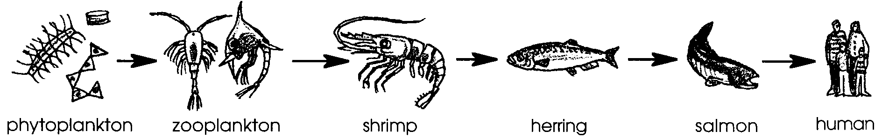

Since almost every organism eats more than one thing and is eaten by more than one other thing, food chains are cross-linked into food webs.
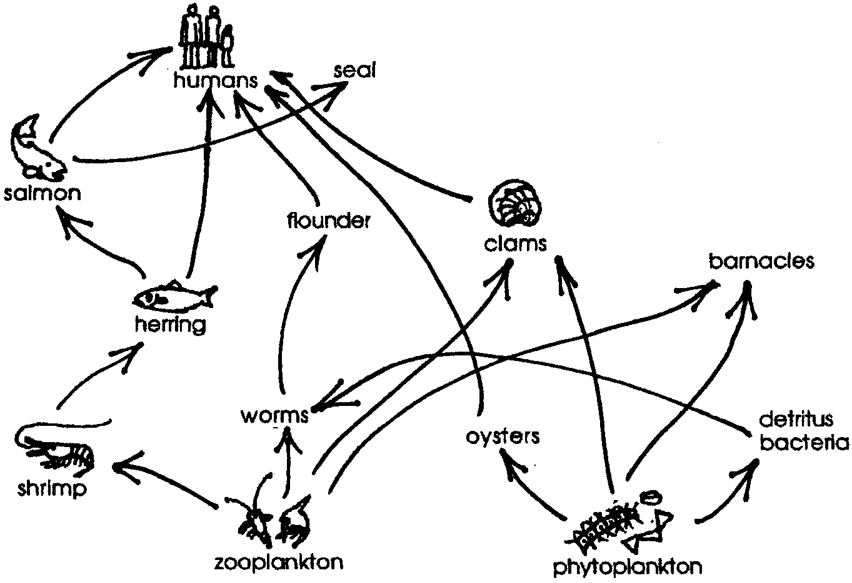

Plankton forms the base of many marine food chains. Phytoplankton are called producers because they use the sun’s energy for photosynthesis. Zooplankton and other animals that eat the producers are called consumers. They cannot produce their own food. Organisms that eat the producers are called first order consumers. They, in turn, are eaten by second order consumers, and so on.

When the plants and animals die, they begin to rot, broken down by decomposers. In the oceans, bacteria are the primary decomposers. Decomposing material, including body wastes, is called detritus. The decomposers eventually break down detritus into the nutrients used by plants for growth and food production, and so the cycle continues. Detritus is particularly important in the food chains/webs of estuaries.

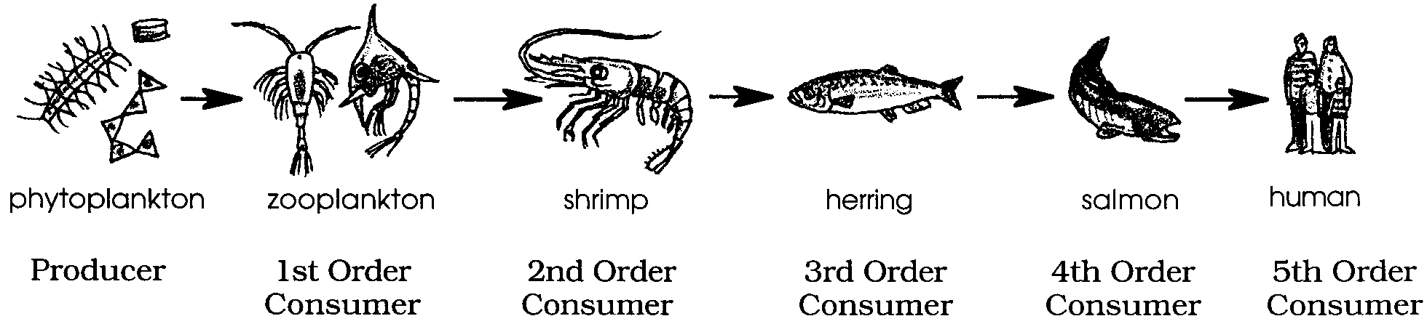

Materials

For each pair of students:

• organism card set

• scissors

• hole punch

• strong thread

• wire (about 12” long pieces of coat hanger) or wooden dowels or straws or bamboo skewers

Teaching Hints

Food chains and food webs, simple diagrams which show feeding relationships, are relatively easy for your students to comprehend. “String For Your Supper” provides your students with an opportunity to construct a food web mobile comprised of marine food chains. The food web provides a springboard for a discussion of the interrelationships required to maintain a living community.

Author’s aside: In developing this curriculum, lessons were reviewed for accuracy by prominent ocean scientists. This lesson was reviewed by Dr. Jim Schumacher, an internationally known oceanographer. His comments regarding this lesson seem important to pass on.

“This unit is extremely critical - a good place to address the responsibility humans have for their Mother Earth. Note that ‘Man did not weave the web of life, he is merely a strand of it. Whatever he does to the web, he does to himself’, was said by Chief Seattle in 1854. Humans directly influence all levels in the web.

For example: Both strip mining and clear-cut logging result in loss of soil during rains. This creates turbid (muddy) waters which limit primary production, and eliminate gravel substrate (bottom of creeks) where salmon eggs must be laid to survive. Thus consumers of young salmon heading to sea (many other fishes, birds and marine mammals) lose their food source, as do all those (including humans) who relish adult salmon.

It is crucial that ‘humans’ have a place in the web, and that our impact on the natural flow of energy through food webs be presented. We are the only animal which so drastically impacts the entire web of life on this planet.

It is a profound but simple truth that if humans do not come to know they are ‘but a strand’, then the web will be broken. How will our children’s children survive if we don’t begin to honor the web?” An important point to keep in mind while teaching these lessons.
Duplicate the activity pages and the organism cards. For best results duplicate the cards on heavy paper or card stock. This activity may be performed by pairs, individual students or by small groups. The number of card sets required is dependent upon the group or class size. Your students may need an introduction to mobile making and the art of finding the center of balance. For ease of construction, the organism cards and cut-out animals indicate, in writing, by whom they are eaten. This information should result in a standardized mobile which will provide the information needed to answer the text questions. A schematic diagram of the mobile follows this “Teacher Background” section.

The display of a completed mobile, preferably a different mobile than the one your students will be assembling, is most helpful. After your students have completed their mobiles, provide a place to display them. You may facilitate this display by providing pre-hung threads from the ceiling, light fixtures, etc. Upon completion, plan to discuss the activity and the “Analysis and Interpretation” questions.

Key Words

community - a group of plants and animals living in a specific region under relatively similar conditions

consumer - organism that cannot produce its own food, but eats other organisms to obtain the energy necessary to sustain life

decomposer - organisms which feed on dead plants and animals

detritus - decomposing material, including dead organisms and waste body products

environment - the living and non-living factors surrounding an organism or group of organisms

first order consumer - organism that eats producers

food chain - outline of who eats whom showing path of energy transfer in an ecological community

food pyramid - a food web diagram showing feeding relationships including the relative numbers of organisms at each energy level

food web - interlocking food chains existing because most consumers eat more than one type of food and are themselves eaten by more than one consumer

organism - general name for any living thing

phytoplankton - plant plankton

plankton - the mostly microscopic plants and animals that drift in water

producer - organism that can make its own food, using inorganic nutrients and energy from the sun

second order consumer - organism that eats first order consumers

third order consumer - organism that eats second order consumers

zooplankton - animal plankton

Extensions

1. Have your students construct food chain mobiles using pictures of marine organisms taken from magazines and other similar sources.

Answer Key

1. In a correctly assembled mobile, the lowest level has the greatest number of organisms.

2. a. The highest or top level (the toothed whale and the baleen whale) has the fewest organisms.

b. The number of organisms at each level decreases as you move up the pyramid. This is an important concept and one that deserves emphasis. This concept is often called the pyramid of numbers.

3. a. The primary producers form the bottom layer of the mobile. This question is designed to reinforce the concept that the entire food web of the ocean depends upon the primary producers.

b. Since each of the first order consumers “feeds” on two primary producer cards, the removal of one primary producer has a limited effect. The first order consumer can simply increase its consumption of the remaining primary producer card.

c. The removal of several primary producers has a different effect. Some of the first order consumers are now without food and will die. The death of these first order consumers adversely influences the second order consumers that feed upon them and so on up the chain. Emphasize the point that the food web is resilient enough to absorb the loss of some of its members. The more links in the food web, in general, the more losses the system can sustain without collapse. The stability of the system is dependent upon its diversity.

4. a. Third order consumers eat second order consumers. This deduction follows from the text.

b. Write the names of your organisms in the proper space below:

Primary 1st Order 2nd Order 3rd Order
Producer Consumer Consumer Consumer

phytoplankton zooplankton squid sperm whale

(12 cards) (6 cards) sable fish

gray whale

5. a. The first order consumers form the second level (from the bottom) of the mobile.

b. Removal of one of the first order consumers has a limited effect on the food web because each second order consumer shown has two first order consumers upon which it feeds.

c. The removal of several first order consumers has a more serious effect. Depending upon the particular first order consumers removed, the gray whales, the squid or the sablefish could find themselves without food. If no suitable alternate prey was available, the second order consumer in question would starve.

d. The removal of several primary producers did more damage than the removal of several first order consumers. The lower an organism is on the food chain, the greater its potential impact when it is eliminated. The removal of any organism affects all of those that are above it on the food chain.

6. a. The final consumers are the sperm whale (third order consumer) and the gray whale (second order consumer).

b. The number of animals that feed on the sperm whale and/or the gray whale is limited. Humans are about the most significant animal that could be added to the top of the mobile.

7. Phytoplankton make up the base of the food pyramid in the mobile. This question reemphasizes the notion that primary producers are the foundation for the entire food web.

8. Destruction of the lowest level (the primary producers) would have the greatest effect on the other organisms.

9. a. The more complex the mobile, the more/less change will occur from the removal of one organism (the correct answer is underlined.) This is so because the most stable communities of plants and animals are those with the greatest diversity. (Emphasize that it is important for us to recognize this concept when we begin to simplify communities by harvesting plants and animals).

b. In the above sentence, “diversity” means the variety of plants and animals, present in the community.

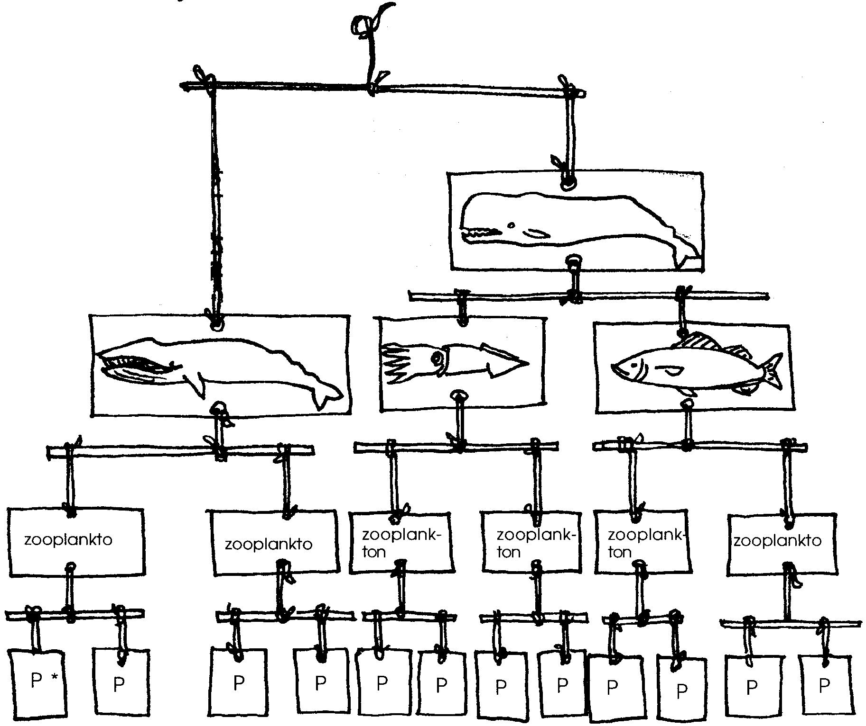
10. Humans are most likely to harm simple/complex communities of plants and animals. (The correct answer is underlined.) (This question is of great importance and provides a springboard for further discussion of the effect of human actions on aquatic ecosystems.)

String For Your Supper

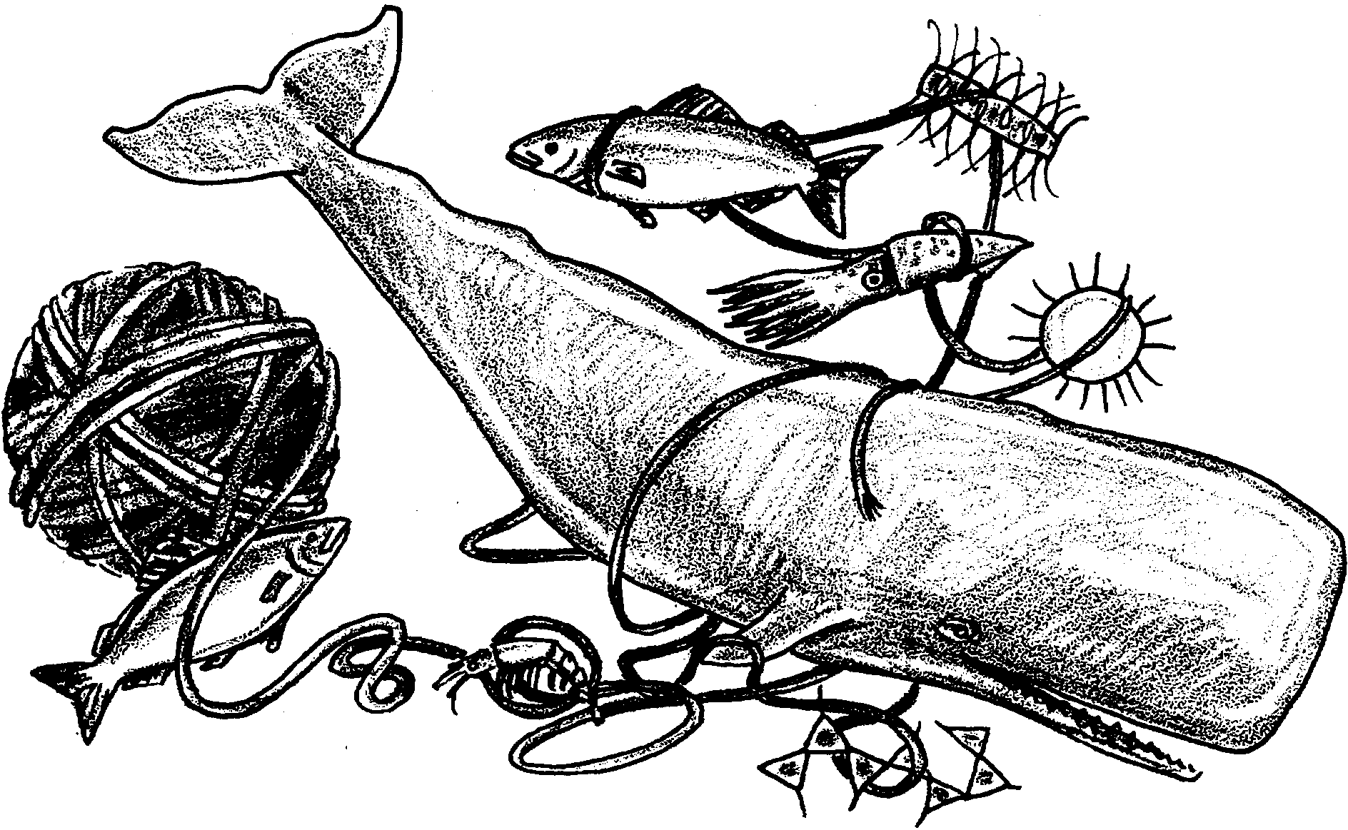
Plants and animals depend upon each other and their environment for the things they need to live. One of the basic requirements for all animals is food. We have seen that some of the biggest animals in the sea eat some of the smallest. Life in the oceans begins with phytoplankton, drifting plants. Most phytoplankton are very small. Phytoplankton use carbon dioxide and water, plus energy from the sun, to grow. A single liter of sea water may contain millions of phytoplankton.

The zooplankton, or drifting animals, eat phytoplankton and each other. Practically all life in the sea depends directly or indirectly upon phytoplankton and zooplankton. The relationships of who eats whom form food chains. The chains join to form food webs. In the following activity you will have an opportunity to create a food web of your own.

Materials:
• organism cards
• scissors
• hole punch
• strong thread
• wire (about 12" long pieces of coathanger) or wooden dowels or straws or bamboo skewers
Procedure:

1. Obtain a set of organism cards and a pair of scissors. Cut out the cards.

2. With the hole punch, punch out the marked dot on each card.

3. Use string and wire to connect the eaters and the eatens. For example:
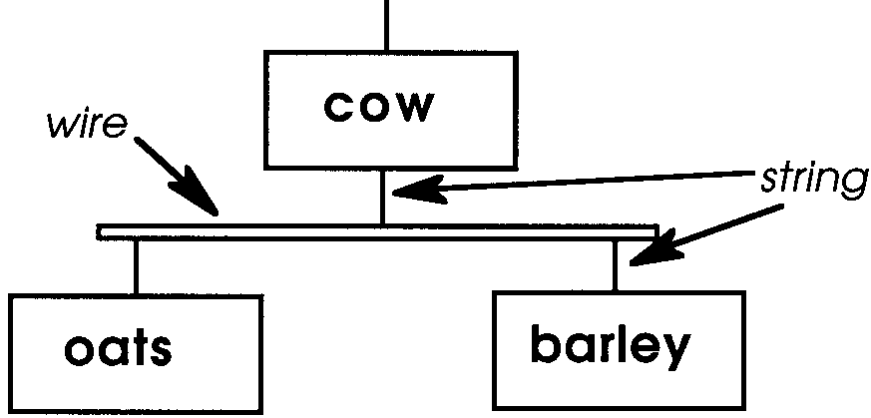

4. To finish your mobile, use string and wire to connect the top two organisms. For example:
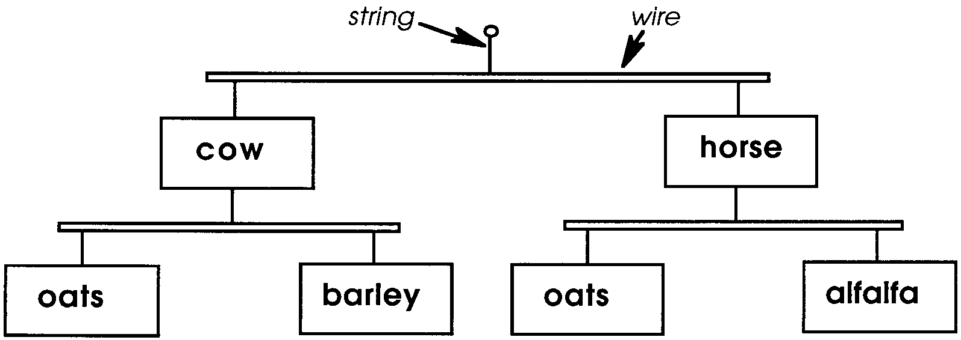

5. Hang your mobile and use it to answer the following questions.

Analysis and Interpretation

1. Which level of the mobile has the greatest number of individual organisms?

2. a. Which level has the fewest organisms?

b. In general, what happens to the number of organisms as you move up the mobile?

3. a. Primary producers are organisms that make their own food. The primary producers in the ocean are the phytoplankton. Where are the primary producers in your mobile?

b. What happens to the animals above if you remove one primary producer?

c. What happens if you remove several primary producers?

4. First order consumers are animals which eat primary producers. They are first to eat the producers. Second order consumers are animals which eat first order consumers.

a. What do third order consumers eat?

b. Write the names of your organisms in the proper space below:

Primary 1st Order 2nd Order 3rd Order
Producer Consumer Consumer Consumer

5. a. Where are the first order consumers in your mobile?

b. What happens when you remove one of the first order consumers?

5. c. What happens when you remove several first order consumers?

d. Did the removal of several first order consumers do more or less damage to your mobile than the removal of several primary producers?

6. a. What are the final consumers in your mobile?

b. What animal could you add to the top of your mobile?

7. A food web such as you have made can also be called a food pyramid. What organisms make up the base of your food pyramid?

8. Destruction of which level would have the greatest effect on the other organisms?

9. a. The more complex the mobile, the more / less change will occur from the removal of one organism. (Circle the correct answer.) This is so because the most stable communities of plants and animals are those with the greatest diversity.

b.In the above sentence, “diversity” means .

10. Humans are most likely to harm simple / complex communities of plants and animals. (Circle the correct answer.)

