LIVING IN WATER
Hr


Getting Ready
You will need these things from your kit:
Aquatic Animals Cards, packet #1
Aquatic Animal Cards, packet #2
Picture Key of Aquatic
Animals Reference books: The New Field Book of Freshwater Life, and Pond Life
jar aquarium
You will also need a pen or pencil and some paper

Introduction
Animals that live below the water's surface in wetlands have many interesting adaptation for living in water. The activities which follow will help you explore some of them.

Activity 1: Big Changes Goin' on
Take out the Aquatic Animals Cards, packets #1 and #2.
Each of the picture cards in packet #1 shows a different aquatic animal. The picture cards in packet #2 are the same animals, only at a different stage of the animals' lives.
1. Can you match each animal to its other life form?
As they grow, some animals change form from one part of their life cycle to the next. For example, tadpoles become frogs. We call major changes like this metamorphosis. Metamorphosis is a big word made up from two Greek words, meta, which means change and morphos, which means shape.



Insects undergo metamorphosis too. As insects grow, their skin is cast off. We call this process "molting." The creature that emerges from the old skin may seem quite different than its previous form.
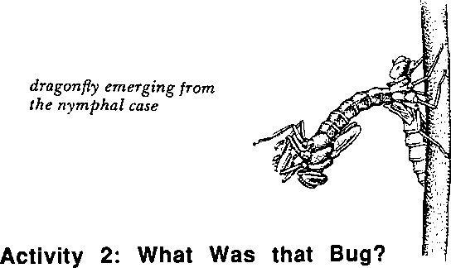
4. Use reference books or the Picture Key of Aquatic Animals to match both sets of aquatic insect cards with the names below:

____ ____Dragonfly‭ ____ ____Giant diving beetle
____ ____Mayfly‭ ____ ____‬Mosquito
____ ____Waterboatman ____ ____Caddisfly
Now check your matches of Aquatic Animal Cards with the answer key on page 42.

Activity 3: Amazing Mayflies
Many aquatic animals have remarkable life cycles. A prime example is the mayfly. Perhaps you have seen adult mayflies, delicate lacy insects that appear briefly near lakes and streams in immense swarms early each summer.

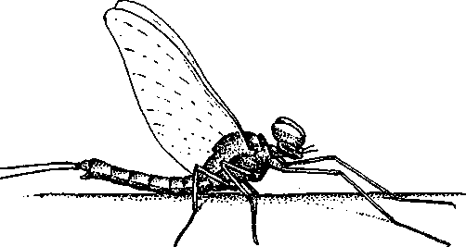

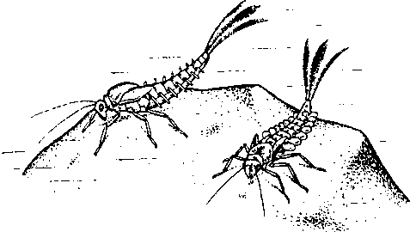
The mayflies you are most likely to see in a pond or stream are not the adults, but rather juvenile mayflies, called nymphs. Most insects, such as the butterfly above, change dramatically from the juvenile stage to the adult. We usually call the juvenile stage of such insects "larva." Some insects progress gradually to adulthood through a series of molts, each stage looking more and more like the adult. The juveniles of such insects are called nymphs.

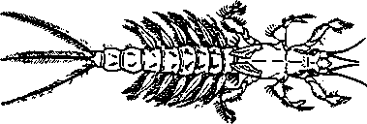
Mayfly nymphs hatch from eggs inside jelly masses or attached by long strings to underwater plants. The young nymphs burrow into the mud, cling to rocks or climb about in submerged plants.You can recognize a mayfly nymph by its three long tails and the gills on either side of its abdomen. If you look closely you may be able to see the gills beating.

2. What might be the purpose of the gills' movements?
Mayfly nymphs stay in the water a very long time before becoming adults, some as long as four years. During this time they graze on the layer of microscopic plants that forms over rocks, plants and the muddy bottom. If you have mayfly nymphs in your aquarium you may see them feeding on algae growing on the glass sides of your tank.
When they're ready to emerge, the nymphs may crawl out of the water on the bank or a plant stalk, shed their nymph skin, and fly away. But some nymphs are able to just burst through the water surface, casting off their skins and taking to the air on their new wings all in just a fraction of a second!

The flying form that emerges is not an adult but a final juvenile stage. Mayflies are the only insects known which are able to fly before they reach full adulthood. Within a few hours the mayfly will shed its skin for the last time and become a true adult.
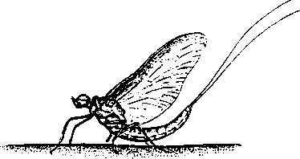
The adults don't eat -- and in fact they have no working mouths. They have but one purpose in life and that is to quickly find a mate and lay their eggs.

Mayfly swarms are dense but short-lived. The males perform a dramatic dancing flight over the water to attract females. After mating, the females fly up and down over the water surface, dipping their abdomens into the water or even crawling below the surface to attach their eggs to the vegetation. This final dramatic episode takes place in just a few short hours. Within a day or two of leaving the water, the adult mayfly is dead.

3. Scientists place mayflies in a group called Ephemeroptera. Find out what the word "ephemeral" means, and explain why mayflies might have been given such a name.

Activity 5: Ah, for a Breath of Air!
The air you breathe may not be on your mind a lot, but it's a terribly important issue for animals living below the surface! They, like you, need a reliable source of oxygen. While there's usually plenty of oxygen available in the atmosphere for land animals, aquatic animals often face shortages of oxygen dissolved in the water.

Some aquatic animals have solved the problem of getting air in ways
that may look familiar to you!

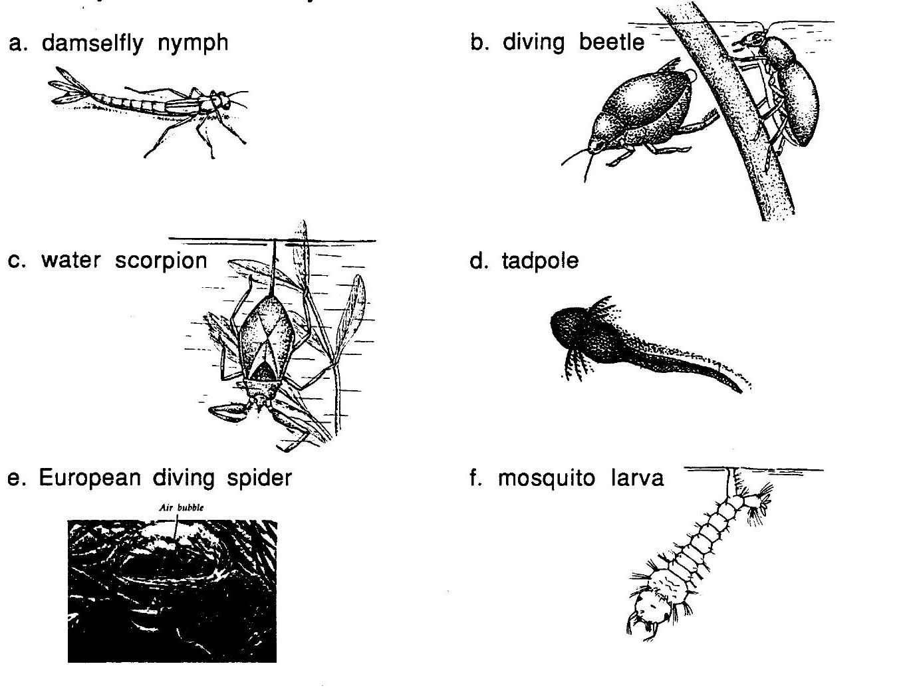
Which of the animals pictured above are probably breathing through a snorkel?
- Which animals carry a "tank" of air around with them under water. (Sometimes they must stop to refill their tank at the surface.)
- Which animals build an underwater "diving bell" full of air which they can live inside of for longer periods?
- Which animals are probably able to take air out of the water with feathery gills. (See p. 43 for information on each of the animals above.)

Activity 6: Animal Close-Up
Choose an animal in your jar to investigate further. Here are some ways to learn more about it:
- Watch it undisturbed in your tank. As you watch, look for adaptations it uses for moving, eating, protecting itself, etc.
- Find out, either by observations or through reading, how it gets air.
- Carefully take it out of the tank with a small net and put it in a small dish of pond water. Use hour hand lens to help you do a detailed drawing.
- Design a simple experiment to learn more about you animal's behavior. For example, if you are able to see movement, feeding or breathing behaviors, what changes in the animal's environment might cause changes in these behaviors?
- Find your animal in one of the resource books. Use the book to help you answer the following questions:
Is this an animal with several distinct life stages?
If so, what is the name of the stage your animal is in now? What other stage(s) does this animal have? Where does it live, what does it eat, and what does it look like?
- Write an illustrated report of what you have learned about this creature. Add your report to the Student Project Library to share with other students.
Answer Key to "What Was That Bug?" from p. 37 A 3 Dragonfly _J
4 Giant diving beetle 1 Mosouito 6 Caddisflv
C 5 Mavflv _|
E 2 Waterboatman |

Answer Key to Ah, for a Breath of Air, from p. 42
- Damselfly Nymph - The three feathery tails on this insect are its gills. Air molecules pass through the thin gill mambrane of the gills into the blood of the damselfly nymph.
- Diving Beetle - Some beetles carry their underwater air supply on their furry undersides. Others swim with a bubble attached to their back side. Diving beetles must come to the surface to fill their "tanks" with air.
- Water Scorpion - The slender tube extending from the water scorpion’s back side works like a snorkel. Whenever this insect needs a breath it backs up a plant stem until the breathing tube breaks above the water's surface.
- Tadpole - Tadpoles breathe with feathery gills on either side of the body. As they mature into frogs, their gills disappear and they develop lungs. Frogs, toads and most salamanders can only breathe above the surface.
- European Diving Spider - This unusual spider carries bubbles of air to its web below the water’s surface. From its "diving bell” home, it makes excursions through the nearby water plants to hunt for aquatic insects and fish.
- Mosquito Larva - Mosquito larvae live below the surface, but they can extend a snorkel-like breathing tube to the surface whenever they need fresh air.
From pp. 12-13, The Water Cycle Model. Here is a hint for building a water cycle model usina houshold objects:
Water cycle simulation
- Place 1/2” of water in the base of the coffee can.
- Put one cup of ice cubes in tilted soup can.
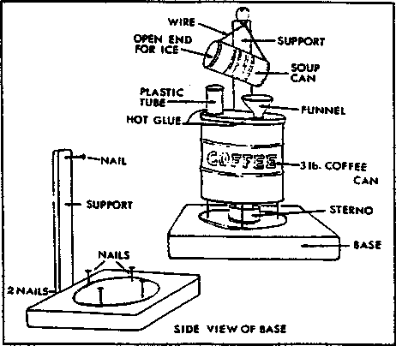
- Light Sterno and place under coffee can.
- Allow water in coffee can to boil rapidly until steam escapes through chimney (tube). Align the coffee can so the rising steam strikes the soup can just under the opening.
- Adjust angle of soup can so condensing water runs down the length of the can and drips into the funnel.
- Relate the phase changes of water you have observed to the steps of the water cycle. Label the accompanying diagram and explain what occurs in each step of the water cycle.
Adapted by Southern Willamette Energy Action Team (SWEAT), Eugene. Oregon, and used with permission.
Adapted with permission from The Stream Scene. Oregon Department of Fish and Wildlife, P.O. Box 59, Portland, OR 97207.

