WORLD IN A JAR
Getting Started
You will be using these materials from the kit:
the jar aquarium, with aquatic animals from your wetland your field notebook
You will also need:
a pen or pencil and paper
The world in your jar is an active place. Take some time to find out what's going on there.
Set aside at least 5 minutes each day to just sit and watch it. Get to know the quieter creatures as well as the more active ones. What habits or behaviors do you notice in these animals? Can you catch them feeding? Over the three weeks that you keep the tank, what changes do you notice in animals and their environment? Do any of them shed their skins or transform into a different life form? Are there eggs in your tank which may be developing?
Start a journal with notes from your daily aquarium observations.
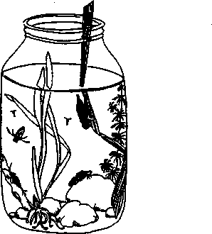
As keeper/caretaker of a "World in a Jar” you have a responsibility on your hands!
How will you know if the environment in the jar has all the things your animals need?
1. What are the life needs of the animals in the jar. Make a list of everything you can think of.
When you feel your list is fairly complete, turn the page.

Did you have these things on your list? (Add any you may have forgotten.)
BASIC NEEDS OF PLANTS AND ANIMALS:
- clean water
- air (the plants need carbon dioxide, the animals need oxygen)
- food for animals
- light for plants
- a stable temperature, within the right range
- an uncrowded environment
- waste products removed
2. Next, take everything on your list and plan how you -- or the aquarium itself will provide it.
Below are some suggestions for the care and feeding of your aquarium.

3. Match each suggestion to one or more items from the Basic Needs List by writing the number from the list in the blank.
A. Tap water has chlorine in it. Always let it stand
overnight before putting any tap water your aquarium.
B. Put a small layer of gravel on the bottom so that
bacteria can live there. Bacteria will help consume the animal wastes.
C. The aquarium should be placed in a lighted place, like
a north window, but not where it receives direct sunlight. Otherwise too many plants will grow.
D. Don't put the aquarium near a direct source of heat,
like a heating duct or space heater. In spring or fall it could even stay outside.
E. Check the pH of the aquarium water each week. If it
changes it's time to give the animals a change of fresh water.
F. Some animals eat living plants, others eat each other.
Some eat dead plants and animals. It's not necessary to add food, but if you can exchange the water in the tank at least once with new pond water there will be plankton in it for the animals to eat.
G. Keep the water level in the gallon aquarium below the
neck of the jar. That will give more surface area for air to enter the water.
H. Plants will provide oxygen for the animals and
animals will provide carbon dioxide for the plants as long as the aquarium isn't too crowded.
I. If the water begins to turn cloudy, that's a sign the
aquarium isn't healthy. Immediately change the water and release some of the animals and plants. It's very likely it is too crowded.

