GET YOUR FEET WET!
Getting Ready
You will need these things from your kit
Field Site Activity Cards
Wetland Study
Exploring Soils
Water Quality
Wetland Plants
Birds and Mammals
Aquatic Animals
Reference Materials
The New Field Book of Freshwater Life, by Elsie Klots
Mac's Guide to waterbirds Pond Life. Golden Nature Guide Recognizing Wetlands. Washington State DNR
Wetland Plants of the Pacific Northwest. U.S. Army Corps of Engineers
soils color card and crayons pH test kit thermometer trowel
strainer and small nylon net small bowl gallon Jar with lid hand magnifier
plant press, blotters and stock paper plastic bags
chemical waste container field notebook
These things are not in the kit, but you will probably want them with you on your field day:
boots
mosquito repellent
sun screen, hat, sun glasses etc.
pencils

Introduction
The best way to learn about a wetland is to explore one yourself.
This chapter, "Get Your Feet Wet" will prepare you to carry out a field study at a local wetland. Part I, "Finding a Wetland," will help you find a pond or lake to study. Part II, "Wading In" will suggest some investigations you can make there. Part III, "When You Return" will start you out on some post-field trip projects using information and materials gathered in the field.
You may not want to bring this study guide with you to the wetland. For this reason, most of the information you will need to carry out the field investigations has been put onto six "field activity cards." Take these cards with you to the wetland to help guide your investigation.

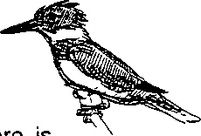
Part I: Finding a Wetland
There are many kinds of wetlands, as you know. Yet there is ' currently no single definition of a wetland agreed upon by everyone. Most people agree that wetlands are covered with water at least part of the time, they have waterlogged soils under and around them, and only certain types of plants tend to grow there, plants such as cattails which can survive in these wet conditions. The activities that follow are best suited to the habitat found along the edge of a small natural pond or lake. It need not be a large pond, but you will find the most interesting aquatic life at a wetland that has been undisturbed for some time.
If you think you know a place that matches this description, this might be a good place to start. If you can't think of such a place, use the suggestions below to help you find one:
On public land such as federal, state or local parks. Look along the borders of lakes and ponds in public places. Be aware that parks may have rules against collecting, however.
If you are limited in what you can take home, you can still use these places for on-site observations. Other public lands worth exploring are drainage ditches alongside roads and parking lots, but do be cautious about traffic.
On private land with permission. Do any of your neighbors or friends have places on their property where water collects during the year? Even people you have never met may be comfortable giving you permission to visit a wetland on their property if you explain your educational purposes for being there. Consider asking managers of commercial properties. For example, a golf course pond may make a good study site if you can visit when the golfers are off the course.
Still stuck? Ask for help! Talk to parents, teachers, and community educators. Other resource people who can be extremely helpful include agents for your Conservation District and your Extension Office (both listed in the county government section of your phone book). Also try the Soil Conservation Service (listed under U.S. government in your phone book.) Their offices will have maps which identify known wetlands in your county.


Part II: Wading In
Once you have found a wetland, there are several topics you can explore there. These areas are outlined below, along with some questions to think about and answer before going to the field. You may choose to do your study all in one visit, or you may decide to do it over several days. You may even want to repeat some of the activities after several weeks time to look for seasonal changes -- in aquatic insects or plants for example.
Read over the general directions below, and then look over the more specific instructions in the field activity cards in your kit. Get to know the equipment and try out some of the activities before going to the field.
An important piece of equipment is your field notebook. Use it to write down the results from each of your field investigations. But also use it to record any other observations you make, personal thoughts or important discoveries inspired by your trip to the wetland. This notebook is for you. Make it your own!
A. A DIFFERENT WAY OF LOOKING
Although wetlands have sometimes been called wastelands, they are usually beautiful places. In fact, wetlands have been the inspiration for wonderful poetry, art, even theater and dance. Plan to take some time when you arrive for some quiet watching. This is your best time to see wildlife, to get to know your wetland -- and perhaps create some poetry and art yourself!
B. THE BIG PICTURE
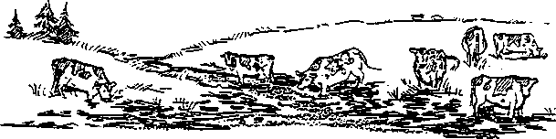
The land surrounding a wetland can affect the wetland habitat in important ways.

- If roads or parking lots are located near a wetland, what kinds of impacts could they have on this habitat? How might the water quality be affected?
- If livestock is present, what might be present in the run-off to the wetland?

Even homes with well-tended yards nearby may cause an impact. What products do people use on their lawns and gardens which might be draining into a wetland?

At your wetland:
Make a sketch or a diagram of your wetland. Include some information on how the land surrounding the wetland is used.
Be sure to indicate on your diagram the area where you are doing your study. Also label the places where you take samples for soil, water, plants and aquatic animals.

C. EXPLORING SOILS
Wetland soils have physical characteristics quite different from other soils. These soils are usually saturated with water and are known by soil scientists as hydric soils.
4. What does "hydric" mean? You may not find this word in a standard dictionary. For a clue, look up words which begin with the prefixes "hydra-" and "hydro-." What do these words usually have in common?
Hydric soils are an important indicator of wetland conditions. To find out if soils are hydric, soil scientists classify soils by their color and their texture. To determine soil color, they use a series of charts known as the Munsell Soil Color Charts.
The color of a soil is also useful in deciding whether it is composed mostly of clay or mostly of organic matter, such as dead plants.
Clay soils, known by scientists as "gleyed soils" are usually blue or grey in color. Organic soils are often dark and smell like rotten eggs, a sign that there's very little oxygen present. Soils may also contain both clay and organic material.
At your wetland:
Prepare for your trip to a wetland by making your own soil color chart. Use Crayola Crayons to color in the squares on the soil color chart in your kit using the "recipe" above each square. Press firmly unless the directions over the square say "(light)." Then carefully cut out all the black circles.
For practice, take a sample of soil from around your house or school. Hold the sample behind the holes of your color chart. Move it around until you find the color that nearly matches the main color of the soil. On the color chart soil numbers 1,5,7,9,10,13,14,15, and sometimes 2 are usually wetland soils.
At your wetland, use your color chart at the wetland to find out whether the soils there are hydric.

Observe and record other information about soil characteristics: moisture and texture, soil particle size, and signs of life in the soil.
D. WATER QUALITY
Water quality tests help you learn about conditions in the water that you can't see or feel directly. Some of these conditions are very important to plants and animals living there. If you plan to set up a pond life aquarium, you will need to know the conditions of the wetland your animals came from in order to keep them comfortable while they're in your care.
Temperature
All aquatic animals and plants live within specific temperatures ranges. The chart below gives some information on the temperature ranges required by certain aquatic organisms.
Examples of Life
Temperature
Warm water, much plant life, many fish diseases
greater than 68 F (20 C) most bass, crappie, bluegill, carp, cat fish, caddisfly
Middle range some plant life, some fish diseases
55-68 F (12.8-20 C) salmon, trout, stonefly, mayfly, caddisfly larvae, and
water beetles
Low range, trout, caddisfly, stonefly, and mayfly larvae
less then 55 F (12.8 C)
(Source: Water Investigation Task Card, Investigating Your Environment Series, U.S. Forest Service.)
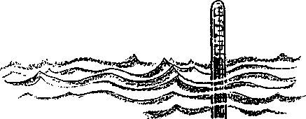
5. Notice that this chart does not give an upper temperature limit for the warm water organisms or a lower limit for the cold water organisms. Do you think this information is realistic? Explain your answer.

Temperature is an extremely important factor for aquatic organisms. Clearly all creatures are most comfortable within their normal temperature range.
6. There is another reason temperature is important to plants and animals. Perhaps you can deduce it from the chart above. (Hint: What might be a serious survival problem for fish at higher temperatures?)
Temperature also affects the amount of oxygen present as dissolved oxygen in the water. As the temperature increases, oxygen in the water decreases.
7. Why would an increase in water temperature be an especially serious problem for animals that breathe with gills?
pH or Acidity
The pH test is used to find out whether a substance is an acid, a base or neutral. It is measured on a scale from 1 to 14. Substances with a pH less than 7 are acids, such as lemon juice or vinegar.
Substances like baking soda or ammonia have a pH greater than 7. These are bases. The chart below shows the pH of some other common items

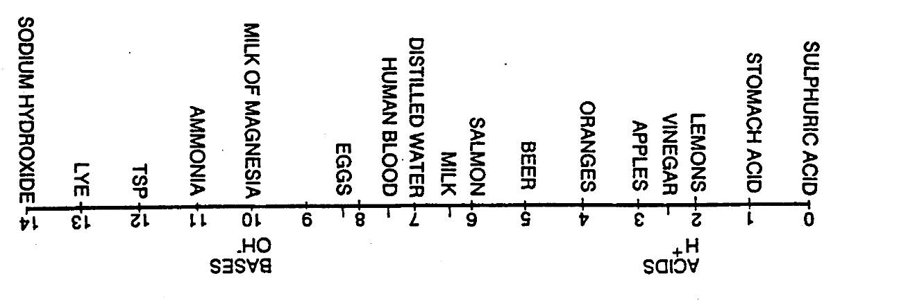

(Source: The Changing Sound, by James A. Kolb, the Puget Sound Project, available from The Marine Science Center, Poulsbo, WA)

The pH of most lakes, rivers and the ocean is between 6.5 and 8.5. Plants and animals live within specific pH ranges. Here are the pH ranges required by certain organisms:
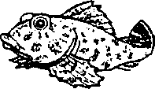
bacteria
1.0-13.0
- 12.0 6.0-9.0
- 8.5 7.0-9.0
- 7.5
algae, plants
carp, catfish
bass, bluegills
snails, clams, mussels
trout, insect nymphs
(Source: Thp World of Water, by Judy Friesem and Libby Palmer, science curriculum for teen girls, Girls Incorporated)
8. Which organisms can tolerate only the narrowest pH range?
9. Which have the widest pH tolerance?

In nature, variations in pH can be caused by naturally occurring substances. However, changes in pH may be the first sign of pollutants in the environment, such as acid rain. This is why it's so important to test pH regularly.
At your wetland:
Take the wetland's temperature: water temperature and air temperature
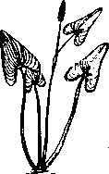
Use the pH test kit to find out whether the water is acid, base or neutral. Directions for this test are on the activity card, Water Quality. For best results, you should try out the pH test kit at home before using it at the wetland.
E. WETLAND PLANTS
Most ordinary plants can't survive in wetlands soils. Those plants which do live in wetlands generally aren't found anywhere else. Why is this? One reason is that the roots of plants need oxygen for their cells to work properly, and you already know that waterlogged soils are usually low in oxygen.

10. How might a plant solve the problem of getting oxygen down to its roots ?
Plants which can live in wetlands often have other special ^ adaptations, characteristics which help them live in this unique environment. At your field station you'll want to look for some of these interesting adaptations. Check the activity card, Wetland Plants for ideas.
The presence of particular plants is an important clue that wetland conditions exist. In your kit is a book called Recognizing Wetlands which will help you do this. A chart in the book called "Wetland Indicator Plants" (pp. 14-19) classifies plants into 5 groups by how often they are found growing in wetlands. Don't worry about learning the complex terms, just learn how to use the chart!
Plants that grow only in wetlands (OBL) are "obligate wetland plants."
Plants that usually grow in wetlands but are occasionally found in non-wetlands (FACW) are "facultative wetland plants."
Plants which grow equally in wetlands and non-wetlands (FAC) are "facultative plants."
Plants which are usually found in non-wetlands but occur occasionally in non-wetlands (FACU) are "facultative upland plants."
Plants which grow only in non-wetlands (UPL) are "obligate upland plants."
Look over this chart before visiting your wetland. After you have identified some of the plants growing there, you can look on the chart to find out where they are most likely to grow.

At Your Wetland:
Look for plants with special adaptations for living in wet places. (See the activity card, Wetland Plants for suggestions.)
Use the resource books in your kit to help you identify 3 common plants growing in or out of the water.
Are any of these plants included in the chart, "Wetland Indicator Plants" in the book Recognizing Wetlands? If so, find out how they are classified.
If you have permission to sample at your field station, carefully dig up 1 to 3 small plants to press. If you carry your plant press to the field you can begin pressing them there, otherwise you'll need to carry the plant samples home to press. Seal them in zip-lock bags and take care not to crush them in transit. You'll find procedures for pressing your samples on the activity card, Wetland Plants.
F. BIRDS AND MAMMALS
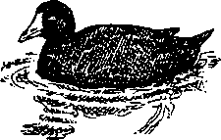
Wetlands provide food and shelter for many birds and mammals. If you arrive and work quietly you may be lucky enough to see some.

Birds
Swimming on the water's surface ducks, geese and other waterfowl feed on underwater plants and animals. Long-legged shorebirds like herons and sandpipers may be present along the shore where they wade into shallow water for fish and bottom animals. If your wetland has woodlands or shrubbery along its banks, perching birds may be present as well.
11. Why do you think so many different kinds of birds are found in wetland habitats?
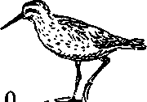
3v

Mammals
Unless you visit your wetland at night, you are less likely to see the mammals themselves than the clues they leave behind. If your wetland has muddy environments, be on the lookout for animal tracks. Visiting animals may have left other clues such as droppings (or scat).
At your wetland:
What birds and mammals are using the wetland? How are they using it? If you see birds or mammals, where do you see them and what are they doing? Identify them if you can using the references, Pond Life or Mac's Waterbird Field Guide.
The activity card, Birds and Mammals has suggestions for identifying tracks and scat of both mammals and birds. With patience and good detective skills, you may be to discover what the animal was doing at the wetland that day!
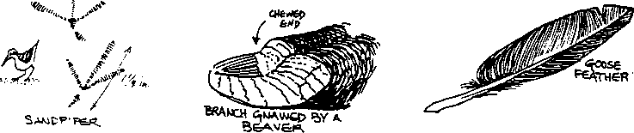
G. AQUATIC ANIMALS
Some of the most interesting creatures in a wetland live in the water. Shallow freshwater ponds are home to many kinds of shrimplike animals, snails, worms, tadpoles and fish. Among the most common and active creatures in the water are aquatic insects.
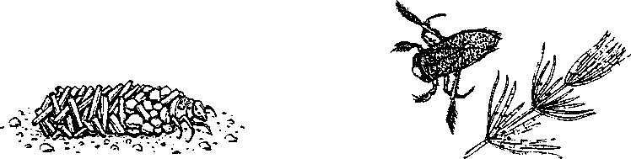
Among these animals are some which can be kept for two to three weeks in an aquarium or gallon jar in your house. The next section of this guide, called "World in a Jar," will help you learn more about the strange lives of these small animals.
At vour wetland:
Observe the aquatic animals at your wetland by quietly watching the water for a while.
Sweep through the water, along the plants and in the mud with a strainer or dip net. Invert the net into a small dish of water for a close-up view.
The activity card, Aquatic Animals will help you determine which animals you can collect and which to leave in the wetland. (If you do plan to take some of the critters home to study, be prepared to choose variety over quantity. Too many will stress their small environment and some or all will die. Please don't bring animals home unless you will be able to return them to the pond within 3 weeks.)
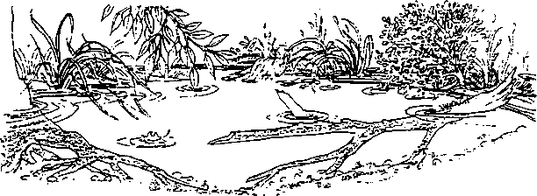

Leaving no Trail
Expert wetland detectives leave behind no signs that they've visited a wetland. Be an expert detective yourself when you go to your wetland. Here are some questions to consider before setting foot in this environment:
What effect will your feet have on soft ground and fragile plants? What can you do to lessen this impact?
How can you minimize the damage caused in collecting soil, plant and aquatic animal samples for your study?
What can you do to leave the wetland as much as possible the way you found it?

Part III: When You Return
Your specimens
Put a few small rocks in the bottom of your jar. Fill it with pond water to just below the narrow part of the neck. Arrange your plants, using the rocks to hold down their roots, if necessary. Then add the animals. If you have added water with the animals, you may need to remove the excess so that the water level remains below the neck constriction.
Follow directions on the activity card, Wetland Plants to press your plant specimens.
Your notes
Look over your notes. Make any necessary additions or corrections while it's all still fresh in your mind. If you're not sure you'll be able to read it later, copy it over!
Begin your entry into the Wet Places Scrapbook
The Wet Places Scrapbook is a record of the wetlands explored by each student who has used this Water World Kit. The information you gather should go in it too. Look at previous students' entries for ideas, but feel free to report on your wetland in your own unique way.
Here are some recommendations on what to include in the Wet Places Scrapbook:
- a state or local map showing where your wetland is located
- some information on the history of the wetland and how it's used today
- at least one diagram, photo or drawing of your wetland site
showing where you did your study
- your description of the soils and plants at the wetland
- your temperature and pH data from the wetland
- animals or animals signs seen there
- one pressed plant from the wetland, or a drawing of one you found
- a poem, sketch, or story to help create in others a mental
picture of your wetland
- suggestions to help other students get the most from their
wetland study

