THE WATER CYCLE

Getting Ready
You will need from your kit:
book, Liquid Magic, for extension activity
You will also need the following things which are not in your kit: a collection of household objects for building a water cycle model (You might want some pots and pans, a funnel, a cookie sheet, and a source of both heat and cold.) your own pen or pencil and some paper

Introduction
More than any other substance on earth, water is the key ingredient of all life. Your own body is 75% water. Yet water is also forever in motion. It changes easily from ice to liquid water to gas and it moves freely across the face of the planet. It also spends time in the cells of all living organisms.
The movement of water also connects us with the earth's past. Some of the water molecules in your mouth as you brushed your teeth this morning might have been the same water drunk by George Washington - or it might have once been inside the body tissues of a dinosaur or a prehistoric trilobite!
Water moves about our environment through pathways that we call the water cycle or hydrologic cycle. Rain falls on the earth and the water moves into the ground or over the surface. It may quickly evaporate and become water vapor again, or it may spend varying amounts of time deep underground or in the ocean. It may even become locked up in glacial ice for thousands of years. Water's movement can be very complex.
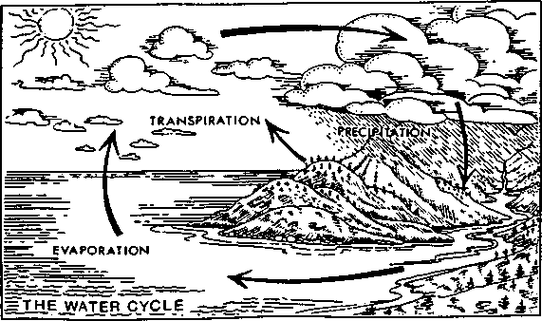
1 1

The Stream Scene. Oregon Department of Fish and Wildlife. P.O. Box 59, Portland. OR 97207.

Activity 1: An Incredible Journey
Write a short story exploring one water molecule's movements around the planet. You might refer to the water cycle diagram on the previous page for ideas, but use your imagination too. Does your molecule change form (solid, liquid, or gas) as it passes through different realms of the earth's surface? Does it become a part of any living animals or plants?
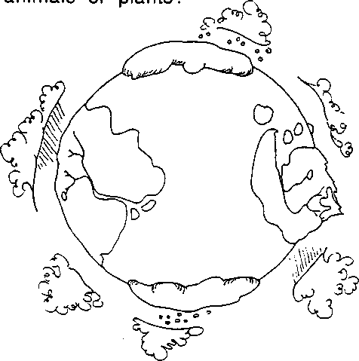

Activity 2: Water Cycle Model
Create your own working model of the water cycle. From ordinary household objects you can invent a device that makes water move from a liquid to a gas and back into a liquid again. Not sure how to begin? Let's start by taking a look at the problem piece by piece.
First it would be helpful to look more closely at some key parts of the cycle.
1. Do you know the meaning of the following terms? Use a dictionary if necessary to help you define each word.
- Evaporation —
- Transpiration (this is important in nature but you don't need to put it in your model) --
- Condensation -
- Precipitation -

2. Next, think of ways to make each step happen using tools around your house or school. Here are some questions to guide you:
What would you need to do to a pan of water to make it evaporate?
How could you catch the water vapor so that it doesn't all escape?
What do you need to do to the water vapor to make it condense back into liquid water?
How can you catch the water again as it precipitates?
You should be able to make a simplified water cycle happen right in your own kitchen! Useful materials to have on hand might include pots and pans, a funnel, a cookie sheet, and a source of both heat and cold. (If you run out of ideas altogether, turn to p. 43 for one design idea.)
3. Draw a diagram of your water cycle model explaining how it works. Label where the parts of the water cycle take place in your model.

Extension Activity:
Water itself is a pretty remarkable substance. To learn more about some amazing things that water and other liquids can do, try some of the experiments in the Science Club book, Liquid Magic, included in your kit. Then share your experiment with your family, your friends, a class of younger students, and/or future users of the Water World Kit.

