WATER WATER EVERYWHERE?

Getting Ready
Plan to do this activity in your kitchen or some other room where you can work freely with water.
You will need these things from your kit: photograph of the earth from space 3 liter jars 5 small plastic cups
stick-on, removable labels (one for each jar and cup) a 50 ml graduated cylinder a 10 ml pipette and bulb a calculator
You will also need a pen or pencil and a piece of paper.

Introduction
Find the picture of the earth from your kit and take a look at your home planet. Only a few decades ago we had never seen a view like this of the earth. Pictures of our our planet taken from spacecraft have changed our image of the earth, and we now give it names like "The Blue Planet" or the "Water Planet." If the earth had been named by a race of beings who first saw it from space, perhaps it would have been given such a name.
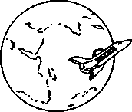
Scientists estimate that the total water on the planet equals 326,000,000 cubic miles. About 3/4ths of the earth's surface is covered with water. That certainly seems like a lot of water! With so much water on earth you would think there would be plenty of water for human needs and a lot left over for nature too.
Yet in many parts of our country and around the world people are arguing about water. There just doesn't seem to be enough water anymore for all the things we want to do with it. If the "Blue Planet" has so much water on it, why are we having these problems?
To find out one reason these problems are with us, try making a model of the earth's water supply. Imagine an earth only 4 feet in diameter. In this "Earth Model" all the water on the planet would equal just one liter! (That's just slightly more than one quart.)
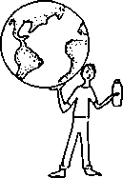

Activity 1: Where's All the Water?
Measure 1000 milliliters (one liter) of water from your sink into one of the two tall jars. (Put it on a table or kitchen counter which will not be damaged by possible spills.) This container represents all the earth's water, possibly its most precious resource.
1. Is all the earth's water usable by humans for drinking and agriculture? Explain.
Of course it's fresh water we're most dependent on. But how much fresh water is there really?
Make a prediction by pouring from the container holding "the earth's total water" the amount of water you think would represent the earth's fresh water supply into the second liter container. Label this container "Fresh Water Prediction." Set it aside for later.
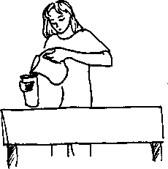
Once again, fill the first container to the liter mark to represent all the water on earth.
2. What are some places on earth that you would look for fresh water?
Here's a place you might not think to look, but there's actually more fresh water here than any other place. It’s the polar ice caps and alpine glaciers.
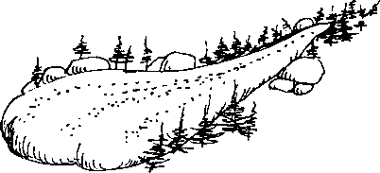
Ice caps and glaciers contain water that fell as snow tens or even hundreds of thousand of years ago! Scientists believe the water stored in glaciers is likely to be held there 10,000 years or more.
Just how much of our planet's fresh water is locked up in these ancient frozen reservoirs? Scientists estimate they hold about 6,980,000 cubic miles of water.
To picture a cubic mile, imagine an ice cube one square mile on each side. Now try picturing 6,980,000 cubic miles of ice!
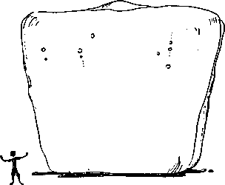
To find out what percentage of the earth's water is frozen, divide 6,980,000 cubic miles by the earth's total water and multiply by 100:
6,980,000 cu. mi./ 326,000,000 cu. mi. x 100 = %

Do that calculation now. Use the calculator in the kit if you like. Record and label your answer on your paper. For example:
3. a. Polar ice and glaciers = % of the earth's total water
Putting this quantity into a percentage makes it easy to find out how much water would be ice in the "Earth Model." Here's what you do. Simply multiply the total water in the "Earth Model" (1000 ml) by the percentage of the earth's water which is ice, then divide by 100. Use the percentage you found in 3 a. above to find the answer:
b. 1000 ml x‭ ‬% /100 =‭ ‬ml ice in the "Earth Model."

an alternative way of expressing this:

b. (1000 ml) x (% of earth's water which is ice) /100 =‭ ‬ml ice in
the "Earth Model"
From the full liter container, measure this amount using the graduated cylinder from your kit supplies. Pour it into a small cup and label the cup "Polar Ice Caps and Glaciers."
If using a graduated cylinder is new for you, here are some tips. The scale on the side shows its volume, divided into milliliters (mis.). Only intervals of 10 ml. are labeled. When using a graduated cylinder to measure volume, always line up the lower edge of the water’s curve (called the miniscus) with the line you're measuring against, as shown.
■HO
■JO
-t0

Where else would fresh water be found? If you dug a hole deep into the earth, in most parts of the world you would find water. This water is called "ground water." Ground water moves very slowly through deep soils and rock, so slowly in fact that it may have taken as many as 10,000 years to get there!

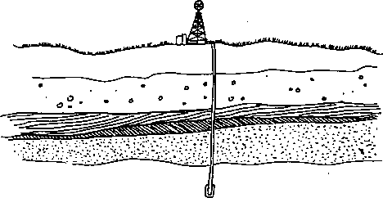

How much of our planet's fresh water is locked up in these deep underground reservoirs? Scientists estimate that 2,000,000 cubic miles of water are contained in the earth's ground water.
To find out what percentage of the earth's water is stored deep in the ground, divide 2,000,000 by the earth's total water and multiply by 100:
2,000,000 cu. mi./326,000,000 cu. mi. x 100 = % of water stored as ground water
Does this calculation look familiar? It should. You can use the same process to calculate all percentages.
4. Follow the same procedure you used earlier to calculate:
- the percentage of the earth's water which is stored as ground
water: %
- the quantity of water which represents ground water in the
"Earth Model": ml
Use the pipette to transfer this amount of water from the earth's total container to a small cup. Label this cup "Ground Water."
If using a pipette is new for you, you might like to spend a few minutes practicing using one. Draw water into the pipette by squeezing the pipette bulb, then empty it.
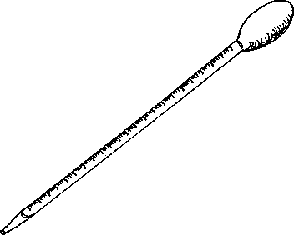

What are the units on the pipette's scale?
To measure a specific quantity, draw the water past unit to which you are measuring, and slowly release the extra water until the water level lines up with the unit you want.
Finally, empty the pipette into the desired container. Don't worry about the small amount of water left in the tip of the pipette.
What about lakes? Chances are you were quick to think of lakes when asked to name sources of fresh water on the planet.

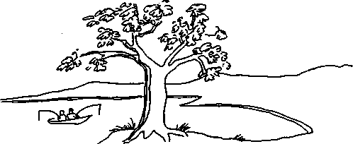

5. a. What is the name of a lake near where you live?
b. What is the name of the biggest lake in the United States?
Lakes are places where most of us can see large amounts of fresh water, yet all the lakes on earth combined hold only 30,000 cubic miles of water.
6. Follow the procedure you used earlier to calculate:
- the percentage of the earth's water held in lakes: %
- the quantity of water which represents lake water in the "Earth
Model": ml
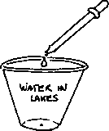
You may have difficulty measuring this amount of water even with the pipette! For the purposes of this exercise, you may use one drop of water to represent all the water found in the earth's lakes. Put this drop in a cup and label it "Water in Lakes."
Some of the earth's water is high above our heads. The atmosphere contains water vapor (the gas form of water) which is the source of rain, snow and clouds. We can't see, smell or taste water vapor, but we recognize it as water as soon as it condenses (reforms into liquid water) as rain or snow.

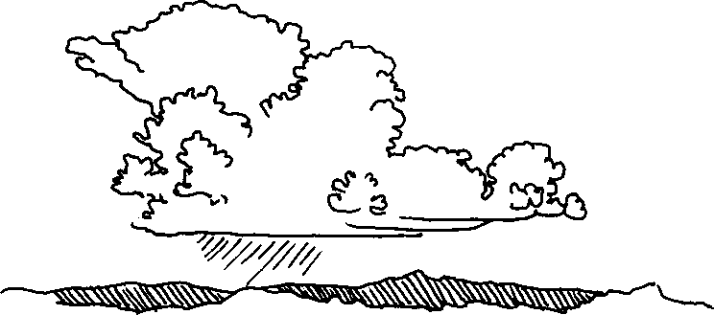

The atmosphere holds an estimated 3,100 cubic miles of water. 7. Calculate:
- the percentage of the earth's water which is held in the
atmosphere %
- the quantity of water representing atmospheric water in the
"Earth Model": ml
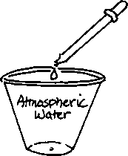
Once again you will need to represent the atmospheric water in the "Earth Model" with a small drop. Put this drop into a cup labeled "Atmospheric Water."
Where else do we find water? In rivers and streams, of course. To understand just how important rivers and streams are to our way of life, try imagining a world without them. Yet all the rivers and streams on the earth contain just 300 cubic miles of water!
8. Calculate:
- the percentage of the earth's water found in rivers: %
- the quantity of water representing rivers in the "Earth Model": ___ml
Use a wet finger to lightly streak the bottom of a cup. Label this cup "Water in Rivers."

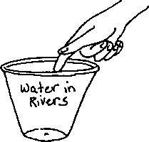

The cups now represent where all the fresh and salt water on the planet is found.
9. How does the total fresh water in the "Earth Model" compare with the prediction you made at the beginning of this activity? (To find out, pour all your freshwater cups into the third liter container, which you can label "the earth's Fresh Water". Put it next to your jar labeled "Fresh Water Prediction.")
- Which jar has more water in it?
- How many times greater or less was your prediction than the actual amount of fresh water in the "Earth Model?"
10. Water is important to people and wildlife in many ways, some of which are in conflict. How many uses of water can you think of?
a.
b.
c.
d.
e.
f.
9-
h.
i.
j-
Can you think of 5 more?
k.

l.
m.
n.

o.

- What are some ways wildlife uses water?
- How many of the 15 uses you listed depend on fresh water? Make a star by each which does.
- What would happen to life on earth if the fresh water disappeared or became polluted?
References:
Jacque-Yves Cousteau and the staff of the Cousteau Society, The Cousteau Almanac. Doubleday & Company Inc., Garden City, New York, 1981, for water resource facts.
Aquatic Project Wild, the Western Regional Environmental Education Council, 1987.

Activity 2: The Water Within
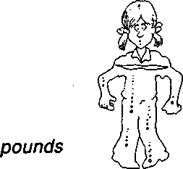
How many gallons of water are there in you? To find out, follow these steps, writing down what you get for each step.
- Weigh yourself:_____pounds

- Multiply your weight by 2.
- Divide your answer by 3. (The answer is the approximate
number of pounds of water in your body.)
- A gallon of water weights about 8 pounds, so divide your answer
by 8. This is the number of gallons of water in your body:‭ ‬
- Where does the water in your body come from?
Activity 2, "The Water Within" adapted with permission from The Stream Scene. Oregon Department of Fish and Wildlife, 1990.

