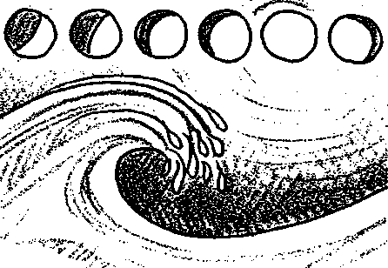

Times and Tides

Key Concepts
- The tides are Hie periodic rise and fall of the waters of the ocean and its inlets.
- The use of tide tables makes it possible to know, in advance, the times and heights of tides, facts which are important to people in many different walks of life.

Background
The tide is the periodic rise and fall of the sea around the edge of the land. Ocean tides occur worldwide, but the degree of fluctuation varies from imperceptible to many meters. In some areas the waters rise and fall once a day, in others the change occurs twice daily.
Tides at Seal Rock Campground have two high waters and two low waters each day but with considerable difference between heights of successive high waters or successive low waters (these differences are called DIURNAL (daily) INEQUALITIES).
People have long noted the importance of tides. From early times, tides have been considered important to navigation and commerce. Tides also play an important role in the lives of seashore animals and plants such as those your students will encounter at Seal Rock. The periodic submergence and exposure create both hardships and opportunities for organisms living in the intertidal zone.
To help make sense out of the tides, early on people began to keep accurate records. Over time the records allowed people to predict tidal changes with some degree of accuracy. Coupling these observations of past tides with astronomical information, scientists can predict the time and heights of tides with a high degree of accuracy. These predictions are compiled by the National Oceanic and Atmospheric Administration (NOAA) into tide tables for North and South America, Hawaii, and the coast of Asia. These tables give the dates, times and water levels for high and low water for 196 sites and the correction figures for an additional 6,000 sites.
Measuring tidal changes accurately is difficult since the ocean bottom near shore is always changing, as well as the amount of water above it. To provide a reference point for tidal change, a standard zero mark is chosen and tides are considered to be positive above that mark and negative below that mark. In the United States, Mean Lower Low Water is chosen as that reference mark. Mean Lower Low Water is the average of the lowest daily tides over a 19 year period.
Although many people are aware that the tides are caused by the gravitational attraction between the earth and the sun and between the earth and the moon, the topic of causality of the tides is very difficult for most students (adults, too!) to grasp due to the abstract‭‬
Seal Rock Marine Trail Curriculum - Olympic National Forest, Quilcene, Washington 98376
Developed by the Institute of Marine Science www.forsea.org
92

concepts involved. Fortunately, students do not need to know the origin of tidal changes to benefit from your trip to Seal Rock. If you do wish to explore tidal mechanisms in more detail, a good source of lessons and activities is "The World of Water: Grades 9 to 12 - Unit III: Tides and the Rocky Shore” available from FOR SEA Institute of Marine Science, P.O. Box 188, Indianola, WA 98342 (on the web at forsea.org).
While tides are clearly complex, it is important for a lot of people to be able to know the times and heights of tides in advance. In "Time and Tides", your students will see that tide tables provide some of the information necessary for a successful trip to Seal Rock beach.

Materials
For each student:
- "Time and Tides" student pages
- Overhead of tide table for week of December 11, 1998 at Seattle (optional)
- Overhead of graphical tide table for January 2000 at Quilcene Bay (optional)
- Tide chart for this year, in booklet form - one for each group

Teaching Hints
In "Times and Tides" students use tide charts and graphs to understand Puget Sound tides, before actually observing their impact on Seal Rock Beach.
Introduce the concept of tides by soliciting student experiences with tidal changes. Tell students that they will be reviewing tide charts and selecting possible days for a class field trip to Seal Rock beach. Provide each student with a set of the "Time and Tides" student pages. You may wish to use an overhead of the tide graph for week of December 11, 1998 at Seattle found in the student pages to familiarize your students with tabular tidal data. If you choose to use the overhead, ask students sample questions which require them to use the data. Similarly you may wish to use an overhead of the graphical tide graph for January 2000 at Quilcene Bay as an overview of graphical tidal data and to discuss the conventions used for showing AM, PM, heights, high tide, low tide, phases of the moon, etc. and to explain other notations that appear: MR=moonrise, MS=moonset, SR=sunnse, SS=sunset.
After students have completed the review of tabular and graphical tide charts, distribute this year's tide chart (booklet form). Ask them a few specific questions to get started. Then have them work in groups of 3 or 4 to complete the remaining task on the "Time and Tides" student pages in which they determine the best day for your class field trip to Seal Rock Campground.
Note: You will have to determine the month and week for the Seal Rock Campground trip prior to having students complete Part III and check to be sure that the parameters given for departure and arrival time make sense for your particular situation.

Key Words
diurnal inequalities - the vertical difference between one high tide and the next high tide
high tide - the tide at its highest point of elevation; time of high water
low tide - the tide at its lowest point of elevation: time of low water‭‬
Seal Rock Marine Trail Curriculum - Olympic National Forest, Quilcene, Washington 98376
Developed by the Institute of Marine Science www.forsea.org
93
minus tide - a low tide that falls below the Mean Lower Low Water value, exposing shoreline usually covered by seawater
mixed tide - a pattern of two high tides and two low tides in 24 hours with a difference between the heights of consecutive high and low tides; the tidal pattern typical of the west coast of the U. S.
slack water - a period when a body of water is between tides.
tide table - tabular or graphic presentation of predictions of the dates, times and water levels for high and low water for a particular site or sites
tides - periodic rise and fall of the waters of the ocean and its inlets, occurring about every 12 hours

Essential Academic Learning Requirements in Science
- The student understands and uses scientific concepts and principles. (1.3)
- The student knows and applies the skills and processes of science and technology (2.2)

Answer Key
Part I - Tide Table
- Answers will vary depending upon students' experiences. It is helpful to know the time and height of the tide for gathering marine plants and animals, construction in the intertidal zone, navigation in shallow water, recreation, etc.
- a. There are two high tides on December 12.
- Ten hours and 48 minutes pass between high tides on December 12.
- The time between tides on December 12 is shorter than the average (by 97 minutes; i.e., 10 hrs 48 mins vs. 12 hrs 25 mins).
- There are two low tides on December 12.
- Thirteen hours and 25 minutes pass between low tides on December 12.
- The first high tide occurs at 2:46 AM on December 13.
- The second low tide on December 13 occurs at 8:20 PM.
- There is a zero foot tide on Wednesday, December 14.
- a. The first high tide on December 13 is 9.5 feet above the average (often called "above zero", rather than "above the average").
- The second high tide on December 13 is 10.9 feet above the average.
- The difference between the heights of the two high tides on December 13 is 1.4 feet (i.e., 10.9 feet - 9.5 feet).
- During the week of December 11, the lowest tide (-1.0 feet) occurs on December 17.
- This lowest tide occurs at 10:35 PM.
- The water level changes 11.3 feet (i.e., 10.3 feet - (-1.0 feet)) from the second high tide to the second low tide on December 17.
Seal Rock Marine Trail Curriculum - Olympic National Forest, Quilcene, Washington 98376
Developed by the Institute of Marine Science www.forsea.org
94
Part II - Graphical Tide Tables
- a. The highest tide in January occurs on January 22 and on January 23.
- The height of the tide is 13.3 feet.
- On January 22, the tide occurs at 6:19 AM; on January 23, the tide occurs at 6 59 AM.
- a. The lowest tide in January occurs on January 20.
- The height of the tide is -3.0 feet.
- The tide occurs at 10:19 PM.
- The tidal range (height from lowest to highest tide) in January is from 13.3 feet to -3.0 feet or 16.3 feet.
- At 12:01 AM on January 9 the tide is slack. Note that the term slack has to be inferred from the text as the period when the tide is neither rising nor falling
- For ease of following the solution, the problem is restated here:
Low tides are best for collecting oysters from the beach. As president of Luvmisleep Oysters, you need to collect oysters in January. Collecting requires a tide of zero feet or less. It's a lot of work and you need to finish and be in bed by 10:00 PM. It takes you an hour and a half to collect your oysters and drive home.
Look at the tide chart. Now, give the times and dates when will you be able to collect oysters in January.
This problem contains several pieces of information for your students to sort out in order to find the times and dates when oysters may be collected. Since the president has to be in bed by 10:00 PM and, because the time to harvest and drive is an hour and a half, the tide of zero feet or less must be no later than 8:30 PM. Armed with this information, the search begins for suitable low tides. Sufficiently low tides occur January 3 to January 10. The next series of sufficiently low tides begins on January 17 and ends on January 24. The next task is to check the times of the low tides to find those that occur by 8:30 PM. In the first low tide series, the earliest low tide is on the 3rd at 9:16 PM, too late to make bed by 10:00 PM. In the second series, the low tide on January 17 occurs at 7:53 PM and is the only one that occurs earlier enough in the series to get the president home and in bed by 10:00 PM. The president will only be able to collect oysters one day in January. Although one work day a month is appealing, it is not very realistic and in the winter oyster growers spend a lot of long, late, cold, wet, dark nights on the oyster beds of Hood Canal.
Part III - Seal Rock Tides
The day, date, and times of the high and low tides for the best day for your class trip will depend upon the data you provide your students.
Seal Rock Marine Trail Curriculum - Olympic National Forest, Quilcene, Washington 98376
Developed by the Institute of Marine Science www.forsea.org

Times and Tides
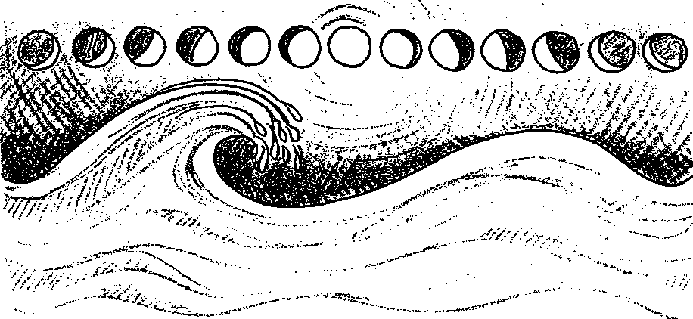

Tide Tables
Every day the waters of the ocean rise and fall. At Seal Rock beach the water rises and falls twice each day. This means that the shorelines are covered with water, then exposed to sun over and over. Many of the plants and animals that live in the shoreline area are also alternately submerged then exposed. People that visit Seal Rock beach often want to know whether the water will be "high" or "low" at a certain date and time.
1. Why might a visitor to Seal Rock beach find it helpful to know the time and height of the tide?
For thousands of years, people wondered "What causes the tides?". We now know the tides are largely caused by the action of the moon and sun on the ocean. This information and the observation of past tides help scientists predict the time and heights of tides. These predictions are printed in tide tables.
Tides differ from area to area. Because of this, tide tables are made for local areas. For example, on the following page is a tide table for Seattle, Washington. Seattle tide tables are often used for the Seal Rock area.
Seal Rock Marine Trail Curriculum - Olympic National Forest, Quilcene, Washington 98376
Developed by the Institute of Marine Science www.forsea.org
96
Times and Tides - Seattle, Washington
Week of December 11,1998
Date | Time | Hiah Tide | Time | Low Tide
Sun., Dec 11,1998 | 12:05 AM | 8.0 ft | 5:04 AM | 4.8 ft
 | 11:43 AM | 11.5 ft | 6:54 PM | 2.2 ft
Mon., Dec 12, 1998 | 1:36 AM | 8.6 ft | 6:15 AM | 5.9 ft
 | 12:24 PM | 11.2 ft | 7:40 PM | 1.4 ft
Tue., Dec 13, 1998 | 2:46 AM | 9.5 ft | 7:25 AM | 6.6 ft
 | 1:02 PM | 10.9 ft | 8:20 PM | 0.6 ft
Wed., Dec 14,1998 | 3:41 AM | 10.3 ft | 8:27 AM | 7.1 ft
 | 1:37 PM | 10.6 ft | 8:56 PM | 0.0 ft
The., Dec 15, 1998 | 4:26 AM | 10.9 ft | 9:19 AM | 7.3 ft
 | 2:11 PM | 10.5 ft | 9:30 PM | -0.5 ft
Fri., Dec 16, 1998 | 5:04 AM | 11.4 ft | 10:03 AM | 7.4 ft
 | 2:45 PM | 10.4 ft | 10:02 PM | -0.8 ft
Sat., Dec 17,1998 | 5:38 AM | 11.8 ft | 10:42 AM | 7.4 ft
 | 3:19 PM | 10.3 ft | 10:35 PM | -1.0 ft

2. Let's see what we can learn from this table.
- How many high tides are there on December 12?
- How much time passes between high tides on December 12?
- The average time between high tides is 12 hours and 25 minutes. How does the time between tides on December 12 compare to this average?
- How many low tides are there on December 12?
- How much time passes between low tides on December 12?
- What is the time of the first high tide on December 13?
- What is the time of the second low tide on December 13?
- On which day is there a zero foot tide?
Seal Rock Marine Trail Curriculum - Olympic National Forest, Quilcene, Washington 98376
Developed by the Institute of Marine Science www.forsea.org
97
"Water Level" changes as the tides rise and fall. Averaging hourly water levels over a 19 year period gives the local average sea level. This average is called Mean Sea Level. "Fine", you say, "but there are two low tides a day in Seattle. Which low tides are averaged?"
The tide heights shown in the tide table are compared to the average of the lowest daily tides. This average is called Mean Lower Low Water. Mean Lower Low Water is the average of the lowest daily tides over the 19 year period. Sometimes the tides are higher than the average. Sometimes they are lower. Tides lower than the average are called minus tides.
They are written with a minus sign in front of them.
3. Let's see what else we can learn from the tide table.
- How high above the average is the first high tide on December 13?
- How high above the average is the second high tide on December 13?
- What is the difference between the heights of the two high tides on December 13?
- During the week of December 11, on which date does the lowest tide occur?
- At what time of day does this lowest tide occur?
- How much does the water level change from the second high tide to the second low tide on December 17?
Seal Rock Marine Trail Curriculum - Olympic National Forest, Quilcene, Washington 98376
Developed by the Institute of Marine Science www.forsea.org
98
Part II - Graphical Tide Tabtes
For many people, page after page of dates and numbers are hard to use Recognizing this“Tides – Quilcene,Quilcene Bay, Dabob Bay is a graphical tide table. The curving line shown on the graph represents the rise mid fall of the tides at Seal Rock beach for the month of January 2000. Use this graphical tide chart to answer the following questions.
- a. On what day does the highest tide in January occur?
b. What is the height of the tide?
c. At what time does it occur?
- a. On what day does the lowest tide in January occur?
b. What is the height of the tide?
c. At what time does it occur?
- What is the tidal range (height from lowest to highest tide) in January?
- What is the tide doing (rising, falling or slack) at 12:01 AM on January 9?
- Low tides are best for collecting oysters from the beach. As president of Luvmisleep Oysters, you need to collect oysters in January. Collecting requires a tide of zero feet or less. It's a lot of work and you need to finish and be in bed by 10:00 PM. It takes you an hour and a half to collect your oysters and drive home. Look at the tide chart. Now, give the times and dates when will you be able to collect oysters in January.
Seal Rock Marine Trail Curriculum - Olympic National Forest, Quilcene, Washington 98376
Developed by the Institute of Marine Science www.forsea.org
99
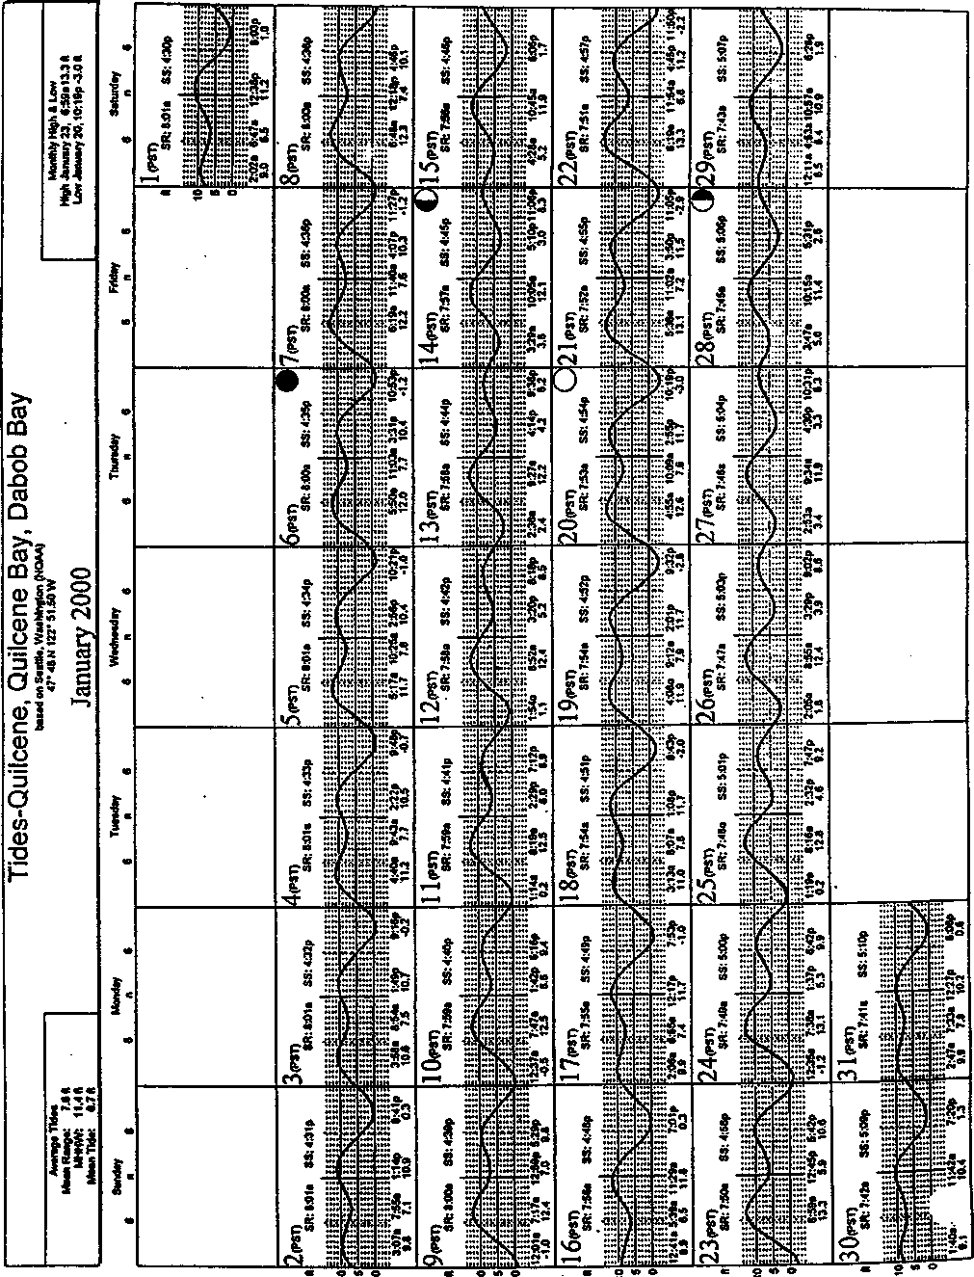
Seal Rock Marine Trail Curriculum - Olympic National Forest, Quilcene, Washington 98376
Developed by the Institute of Marine Science www.fbrsea.org
100

Part III - Seal Rock Tides
Obtain a copy of a current tide table for the area around Seal Rock beach. After carefully examining everyone's schedule, your teacher has chosen the month and the week for your class tnp to Seal Rock Campground. It's your task to choose the best day. Here's what you need to know to help you choose:
- You need to arrive at Seal Rock Campground one hour after your school day begins.
- You need to leave Seal Rock Campground one hour before your school day ends.
- You need to have as much time as possible to study oysters which are best seen at tides of zero or less.
In the space below, write the day, date, and times of the high and low tides for your choice of best day for your class trip.
Seal Rock Marine Trail Curriculum - Olympic National Forest, Quilcene, Washington 98376
Developed by the Institute of Marine Science www.forsea.org
101

