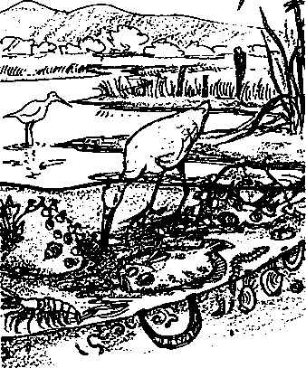
Connections

Key Concepts
- A food chain describes the relationship of animals to the organisms they eat, and to the animals which eat them.
- An important balance between food and prey organisms must be maintained or the relationships shown in the food chains break down.
Every animal lives within its own specific habitat, i.e., the environment or "neighborhood" in which it lives. An animal's habitat satisfies its many survival needs including those for food, water, oxygen, and shelter.
Seal Rock Campground contains three discrete habitats: forest, intertidal shoreline, and the open waters of Hood Canal. Each habitat supports an assortment of plants and animals, some unique to a particular habitat, others easily passing between them.
The intertidal shoreline and the open waters of Hood Canal are influenced by the nearby Dosewallips estuary. Estuaries, the mixing zones where rivers flow into the sea, rank beside tropical rain forests as the most productive ecosystems on earth. A river is like a conveyor belt which carries dissolved and suspended materials downstream to the river mouth. When river water comes in contact with sea water, much of a river's particle load may be dropped, both by the slowing of the water and by chemical interactions with salt water. An estuary receives the fine particles carried by the river, but also many nutrients, and the result is often a shallow, fertile environment flushed by tidal action which can support dense stands of eelgrass and salt tolerant marsh grasses. Sheltered by this vegetation is a teeming community of small fishes and invertebrates. In the Dosewallips estuary these small fishes and invertebrates provide the food supply needed by salmon smolts as they leave the river and prepare to venture into the marine environment of Hood Canal.
The following map of the Dosewallips estuary shows the depositional pattern of sediments from the river. Notice that currents and water flow in Hood Canal move sediments from the river along the shoreline and on to Seal Rock beach.
Seal Rock Marine Trail Curriculum - Olympic National Forest, Quilcene, Washington 98376
Developed by the Institute of Marine Science www.forsea.org
74
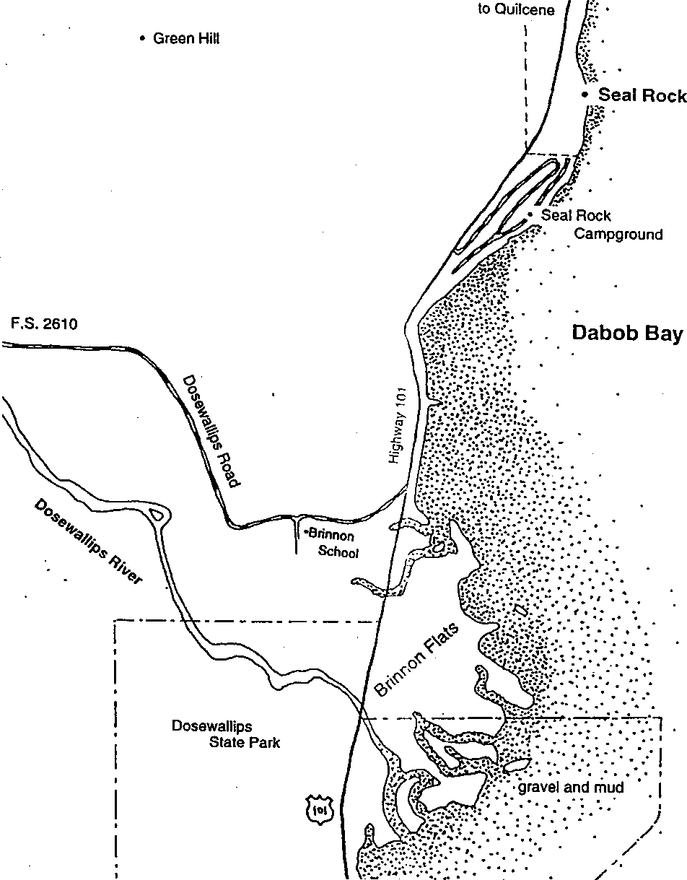
Seal Rock Marine Trail Curriculum - Olympic National Forest, Quilcene, Washington 98376
Developed by the Institute of Marine Science www.forsea.org
75

Food chain is an important concept introduced in "Connections" using estuary food chains as an example. Living things are intimately connected to what they eat and to the organisms that prey upon them. We can represent these relationships using arrows. The arrows reflect the movement of energy and matter in the shape of a plant or animal. For convenience, the arrows may be thought to signify .is eaten by. A simplified food chain used in this lesson looks like this:
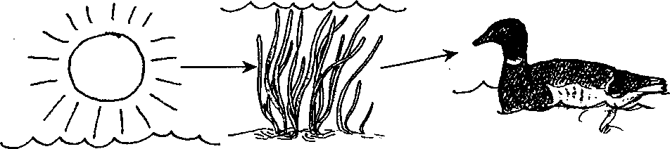
In this food chain, the sun's energy is captured in the eelgrass. Some of the energy is transferred to the black brant when it eats the eelgrass. This underscores the fact that the arrows in a food chain also represent energy transfer.
A more typical food chain in an estuary begins not with living eelgrass as in this example, but rather with dead eelgrass or other vegetation.
Throughout this lesson the term "detritus" is used for this dead organic material, that is, partially decomposed plant and animal remains. Detritus is an extremely important food source in an estuary. Only a few animals such as the black brant feed directly on the large volumes of seagrass and algae produced in an estuary, but nearly all estuary animals eat these plants indirectly after they have become detritus. Detritus is processed in large quantities by a myriad of tiny invertebrates, including the important food animals for salmon.
One such detrital food chain might look like this:
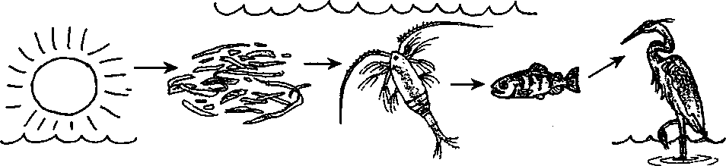
In this food chain, the sun's energy is stored in the tissues of eelgrass. After it is dead, the eelgrass is eaten by copepods, tiny relatives of shrimp which are abundant in estuaries. The copepods are eaten by salmon smolt, which are in turn consumed by herons.
The four organisms above occupy positions in the diagram called trophic levels. Trophic levels are discrete steps in the transfer of food energy from plants which first produce it through each of the organisms which use it. For example, we call eelgrass the "producer," because it is the original producer of all the food energy flowing through this chain.
Copepod is the "first order consumer," the first to consume the food energy, while salmon
Seal Rock Marine Trail Curriculum - Olympic National Forest, Quilcene, Washington 98376
Developed by the Institute of Marine Science www.forsea.org
76

smolt is the "second order consumer," etc. In actuality, there may be a number of microorganisms at work between the detritus and the copepods but these will be disregarded here for the sake of simplicity.
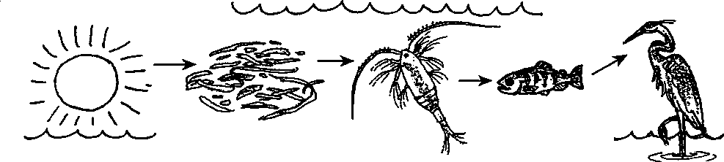
Energy Source

Producer | 1st | 2nd | 3rd
 | Order | Order | Order
 | Consumer | Consumer | Consumer

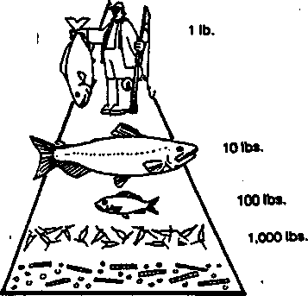
A widely accepted theory from the field of ecology holds that an organism at one trophic level is maintained by eating approximately 10 times its own weight in food from the next lower trophic level. In our food chain, this means that it takes 10 times as much salmon (by weight) to sustain a heron, and likewise, 100 times the heron's weight in copepods are needed to maintain the salmon which the heron eats. This concept is often expressed as a pyramid, with horizontal layers representing producers and the various levels of consumers.
4TH HUMAN
3RD LARGE FISH
2ND SMALL FISH
1ST ZOOPLANKTON
PRIMARY PRODUCERS PLANKTON
10.000 lbs.

Who's For Dinner?" involves your students in a role playing game that graphically illustrates this principle. By playing this game, they will discover that the number of organisms in each tropic level helps determine whether the food chain as a whole can survive.
In "Who's For Dinner?" your students will play the roles of copepods, salmon, and herons. The first link in the food chain will be detritus, represented in the game by popcorn, spread over an outdoor game area. The student copepods "eat” the detritus, by placing it in plastic
Seal Rock Marine Trail Curriculum - Olympic National Forest. Quilcene, Washington 98376
Developed by the Institute of Marine Science www.forsea.org
77

bag "stomachs", the student salmon "eat" the copepods, and the heron, in turn, "eat" the salmon. The object of the game is for each animal to get something to eat without being eaten during the timed course of the game. Students will quickly discover they need to manipulate the size of each population or some animals will become extinct.

Lesson Plan

Student Objectives:
- Students will explore the concept of a food chain through a guided reading, by diagramming food chains, and by playing an active role playing game which simulates an estuary food chain for salmon smolts.
- Students will discover that there is an important balance between food and prey organisms which must be maintained or the system breaks down.

Space:
"Who's For Dinner?" is best played outdoors on a grassy area about 15 meters square;
however, a gymnasium or parking lot will also work.

Materials:

Part I
- One copy per student, "Connections"
- Optional Video: ESTUARY
(ESTUARY 91591 (VHS) 12 mm. available from: your
local ESD or film distributor. By Bullfrog 1979)

Part II
- 4-5 liters of popped corn
- one per student, ANIMAL STOMACHS
(plastic sandwich bags, each marked with a strip
of masking tape 4 cm from bottom of bag)
- 3 stacks of colored paper
- including approximately: 30 sheets yellow, 20 sheets green, 20 sheets blue
- two safety pins per student
- watch with a second hand
- clipboard and paper
- marking pen
- one copy per student, "Who's For Dinner?"
- loud whistle for starting and stopping the game

Procedure:

Part I
1. The optional film or video, ESTUARY, makes a good introduction to this important habitat.
Seal Rock Marine Trail Curriculum - Olympic National Forest, Quilcene, Washington 98376
Developed by the Institute of Marine Science www.forsea.org
78
- Introduce the concept of a food chain by using an example familiar to the students such as the following:
Grass -» Grasshopper -> Spider -> Bird
Over the diagram, label the trophic levels in the food chain. Grass produces the food
energy initially, therefore it is the "producer". Grasshopper is a "1st Order Consumer,"
Spider is a "2nd Order Consumer," and Bird is a "3rd Order Consumer."
Producer 1st Order 2nd Order 3rd Order Consumer Grass -> Grasshopper -> Spider -» Bird
Ask the students where the energy in this food chain comes from originally. (The sun)
Place the sun in the diagram before grass.
- Explain that in an estuary the most important producers are eelgrass and algae, but that most animals only feed on them after the plants are dead. Showing your students a container of partially composted leaves and grass may help them recognize that detritus is found on land too.
- Assign your students the student text, "Connections", which includes the task of diagramming a salmon smolt food chain.

Part II:
- Hand out plastic bag "stomachs" to all your students, and divide your class into thirds. One group will play the part of copepods, one will represent salmon, and one will be heron. Pin a sheet of yellow paper to the front and back of each copepod. Use pink paper to label salmon and blue paper for heron.
The fact that you have a surplus of colored paper will allow you to change the population
numbers as the game progresses.
- Spread 3/4 of the popcorn over the playing area.
- When the game starts, copepods will "eat" detritus by picking up popcorn and putting it in their "stomachs." Salmon will "eat" copepods by lightly tagging copepods, whereupon, the contents of the copepods" stomachs are transferred to the stomachs of salmon.
When a heron captures a salmon, he or she takes the salmon's whole stomach. Note that herons do not eat copepods and salmon do not eat detritus. Tagged students go to the sidelines and wait for the end of the round.
- Blow the whistle and say "Go!" You may want to stop the first game after only a minute or so, since one of two things usually happens immediately. Either all the copepods are tagged before they have a chance to forage, or all the salmon are eaten immediately, allowing the copepods to continue gathering popcorn freely and "get fat."
- Analyze how many animals actually survived. For a copepod to survive, popcorn must fill the stomach bag to the bottom of the tape (4 cm). For the salmon or heron to survive, popcorn must fill the bag to the top of the tape (6 1/2 cm). Chart the survival numbers for each animal on your clipboard. If at least one of each kind of animal survives, you have an on-going food chain. Return the popcorn to the playing area after each round of the game.
- Now ask your students for suggestions on how to change the game so that after a 5- minute round, a better balance between the remaining animals results. Experiment with
Seal Rock Marine Trail Curriculum - Olympic National Forest, Quilcene, Washington 98376
Developed by the Institute of Marine Science www.forsea.org
79
rule variations which might accomplish this. Here are some changes your students may suggest:
- Change the number of copepods, salmon or heron.
- Let the copepods come back as another copepod once after being captured and giving up their popcorn.
- Provide a "safety zone" for copepods and/or salmon where they can be safe. This could represent the shelter of an eelgrass bed.
- Timed releases: let the copepods go first and forage unmolested. One minute later release the salmon, and later the herons,
- Spread out more popcorn.
Change only one rule at a time. Before actually testing it, have your students predict with a show of hands what they think will be the outcome of each rule change. Afterwards, tabulate the survival numbers of each animal again.
7. Back in the classroom, have the students answer the questions in the student text, "Who's For Dinner?" After they have finished, use these questions as the basis for a discussion.
Other possible questions for discussion:
- Which variation provided the most realistic conditions? (answers may vary)
- Would (or did) shelter make a difference to the survival of copepods? salmon? (probably it would)
- Are there any plants or animals which are not part of any food chains? (No)

Essential Academic Learning Requirements in Science
- The student understands and uses scientific concepts and principles. (1.1, 1.2, 1.3)
- The student knows and applies the skills and processes of science and technology (2.1,

2.2)

Answer Key:

Part I
- The fine particles and nutrients carried by the river and the shallow, relatively flat terrain are features that make estuaries rich with life.
2.
Sun -> dead eelgrass -» copepod -> young salmon -» heron
- The primary difference between phytoplankton and zooplankton is that phytoplankton are plants that produce their own food while zooplankton are animals that must obtain their food from other sources. Your students may not recognize this important distinction at this point. They may instead refer to the pictures above in search of differences. This latter approach is acceptable but you need to point out the primary difference during your discussion of this material.
Seal Rock Marine Trail Curriculum - Olympic National Forest, Quilcene, Washington 98376
Developed by the Institute of Marine Science www.forsea.org
80

- Six molecules of oxygen are released for each sugar molecule produced by the phytoplankton. This question is designed to let you see if your students have a grasp of what the equation for photosynthesis is saying.
- The answers depend upon the experience of your students. This question is designed to help relate the new concept to familiar situations. If your students have difficulty with the concept of food chains, you might have them practice with land based food chains including the standard:
Grass -» cow -» human
- Since the small fish is a second order consumer, we would call a medium sized fish that ate the small fish a third order consumer.
- The answers will depend upon previous experience. Any reasonable answer is acceptable. The level of the consumer added will vary with the animals chosen.
- Answers will vary. Accept any answer. The object of this question is to get your students thinking about the magnitude of food moved along the links of a food chain.
- The problem may be set up as follows:
5.75 oz x 24 cans = 138 oz x 1 lb. = 8.625 lbs, salmon x 10.000 Ibs.of phytoplankton = 86,250 lbs of can case 1 16 oz case pound of smoked Coho salmon phytoplankton!
- Since oysters are noted as second order consumers in the food chain shown in the text, one pound of smoked oysters would require 100 pounds of phytoplankton. As such, the problem may be set up as follows:
5.75 oz x 24 cans = 138oz x 1Jb.= 8.625 lbs, salmon x 100 Ibs.of phytoplankton can case 1 16 oz case pound of smoked oysters
862.5 lbs of phytoplankton!
- Strictly speaking, to maximize the amount of marine food available to people, we should harvest the producers (phytoplankton) directly. This is not always possible for many reasons both economic (cost of harvesting a diffuse organism) and sociological (people often will not eat new and strange tasting items). The farther down the food chain we feed, the greater the amount of food available.
- Humans would be affected in many ways by the death of all of the ocean's plankton just as we are diminished by the death of any species. In specific, however, we would find ourselves without most of the food we harvest from the ocean and without oxygen to breathe. Fairly considerable negative impacts!

Part II:
- There is no single correct answer to this question, but hopefully students have discovered that the size of the predator population must be significantly smaller than the population it feeds upon. In other words, the copepod population needs to be larger than the salmon population, which must be larger than the heron population for a balance to exist.
- If less detritus is present, more copepods would starve, therefore more salmon and herons would probably starve as well.
- If no salmon were present, the copepod population would grow dramatically, so long as
food is available. If detritus became scarce, some copepods would starve.‭ ‬
Seal Rock Marine Trail Curriculum - Olympic National Forest, Quilcene, Washington 98376
Developed by the Institute of Marine Science www.forsea.org
81

- If no salmon were present, the entire heron population would starve in this simulation. In real life, the herons would likely move elsewhere.
- Yes. The food chain in this game, and in an actual estuary depends upon detritus. Sea grasses and large algae are the largest source of detritus in an estuary. Students may also mention the important role of plants in providing shelter for salmon in an estuary.
- Answers may vary. A vegetarian will have a very simple food chain, while a person who eats seafood, such as salmon may have a relatively long one. Here are some examples:
Sun Com -> Human
Sun -» Grass -> Beef -> Human
Sun -»• Eelgrass -» Copepod -> Salmon smolt -> Ling cod -» Human (as detritus)
Seal Rock Marine Trail Curriculum - Olympic National Forest, Quilcene, Washington 98376
Developed by the Institute of Marine Science www.forsea.org
82

Connections
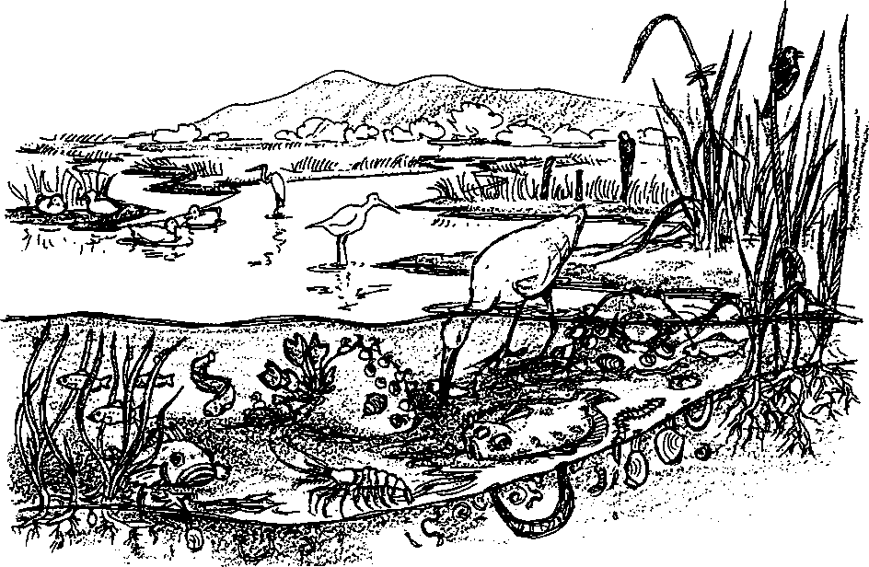

Part I
Seal Rock beach seems like a place apart, a special spot hardly influenced by space or time. Actually, Seal Rock beach is influenced by many things. The Dosewallips River just to the south is one of them. The Dosewallips River drains a large area of the Olympic mountains. The water flows down the steep mountain slopes, finally fanning out in the Dosewallips estuary. Estuaries, the mixing zones where rivers flow into the sea, rank beside tropical rain forests as the most productive ecosystems on earth.
Fine particles and nutrients carried by the Dosewallips create a shallow, fertile environment with dense stands of eelgrass and salt tolerant marsh grasses. Sheltered by this vegetation is a teeming community of small fishes and invertebrates.
In the winter, silvery chinook salmon, about five inches long, swim in the estuary. Fat from feeding on tiny water bugs, they are finally ready to leave the river and begin the seagoing phase of their lives.
1. What features make estuaries rich with life?
Seal Rock Marine Trail Curriculum - Olympic National Forest, Quilcene, Washington 98376
Developed by the Institute of Marine Science www.forsea.org
Estuaries are ideal environments for salmon as they prepare to make their ocean migration. As they move into the estuary, they find their dinner waiting. The shallow water and muddy bottom is teaming with small, shrimp-like animals which eat dead eelgrass. One kind are called marine copepods, and the young salmon find them delicious.
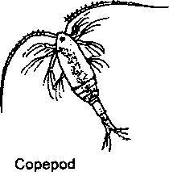
As the small fish fill their bellies, some of them become a meal for other animals lurking in the estuary, birds like herons and kingfishers, or larger fish. We have a special name for the relationship of animals to the organisms they eat, and to the animals which eat them. We call this relationship a food chain.
2. Use the organisms listed below to complete a Dosewallips estuary food chain. Draw the organisms in the box below and connect them with arrows that show the direction of the energy transfer (from the eaten to the eater).
copepod
sun
heron
dead eelgrass young salmon
Energy Source | Producer | 1st | 2nd | 3rd
Energy Source |  | Order | Order | Order
 |  | Consumer | Consumer | Consumer

Copepods are also abundant in the waters off of Seal Rock. Here they eat tiny plants called phytoplankton. "Plankton” comes from a Greek word "plankton" which means wandering and "phyto" comes from a Greek word meaning plant. Phytoplankton and their animal counterparts called zooplankton are wanderers in the sense that they just float along with the water. These organisms have a limited ability to swim, in a real sense they are at the mercy of the tides and currents.
Seal Rock Marine Trail Curriculum - Olympic National Forest, Quilcene, Washington 98376
Developed by the Institute of Marine Science www.forsea.org

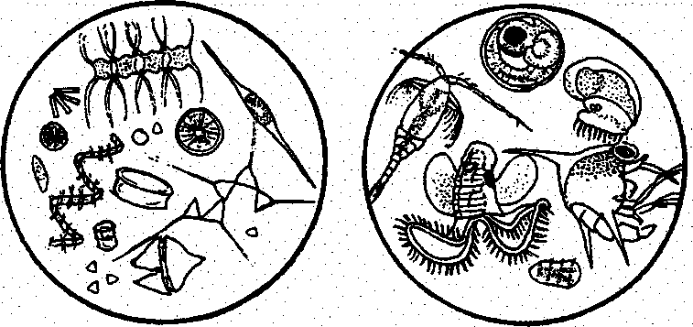
phytoplankton zooplankton
3. What is a major difference between phytoplankton and zooplankton?
Phytoplankton support most of the herbivores (plant eaters) in the waters off Seal Rock beach. As the area's primary producers, phytoplankton trap and store the energy contained in sunlight. In the process of photosynthesis, the phytoplankton use carbon dioxide (CO2) and water to produce more organic matter (food) than any other group of plants.
4. The equation:

(in sunlight)

6 C0₂ + 6H₂0 > C₆H₁₂ 06 + 6 0₂
describes photosynthesis. It tells us that through a long process which occurs in the presence of sunlight, six carbon dioxide molecules (C0₂) and six water molecules (H₂0) are combined to give us one molecule of a simple sugar (CeHi₂06) and six molecules of oxygen (0₂). How many oxygen molecules are available to animals including humans from the production of each sugar molecule by phytoplankton?
The phytoplankton species near Seal Rock are food for local copepods (which, by the way, are zooplankton). Animals, such as oysters, mussels and clams, that feed by filtering the water eat lots of copepods. As we can guess from what happened to the young salmon in the Dosewallips estuary, these filter feeders are fed upon, in turn, by larger invertebrates and fish. All of these animals either consume directly or indirectly the food that the producers
Seal Rock Marine Trail Curriculum - Olympic National Forest, Quilcene, Washington 98376
Developed by the Institute of Marine Science www.forsea.org

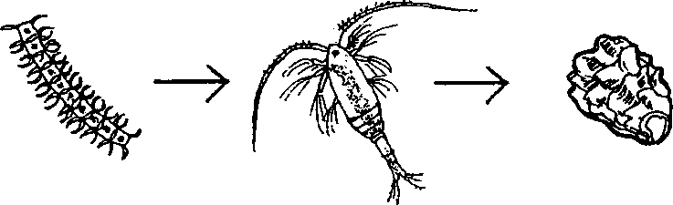
have stored. As a result, we call these animals consumers. We might draw another food chain to help see the relationships:
phytoplankton
(producer)
zooplankton
(consumer)
Olympia oyster (consumer)

This simple food chain shows us that the small fish ate the zooplankton that ate the phytoplankton. The arrows show which way the energy and matter stored by the plants are moving.
5. Use your knowledge of Puget Sound plants and animals to draw another food chain with at least three members. Label the producer and the consumers.
Sometimes it is helpful for us to know whether the consumer we are taking about was the one who ate the producer, or one who are another consumer. To accomplish this, we call a consumer who eats green plants a first order consumer. A consumer who eats a first order consumer is called a second order consumer and so on. At each energy transfer (for example, a second order consumer eating a first order consumer) about 80 to 90% of the energy is "lost", only 10 to 20% of the energy is available to the higher order consumer. Because of this energy loss food chains are seldom over four or five links long.
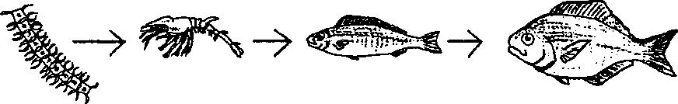
6. In the food chain shown below, what would we call a medium sized fish that ate the
small fish?

Seal Rock Marine Trail Curriculum - Olympic National Forest, Quilcene, Washington 98376
Developed by the Institute of Marine Science www.forsea.org

Aha? , I hear you say, "What about the Pacific Herring that eats both zooplankton and phytoplankton?" Okay, you've got me. When the herring eats the phytoplankton it is a first order consumer and when it eats the zooplankton it is a second order consumer. We can draw the food chain like this:
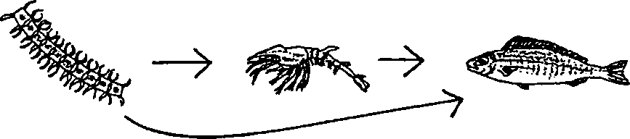
phytoplankton > zooplankton > small fish
(producer) (first order consumer) (second order consumer and
> first order consumer)
Now our food chain has become a food web. A food web is made of several food chains. We can find many such food chains and food webs, both on land and in the sea. Sometimes they can become very complicated.
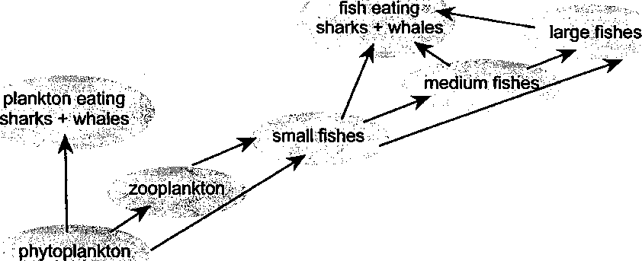
We could continue to add members to this web until it became very much more complicated.
7. Add one more member to the food chain shown above. What level consumer is your addition?
Seal Rock Marine Trail Curriculum - Olympic National Forest, Quilcene, Washington 98376
Developed by the Institute of Marine Science www.forsea.org

Let's look at our food chain again. It is obvious that a plankton feeding shark would have to eat a great deal of plankton to stay alive. Let's isolate one food chain out of our web and see how much phytoplankton it takes to feed a fourth order consumer, a large Coho salmon from the Dosewallips River.
8. Before you start, make a guess by filling in the blank in the following sentence. I think it takes about pounds of phytoplankton to make one pound of fourth order
We have a clue. We've seen that processes like respiration ("breathing") and natural mortality (death) cause the loss of 90 percent of the energy at each step in the food chain. Let's see how much phytoplankton it would take to produce one pound of our salmon: it takes 10 pounds of medium fish which needed to eat 100 pounds of small fish which needed to eat 1,000 pounds of zooplankton which needed to eat 10,000 pounds of phytoplankton!
consumer.
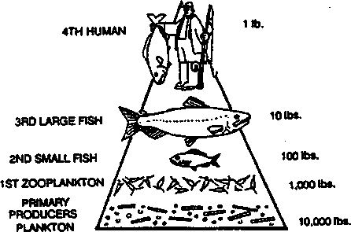
Wow! To produce one pound of our Coho salmon, we had to start with 10,000 pounds or 5 tons of phytoplankton. Without phytoplankton, we would have no fish to eat.
9. Caught off the Straits of Juan de Fuca, smoked Coho salmon comes to our supermarkets usually packed in 5 3/4 ounce cans. There are 24 of these cans in a case. How many pounds of phytoplankton were required to produce each case of smoked Coho salmon? Please show your work. (Hint: How many pounds of tuna are there in a case?)
10.Oysters are also harvested, smoked and delivered to our supermarkets packed in 5 3/4 ounce cans. There are 24 of these cans in a case, too. How many pounds of phytoplankton were required to produce each case of smoked oysters? Please show your work. (Hint- Look at the food chains diagramed above to determine what order consumer the oyster is.)
Seal Rock Marine Trail Curriculum - Olympic National Forest, Quilcene, Washington 98376
Developed by the Institute of Marine Science www.forsea.org

1 l.To maximize the amount of marine food available to people, what level consumer should we harvest?
The health of phytoplankton has a direct impact on the life found in the waters near Seal Rock and on human welfare.
12. What are two ways humans would be affected by the death of the ocean's phytoplankton?
a.
b.
Seal Rock Marine Trail Curriculum - Olympic National Forest, Quilcene, Washington 98376
Developed by the Institute of Marine Science www.forsea.org
Part 11
Who's For Dinner?
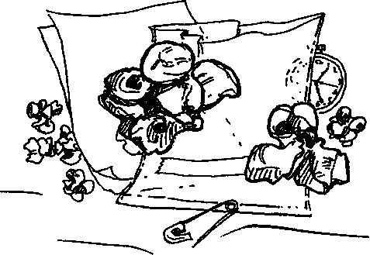
After playing the game "Who's for Dinner?" think carefully about each of the following questions, then write the answers below:
1. Assume that the goal of the game is to keep all three animal species from going extinct. From your experience playing the game, how would you balance the players? How many players should play the parts of copepods, salmon and heron? (Remember — a species must have at least two survivors after each round to keep from going extinct.) Use the number of students in your class as the total number of players.

Copepods

Salmon

Heron

Total
2. What would happen if only half as much detritus were present?
Seal Rock Marine Trail Curriculum - Olympic National Forest, Quilcene, Washington 98376
Developed by the Institute of Marine Science www.forsea.org
- Suppose that one year no salmon were present. What would happen to the copepod population?
- What would happen to the heron population that year?
- Do salmon in an estuary need plants to survive? Explain your answer.
- Make a diagram of one food chain you are part of. Begin your food chain with the sun, and end the food chain with you.
Seal Rock Marine Trail Curriculum - Olympic National Forest, Quilcene, Washington 98376
Developed by the Institute of Marine Science www.forsea.org

