Watersheds

Key Concepts
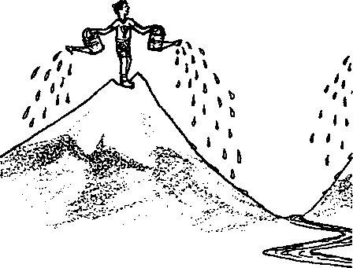
- A watershed is all the land which drains into a river or body of water.
- Most of the water flowing into a river originates as rain or snow, falling somewhere within the watershed.
- All the activities taking place in a watershed, those far from the river as well as those right beside it, can have an impact on a river's water quality — and on whether salmon can survive there.
- The concept of watershed is important to the effective management of water quality problems.
A watershed is all the land which drains into a river or body of water. Although we often picture a river originating from a spring, most of the water flowing into a river originates as rain or snow, falling somewhere within the watershed. The water will pass either over the surface or below the surface on its way to the river.
Watersheds can be very complex systems which may differ from one another in significant ways because of variations in geology, soil conditions, rainfall, topography, and land use, but the main thing to remember is that everything happening within a watershed can have an impact on the river which drains the watershed. For this reason, it has been said that salmon don't actually live in streams, they live in watersheds.
The concept of watershed is becoming increasingly important to the effective management of water quality problems, since users of a watershed ultimately share responsibility for the resource. Political boundaries often cut across watersheds, making these cooperative efforts more difficult.

Teaching Hints
"Watersheds" is a two-part activity. In Part I, students are faced with a challenge posed to a university engineering class: design an effective watershed model. Part II is organized around a series of map activities which will begin by establishing the boundaries of watersheds, then focus on activities within the Dosewallips watershed which can affect the habitat of salmon migrating past the nearby Seal Rock Campground.
Seal Rock Marine Trail Curriculum - Olympic National Forest, Quilcene, Washington 98376
Developed by the Institute of Marine Science www.forsea.org

Lesson Plan

Student Objectives:
- Students will understand the concept of a watershed as the area of land which drains into a river.
- Students will experiment with modeling watersheds and will create a portable watershed model, suitable for teaching younger students, which shows farms, cities, rural homes and how each adds contaminants to water downstream.
- They will recognize that all the activities taking place in a watershed, those far from the river as well as those right beside it, can have an impact on a river’s water quality — and on whether salmon can survive there.

Materials:

Part I
- One copy per student, "Watersheds"
An assortment of items from which students may choose, including:
- aluminum foil
- labels
- marking pens
- dropper bottles
- plastic paint-roller trays
- small shovels, trowels, or large spoons
- A source of dirt or sand
- Some "instant” vegetation — leaves, twigs, grass, etc.
- A watering can

Part 11
- One copy per student, DOSEWALLIPS WATERSHED AND LAND USES MAP Graphics:
- WATERSHED
- PUGET SOUND RIVERS
- Large sheet of paper (2 sheets of butcher paper, taped together)
- Marking pens

Procedure:
- Introduce the concept watershed to your students using the watershed diagram as a transparency, or draw your own.
- Outline the challenge based on the Florida A&M assignment and have your students work in groups of 3-4 to create a watershed model. Decide beforehand how complex you wish the models to be and provide materials appropriate to that level of complexity. If you wish to have your students use the models in teaching younger students, let them know at this time.
- Upon completion of the watershed models, provide a time for groups to share their creations with the class as a whole.
- Have your students read independently and complete WATERSHEDS, Part II.
Seal Rock Marine Trail Curriculum - Olympic National Forest, Quilcene, Washington 98376
Developed by the Institute of Marine Science www.forsea.org

- Discuss their answers to question 1 before continuing to question 2 and 3. See the answer key for assistance.
In going over their responses to question 1 (f), Puget Sound Watersheds, both you and they need to understand that with the information they have been given, they can only make approximations of the Puget Sound watershed boundaries. For that reason, the drawings will vary somewhat. However, their drawings should reflect an understanding that watersheds never cross rivers, and that all land falls into the watershed of some river.
To assist you in discussing Puget Sound watersheds with your class (or possibly to help them get started with the assignment), you can use the map, PUGET SOUND RIVERS as a transparency. With watershed boundaries added, this map should look like the map provided in the answer key at the end of this section.
- Tape the large sheet of paper to the wall at the front of the class and with a marking pen, make a rough sketch of a watershed. If you like, you can use the graphic, WATERSHED, included in this guide for your model. You may want to prepare this diagram ahead of time.
Explain to your students that this represents a Puget Sound watershed. Ask the students to turn to their table group or nearby students and brainstorm at least five different uses of the land which might be present on this watershed.
Go around the room asking them to share their ideas. As an idea is suggested, have a student draw or simply label the land use on the diagram. Meanwhile, record the land uses they suggest on the board or on another sheet of butcher paper. Then ask the class to list possible water quality problems caused by each land use. Here are some ideas if the class gets stuck:
pulp and paper mills
farming
pesticides herbicides animal wastes
logging
silt from erosion herbicides
wastewater
wood fiber particles
marinas and boaters
bottom paint
sewage
oils
trash
households lawn & garden chemicals motor oil, antifreeze septic tank overflow pet wastes
landfills
wide variety of chemicals
industries toxic wastewater

municipal sewage treatment plants
highways gasoline, oil, lead exhaust
urban development
runoff from streets
treated wastewater (still contains many contaminants)
Seal Rock Marine Trail Curriculum - Olympic National Forest, Quilcene, Washington 98376
Developed by the Institute of Marine Science www.forsea.org

Ask: How do contaminants which are released far from the river's edge affect the water in the river?
(Water travels in underwater streams or aquifers from the source of the contaminant to other parts of the watershed. The graphic, WATERSHED might be useful in illustrating this.)
8. Give your students questions 2 and 3 of "Watersheds" to complete. They will need to use the DOSEWALLIPS WATERSHED AND LAND USES MAP for this activity.

Essential Academic Learning Requirements in Science
- The student understands and uses scientific concepts and principles. (1.2, 1.3)
- The student knows and applies the skills and processes of science and technology (2.1,
2.2)
- The student understands the nature and contexts of science and technology (3.1, 32.)

Answer Key:
1. Puget Sound Watersheds
- No
- The rivers all lie in valleys.
- No
- No
- No
- Watersheds of Puget Sound
- The correct answer will depend on where your students live.
(cont. on next page)
Seal Rock Marine Trail Curriculum - Olympic National Forest, Quilcene, Washington 98376
Developed by the Institute of Marine Science www.forsea.org
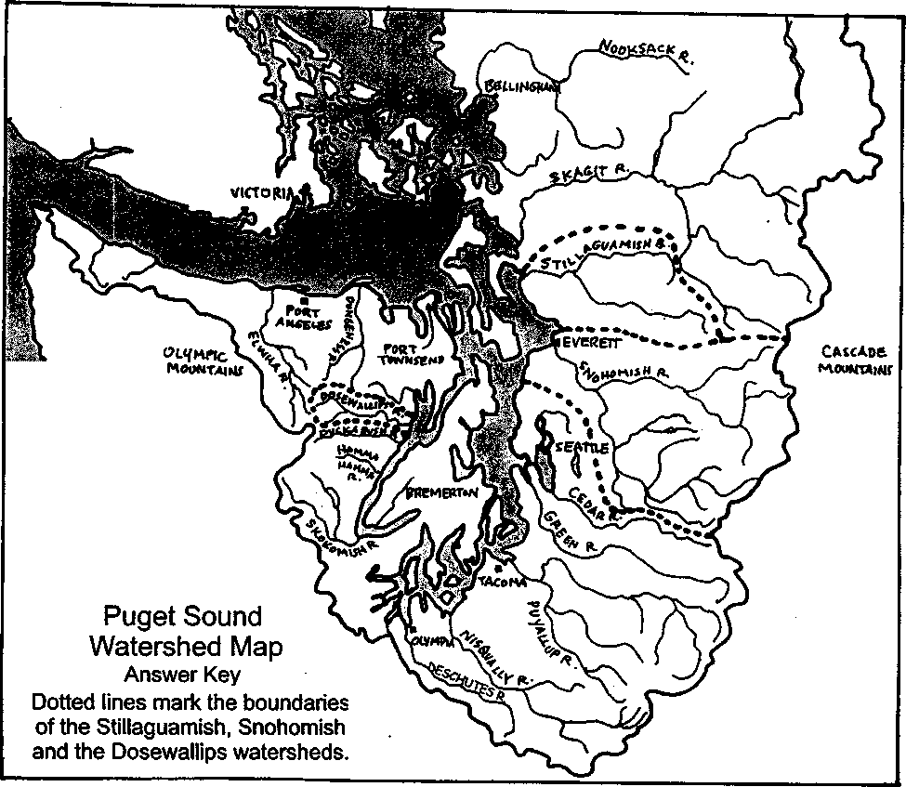
- Dosewallips River Watershed
- highway 101 and logging and other small unnamed roads.
- farming, residential, forest management, recreation
- forest management/logging
- The Big Picture
- A watershed is the land which drains water into a river.
- A river's ability to support salmon depends on the ways people use the river's watershed, not just on the characteristics of the immediate river.
- Answers will vary. Any three of the examples listed in procedure step 6 above are acceptable.
Seal Rock Marine Trail Curriculum - Olympic National Forest, Quilcene, Washington 98376
Developed by the Institute of Marine Science www.forsea.org

Watersheds
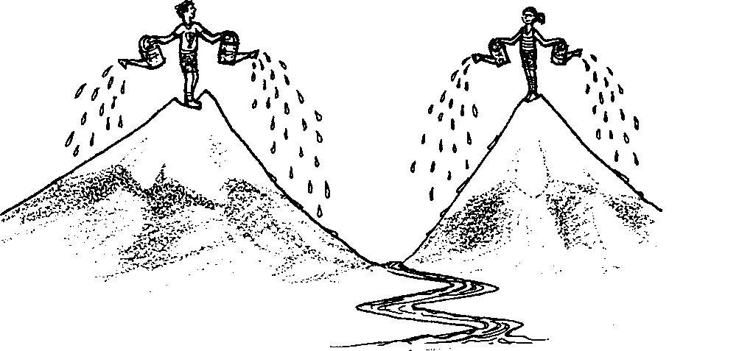
Many odors drift past salmon as they swim by Seal Rock Campground and head upstream in the nearby Dosewallips River. There are the smells of leaves and dry grasses in the water, of diy grass. There is the distinct odor of cows from a farm up the valley. She can smell diesel oil and a trace of motor oil from logging trucks in the mountains. Even the faint odor of soap from a hiker's camp stands out in the current.
Salmon can read such stories from the river because the water in it has touched all parts of the river basin, or watershed. A river’s watershed is all the land which drains water into the river when rain or snow falls. Every river is part of a watershed, with "walls of hills and mountains, a floor of river or lake, and a roof of rain clouds."*
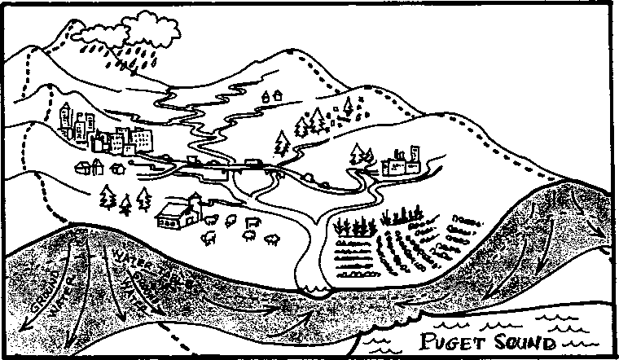
*Peter Warshall, as quoted in "Soundwaves" Vol.2. No.1. March/April 1987. Seattle: Puget Sound Water Quality Authority
Seal Rock Marine Trail Curriculum - Olympic National Forest, Quilcene, Washington 98376
Developed by the Institute of Marine Science www.forsea.org
68

Part I
Watersheds are often so large that it is hard to understand what is happening in them. To help, scientists and planners often use models. But models aren't always easy to make either. Here's an assignment from the engineering program at Florida Agricultural and Mechanical University:
Florida A&M University
Biological and Agricultural Systems Engineering Program
College of Engineering Sciences, Technology and Agriculture
ABE Senior Design Project: Watershed model
Background
Many engineering principles are rather abstract and difficult for students to understand. Having interactive, working models can help teach fundamental principles in Agricultural and Biological Engineering to students and to increase interest in high school students (prospective ABE students).
Objectives
Make a watershed model that shows how water quality is affected by all members of a watershed. Incorporate water in the model and a method of testing for and locating the source of contaminants. The model must be transportable, low cost to build, and interactive for the user (more than just a demonstration).
Deliverables
- Interactive watershed model showing farms, cities, rural homes and how each adds contaminants to water downstream.
- Incorporate water (sprayers, irrigation, lawn sprinklers, etc.) and testing methods.
- Plans of the model (computer generated).
- Lesson plan describing how the model should be used, what can be learned from the model, and explain the engineering principles involved.
Why should college students have all the fun? Here's your challenge:
Use the materials provided by your teacher to make a model to teach younger students about watersheds. Your model must meet the same objectives set by Florida A&M (except for contaminant testing) and deliverables 1, 2a (incorporate water), 4a (how the model is used), and 4b (what can be learned from the model).

Part II
Now that you've had some experience with watersheds, let's take a closer look at some Puget Sound watersheds. Look carefully at the Puget Sound rivers on the map on the following page. In a minute you are going to outline each river’s approximate watershed. But first consider these questions.
Seal Rock Marine Trail Curriculum - Olympic National Forest, Quilcene, Washington 98376
Developed by the Institute of Marine Science www.forsea.org
69
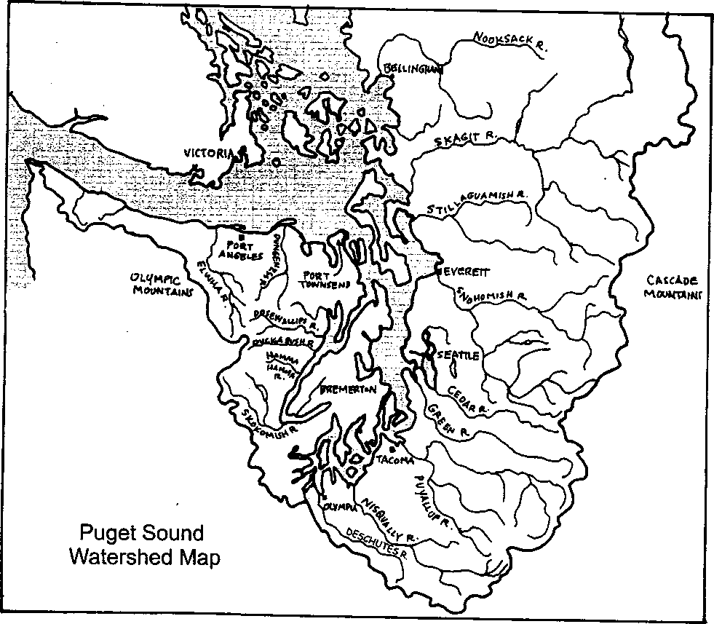
1. a. Does this map actually tell you where the hills lie?
- What clues does it give you about where the valleys are?
- Will the edge of a watershed ever cross a river?
- Will any land not fall within any watershed? (Should there be any space between watersheds?)
- Can a point of land be within more than one watershed?
Seal Rock Marine Trail Curriculum - Olympic National Forest, Quilcene, Washington 98376
Developed by the Institute of Marine Science www.forsea orq
70
- Now, using a sharp pencil, draw the boundary around the watershed of the Snohomish River. Now, draw the boundary of the Stillaguaxnish River watershed. Finally, draw the boundary of the Dosewallips River watershed.
(Hint: For each watershed, follow the ridgeline around the entire river basin.)
- What river's watershed do you live in? Is it on this map?
2. Dosewallips River Watershed. More salmon swim past Seal Rock Campground and enter the Dosewallips River. Everything happening in the watershed may be having an effect on the river. Examine the DOSEWALLIPS WATERSHED AND LAND USES MAP, which you will find as the last page of this lesson, to find out some of the things happening here which might influence the salmon as they try to reach their spawning grounds.
- What roads pass through the watershed?
- What are four kinds activities people are using the land for in the lower valley?
- What is the primary activity taking place along Rocky Brook which feeds the Dosewallips River?
3. The Big Picture
a. What is a watershed?
Seal Rock Marine Trail Curriculum - Olympic National Forest, Quilcene, Washington 98376
Developed by the Institute of Marine Science www.forsea.org
71
b. It has been said that salmon don't live in rivers, they live in watersheds. What could this statement mean?
c. List three land uses in the Dosewallips watershed which influence water quality. Give at least one way each of them may degrade the quality of the water entering Hood Canal.
Seal Rock Marine Trail Curriculum - Olympic National Forest, Quilcene, Washington 98376
Developed by the Institute of Marine Science www.forsea.org
72
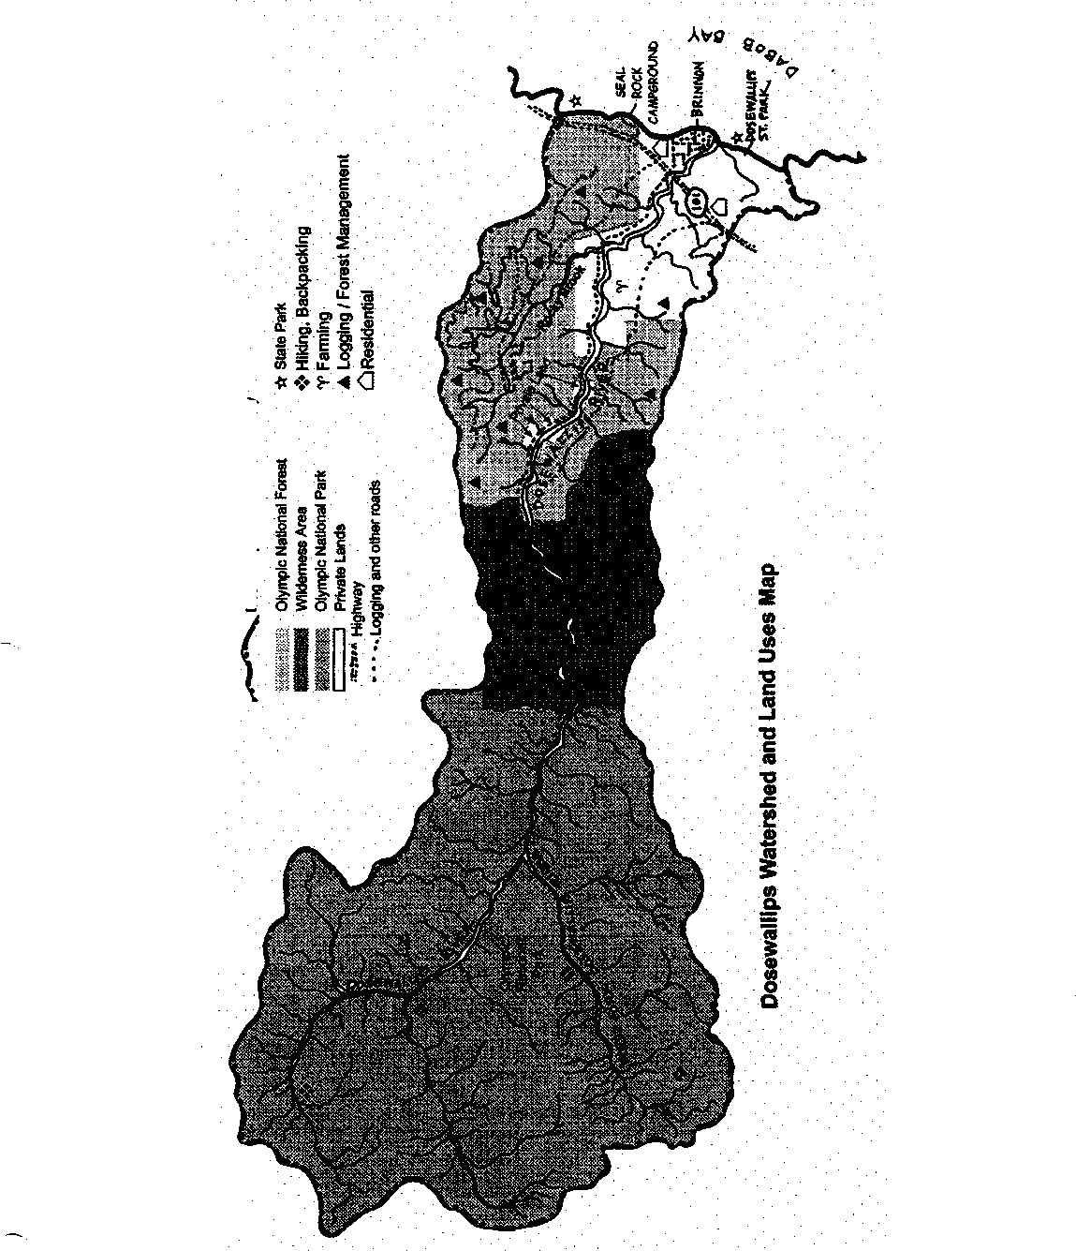
Dosewallips Watershed Boundary

Seal Rock Marine Trail Curriculum - Olympic National Forest, Quilcene, Washington 98376
Developed by the Institute of Marine Science www.forsea.org
73

