Shell Game

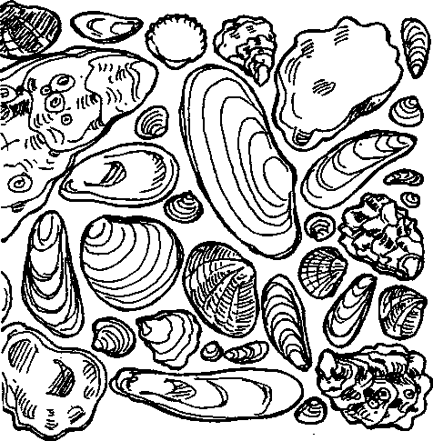
Key Concepts
- Much can be learned about human interaction with plant and wildlife species through a study of artifacts left behind.
- By knowing the time and conditions under which artifacts were deposited, we are able to better reconstruct the lifestyle of those individuals who made the deposit.
- Human populations are influenced by the health of plant and animal populations and, in turn, can significantly influence those populations.
"Shell Game" uses a final report from an archaeological dig at Seal Rock as a vehicle for studying Native American interactions with the fauna and flora of Seal Rock. Excerpts from the report lead the student from an overview of Seal Rock climate, to its flora, then to its fauna with an eventual focus on the Olympia oyster as an indicator of both how humans utilized the resources at Seal Rock and how human actions have contributed to a change in oyster populations.

Materials
For each student or pair of students:
• "Shell Game" activity sheets

Teaching Hints
Through selected excerpts and guiding questions, "Shell Game" endeavors to make a highly technical report comprehensible to your students. If you wish to explore this topic in more detail, the entire report, entitled "ARCHAEOLOGICAL TESTING AT SEAL ROCK (45- JE-15); OLYMPIC NATIONAL FOREST, WASHINGTON" by GARY C. WESSEN, Ph.D. 1987, is available from the Olympic National Forest.
You may choose to begin this activity immediately following completion of "Dig It!" which provides the context for the report.
Duplicate the "Dig It!" activity pages, one set per student. You may choose to have students do this activity as homework or as an in-class assignment. If you are comfortable
Seal Rock Marine Trail Curriculum - Olympic National Forest, Quilcene, Washington 98376
Developed by the Institute of Marine Science www.forsea.org
with students helping each other work through the text and questions, this is a good activity for such learning.
Whether you choose to have students complete the activity as homework or in-class work, plan to provide time for a discussion of the questions and concepts. Use the table depicting shellfish remains to point out the trends seen in the data: in particular the predominance of oyster shells and the unusual numbers of blue mussel (Mytilus edulis) found in Stratum III.

Essential Academic Learning Requirements in Science
- The student understands and uses scientific concepts and principles. (1.2, 1.3)
- The student knows and applies the skills and processes of science and technology (2.1)
- The student understands the nature and contexts of science and technology. (3.1, 3.2)

Answer Key
- Winters at Seal Rock are accompanied by high precipitation and relatively mild temperatures.
- January and February have the lowest mean temperature. Note: The question intentionally asks for "month", to focus attention and challenge students to question the question.
- July has the lowest mean rainfall at .64 inches.
- 14.44 inches of rain fall in the wettest month, which is November.
- Answers will vary. Since the question asks for an opinion, accept any span of months from March to October as long as the choice is supported by reasonable justification.
- The three trees likely to be most common at Seal Rock Campground are western hemlock (Tsuga heterophylla), western red cedar (Thuja plicata), and Douglas fir (Pseudotsuga menziesiij.
- Today’s visitors want to avoid Pacific poison oak, (Rhus diversiloba), because of the painful rash it can cause. This question is a forewarning to be aware of poison oak on the field trip to Seal Rock Campground.
- The large mammals most likely eaten by Native Americans visiting the Seal Rock Campground include elk (Cervus canadianus), and deer (Odocoileus hemionus). Some students may add black bear (Ursus americanus) and/or harbor seals (Phoca vitulina).
- Of the fish listed, salmon most likely provided the most food for the Native Americans visiting the Seal Rock Campground. This question requires some prior knowledge regarding Native American dietary regimes.
- The Olympia oyster (Ostrea lurida) were the oyster most likely eaten by the Native Americans visiting the Seal Rock Campground.
- Coast Salish is the broad grouping of Native Americans to which the people who used Seal Rock belong.
- The people at Seal Rock belonged to the Quilceed "tribe".
- They used the skills of fishing, hunting, and plant material gathering to secure enough
to eat.
Seal Rock Marine Trail Curriculum - Olympic National Forest, Quilcene, Washington 98376
Developed by the Institute of Marine Science www.forsea.org
53
- a. Stratum III, had the greatest number of shellfish (a total of 914 individuals).
- Two possible explanations for this greater abundance include variants of the following:
- There were more people eating the shellfish and leaving behind the shells.
- There were more shellfish available to be eaten.
- Stratum III contains higher concentrations of Olympia oysters and blue mussels and proportionally lower concentrations of steamer clams and moon snails
- a. The scientific name of the most commonly found shellfish is Ostrea lurida.
- The common name of this shellfish is the Olympia oyster. This question is included to inspire students to decipher the scientific names of animals they know.
- The percentage of the total does this most commonly found shellfish represent in each stratum
- =342/613x100
- =605/914x100
- =332/630x100
- = 142/266 x100
- Answers regarding a typical day's shellfish diet for the Native Americans living at Seal Rock will vary but should be consistent with the data in Table 6.
- a. Possible explanations for the change seen in the oyster populations include:
- Habitat change from natural disaster or progressive alteration
- Overharvesting of Olympia oysters.
- Habitat change due to human activities such as erosion, pollution, bulkheading, etc.
b. While the question asks for an opinion, the reason behind the answer should be logical.
Note: More information and lessons regarding changes in Puget Sound oyster populations may be found in The Changing Sound, Puget Sound Project curriculum for grades 9-12 available from FOR SEA Institute of Marine Science, Box 188 Indianola, WA 98342 or on the web at www.forsea.org
Seal Rock Marine Trail Curriculum - Olympic National Forest, Quilcene, Washington 98376
Developed by the Institute of Marine Science www.forsea.org

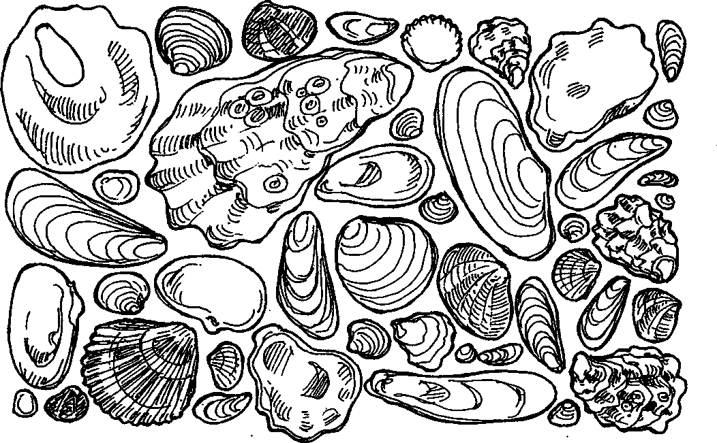
Shell Game


The beach at Seal Rock Campground is a great place to find shells. You can hardly take a step without finding a shell underfoot. Archaeologists have also found lots of shells in their excavations at Seal Rock. What do all of these shells tell us about Seal Rock and the people who have visited the area? Let's start by ‘ looking at an archaeological report.

Seal Rock Marine Trail Curriculum - Olympic National Forest, Quilcene, Washington 98376
Developed by the Institute of Marine Science www.forsea.org

Hmmm, let's look a little further.
A small-scale archaeological investigation undertaken at 45-JE-I5, Seal Rock, Washington has provided substantial new information about this site. Investigation of the site boundary confirmed the location and dimensions of the originally reported portion of the site and succeeded in locating a second area of shell midden deposits located approximately 150 meters south of the former. Investigation of the depositional history of the site indicates that it is composed of at least four major cultural depositional strata. Analysis of the contents of these strata suggest that Seal Rock was probably a seasonal camp and that cultural activities here were primarily orientated toward the exploitation of anadromous fish bound for the nearby Dosewallips River. Secondary activities probably included: fishing for nearshore marine fish, hunting for large terrestrial mammals, shellfish collecting, and the manufacture of bone and stone artifacts. Radiocarbon dating of cultural deposits at Seal Rock indicates that this is a late prehistoric site representing occupation between approximately 1200 and 1400 A.D.
Not that helpful, you say? Let's see if we can look within the report for clarification. How about page 4...
The climate of the northeastern Olympic Peninsula region is ... characterized by mild temperatures and high precipitation; the typical pattern is heavy winter precipitation and relatively cool, dry summers....
Local weather conditions for the Seal Rock project area have been recorded at Brinnon, at an elevation of 80 feet (Phillips and Donaldson 1972). This station reports a mean annual temperature of 51 degrees (F); a monthly mean low of 34 degrees in January and February and a monthly mean high of 74 degrees in July. Precipitation at this locality has an annual mean of 74.81 inches, almost all of which falls as rain. The monthly mean low is .64 inches in July; the monthly mean high is 14.44 inches in November.
Once we know that "mean" means "average", we can learn a few things about Seal Rock. 1. What are winters like at Seal Rock?
2. Which month has the lowest mean temperature?

Seal Rock Marine Trail Curriculum - Olympic National Forest, Quilcene, Washington 98376
Developed by the Institute of Marine Science www.forsea.org
- Which month has the lowest mean rainfall?
- How much rain falls in the wettest month?
- Archaeologists believe that Native Americans lived at Seal Rock but only seasonally. Look at the weather data, which months do you think Native Americans spent at Seal Rock? Why?
What were some of the attractions that might have brought Native Americans to the area? Let's see what the report has to say about vegetation.
Vegetation is one of the most spectacular aspects of the Olympic region as a whole, and of the Seal Rock project area in particular...
The flora of the immediate vicinity of the Seal Rock project area is dominated by western hemlock (Tsuqa heterophylla), western red cedar (Thuja plicata), and Douglas fir (Pseudotsuqa menziesii). Pacific madrona (Arbutus menziesii) is very common along the shoreline. Prominent understory plants here include salal (Gaultheria shallon), snowberry (Symphoricarpos albus), and oceanspray (Holodiscus discolor). Uncommon in the region, but present at Seal Rock, is Pacific poison oak (Rhus diversiloba).
Native Americans prized western red cedar. It could be made into long, straight canoes, pliable rope, watertight boxes, masks and countless other items. It also provided a great umbrella for protection from the rain.
- Which three trees are likely to be most common at Seal Rock Campground?
- Which plant might today's visitors want to avoid? Why?
What can be learned about the fauna, or animals, of Seal Rock Campground?
Seal Rock Marine Trail Curriculum - Olympic National Forest, Quilcene, Washington 98376
Developed by the Institute of Marine Science www.forsea.org
The immediate vicinity of the Seal Rock project area...hosts...a wide range of mammals, birds, marine and anadromous fish, and shellfish.
Mammals which could occur in the project area include both large game and a variety of smaller animals. The most conspicuous large game which might move through here are elk (Cervus canadianus), deer (Odocoileus hemionus), and black bear (Ursus americanus).
Smaller terrestrial mammals common in the area today include the raccoon {Procyon lotor), beaver (Castor canadensis), and river otter (Lutra canadensis). The nearshore waters of Hood Canal contain harbor seals (Phoca vitulina); harbor porpoise (Phocoena phocoena) and/or Dali porpoise (Phocoenoides dalli) may also occasionally visit the area.
Marine and anadromous fish around Seal Rock probably include most forms typical to protected marine waters throughout western Washington. Most species of salmon (Oncorhynchus spp.) are present in the area as they pass to the spawning grounds on the Dosewallips and other nearby rivers. Other prominent fishes in the nearshore waters include dogfish (Squalus acanthias), lingcod (Ophidon elongatus), herring (Clupea hareengus), and several varieties of rockfish (Sebates spp.), sea perch (Embiotocidae), and sculpin (Cottidae).
The marine invertebrate population at Seal Rock is that common to most of Hood Canal. Important bivalves in the area include the steamer clam (Protothaca stainea), butter clam (Saxidomus giganteus), basket cockle (Clinocardium nuttalli), and the blue mussel (Mytilus edulis). The native Olympia oyster (Ostrea lurida) was formerly widespread here, but this animal has been largely replaced by the introduced Japanese oyster (Crassostrea gigas). Common gastropods here include limpets (Acamea spp.), dogwinkles (Thais spp.), and the moon snail (Polinices lewisi).
- Which large mammals were most likely eaten by Native Americans visiting the Seal Rock Campground?
- Of the fish listed, which one most likely provided the most food for the Native Americans visiting the Seal Rock Campground?
- Which species of oyster were most likely eaten by the Native Americans visiting the Seal Rock Campground?
Seal Rock Marine Trail Curriculum - Olympic National Forest, Quilcene, Washington 98376
Developed by the Institute of Marine Science www.forsea.org

Just who were these Native Americans?
The ethnographic and probable late prehistoric occupants of the Seal Rock project area were members of a broad grouping of peoples referred to as the Coast Salish. ...of these groups, the Quilceeds, occupied the northern portion of the Hood Canal including the Seal Rock area. The modern place name "Quilcene" is taken from the name of this group.
...They were skilled fishermen, hunters and plant material gatherers who possessed a great deal of knowledge about the resources available in their environment.
1 l.To which broad grouping of Native Americans did the people who used Seal Rock belong?
12.To which "tribe" did these people belong?
13. What skills did they use to secure enough to eat?
To find out more about how these people made their living, the archaeologists dug a "test pit", a straight sided hole, to see what they might find at different levels. They found five distinct layers of materials.
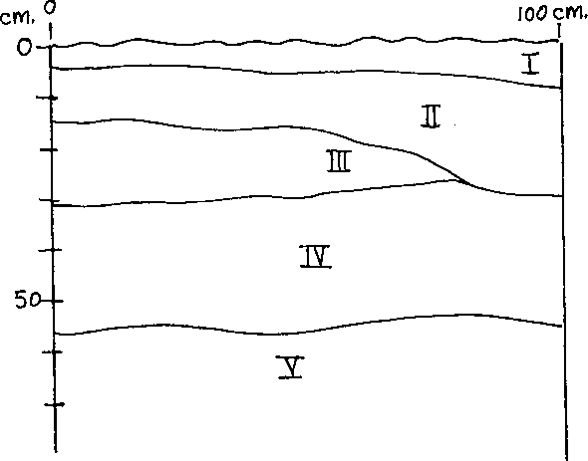
Seal Rock Marine Trail Curriculum - Olympic National Forest, Quilcene, Washington 98376
Developed by the Institute of Marine Science www.forsea.org

The archaeologists also took core samples to give them more data about each layer. Here's some of what they found out about the shellfish these people ate.
Shellfish Remains
Shellfish remains were the most abundant faunal materials represented at Seal Rock. The total sample recovered during the investigation includes 4,458 bivalve, univalve, and crab remains and 27 grams of barnacle shell. All shellfish remains were cleaned, identified, and counted....
Minimum Number of Individuals estimates for the Sea Rock shell taxa, by strata, are presented in Table 6.
Table 6
MINIMUM NUMBER OR INDIVIDUALS ESTIMATES AND BARNACLE WEIGHTS FOR SHELLFISH SAMPLES RECOVERED FROM 45-JE-15, SEAL ROCK, WASHINGTON.
TAXA STRATA
 | II | III | IV | V
Ostrea lurida | 342 | 605 | 332 | 142
Protothaca staminea | 60 | 22 | 74 | 21
Saxidomus aiaanteus | 21 | 1 | 16 | 15
Clinocardium nuttalli | 22 | 49 | 10 | 2
Tresus so. | 32 | 9 | 19 | 19
Mvtilus edulis | 27 | 208 | 77 | 15
Polinices lewisi | 104 | 2 | 88 | 49
Thais lamellosa | 4 | 1 | 9 | 3
Acmaea so. | 1 | 16 | 5 | -
Cancer Droductus | - | 1 | - | -
MNI Totals | 613 | 914 | 630 | 266
Balanus sdd. (oms.) | 4 | 17 | 6

14.a. Which layer, or stratum, had the greatest number of shellfish?
b. What are two possible explanations for this greater abundance?
1.
2.
Seal Rock Marine Trail Curriculum - Olympic National Forest, Quilcene, Washington 98376
Developed by the Institute of Marine Science www.forsea.org

c. The archaeologist writes, "While all strata contents are quite similar, Stratum III is in some contrast to Strata II, IV, and V." What is the contrast in Stratum III?
15. a. What is the scientific name of the most commonly found shellfish?
b. What is the common name of this shellfish?
(Hint: You can find the common name of all of these shellfish in the findings about the fauna of Seal Rock Campground which are listed earlier in this activity.)
c. What percentage of the total does this most commonly found shellfish represent in each stratum?
II
III
IV
V
16. Look at the data. Think about life on the beach. Now, in the space below, create a typical day's shellfish diet for the Native Americans living at Seal Rock.
Seal Rock Marine Trail Curriculum - Olympic National Forest, Quilcene, Washington 98376
Developed by the Institute of Marine Science www.forsea.org
17. The Native American use of the Seal Rock site seems to have ended shortly before
European explorers entered Puget Sound. Since that time some changes have occurred in the animal population. Earlier in their report, the archaeologists noted that:
The native Olympia oyster (Ostrea lurida) was formerly widespread here, but this animal has been largely replaced by the introduced Japanese oyster (Crassostrea gigas).
a. Think about changes that have occurred since European settlers arrived. What are three possible explanations for the change seen in the oyster populations?
1.
2.
3.
b. Which explanation seems most likely to you? Why?
Seal Rock Marine Trail Curriculum - Olympic National Forest, Quilcene, Washington 98376
Developed by the Institute of Marine Science www.forsea.org

