The Water Cycle

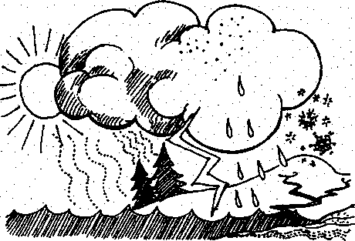
Key Concepts
1. Forever in motion, the water
cycle moves water through the Seal Rock Campground forest, shore, and open water habitats.
2. Water connects the natural areas of Seal Rock Campground.
As essential as water is to life, living things including humans can do very little to increase the amount of water present on the planet. While there is about the same amount of water on earth today than there was when the dinosaurs roamed our planet, most of that water is in different places. We use the term "water cycle" to describe a primary way water circulates on earth. Essentially, there are three stages in the cycle: evaporation, condensation (cloud formation), and precipitation. Heat from the sun evaporates water from surfaces including lakes, rivers, and oceans, putting water vapor into the air. As the water vapor cools, it condenses, forming tiny droplets in clouds. The clouds meet cold air and the water falls down to the Earth's surface as precipitation—rain, sleet, or snow. Some of the precipitation soaks into the soil. This water is either used by plants or stays as a layer of underground water called groundwater. Some of the water makes its way back to the sea as "runoff, sculpting the landscape as it travels back to its starting place.
The amount of water vapor in the atmosphere is not trivial If all the water vapor in the atmosphere were to suddenly condense and fell out as rain, it would cover the entire Earth with one inch of water. Even so, this is a small fraction of the water found in the oceans and locked up in polar ice and glaciers.

Materials:
- 'The Water Cycle” activity pages, one set per student
- Assortment of:
- pots and pans
- funnels
- cookie sheet
- tin cans
- plastic baggies
- jars / containers
- heat source (hot plate, hot water)
- cold source (ice, cold water)
- a hot pad under the stemo over the wood base
Seal Rock Marine Trail Curriculum - Olympic National Forest, Quiicene, Washington 98376
Developed by the Institute of Marine Science www.forsea.org
35

Teaching Hints
Students are introduced, or reintroduced to the water cycle, after which they write a poem or short story describing a water molecule's journey through the cycle and then create a water cycle model using assorted household or laboratory items.
Reread Activity 2: Water Cycle Model as a way of anticipating any difficulties your class may have in creating a model from the rather open ended instructions found in the student text. The questions are designed to help students think about their everyday experiences with the processes involved in the water cycle. Circulate through the class, answering questions with questions as often as possible to help coax your students along. Be aware of any use of heat sources that pose a safety concern.
Here are simple ways to achieve each of the principal processes of the water cycle:

Condensation:
Remove the label from an empty tin can and fill it with ice. Add water and a few drops of food coloring. Let it stand on a table for a few minutes until the can seems to "sweat", and drops of clear water form on the outside as water vapor—water in the form of gas—in the air around the can is cooled by the ice.

Precipitation:
Boil water in the bottom pan of a double boiler (or the larger of two pots). Place cold water and ice cubes in the top pan (or smaller of the two pots) and hold it slightly above the boiling water until the cold surfaces of the upper pot cool the steam from the boiling water and it "rains".

Evaporation:
Wet the bottom of a large flat dish with a thin layer of water and place it, uncovered, on the table or near a heat source to stand. Check the dish periodically to note the drying due to evaporation as water molecules escape only from the surface.
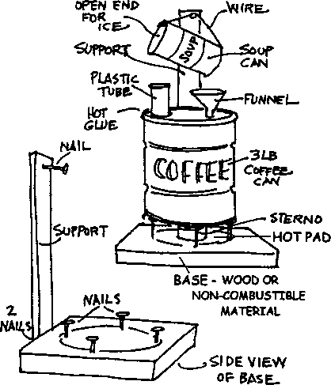
A rather elaborate water cycle model created by one group of students is shown below:
Water Cycle Simulation
- Place 1/2" of water in the base of the coffee can.
- Put one cup of ice cubes in tilted soup can.
- Light Stemo and place under coffee can.
- Allow water in coffee can to boil rapidly until steam escapes through chimney (tube). Align the coffee can so the rising steam strikes the soup can just under the opening.
- Adjust angle of soup can so condensing water runs down the length of the can and drips into the funnel.
- Relate the phase changes of water you have observed to the steps of the water cycle. Label the accompanying diagram and explain what occurs in each step of the water cycle.
Adapted by Southern Willamette Energy Action Team (SWEAT),
Eugene, Oregon and used with permission.
Adapted with permission from The Stream Scene, Oregon
Department of Fish and Wildlife, P.O. Box 59, Portland, OR 97207
Seal Rock Marine Trail Curriculum - Olympic National Forest, Quilcene, Washington 98376
Developed by the Institute of Marine Science www.forsea.org

Essential Academic Learning Requirements in Science
- The student understands and uses scientific concepts and principles. (1.3)
- The student knows and applies the skills and processes of science and technology. (2.1,
2.2)
- The student understands the nature and contexts of science and technology. (3.1)

Answer Key
1. A correctly labeled water cycle drawing follows:
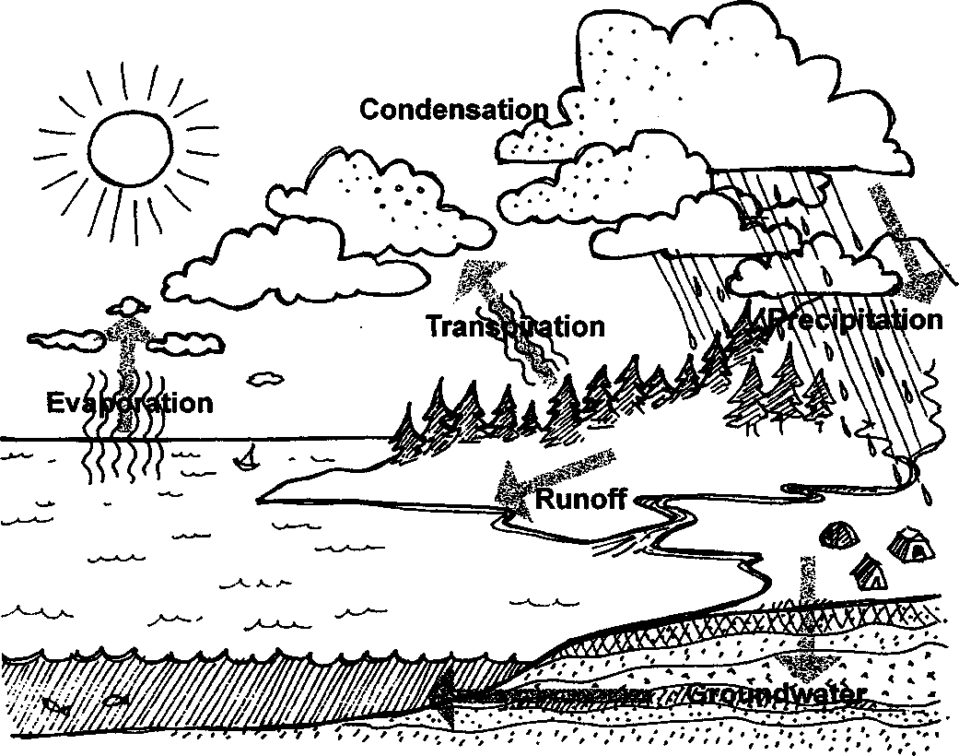
Seal Rock Marine Trail Curriculum - Olympic National Forest, Quilcene, Washington 98376
Developed by the Institute of Marine Science www.forsea.org

Activity 1: An Incredible Journey
Consider having students share their poems or short stories.

Activity 2: Water Cycle Model
- Definitions follow:
Evaporation - With regard to the water cycle, change of water from liquid to vapor as a result of heat from the sun; puts water vapor into the air.
Transpiration - movement of water in a plant from the roots, through the stem and out through stomata on the leaves.
Condensation - With regard to the water cycle, the change of water vapor into a liquid and the formation of tiny droplets in clouds.
Precipitation - With regard to the water cycle, rain, hail, snow which forms when
clouds meet cold air and the condensed water droplets become too heavy to remain in the atmosphere and fall to earth.
- - 4. Answers depend on the watershed model created.
Seal Rock Marine Trail Curriculum - Olympic National Forest, Quilcene, Washington 98376
Developed by the Institute of Marine Science www.forsea.org

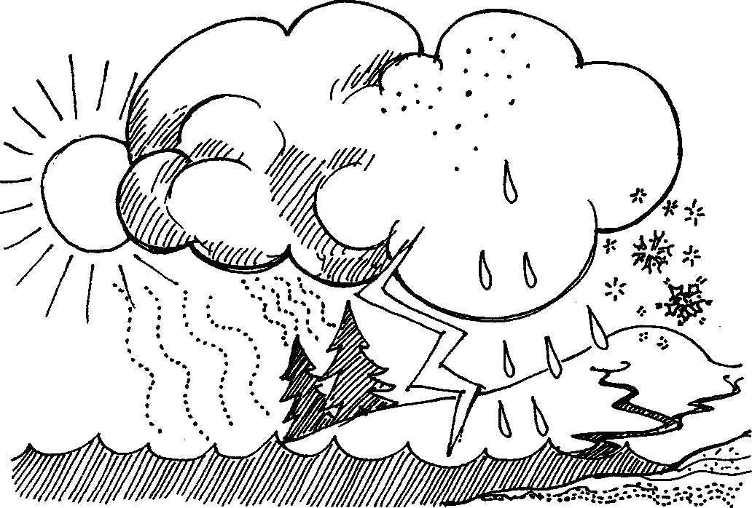
The Water Cycle

How does water connect the natural areas of Seal Rock Campground? Water is forever in motion. It changes easily from ice to liquid water to gas and it moves freely across the face of the planet, including around, over, and through Seal Rock Campground. It also spends time in the cells of all living organisms.
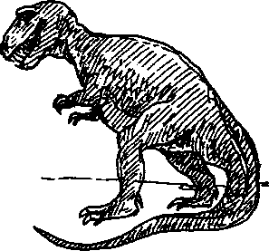
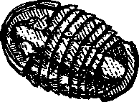
The movement of water also connects us with the earth's past. Some of the water molecules in your mouth as you brushed your teeth this morning might have been the same water drunk by Captain George Vancouver as he sailed
into Puget Sound in 1792 — or it might have once been inside the body tissues of a dinosaur or a prehistoric trilobite!
Water moves about our environment through pathways that we call the water cycle or hydrologic cycle. Rain falls on the earth and the water moves into the ground or over the surface. It may quickly evaporate and become water vapor again, or it may spend varying amounts of time deep underground or in the ocean. It may even become locked up in glacial ice for thousands of years. Water's movement can be very complex.
Seal Rock Marine Trail Curriculum - Olympic National Forest, Quilcene, Washington 98376
Developed by the Institute of Marine Science www.forsea.org

Label Water cycle drawing of Seal Rock with the following:
Condensation - As the water vapor cools, it changes to a liquid and forms tiny droplets in clouds high above
Precipitation - Clouds meet cold air and the condensed water droplets become too heavy to remain in the atmosphere and fall to earth from the sky as rain or hail
Evaporation - Heat from the sun causes water to become vapor and leave the surface of Hood Canal, putting water vapor into the air
Transpiration - some of the precipitation soaks into the soil and is used by forest plants which, in turn, give off water vapor
Runoff - water that has fallen as rain and which moves downhill through the campground on the surface of the earth
Groundwater - some of the precipitation soaks into the soil and stays as a layer of underground water between saturated soil and rock that supplies wells and springs
Seal Rock Marine Trail Curriculum - Olympic National Forest, Quilcene, Washington 98376
Developed by the Institute of Marine Science www.forsea.org
Activity 1: An Incredible Journey
Write a poem or short story exploring one water molecule's movements around Seal Rock Campground. You might refer to the water cycle diagram on the previous page for ideas, but use your imagination too. Does your molecule change form (solid, liquid, or gas) as it passes through different realms of the earth's surface? Does it become a part of any living animals or plants?
Seal Rock Marine Trail Curriculum - Olympic National Forest. Quilcene, Washington 98376
Developed by the Institute of Marine Science www.forsea.org

Activity 2: Water Cycle Model
For each group of 3-4. you will need the following things:
- a collection of household objects for building a water cycle model
- pen or pencil
- paper
Create your own working model of the water cycle. From ordinary household objects you can invent a device that makes water move from a liquid to a gas and back into a liquid again. Not sure how to begin? Let's start by taking a look at the problem piece by piece.
First it would be helpful to look more closely at some key parts of the cycle.
1. Do you know the meaning of the following terms? Use a dictionary if necessary to help you define each word.
- Evaporation -
- Transpiration (this is important in nature but you don't need to put it in your model) -
- Condensation -
- Precipitation -
2. Next, think of ways to make each step happen using tools around your house or school. Here are some questions to guide you:
What would you need to do to a pan of water to make it evaporate?
How could you catch the water vapor so that it doesn't all escape?
What do you need to do to the water vapor to make it condense back into liquid water?
Seal Rock Marine Trail Curriculum - Olympic National Forest. Quilcene, Washington 98376
Developed by the Institute of Marine Science www.forsea.org
How can you catch the water again as it precipitates?
Useful materials to make a simplified water cycle might include pots and pans, a funnel, a cookie sheet, and a source of both heat and cold.
3. Draw a diagram of your water cycle model explaining how it works. Label where the parts of the water cycle take place in your model.
4. In parentheses, add the name of the part of Seal Rock campground that corresponds to each model part.
Seal Rock Marine Trail Curriculum - Olympic National Forest, Quilcene, Washington 98376
Developed by the Institute of Marine Science www.forsea.org

