The Puget Sound Game
Used with permission from FOR SEA institute of Marine Science P.O. Box 188, Indianola, WA 98342 www.forsea.org

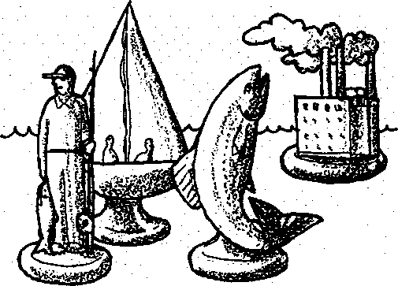
Key Concepts
- People and other animals depend on Puget Sound's marine and freshwater resources.
- Students, as individuals, affect the Puget Sound environment by ordinary life-style decisions.
- In the Puget Sound region, individuals, groups, and industries face complex economic decisions regarding whether to pollute or not.

Background
Water has been the connecting thread which runs through the activities in this Seal Rock Marine Trail Curriculum Guide. Water, too, is the connecting thread which unites the amazing variety of natural areas at Seal Rock Campground, from forest to shoreline to the open waters of Hood Canal. We began this guide by stating that:
Seal Rock Campground is a part of the larger Hood Canal and Puget Sound systems and affects those systems and is, in turn, affected by them.
We conclude with the same recognition as your students play the "Puget Sound Game", a simulation in which they are asked to assume roles that represent a variety of individuals who use Puget Sound and its tributaries.
Although the Puget Sound Game is a culminating activity, it does not have to be the final one. Consider having your students work together to create a 3-D classroom model which demonstrates the interrelationships between the forest, intertidal beach, and open water ecosystems. Or, have them work in small groups to create a poster which describes these interrelationships, focusing on the benefits each ecosystem gives to the other two. Or, have them create a photo or video essay that tells the story of the interrelationships. Whichever culminating activity you choose, in your discussions with your students, focus on these interrelationships and the ways in which humans can strengthen or weaken them.

Teaching Hints
The health of Puget Sound is tied to all of us who use the Sound. In this activity, students participate in a simulation in which they are asked to assume roles that represent a variety of individuals who use Puget Sound and its tributaries. While fulfilling these roles, the students make action choices appropriate to their roles. Meanwhile, a 10-gallon aquarium filled with water, representing Puget Sound, will be altered as these decisions are made, graphically illustrating the impact of all our water uses on the Sound’s water quality.
Seal Rock Marine Trail Curriculum - Olympic National Forest, Quilcene, Washington 98376
Developed by the Institute of Marine Science www.forsea.org
243
Through this game, students will experience many issues related to pollution, values, laws, and economics in a dynamic setting.
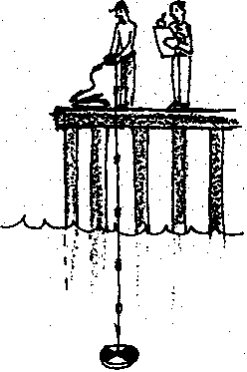
During the course of the game contaminants will be introduced to Puget Sound and its tributaries. Contaminants will include food coloring, dirt (representing siltation), confetti (trash) and a solution of ammonia and water (an invisible contaminant). At several points in the game students will need to test the water quality. Three different water quality tests will be used in the game.
- Comparing a water sample to a pre-mixed color standard. When the water sample is darker than the standard, it is considered to be contaminated.
- Lowering a Secchi disk from the surface and recording at what depth it is no longer visible. A Secchi disk is a standard piece of water quality equipment
- Testing the pH of the water with litmus paper. As the ammonia solution is added, the pH will rise in "Puget Sound.' For the purposes of this game, students do not need to understand the meaning of pH. This test is used strictly as a convenient method for sampling an invisible contaminant.
- Some students will also have the opportunity to try catching fish. They will find that as Puget Sound's water becomes darker, catching the fish on the bottom becomes much more difficult.
Thirty role cards are provided in this lesson. If you have fewer than 30 students, you could eliminate some roles; however, most teachers prefer to distribute more than one role to certain students. Teachers who have used this activity report that it easily takes an hour to work through all 30 roles. Your scheduling requirements and the attention span of your students will dictate whether to conduct the activity all at one time or whether to break it up over several days.
This game is both whimsical and serious. Do not worry if your students take the game lightly as it is played. Its message will probably be clear no matter what choices are made, and regardless of the spirit in which it is played!
As you experiment with the Puget Sound Game you will surely come up with ideas of your own for expanding or improving the game. For example, the game does not include the roles of state and federal regulations and regulators, and the fines and penalties they can levy, as factors influencing the decisions people make regarding their actions. We hope you will share these ideas with us.

Lesson Plan
Student Objectives:
• The students will become more aware of how people and animals depend on Puget Sound's marine and freshwater resources.
Seal Rock Marine Trail Curriculum - Olympic National Forest, Quilcene, Washington 98376
Developed by the Institute of Marine Science www.forsea.org
- They will consider ways that they, as individuals affect the Puget Sound environment by ordinary life-style decisions.
- They will recognize the complexity of economic decisions faced by polluters in our region.

Materials:
- An open, carpeted area indoors, or a flat, concrete area outside, on which a large representation of Puget Sound and its tributaries can be drawn with chalk or masking tape.
- Map, PUGET SOUND AND ITS RIVERS for reference when laying out playing area.
- A 10-gallon aquarium, filled with clean water to represent Puget Sound.
- Glass or clear plastic jars (one pint to one quart) of clean water to represent the rivers emptying into Puget Sound.
- 12 folded tagboard labels, each with the name of a Puget Sound river. Dungeness, Dosewallips, Duckabush, Hamma Hamma, Skokomish, Nisqually, Puyallup, Green, Snohomish, Stillaguamish, Skagit, and Nooksack should be represented.
- A bottle of blue food coloring, with dropper. Label this "Colored Contaminant"
- A solution of 1/2 cup ammonia in 1/2 gallon of water. Label this jar; "Clear Contaminant".
- A cup of fine dirt and a tablespoon measure.
- A couple tablespoons of paper "confetti," (made with a hole punch).
- A clear plastic or glass container (about 1 cup, or 250 ml) for taking water samples.
- An identical container of tinted water to use as a standard for comparing the extent of pollution. One drop of food coloring per quart of water makes a good water quality standard.
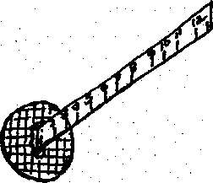
- Miniature Secchi disk for measuring water turbidity. Run a sheet of transparency film through a Xerox machine to print a simple pattern or small printed message onto the film. Cut out a 2" circle of the film containing the printed pattern and glue it to the end of a ruler with rubber cement or airplane glue. The numbers on the ruler should read smaller to larger away from the disk.
- Litmus paper, range 6-10, with color key.
Seal Rock Marine Trail Curriculum - Olympic National Forest, Quilcene, Washington 98376
Developed by the Institute of Marine Science www.forsea.org

- "fishing pole" made from a stick, a piece of string, and a paper clip bent to form a "hook." (Test the fishing pole yourself before the game to make sure the hook hangs at an angle that can catch a fish.)
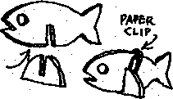
- At least 8 plastic "fish," cut from a coffee can lid or other piece of flexible plastic, and slotted to fit into bases so that they stand upright (See diagram.) Punch a hole in each fish so that it can be caught from above with the hook. Weight each fish with a paper clip so it will sit on the bottom of the tank.
- 2 large (pound size) bags of m&m's, or equivalent number of fish crackers or other popular snack item. These will represent currency in the Puget Sound Game.
- A basket or paper bag labeled "Resource Savings Bank," or some other appropriate title. You will use the bank when collecting the students' payments.
- One set of student role cards.

Procedure:
- First create the game setting. Give some of your students the task of drawing a large map of Puget Sound on the ground, using chalk or masking tape, or do this yourself. This map can be very general and simplified, but it should include the mouths of the following rivers:
Dungeness, Dosewallips, Duckabush, Hamma Hamma, Skokomish, Nisqually,
Puyallup, Green, Snohomish, Stillaguamish, Skagit, and Nooksack.
Place a pint jar of clean water near the mouth of each Puget Sound river. Label each jar with the name of the river it represents.
Note: It's easiest to first sketch the map lightly in chalk, then go over it with tape.
Place the aquarium representing Puget Sound in the center of the map, within the boundaries of Puget Sound, or at least in a central location. Fill with clean water, and arrange six fish on the bottom. Position the contaminants, the water quality testing equipment, the fishing pole and the remaining fish near the aquarium.
- Briefly introduce the setting and equipment for the Puget Sound Game to your class. When explaining the three water quality tests, have a student model each test procedure ariH note the status of Puget Sound’s water before any pollutants have been introduced.
- Distribute a role card and 10 pieces of "currency" to each student
If you have a small group, assign students more than one role. If you have more than 30 students, you can create additional roles. Each role should require an action.
- Have the students read their cards silently and consider the action they will take. Some students will need to make decisions as part of their actions.
Seal Rock Marine Trail Curriculum - Olympic National Forest, Quilcene, Washington 98376
Developed by the Institute of Marine Science www.forsea.org

- To play the game, each student, in playing order, reads his role aloud and announces any decision he or she makes in that role.
- As part of his/her turn, a student performs the action called for on the role card:
polluting the water, paying money, withdrawing water, catching fish, measuring the extent of pollution, etc.
- Many issues will he raised as the cards are read. Feel free to take some time discussing them before moving on. Some issues may be familiar, but others might need some clarification.

Follow-up Questions on the Puget Sound Game
- What is the point, or message in the Puget Sound Game? (What does a person learn by playing it?)
- Why was it sometimes difficult for people to make decisions which would protect or improve the water quality in this game?
- If players chose short term profits over protecting the environment, the water quality was likely to suffer. What were some long-term costs which individuals or society as a whole might end up paying for later as a result of such decisions?
- Pollution sources like the copper smelter in this game, which discharge large amounts of waste from a single point are called point sources of contaminants.
- What is another example of a point source of pollution used in the Puget Sound Game?
- What is an example of a point source of pollution in the area in which you live?
- Non-point source is the term for sources of contamination which are hard to locate, because they come from many places. Often, they are caused by the behaviors of individuals. The backyard gardener is an example of a non-point source in this game.
- What is another example of a non-point source of pollution used in the Puget Sound Game?
- What is an example of a non-point source of pollution in the area in which you live?
- What is something you or your family could do to improve the water quality in Puget Sound?
Seal Rock Marine Trail Curriculum - Olympic National Forest, Quilcene, Washington 98376
Developed by the Institute of Marine Science www.forsea.org
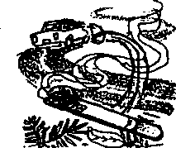

I am a careless tourist from Silverdale driving through the Cascades. I throw a burning cigarette out of my car window and start a major forest fire in the National Forest. Many trees are destroyed. Erosion is increased, and ashes and mud pollute the Stillaguamish watershed. Mud also washes into Puget Sound.


(Add 1 tsp. dirt to the Stillaguamish watershed and 1 tsp. to Puget Sound.)
I live near the Nooksack River. My septic tank is old, and it has been leaking into the river. This isn't a problem for me. The well I use for my household water supply still has plenty of clean water, but people downstream have to live with my septic waste. It would cost me $500 to repair my septic system. I could also use this money for a trip to Florida. I must choose whether to pay to have my septic system fixed, or let it continue polluting the river and save my money.
(Either pay one piece of "money" or add two drops of color to the Nooksack watershed and four drops to Puget Sound.)

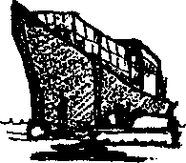
I am the owner of a ship which is carrying products made in Japan to California where they will be sold. I need to refuel the ship in Puget Sound. I can either call a fuel barge to meet the ship in the Strait of Juan de Fuca, or I can have the ship travel the extra distance to a fuel dock in Seattle. I can save my company $10,000 by not taking the ship all the way in to a fuel dock in Seattle. On the other hand, I know that using a fuel barge may be riskier to the environment. With so many barges moving around the Sound, accidents are more likely to happen. It's hard to keep from spilling small amounts of fuel when we transfer it, and there's seldom any clean-up equipment nearby.
(If you choose to refuel at a well-regulated fuel dock, pay five pieces of "money". If you choose to risk spilling some oil into Puget Sound, add 1/2 cup of clear contaminant to Puget Sound.)
Seal Rock Marine Trail Curriculum - Olympic National Forest, Quilcene, Washington 98376
Developed by the Institute of Marine Science www.forsea.org
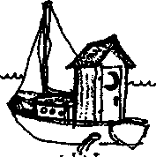
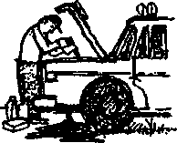
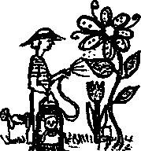

4.
I live on Bainbridge Island and work in Seattle. I have a sailboat which I take out when I can take time off from my busy lifestyle. At the marina where I keep my boat, there is no sanitary pumpout station for emptying the holding tank from my head (nautical toilet). Since I'm not willing to make a special trip to one further away, I just flush it once I get on the water. It saves me lots of time.
(Add three drops of color to Puget Sound.)
I live near Shelton. When I change the oil in my truck I just let it run into the ground. It eventually seeps through the soil and pollutes the water in the Sound. I know that waste oil can be recycled at a service station nearby, but I'm too lazy to do it.
(Add four drops of color to Puget Sound.)
6.
I like to keep my lawn looking nice, so I use lots of fertilizer and weed killer on it. I also grow unusual ornamental shrubs in my yard which can’t survive here without special insecticides to protect them from pests. I can't imagine what my yard would look like if I ever had to stop using these chemicals. I suppose it's all washing into the Puyallup River, since that's the watershed I live in.
(Add one tsp. of clear contaminant to the Puyallup River and 1/4 cup to Puget Sound.)
Seal Rock Marine Trail Curriculum - Olympic National Forest, Quilcene, Washington 98376
Developed by the Institute of Marine Science www.forsea.org

5.

I have a dairy farm near the Snohomish River. One of its tributaries runs through my pasture. I know I really shouldn't let my cows walk through the stream. Their manure gets into the water and their feet cause the banks to erode. But it's easier and cheaper for me to let the cows get their water from the stream than to pump water over to the pasture. If I decide to protect the stream it will cost me.

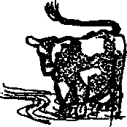

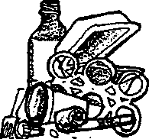

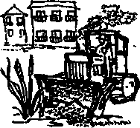
(Either pay two pieces of "money" or add two drops of color
to the Snohomish River and six drops to Puget Sound.)
I have a waterfront home in the northern Sound. My friends and I hang out at the beach nearly all summer long. We have big parties with lots of food and drinks. Sometimes we're a little careless with our trash, and lately I've started seeing chunks of Styrofoam and plastic containers everywhere. Doesn't this stuff ever break down?
(Add a pinch of confetti to Puget Sound.)
I am a developer. I make money by building and selling condominiums. People like to live along the water. I am interested in filling in some of the wetlands at the mouth of the Nisqually to build my condominiums. If I do this, it will take away habitat for salmon and other wildlife.
(If you choose to build your condos, reach into the Sound and remove one fish. If you decide to protect them, pay the bank three pieces of "money")
Seal Rock Marine Trail Curriculum - Olympic National Forest, Quilcene, Washington 98376
Developed by the Institute of Marine Science www.forsea.org

I work for a large timber company with timber holdings on both sides of Puget Sound. In managing our forests we often use herbicides to keep "weed trees" like alder from competing with our cash crop. If we stopped using herbicides, our trees would grow more slowly, and fewer valuable trees could be harvested. But herbicides eventually wash into the water and pollute Puget Sound. We must decide whether to continue using herbicides or give up some of our profits.


(If you choose to stop using herbicides, pay five pieces of "money". Otherwise, add one tsp. of clear contaminant to each of the rivers emptying into Puget Sound. Add 1/2 cup to Puget Sound itself.)

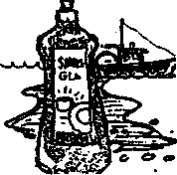

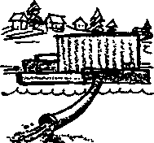
I'm a commercial fisherman. The engine on my gillnet boat leaks oil into the bilge, the inside of my boat. Water also collects in the bilge, so I have to bump out this oily mess every so often. If the Coast Guard spotted my boat making an oil slick, it would fine me $5,000. Before I start up the bilge pump, I pour detergent into the oily bilge water. This makes the oil break up and mix with the water so nobody ran see it. I know it's against the law to do this, but I sure don't want the Coast Guard catching me with an oil slick behind my boat.
I wish there was some other place I could pump my bilge water, but if there is, you tell me about it!
(Add 1/4 cup clear contaminant to Puget Sound)
I help operate a primary sewage treatment plant for a small city on the Strait of Juan de Fuca. A new secondary treatment plant would pollute the water less than our primary treatment plant does. But we doubt the citizens in our town would be willing to pay an extra charge to build a secondary sewage treatment plant.
(Many communities around Puget Sound are facing this problem, so take a class vote. Would these citizens tax themselves one piece of "money" each to build better sewage treatment plants around the Sound? If the majority votes yes, each person in the class must pay the bank one piece of "money". You can then place secondary treatment plants all around Puget Sound. If the class votes no, add ten drops of color to Puget Sound.)
Seal Rock Marine Trail Curriculum - Olympic National Forest, Quilcene, Washington 98376
Developed by the Institute of Marine Science www.forsea.org
I raise fruits and vegetables on my farm near the Skagit River. I use chemical fertilizers and pesticides on my crops, and some of these chemicals wash into the river. I know some farmers have switched to organic farming methods, but I wonder if they're making as much money as I can by using these chemicals.
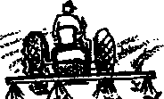
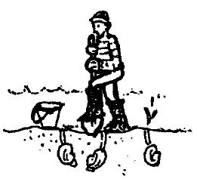
(If you decide to farm organically, pay two pieces of "money" for losses you may have to take when you first switch over. If you decide against it, add 1 tsp. of clear contaminant to the Skagit River and 1/4 cup to Puget Sound.)
13.
14. |  | I live on the water near Port Orchard. I like to dig clams from my beach. If the water becomes polluted, the clams will be contaminated and my beach will be closed to shellfish harvesting.
 |  | (Take a water sample. Use a litmus paper strip to test the water. If it tests 8 or higher on the color scale, the water is contaminated and you may not dig the clams from your beach.)

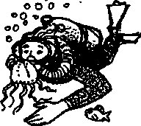
I live in Chicago and I love to scuba dive. I come to Puget Sound because it has such interesting underwater life. If the places I like to dive become too polluted, I won't see as many interesting creatures and I'll look for another place to dive.
15.
(Use the Secchi disk to test the water. Lower it in the water, and if you can't see the circle six inches from the surface, you won't be back to dive in the Sound anymore.)
Seal Rock Marine Trail Curriculum - Olympic National Forest, Quilcene, Washington 98376
Developed by the Institute of Marine Science www.forsea.org


I am chief biologist for a salmon hatchery on the Nooksack River. We hatch and raise the fish in water from the river, and of course, the fish are released into the river when they are big enough- If the water is too polluted, the fish won't survive and the salmon won't make it to Puget Sound.
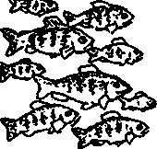

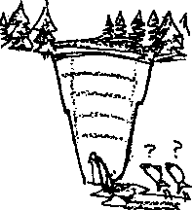

(Take a water sample from the Nooksack River.
rf=h
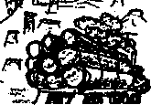
Compare it with the water quality standard. If it is darker than the standard, the fish will not survive. Pay three pieces of "money" and look for another job. If it is lighter, add two fish to Puget Sound.)
I work for a power company which wants to put a dam on the Dosewallips River. All that water is just going to waste, but it could be generating cheap power for people and businesses moving into the Puget Sound area. A few salmon runs might be hurt, but wouldn't we rather have a strong economy?
(Have the class vote whether to dam the Dosewallips River. If the class votes yes, remove half the water from the Dosewallips River and pour it out into a sink or waste bucket. Reach into Puget Sound and remove two fish. If the class votes not to dam the Dosewallips River, turn off one light in the classroom.)
I work for a logging company which has been harvesting timber in several parts of the Puget Sound area. We have been cutting on steep slopes and sometimes working too close to the streamside. Now that the winter rains are here, erosion and mud slides are carrying large amounts of silt into the river.
(Put 1 tsp. dirt into each river entering Puget Sound. Add 6 tsp. dirt into Puget Sound and stir gently.)
Seal Rock Marine Trail Curriculum - Olympic National Forest, Quilcene, Washington 98376
Developed by the Institute of Marine Science www.forsea.org

I am the manager of a harbor near Bremerton. I want to dredge the harbor deeper to let bigger ships use our docks, so we can employ many more people. The trouble is, the bottom sediment that needs to be removed is contaminated with toxic materials. It would cost us $1,000,000 to have it shipped to a toxic waste disposal site on land where it would be out of the water for good. If we did this we would have to charge the ships more money to stay in our harbor. I'm asking for permission to get rid of it in a cheaper way, by putting it back in Puget Sound somewhere else.
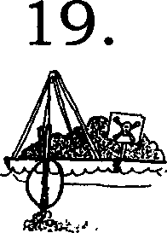

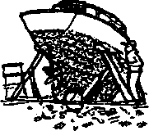
(Ask for a class vote to decide whether you will be allowed to dump the toxic sediment back into Puget Sound. If the class votes yes, add 8 drops of color to Puget Sound. If it votes no, pay 5 pieces of "money")
I just bought a sailboat which needs some work. I need to have it hauled out so I can repaint the bottom. I will have to scrape all the old paint off before I can put the new paint on. The paint has copper and other chemicals in it to keep barnacles from growing on the boat. When I scrape the old paint off, it just falls on the ground where it will just wash right back into the water.
(Add 1/4 cup of clear contaminant to Puget Sound.)
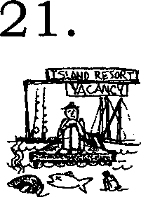
I run a resort on the San Juan Islands. People come from all over the country to spend their vacations sailing, fishing, and having a good time on the water. If the water is polluted, people will stop coming here and I'll go out of business.
(Use the Secchi disk to test the water. Lower it in the water, and if you can't see it 6 inches from the surface, turn in all of your "money" and go out of business.)
Seal Rock Marine Trail Curriculum - Olympic National Forest, Quilcene, Washington 98376
Developed by the Institute of Marine Science www.forsea.org

I just cleaned my basement. I discovered 10 cans of old paint and some very old pesticides and weed killers which I can't use. I know it's not legal, but it would be easy to just hide them in my garbage can with my other household waste and have them taken to the county landfill. At the landfill, these chemicals would eventually leach into the groundwater. Or I could spend a few minutes on the phone learning where I should take them, and then taking them to a place where they will be disposed of safely. I wonder whom I would call?

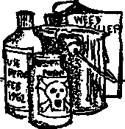


(If you decide to just hide them in your garbage can, add 1/4 cup of clear contaminant to Puget Sound. If you decide instead to spend some of your valuable time disposing of these materials properly, pay one piece of "money". A call to your county health department or your county extension office would be a good place to start.)
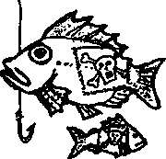
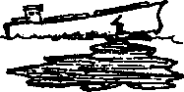
I am a commercial fisherman trying to catch bottom fish near Everett. If I catch fish that contain toxic materials higher than federal standards, I cannot sell them to the public and I will not be able to make my boat payments. I will have to go out of business.
(Take a water sample from Puget Sound. Compare it with the standard color. If it is darker than the standard, the fish are too contaminated to sell. Turn in all of your money" and go out of business. If the water is lighter than the standard, take one minute to try catching some fish.)
I am an executive for a company which ships crude oil to an oil refinery in Anacortes in northern Puget Sound. Some people are suggesting we replace our old tankers with new ships that have double hulls, with two layers of steel to hold the oil. They say this would prevent oil from escaping as easily in case of an accident.
It would cost us millions to make this change, and naturally we would have to pass this cost on to our customers. Gas would cost more at the pump. We certainly aren't going to do this unless we're required to do it by law.
(Take a classroom vote. Would the people be willing to pay more to drive their cars in order to reduce the chance of a major oil spill in Puget Sound? If they agree, each person pays 1 piece of "money". If they don't, add 15 drops of color to Puget Sound.)
Seal Rock Marine Trail Curriculum - Olympic National Forest, Quilcene, Washington 98376
Developed by the Institute of Marine Science www.forsea.org
I am the manager of a copper smelter near Tacoma.

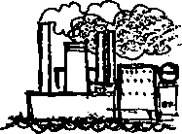

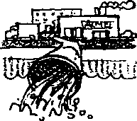

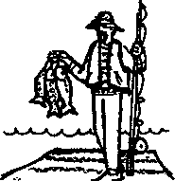
Our refining process is polluting the air and water of Puget Sound. Toi clean up our factory would cost us $1,000,000. If we have to pay that much, we will have to cut back our business and 250 people will lose then- jobs. I have to choose whether to stop polluting but put workers out of a job, or to continue to operate the way we have been.
(Either pay 5 pieces of "money" or add 1 cup of clear contaminant to Puget Sound.)
I represent a manufacturing company located on the Green River. We use 400,000 gallons of clean water from the river every day in our manufacturing process. Then we return 200,000 gallons of polluted water to the river each day. To clean up our process so that we didn't pollute the water, it would cost $1,000,000.
(Remove 1 cup of water from the Green River and pour it into a sink or waste bucket. If you continue to pollute the river, add 2 drops of color to the remaining water in the river and 8 drops to Puget Sound.) If you decide instead to "come clean, "pay 5 pieces of "money".)
I live in Seattle. I can’t afford a car, but I love to go fishing. Each weekend I ride the bus down to the waterfront to fish for flounder off the piers. I have always taken the fish I catch home to eat. Is the water so polluted that the fish I'm eating are contaminated?
(Take a water sample. Use a litmus paper strip to test the water.
If the water tests less than 8 on the color scale, you are still healthy. But, if it tests 8 or higher on the color scale, you will get cancer from eating contaminated fish. Pay 5 pieces of "money" for your medical expenses, give away the rest to your friends and relations, and die!)
Seal Rock Marine Trail Curriculum - Olympic National Forest, Quilcene, Washington 98376
Developed by the Institute of Marine Science www.forsea.org
I have come from Boston to vacation in Port Townsend. I have paid for a charter boat to take me out fishing. I also spend money to stay in motels and to eat in restaurants while I'm in town. If the water is too polluted and I can't catch any fish, I'll just take my money and vacation somewhere else.
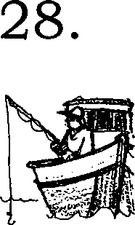

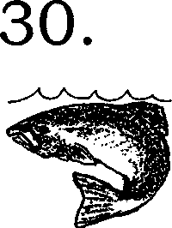
(Try to catch fish. If a fish is caught, everybody in the class receives one piece of "money"; because tourist dollars are flowing into the region.)
I am a pollution control agent for the State of Washington. We do have laws to protect the environment, but sometimes they are violated. It takes people like me to enforce the law and take violators to court. And it takes tax money to pay my salary so I can do this work. But many people complain about taxes. Would you tax yourself so that there will be money to enforce clean water laws?
(Take a vote. If the class votes to tax themselves, everybody pays 1 piece of "money". If the class voted to hire you, you may then issue a fine to up to three people in the room who polluted during the game. Charge these violators 1 piece of "money" each. Naturally, you won't want to tell them this before they vote!)
I am a salmon living in Puget Sound. I depend on Puget Sound and its rivers to complete my life cycle. If Puget Sound becomes polluted or its natural habitats are destroyed, I may not be able to get all the things I need from my environment. Then you may not see so many of me returning to Puget Sound.
(Take a water sample and compare this with the water quality standard. Also test the water with litmus paper. If the water is darker than the standard, or if it reads greater than 8 on the litmus paper color scale, remove two fish from Puget Sound. -If it is lighter, add two fish. There were six fish at the beginning of the game. How many fish are left?)
Adapted from The Lake Superior Game, by Barbara Liukkonen, printed in Lacustrine Lessons, Sea Grant Extension Program, University of Minnesota‭ ‬
Seal Rock Marine Trail Curriculum - Olympic National Forest, Quilcene, Washington 98376
Developed by the Institute of Marine Science www.forsea.org
257

