Drop by Drop

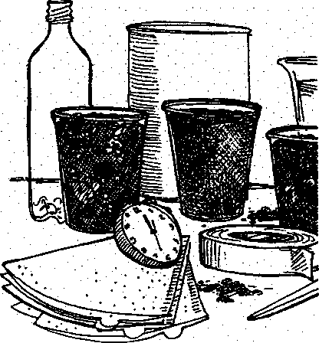
Key Concepts
- Soil is a complex substance which influences the health of ecosystems.
- Soil compaction influences water infiltration.
- Water infiltration is a function of soil texture.
- Human activities can cause soil compaction.

Background
In "Don't Tread on Me", students compared the speed with which water can enter the soil in areas of low human activity to the speed with which water can enter the soil in areas of higher human activity. In 'Drop by Drop", students compare their findings at Seal Rock Campground with results from percolation tests they conduct on the school site. Then, they examine the role of texture in percolation.
Soil is a complex mixture of living, formerly living, and non-living components. The nonliving clay, silt, sand, water and air are enriched by decaying organic matter and a host of microscopic and macroscopic organisms. The particular mixture of these items determines whether water and air, both necessaiy for plant growth, move easily through the soil. This ease of passage of water, called percolation, is a function of the spaces between the mineral particles and other soil components. The relative proportion of different types and sizes of soil particles is called soil texture.
Soil texture in the Pacific northwest has been greatly influenced by our geologic past. The steep hills on the west side of Hood Canal are formed of hard basalt rocks covered by a top layer of material worn down over the centuries. Once on the ocean floor, this basalt was pushed upward by tectonic motion as the plate under the Pacific Ocean collided with the North American continental plate and is a principal parent material for our soils.
Other raw materials were carried into the region when glaciers moved down from the north. The glaciers followed an old eroded streambed between the steep hills of the west side and the older, more eroded and gentler sloped hills of the east side of the canal
The glaciers scoured the old riverbed, leaving the canal we see today. When they retreated about 12,000 years ago, they dumped silt, sand and gravel onto the land. Although much organic matter has been added since that time, soils in this area are still acidic, shallow and poor in nutrients.
The glaciers influenced both soil compaction and soil texture. The immense, heavy glaciers tightly compacted soils in some areas. These soils tend to absorb water poorly and
Seal Rock Marine Trail Curriculum - Olympic National Forest, Quilcene, Washington 98376
Developed by the Institute of Marine Science www.forsea.org

to dry out easily. In other areas, glacier meltwater washed away the fine silt, leaving behind gravel and sand. The large spaces enable water to flow between the sand and gravel particles. These gravel and sand deposits and the water flow through them are important today as the source of all our well water. These sand and gravel aquifers are very slowly recharged by rains, a fact easily overlooked as houses and pavement replace trees and vegetation causing rainwater to quickly run off into Puget Sound, rather than being absorbed by the soil.

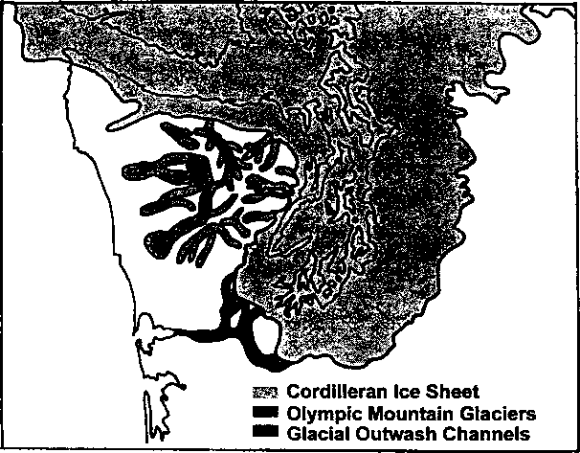
Here's what you'll need:

For each student team:
- percolation cylinder
- board
- measuring container
- milk carton or other container
- water
- watch with second hand, stopwatch or timer
- soil samples
- clear plastic soda bottle
- coffee filters
- clear 8-oz. plastic cup for each material to be tested
- masking tape for plastic cup labels
- scissors

For each student:
- notebook with a firm back
- pencil
- "Drop by Drop" student activity pages

Teaching Hints
Note: In Part II, you may wish to have students bring sample soil from their homes. If so, a week before conducting this activity ask students to each bring a 1/2 cup of soil. Students are also a good source of clear plastic soda bottles (1 or 2 liter size).
In "Part I - The School Scene”, students compare percolation rates and soil compaction around school with those they found at Seal Rock Campground. You may wish to demonstrate the technique by way of a refresher
In "Part II - Are All Soils Created Equal?", students investigate the role of soil texture in determining percolation rates and use the information they gather to help further explain
Seal Rock Marine Trail Curriculum - Olympic National Forest. Quilcene, Washington 98376
Developed by the Institute of Marine Science www.forsea.org
224

sand, and a variety of local soils. Caution students to use care in cutting the soda bottles. You may wish to use a sharp knife to start each cut by making an opening large enough for one blade of the scissors to be inserted. Since you will be left with quantities of wet soil, decide beforehand where you would like students to deposit their "used" samples. Five ’ gallon buckets work well.

Essential Academic Learning Requirements in Science
- The student understands and uses scientific concepts and principles. (1.2, 1.3)
- The student knows and applies the skills and processes of science and technology (2.1,

2.2)
- The student understands the nature and contexts of science and technology. (3.1)

Answer Key

Introduction
Answers depend upon the experimental results.

Part I - The School Scene
1. - 3. Answers depend upon the experimental results.
- While answers depend upon the experimental results, it is quite possible that the direct relationship between soil compaction and length of percolation time will not be found. This anomaly sets the stage for Part II in which students examine soil texture, another factor which contributes to percolation rate.

Part II - Are All Soils Created Equal?
1. - 4. Answers depend upon the experimental results.
- A high level of activity and compaction can percolate more rapidly than a less used site because of differences in soil texture.
- It is important or useful to test the percolation rate of soil in placing septic systems, building foundations, bridge footings, and other construction projects.
Seal Rock Marine Trail Curriculum - Olympic National Forest, Quilcene, Washington 98376
Developed by the Institute of Marine Science www.forsea.org

Drop by Drop
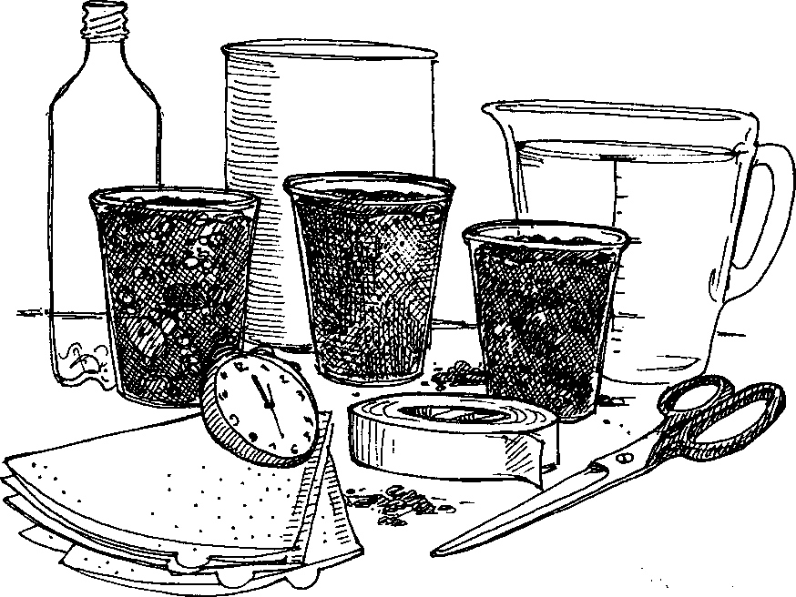
Hmmm.. .where'd I put that percolation cylinder anyway? In "Don't Tread On Me" you used a percolation cylinder (It looked a lot like a tin can, remember?) to study soil compaction.
Soil compaction occurs when soil particles are pressed together.
Soil compaction slows the rate at which water can enter the soil. We call this the percolation rate. Recall that you tested the percolation rates in an area of low human activity and in an area of higher human activity.
1. Of the areas you tested, which had the slowest percolation rate?
2. Of the areas you tested, which had the greatest soil compaction?

Part I - The School Scene
Why should we care about how fast water enters the soil? For one thing, if water doesn't enter the soil, it can flow rapidly across the surface causing erosion. Erosion can be a problem in areas as diverse as Seal Rock Campground and your school. In the following activity you will compare percolation rates and soil compaction around your school with those you found at Seal Rock Campground.
Seal Rock Marine Trail Curriculum - Olympic National Forest, Quilcene, Washington 98376
Developed by the Institute of Marine Science www.forsea.org

Here's what you'll need:
- percolation cylinder
- board
- measuring container
- milk carton or other container
- water
- watch with second hand or stopwatch
- notebook with a firm back
- pencil

Here's what to do:
- Work with the your team from the Seal Rock Campground trip. You'll be measuring percolation rates at three sites at your school. Choose one site away from foot or car traffic, one in a heavily used area, and one other that you're curious about.
- Here's a reminder of how to measure the rate.
- Push the cylinder into the soil to the mark on its side. Do this by placing the board on top of the cylinder and pressing the can into the soil with your hands. If the soil is too hard for you to push the cylinder in with your hands, carefully apply foot pressure.
- Fill your measuring container with water from the source provided by your teacher.
- Get ready to record the time. When you are ready, have a team member pour the measuring container full of water into the top of the percolation cylinder. Begin recording the time now on your data sheet.
- When the water has completely soaked into the ground so that there are no puddles of water at the surface, record the ending time on your data sheet.
- Calculate the "Elapsed Time" which is the time it took for the water to soak into the ground. (This is easy if you used a stopwatch, otherwise subtract the "Beginning Time" from the "Ending Time".) Record the "Elapsed Time" on your data sheet.
- Repeat this procedure for your two other sites. Be aware of people or vehicles in the heavily used area. Be careful and courteous. Record your results on the data sheet.

Thinking about the data:
1. Which one of your sites had the most rapid percolation?
2. Which one of your sites had the slowest percolation?
Seal Rock Marine Trail Curriculum - Olympic National Forest, Quilcene, Washington 98376
Developed by the Institute of Marine Science www.forsea.org

3. Compare percolation rates for your sites with those of the rest of the class. Use the combined data to answer these questions:
- Which areas of your school had the most rapid percolation rates?
- Which areas of your school had the slowest percolation rates?
- In areas with slow percolation rates, what activities might have caused the soil to become compacted?
What might be done to reduce soil compaction in those areas with slow percolation?
4. What relationship did you find between the amount of use on the site and the percolation rate? (Do your data seem contradictory? Compaction isn't the only thing that determines percolation rate. The next activity highlights another factor that influences percolation rates.)
Seal Rock Marine Trail Curriculum - Olympic National Forest. Quilcene, Washington 98376
Developed by the Institute of Marine Science www.forsea.org

Part II - Are All Soils Created Equal?
While using your percolation cylinder you may have noticed that the soil looked different from one site to the next. Recall that soil is a complex mixture of living, formerly living, and non-living components. The non-living clay, silt, sand, water and air are enriched by decaying organic matter and a host of microscopic and macroscopic organisms. The particular mixture of these items determines what the soil looks like and how it behaves. In the next activity you'll explore percolation rates in different soil types.

Here's what you'll need:
- soil samples
- clear plastic soda bottle
- coffee filters
- bucket of water or access to a sink
- clear 8-oz. plastic cup for each material to be tested
- masking tape for plastic cup labels
- watch or timer
- scissors

Here's what to do:
- Carefully cut the plastic bottle and assemble the pieces as shown below:
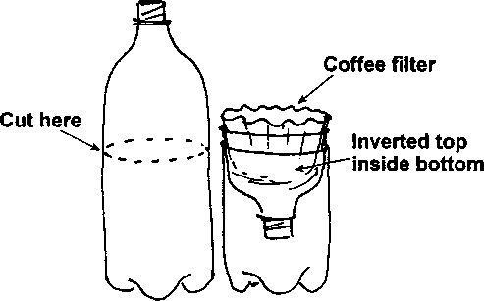
- Put 1/2 cup of the first soil sample into a coffee filter.
- Slowly pour 8 ounces of water onto the soil. Start recording the time just as the last drop of water hits the soil. Stop recording the time when all the water has seeped through and the droplets stop falling. Enter the times and the water color on your data sheet.
- Pour the water in the bottom of the container into a clear 8-oz plastic cup and label it with the type of soil used. Set it aside for later investigation.
- Repeat steps 1 to 4 above, using each of the soil samples in turn. Use a fresh coffee filter for each sample. Enter the times and the water color for each sample on your data sheet.
Seal Rock Marine Trail Curriculum - Olympic National Forest, Quilcene, Washington 98376
Developed by the Institute of Marine Science www.forsea.org

Thinking about the data
- The relative proportion of different types and sizes of soil particles is called soil texture. Look at the soil samples and decide if they have a fine, medium, or coarse texture. Here are definitions you may use :
- A fine soil has individual particles that are difficult to see.
- A coarse soil has most lots of particles 3 mm or greater in size.
- A medium soil has lots of visible particles 3 mm or smaller in size.
Record the soil textures on your data sheet.
- Compare the times required for the water to pass through each soil sample,
- Which one of your samples had the most rapid percolation?
- Which one of your samples had the slowest percolation?
- Think about these two soil samples. What are differences in the soils that might explain the differences in the percolation rates?
- Look at the water in the labeled plastic cups. Arrange the cups of water from the cleanest looking to the muddiest. (Do not drink the water (or give it to your friends), no matter how clean it looks. It may have harmful microorganisms in it.)
- Which water looks the clearest?
- Which water looks the muddiest?
- Look at the series of cups. Think about how they differ from each other. Now, on each of the cups, write the time it took that sample to percolate. Does there seem to be a relationship between the time and the color of the water? If so, what is the relationship?
Seal Rock Marine Trail Curriculum - Olympic National Forest, Quilcene, Washington 98376
Developed by the Institute of Marine Science www.forsea.org

d. Look at the series of cups, again. Now, on each of the cups, write the soil texture for that sample. Does there seem to be a relationship between the soil texture and the color of the water? If so, what is the relationship?
Record the soil textures on your data sheet.
- Think about the results you obtained in both Parts I and II. From your experiments, what are two factors that influence percolation rate?
- At the end of Part I, you were asked, "What relationship did you find between the amount of use on the site and the percolation rate?" Think about what you now know. Explain how a site with a high level of activity and compaction could percolate more rapidly than a less used site.
- Why might it be important or useful to test the percolation rate of a soil?
Seal Rock Marine Trail Curriculum - Olympic National Forest. Quilcene, Washington 98376
Developed by the Institute of Marine Science www.forsea.org

Percolation and Soil Compaction
Use the datachart below to record your results. Be sure to include the location of your site in your description.
Soil From Area of Low Human Activity
Description of Site:
Beginning Time:
Ending Time:
Elapsed Time:
Soil From Area of Higher Human Activity
Description of Site:
Beginning Time:
Ending Time:
Elapsed Time:
Soil From Area of
Description of Site:
Beginning Time:
Ending Time:
Elapsed Time:

Seal Rock Marine Trail Curriculum - Olympic National Forest. Quilcene, Washington 98376
Developed by the Institute of Marine Science www.forsea.org
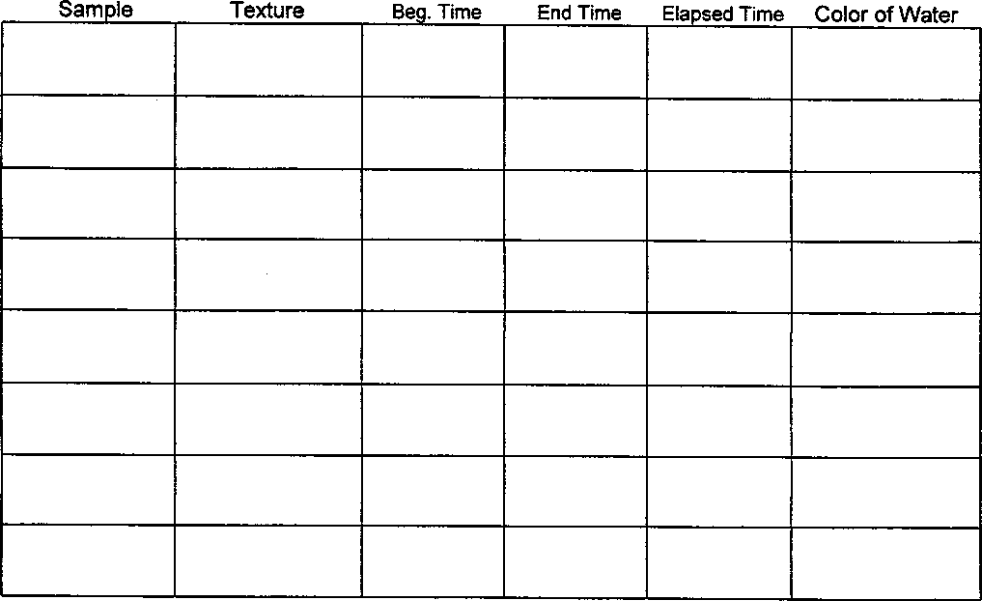

Percolation Rates in Different Soil Types
Seal Rock Marine Trail Curriculum - Olympic National Forest, Quilcene, Washington 98376
Developed by the Institute of Marine Science www.forsea.org

