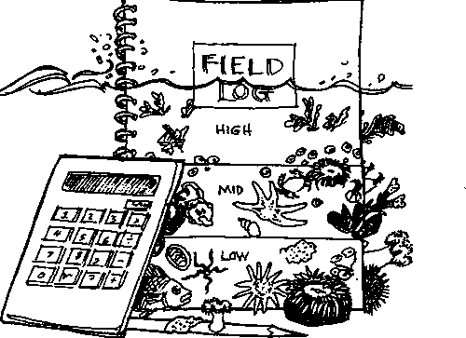
Key Concepts

Zoning Out
- Intertidal animals live in preferred zones determined largely by their tolerance for exposure to the air at low tide.
- Animals who live in upper tidal zones endure the hazards of exposure at low tide, but also avoid predators who cannot stay in the upper tidal zones.

Background
In the activity "Living in the Tidal Zone", students examined intertidal zonation and the animals that live in the different zones. In "Zoning Out", students use the data they collected to learn more about the intertidal beach at Seal Rock Campground.
Although interitdal zonation is more obvious in other areas of the Olympic Peninsula, students should have been successful in observing zonation on the gentler slopes of Seal Rock beach. In their survey of the zones, they enumerated total organisms. In future studies, you may wish to have them compare the relative abundance from zone to zone of one or two organisms.
Background information on intertidal zonation is found in the Teacher Background section of the activity "Living in the Tidal Zone".

Materials
- student notebooks from Seal Rock Campground site visit
- student site maps from Seal Rock Campground site visit
- "Zoning Out" student activity pages

Teaching Hints
Note: Since "Zoning Out" utilizes data collected during the class trip to Seal Rock Campground, it is imperative that students bring their notebooks and site maps from the trip to class.
In "Part I. - Tide's Out?" students describe their solution to the tidal challenge..."How can a stake or relatively straight piece of driftwood tell you what the tide is doing?"
In "Part II, A Where's that line?" students compare their measurements of zone widths with those of others in their class and consider possible sources of the differences observed.
In "Part II, B Who lives here?" students calculate sample averages and class averages for the number of organisms per 50 cm2 in each tidal zone, then use the averages to answer a variety of questions. Be aware that students may find some of the analysis confusing
Seal Rock Marine Trail Curriculum - Olympic National Forest, Quiicene, Washington 98376
Developed by the Institute of Marine Science www.forsea.org
210

because the same questions are repeated several times. The repetition is intentional. Students are to use different data sets to answer the different iterations. The process is designed to help students gain an empirical sense of the utility of multiple samples, averaging, and pooling data.

Essential Academic Learning Requirements In Science
- The student understands and uses scientific concepts and principles. (1.1, 1.2, 1.3)
- The student knows and applies the skills and processes of science and technology. (2.1)
- The student understands the nature and contexts of science and technology. (3.1, 3.2)

Answer Key

Tart I. - Tide's Out?"
- Answers may vary. Possible sources of error include different definitions of the margin between zones, measurement errors, misreading of tape, and recording errors.

Tart II. A Where’s that line?"
1. a. Multiple samples were taken to increase the likelihood that the area sampled was representative of the entire area.

"Part II. B Who lives here?"
1. b.- 2.d. Answers depend upon experimental results.

Analysis and Interpretation
- Environmental factors that may cause differences in numbers of organisms from one tide level to another include length of time exposed to air, changes in temperature, food availability and oxygen levels.
- Animals may not move into the upper tidal zone because of extremes in temperature, long exposure to air, drying, suffocation, battering by waves and insufficient water movement to remove wastes.
- Animals may not extend their range to lower tidal zones because other animals out- compete them for space in that zone or predators readily decimate their populations. They may stay in upper tidal zones because they prefer those temperatures or other characteristics of the upper tidal areas. It is interesting to note that often species are able to live quite well under the conditions found on other parts of a piling, yet they are not found on the other parts. The explanation lies in the fact that while they are able to survive in these other locations, other animals can survive better, and these other organisms out-compete the species trying to extend its territory. The living environment, then, has a pronounced effect on where an organism can five.
- The answer depends upon the organisms chosen. While the protective adaptations may be gleaned from the pages of a book, also encourage students to use their observational powers to answer this question.
Seal Rock Marine Trail Curriculum - Olympic National Forest, Quilcene, Washington 98376
Developed by the Institute of Marine Science www.forsea.org
211

Zoning Out

In the activity "Living in the Tidal Zone", you had a chance to look at intertidal zonation and the animals that live in the different zones. In the following activity, you'll use the data you collected to learn more about the intertidal beach at Seal Rock Campground.

Part I. - Tide's Out?
1. a. Think back to the tidal challenge...How can a stake or relatively straight piece of driftwood tell you what the tide is doing? In the space below, describe the technique you developed.
b. Did your technique give you the information you needed to tell you what the tide was doing? If not, how would you change your technique to make it work?
Seal Rock Marine Trail Curriculum - Olympic National Forest. Quilcene, Washington 98376
Developed by the Institute of Marine Science www.forsea.org
- The major food source for animals attached to rocks is water-borne plankton.
- Oil and gasoline slicks are particularly devastating to rocky shore organisms since the changing water levels allow the slick to coat a large area of the rocks. The students may think of other types of pollution.
- The tides alternately wet and dry intertidal animals. Organisms are subjected to changes in temperature and to ultraviolet radiation. The tides also bring and carry away food and oxygen and cool water.
Seal Rock Marine Trail Curriculum - Olympic National Forest, Quilcene, Washington 98376
Developed by the Institute of Marine Science www.forsea.org

Part II, A Where's that line?
Look in your notebook to find your map of Seal Rock Campground. Look for the widths of each of the tidal zones that you recorded on the map.
1. Compare your results with those of others in your class. Were all of the zone widths the same? If not, what are two possible sources of the differences observed?

Part II, B Who lives here?
1. a. Remember that clever 50 square centimeter sampling tool? Recall that you sampled three times in each tidal zone. Why did you sample more than once?
b. Look at your data sheet in your notebook. For each zone, calculate an average number of organisms per 50 cm2. This is easy. To find the average number of organisms per 50 cm2 for each of the zones, first add the numbers you found for each of the three samples. Then divide the total by three.
(Hint: Let's say you found 30 organisms in Sample 1 in the high tide zone, 22 in Sample 2, and 16 in Sample 3. The average would be :
30 + 22 + 17 organisms = 23 organisms per 50 cm² in the high tide zone
3 samples
Record your averages in the table below:
Zone | Average number / 50cm²
High tide
Mid tide
Low tide

c. Now use these sample averages to answer the same questions you answered on-site with just your data, namely:
6. Look back at the prediction you made regarding the number of organisms you would find in these two zones. How did the results compare with your predictions?
Seal Rock Marine Trail Curriculum - Olympic National Forest, Quilcene, Washington 98376
Developed by the Institute of Marine Science www.forsea.org
- What are two possible reasons that might explain why this zone had more organisms than the others?
d. How do the answers from your using data alone compare with those using the averages of the three samples?
2. Now there's data, and there's data...
a. Combine your averages with those from the other groups. Then find the average of the averages! Record your averages in the chart below:
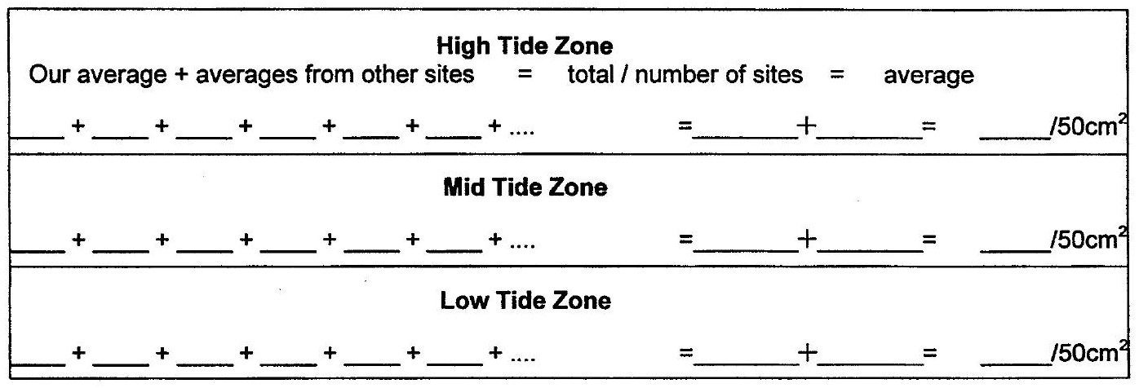
b. Now use these class averages to answer the same questions you answered on-site with just your data, namely:
- Look back at the prediction you made regarding the number of organisms you
would find in these two zones. How did the results compare with your
predictions?
- a. Which zone had the most organisms?
- What are two possible reasons that might explain why this zone had more organisms than the others?
- How do the answers from your using data alone compare with those using the class averages?
- Look at your results, your averages, and the class averages and write a sentence stating which set of data you have the most confidence in and why.

Seal Rock Marine Trail Curriculum - Olympic National Forest, Quilcene, Washington 98376
Developed by the Institute of Marine Science www.forsea.org

Analysis and Interpretation
- What is one environmental factor that might cause a difference in the number of organisms from level to level?
- What are two environmental factors that might limit a species, keeping it from extending into the upper tide zone?
- What are two environmental factors that might limit a species extension into the low tide zone?
- Pick one organism from each zone and describe how it protects itself from drying out in the sun at low tide on summer days or freezing at low tide in the winter.
- The majority of the animals you counted probably are attached. Many do not travel to find food. What, then, is the major food source for these sessile (attached, non-moving) animals?
Seal Rock Marine Trail Curriculum - Olympic National Forest, Quilcene, Washington 98376
Developed by the Institute of Marine Science www.forsea.org
6. What types of environmental pollution do you think would be particularly devastating to rocky shore organisms?
7. The tide is perhaps the most important environmental factor affecting rocky shore and piling organisms. How does the tide affect these organisms?

Extra credit:
Show the abundance of animals graphically. Construct a single graph showing the number of animals in each tidal zone. Use different colored lines to show your results, your averages, and the class averages for each zone. Be sure to give your graph a title and indicate which line represents which data.
Seal Rock Marine Trail Curriculum - Olympic National Forest, Quilcene, Washington 98376
Developed by the Institute of Marine Science www.forsea.org

