Seeing the Forest and the Trees

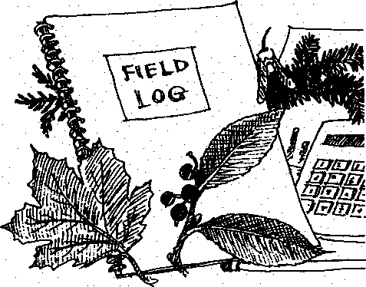
Key Concepts
1. The forest at Seal Rock Campground contains a variety of trees.
2. Sampling techniques are useful tools for studying the forest ecosystem.
3. Olympic Peninsula forests are home to exceptionally large trees.

Background
In the on-site activity "Can't See the Forest for the Trees", students had a chance to sample the forest ecosystem at Seal Rock Campground. In "Seeing the Forest and the Trees", they use the data collected to help give them the better picture of the forest
Hopefully, your visit to Seal Rock Campground emphasized that the Pacific northwest is a great spot for growing trees. Consistent light of even intensity, rainfall from 35-50 inches per year, moderate temperatures in both summer and winter, and nutrients from decaying vegetation which provide necessary nutrients over a long period of time all combine to produce excellent growing conditions for forest trees.

Materials:
- student notebooks from Seal Rock Campground site visit
- large piece of butcher paper or similar for class graph
- "Seeing the Forest and the Trees" student activity pages

Teaching Hints
Note: Since "Seeing the Forest and the Trees" utilizes data collected during the class trip to Seal Rock Campground, it is imperative that students bring their notebooks from the trip to class.
In "Part I- What grows there?", students pool data to determine tree frequencies at Seal Rock Campground and compare those frequencies with tree frequencies found on their particular site. You will need a large sheet of paper on which students can construct a bar graph of their results.
In "Part II - How many trees make a forest?", students pool class data, gathered as teams from 4 m x 10 m study plots, to determine the number of each of the four most common trees found by the class. They then calculate the average number for each of the trees per plot and extrapolate from these averages to the number of each type of tree in the entire forested area of Seal Rock Campground. While the mathematics is straightforward, be aware that some students may need help in setting up the problems.
Seal Rock Marine Trail Curriculum - Olympic National Forest, Quilcene, Washington 98376
Developed by the Institute of Marine Science www.forsea.org
In "Part III - Big Trees", students compare the results of their searches for the biggest trees in Seal Rock Campground with the results of the American Forestry Association search. Note that questions l.e and l.f. provide opportunities to discuss the growing conditions responsible for Pacific northwest forests, as well as human impact on those forests.

Essential Academic Learning Requirements in Science
- The student understands and uses scientific concepts and principles. (1.1, 1.3)
- The student knows and applies the skills and processes of science and technology (2.1,

2.2)
- The student understands the nature and contexts of science and technology. (3.1)

Answer Key

Part I- What grows there?
Answers depend upon experimental results.

Part II - How many trees make a forest?
1. - 2. Answers depend upon experimental results.
3. a. The additional piece of information needed to estimate the number of trees of each type in the entire campground is the total area of the campground.
3. b. Answers depend upon experimental results.

Part III - Big Trees
1. a. - d. Answers depend upon experimental results, but Seal Rock Campground trees will be smaller than the records (most of which are found on the west side of the Olympic mountains).
1. e. While answers will vary, most will think that the growing conditions at Seal Rock Campground are poorer than those where AFA record trees were found.
1. f. Possible human factors which could account for the differences in size between the trees at Seal Rock Campground and the AFA record trees include logging and fire. Many record trees are found in remote areas, protected from disturbance for the veiy long periods necessary to achieve such growth.
Seal Rock Marine Trail Curriculum - Olympic National Forest, Quilcene, Washington 98376
Developed by the institute of Marine Science www.forsea.org


Seeing the Forest and the Trees

In the activity "Can't See the Forest for the Trees", you had a chance to sample the forest ecosystem at Seal Rock Campground. In the following activity, you'll use the data you collected to help give you a better picture of the forest.

Part I. - What grows there?
Go back in your mind's eye and see yourself walking through the forest, from tree to tree, wrapping them with string as you go. Got the picture? Your wanderings gave you a sample of the kinds of trees in the Seal Rock Campground forest. A single sample might not be representative of the whole campground. How can we increase our faith, or reliability, in our answer? Easy, take more samples...or, in this case, combine your sample with those of the other groups from your class.
The class data is perfect for a bar graph.
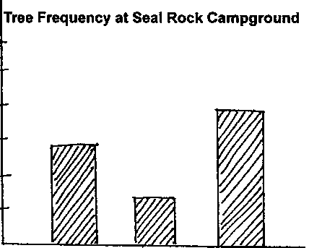
Cedar Hemlock Etc.
As a class, make one on a large sheet of paper. Put the kinds of trees on the x-axis across the bottom and the number of trees on the y-axis like this:
N
U
MBE
R
Seal Rock Marine Trail Curriculum - Olympic National Forest, Quilcene, Washington 98376
Developed by the Institute of Marine Science www.forsea.org

Use the data from your bar graph to answer the following questions:
- a. Of those your class wrapped and identified, which was the most common tree in the Seal Rock Campground?
b. Look back at the prediction you made before you began. How did this result compare with your prediction for the most common tree in the Seal Rock Campground? (Hint: Your prediction should be on one of the first pages in your notebook.)
- In total, how many trees did your class sample?
- How many different kinds of trees did your class sample?
- Look at the kinds of trees you found. How does your sample compare with the class results?

Part II - How many trees make a forest?
Your next vision of Seal Rock Campground should be that of your team holding a 4 m section of string as they walk along a 10 m string stretched straight through your study area. Your stroll gave you a different kind of sample of the Seal Rock Campground forest. This time you took a rectangular sample of 40 square meters (10 m string x 4 m string). Once again, a single sample might not be representative of the whole campground. So, to increase our faith in your answer, combine your sample with those of the other groups from your class.
Of the four most common trees found by the class, list the number of each:
Number our site + number on other sites = total
+ | + | + | + | + | + .. | .. = of tree 1 (name: | )
+ | + | + | + | + | +.. | .. = of tree 2 (name: | )
+ | + | + | + | + | + .. | .. = of tree 3 (name: | )
+ | + | + | + | + | + .. | .. = of tree 4 (name: | )

Seal Rock Marine Trail Curriculum - Olympic National Forest, Quilcene, Washington 98376
Developed by the Institute of Marine Science www.forsea.org

Use this data to answer the following questions:
- a. Of the four most common trees you counted, which was the most numerous tree in the Seal Rock Campground?
b. How many of this tree were there in the total sample taken by your class?
c. Look back at the prediction you made before you began. Recall that you used the data you collected in Part I to help make your prediction. How did these results compare with your prediction for the numbers of the four most common trees in the Seal Rock Campground? (Hint: Your prediction should be on one of the first pages in your notebook.)
- But these numbers still don't tell us how many trees of each type are found in the entire campground. To find the total number you first need to use the class data to find the average number for each of the trees that you would find on a 40 meter square plot. That’s easy, just divide each total by the number of teams.
(Hint: Let's say you found 300 Pacific madrone trees between the 10 teams in your class. The average would be:
300 Pacific madrone trees = 30 Pacific madrone trees per team 10 teams
Calculate and record the averages of each of the four most common trees:
of tree 1 (name: )
of tree 2 (name: )
of tree 3 (name: )
of tree 4 (name: )
- a. But these numbers still don't tell us how many trees of each type are found in the entire campground. They only tell us the average number of each type in a single 10 m x 4 m plot. What additional piece of information would you need to have to estimate the number of trees of each type in the entire campground?
Seal Rock Marine Trail Curriculum - Olympic National Forest. Quilcene, Washington 98376
Developed by the Institute of Marine Science www.forsea.org

(Hint: Estimating the number of trees assumes that the trees are distributed throughout the campground in the same way that they are distributed in the area sampled by the class.)
b. Let's assume:
- the class averages are representative of the way trees are found throughout the campground,
- the total area of forested area of Seal Rock Campground is 22,400 square meters.
Use these assumptions to calculate the number of each of the four most common types of trees in the entire campground. Show your work and record your answers in the space below.

Part III - Big Trees
Picture yourself hugging those big trees back on your study area. Hugging with your 10 m string in your hands let you measure the largest living example of each of the four most common tree species at Seal Rock Campground.
Compare your biggest trees with those of the other teams and record the size of the largest of each of the four most common trees:
of tree 1 (name: )
of tree 2 (name: )
of tree 3 (name: )
of tree 4 (name: )
Use this data to answer the following questions:
1. The Olympic Peninsula is world renown for its spectacular trees. Coniferous forest trees thrive in our area's relatively mild winter temperatures. One Sitka spruce boasts a circumference of 17.96 m or 707 inches! That's a diameter of 5,72 m or about 18 feet.
The American Forestry Association recognizes the largest of these trees in their list of champions. Some of them include an:
Alaska cedar (11.48 m or 452 inch circumference)
Grand fir (5.82 m or 229 inch circumference)
Subalpine fir (6.43 m or 253 inch circumference)
Seal Rock Marine Trail Curriculum - Olympic National Forest, Quilcene, Washington 98376
Developed by the Institute of Marine Science www.forsea.org

Western hemlock (8 m or 316 inch circumference)
Vine maple (88.9 cm or 35 inch circumference),
Douglas fir (13.56 m or 534 inch circumference)
- Are any of these trees the same species as any of the four most common tree species at Seal Rock Campground?
- If so, which ones?
- How do your record trees compare with those of the American Forestry Association?
- What percentage of the record trees are your trees? (This is easy to find: Divide your record by the AFA record and multiply the answer by 100).
- How do you think the growing conditions at Seal Rock Campground compare with those where the AFA record trees are found?
- Growing conditions might not be the only reason for the differences in size. What is one possible human factor that could account for the differences in size between the trees at Seal Rock Campground and the AFA record trees?
Seal Rock Marine Trail Curriculum - Olympic National Forest, Quilcene, Washington 98376
Developed by the Institute of Marine Science www.forsea.org

