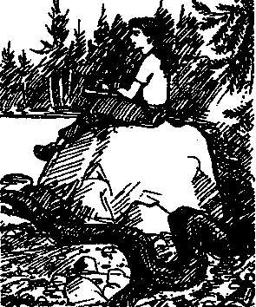
Sounds Good to Me

Key Concepts
- Our sense of hearing is a powerful tool for gathering data.
- Quiet reflection can provide insight into the complex interactions that occur in an ecosystem.
- Seal Rock Campground provides a refuge from human activity and noise.
Seal Rock Campground and similar spots are good places to escape from a lot of the human noise that surrounds us daily. In many ways, the human noise de-sensitizes us to the sounds of nature. Philosophers for ages have recognized the benefits of solitude and of listening with a keen ear to the nature around us.

Materials
- "Sounds Good to Me" activity sheet
- notebook with a firm back
- pencil
- colored pencils or markers, optional

Teaching Hints
"Sounds Good to Me" is a final reflection on the day and on the sounds of Seal Rock Campground. Students disperse to self-selected scenic spots for 5 or more minutes of listening followed by writing.
Since it is likely that not all students will have timepieces, you may elect to have them estimate the time periods or you may call out times or sound a horn at the intervals mentioned. Time periods are not critical. What is important is that students have a significant period during which they are silent and listening.
Students are asked to describe their impressions of all the sounds they've heard in enough detail to amaze a reader. Poetry or prose, pictures, song lyrics, and music are presented as vehicles for description. While you may choose to have them complete their descriptions as homework or classwork, there is some benefit in having them formalize their description on the site.

Essential Academic Learning Requirements in Science
- The student understands and uses scientific concepts and principles. (1.3)
- The student knows and applies the skills and processes of science and technology (2.1)
Seal Rock Marine Trail Curriculum - Olympic National Forest, Quilcene, Washington 98376
Developed by the Institute of Marine Science www.forsea.org

Sounds Good to Me
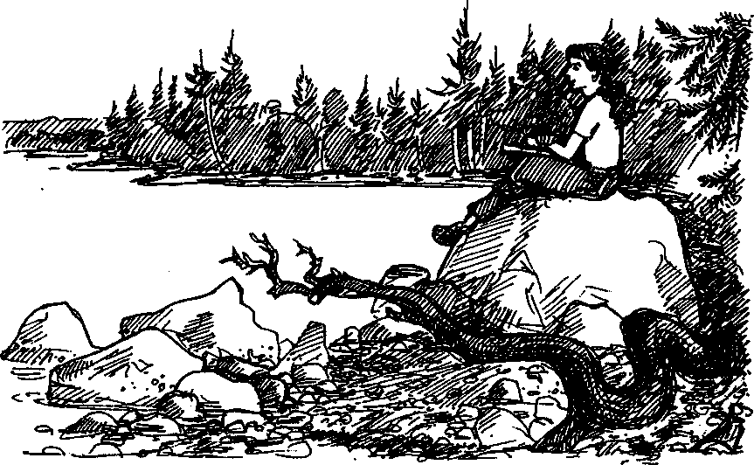
We are a noisy species. From cars to airplanes, the way we travel is noisy. From stereos to soccer, the way we entertain ourselves is noisy. Seal Rock Campground is a good place to escape from a lot of the human noise.

Here's what you'll need:
- notebook with a firm back
- pencil
- colored pencils or markers, optional

Here's what to do:
- Think about the beautiful sites you've seen today. Choose one of them away from all of your classmates where you can sit by yourself.
- Go to your spot.
- Think about all the living things, from people to plants, that you've encountered today. Think about how they interact with each other. Think about how they interact with the rest of their environment, too.
Which of today's living things or interactions was the most amazing to you?
Seal Rock Marine Trail Curriculum - Olympic National Forest, Quilcene, Washington 98376
Developed by the Institute of Marine Science www.forsea.org
- Now, dose your eyes and listen in silence for a minute or so. (It will seem like forever.)
- After you open your eyes, begin to record in your notebook the natural sounds and human sounds that you hear. Record them for 3-5 minutes.
- In your notebook, describe your impressions of all the sounds you heard in enough detail that a reader will be amazed. You may use poetry or prose, pictures, song lyrics, music, or whatever for your description.
Seal Rock Marine Trail Curriculum - Olympic National Forest, Quilcene, Washington 98376
Developed by the Institute of Marine Science www.forsea.org

