It's Your Campground

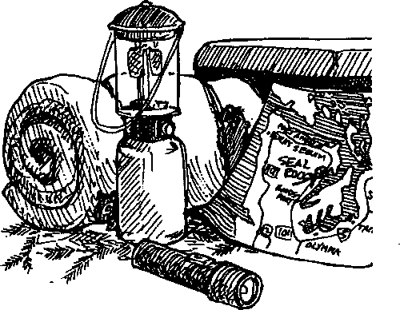
Key Concepts
- Seal Rock Campground is a part of the larger Hood Canal and Puget Sound systems and affects those systems and is, in turn, affected by them.
- Seal Rock Campground contains a variety of natural areas from forest to shoreline to open marine waters.
Although only about 30 acres in size, Seal Rock Campground contains an amazing variety of natural areas from forest to shoreline to the open waters of Hood Canal. In "It's Your Campground" students use a series of maps to narrow their focus from Puget Sound to Hood Canal to Seal Rock Campground. Additional background information about Seal Rock Campground is found at the end of this "Teacher Background" section.

Materials:
For class:
- Road map or atlas
- For each student or pair of students:
- "It's Your Campground" activity sheets
- Colored pencils, crayons or markers (preferably: blue, gray, red, and green)

Teaching Hints
Through an examination of progressively larger scale maps, "It's Your Campground" continues the focus on water as the link connecting the forest, shoreline, and adjacent marine habitats of Seal Rock Campground to each other, as well as to Hood Canal and Puget Sound.
Duplicate the "It's Your Campground" activity pages, one set per student. You may choose to have students do this activity as homework or as an in-class assignment. If you elect to have students complete the activity in class, secure sufficient sets of colored pencils, crayons or markers to minimize "traffic backups".
If you are comfortable with students helping each other locate the geographic sites, one large road map or one atlas will suffice. Otherwise, 3-4 maps and atlases should be provided.
Whether you choose to have students complete the activity as homework or in-class work, plan to provide time for a discussion of the questions and maps. Use the Seal Rock Campground map to emphasize the three natural areas found at the Campground: forest,
Seal Rock Marine Trail Curriculum - Olympic National Forest, Quilcene, Washington 98376
Developed by the Institute of Marine Science www.forsea.org
25

shoreline, and open waters, as well as the human created areas: roads, parking areas, and campsites.

Essential Academic Learning Requirements in Science
- The student understands and uses scientific concepts and principles. (1.2, 1.3)

Answer Key
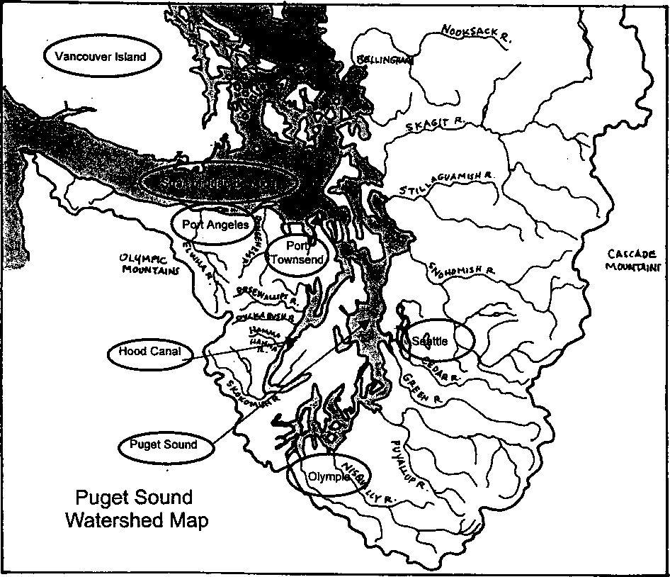
1. The figure below shows a correctly completed map:

- Seal Rock Campground should be circled on student maps.
- Seal Rock Campground is located on Dabob Bay.
The Dosewallips River is close to Seal Rock Campground.
4.
Seal Rock Marine Trail Curriculum - Olympic National Forest, Quilcene, Washington 98376
Developed by the Institute of Marine Science www.forsea.org
26

- a. There are 41 campsites at Seal Rock Campground.
- Three restrooms are found at the campground.
- No, only two of the three restrooms are found within the campsite area.
- Aside from walking, picnicking takes place next to the Nature Trail.
- a. The Marine Trail should be labeled on student maps.
b. The Marine Trail is handicap accessible as evidenced by symbol on the view point.
- a. Student maps should be colored as follows:
Blue to show the open waters of Hood Canal.
Gray to show the beach
Red to show the roads and parking areas
Green to show the upland areas where the campsites and Nature Trail are found
- The animals shown in Hood Canal include a shore crab, an oyster, clams, and a shrimp. Not all students may recognize all of these animals.
- Water running downhill from the green upland areas where the campsites and Nature Trail are found can carry contaminants, soil, etc. into the intertidal and marine ecosystems. The object of this question is to encourage students to look for the connections between the various habitats at Seal Rock Campground.
Seal Rock Marine Trail Curriculum - Olympic National Forest, Quilcene, Washington 98376
Developed by the Institute of Marine Science www.forsea.org
27

Welcome to Seal Rock Campground
- by Libby Palmer, Port Townsend Marine Science Center
Where s the rock? Does it look like a seal? Or is it a rock that seals rest on? Is it on the shore? Or only exposed at low tide? Is it right in front of the campground? Or further up or down the beach?
Visitors always ask ... and no one knows the answer! Maybe your students can write a legend about the origin of the name.
History
Seal Rock Campground sits on a sloping hillside that is the base of Green Hill, a 2380' high foothill of the Olympic Mountains. It lies along Route 101, connecting much of the Olympic Peninsula to the capital city of Olympia. The nearby towns of Brinnon and Quilcene were first settled in the middle of the 19th century but a road connecting them was not built until 1896. The actual land the campground lies on had been owned by a logging company until it was abandoned in the early 1920’s. The land was then acquired by the Olympic National Forest. In the 1930's, the road was finally paved and recreational camping began soon after that. Winter storms swept over the old highway, threatening to wash it away and so, in 1958, it was relocated further up the slope. The present campground was developed between 1959 and 1961.
Geology
A look at the soils exposed at the shoreline gives a good picture of the area's geology. Layers of gravels and sands transported by glaciers about 12-15,000 years ago predominate, with just an occasional exposure of bedrock. The big granite cobbles and boulders seen on the beach were all transported to the site by glaciers, pushed along by the ice fields or tumbled in the water flowing beneath the glacier. Geologists believe that the last glaciers retreated (melted) from this area about 12,000 years ago.
Although only about 30 acres in size, Seal Rock Campground is unusual in the variety of natural areas it contains. Forest, shoreline and the adjacent waters of Hood Canal compete for a camper's attention.
With an average annual rainfall of about 50" per year, the campground contains a small but rich forested area. The major tree species found are Western hemlock, Western red cedar and Douglas-fir. The deep red trunk of the Pacific madrone can be seen only along the shoreline, where sunlight actually reaches the trees. Beneath the trees, the common native understory plants are salal, evergreen huckleberry, snowberry and oceanspray. A nonnative plant unusual to this area but present just above the shoreline is poison oak.
Mammals that probably move through the campground include Roosevelt elk, black-tailed deer, black bear, raccoon, beaver and river otter. Resident squirrels and chipmunks can also be seen scampering around the campsites.
The campground shores are covered with rocks and cobble, almost all of them bearing Pacific oysters. On and between the oysters live a world of marine invertebrates: barnacles, limpets, snails, chitons, sea stars, tunicates and crabs. Shore birds (yellowlegs, sandpipers and gulls) peck for food at the water's edge while osprey and bald eagles watch carefully from the heights of nearby trees. Beyond the water's edge lie the cold salt waters of Hood Canal, part of the larger estuaiy system of Puget Sound. Its waters are filled with an assortment of marine fish: several species of salmon, dogfish, herring, rockfish, sea perch
Seal Rock Marine Trail Cunriculum - Olympic National Forest, Quilcene, Washington 98376
Developed by the Institute of Marine Science www.forsea.org
28

and sculpin, among others. Riding on the water's surface are a variety of seabirds and ducks: gulls, marbled murrelets, mergansers, grebes, bufllehead and harlequin ducks.
Interesting Facts
Seal Rock Campground has 42 tent/trailer sites among the trees, with several along the waterfront. There are also nine picnic sites and a group camp site. Access to the beach is along a path at the northern end (leading to a boat ramp) and a series of steps at the southern end. Two signed interpretive trails, one devoted to Native American use of the area and the other to its natural features, are wheelchair accessible and provide interesting, easy walks for visitors. Other activities possible at the campground include beachcombing, birdwatching, picnicking, swimming, harvesting shellfish and small boating. Stores and business services are conveniently located in nearby Brinnon, less than a mile away.
The campground attracts about 34,000 visitors during the recreation season. It is one of the very few National Forest campgrounds on salt water with harvestable oysters for public use.
Seal Rock Marine Trail Curriculum - Olympic National Forest, Quilcene, Washington 98376
Developed by the Institute of Marine Science www.forsea.org
29

It's Your Campground
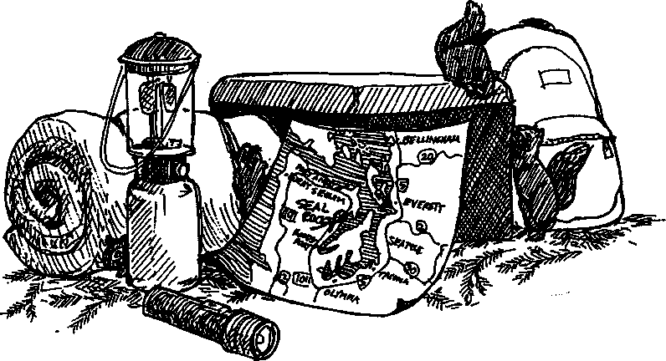
Think of the Northwest and we think of water. Water dominates our landscape and our history. The waters of Puget Sound lie in the heart of Western Washington. Nearly three million of us live along the shorelines of Puget Sound, on dozens of rivers and lakes, thousands of creeks, and in the cities that have grown up along these waterways. We share this region with a vast array of plants and animals whose survival depends on the purity of our water.
1. The figure on the following page is an "ecological map" of Puget Sound. It shows everything that drains west from the crest of the Cascades or east from the Olympic Mountains into Puget Sound. On your map identify and label the following (Hint: Use an atlas or road map, if you get stuck):
- Strait of Juan de Fuca
- Vancouver Island
- Port Angeles
- Seattle
- Port Townsend
- Hood Canal
- Puget Sound
- Olympia
Seal Rock Marine Trail Curriculum - Olympic National Forest, Quilcene, Washington 98376
Developed by the Institute of Marine Science www.forsea.org
30

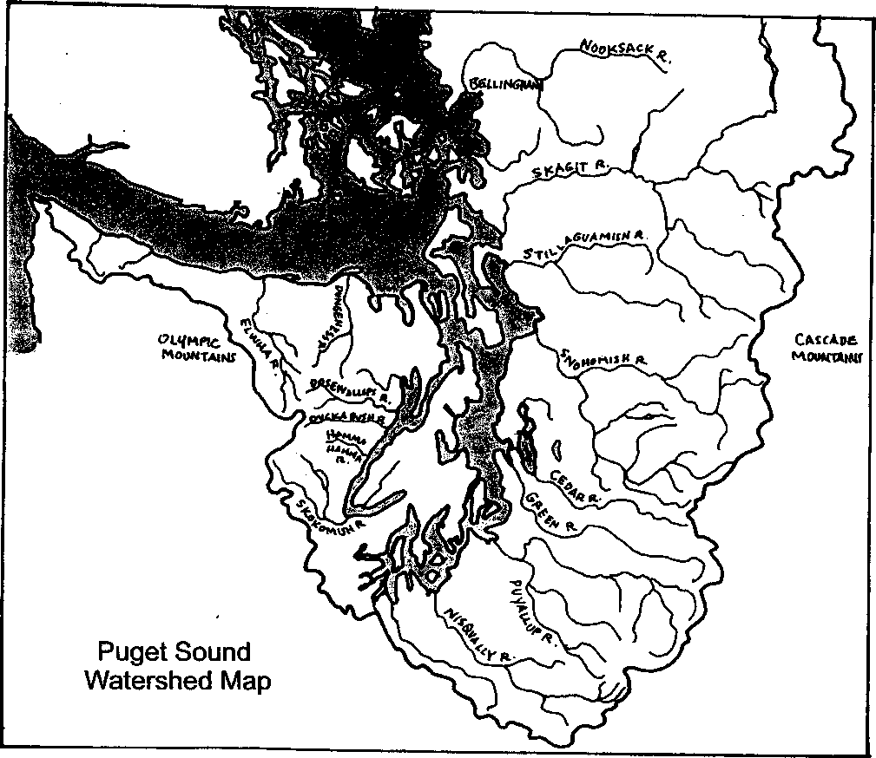
Seal Rock Marine Trail Curriculum - Olympic National Forest, Quilcene, Washington 98376
Developed by the Institute of Marine Science www.forsea.org
31

²' rnM for “ ^{l0Ca}‘^{ed} °f ”^{00d Cana1}' ^{Hood 031181 is to}° ³¹¹¹³¹¹ on the above
map for you to find the campground. On the map below circle Seal Rock Campground.
- On which bay is Seal Rock Campground located?
- Which River is closest to Seal Rock Campground?
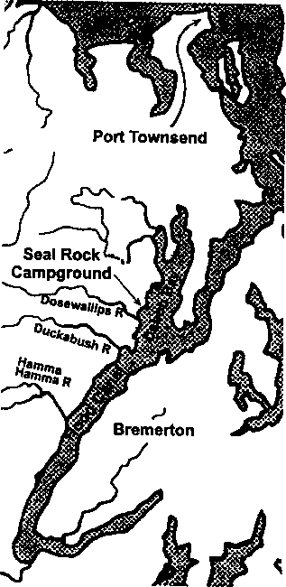
- The Hood Canal Map is still too small to show much detail of Seal Rock Campground. The following Seal Rock Campground map is from the two page "Recreation Opportunity Guide" which the Olympic National Forest uses to tell people about the campground. Use this map to answer the questions which follow:
- How many campsites are found at Seal Rock Campground?
- How many restrooms are found at the campground?
- Are all of the restrooms found within the camping area?
Seal Rock Marine Trail Curriculum - Olympic National Forest, Quilcene, Washington 98376
Developed by the Institute of Marine Science www.forsea.org
- The dashed line shows the Nature Trail. Aside from walking, what recreational activity takes place next to the Nature Trail?
- a. The dotted line ( ) shows the Marine Trail. Label the Marine Trail on your map.
b. Look at the Marine Trail. Is the trail handicap accessible? What evidence did you use to reach your conclusion?
- a. Use colored pencils or crayons to show the following areas:
- Blue to show the open waters of Hood Canal.
- Gray to show the beach
- Red to show the roads and parking areas
- Green to show the upland areas where the campsites and Nature Trail are found b. What animals are shown in Hood Canal?
c. How might something happening in the green area of your map affect these animals?
Seal Rock Marine Trail Curriculum - Olympic National Forest, Quilcene, Washington 98376
Developed by the Institute of Marine Science www.forsea.org
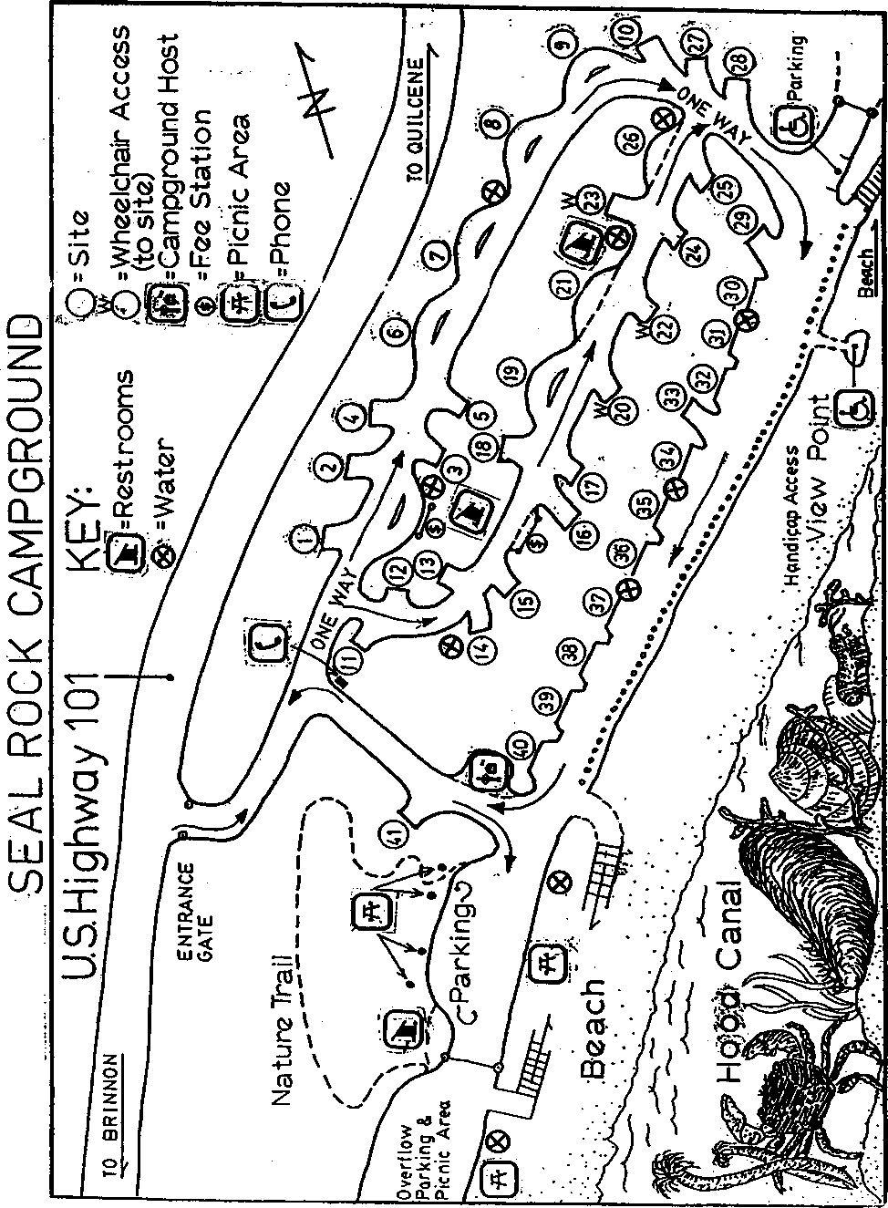
Seal Rock Marine Trail Curriculum - Olympic National Forest, Quilcene, Washington 98376
Developed by the Institute of Marine Science www.forsea.org
34

