Mini-spills

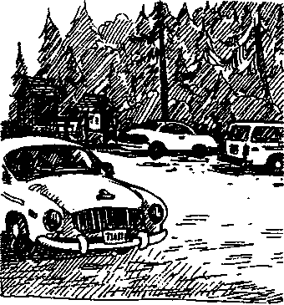
Key Concepts
- Oil pollution can have an adverse effect on natural systems.
- Everyday activities can permit oil to enter the environment.
- Personal action can decrease the amount of oil that reaches Hood Canal and other bodies of water.
Major oil spills provide dramatic evidence of the adverse impact of oil on plant and animal life. Adult birds die, bird eggs are killed when oil seeps into eggs, fish suffocate when their gills become clogged, spawning salmon cannot navigate, and marine and terrestrial animals that ingest food and water contaminated by oil become ill.
Fortunately, major oil spills are rare. But what about those mini-oil spills that happen when our vehicles leak oil, when we spill fuel, and the like? In fact, these spills introduce more oil into our waters by volume than do major spills. While the impact of these minispills is less obvious and less immediately severe, there are long-term, chronic effects on wildlife. As a result, it is important that students be aware of how oil enters the environment and what they may do to minimize that entry and the harm it can cause.

Materials
For each student:
- "Minispills" activity pages
- notebook with a firm back (including "Follow that Drop” map made earlier)
- pencil
- colored pencil or pen, optional

Teaching Hints
"Minispills"is a brief activity which brings closure to the "Follow that Drop" activity with which students began their study of Seal Rock Campground. In the activity, students locate signs of oil spillage in the campground parking lots, then trace the flow of that oil into Hood Canal and add that information to their map.
Since students will be starting in the campground parking lot areas, caution them to be aware of people or vehicles using the area and to be careful and courteous.
Seal Rock Marine Trail Curriculum - Olympic National Forest Quilcene. Washington 98376
Developed by the Institute of Marine Science www.forsea.org

Essential Academic Learning Requirements in Science
- The student understands and uses scientific concepts and principles. (1.3)
- The student knows and applies the skills and processes of science and technology (2.1,
2.2)
- The student understands the nature and contexts of science and technology. (3.2)

Answer Key
Thinking about it...
- Answers ask for student opinions. As such, accept any reasonable answer.
- Installing separation basins or other mechanical devices to catch and hold oil in the runoff is something that can be done to decrease the likelihood that oil from parking areas will reach Hood Canal. Students may have other ideas, as well.
- Answers will vary. The point of this question is to reinforce the notion of personal action as an effective way to decrease the amount of oil that reaches Hood Canal.
Seal Rock Marine Trail Curriculum - Olympic National Forest, Quilcene, Washington 98376
Developed by the Institute of Marine Science www.forsea.org

Mini-spills
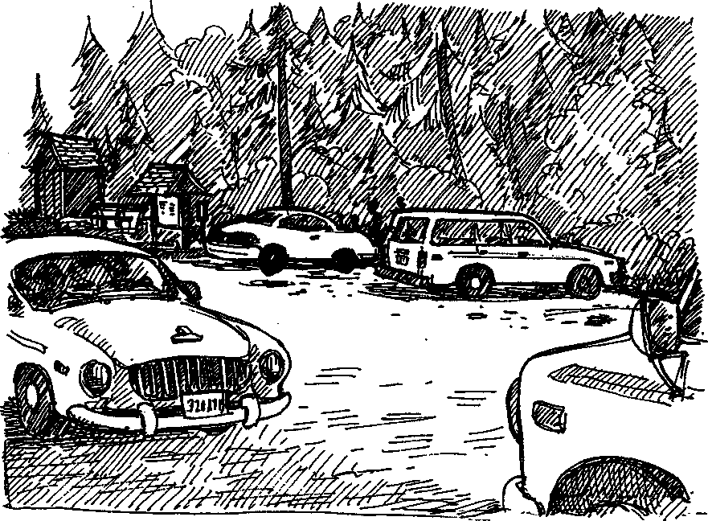
Oil spill at Seal Rock Campground? How could that happen? Unfortunately, it happens all
too easily. Even the most well-tuned car produces some oil pollution. Oil drips on to
roadways and parking lots. Where do these drips and drops go at Seal Rock Campground?
Let's find out.

Here's what you'll need:
- notebook with a firm back (including "Follow that Drop" map you made earlier)
- pencil
- colored pencil or pen, optional

Here's what to do:
- Examine the parking areas, looking for signs of oil pollution. Signs will include fresh oil, dark oil stains, and iridescent ("rainbow-colored") slicks floating on water flowing across the pavement.
- In your notebook, find the map you made for "Follow that Drop".
- Imagine that the oil you see is picked up by rain falling on the parking lot. On foot, or on your map, trace the path of the oil/water mixture from its start to its finish.
Seal Rock Marine Trail Curriculum - Olympic National Forest, Quilcene, Washington 98376
Developed by the institute of Marine Science www.forsea.org
4. On the map you made for "Follow that Drop", use a different color pencil or a dotted line to show the movement of the oil. Show where the oil/water mixture leaves the parking area and all of the areas it passes over until it enters the waters of Hood Canal.

Thinking about it...
- a. How great of an impact do you think the oil that enters Hood Canal from parking areas has on life in the canal?
b. Would your answer be different if you knew that 20,000 vehicles visit Seal Rock Campground each year?
- What is something that can be done to decrease the likelihood that oil from parking areas will reach Hood Canal?
- What is something that you can do to decrease the amount of oil that reaches Hood Canal?
Seal Rock Marine Trail Curriculum - Olympic National Forest, Quilcene, Washington 98376
Developed by the Institute of Marine Science www.forsea.org

