Don't Tread on Me

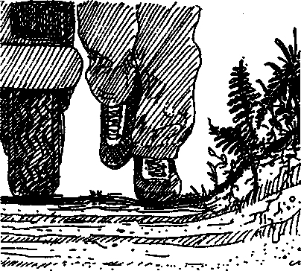
Key Concepts
- Soil is a complex substance which influences the health of ecosystems.
- Soil compaction influences water infiltration.
- Human activities can cause soil compaction

Background
Plants derive the nutrients they need to grow and prosper from the soil. Soil is a complex substance comprised of a mixture of inorganic minerals (mostly clay, silt, and sand), including decaying organic matter, air, water, and microscopic and macroscopic organisms.
The organisms that live in the soil depend not only on the inorganic minerals and decaying organic matter but also on the ability of water and air to penetrate the soil. The ease of passage of water, called percolation, and air into and out of the soil is a function of the spaces between the mineral particles and other soil components. The relative proportion of different types and sizes of soil particles is called soil texture.
Soils with an almost equal mixture of sand and silt are called loam soils. Loamy soils allow water and air to easily enter, and they hold water that plants can then utilize. Soils with a high proportion of sand have a high permeability to water and air because of the relatively large spaces between particles. As a result, sandy soils do not hold water well. Clay particles do not easily separate from each other. Because of this, soils with a high clay concentration tend to have small spaces which hamper the easy passage of air and water.
Human activities can cause soil compaction which affects a soil's productivity. Foot or vehicle traffic compact soil. The degree of compaction is determined by the kind of activity and by the soil type. Unfortunately, once compacted, the soil particles do not easily separate from one another. This means that the activities can reduce air and water passage for an extended period.
Soil compaction has a number of harmful effects. Penetration by plant seeds and roots is hindered, soil organisms may not have enough air and water to survive hereby reducing fertility, and erosion increases.
Soil compaction in places such as Seal Rock Campground is a complex issue. When a lot of people walk or drive repeatedly in the same place compaction generally occurs. How do campground managers cope with the problem of compaction? One approach is to limit the area affected by the compaction by encouraging or requiring people to use specific well- defined trails. Another approach is just the opposite, the impact is spread out by not
Seal Rock Marine Trail Curriculum - Olympic National Forest, Quilcene, Washington 98376
Developed by the Institute of Marine Science www.forsea.org
building trails so that no area is compacted as much as it would be if it were a trail. Still another approach is to not allow people into sensitive areas at all because of this and other impacts. The approach chosen depends upon the particular site.

Materials
For each team:
- percolation cylinder
- board
- measuring container
- milk carton or other container
- water
- watch with second hand or stopwatch
For each student:
"Don't Tread on Me" activity pages
- notebook with a firm back
- pencil

Teaching Hints
In "Don't Tread on Me", students compare the speed with which water can enter the soil in areas of low human activity to the speed with which water can enter the soil in areas of higher human activity.
You may choose to have your students complete "Don’t Tread on Me" near the end of their day at Seal Rock Campground as a way of including a look at human impact on the campground.
Avoid compounding the soil compaction problem at the campground by helping students select low impact areas that will not suffer from the activity. Their choice of areas that show evidence of foot or car traffic should be monitored for safety. Caution students to be aware of people or vehicles using the area and to be careful and courteous.
For each percolation cylinder you will need a tin can (4" diameter x 7" tall fruit juice cans work well, but other sizes will do). Remove both ends from each tin can. For most sites at Seal Rock Campground this is all the preparation you'll need. However if you want students to sample roadways that have been highly traveled, you may elect to make a few cylinders with sharper cutting edges by cutting the rolled edge or lip off one end of the can. If you choose to do so, dull the sharp edge somewhat with a fine file, emery cloth, or sandpaper.
To assure that all samples are taken in a uniform fashion, mark the outside of each can about 1 inch from one end (the sharp end, if you've cut off a rolled edge) with masking tape or with a permanent marking pen. This mark denotes the depth that the can is pushed into the soil. Prepare a couple of extra cans and boards in the event that some become damaged.
Provide a measuring container to each group (an 8 ounce yogurt cup provides an easy 1 cup measure) and a larger container, such as a milk cartoon, which serves as a reservoir. You may elect to have a single reservoir container in a centred location. Although the directions in the student activity pages are relatively self-explanatory, you may wish to demonstrate the use of the percolation cylinder.
Seal Rock Marine Trail Curriculum - Olympic National Forest, Quilcene, Washington 98376
Developed by the Institute of Marine Science www.forsea.org

Essential Academic Learning Requirements in Science
- The student understands and uses scientific concepts and principles. (1.2, 1.3)
- The student knows and applies the skills and processes of science and technology (2.1,
2.2)
- The student understands the nature and contexts of science and technology. (3.1)

Answer Key
Thinking about the data:
1. - 3. Answers depend upon the experimental results.
- While answers may vary depending upon the site, soil may be compacted by people (and animals) walking on it and by vehicle travel.
- Soil compaction increases soil erosion by decreasing plant growth. Plants help hold soil in place with their roots and decrease the impact of rain falling on the soil. Because the rain does not sink in, run-off is more rapid, carrying away more soil.
Seal Rock Marine Trail Curriculum - Olympic National Forest, Quilcene, Washington 98376
Developed by the Institute of Marine Science www.forsea.org

Don't Tread on Me
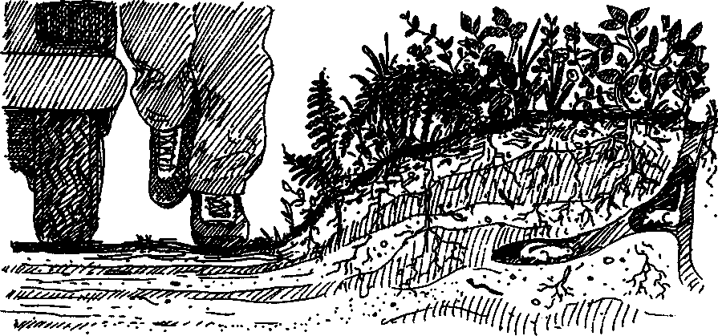
Soil, it’s what's behind (or under) it all. Healthy soil means a healthy forest. Soil is a complex mixture of living, formerly living, and non-living components. The non-living clay, silt, sand, water and air are enriched by decaying organic matter and a host of microscopic and macroscopic organisms. The particular mixture of these items determines whether water and air, both necessary for plant growth, move easily through the soil.
Some human activities change the ability of air and water passage in the soil by pressing the soil particles together more closely. We call this pressing compaction. For example, when a lot of people walk on the same place, the soil can become compacted. Compaction can change soil for a long time, the Oregon Trail created by early pioneers over 100 years ago is still visible in many areas.
Soil compaction is a concern wherever a path is found. In this activity you will compare the speed with which water can enter the soil in areas of low human activity to the speed in areas of higher human activity.

Here's what you'll need:
- percolation cylinder
- board
- measuring container
- milk carton or other container
- water
- watch with second hand or stopwatch
- notebook with a firm back
- pencil
Seal Rock Marine Trail Curriculum - Olympic National Forest, Quilcene, Washington 98376
Developed by the Institute of Marine Science www.forsea.org

Here's what to do:
- Find a patch of soil away from foot or car traffic.
- Notice that your percolation cylinder has a mark on the outside 1 inch from the bottom end. Push the can into the soil to this mark. Do this by placing the board on top of the cylinder and pressing the can into the soil with your hands. (The board distributes the pressure evenly.) If the soil is too hard for you to push the cylinder in with your hands, carefully apply foot pressure.
- Fill your measuring container with water from the source provided by your teacher.
- Get ready to record the time. When you are ready, have a team member pour the measuring container full of water into the top of the percolation cylinder. Begin recording the time now on a data sheet that looks something like the following:
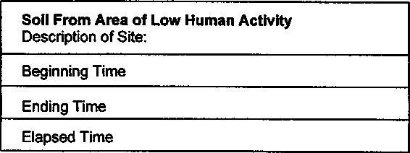
- When the water has completely soaked into the ground so that there are no puddles of water at the surface, record the ending time on your data sheet.
- Calculate the "Elapsed Time" which is the time it took for the water to soak into the ground. (This is easy if you used a stopwatch, otherwise subtract the "Beginning Time" from the "Ending Time".) Record the "Elapsed Time" on your data sheet.
- Now, find a patch of soil that shows evidence of foot or car traffic (trails, paths, roadways are good places to look). Be aware of people or vehicles using the area. Be careful and courteous.
- Determine the percolation rate for this new site using the same technique you used for the soil from the area of low human activity.
- Use the board to push the can into the soil to the mark. If the soil is too hard for you to push the cylinder in with your hands, carefully apply foot pressure.
- Fill your measuring container with water from the source.
Seal Rock Marine Trail Curriculum - Olympic National Forest. Quilcene, Washington 98376
Developed by the Institute of Marine Science www.forsea.org
c. Get ready to record the time. When you are ready, have a team member pour the measuring container full of water into the top of the percolation cylinder. Begin recording the time now on a data sheet that looks something like the following:
Soil From Area of Higher Human Activity
Description of Site:
Beginning Time
Ending Time
Elapsed Time
d. When the water has completely soaked into the ground so that there are no puddles of water at the surface, record the ending time on your data sheet.
Calculate the "Elapsed Time" which is the time it took for the water to soak into the
ground. (This is easy if you used a stopwatch, otherwise subtract the "Beginning Time" from the "Ending Time".) Record the "Elapsed Time" on your data sheet.

Thinking about the data:
- Which site had the most rapid percolation?
- Which site seemed to have the most healthy plant growth?
- Which site seems to have the most compacted soil?
- What activities might have caused the soil to become compacted?
- Soil washing into Hood Canal can harm oysters and other animals living on the intertidal beach. In what ways might soil compaction increase soil erosion?
Seal Rock Marine Trail Curriculum - Olympic National Forest, Quilcene, Washington 98376
Developed by the Institute of Marine Science www.forsea.org

