Fake 'em Out


Key Concepts
- Intertidal animals are particularly well adapted to endure the stresses of long exposure at low tide.
- Simulating tidal changes can cause animals to alter their behavior.
Animals that live in the upper intertidal zones, submerged only for a short time during each tidal cycle, display remarkable endurance. Barnacles are one of the most common rocky shore intertidal marine animals. In fact, they live in many marine intertidal habitats. As the tide goes out, they can hold a small amount of water in their shells, close their shell plates, and rest through severe environmental stresses until cool salt water returns. They can endure salinity changes, wide ranges in temperature, and long periods of exposure at low tide.
Background
Barnacles also are fascinating to watch. When underwater, they repetitively extend their cirri, modified appendages, and sweep them through the water to trap plankton and to absorb oxygen. As students watch barnacles, they will find that barnacles can vary the way they move their cirri. Small barnacles often beat at different rates than large barnacles.
Other intertidal animals such as chitons and limpets display other adaptations for survival. They fasten themselves firmly to their substrate, avoiding drying. Chitons, limpets and snails must be sure the tide has returned to cover them before they release their holds.

Materials

For each team:
- large, open container (milk cartons work fine)
- waterproof, plasticene clay (a baseball-sized lump)
- magnifier, if available

For each student:
- notebook with a firm back
- pencil

Teaching Hints
In "Fake 'em Out", students create an artificial tide and observe how it affects intertidal animals. First, they simulate wave action by splashing a cluster of barnacles and other animals. A little bit of splashing will often cause barnacles to resume moving their cirri, or
Seal Rock Marine Trail Curriculum - Olympic National Forest, Quilcene, Washington 98376
Developed by the Institute of Marine Science www.forsea.org
185
feathered feet. Next, they create a clay dam which allows them to submerge their cluster of animals. Water trapped in the dam encourages movement in reluctant barnacles as well as in snails, limpets, and chitons.
If possible, circulate between groups, helping teams locate animals that have withdrawn to avoid the effects of exposure during low tide.
Note that some clays are not waterproof. Be sure to try your clay prior to heading to Seal Rock beach.

Essential Academic Learning Requirements in Science
- The student understands and uses scientific concepts and principles. (1.3)
- The student knows and applies the skills and processes of science and technology (2.1,
2.2)

Answer Key
1. - 2. Answers will depend upon experimental observations.
- The artificial high tides differ from real high tides in terms of duration (the artificial tides are much shorter), warming (the small volume of water can heat more rapidly), and pressure (since the depth of water covering the animal is less, the pressure on the animal is also less).
- Intertidal animals retreat into their shells or fasten themselves to the rock during low tide to avoid desiccation (diying out) and warming. Their behavior also helps reduce their becoming prey.
Seal Rock Marine Trail Curriculum - Olympic National Forest, Quilcene, Washington 98376
Developed by the Institute of Marine Science www.forsea.org

Fake 'em Out
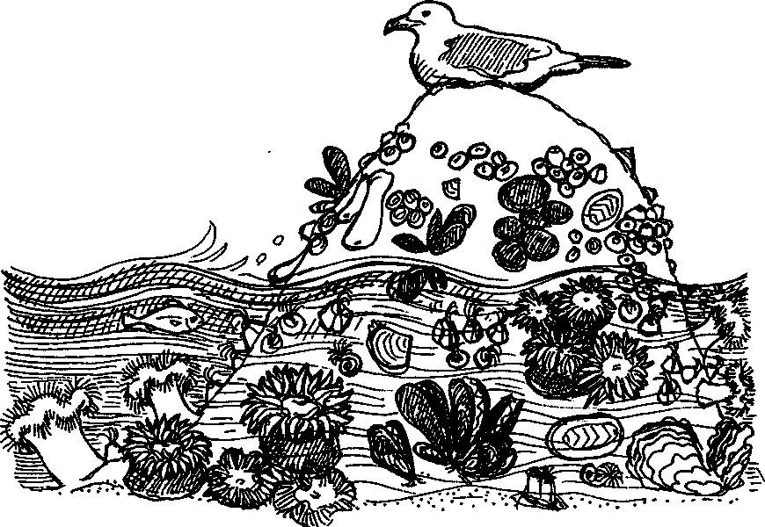
Many animals deal with low tide by closing up shop. Limpets and chitons stop moving and hold on firmly to their rocky perch. Oysters and mussels close their shells tightly, keeping a pool of water inside to avoid drying out. Barnacles dose their shell plates, too. This means that these animals are hard to see at low tide. What can be done about this situation?
In this activity, you'll create an artificial high tide and see if it changes the way these animals appear. Making intertidal animals think the tide is high takes one or two steps. Some animals need to feel the wave action, others also need to be submerged.

Here's what you'll need:
- large, open container (milk cartons work fine)
- waterproof, plasticene clay (a baseball-sized lump)
- notebook with a firm back
- pencil
- magnifier, if available

Here's what to do:
1. Find a cluster of barnacles (if the cluster contains other types of intertidal animals, so much the better!)
2. Fill a large, open container with water from Hood Canal.‭
‬
Seal Rock Marine Trail Curriculum - Olympic National Forest, Quilcene, Washington 98376
Developed by the Institute of Marine Science www.forsea.org
187
- Splash the barnacles with water from the container to simulate wave action. Continue splashing until your container is empty to be sure your animals feel the "wave action". As you splash, watch your animals for any changes. In your notebook, record all the changes you see. Be sure and include a sketch.
- Some animals need to be submerged. Since it will take a lot of containers of water to submerge these animals, let's try another approach. Get a lump of plasticene clay about the size of a baseball or tennis ball. Use the clay to build a clay dam to hold water around your animals. Don't press clay against any animal since the clay may harm the animal. Your dam might look something like this:
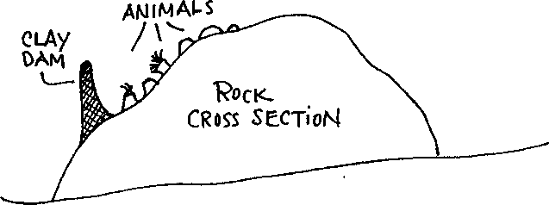
- Fill your dam with water from Hood Canal and observe the submerged animals. Watch your animals for any changes. In your notebook, record all the changes you see.
- As they move, the animals use the oxygen dissolved in the water behind your dam. To keep your animals from suffering a lack of oxygen or from overheating, replace all of the water in your dam every 10 minutes, more frequently if it's very warm.
- If you have time, repeat your splashing and dam making at another site. Be sure and record what you see.
- When you have finished making your observations, carefully remove the dam while you watch your animals for any changes. In your notebook, record all the changes you see.
- Collect all of your clay dams.
Thinking about artificial tides...
1. How long did it take for your animals to respond when you splashed or covered them with water?
b. Did they all take the same amount of time?
Seal Rock Marine Trail Curriculum - Olympic National Forest, Quilcene, Washington 98376 Developed by the Institute of Marine Science www.forsea.org
- a. What did the animals do when you removed the dam?
b. How long did it take for them to respond?
- How do your artificial high tides differ from real high tides?
- Why do these animals retreat into their shells or fasten themselves to the rock during low tide?
Seal Rock Marine Trail Curriculum - Olympic National Forest, Quilcene, Washington 98376
Developed by the Institute of Marine Science www.forsea.org

