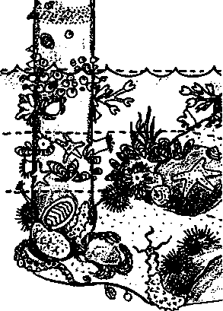
Key Concepts
1. Intertidal animals live in preferred zones determined largely by their tolerance of exposure to air at low tide.
2. Animals who live in upper tidal zones endure the hazards of exposure at low tide, but also avoid predators who cannot stay in the upper tidal zones.

Background
For hundreds of years, people observed that plants and animals of the intertidal zone tend to occur in relatively distinct bands related to the amount of time that an area is exposed to air. Large, vertical rock surfaces such as those found on the west side of the Olympic Peninsula show these zones clearly. Although the zones are less distinct, they may also be observed on the gentler slopes of Seal Rock beach.
As the tides rise and fall, organisms living on rocky beaches or on pilings are subjected to various environmental hardships. Because the hardships differ from one spot to another, we find that the animals and plants found in those spots differ. Some are better adapted to live high on the beach while others do better low on the beach where they are underwater more of the time.
Habitats high on the beach are exposed to the air for several hours each day. Organisms living there must cope with overheating in the summer, freezing temperatures in the winter, the constant threat of desiccation, and the lack of food and oxygen during the long exposure periods. Animals resting in tidepools may find the salty water in their tidepool quickly diluted by a rainstorm. Conversely, a hot summer day may lead to evaporation which dramatically increases the salinity in the tidepool. Organisms exposed at low tide also are easy targets for land predators such as raccoons and birds.
Barnacles, limpets and mussels are examples of animals well-adapted to this stressful habitat. They are protected from predators by hard shells and can hold small amounts of water inside their shells to avoid desiccation as they wait until the tide returns. These animals tend to be small; the tiniest barnacles, for example, live near the splash zone where they may be uncovered most of the time.
Unlike the upper beach areas, habitats in the low tide zone are not exposed to the air for very long each day. Animals living in this zone, such as sea anemones and sea urchins, ran endure a short amount of time out of the water, often hunkering down in a crevice and covering themselves with pebbles and seaweed. Organisms that would dry out at the higher levels do well here. The animals in these habitats do not necessarily need hard armor and are often softer than those in the upper beach and oxygen, With the greater availability of food and oxygen, they also often grow to be larger.

Seal Rock Marine Trail Curriculum - Olympic National Forest, Quilcene, Washington 98376
Developed by the Institute of Marine Science www.forsea.org
163

The low tide zone does pose two problems which the tiny barnacle escapes living higher up the beach. Unlike in the sparsely populated splash zone, living space is at a premium in ttie low tidal areas. Species must vie with one another for living space. When two clones of sea anemones meet, for example, they sting each other, creating a neutral zone between the two colonies. When the battering action of the winter storms breaks away clumps of seaweed or animals, other organisms quickly colonize the newly vacated rock. If larvae do not find a space to live on the crowded rocks or pilings, they will perish.
The second hazard unique to the low tide zone, is the presence of marine predators. Sea stars, for example, crawl up the beach with the tide, stopping to feed in areas under water long enough for them to complete a meal. Only a few of the barnacles which settle in these low tide areas avoid predation long enough to eat their fill of plankton and grow large enough to foil the hungry predators. While the small barnacles high on the beach may have to wait a long time between tides, they escape the threat of the sea stars.

Materials
For each student team:
- tide chart from "Time and Tides", Part III, Seal Rock Tides
- watch or timepiece
- stake or relatively straight piece of driftwood
- campsite map
- notebook with a firm back
- pencil
- 10 meter long cord (marked in 1 meter intervals with the first meter also marked in decimeter intervals)
- intertidal field guides for plant/animal identification
- 50 square centimeter measure

Teaching Hints
In "Living in the Tidal Zone", students study the intertidal zonation of Seal Rock beach. In Part I, students use the tide table for Seal Rock beach from "Time and Tides", Part III, Seal Rock Tides to determine whether the tide is ebbing or flooding. In Part IIA, they search for signs indicating the breaks between the tidal zones, measure the width of the beach, and record the positions of the breaks between the zones. In Part IIB, students use a 50 square centimeter sampler to compare the relative numbers of organisms in each tide zone.
"Part I - Tide's Out" question 2. b. asks student to use a stake or straight piece of driftwood to experimentally determine the status of the tide. The easiest way for students to accomplish this task is for them to "plant" the stake or driftwood at the water's edge and wait to see if the water recedes from the stick or advances up the stick. If your students are having trouble devising a technique, coax them to the above.
Part IIA requires students to record data on the campground map they used in "Upon Arrival...getting familiar with Seal Beach Campground".
For Part IIB, students use a 50 square centimeter sampler. A clear lid from an 8 oz yogurt container suffices for a simple, but suitable, 50 square centimeter sampler. You can also make mini-loop samplers by forming a circle from a 25 cm long piece of tubing or rectangular 50 square centimeter samplers by forming a square with 7.1 cm sides from a piece of stiff wire 28.4 cm long.
Part IIB also calls for student teams to make three samplings at each tide level If time is an issue, you may elect to have students make a single sample. If you elect to complete the follow-up activity for this lesson, individual data is pooled which reduces the need for each team to collect multiple samples.

Seal Rock Marine Trail Curriculum - Olympic National Forest, Quilcene, Washington 98376
Developed by the Institute of Marine Science www.forsea.org
165

Essential Academic Learning Requirements In Science
- The student understands and uses scientific concepts and principles. (1.1, 1.2, 1.3)
- The student knows and applies the skills and processes of science and technology. (2.1)
- 3. The student understands the nature and contexts of science and technology. (3.1,

Answer Key
5. a. Typically, low or mid tide zones have the most organisms.
b. Low and mid tide zones are exposed to air for shorter lengths of time so more animals can tolerate life in these areas. Mid tide zones sometimes are more heavily populated because subtidal predators do not venture that high up on the beach or piling.
Seal Rock Marine Trail Curriculum - Olympic National Forest, Quilcene, Washington 98376
Developed by the Institute of Marine Science www.forsea.org
165

Living in the Tidal Zone
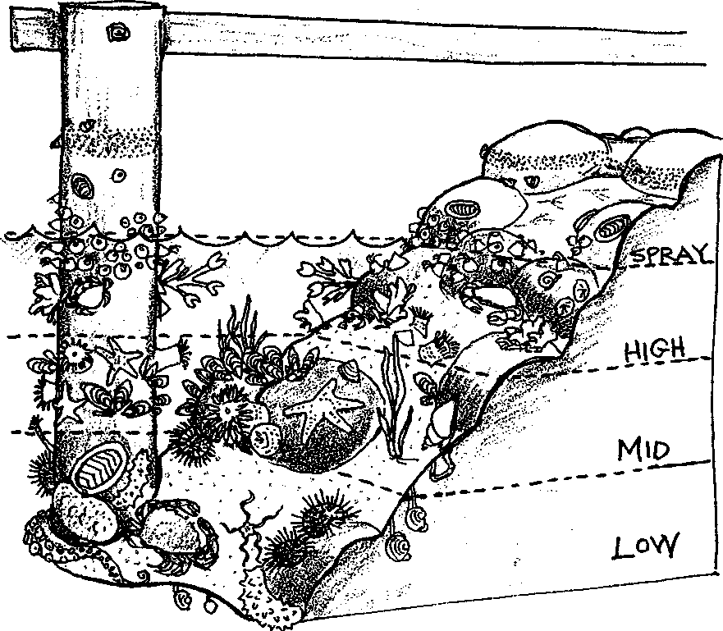
On rocky shores, the changing water level caused by the tides produces horizontal bands, or "zones", featuring distinct plant and animal communities. Zones on a beach are determined by the amount of exposure to air relative to its cover by the tidal waters. The west side of the Olympic Peninsula with its large, vertical rock surfaces shows these zones clearly. You can also observe zonation on the gentler slopes of Seal Rock beach.
As you walk down the beach, look for the area affected by splashed or wind-carried saltwater. This area is called the spray zone and is beyond the upper limit of the tidal wave wash.
The next section is the high tide zone. This area is found at the extreme upper limit of the tidal wave wash. It is exposed to air most of the time. At Seal Rock, bright green algae (Enteromorpha sns.) near the southern staircase are characteristic species of this zone.
The second section from the top is the mid tide zone. This zone is found at the level of the higher low tides. This area is not exposed to air by all tides. At Seal Rock beach, this zone is characterized by barnacles, brown algae (Fucus sps.), mussels, crabs, oysters, anemones, a variety of snails and the common ochre seastar. The mid tide area contains the largest number of species on the shore.

Seal Rock Marine Trail Curriculum - Olympic National Forest, Quilcene, Washington 98376
Developed by the Institute of Marine Science www.forsea.org

The lowest section is the low tide zone. This zone is underwater more than it is exposed to air. In fact, it is only exposed to the air during the very lowest tides of the year. A variety of sea stars, sea anemones, sea urchins, sponges and tunicates are found in the low tide zone.
Animals and plants live where their environmental requirements are fulfilled Within a zone, the community of organisms finds its needs fulfilled. Zonation helps us understand the communities of organisms found on any beach. It also enables us to predict where we will find certain creatures. Barnacles, for example, do well at the high tide zone. They can survive the long periods of time out of water and they are beyond the reach of most sea stars and other predators. Sponges, however, will survive only in the low tide zone. They cannot tolerate much exposure to air.
In this activity you will have a chance to sample, identify, count and analyze some of the species located in the tidal zones on Seal Rock beach.

Materials:
- tide chart from "Time and Tides", Part III, Seal Rock Tides
- watch or timepiece
- stake or relatively straight piece of driftwood
- campsite map
- notebook with a firm back
- pencil
- 10 meter long cord (marked in 1 meter intervals with the first meter also marked in decimeter intervals)
- intertidal field guides for plant/animal identification
- 50 square centimeter measure

Part I - Tide's Out?
- Gather as a team around the top of the steps, next to the Trailhead sign, at the southern end of the campground. Arrange yourselves so that you so have a clear view down to the beach.
- a. Look at your tide chart or graph for Seal Rock Beach. Check the time.
According to the chart, what do you think the tides are doing now? Rising?
Falling? Slack (between the two)?
b. Use a stake or relatively straight piece of driftwood to determine experimentally what the tide is doing. (How can a stake or relatively straight piece of driftwood tell you what the tide is doing? Not by floating or resting horizontally on the beach...how then?) In your notebook, describe your technique for telling what the tide is doing.
c. When does the lowest tide occur today?

Seal Rock Marine Trail Curriculum - Olympic National Forest, Quilcene, Washington 98376
Developed by the Institute of Marine Science www.forsea.org

Part II - Determining Zones
Part A - Where's that line?
Investigate the high, middle and low tide areas to find as many living plants and animals as possible. Use your prior knowledge and available field guides to identify the organisms found m each tidal zone. If the tide is rising, start at the low tide area. If the tide is falling, start at the high tide area. Look closely at the animals and plants you've found and identify the high tide and mid tide zones. If the tide is very low, identify the low tide zone, too.

- Look for signs that indicate where one zone ends and another begins. The margins are easiest to see on the taller rocks or on fallen trees which extend into the water. (Even so the edges are often a little fuzzy.)
- Use your 10 m string to measure the width of the beach exposed by today’s low tide. Measure also the width of each of the tide zones you have identified. Record these widths on your map of Seal Rock Campground.
Part B - Who lives here?
- Obtain a 50 square centimeter sampling tool. Look at its size.
- Estimate the number of organisms within each zone that you would find in 50 square centimeters. Record your estimates in your notebook as follows:

Zone | Estimated number / 50cm²
High tide
Mid tide
Low tide

3. Now, determine the actual number of organisms. Here’s how. Stand on the border
between two tide zones. Take three steps into the zone you wish to sample. Stand facing the water. Use your right hand to gently toss the 50 square centimeter sampler over your left shoulder. Count the number of organisms that fall within the area covered by your sampler. Record the number of organisms as Sample 1 in your notebook as follows:
Sample | Zone | Actual number / 50cm²
1
2
3

Seal Rock Marine Trail Curriculum - Olympic National Forest, Quilcene, Washington 98376
Developed by the Institute of Marine Science www.forsea.org

Take one more step into the zone and repeat your sampling procedure to take Sample 2. Again, stand facing the water and use your right hand to gently toss the 50 square centimeter sampler over your left shoulder. Count the number of organisms that fall within the area covered by your sampler. Record the number of organisms as Sample 2 in your notebook.

Take one more step into the zone and repeat your sampling procedure to take Sample 3. Count the number of organisms that fall within the area covered by your sampler Record the number of organisms as Sample 3 in your notebook.
4. Look back at the prediction you made regarding the number of organisms you would find in this zone. How did this result compare with your prediction?
5. Take three samples in each of the other tide zones you were able to identify. Use the same procedure you used in step 3. Be sure to record your findings in tables like these:
Sample | Zone | Actual number / 50cm²
1
2
3

Sample | Zone | Actual number / 50cm²
1
2
3

Seal Rock Marine Trail Curriculum - Olympic National Forest, Quilcene, Washington 98376
Developed by the Institute of Marine Science www.forsea.org

6. Look back at the prediction you made regarding the number of organisms you would find in these two zones. How did the results compare with your predictions?
7. a. Which zone had the most organisms?
b. What are two possible reasons that might explain why this zone had more organisms than the others?
Seal Rock Marine Trail Curriculum - Olympic National Forest, Quilcene, Washington 98376
Developed by the Institute of Marine Science www.forsea.org

