Moving That Water Around

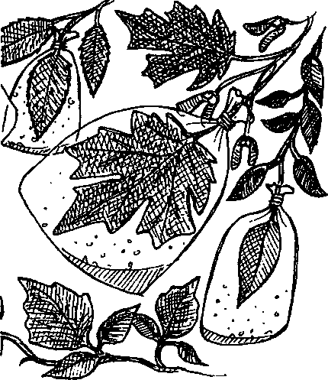
Key Concepts
- Transpiration is an important process which significantly affects the flow of water in forest ecosystems.
- The amount of water transpired differs between plant species, within a species, with the seasons, and with amount of sunshine.
- The forest at Seal Rock Campground is stratified, with different plants found in the overstory than in the understory.
- Careful observation provides information useful in determining the flow of matter within an ecosystem and between ecosystems.
Transpiration, the evaporation of water from plant surfaces into the air, is one of the primary drivers of the water cycle, moving water from the ground into the atmosphere. Via transpiration, individual plants can move thousands of gallons of water each year. Multiply that number of gallons by the number of plants in a forest ecosystem and one begins to grasp the significance of this water movement to climate and rainfall patterns.
Most transpiration occurs through the leaves or needles. Water absorbed by the roots moves upward through the plant with about 75% of the water eventually leaving through stomates, or stomata, which are small openings on the leaf and stem surfaces. Stomata regulate the amount of water transpired by changing the opening size.
An average rainfall at Seal Rock Campground is 50 inches per year. Transpiration plays an important role in water movement, partly by changing the rate of runoff.
The amount of water transpired differs between plant species, within a species, with the seasons, and with amount of sunshine.
In "Moving That Water Around", students experimentally compare rates of transpiration to help them gain an understanding of the role of transpiration in forest ecosystems and in the larger water cycle.
Seal Rock Marine Trail Curriculum - Olympic National Forest, Quilcene, Washington 98376
Developed by the Institute of Marine Science www.forsea.org
155

Materials
For each student team:
- 8 clear, plastic bags
- 8 twist ties or short pieces of string
- permanent marker
- watch or other timepiece
- Plant ID cards
- cloudy day supplies:
- cobalt chloride paper
- tape
- 8 paper clips For each student:
- campsite map
- notebook with a firm back
- paper for rubbings
- pencil, crayon or oil pastel for rubbing
- optional: magnifier

Teaching Hints
Two techniques are presented for determining rates of transpiration. The first involves simply capturing transpired water in a plastic bag. The second involves the use of cobalt chloride paper as an indicator of moisture from transpired water. The latter method provides results more quickly. Since the rate of transpiration is affected by sunlight and temperature, the cobalt chloride technique is preferred on cloudy or cool days or where time is an issue.
For this activity, student teams may work on the same plot they examined in "Can't See the Forest for the Trees" or you may choose new areas for the teams. To obtain comparison data for later class discussion, consider having several student teams make the same comparisons. If you are using the second method, you may wish to demonstrate the color change in cobalt chloride paper beforehand.
Flan to devote some time to a discussion of the experimental results, either on-site or back in the classroom.

Essential Academic Learning Requirements in Science
- The student understands and uses scientific concepts and principles. (1.1, 1.3)
- The student knows and applies the skills and processes of science and technology (2.1,
2.2)
- The student understands the nature and contexts of science and technology. (3.1)
Seal Rock Marine Trail Curriculum - Olympic National Forest, Quilcene, Washington 98376
Developed by the Institute of Marine Science www.forsea.org
156

Answer Key
1.-6. Answers depend upon the comparisons made and the experimental results.
7. Transpiration is important to the entire ecosystem because it moves water from the soil into the atmosphere where it can moderate temperature and be available for precipitation in the short run and moderate weather and climate in the long run.
Seal Rock Marine Trail Curriculum - Olympic National Forest, Quilcene, Washington 98376
Developed by the Institute of Marine Science www.forsea.org
157

Moving That Water Around
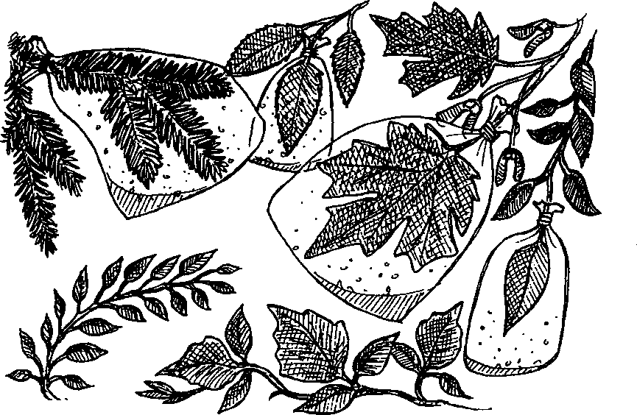
Each year over four feet of rain falls at Seal Rock Campground. That's a lot of water. Some of it runs off the land and into Hood Canal. Some is absorbed by the land. Forest trees and other forest plants need this water to stay alive. While they absorb some water from the rain that falls on them, plants get most of the water they need from the rain that has soaked into the soil. Absorbed by the roots, the water moves upwards throughout the plant.
A medium sized red alder tree may absorb 250 liters (about 60 gallons) of water each day in the summer. That's about two garbage cans of water a day. Clearly, red alder trees don’t add two garbage cans worth of plant material to themselves each day. What happens to all of this water? As it turns out, most of the water absorbed moves up the plant to the leaves and stems where it exits the plant through small openings called stomates (or stomata). This evaporation of water from the leaves and stems is called transpiration. Transpiration plays a very important role in the movement of water between ecosystems in the water cycle.
Does the amount of water transpired differ from plant to plant? How about from leaf to leaf on the same plant? Between stems and leaves? The technique described below helps you answer these and other questions.

Here's what you'll need:
- 8 clear, plastic bags
- 8 twist ties or short pieces of string
- permanent marker
- watch or other timepiece
- Plant ID cards
- campsite map
- notebook with a firm back
- paper for rubbings
Seal Rock Marine Trail Curriculum - Olympic National Forest, Quilcene, Washington 98376
Developed by the Institute of Marine Science www.forsea.org
158

- pencil, crayon or oil pastel for rubbing
- optional: magnifier
- cloudy day supplies:
- cobalt chloride paper
- tape
- 8 paper clips

Here's what to do:
Sunnv davs:
Since a plastic bag holds water, it can be used to capture the water transpired through leaves. Simply slip the bag over the leaves, tie the open end closed around the stem, and wait. The amount of water transpired can be compared if the bag is left on each plant the same amount of time.
- Decide upon the comparison you wish to make from the list below. (Do any two of the first four comparisons and comparison 5.)
- Choose the plant (or plants) you wish to test. If necessary, use the Plant ID cards to identify the species. (Still can't figure out what kind of a plant you have? Make a rubbing of a leaf and give the plant a number instead of a name.)
- Write the name of the plant and the time of day on the outside of a plastic bag.
- Slip the bag over the end of the stem which holds the leaves you wish to study. For comparisons, do your best to include the same amount of foliage in each bag.
- Let the bag remain on the plant for at least 60 minutes. While you're waiting, you’ll have time to do one of the other activities assigned by your teacher.
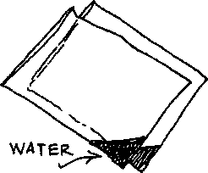
- After the time has passed, carefully remove the bag. You can compare the amount of water in two bags by allowing the water to run into the same comer of each bag.
- Record the results. Be sure you include the comparison you're making, the plant species, and the time elapsed.
Seal Rock Marine Trail Curriculum - Olympic National Forest, Quilcene, Washington 98376
Developed by the Institute of Marine Science www.forsea.org
159

Comparisons...
- Compare transpiration between a small leaf and a large leaf on the same plant.
- Compare transpiration between conifer needles and broad leaves.
- Compare transpiration between a leaf in the shade and a leaf of the same size and shape in the sun.
- Compare transpiration between a live leaf and a dead leaf attached to the same tree.
- Make up your own comparison and do it!
Cloudy days:
Clouds slow the rate of transpiration. Because the amount of water transpired is less, we need to use a slightly different method. Cobalt chloride paper can be used to check for water vapor. The paper is blue when it's dry, pink when it's wet. The amount of water transpired can be compared by measuring the time for the color change from blue to pink.
- Decide upon the comparison you wish to make from the list below. (Do any two of the first four comparisons and comparison 5.)
- Choose the plant (or plants) you wish to test. If necessary, use the Plant ID cards to identify the species. (Still can't figure out what kind of a plant you have? Make a rubbing of a leaf and give the plant a number instead of a name.)
- Write the name of the plant and the time of day on the outside of a plastic bag.
- Place a piece of clear tape on both sides of one section of a piece of cobalt chloride paper. The taped area will remain dry (blue) and the uncovered area will be exposed to detect any moisture:
tape-

cobalt
chloride, paper-
- Use a paper clip to place the dry, taped cobalt chloride paper on the leaf you wish to test.
- Slip the bag over the end of stem which holds the leaf and cobalt chloride paper you wish to study.
Seal Rock Marine Trail Curriculum - Olympic National Forest, Quilcene, Washington 98376
Developed by the Institute of Marine Science www.forsea.org
160

7. Use your watch to compare the time it takes for the leaf to change the color of the cobalt chloride paper from blue to pink. (Allow 5-15 minutes for the change to take place.) Record the time.
8. Record the results. Be sure you include the comparison you're making, the plant species, and the time elapsed.
Comparisons...
- Compare transpiration between a small leaf and a large leaf on the same plant.
- Compare transpiration between conifer needles and broad leaves.
- Compare transpiration between a leaf in the shade and a leaf of the same size and shape in the sun.
- Compare transpiration between a live leaf and a dead leaf attached to the same tree.
- Make up your own comparison and do it!

What did you find?
- Which leaf transpired the most?
- If you made this comparison, which leaf transpired most, a small leaf or a large leaf on the same plant?
- If you made this comparison, which leaf transpired most, conifer needles or broad leaves.
Seal Rock Marine Trail Curriculum - Olympic National Forest, Quilcene, Washington 98376
Developed by the Institute of Marine Science www.forsea.org
161
- If you made this comparison, which leaf transpired most, a leaf in the shade or a leaf of the same size and shape in the sun.
- If you made this comparison, which leaf transpired most, a live leaf or a dead leaf attached to the same tree.
- Describe the comparison you made and your results.
- Transpiration is important to the individual plant because it moves water and nutrients from the soil up into the plant. How is transpiration important to the entire ecosystem?
Seal Rock Marine Trail Curriculum - Olympic National Forest, Quilcene, Washington 98376
Developed by the Institute of Marine Science www.forsea.org
162

