Looking More Closely

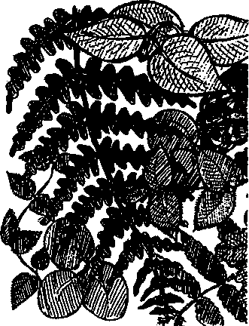
Key Concepts
- Species diversity is a measure of the complexity and health of an ecosystem.
- The forest at Seal Rock Campground is stratified, with different plants found in the overstoiy than in the understories.
- Careful observation provides information useful in establishing food web relationships.
- Sampling techniques are useful tools for studying the forest ecosystem.
The forest ecosystem at Seal Rock Campground is home to an amazing diversity of plant species. In turn, this assemblage of plants provides a diversity of habitats for animals, those places where animals find the food, shelter, water, and space needed to survive. In the Seal Rock Campground area, forests provide habitat for the greatest diversity of animal species - hundreds of mammals, birds, fish, amphibians, and invertebrates.
While trees are the most obvious plants in a forest, they're not the only ones. In "Looking More Closely..." students observe the variety of forest species by collecting data to construct a diversity index. Diversity in this case means the variety of species of plants present in the study area. This type of diversity is called "species diversity" as opposed to ecological diversity or genetic diversity. Ecological diversity is defined as the variety of ecosystems and plant and animal communities that interact with each other while genetic diversity is the variability in genetic make-up among individuals of the same species. Each of these types of diversity is critical to life as we see it at Seal Rock Campground.
In discussing diversity and these Seal Rock Campground activities, it is helpful to spend some time with the concept of "microhabitat", the specific part of a place where an organism lives. Deer and pileated woodpeckers may both live in the forest ecosystem but in veiy different parts. Since microhabitats are where organisms live, changes which may seem small when one looks at the whole forest can have profound effects on individual organisms. While the destruction of an ecosystem affects all of the microhabitats within it, it is also true, although often less obvious, that the destruction of microhabitats can eventually lead to the destruction of an entire ecosystem.
Seal Rock Marine Trail Curriculum - Olympic National Forest, Quilcene, Washington 98376
Developed by the Institute of Marine Science www.forsea.org
140

Materials:

For each student:
- campsite map
- "Looking More Closely..." activity pages
- notebook with a firm back
- paper for rubbings
- pencil, crayon or oil pastel for rubbing
- 10 meter long cord (marked in 1 meter intervals with the first meter also marked in decimeter intervals)

For each team:
- Oopa-Hoopa (see construction diagram below)
- Plant ID cards

Teaching Hints
Three activities focus on the diversity within the forest ecosystem of Seal Rock Campground. In the first, students examine diversity of small understory plants in a one square meter plot to obtain data to calculate a diversity index for their study area. In the second, students conduct a hunt for animal signs, shake the brush to find the insects responsible for leaf damage they've located, and search the soil and leaf litter for additional animals and signs. Finally, students examine stratification in their study plot, make a drawing of the cross section of the layers observed, and diagram parts of the food web that exists in their study plot.
For this activity, student teams may work on the same plot they examined in "Can't See the Forest for the Trees" or you may choose new areas for the teams. In Part I, students toss a hoop with a 1 square meter area (see directions below) and study the plants within the hoop. If the forest understory plants are large, the hoop may land as a "leaner”. In this case, students may either toss again, or use their 10 m cord to make a square of cord, tangent to the base of the hoop, with 1 m long sides. The object of the hoop exercise is to provide students with another opportunity to take samples as a way of studying a large and complex system. Before students begin, go over the above contingencies and explain how to do subsamples within the hoop in case they land on a large number of similar, small plants.
In Part II, students expand the size of their study circle by placing the midpoints of their 10 m cords at the center of the hoop and creating a spoke-like pattern, the ends of which fall on the circumference of the new study circle. Note that students have to extrapolate the curves between the ends of the cords, a fact which provides an opportunity for discussions of accuracy, precision, etc.
Although your students will do much more synthesis back in the classroom, Part III provides them with an opportunity to pull together some of their observations. Since any one group is unlikely to have all the information needed to create a food web for the Seal Rock Campground forest, some students may find this activity frustrating. Alert them that all food web diagrams have been created in just such a stepwise, fits and start fashion. As new data becomes available to your students, new links can be added to their web.
Seal Rock Marine Trail Curriculum - Olympic National Forest, Quilcene, Washington 98376
Developed by the Institute of Marine Science www.forsea.org
141

Essential Academic Learning Requirements in Science
- The student understands and uses scientific concepts and principles. (1.1, 1.3)
- The student knows and applies the skills and processes of science and technology (2.1,
- The student understands the nature and contexts of science and technology. (3.1)

Answer Key
Answers depend upon experimental results.

Making A Oopa-Hoopa
hose (old garden hose works fine)
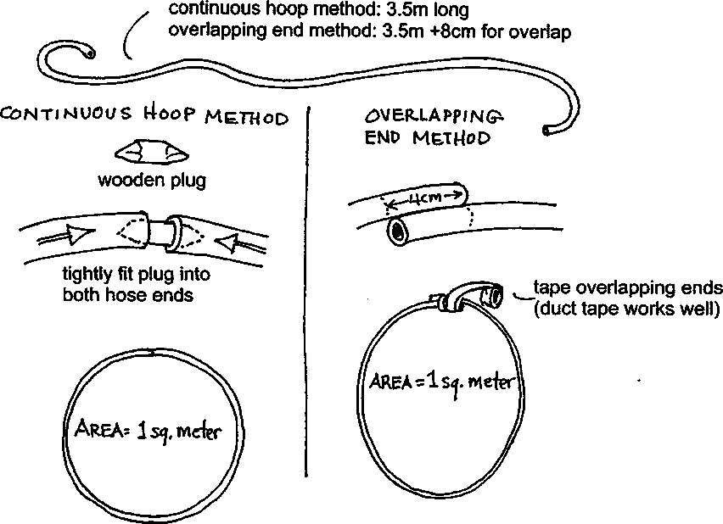

Seal Rock Marine Trail Curriculum - Olympic National Forest, Quilcene, Washington 98376
Developed by the Institute of Marine Science www.forsea.org
142

Looking More Closely
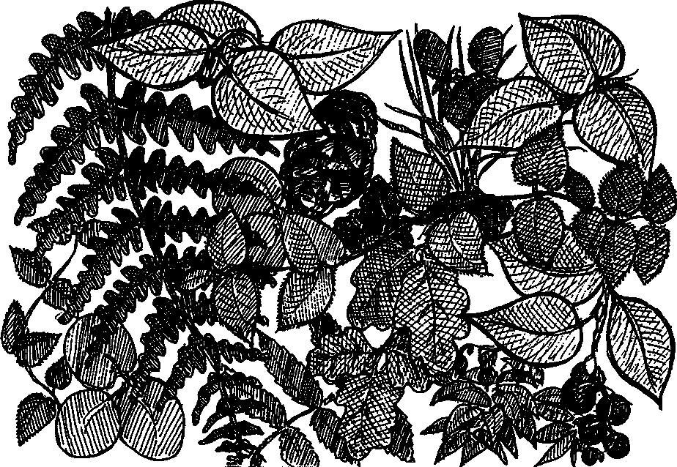
While trees are the most obvious plants in a forest, they're not the only ones. Let's look a little closer to see what else grows in the forest by collecting data to create a diversity index. Diversity in this case means the variety of species of plants present in your study area. We call this "species diversity".
We can also speak of ecological diversity, the variety of ecosystems and plant and animal communities that interact with each other. For example, we can say that Seal Rock Campground has a rich ecological diversity which includes the forest, the intertidal beach, and the deep waters of Hood Canal.
Scientists also speak of genetic diversity which is the variability in genetic make-up among individuals of the same species. Some of the differences you'll see in plants of the same species in your study plot are due to age, some due to environmental conditions, and some are due to differences in the genes that govern growth.
Each of these types of diversity is critical to life as we see it at Seal Rock Campground. Your challenge is to measure the species diversity in one square meter.

Here's what you'll need:
- Oopa-Hoopa
- Plant ID cards
- campsite map
- notebook with a firm back‭
Seal Rock Marine Trail Curriculum - Olympic National Forest, Quilcene, Washington 98376
Developed by the Institute of Marine Science www.forsea.org
143
- paper for rubbings
- pencil, crayon or oil pastel for rubbing
- 10 meter long cord (marked in 1 meter intervals with the first meter also marked in decimeter intervals)
- square of butcher paper
- optional: magnifier

Here's what to do:
- Stand near the center of your study area (either the area you studied in "Can't See the Forest for the Trees" or an area assigned by your teacher).
- Take your Oopa-Hoopa and hold it at "3 o'clock" and "9 o'clock". Look carefully to make sure that your team members are behind you and that no one is in the line of fire. Then, call out "Oopa-Doopa-Hoopa", close your eyes and gently toss your Oopa-Hoopa into another part of your study area. Be careful and be aware!
- Now that your Oopa-Hoopa has landed, count the total number of each species of plant found within the hoop. Use the Plant ID cards to help you name the plants. If you can't identify a particular plant, ask your team members for help. If they can't help you, do a rubbing of a plant leaf so that you can ask for help later. In the meantime, give the plant a descriptive name or a number. Here are some parameters, or guidelines, for counting:
- do not count plants that are beneath the hoop itself,
- if your hoop contains hundreds of the same species (for example, grass seedlings), estimate the number of plants, rather than count each one. Here's how: First, count the number of plants in a small section of known size. Second, estimate how many of those small sections of plants there are inside the loop. Finally, multiply the number of plants per section times the number of sections. For a plot with 26 plants per 10 cm x 10 cm area and 20 such areas inside the hoop, it works like this:
26 plants x 20 (10cm X 10cm area) = 520 plants
(per 10cm x 10cm area) 1 meter plot 1 meter plot
- Collect your data in a table such as this:
Species name | Total # of individuals
1.
2.
3.
etc.
Total species = | Total individuals =

Seal Rock Marine Trail Curriculum - Olympic National Forest, Quilcene, Washington 98376
Developed by the Institute of Marine Science www.forsea.org
144

Looking at the data...
While you'll be calculating the diversity index for your area when you get back to school, let's look at a few things now.
- Which plant species was most numerous?
- Did the most abundant species also cover the greatest area within your plot?
- Which plant species was least abundant?
- How does the most numerous plant species grow in relation to the least numerous plant species? (for example, next to, on top of, a long way from...)
- What factors might cause these plant species to grow in different locations within your plot?
- Why is diversity or variety of the plants at Seal Rock Campground more important than the sheer number of plants?
- What can be done to ensure that the diverse collection of plants found in the campground continues to thrive?
Seal Rock Marine Trail Curriculum - Olympic National Forest, Quilcene, Washington 98376
Developed by the Institute of Marine Science www.forsea.org
145

Who's Been Eating Here?
Many animals eat plants. Black-tailed deer are the most visible large plant eaters at Seal Rock Campground. Squirrels and chickadees are common mid-size plant eaters. Small plant eaters such as mice and gophers are immense compared to the host of tiny insects that feed on forest plants. While beetles and grasshoppers and other insects eat small quantities of plant material as individuals, their combined effect is much greater than the effect of the larger animals because there are so many of them!
Here's what to do:
1. Conduct a "big to small hunt" for signs of animals (or the animals themselves!). Use your 10 m cords to help lay out a 10 m circle to explore. Each team member needs to find the center mark on her or his cord and then place the center mark in the center of the Oopa- Hoopa, making a spoke-like pattern:

The area you'll examine is the area inside the circle made by connecting the ends of the "spokes" (cords).
What kind of signs will you be looking for? Paw or claw prints, feathers or bits of hair, scat (droppings), browsed (partially eaten) vegetation (for example, deer bite off the new growth from shrubs), dead animals, burrows or runways are some of the things you might find.
2. For each sign you find, make a brief written or pictorial description and the name of the animal that made or left the sign, if you know it or can make a reasonable guess.
Seal Rock Marine Trail Curriculum - Olympic National Forest, Quilcene, Washington 98376
Developed by the Institute of Marine Science www.forsea.org
146
- What kinds of signs do those tiny animals leave? Here are a few examples of things to look for:
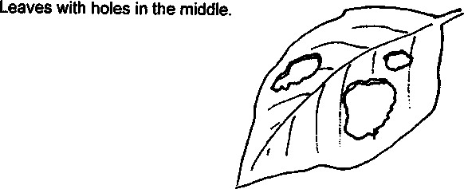
Leaves with the edges chewed away.
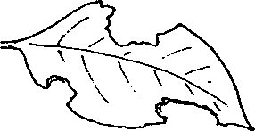
Leaves with curled, browning or shriveled edges.
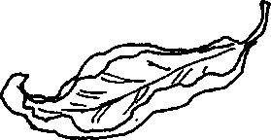
Leaves that show surface scraping.
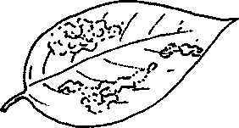
- How many damaged plants did you find?
- Which plant species is the most common food source?
Seal Rock Marine Trail Curriculum - Olympic National Forest, Quilcene, Washington 98376
Developed by the Institute of Marine Science www.forsea.org
147
- Now carefully explore the damaged plant looking for the animal who did the eating. Do a shake down" to gather more evidence. Here's how:
Take the sheet of butcher paper and fold one inch of each edge upward to form a shallow box.
Place the box you've just made under one of the damaged plants.
Now grasp a branch and give it a shake to see who will fall into your box.
- If available, use a magnifier to examine the animals in your box. Most of the animals are insects (they have six legs).
- How many animals did you find?
- How many different kinds of animals did you find?
- How might you tell if one of the animals you found is responsible for the damage to the plant?

The Underground
Not all of the tiny animals in your area live on the plants, many live on the ground, in the leaf litter, or in the ground. Within the area of your Oopa-Hoopa, carefully examine the ground, moving leaf litter gently to one side. Look for insects, worms, slugs, centipedes, millipedes, sow bugs, spiders, ticks, mites, etc. Look for signs of small animals, too, such as holes made in the ground, burrows, or trails. Record your findings, then carefully replace the leaf litter and anything else you may have disturbed.
- a. What animals or animal signs did you find?
b. How many different kinds of animals or signs did you find?
Seal Rock Marine Trail Curriculum - Olympic National Forest, Quilcene, Washington 98376
Developed by the Institute of Marine Science www.forsea.org
148
9. a. What do you think the animals living in the forest litter eat?
b. What makes you think so?
10. Use the plant and animal information you've gathered to create a forest food chain for your study area.
Seal Rock Marine Trail Curriculum - Olympic National Forest, Quilcene, Washington 98376
Developed by the Institute of Marine Science www.forsea.org
149

Stepping back...
Walk down to a road or trail edge from where you can look back on your study area Look closely at what you see. Think about what you see, then draw the cross section showing the different layers of the forest. On your drawing, label the layers. Then write about the interactions you can see between the layers. Finally, diagram whatever parts you can of the food web that exists within the forest you see before you.
(Hint: Think about light and shade, about rainfall, and about who eats whom).
Seal Rock Marine Trail Curriculum - Olympic National Forest, Quilcene, Washington 98376
Developed by the Institute of Marine Science www.forsea.org
150

