Can't See the Forest for the Trees

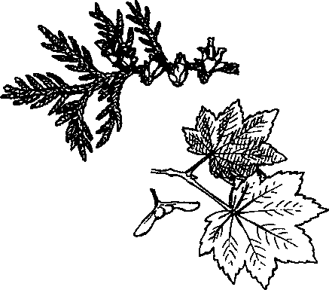
Key Concepts
- The forest at Seal Rock Campground contains a variety of trees.
- Sampling techniques are useful tools for studying the forest ecosystem.
- Olympic Peninsula forests are home to exceptionally large trees.

Background
The Olympic Peninsula is world renown for its spectacular trees, one Sitka Spruce boasts a circumference of 707 inches! That's a diameter of about 18 feet. Clearly, the forests are old and well-established. They are dominated by conifers which thrive in the area's relatively mild winter temperatures. During the fall, winter and spring, they absorb water through the large surface area of their abundant needles and store the water in their trunks in preparation for the dry summer period.
Giant trees of many species grow on the Olympic Peninsula. Alaska yellow cedar (11.48m or 452 inch circumference), grand fir (5.82m or 229 inch circumference), subalpine fir (6.43m or 253 inch circumference), Western Hemlock (8m or 316 inch circumference), Vine Maple (88.9cm or 35 inch circumference), and Douglas fir (13.56m or 534 inch circumference) reach amazing sizes. Within the Seal Rock Campground a variety of trees are found. Douglas fir, western hemlock, western red cedar, and Sitka spruce are common conifers. The Pacific madrone, an evergreen hardwood tree, distinguished by its red, exfoliating bark, is frequently found along the shoreline.
In "Can't See the Forest for the Trees", students learn to identify the more abundant species as they complete two types of transects and hunt for the largest trees in the campground.

Materials
For each student:
- "Can't See the Forest for the Trees" activity pages
- campsite map
- notebook with a firm back
- pencil
- 10 meter long string or cord (marked in 1 meter intervals with the first meter also marked in decimeter intervals)
Seal Rock Marine Trail Curriculum - Olympic National Forest, Quilcene, Washington 98376
Developed by the Institute of Marine Science www.forsea.org
130

For the class:
• large sheet of butcher paper for bar graph

Teaching Hints
"Can't See the Forest for the Trees" provides a more detailed look at the forest explored by students in the various activities presented in "Upon Arrival...getting familiar with Seal Rock Campground". In Part I, students predict the most common tree in their study area, conduct a modified straight line transect to determine the most common tree species, and compare their results with their predictions. In a follow-up activity, students combine team data and create a bar graph as they increase the size of their sample.
In Part II, students predict the abundance of the four most common trees in their study area, then survey a 4 m x 10 m area to determine abundance. Again, team data is combined in a follow-up activity in which students estimate the numbers of each tree species in the entire Seal Rock Campground area.
In Part III, students find and measure the trunk circumference of the largest living example of each of the four most common tree species at Seal Rock Campground.
For these activities students will be working in their small groups (see Teaching Hints for the previous activity, "Upon Arrival...getting familiar with Seal Beach Campground"). Decide beforehand how you wish to distribute the teams throughout the forest. One approach toward randomness is to walk the Nature Trail or upper campsite road and send a team into the woods after each fixed number of paces. You can also simply let students choose their study area, but be aware that teams will likely aggregate.
Preferably, each student will have a 10 meter long sring (marked in 1 meter intervals with the first meter also marked in decimeter intervals). Part I requires three such cords per team while Parts II and III require two.

Essential Academic Learning Requirements in Science
- 1. The student understands and uses scientific concepts and principles. (1.1, 1.3)
- 2. The student knows and applies the skills and processes of science and technology

(2.1, 2.2)
- 3. The student understands the nature and contexts of science and technology. (3.1)

Answer Key
Answers depend upon experimental results.
Seal Rock Marine Trail Curriculum - Olympic National Forest, Quilcene, Washington 98376
Developed by the Institute of Marine Science www.forsea.org
131

VINE MAPLE
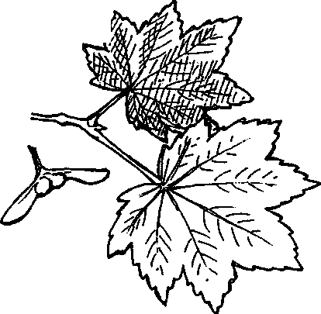
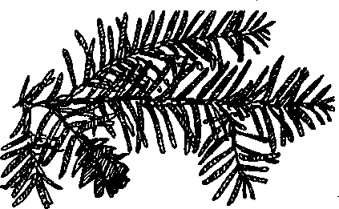
Acer circinatum
v
Vine maples grow as a shrub or scraggly deciduous tree up to 20 feet tall with "maple" leaves, 7-9 lobed. Winged seeds grow as twins, 1-2 inches long.
Vine maples generally grow under other trees where some light reaches the forest floor, often in moist to wet areas.
In the fall, vine maple leaves are a magnificent, bright red.
WESTERN HEMLOCK
Tsuga heterophylla
Western hemlocks grow up to 200 feet tall. Their hanging top distinguishes them from other conifers. Bark is ridged and reddish-brown, up to an inch thick in older trees. Needles are short, flat and blunt, irregularly spaced with alternating lengths. Cones are 1/2-3/4" long and hang down from the branches.
Western hemlock has the densest canopy, produces the most seeds, and is more shade tolerant than any other conifer in the Northwest.
WESTERN RED CEDAR
Thuja plicata
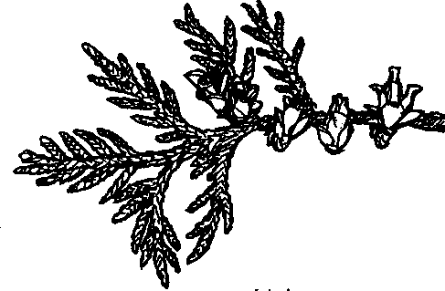
Western red cedar can grow to be a giant tree. The trunk has a fluted base. On mature trees, the branches are often long and point downwards. Bark is thin and stringy, leaves scaly and blunt.
Branchlets hang like fronds or sprays from main boughs.
Cedar is one of the most versatile and important resources to coastal Native people. The bark is stringy and fibrous and can be woven into baskets, mats, and clothing. Cedar wood contains a natural fungicide which inhibits rot, making the wood valuable for outdoor uses.
Seal Rock Marine Trail Curriculum - Olympic National Forest, Quilcene, Washington 98376
Developed by the Institute of Marine Science www.forsea.org
132

DOUGLAS-FIR
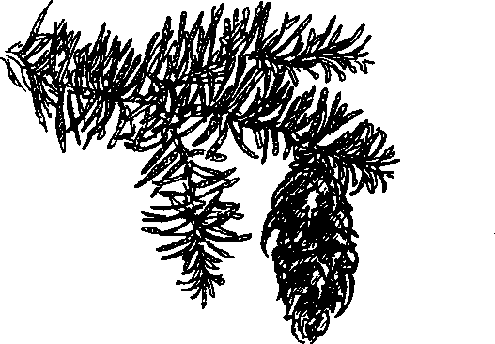
Pseudotsuga menziesii
Douglas fir is a large, evergreen tree with thick, ridged and rough brown bark. Its needles are spirally arranged with one groove on the upper surface and two white bands on the lower surface. Douglas fir cones hang down and are green when young, turning reddish brown to gray as they mature. Bracts, scale-like structures on the cone, are prominently three forked.
Under natural conditions, Douglas-fir establishes primarily after forest fires. The trees have very thick bark which allows them to survive moderate surface fires.
RED ALDER
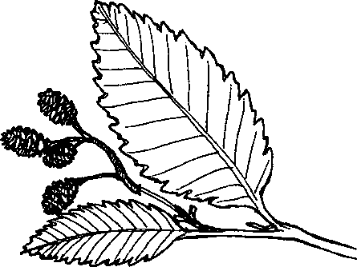
Alnus rubra
Red alder is the most common deciduous tree in many Olympic Peninsula forests. Often growing in dense stands, it is a narrow tree with dark green, serrated, ellipticalshaped leaves. Red alder bark is fairly smooth, thin, grayish in color and covered by warty blisters.
Common along streams, roads, clear cuts, burned areas, and open places, Red alder is tolerant of rocky soils but intolerant of shade. It readily pioneers disturbed areas and improves the soil in two ways; by building up the humus layer on the forest floor, and by increasing nitrogen levels through its nitrogen fixing root nodules.

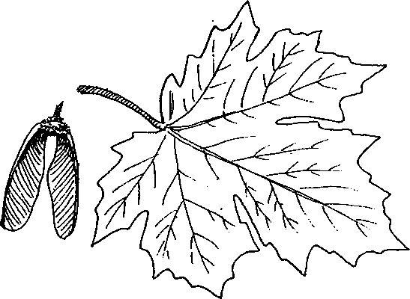
BIGLEAF MAPLE
Acer macrophyllum
A bigleaf maple tree has multiple branches which create a large, spreading crown. The leaves grow to be 8-12 inches in diameter and are 5-lobed, with smooth edges. Fragrant yellow flowers in hanging clusters; paired, winged seeds. On older trees the bark is dark and furrowed, while on younger trees it is often a light gray-brown.
Bigleaf maple is the largest of any maple. Second only to red alder as the most abundant deciduous tree in Olympic Peninsula forests, bigleaf maples are often found in Olympic rainforests draped with mosses and licorice ferns.
Seal Rock Marine Trail Curriculum - Olympic National Forest, Quilcene, Washington 98376
Developed by the Institute of Marine Science www.forsea.org
133

PACIFIC MADRONE
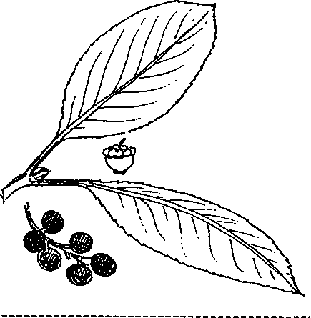
Arbutus menziesii
Pacific Madrone is a small- to medium-sized tree with heavy branches. Its young bark is a bright chartreuse green and smooth while the older bark is brownish-red and peeling. Its leathery evergreen leaves are oval and dark and are not shed in the fall. In the spring, it produces white, urn-shaped fragrant flowers in large, drooping clusters. The flowers produce the orange-red berries of fall.
Pacific madrone are often found on dry, sunny, often rocky sites with coarse-textured soils. At Seal Rock Campground, they are common where the intertidal ecosystem meets the forest.
Seal Rock Marine Trail Curriculum - Olympic National Forest, Quilcene, Washington 98376
Developed by the Institute of Marine Science www.forsea.org
134

Can't See the Forest for the Trees
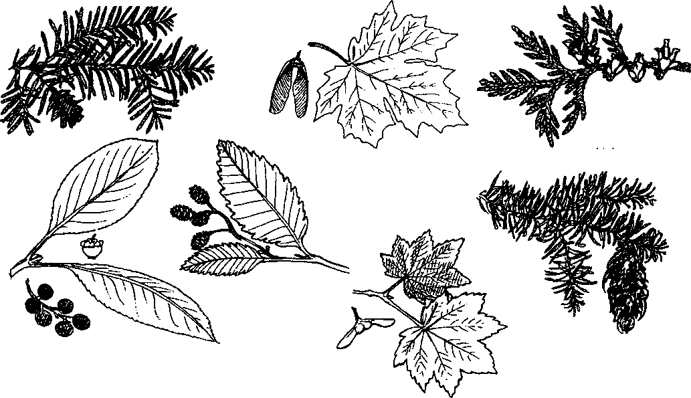

Part I - What grows there?
Wow, there sure are a lot of trees around here. What kind are they? How many are there of each kind? Here's challenge number 1...
What's the most common tree in your area?
I predict that the most common tree in my area is (Don't know its name? Describe it with a picture or words.)
I predict that the most common tree in the Seal Rock Campground is
1. Use your 10 m cords to find out. Pick any tree taller than you for a starting point. Have a team member hold one end of a 10 m cord against that tree. Unwind the cord as you walk to the next closest tree. Wrap the cord around this second tree. Now walk to the
Seal Rock Marine Trail Curriculum - Olympic National Forest, Quilcene, Washington 98376
Developed by the Institute of Marine Science www.forsea.org
135
next closest tree in the same general direction that you moved from the first tree to the second. Your path might look like this:
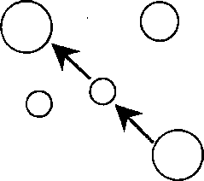
Keep walking and wrapping until you run out of cord. At that point start your second 10m cord (Caution: only tie the two cords together if you know you will be able to separate them easily. You'll need your personal 10 m cord later). Continue walking and wrapping in the same general direction until you run out of your second 10 m cord. Add a third cord and keep going until you end up with 30 m of wrapped trees.
2. Your next task is to count the number of each of the different species of trees you have wrapped (include the first tree in your count). Divide your group so that each person starts counting and identifying at a different spot (Use care not to overlap your counts), Record each type and its number in a data chart (Write neatly, you'll be sharing your data with other groups).
(Don't know what type of tree you're looking at? The Tree ID cards your teacher has will help.)
3. Of those you wrapped and identified, which was the most common tree in your area?
b. How did this result compare with your prediction?
Seal Rock Marine Trail Curriculum - Olympic National Forest, Quilcene, Washington 98376
Developed by the Institute of Marine Science www.forsea.org
136

Part II - How many trees make a forest?
So now we know a little bit about what kind of trees are growing here. We even know something about which are most common. Now we can attack our second question: How many are there of each kind of tree? Here's challenge number 2...
Of the four most common trees in your area, how many are there of each?
I predict that in my area there will be:
of tree 1 (name: )
of tree 2 (name: )
of tree 3 (name:. J
of tree 4 (name: J
I predict that in the Seal Rock Campground there will be:
of tree 1 (name: )
of tree 2 (name:_ )
of tree 3 (name:_ )
of tree 4 (name: )
1. Use your 10 m strings to find out. Have two team members stretch a 10 m string
between them, then lay it on the ground. Next have two team members unwind 4 m from a second 10 m string and pull the 4 m section taut. Keeping the four meter separation, have a third team member grasp the mid-point of the four meter section. Now as a threesome, walk along the 10 m line so that each end of the 4 m section is 2 m from the line. You should look like this:

As you walk, count each tree of each of the four species which your 4 m string touches as you walk the 10 m string. Record your numbers in a table.
Seal Rock Marine Trail Curriculum - Olympic National Forest, Quilcene, Washington 98376
Developed by the Institute of Marine Science www.forsea.org
137
(Hint: You may wish to have other team members do the identification and/or recording, leaving the "cord holders" to wind their way through the forest while keeping their cord as taut as possible.)
2. a. Of the four most common trees in your area, list the number of each:
of tree 1 (name: J
of tree 2 (name: )
of tree 3 (name: )
of tree 4 (name: _J
b. How did these results compare with your prediction?
3. You've just taken a different kind of sample of the Seal Rock Campground forest. This time you’ve taken a rectangular sample of 40 square meters (10 m string x 4 m string). When you get back to class, you'll have a chance to see how your sample compares with those of the other groups from your class.
Part III - Big Trees
Man, some of these trees are so big... How big is "so big”? Why not measure a few and find out? Here's challenge number 3...
Find and measure the largest living example of each of the four most common tree species at Seal Rock Campground.
First, we need to agree on "largest". Foresters use a common measurement called DBH (Diameter Breast Height) as a way of determining their volume. Since circumference and diameter are related, you'll be measuring circumference at breast height which is defined as 4 1/2 feet above the ground.
Once you've found a tree to measure, here's how to do it. Place your foot on the 2 meter mark of your 10 m string (choose the end with the decimeter measures). Hold the string vertically, taut against the tree. Measure the circumference at the 1.6 m mark by wrapping another 10 m string around the trunk at the top of the short string and holding on to mark where it reaches its starting point. Then use the decimeter end of a third 10 m string to measure the length of the string. Estimate to the nearest centimeter. Repeat this procedure for the next species.
Record the circumferences of your largest trees:
m, tree 1 (name: )
m, tree 2 (name: )
m, tree 3 (name: )
m, tree 4 (name: )
Seal Rock Marine Trail Curriculum - Olympic National Forest, Quilcene, Washington 98376
Developed by the Institute of Marine Science www.forsea.org
138
Think about these questions,
- Did you find bigger trees in only a few areas or were they evenly distributed throughout? Why might that be so?
- What conditions do you think produce the biggest trees?
- What species of wildlife might use the large trees at Seal Rock?
Seal Rock Marine Trail Curriculum - Olympic National Forest, Quilcene, Washington 98376
Developed by the Institute of Marine Science www.forsea.org
139

