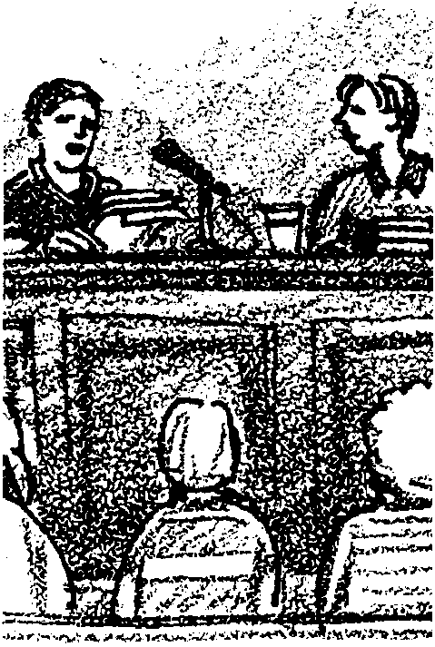
Point/Counterpoint

Key Concepts
1. Environmental issues are complex.
2. People of good faith can interpret the same data in different manners.

Background

The environmental issues facing us today are multifaceted. Many times, in fact most of the time, we are called upon to make serious decisions based on incomplete knowledge of the outcomes of our choices. In such situations of ambiguity, people often interpret the same data in different manners. Expert witnesses express contradictory opinions and the public is left to wonder where the “truth” lies.

“Point/Counterpoint” provides your students with a forum in which to demonstrate their knowledge gains. The activity involves students presenting arguments for opposing positions on a controversial issue. Presentations are limited to sixty seconds per student presentation. No time is provided for rebuttal. Some suggested topics follow:

• Offshore Drilling/No More Offshore Drilling

• Superports/No More Superports

• Supertankers/No Supertankers

• Money for More Oil Exploration/Money for Other Sources of Energy

• Money for Conservation Measures/Money for Exploration

• Used Crankcase Oil Pollution/Offshore Platforms or Tanker Oil Pollution

• Nuclear Energy/Oil and Gas Energy

• The Alaskan Shore Has Mended/Has not mended from the Exxon Valdez spill

Add and/or substitute additional topics based on current energy issues.

Materials

• “Point/Counterpoint” activity sheet

• reference materials
Teaching Hints

Students select their issue and their position on the issue by a drawing. Organize the drawing in a manner convenient to you. You may wish to write the positions on slips of paper and place them in a bowl by the class entry. Each student would then pick up one slip as she came into class. You will need to generate a master list from the slip drawing to circumvent the “I forget’s.” For added drama you may elect not to tell students who their opponents are until it is time for their debates. Some students will draw a position to defend which they do not personally favor. If this is the case, encourage them to play the devil’s advocate.

Since you will probably have more students than positions, you will need to have more than one presentation on the same issue. In this case, the drawing positions may be set up as follows:

• Superport A/No Superport A

• Superport B/No Superport B

• Offshore Drilling A/No More Offshore Drilling A

• Offshore Drilling B/No More Offshore Drilling B
etc.

Give your students time to prepare their presentations (either in class or out). During the presentations, you should act as timer. You may elect to interject some summary comments but try to avoid monopolizing the discussions. You may also wish to provide blank outline pages so that your students may summarize the arguments of their classmates in preparation for a quiz or other evaluation instrument.

Key Words

issue - a matter of wide public concern

position - point of view; the principle or position being put forth as a fact or truth

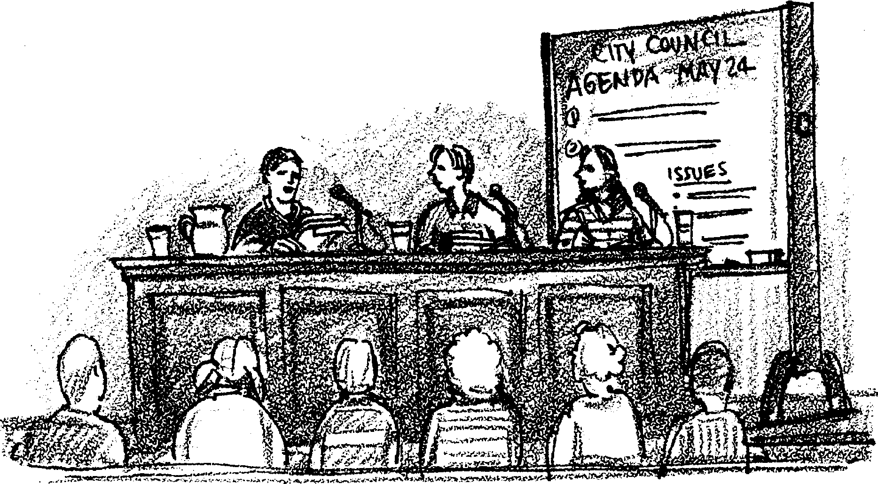
Point/Counterpoint

Superports, offshore drilling, supertankers, oil pollution are all issues of concern for the future. How do you feel about oil energy? In the following activity you will have a chance to express your opinions. You’ll also be able to show how the “facts” support your opinions.

Follow the directions of your teacher to draw your issue and position. The position you draw may not be the position you actually support in real life. However you are to support the position you draw as though you have always favored and supported it. Your presentation will be one minute in length. Time will be called after one minute. You will probably want to make an outline of what you want to say. An outline will keep you from leaving out your key points. Your outline may differ from the one given below. You may have more or less points.

Position

By

I.

A.

B.

C.

II.

A.

B.

C.

III.

A.

B.

C.

