Black Tide

Key Concepts
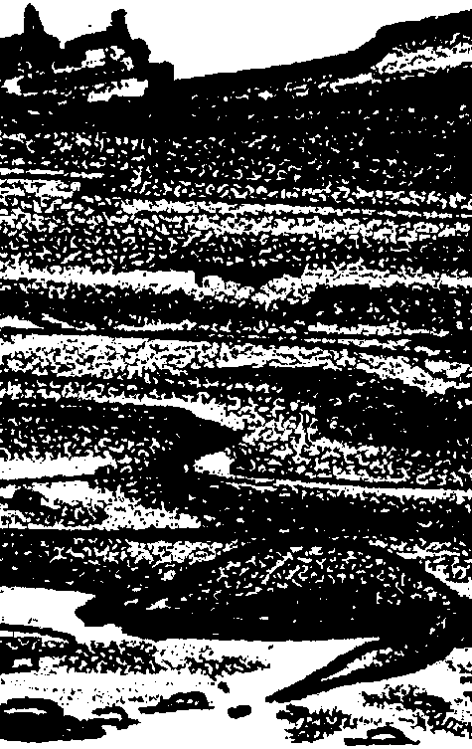
1. Nearly two thirds of the oil pollution in the marine environment comes from users of oil rather than producers of oil.
2. Oil spill cleanup is affected by the type of oil, type of shoreline, weather, and other factors.
3. A variety of ways are used to clean up oil spills, including “mopping” up the oil, skimming it off the surface, burning the oil, applying chemicals to break up the oil, relying on micro-organisms to break down the oil, or cleaning up the oil when it reaches the shoreline.
4. Crude oil contains the components of gasoline, tar, kerosene and all other “petroleum products”.
5. Oil spill cleanup involves choosing the method that will do the least damage to the environment under the operative circumstances. There is no “ideal” solution.

Background

A staggering total of six million tons of oil enter the marine environment annually. Some 60% of this oil pollution is consumer related, coming from industrial and non-industrial sources, such as shipping, auto and boat maintenance, crankcase leaks and oil changes, and urban run-off! Of the remaining pollution, 30% is oil supply related (refineries, tanker accidents, offshore rigs) and 10% comes from natural seeps and atmospheric fallout.

For most of your students, the term “oil pollution” is synonymous with tanker accidents and leaking refineries. Because the oil comes from a single source, these types of oil pollution are called “point sources”. Unfortunately, much of the oil in the marine environment comes from “non point” sources, actually many sources each contributing a small amount of pollution. As can be imagined, non-point pollution, such as pollution from crankcase oil, is very difficult to control. Oils transported by tankers differ greatly. Some are light and volatile, while others, such as crude and crankcase oils, are heavy or viscous. The rate of evaporation for any oil is related to the viscosity. Light oils, like kerosene, can evaporate completely in one day while only a small portion of the heavier oils evaporate, making heavier oils more persistent in the environment.

The different components of an oil (or different types of oil) behave differently when mixed with water. Some of the components will dissolve into the water and are toxic to marine life. Other components can trap water into the surface oil slick forming an emulsion (milk is an emulsion of water and animal fat). This emulsion will increase the volume of the slick, perhaps as much as three or four times, and will often form a mixture as viscous and sticky as honey.

In instances where the oil quickly dissolves or disperses in water, the impact on the marine environment may not be readily visible, even though the dissolved or dispersed oils may be very toxic to marine life. A 1993 spill near the Shetland Islands north of Scotland dispersed in a few days. Although the oil seemed to disappear, the toxic compounds were mixed into the water and contaminated or “tainted” many fish. Although uncommon, some oils adhere to sediment and organic matter, forming droplets which sink, transporting the contaminants to the seafloor.

Point out to students that often the oil being transported is crude oil. Crude oil contains thousands of different chemicals, from waxes to light and volatile liquids and gases. Immediately upon release into the sea, the oil begins to change. The volatile components begin to evaporate and the oil changes chemically when exposed to the sun. The evaporation causes the obnoxious smell associated with spilled oil. This is the most toxic stage of the spill.

If the seas are turbulent with high winds or swift currents, the oil will disperse across and throughout the water. This action produces oil droplets of varying sizes. The larger droplets rise back to the surface, while smaller ones remain in the water column.

Standard operating procedures when responding to spills involves first, stopping the source of the spill, then containment of the spilled oil, followed by the removal of oil from the contained area. The following is a list of containment and removal techniques:

1. Booms and skimmers to contain and collect oil (CALM seas)

2. Vacuum (CALM water only)

3. Absorbents:

a. straw, sawdust become waterlogged and difficult to remove

b. synthetic absorbents; absorb oil but not water

c. problem of oiled absorbent disposal (the contaminated materials must be treated as toxic waste)

4. Sinking agents: sand, clay, cement

a. sink to sea floor and impact bottom dwellers

b. natural degradation of oil retarded at depth

c. droplets are released from sediments and rise to surface again

d. PROHIBITED in U.S. waters

5. Burning:

a. Leaves residue: toxicity is undetermined but scientists think the residue is relatively inert

b. pollutes air (similar to smoke from forest fire or wood stoves)

c. must be performed within 24-48 hours of spill (before volatile compounds evaporate)

d. has a very high removal efficiency: greater than 90% of oil removed from water if burned (Where does it go? Field tests have indicated that approximately 10% goes into smoke, 1-2% is left as residue and the rest is combusted.)

6. Chemical dispersants: increase dispersability of oil, remove it from the water surface and scatter the oil in the water column. Instead of floating on the surface, the oil moves in three dimensions as a “fog” in the top 1-3 m of the water. May help birds and sea otters and reduce shoreline impact, but what about fish? The dispersed oil may affect plankton or larval fish over the short term, but does not appear to affect adult fish because the oil is quickly diluted to low concentrations.

a. Early types did more harm than good: toxic

b. Now many are water based rather than solvent based, making them less toxic.

When the oil reaches the shoreline, many other methods may be employed, among them are:

7. Manual pick up: The most common method of dealing with oil on the shoreline employs hand collection of oil, usually with absorbent materials.

8. High pressure flushing: May result in increased penetration of oil into sediments. The Exxon Valdez experience has shown that low pressure flushing would have been less damaging to organisms. Low pressure washing, however, may not work on very thick oil.

9. Mechanized equipment: Earth movers expose shoreline to erosion, affect organisms and habitat.

To date, most techniques have been only marginally successful. The mixed oil and water that is removed presents a disposal problem. One technique that holds promise for having few inherent environmental dangers involves the use of bacteria.

10. Bioremediation: Oil-eating bacteria are naturally occurring micro-organisms which break down the oil into harmless compounds. There are about 40 different types of bacteria and fungi that metabolize oil. It is a very slow process, however, and the conditions must be favorable for the growth of the bacteria. Growth of bacteria is affected by temperature, availability of small droplets of oil, (microbes work around the outside edges of an oil slick, so small droplets rather than a large pool of oil allows them to work faster by increasing the “edges” or surface area available to them) and the presence of nitrogen and phosphorus as nutrients for the bacteria.

Research in using microorganisms to clean up oil is relatively recent, but continues to bring promise. Bioremediation has been used successfully for some time on land-based oil spills around oil rigs and on contaminated soil from leaking underground storage tanks at gas stations. On land, the temperature and nutrient levels can be better controlled to encourage micro-organism growth. Bioremediation tests on the Exxon Valdez spill have been inconclusive. It appears that on the beach, a thin coating of oil disappeared faster when nutrients favorable to oil-eating bacteria were applied. It took several weeks for noticeable change to occur. So far attempts to encourage microbe growth in open water situations have not worked as well.

Students may be interested in comparing the 1989 Valdez, Alaska, spill to some of the following famous petroleum accidents. The grounding of the tanker, Exxon Valdez, released 10.5 million gallons (250,000 barrels) of crude oil into the fragile waters of Prince William Sound. (This represents one fifth of its total cargo of 55 million gallons of North Slope crude.)

It is often difficult to compare spills because a variety of units are used to report their magnitude: gallons, barrels (abbreviated “bbl.” and equivalent to 42 gallons), tons (this changes with the viscosity of the oil).

Torrey Canyon: March 1967, English Channel. About 860,000 bbl. of crude oil spilled and fouled over 135 miles of the French coast.

Argo Merchant: December, 1976, Nantucket Island, U.S.A. 183,000 bbl. spill may have caused damage to the plankton in the Georges Bank (debate on this point continues).

Santa Barbara Blowout: January 1979, California. Some 100,000 bbl. of crude oil were released, over 40 miles of California coastline was covered by oil.

Ixtoc I: June, 1979, Yucatan Coast and Texas beaches. From 2,450,000 to 3,500,000 bbl. of oil spilled over an eight month period from a blowout on this exploratory well in the Bay of Campeche.

Materials

Activity #1 – Cleaning Up Oil Spills
In “Cleaning Up Oil Spills”, students use a variety of materials that simulate actual cleanup technology to clean up a mini oil spill:

For the class:

• used motor oil

• cut-open milk cartons or #10 cans for oily waste

• newspapers to cover tables

• absorbent pads (acquire at a USCG Marine Safety Office or a marine supply store)

• aluminum pie pans or pans made from the bottom 3" of plastic gallon milk jugs (add water to create “ocean”)

• worksheets

• wood splints and matches

• a tablespoon of sand

For each group of 3 – 4 students:

• spoon

• 2 eye droppers (or oil and detergent in separate dropper bottles)

• pieces of nylon stockings, Styrofoam, cardboard, string, cotton balls

• hay or other absorbent natural material

• a bird feather (available at craft stores)

• other materials students bring from home

• detergent

• used motor oil*

*Note: Used motor oil may contain certain hazardous materials. Students should use care in handling, avoiding contact with skin and immediately wiping up spills.

Teaching Hints

“Black Tide” is a simulation activity designed to give your students insight into the difficulties involved in controlling oil spills.

Contact the closest United States Coast Guard Marine Safety Office. They are generally most happy to supply you with current information and samples of materials that they are using in oil cleanup.

Duplicate the student worksheets (one set per student or group). Set out materials for easy access.

You may wish to encourage students to bring materials from home that they think would remove oil from their “oceans”. If sand or dirt is used as a sinking agent, emphasize the fact that because of the damage it does to bottom dwellers, it is prohibited in U.S. waters as a cleanup method.

Procedure

1. Distribute the student worksheets. Have students cover tables with newspaper and gather the necessary materials to complete the activity.

Have students proceed on their own, following the stepwise procedures in the student pages and recording their observations. During the work period, circulate among the groups and provide a pinch of sand to each group to place on their “spill”. What happens? (Sand absorbs the oil and sinks to the bottom.) Is this a good idea?

2. When students have tried using the materials, ask for a class vote on which material was most effective in cleaning up oil. List the materials provided on the chalkboard and record the votes by each item. “The class has decided that ( ) is the most effective cleanup material. Let’s suppose that the Exxon Valdez spill was cleaned up with ( ). You now have 8 million tons of oily ( ). Where do we put it?” Discuss possible disposal options for oily materials. Lead the class to see that there is no good answer: burying contaminates the water system, burning pollutes the air. Just because the oil is removed from the water does not get rid of the problem of disposal.

3. In Arctic waters where there are icebergs, the Coast Guard BURNS the oil. Ask for a volunteer who would like to try burning an oil spill. Place a new oil spill on the water in one of the small pans. Provide safety glasses. Light one of the wooden splints and hand it to the student. Allow several students to try burning the oil. The chances of the oil igniting are very small, because oil must be several inches thick to burn. Ask the class about the three things needed for burning: Oxygen (in the air), Fuel (the oil), and Heat (burning splint). Ask for their ideas concerning why the oil does not burn. In this case there is not enough heat applied to ignite the oil. To overcome this problem, the Coast Guard sometimes uses napalm (a gelatinous, highly volatile form of gasoline) to create a fire which produces enough heat to ignite polar oil spills. If the oil in polar regions is not removed quickly, it becomes encapsulated in the icebergs and reappears again as the ice melts in the spring.

4. When it is time for cleanup, set a good example in the way that you handle wastes from this activity. This is a fitting time to discuss the fact that consumer related activities and run-off are a major source of oil pollution in the marine environment. The equivalent of the Exxon Valdez oil spill (10.5 million gallons) is disposed of each year into sewage systems! Discuss the proper disposal of used oil after the oil is changed in a car. Used oil should never be dumped on the ground or on a gravel driveway. Rain water carries oil disposed of in this fashion as run-off into a stream, lake or salt water bay. Used motor oil should never be dumped in a storm sewer drain. This oil eventually ends up in water supply systems, streams, lakes or bodies of salt water. When oil is disposed of in landfills, surface water can carry oil from the disposal site into nearby streams or rivers or into the ground water. Just one quart of oil can contaminate up to 2 million gallons of drinking water. The only proper method of disposal is to return the used oil to a service station recycling center or collection depot so that it can be re-refined into motor lubricant again or used as fuel.

Have students absorb as much oil from their ocean as they possibly can. Dispose of the oily materials in the milk cartons, well wrapped.

As part of the follow-up and clean-up activities, you may want to demonstrate Coast Guard absorbent material. This is the most effective way to pick up oil. Cut the material into small pieces and have students use them at the end. Absorbents pick up the oil and not the water because of the material’s affinity for oil and not for water.

Key Words

absorption - the process of taking in, soaking up

booms - a barrier composed of floats, a skirt and an anchoring system; used to enclose floating oil, divert oil, or protect an area

by-products - something produced in the making of something else; side effect

containment - to hold within, enclose

dispersant - a chemical which causes oil to distribute widely

simulation - activity that imitates a real life situation

Extension

1. Contact your local town or city administration office to obtain information about how the problems of urban run-off, and waste oil products are handled.

Answer Key

Cleaning Up Oil Spills

Analysis and Interpretation:

1. a-c. Answers depend upon experimental results.

2. a. The most obvious containment material included in the materials list is string. The cardboard and Styrofoam may also serve to contain the spill.

b. Booms work best in calm waters. Calm waters come from windless weather and slow currents.

3. a. The answers will vary depending upon the specific techniques used by your students.

b. Moving the oil to land does not cause the oil spill to vanish, it just moves it from one place to another. Note that there will still be the problem of disposal of the removed oil and oil soaked materials.

4. a. The detergent will emulsify the oil, changing the physical characteristics of the spill. If the detergent (dispersant) works well, the oil will become dispersed as small droplets into the water. Use of dispersants is not combined with mechanical removal, but is meant to break up the oil and make it more available for natural microbial action. It also allows greater penetration of the oil into sand and sediments.

b. This question calls for an opinion. Dispersants may be best suited for use in the open sea, away from shallow sediments and beaches. Note that many detergents are harmful to living organisms, a fact which influences the choice of dispersant material and the location conditions under which it is used.

5. a. Burning puts about 10% of the oil into the atmosphere as various compounds and 88% into the atmosphere as the products of combustion (largely CO₂ and H₂0). The remaining 1-2% is left as residue.

b. The problems that burning oil might cause are the same as those caused by air pollution (respiratory problems, photo-chemical smog, deterioration of air quality, etc.). It may be worth noting that an oil spill burn usually only lasts 1-2 hours and, as such, is not an on-going source of pollution. Oil burns with a greater chance of producing photo-chemical smog or deterioration of air quality for any period of time result from uncontrolled burns from accidents such as the Kuwait fires or tanker fires.

c. Causing oil to burn on water is difficult unless the oil layer is relatively thick. The whole layer must be raised to ignition temperature. This fact makes an interesting demonstration for the class. The oil is nearly impossible to ignite. Use a burning splint or stick to try. Oil spills have been ignited by dropping incendiary bombs (napalm) on them from airplanes.

6. The weather and wave action are obvious factors which affect the success of spill cleanup in the oceans.

7. a. While answers will vary, the most obvious techniques for dealing with oil on beach sands is to scrape off the oil-soaked sand and dispose of it. There is the problem of limited disposal space. The technique must be done carefully so as not to harm the habitat. Sometimes cleanup can be more harmful than leaving it alone in such sensitive areas as wetlands.

b. Shore animals that can move are likely to be LESS affected by the oil on the beach than non-moving animals. However, there is concern that mobile animals, like birds, can enter the area and become contaminated.

8. a. Most of your students will probably feel that the person or organization that causes the spill should be responsible for cleaning it up.

b. This second question is included to denote a difference in responsibilities. Most students, along with the public as a whole, will feel that the responsible party should pay for cleanup. A case can be made, however, that the group that causes the spill should pay but should not be responsible for the cleanup operation. The thought is that a “disinterested” third party might be better able to decide when the spill is cleaned up than a “most interested” first party who is paying the bill. Discuss the fact that the most important thing is to be sure the cleanup is monitored properly.

9. It is unlikely that you will get unanimity on the list of priorities. During the discussion, ascertain the reason behind the choices your students made. Present your list of priorities only after you have discussed the lists of your students. This is a good time to discuss the problem of nutrient availability, temperature, etc. for oil-eating bacterial growth.

Activity #2 - What’s Happening Locally?

Teaching Hints

In “What’s Happening Locally”, students inform themselves about their city’s or town’s way of dealing with consumer related oil pollutants. The information should lead to action as your students become part of the solution to this problem.

Preparation:

Collect local newspaper articles related to oil pollution.

Procedure:

1. Define the non-point pollution problems related to waste oil. You may present a newspaper article or initiate a discussion of students’ perception of local problems and issues.

2. Provide your students with the names of local agencies concerned with oil pollution. In groups, collect and record information about how oil pollutants are being handled by contacting these local agencies. Be sure to include resources representing all sides of the issue. As part of your information gathering process prior to this activity, you may wish to alert the agencies to the likelihood of student calls. Visit any local sites that are affected.

3. Help students to compile the information and sort it according to topics. Suggest they try sorting the information in terms of the science (i.e. reactions of oil and water, research being done), the technology (i.e. utilization of oil), and the society (i.e. effects of pollution on people, people’s responsibility to the environment).

At this point, you may want to redefine and narrow the scope of the discussion, perhaps focusing on a single issue or even addressing a specific site that is being affected by oil pollution.

4. It may be helpful to divide the issue into sub-topics and have the groups report on specific topics to compile a complete picture. Based on the information presented, conclusions should be drawn and debated among the class. As a group, help students come to some resolution and recommendation that will improve the situation.

5. Write letters to the people and agencies contacted to inform them of the results of the class research and the class recommendations. Be sure to thank the agencies for their cooperation.

6. Finally, have students evaluate their work and resolution or recommendation. What would they do differently next time? Is their solution reasonable and realistic?

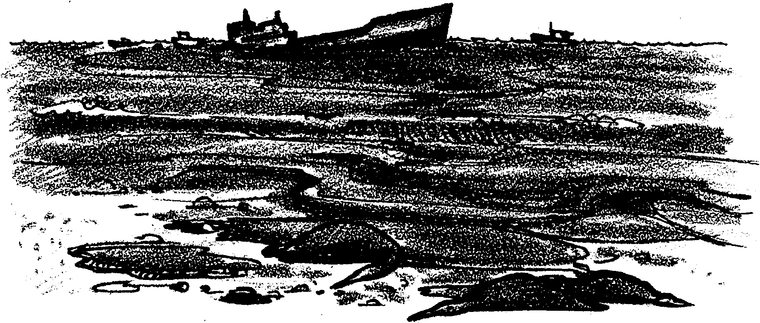
Black Tide

The disaster that everyone dreaded has happened once again. A huge super-tanker carrying 55 million gallons of North Slope crude oil has run aground in the Gulf of Alaska. Thousands of birds, fish and mammals are at risk from the resulting leak of 10.5 million gallons of oil. What can be done to clean up the spill? In the following activity, you will create an oil spill and have an opportunity to attempt cleaning up that spill.

Materials:
• aluminum pie plate, or similar container
• used motor oil
• detergent
• cotton balls
• spoon
• 2 eye droppers (or dropper bottles for oil and detergent)
• small pieces of nylon stocking, Styrofoam, cardboard, and string
• hay
• designated dump for oily materials
• absorbent pads (Coast Guard)
• materials from home (optional)

YOUR ASSIGNMENT: Determine which material cleans up oil the best

Procedure

1. Obtain an aluminum pie plate or similar container. Place about an inch of water in the plate.

2. Place a small “oil spill” on your ocean by adding 5 drops of used motor oil.

3. The problem you now face is the same as that faced by workers in Valdez, Alaska. How can you clean up the oil with the materials on hand? Select any of the materials available and use them to clean up the oil slick. Use a watch with a second hand to determine the amount of time it takes you to clean up the spill. Use the Data Chart to record the results.

4. Repeat the simulation by adding more oil. Try each material, and record the results.

5. You have been very lucky. The weather for your oil recovery operations has been fair and calm. Many oil spills occur when the weather is stormy. To simulate rough weather, carefully make waves in your model ocean by gently tilting the pan up and down to simulate rough water. Repeat two of the techniques with the rough water. Record your data in the Data Chart.

6. Create another oil spill. Add 5 drops of liquid detergent on the oil spill. Be sure the detergent is placed ON the oil. Record your observations in the Data Chart.

7. Clean up your lab station. Place the used oil in the container provided by your teacher.

Analysis and Interpretation:

1. a. With which method were you able to most thoroughly clean up the oil spill?

b. With which method were you able to most rapidly clean up the oil spill?

c. Which method do you think is most effective for cleaning up your spill? Explain.

2. a. The first activities following an oil spill usually involve attempts to contain the spill. Containment keeps the spill from spreading. Which of the materials provided would help to contain an oil spill?

b. Ocean spills are often contained by booms. A boom is a barrier or “fence” of some type. Floating logs, foam, and rubber tubes have been tried. Under what weather conditions would booms work best?

3. Most of the oil removal techniques which use the materials provided remove the oil by absorption. The oil is picked up (absorbed) on other substances, like straw, nylon, etc. The oil-soaked material is then removed from the water.

a. Which of the techniques you used removed oil by absorption?

b. Some people say that these techniques simply move the oil spill from the water to the land. What do you suppose they mean?

4. a. What effect did the detergent have on an oil spill?

b. Under what conditions do you think a dispersant (detergent) might be advisable for oil cleanup? Why?

5. Fire is another technique often used to remove oil spills. The oil spill is ignited and allowed to burn.

a. Where does the oil from the water go when it is burned?

b. What kind of problems might this cause?

c. How might the oil spill be ignited on water?

6. What are some factors which affect the clean up of oil spills in the ocean?

7. When the oil reaches the beach, other problems occur.

a. What is one technique you might use to remove oil from beach sand?

b. Shore animals that can move are likely to be more/less affected by the oil on the beach than non-moving animals. (Circle the correct answer).

8. a. Who should be responsible for cleaning up the spills?

b. Who should pay for cleaning up the spills?

9. Some bacteria use oil as their only food source. Ocean scientists have tried to “plant” these bacteria in oil spills. For these bacteria to be successful in cleaning up spills, the bacteria have to pass several tests. Some of the tests are listed below.

Rank these tests in order of importance. In the blank next to the test, write the order number. The most important test to consider would be number one; the next important, number two; and so on.

cost of the bacteria

the bacteria will produce no harmful by-products

the bacteria will eat the oil quickly

the bacteria will disappear when their job is done

the bacteria will eat the oil thoroughly

Oil On Water – Cleaning Up Oil Spills

