Trouble In the Sound:

The Exxon Valdez Oil Spill
Lesson by Linda Hagelin – Saratoga, CA

Key Concepts
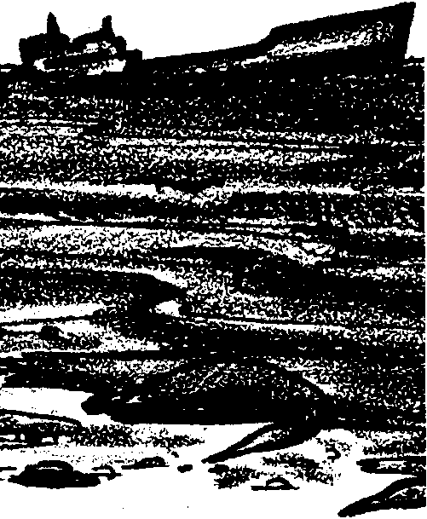
1. There are no easy answers to oil spill cleanup. Cleanup choices involve selecting the method that does the least damage when all circumstances are considered.
2. Short term effects of spilled oil include dead birds and mammals, blackened shoreline.
3. Long term effects are not completely known; but, in Alaska, oil persists under mussel beds and sediments, and reappears periodically.
4. With time, natural degradation from oil-eating organisms occurs and the oil will finally disappear...this may take years.

Background

Background for “Trouble in the Sound: The Exxon Valdez Oil Spill” is found in the following Science World article: “Oil Spill: The Lessons of Valdez.”

Materials

For each student:

• “Oil Spill: The Lessons of Valdez”, Science World article.

• writing paper and pencils

Teaching Hints

This activity introduces your students to some of the details of the Exxon Valdez oil spill in Prince William Sound, Alaska on March 24, 1989. The article is used as a springboard for class discussion and to allow students to explore their own understanding of what an oil spill means to a natural environment. This activity is meant to give a background for the simulated oil spill called “Black Tide” which follows.

Procedure

1. Ask the class: “Who has heard of the Exxon Valdez oil spill in Alaska? What do you know about oil spills?” Lead a discussion exploring the students’ understanding of oil spills in general and the Exxon Valdez spill in particular.

2. Break the class into groups of 3 or 4 students. Ask the groups to discuss among themselves their ideas of how oil spills affect the following: (Post these questions on the board)

• Effects on wildlife: birds? fish? mammals?

• Effects of oil on shoreline: rocky shore? sandy shore? marsh?

• Behavior of oil in the ocean: what happens when oil spills onto water?

• Types of cleanup methods: how do you pick up the oil?

3. Allow the groups about 15 minutes to discuss the questions and to prepare to share their ideas with the class. Remember that the students have been given no formal information yet, this is a chance for you to see what kind of understanding your students bring to class about oil spills.

4. Give each group a chance to share their ideas. Make a note of the main points that the groups mention under each question. You can review these points with the class later to see how their ideas may change after more information and the oil spill simulation activity have been presented. Ask the groups to support their ideas. Probe for details. For example, if a group says that “Oil kills sea birds” or “Oil coats the rocks on the shoreline”, ask the students to explain HOW they think oil kills sea birds. Ask them to tell WHAT EFFECT they think oil coating the rocks on the shoreline will have on the plants and animals that live there. Ask them to think one step beyond the obvious.

5. Read the article “Oil Spill: the Lessons of Valdez” in groups. Students revise and amplify their ideas about the questions above. Groups share any new or revised thoughts with the class. Again ask students to support their conclusions with personal experience or reference to the article.

Oil Spill: The Lessons of Valdez
by Joyce Cohen

By now, you have heard a lot about the oil spill that occurred in Alaska’s Prince William Sound. It happened last spring, just after midnight on March 24, 1989. Good Friday. An oil tanker owned by the Exxon Corporation was sailing out of the port of Valdez. The ship, called the Exxon Valdez, went off course to avoid ice, and never got back into its lane. Instead, it hit rocky Bligh Reef. By the time the sun came up, nearly 11 million gallons of thick black crude oil were spreading through the sound.

Within weeks, oil washed up on nearly 400 miles of the sound’s coastline. Currents carried the oil southwest out of the sound to contaminate beaches hundreds of miles from the spill.

Scientists and others are cautious about predicting the long-term effects of the spill. Two factors make predictions especially difficult: Each kind of crude oil has unique properties and this is the first major spill of Alaskan crude; and scientists don’t have a good understanding of how oil behaves in icy waters, like those of Prince William Sound.

THE SPOILS OF OIL

Oil is hydrocarbon, a naturally occurring compound of hydrogen and carbon. It forms when buried remains of plants and animals “cook” at moderate temperatures and pressures deep in the Earth’s crust. Crude oil right from the ground is refined (separated) into various products like home heating oil and gasoline. Crude oil contains some toxic hydrocarbons, like benzene.

Oil isn’t easy to clean up. Jon Robinson of the National Oceanic & Atmospheric Administration estimates that human efforts will get rid of about 10 percent of the oil from the Valdez spill.

The rest will disappear over time, by the action of wind, waves, and weather. For example, some of the oiled beaches in Prince William Sound are “high-energy” environments. Waves pound the rocks, keep the oil from settling and breaking it up into smaller and less dangerous droplets. Of course, many of the sound’s best wildlife spots are in quiet bays, where the water is calm. Oil seeps into those beaches and will stay there longer. Robinson estimates that “it will be more than five years before the beaches are back to normal.”

It’s important to start cleaning up a spill immediately, before oil has a chance to spread. That didn’t happen at Valdez, in part, observers say, because nobody was prepared for a spill of this size.
Dispersants - chemicals that break down the oil into tiny pieces - should have been applied immediately. But they were in short supply. So were planes and spraying equipment. There was disagreement over whether to use the chemicals which scientists fear might harm ocean life.

Booms and skimmers worked poorly. Booms are floating “sausages” with skirts that hang a few feet below the surface. They corral the “pancake” of floating oil. Skimmers then collect the oil by sucking or scooping it up. But there was too much oil and not enough equipment. Some of the skimmers jammed or broke. (See SW May 19, 1989, page 3, Teachers’ Edition, for more detail on the various cleanup methods.)

Cleanup got harder as time went by. After a few days, oil in the sound moved toward the open ocean and started to weather. The oil mixed with water, forming a gloppy, smelly substance called “chocolate mousse” that can’t be sucked up. As water and lighter parts of the crude oil evaporated, the mousse thickened and hardened, forming what are known as “tar balls”. These had to be picked up by hand.

Eventually, nature will take over. The tar balls will sink. Some microorganisms in the ocean will digest them for food. This process is called microbial degradation.

BLACK DEATH

Meanwhile, users of the sound feel the effects. Thousands of sea otters call it home. More than 200 species of birds, residents as well as migrants from faraway places, have been spotted here. Large numbers of whales, seals, and sea lions live in the sound. Bears, deer, and other animals live around it.

Otters attracted most of the early attention. They freeze to death when their fur gets oily and clumps together, letting icy water reach their skin. Scientists also discovered otters dying from organ damage. The animals got a dose of toxic compounds in the oil when they cleaned their fur. Or they breathed toxic fumes as the compounds evaporated in the days following the spill. By mid-June 800 bodies had been recovered.

Oil-coated birds also freeze then their feathers clump together. Plus, oil reduces their buoyancy, or ability to float - so some seabirds drown. The mid-June body count for birds was 25,000. Scientists worried that nesting birds might bring oil back to their nests. “Just a drop can kill the eggs,” says Jill Parker of the U.S. Fish & Wildlife Service.

To scientists’ relief, plankton, the microscopic plants and animals that form the base of the food chain, were not wiped out. Clean water flowing into the sound from the Gulf of Alaska has been bringing new plankton with it.

Immediately after the spill, there was much concern for Prince William Sound’s $100 million fishing industry.

Adult fish did not die in large numbers. Nor did testing reveal that fish were contaminated with oil. Nevertheless, fishing for herring was banned for the year and salmon fishing was tightly regulated. Why?

Herring live near shore, where much of the oil ended up. Their eggs - a prized food for the Japanese - stick to seaweed, which soaks up oil. The herring fishery was closed to avoid taking chances with a tainted product.

Adult salmon were in the open ocean at the time of the spill, about to begin their migration back to their birth streams. Salmon are normally netted during this migration. The real fear was that the nets would become oiled and transfer the oil to the fish. State fishing experts kept a close watch on the salmon boats. If any equipment or fish was oiled, the boat’s entire catch was destroyed.

AN EXPENSIVE LESSON

Because it’s impossible to guarantee there won’t be another spill, experts say we should learn from this one. For example, some say that tankers with double hulls - two hulls separated by air space - would be less likely to leak when they run aground. A few double-hulled tankers are already in use.

Environmentalists stress the importance of conservation to lessen the need for oil. “A tremendous amount of oil could be saved if cars got 40 or 50 miles per gallon,” says Jack Hession of the Sierra Club. “The technology is there.”

“Oil Spill: The Lessons of Valdez” is used by permission from
Science World September 8, 1989. Copyright @ 1989 Scholastic, Inc.

