Who Needs Energy?


Key Concepts
1. Oil is an important source of power for modern civilization.
2. Exploration activities pose a risk of oil spills and there are no easy answers about oil spill prevention.
3. The greatest source of oil contamination in ocean water is not from spills by commercial activities, but by citizen carelessness.

Background

Over the past half century, there has been a dramatic increase in the importance of oil as a source of power. The activities which follow provide your students with an opportunity to examine some of the issues concerning offshore drilling and transport of oil. Energy production and use are topics laden with controversy. Provide a classroom atmosphere conducive to rational discussion based on facts as well as on opinion.

The first activity, “Who Needs Energy?”, is a personal energy profile designed to focus your students’ attention on the role of oil energy in their lives. “It Came From Beneath The Sea” provides a look at offshore oil exploration and production while offering a brief glimpse at the incredible technology employed by the oil industry. “Trouble in the Sound” explores the issues related to the Exxon Valdez oil spill in Prince William Sound, Alaska. “Black Tide”, which follows “Trouble in the Sound”, provides your students with opportunities to clean up simulated oil spills. The topic is concluded with “Point/ Counterpoint”, a one minute “debate” in which pairs of students provide evidence supporting opposing positions on controversial issues.

In all of the above activities, it is important that you provide sufficient factual information to allow your students to reach logical conclusions. The issues are most pressing and serious. The world’s production of oil is something on the order of 600 billion gallons per year. About 60 percent of this amount is moved at sea, or about 360 billion gallons. In addition, oil constitutes about 60 percent of all goods transported at sea. All of this 360 billion gallons is loaded and unloaded, and nearly all of it passes through restricted shipping lanes at least once.

A minimum estimate of the amount of oil lost at sea states that annually 0.1 percent of all oil moved at sea is spilled, or about 360 million gallons. The actual influx of oil into the sea is much higher, due to accidents in the extraction of oil from the sea floor, the sloppy use of fuel oil by ships at sea, or the oil introduced into the ocean by urban runoff and sewage wastes.

Oil and oil products are very complex mixtures of chemicals. Low-boiling saturated hydrocarbons produce anesthesia and narcosis at low concentrations and can cause cell damage and death at higher concentrations.

Often a spill of oil into the marine environment is fatal for marine birds. The most affected are those birds which live in close association with the sea surface, rather than birds which fly much of their time or those which wade along the shore. These birds are more exposed to the oil as they float on the water surface and/or dive into the water for their food. Their feathers become coated with oil and the insulating ability is greatly reduced. They become wet and cold and then lose a great deal of energy trying to keep warm. They attempt to clean themselves by preening, ingesting toxic substances from the oil in the process. If and when they arrive on shore, they are often nearly immobile, cold, wet, starving, and sick. Very little can be done to save them. Bird rehabilitation centers are often set-up in an effort to reduce the toxic effects of the oil (by using drugs and stomach pumping), to clean the feathers (by washing), and to keep the birds warm until their natural insulating abilities are regained. The added stress of being captured and “treated” is too much for many birds and often more than half of these treated birds quickly die.

Other immediate effects of oil on marine life after a major spill depend on the type of oil, where it is spilled, how quickly it reaches the shore, and what kind of shore it encounters. The experiences with each major spill have been different.

Biologists are beginning to discover that the problems caused by oil spills on the sea are not limited to the immediate kill of marine birds, the immediate toxicity to shallow-water marine life, the smothering of intertidal animals, or the tainting of shellfish. Research demonstrates that, even eight months after a spill of fuel oil, oil constituents may still be present in bottom sediments, both inshore and offshore. They may also be present in marine organisms, including commercially important clams.

Half of the world’s catch of fish comes from 0.1 percent of the ocean surface. Near shore areas produce most of the clams, oysters, and other invertebrates commercially harvested. Large oil spills and smaller daily spills in coastal waters could contaminate these highly productive regions.

In addition, the extent of pollution of the open seas causes considerable concern. Thor Heyerdahl, on his trip across the Atlantic Ocean during the summer of 1970, reported this oceanwide pollution: “Clots of oil are polluting the midstream current of the Atlantic Ocean from horizon to horizon....During the 27 days of sailing so far, oil lumps in varying quantities have been observed uninterruptedly every day....It is entirely possible that the pollution area spans the entire ocean, from the coast of Africa to the coast of Tropical America.”

We are on the horns of a dilemma: Increasing demands for oil increase the risks of oil spill. Necessary efforts to meet these demands need to be coupled with a public policy which seeks to prevent continued contamination of the sea by oil, whether in drilling, transport, sewage disposal, or in use as a fuel.

Materials

• “Who Needs Energy?” activity sheet

• “It Came From Beneath the Sea” activity sheets

Teaching Hints

Duplicate the activity and text pages. One set is recommended per student. “Who Needs Energy?” and “It Came From Beneath The Sea” are best accomplished by individual students as homework or in-class assignments. A brief discussion of “Who Needs Energy?” should immediately follow its completion by your students. During the discussion emphasize the myriad of ways our everyday lives are dependent upon oil energy and oil derived products. Follow the discussion with an introduction to “It Came From Beneath The Sea”. Again, plan to allow time for a discussion of the text questions found in “It Came From Beneath The Sea”.

Key Words

bit - the cutting end of a drill; has sharp projections to dig through rock

caprock - impermeable rock that traps oil and gas underground

continental shelves - underwater edge of continent where oil may be found

crude oil - naturally occurring oil, unrefined

derrick - oil drilling tower

drill string - pipe with the drill on the end

energy - fuel source used to provide power for cities and transportation

hydrophone - instrument to measure sound waves underwater

impermeable - non-leaking

jack-up rig - early oil drilling rig confined to shallow water

moorings - a secure place to tie up a ship

offshore - in coastal ocean waters

oil - source of energy occurring naturally underground from fossilized remains of plants and animals

petroleum - crude oil, naturally occurring oil

oil pressure-control devices - shut off oil flow automatically in emergency

refineries - factories where crude oil is processed into gasoline and other products

reservoir - porous rock such as limestone or sandstone containing trapped oil

seismic survey - controlled explosions set off by geologists in search of oil who record the sound wave movement through rocks

seep - a slow “leak” of oil from underground

semi-submersible rig - oil drilling platform that can be floated to drilling site in coastal waters

sound waves - vibration caused by sound moving through a substance such as air, water, rock

submerged - under water

Answer Key

Who Needs Energy?

1. - 5. There are no “right” answers for the questions posed. The questions are presented to encourage reflection and discussion.

It Came From Beneath The Sea

1. Experts think that more than/less than 26 percent of the world’s known reserves will come from beneath the seas. (The correct answer is underlined.)

2. The first offshore wells were drilled from rigid platforms.

3. a. As we are forced to go deeper for oil, the cost of the oil increases.

b. In the future, the difference between the cost of solar power and oil power will be more/less. (The correct answer is underlined).

4. The drawing below is correctly labeled.
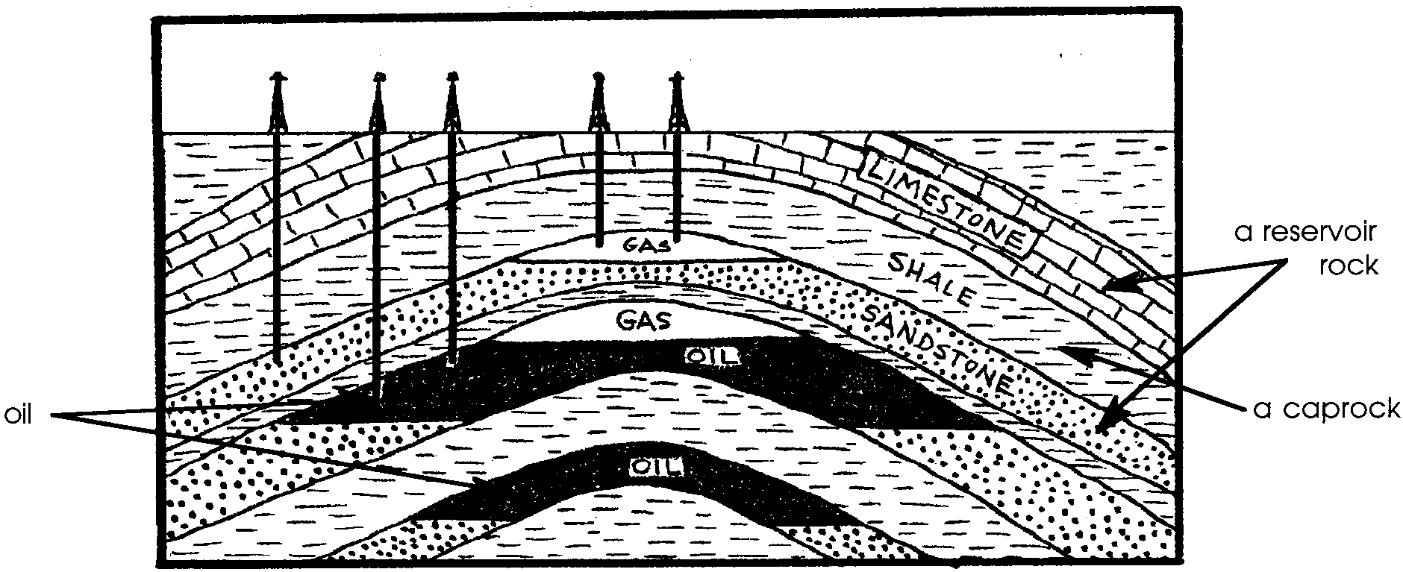

5. The explosions produce sound waves which travel downward through the seabed rocks. Each layer reflects the wave to a different degree. The variations in the reflections show the structure of the rocks beneath the sea.
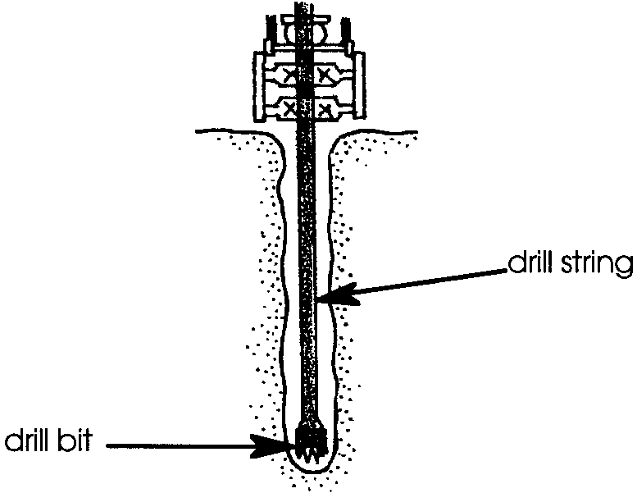
6. The drawing on the right shows a correctly labeled drilling rig.

7. The four types of oil exploration rigs mentioned are:

a. template rig

b. jack-up rig

c. semi-submersible rig

d. drill ship rig

8. A production platform has fewer/more wells than an exploration platform. (The correct answer is underlined).

9. One item, mentioned in the text, oil companies must buy for offshore drilling is a fleet of work boats. Offshore rigs also have to provide food and housing for the workers.

10. Two methods used to transfer oil and gas to shore include:

a. pipeline

b. tanker

11. While answers will vary, most will state that bad weather will make tanker loading more difficult thereby increasing the likelihood of oil spills.

12. Four possible places spills could occur in the oil production process include:

a. at the wellhead on the sea floor

b. at the wellhead on the platform

c. during on-platform processing

d. during shipping from platform to tanker or pipeline

e. during transfer from pipeline to tanker

f. during transfer from tanker or pipeline to refinery.

Who Needs Energy?

Why do we need to drill under the seas for oil? How does the energy from oil affect our lives? Let’s begin to answer these questions by filling out the personal energy profile below.
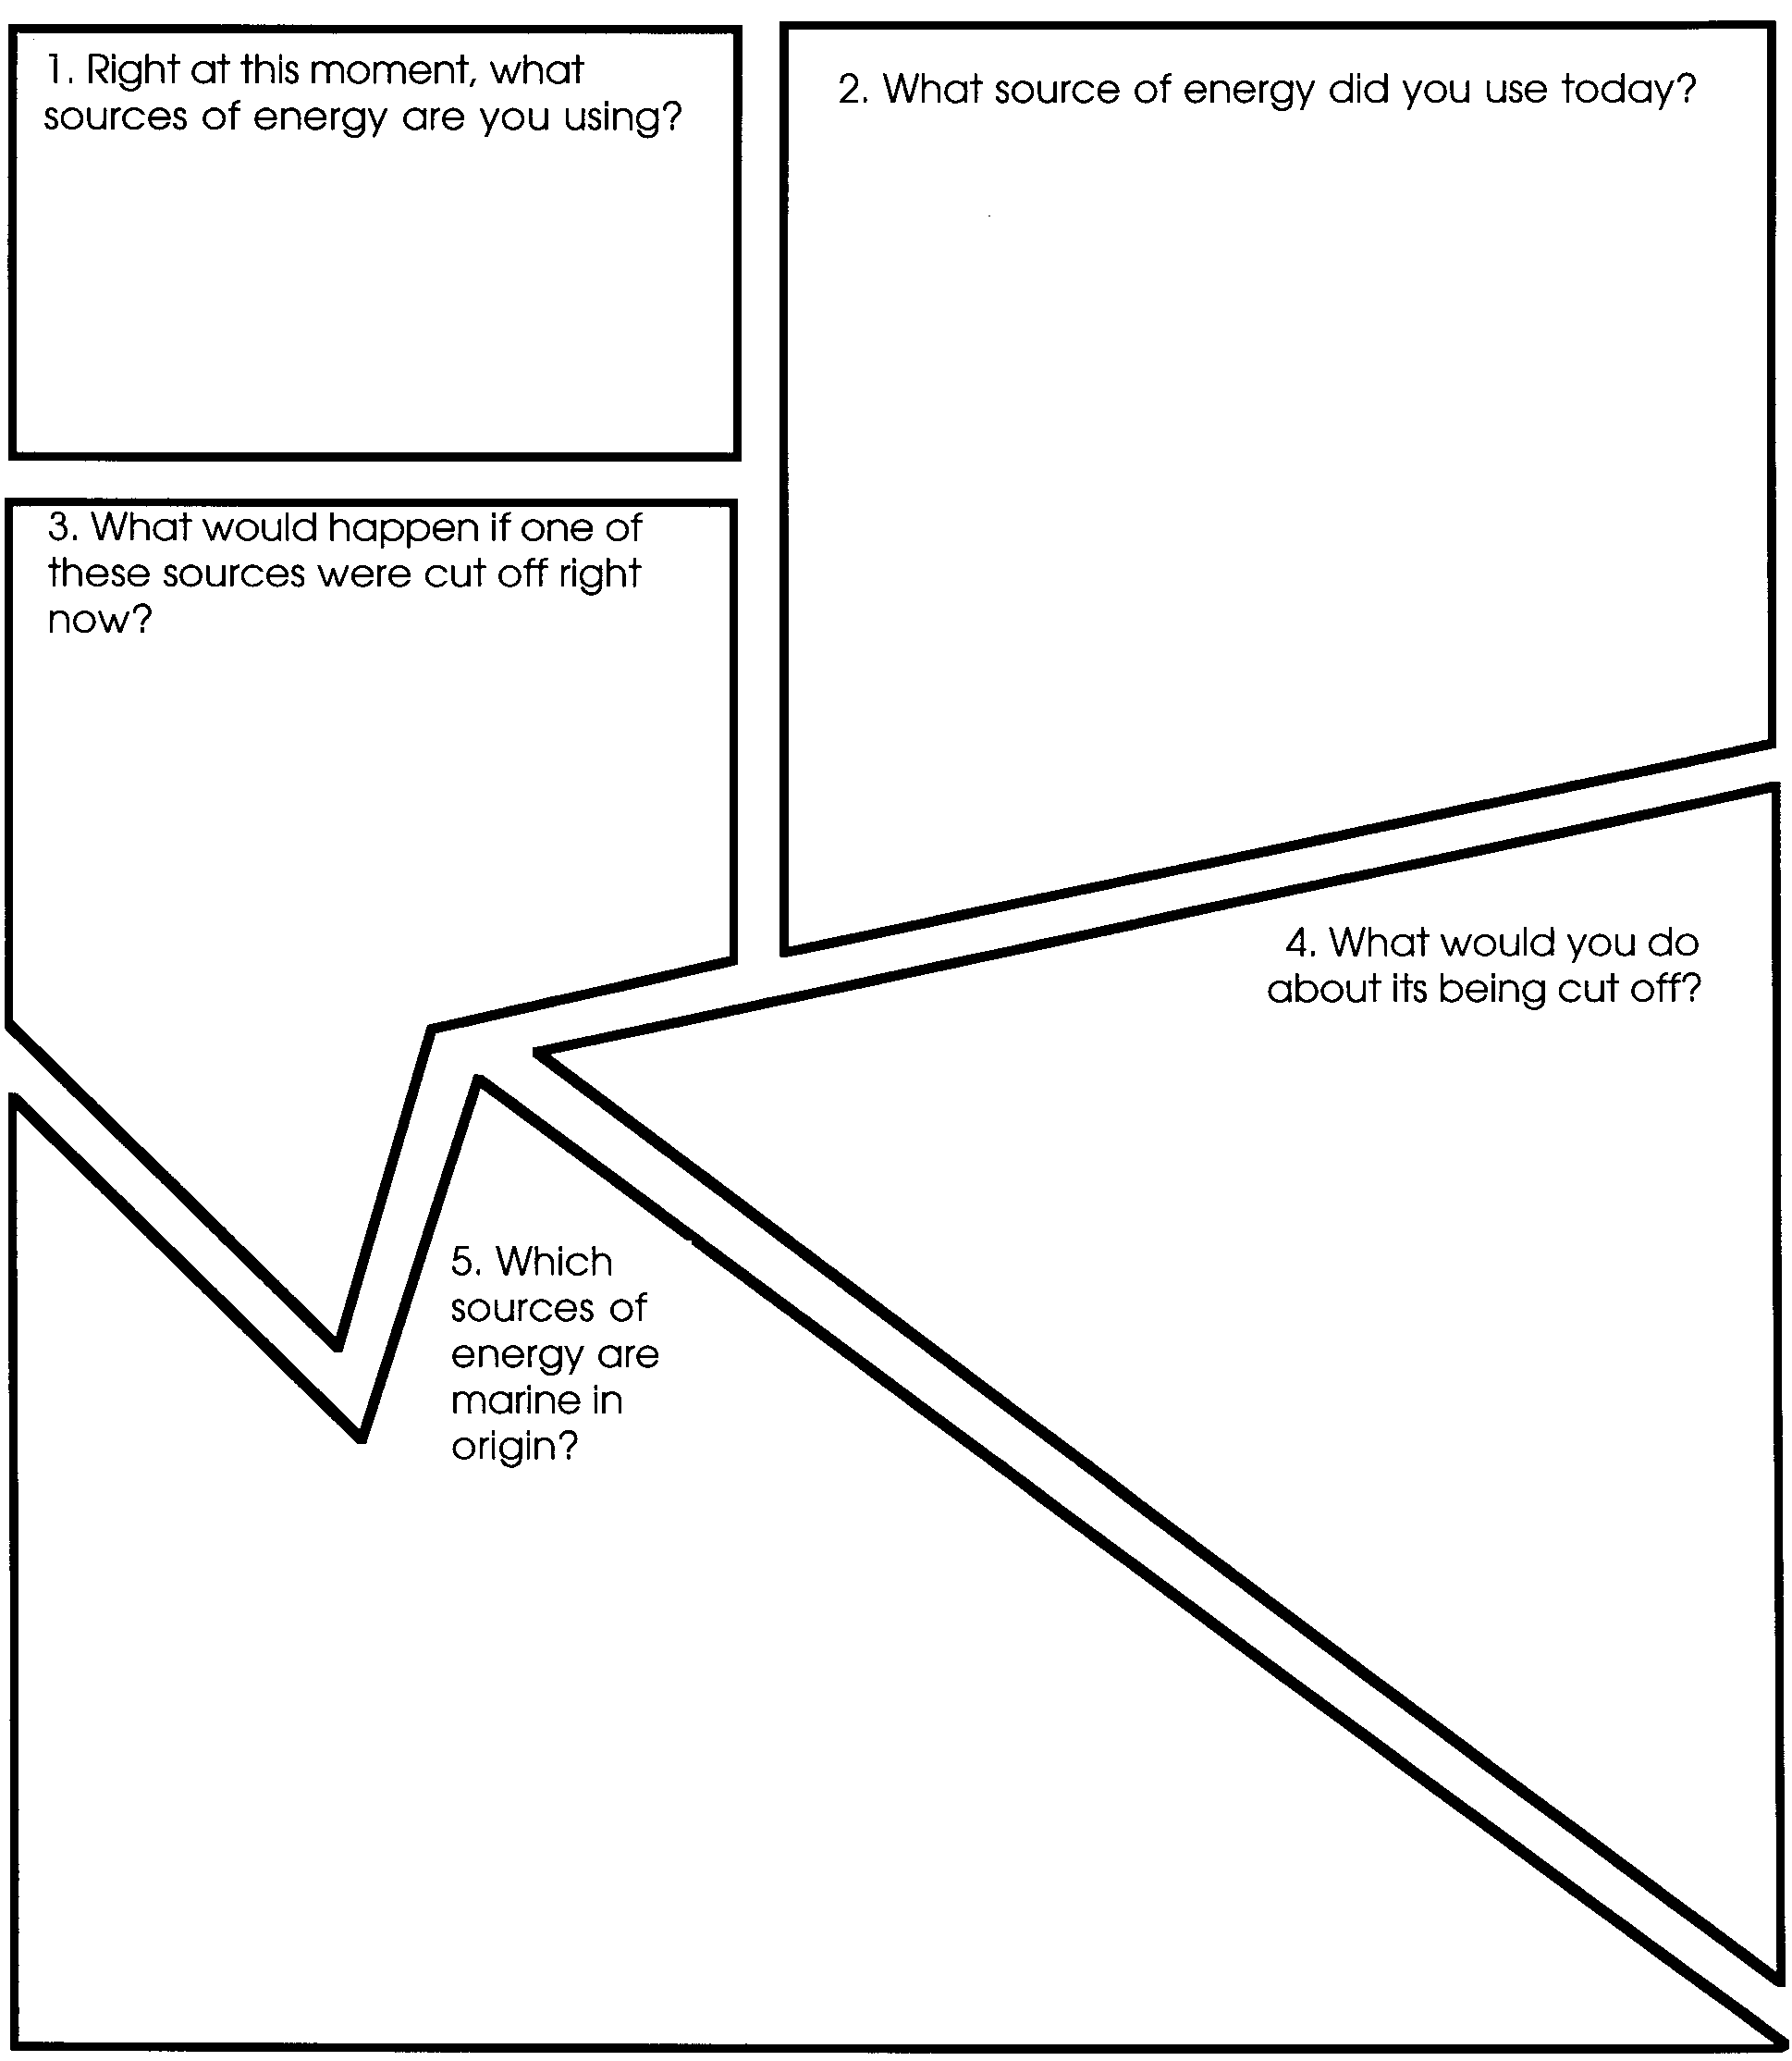
It Came From Beneath the Sea

No question about it. We use energy from oil every day. We are an “oil-based” society. People traditionally think of the harvest of the sea in terms of food. Recently, attention has been turned to another harvest: the harvest of the minerals that lie beneath the sea. An estimated 26 percent of the world’s known oil reserves are submerged beneath the seas. Some experts think exploration will greatly raise that percentage. An increasing amount of the world’s oil will be drawn from beneath the ocean. The end of the oil age will occur when the oil in the deeper parts of the ocean is exhausted.

1. Experts think that more than/less than 26 percent of the world’s known reserves will come from beneath the seas. (Circle the correct answer).

Oil has seeped from the sea floor off the coast of California since long before the first Europeans arrived. For centuries this seeping oil was considered a nuisance. As on shore oil became more difficult to locate, explorers looked to the sea. Recalling the oil seeps, the area near Santa Barbara, California, looked promising.

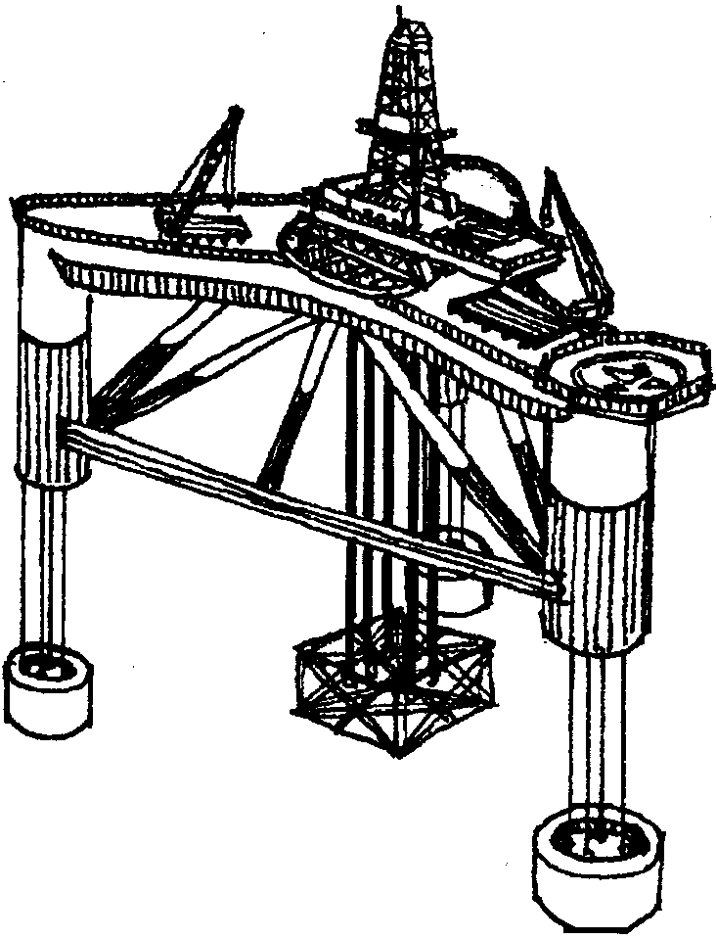
Before wells could be drilled many problems had to be solved. The first offshore oil wells were drilled from rigid platforms built in shallow water.

The next development in offshore oil exploration happened in the Gulf of Mexico. During the summer and fall of 1947, the first undersea well was completed from a mobile (moveable) platform.

Exploration for petroleum is taking place on all continental shelves except the Antarctic. There is an increasing demand for oil. As a result it is important to know the success rate in finding new fields. It is also important to know the time involved in the discovery, and the development of the field for production. This knowledge is important in predicting the role of offshore oil in future energy supplies. Of course, the major problem still is that we do not know where oil is located. Many wells that are drilled find no oil. To tap more underwater oil deposits, wells will have to be drilled in deeper water. It now costs seven times more to drill for oil offshore than on land. As drilling begins in deeper water, the costs rise even more. Even if there are large submerged oil deposits, they will be expensive to develop.
3. Solar power now costs more than oil power.

a. As we are forced to go deeper for oil what happens to the cost of the oil?

b. In the future, the difference between the cost of solar power and oil power will be more / less. (Circle the correct answer).

The Search For Oil

All the world’s major oil fields on land have probably been found and are being worked. It is the oil that lies underwater that interests us. Petroleum, or oil, comes from the decay of ancient marine plants and animals.

Both on and offshore, explorers for oil are looking for the same types of rocks and structures. They look for:

a. a source rock rich in plant and animal remains.

b. a reservoir rock (sandstone or limestone) into which the oil and gas can move.

c. an impermeable (non-leaking) seal or caprock (shale or salt) for the reservoir. The caprock traps the oil or gas in the reservoir.
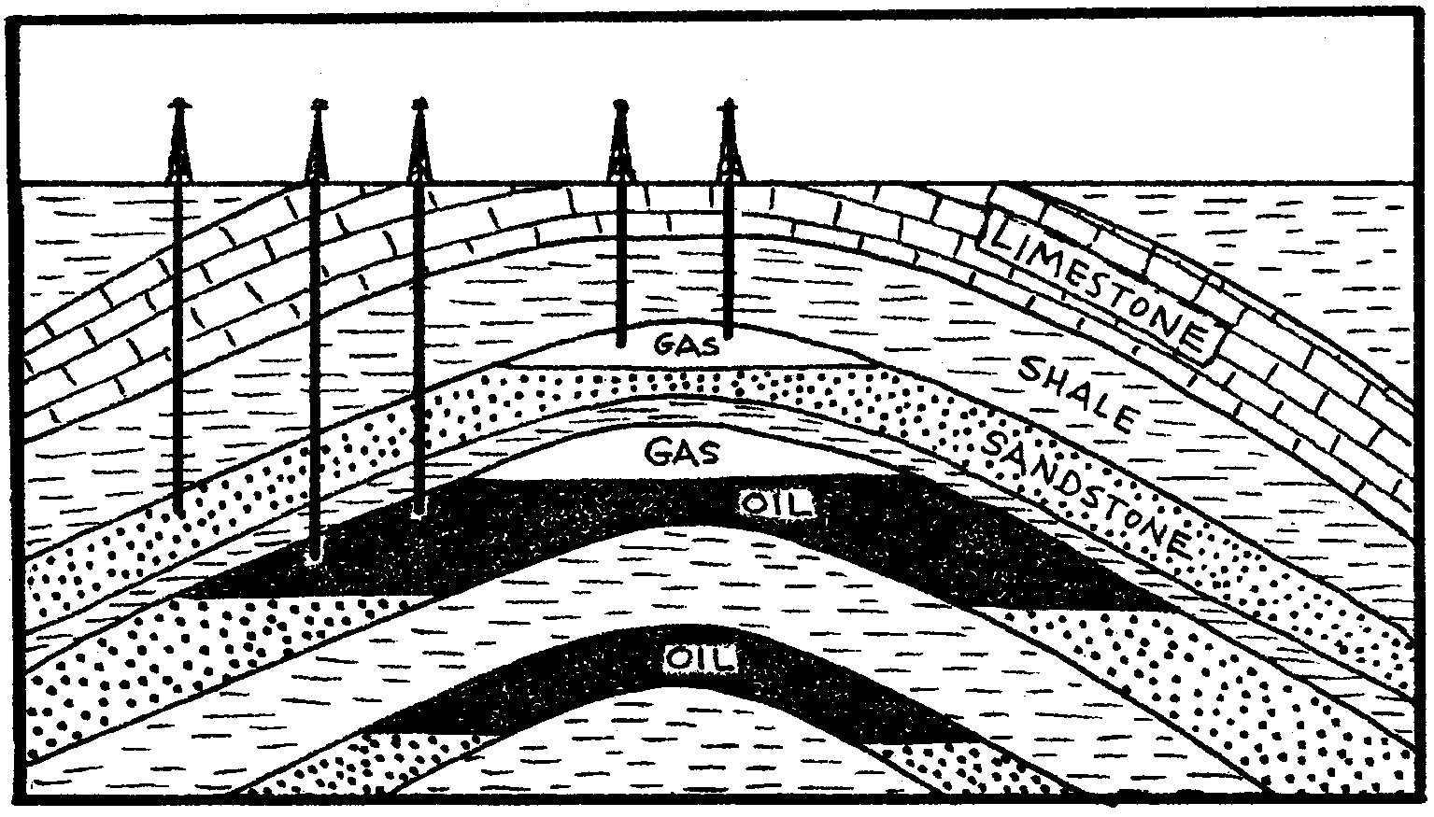

4. On the drawing above label the three features necessary for oil production:
a. oil
b. a reservoir rock
c. a caprock or seal rock
Geologists searching for oil set off controlled explosions on the surface of the sea. The sound waves from the explosion move down through the seabed rocks. Each layer reflects the wave to a different degree. A series of instruments, called hydrophones, record the sound waves. The variations in reflections show the structure of the rocks beneath the sea. This process is called a seismic survey.

5. How do explosions help geologists determine the structure of the rocks beneath the sea?

Drilling For Oil

Experts study the results of the seismic survey. If they think the chances of finding oil are good, they drill a well. A well is really a deep hole and is the only way to determine the presence of oil.

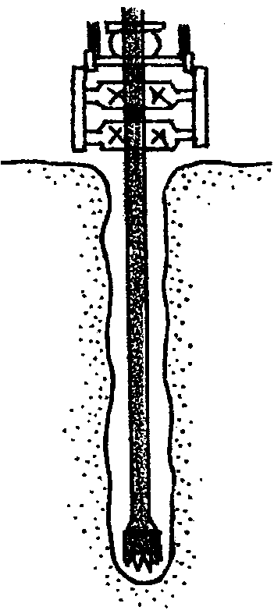
The majority of the holes drilled contain only water or uneconomic amounts of oil. A drilling bit is used to cut through the rock. The bit is connected to a pipe called the drill string. Engines drive the drilling bit into the earth. Pipes are added to the drill string as it goes down. Mud and rock come up the drill string. If the drillers find oil, it rushes up the drill string. To keep the oil from gushing uncontrollably up the pipe, drillers use complex systems of pressure-control devices. Just discovering oil proves nothing. What counts is the amount and accessibility of the oil. Engineers test to see whether a field is worth commercial exploration. If it looks promising, more wells will be drilled. These wells are placed to determine the size and shape of the field.

6. On the drawing to the right, label:
a. the drill bit
b. the drill string

Drilling in the sea requires special equipment. Before 1953, offshore drilling rigs were confined to shallow waters. The development of the “jack-up rig” allowed exploration in water up to 300 feet deep. The legs of the jack-up rig sit on the bottom of the sea. Workers can make its legs taller or shorter.
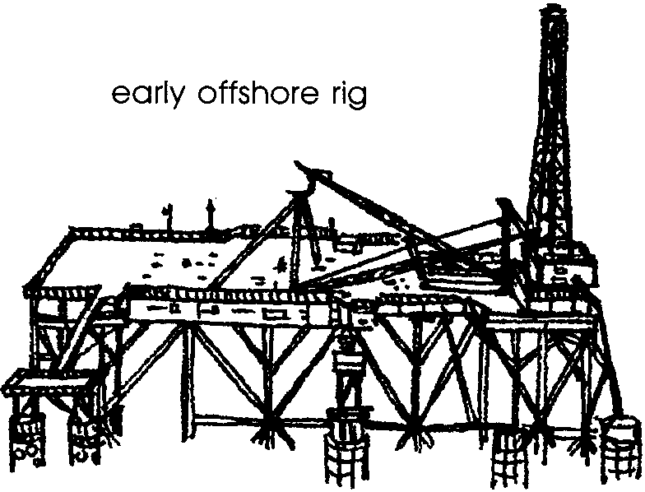
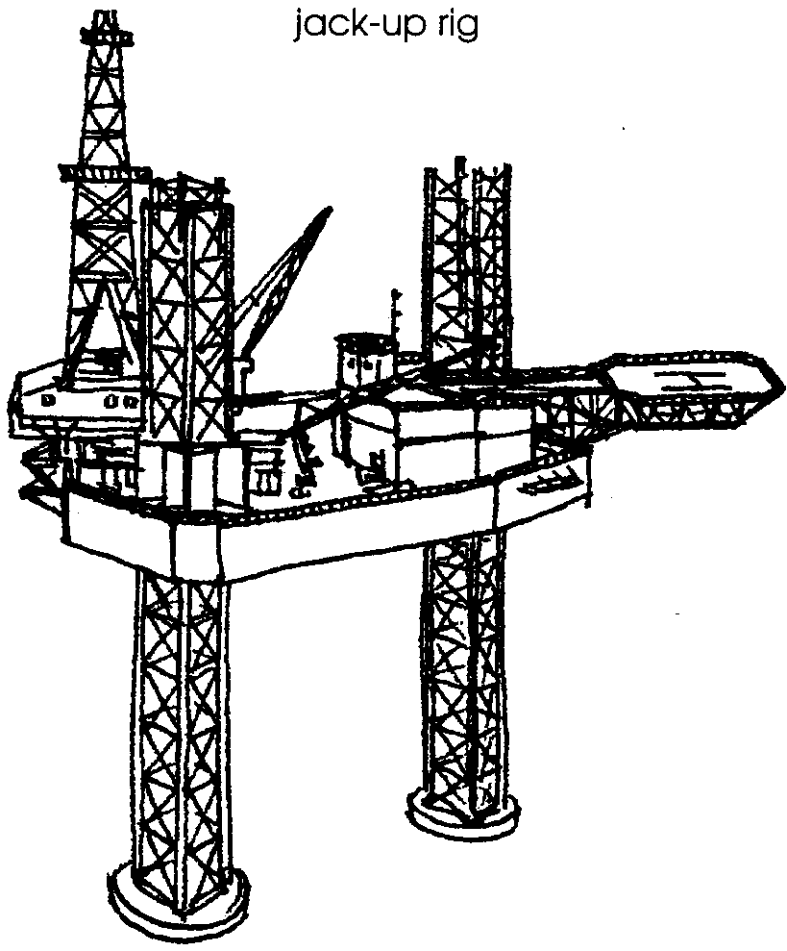

In 1962 there was another breakthrough, the semi-submersible rig. Special legs, filled with air, let it be floated out to the drilling site. There it is held in place with anchors.
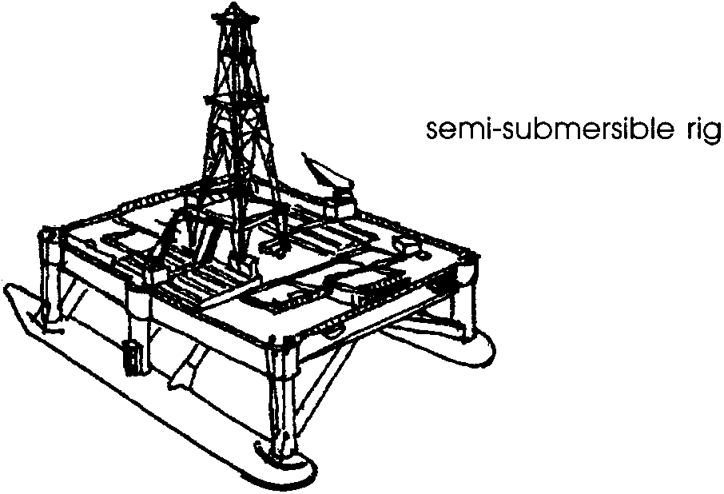

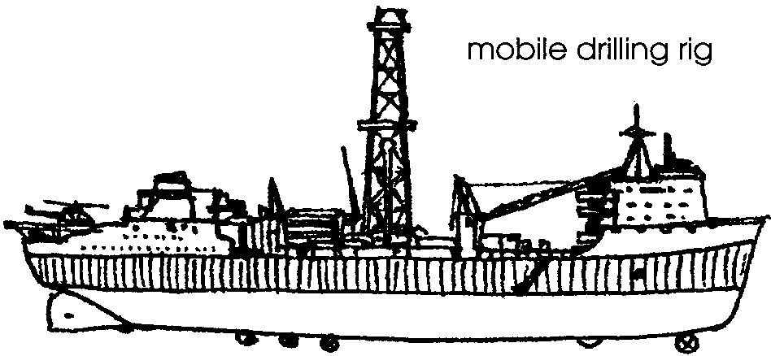
In 1971 the first modern drill-ship was used. It has a derrick (drilling tower) built on its deck. The drilling bit and the drill string go through a hole in the bottom of the ship. Other drill-ships had been in use for nearly 20 years. This advanced type is able to stay over a well in deep water by using directional propellers. These mobile drilling rigs are sent all over the world.
7. What are four types of oil exploration rigs?
a.
b.
c.
d.

In the ocean, these drill rigs determine the size and shape of the field. Oil company experts then decide whether to develop the field. Development means several years of costly drilling from a fixed platform. Plans must also be made to move oil from the well to refineries.

Drilling For Production

Drilling for production is expensive. A production platform must be built to support drilling equipment for several wells. The platform must also hold oil and gas processing equipment. In addition, it must be strong enough to last for 30 years. The base of the platform is built on land. It is pulled out to sea on its side by tugboats. At the well it is turned over and set in the sea. Next the production platform is built. Cranes on barges put the decks in place. They also lift buildings, a drilling derrick, and processing equipment onto the platform.

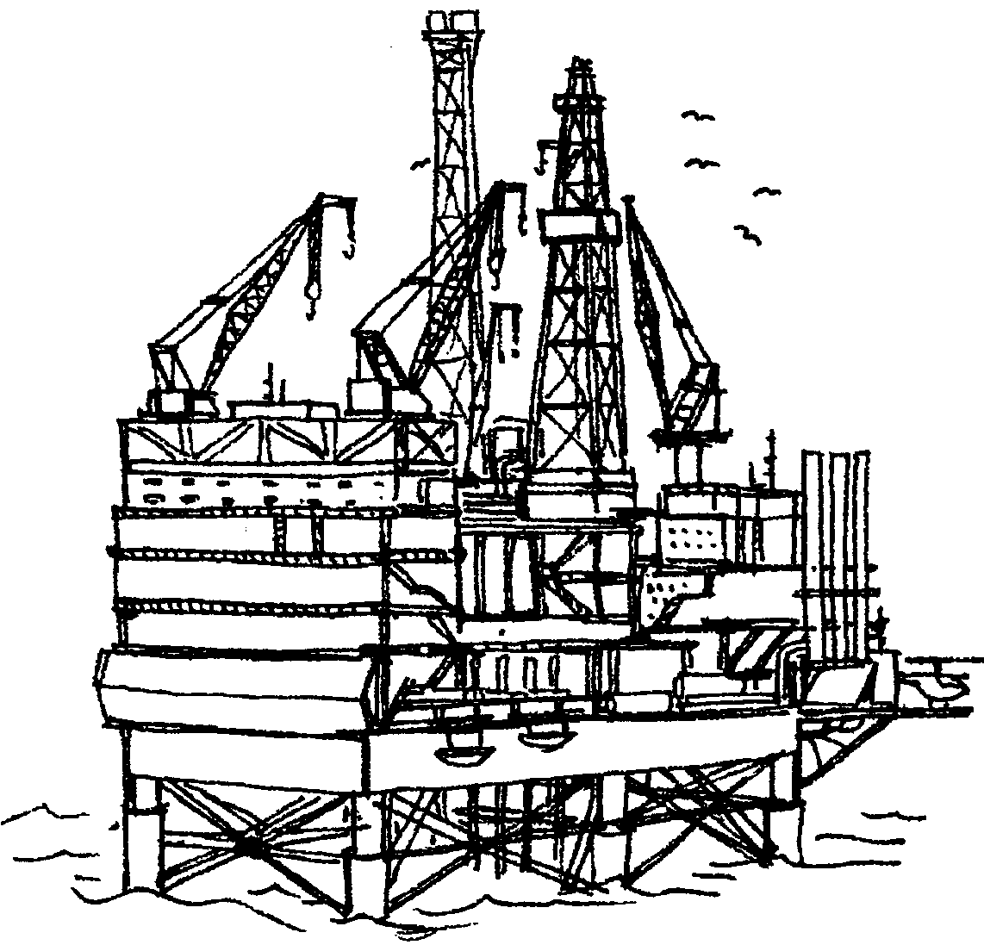

8. A production platform has fewer / more wells than an exploration platform. (Circle the correct answer.)
The production platform is like a factory. Everything needed to get oil up from the well and ashore is on board the platform. When the platform is ready, the wells are drilled. The biggest modern platforms may have two derricks drilling simultaneously. These big platforms have double crews working round the clock. There may be living quarters for as many as 140. As many as 60 wells may be drilled outward from each platform. A fleet of work boats and helicopters bring in pipe, casing, cement, mud, workers, fuel and food.

9. Drilling oil wells is very expensive. Offshore wells are more expensive than land wells. What is one item oil companies must buy for offshore drilling they don’t buy for land drilling?

After the wells are drilled, the production equipment is put in place. This includes a complex group of control valves. The valves, called the Christmas Tree, shut off automatically if there is any damage to the well. On the deck of the platform the various parts of the crude-oil or gas mixture are separated. The oil and gas are transferred to a tanker or pumped through a pipeline to the shore. Once all the equipment is working, the complete platform can be automated. The platform may then be controlled from a computer onshore. Production platform installation takes 6 to 8 years.

10. What two methods are used to transfer oil and gas to shore?
a.
b.

Getting The Oil Ashore

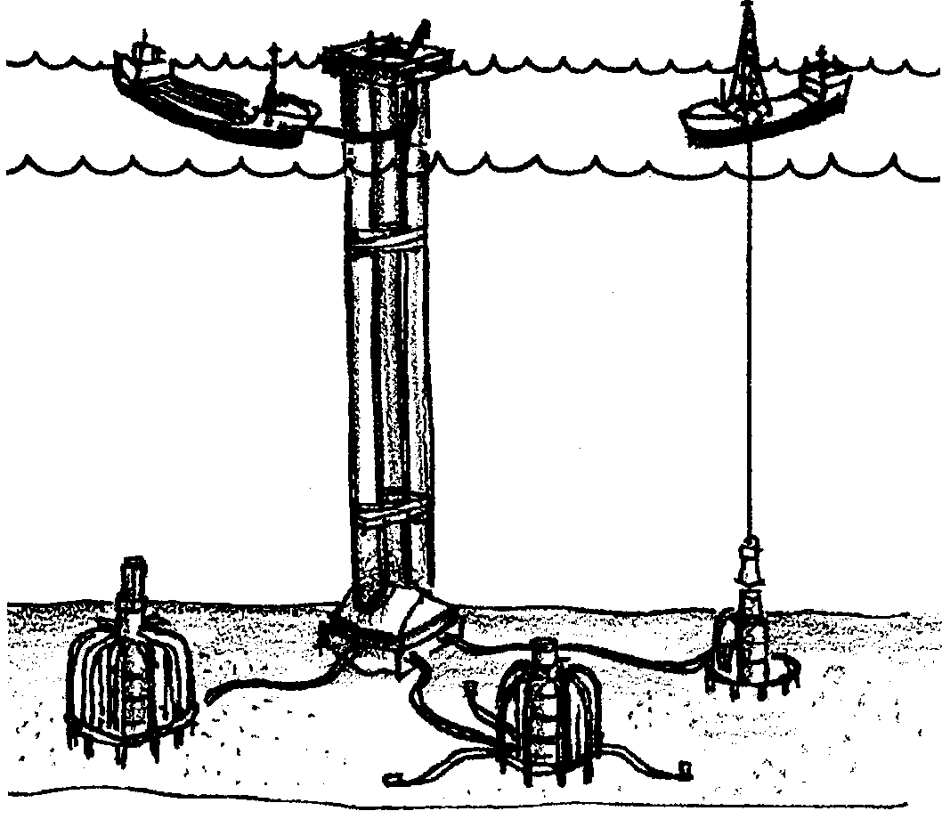
Wells have been drilled. Oil and gas are flowing to the platforms. The next challenge involves transporting the crude oil and natural gas from the offshore wells to coastal areas. Within a field, pipelines are usually laid from all the platforms to a central point. These pipelines are under water. From the central point, a pipeline to shore may be laid. If the field is far offshore, the oil is taken to shore by tanker. Tanker moorings are anchored to the sea bed. A floating hose carries the oil from the sea bed through the mooring buoy to the tanker.
11. How do you suppose bad weather affects loading oil on tankers?

When the oil reaches shore, it moves to refineries. Refineries process the crude oil into gasoline, heating oil and many other products. That quart of oil you buy at the store has a very long and complicated history. It’s had its beginning as living plants and animals. Many hands have worked to produce the oil. Much money has been spent to find and make it. Please use the oil wisely.

12. Oil production is complicated. There are many places where oil spills can occur. List four possible places where spills could occur.
a.
b.
c.
d.

