The Bountiful Bay Game - Use vs. Abuse

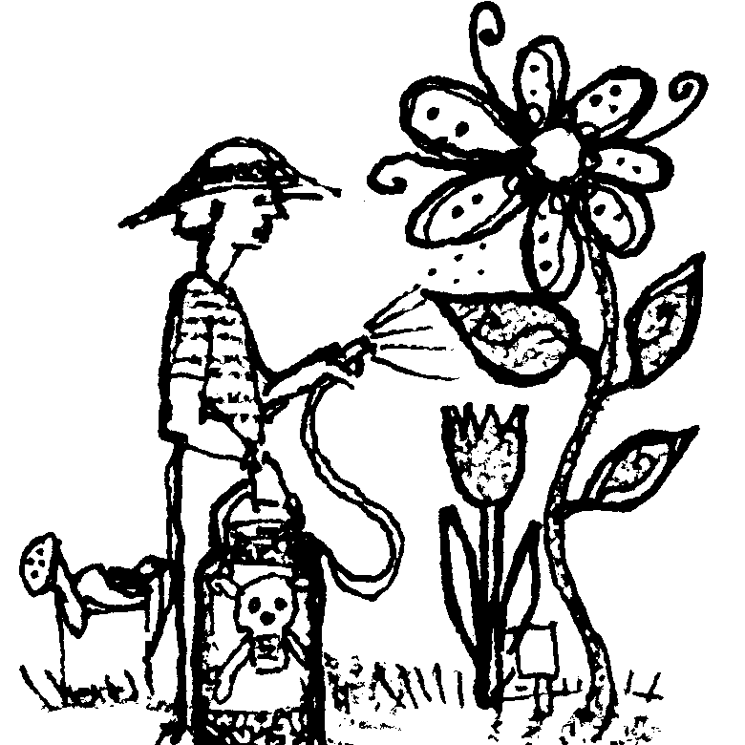
Key Concepts
Written by Judy D'Amore, Marine Science Centers, Port Townsend and Poulsbo, WA. Adapted from The Lake Superior Game, by Barbara Liukkonen, printed in Lacustrine Lessons, Sea Grant Extension Program, University of Minnesota)
1. Each of us is constantly making decisions which affect the condition of our natural environment.
2. Sometimes our decisions have consequences we can’t foresee at the time. Often it is an innocent person, or the environment itself that suffers the consequences.
3. Our economic system frequently rewards actions which bring short-term gain instead of behaviors which are in our best interest over the long-term.

Background

“The Bountiful Bay Game” employs an interactive game format which has been used successfully to call attention to water quality issues in watersheds around Puget Sound and Lake Superior. It is presented here in a more generic form, featuring an imaginary bay, named “Bountiful Bay”, which is experiencing some regional issues and conflicts not too dissimilar from what many communities are facing in real life. Although Bountiful Bay is a salt water bay, the problems experienced in this parable put watershed issues into a larger perspective: peoples’ actions often affect more than their local watershed. Impacts are passed downstream to watersheds below, ultimately reaching the salt water bays which receive the water in the end.

After playing the Bountiful Bay game, students may want to use the same format to create a game which highlights water quality issues of their own regions.

In “The Bountiful Bay Game”, students participate in a simulation in which they assume roles of individuals who, like us all, use and have an impact on water. While fulfilling these roles, the students take actions appropriate to their roles, actions which alter the water quality in some simulated water bodies. One of these is a 10 gallon aquarium filled with water, representing the salt water bay in the game. Other props are water-filled plastic cups which represent rivers draining into this bay. Over the course of the game, the water quality will inevitably change, graphically illustrating the impact each of us has on our water resources.
During the course of the game, contaminants will be introduced to “Bountiful Bay” and its tributaries. Contaminants will include food coloring, dirt (representing siltation), confetti (trash) and a solution of ammonia and water (an invisible contaminant). At several points in the game students will need to test the water quality. Three different water quality tests will be used in the game:

• Comparing a water sample to a pre-mixed color standard. When the water sample is darker than the standard, it is considered to be contaminated.

• Lowering a secchi disk from the surface and recording at what depth it is no longer visible. A secchi disk is a standard piece of water quality equipment used for measuring the turbidity or cloudiness of the water.

• Testing the pH of the water with litmus paper. As the ammonia solution is added, the pH will rise in Bountiful Bay. For the purposes of this game, students do not need to understand the meaning of pH. This test is used strictly as a convenient method for sampling an invisible contaminant.

Some students will also have the opportunity to try catching fish. They will find that as Bountiful Bay’s water becomes darker, catching fish on the bottom becomes much more difficult.

The Bountiful Bay Game is both whimsical and serious. Do not worry if your students take the game lightly as it is played. Its message will be clear no matter what choices are made, and regardless of the spirit in which it is played!

Materials

For class of 32:

• An open, carpeted area indoors, or a flat, concrete area outside, on which a large map of Bountiful Bay and its tributaries can be drawn with chalk or masking tape. (A good alternative is to make a permanent map on a piece of plastic tarp. This is quite easy if you make a transparency of the original map, tape the tarp to a wall and trace around a projected image of the map on the tarp.)

• A 10 gallon aquarium, filled with clean water to represent Bountiful Bay.

• 8 clear plastic cups, each labeled with the name of one of the rivers in the game

• A bottle of blue food coloring, with dropper. This is the“Colored Contaminant”.

• A solution of 1/2 cup ammonia in 1/2 gallon of water. This is the “Clear Contaminant”.

• A cup of fine dirt and a tablespoon measure.

• A few tablespoons of paper “confetti” (made with a hole punch).

• A clear plastic or glass container (about 1 cup) for taking water samples. Label this cup “Water Sample”.

• An identical container of tinted water, labeled “Water Quality Standard”, to use as a standard for comparing the extent of pollution. One drop of food coloring in 1 1/2 quarts of water makes a good water quality standard.

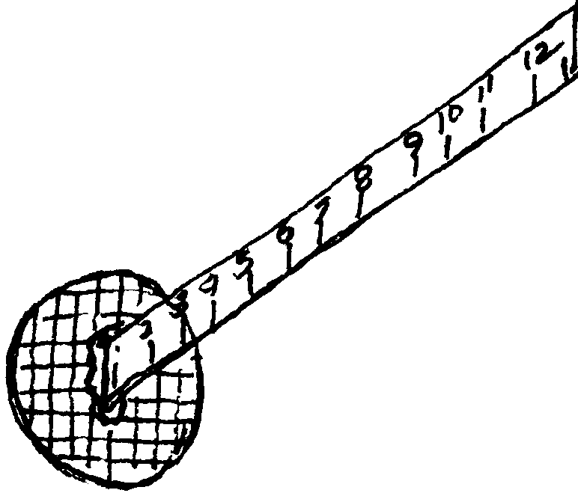
• Miniature secchi disk for measuring water turbidity. Run a sheet of transparency film through a xerox machine to print a simple pattern or small printed message faintly onto the film. Cut out a 2" circle of the film containing the printed pattern and use a thumb-tack to attach it to the zero-end of a wooden ruler.

• Litmus paper, range 6-10, with color key.

• “Fishing pole” made from a stick, a piece of string, and a paper clip bent to form a “hook”. (Test the fishing pole yourself before the game to make sure the hook hangs at an angle that can catch a fish.)

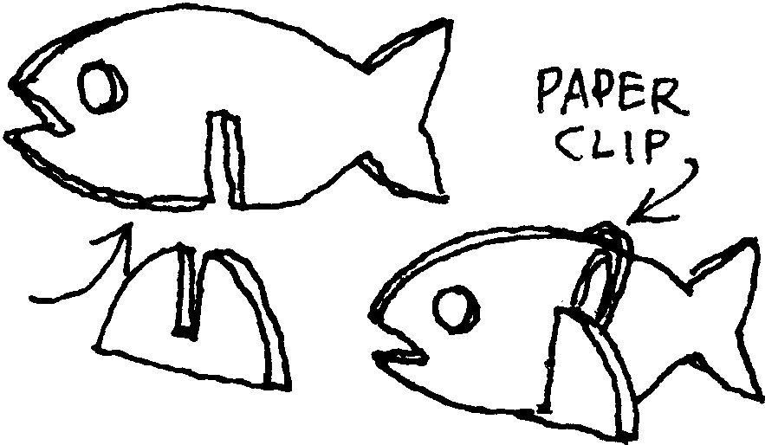
• 10 plastic “fish”, cut from a coffee can lid or other piece of flexible plastic, and slotted to fit into bases so that they stand upright. (See diagram.) Punch a hole in each fish so that it can be caught from above with the hook. Weight each fish with a paper clip so that it will sit on the bottom of the tank.

• A container labeled “Resource Savings Bank”, or some other appropriate title. You will use the bank when collecting the students’ payments.

• One class set of student role cards.

Materials continued on next page...
For each student:

• 10 money units (M & M’s, Reese’s Pieces, fish crackers, etc.) in paper cup or envelope. For a typical class one pound size bag of M & M’s is sufficient, though you’ll need two if you use M & M’s Peanut. (Some teachers use paper certificates redeemable for candy at the end of the game.)

• class set of Bountiful Bay student questions.

Teaching Hints

Before the activity:

1. Create the game setting. Have some of your students draw the game setting on the floor with chalk or masking tape. Or, if you have made a map on a tarp, simply spread it on the floor.

2. Fill each plastic cup with water and place it on the appropriate river on the floor map.

3. Fill an aquarium with clean water, label it “Bountiful Bay”, and place it near the map. (Many teachers like to put it on a rolling cart so it can be easily moved aside if the game needs to be continued another day.) Arrange six fish on the bottom of the aquarium. Position the contaminants, the water quality testing equipment, the fishing pole and the remaining fish near the aquarium.

4. Prepare the Water Quality Standard: one drop of food coloring in about a quart and a half of water. Pour some into the cup labeled “Water Quality Standard”.

5. Mix up Clear Contaminant: 1/2 cup of ammonia in 1/2 gallon of water.

6. Duplicate and cut the role cards if necessary.

7. Count “money units,” place 10 per student in paper cups or envelopes.

8. Copy Bountiful Bay student pages.

When students arrive:

1. Introduce your students to Bountiful Bay, an estuary. (Explain briefly that an estuary is a saltwater bay that has freshwater rivers or streams running into it.) Bountiful Bay is a beautiful salt water bay known for its excellent fishing, crystal clear streams and spectacular scenery. Tell them that over the years, its small towns have become cities, many new business have moved into the area, and people are buying property along its shorelines. They, the students will be playing the roles of many of the people who live, work and play in the watersheds which flow into Bountiful Bay.

2. Point out each part of the setting and equipment for the Bountiful Bay game.

3. Explain and model each of the three water quality tests, noting the status of Bountiful Bay’s water before the game begins:

a. Take a water sample from the aquarium in the clear “Water Sample” cup. Compare it to the Water Quality Standard.

b. Lower the secchi disk into the water and see if you can see the disk 6 inches below the surface.

c. place a few drops of water on a piece of litmus paper and compare it to the color key.

4. Distribute a role card and 10 pieces of “currency” to each student. (If you have fewer than 32 students, assign some students more than one role.)

5. Have students read their cards silently and consider the decision and/or action they will take. Have them note the number on the corner of their card. This is the playing order of the game.

6. To play the game, each student, in turn, reads her role aloud and announces any decision she makes in that role. Then the student performs the action called for on the role card: polluting the water, paying money, sampling water, catching fish, calling for a class vote, etc.

7. Many issues will be raised as the cards are read. Feel free to take some time discussing them before moving on. Some issues may be familiar to students, but others might require clarification.

8. After playing the game, have students answer the questions on the Bountiful Bay student page.

Note: The Bountiful Bay Game takes approximately 90 minutes to complete. If your class periods are shorter, you will need to interrupt the game and save all props for the next day. Students cards and money can be saved in labeled envelopes, river cups and other materials can be stored on a cart, along with the aquarium. If you plan to do this activity with more than one class a day in periods of less than 90 minutes, you will need an aquarium and river cups for each class.

Key Words

non-point source pollution - contaminants which are placed in the environment by individuals; non-point source pollution is often difficult to locate and correct

point source pollution - contaminants which enter the environment from a single source, such as the outfall of a city’s sewage treatment plant or a factory

watershed - all the land which drains water into a river or other body of water whenever it rains or snows

Extensions

1. Create Your own Game: After playing the Bountiful Bay Game, have your class brainstorm and research issues which are specific to their own region or community. They can then write an interactive game of their own using the Bountiful Bay Game as a model: i.e., the Great Salt Lake Game, the Delaware Bay Game, the Missouri River Game, etc. Developing a game based upon regional issues and then teaching it to younger students or other groups within the community can be an extremely rich and challenging experience for students.

2. Environmental Detectives: How do people in your community use and impact water resources? The following activity was designed by educators at the Port Townsend Marine Science Center to help students examine waterfront activities in and around the community’s port which might be adversely affecting the region’s water quality. Perhaps you can find a way of adapting this model to help students explore issues important in your own community.

Preparation:

Teachers prepare by contacting individuals and business people working at the port who are willing to spend some time giving young people a background on how they make their livings at the port, providing information on some environmental issues connected with their work, and discussing how they deal with these issues. These resource people include fishermen, fish processors, boat builders, and other people involved in other marine related industries. The quality of the experience for students depends greatly on the ability of these individuals to hold the students’ interest. They are therefore chosen carefully and given due acknowledgment for their time and effort.

Students prepare by discussing what their own parents do for a living. They consider the fact that as their own parents make a living at a particular location, most of the people they will talk to at the port are earning a living there. Students discuss how to ask questions with a spirit of tact and respect.

With these considerations in mind, students can brainstorm questions they hope to answer about how hazardous materials are handled at the port.

Port Tour

The day of the port tour, students and adult helpers walk through the port as a class, meeting resource people at designated times, stopping to speak to others informally, or to investigate the marine life growing on pilings and docks. The goal of this portion of the day is simply to gather information. For example, students learn about the differences in anti-fouling bottom paints for boats, the proper and improper disposal of sewage generated on boats, the problems raised by engine oil when it leaks from a motor into the bilge of a boat. They learn that many of these problems have no easy answers. Hopefully they also discover that people usually approach water quality issues with good intentions.

After lunch, students are given pencils and clipboards, and sent off in small groups as conduct their own investigations. They become “Environmental Detectives”, in search of potential water quality hazards. They look for such evidence as oily rags, paint brushes or paint chips on the ground, unlabeled barrels containing hazardous materials, oil slicks, or signs of raw sewage. Over the years, students have reported all of these. Students are of course reminded to conduct these investigations with tact and discretion.

While students search for “clues”, their teachers stay in the area, but they do not take an active part in the investigations. At the end of the designated time, students reconvene and eagerly share findings. Results are compiled and students discuss possible actions to take. Actions suggested over the years have included reports to the port administration office, letters to the local newspaper, and informational posters created by students for public education around the port. On one occasion, students reported excitedly that they had seen a can of TBT anti-fouling paint, an especially toxic material which had been banned for a number of years. This report triggered an investigation by the port and the Washington Department of Ecology for the origin of this can of paint, an outcome in which students felt ownership and satisfaction.

Although “Environmental Detectives” has proved a rich and valuable experience for students, on occasion it has sparked criticism. These incidents have come about through the perception by some groups that students were being given a biased picture of issues, or that some perspectives were simply not presented. To avoid misunderstandings and to insure that students really are seeing all sides of issues, it has been extremely important to invite the participation of all groups active at the port who might have such concerns to take part in planning or implementing this program. By taking these precautions, misunderstandings have all but disappeared, and community support for the program has strengthened.

This model has been duplicated successfully by teachers in other waterfront communities. We hope you will let us know of novel ways you have been able to put this model to use in your own community.

The Bountiful Bay Game was adapted from The Lake Superior Game, by Barbara Liukkonen, printed in Lacustrine Lessons, Sea Grant Extension Program, University of Minnesota)

Answer Key

1. Answers may vary.

2. Long term costs include loss of one’s job or health because of water quality degradation.

3. a. The sewage treatment plant in Randal and the manufacturing company on the Jango River are both examples of point source polluters.

b. Answers vary depending on your region.

4. a. There are many examples of non-point pollution in the Bountiful Bay Game: the person changing his oil, the backyard gardener, the dairy farmer, the furniture repair shop, the people at the beach party, the vegetable farmer, the person painting her sailboat, etc.

b. Answers vary depending on your region.

5. Accept any thoughtful answer.

6. Many ideas for improving water quality are suggested in the game: recycling waste oil, disposing of hazardous substances properly, cutting back on use of fertilizers and pesticides, etc.
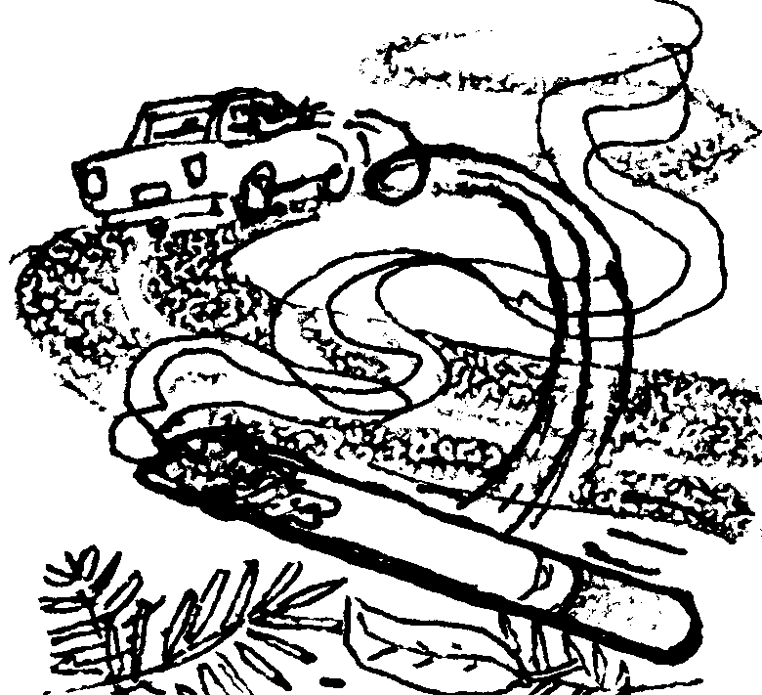
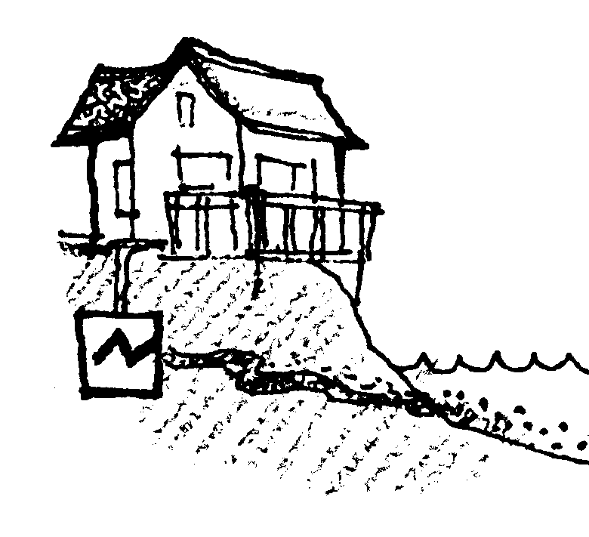
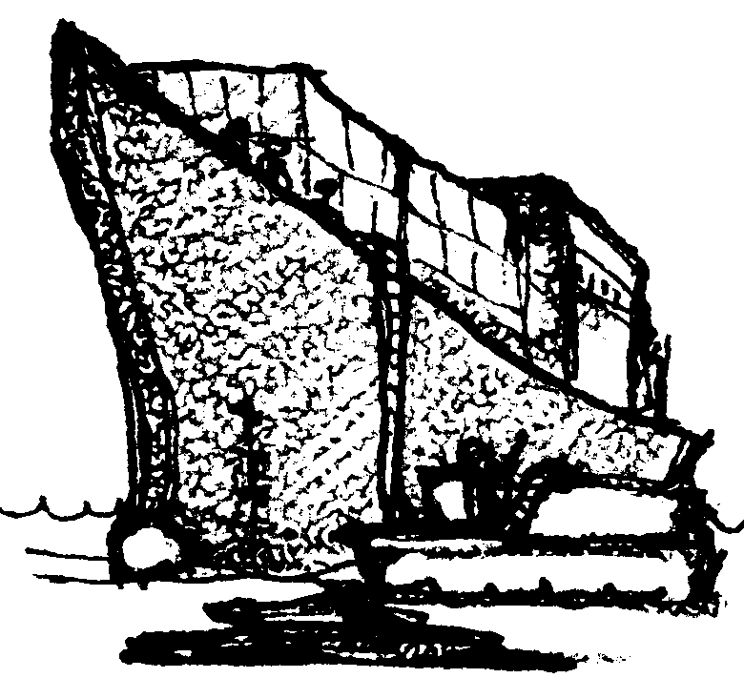

I am a careless tourist from Newport. I am driving through the Mystic Peaks Wilderness Area. I throw a burning cigarette out my car window. It starts start a major forest fire in the forest. Many trees are destroyed. With the trees gone, erosion is increased. Ashes and mud pollute the Ruby River watershed. Mud also washes into Bountiful Bay.

(Add 1 teaspoon of dirt to the Ruby River watershed. Also add 1 teaspoon of dirt to Bountiful Bay.)

I am the owner of a ship. It is now carrying products made in Japan to Europe where they will be sold. I need to refuel the ship in Bountiful Bay. I can call a fuel barge to meet the ship just inside Strawberry Spit. Or I can have the ship travel the extra distance to a fuel dock in Burlington. It will cost my company $10,000 more to take the ship all the way in to Burlington. In Burlington, there is equipment to catch any fuel we spill. On the other hand, we can save money by using a fuel barge. If we do, we may spill a little fuel near Strawberry Spit.

(If you choose to refuel at a well-regulated fuel dock, pay 5 pieces of “money”. If you choose to risk spilling some oil into Bountiful Bay, add 3 teaspoonfuls of clear contaminant to Bountiful Bay.)

I live near the Jersey River. My septic tank is old. It has been leaking into the river. This isn’t a problem for me. The well I use for my household water supply still has plenty of clean water. It’s sad, but people downstream have to live with my septic waste. It would cost me $500 to repair my septic system. I could sure use this money for a vacation I’m planning to Acapulco. I must choose. Should I pay to have my septic system fixed? Or, should I save my money and let it continue polluting the river.

(Either pay 1 piece of “money” or add 2 drops of color to the Jersey River and 4 drops to Bountiful Bay.)
1.

2.

3.

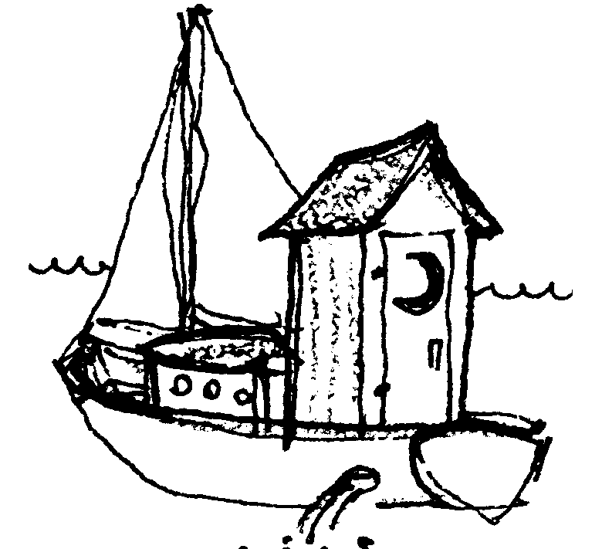
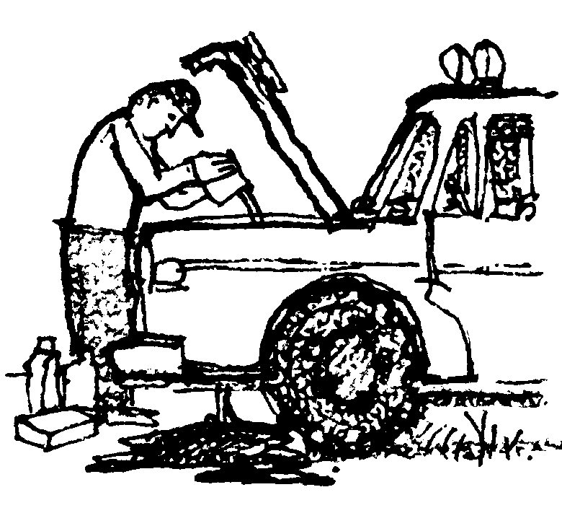

I live on Catalina Island. I work in Burlington. I have a sailboat at a nearby marina. I take my boat out whenever I can take the time off from my busy lifestyle. At the marina there is no sanitary pumpout station for emptying the holding tank from the toilet on my boat. I’m not willing to make a special trip to one further away. I just flush it when I get on the water. It saves me lots of time.

(Add 3 drops of color to Bountiful Bay.)

I live near Randal. When I change the oil in my truck, I just let it run into the ground. It probably seeps through the soil and pollutes the water in the Bay. I know that waste oil can be recycled at a service station nearby. I’m too lazy to do it.

(Add 4 drops of color to Bountiful Bay.)

I like to keep my lawn looking nice. I use lots of fertilizer, weed killer and insecticides. I can’t imagine what my yard would look like if I ever had to stop using these chemicals. I suppose it’s all washing into the Lacey River, since that’s the watershed I live in.

(Add 1/2 teaspoon of clear contaminant to the Lacey River. Also add 1 teaspoon to Bountiful Bay.)
4.

5.

6.

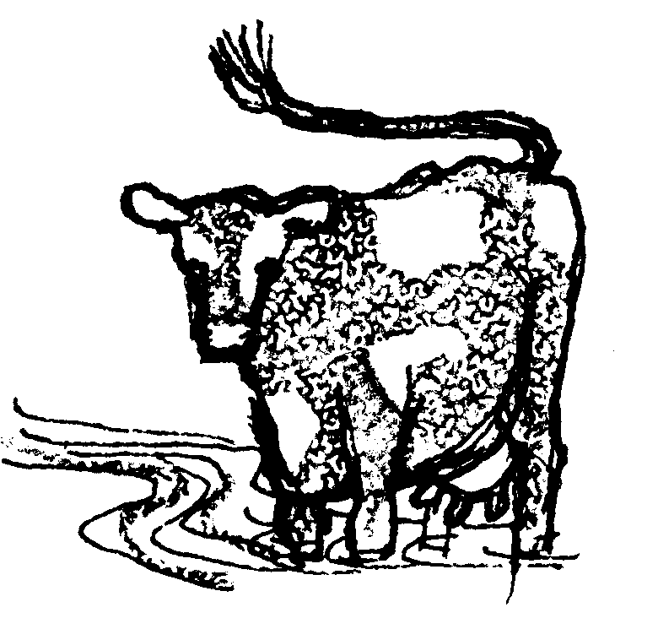
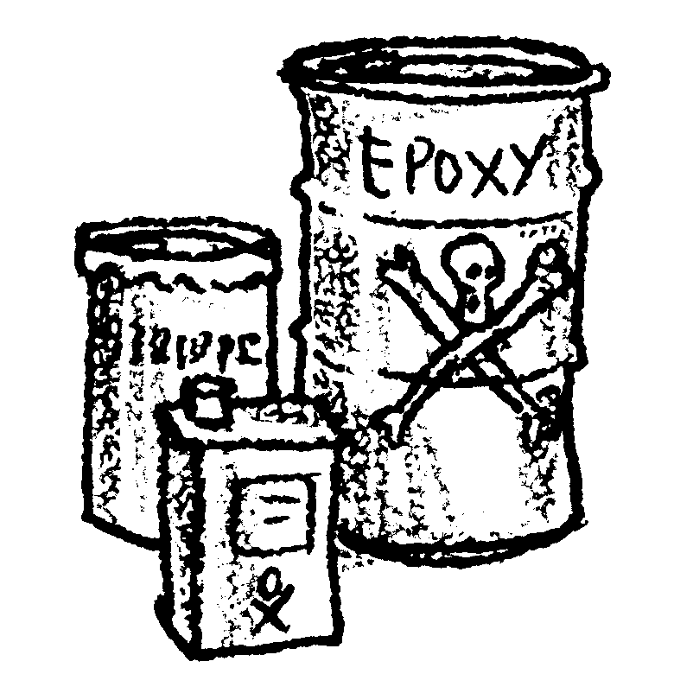
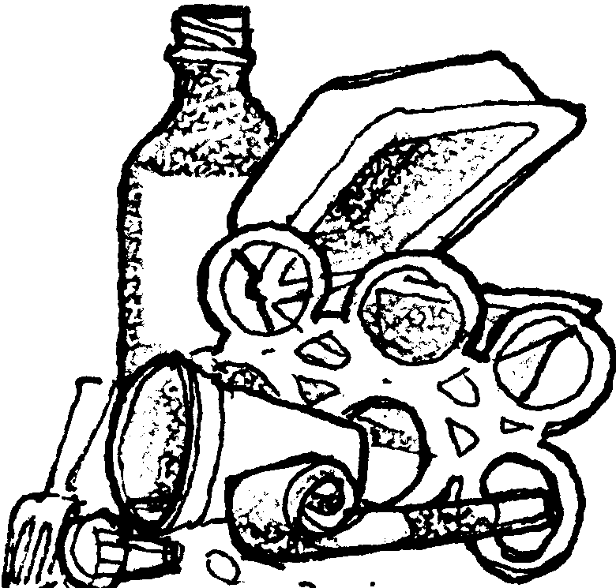

I have a dairy farm on Turkey Creek. Turkey Creek runs into the Sabine River. I know I really shouldn’t let my cows walk through the creek. Their manure gets into the water. Their feet cause the banks to erode. But it’s easier and cheaper for me to let the cows get their water from the stream than to pump water over to the pasture. If I decide to protect the stream it will cost me $1500 for fencing and a watering system for my cows.

(Either pay 2 pieces of “money”, or add 2 drops of color to the river and 6 drops to Bountiful Bay.)

I own a small business repairing furniture in the town of Burley. I use a lot of chemicals like epoxy and paint strippers. They are very toxic to people. They must be hazardous to the environment too. After I use them I have to throw them away somewhere. It’s illegal to dump them into the ground. On the other hand it would cost me $200 each month to have them taken to a hazardous waste disposal site. I’m not sure my business can afford this expense.

(If you decide to have these chemicals disposed of properly, pay 2 pieces of “money.” If you just dump them on the ground, add two drops of color to the Rosalie River and two drops to Bountiful Bay.)

I have a waterfront home on Strawberry Spit. My friends and I hang out at the beach nearly all summer long. We have big parties with lots of food and drinks. Sometimes we’re a little careless with our trash. Lately I’ve started seeing chunks of Styrofoam and plastic containers everywhere. Doesn’t this stuff ever break down?

(Add a pinch of confetti to Bountiful Bay.)

7.

8.

9.

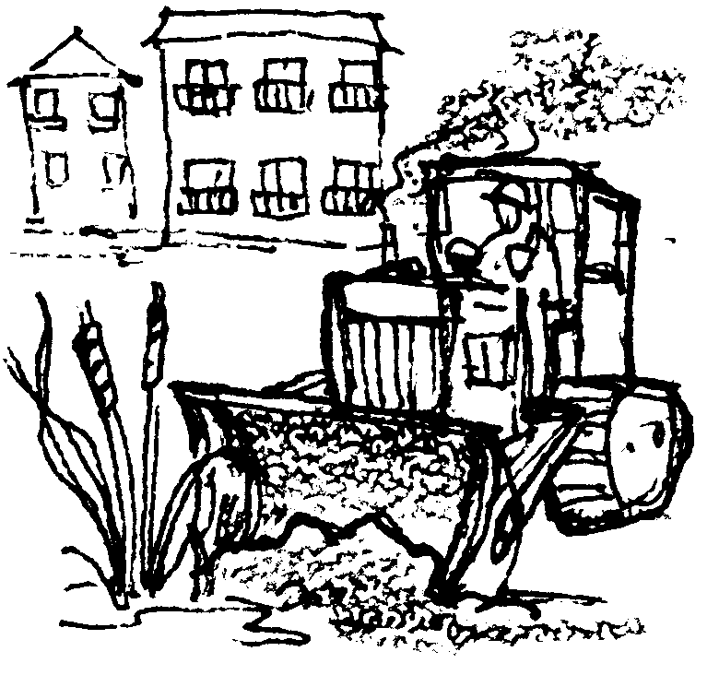
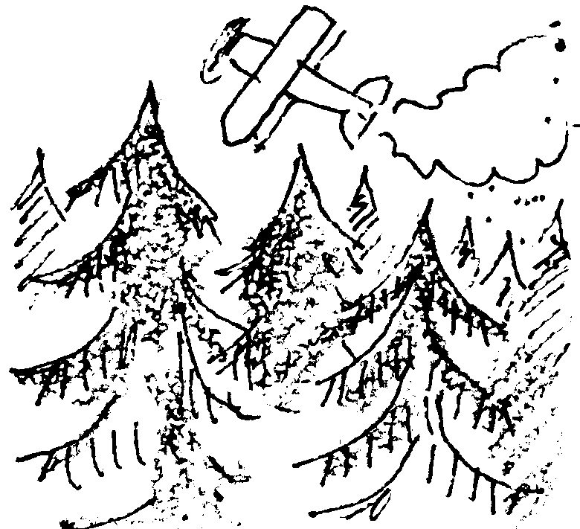
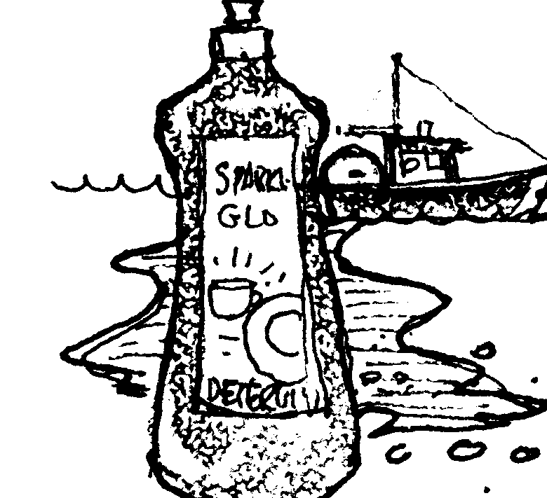

I am a developer. I make money by building and selling condominiums. People like to live along the water. I am interested in filling in some of the wetlands at the mouth of the Jersey River. I want to build some more condominiums. If I do this, it will take away habitat for fish and other wildlife.

(If you choose to build your condos, reach into the Bay and remove one fish. If you decide to protect them, pay the bank 3 pieces of “money.”)

I’m a commercial fisherman. The engine on my boat leaks oil into the bilge (the inside of my boat). Sometimes water collects in there, too. To stay afloat I have to pump out this oily mess every so often. If the Coast Guard spotted my boat making an oil slick, I could be fined $5000. Before I start up the bilge pump, I sometimes pour detergent into the oily bilge water. This hides the oil so you can’t see it. Of course, it’s still there. It’s against the law to do this, but I sure don’t want the Coast Guard catching me with an oil slick behind my boat.

(Add 2 teaspoons clear contaminant to Bountiful Bay.)

I work for a large timber company. The company owns timber land all along the west side of Bountiful Bay. We often use herbicides to keep “weed trees” from competing with the trees we want to grow. If we stopped using herbicides, we would have fewer trees to harvest. We would make less money. But herbicides will wash into the water and pollute Bountiful Bay. We must decide. Should we continue using herbicides? Or should we give up some of our profits?

(If you choose to stop using herbicides, pay 5 pieces of “money”. Otherwise, add 1 teaspoon clear contaminant to the Makaw, the Ruby, the Andara, and the Jersey Rivers. Add 3 teaspoons to Bountiful Bay itself.)
10.

11.

12.

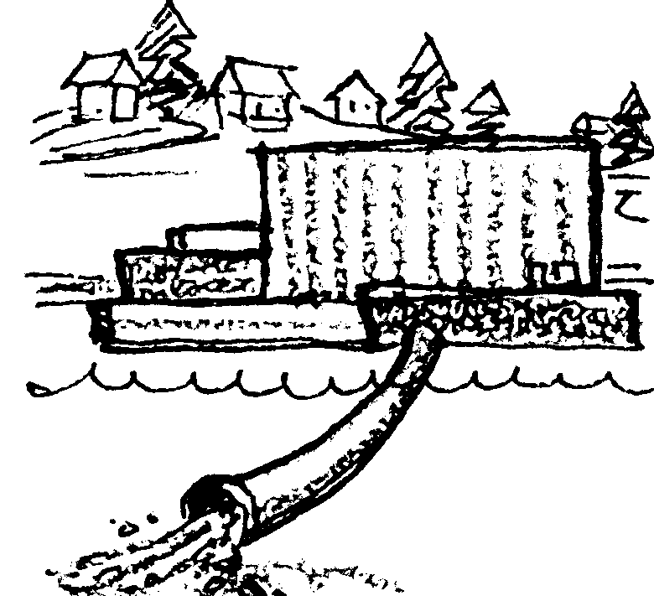
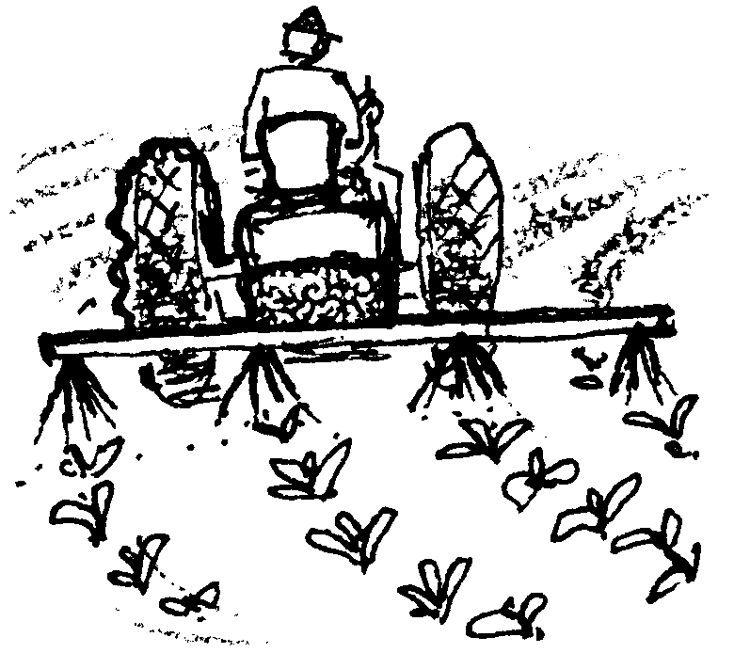
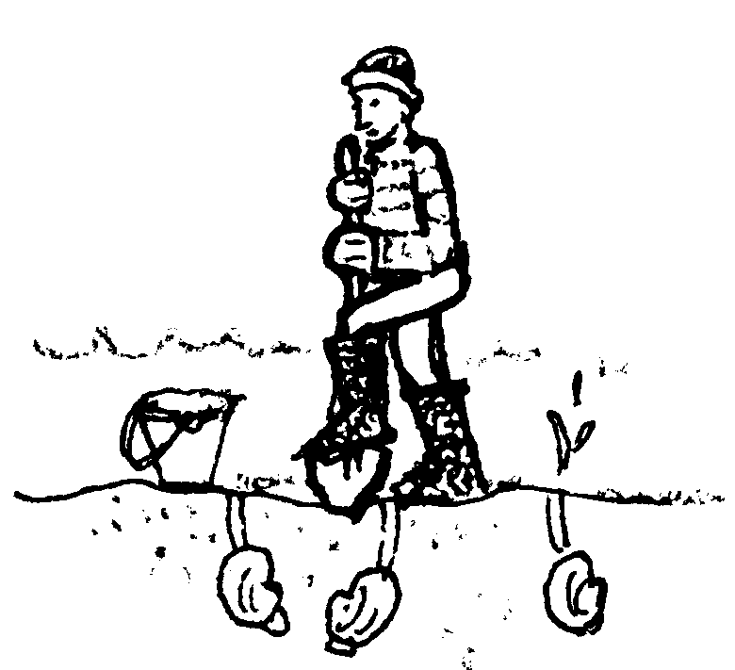

I work for the City of Randal. I help operate our primary sewage treatment plant. A new secondary treatment plant would pollute the water less than our plant does now. We wonder if the citizens in our town would be willing to pay extra to build a secondary sewage treatment plant.

(Many communities around Bountiful Bay are facing this problem, so take a class vote. Would these citizens tax themselves 1 piece of “money” each to build better sewage treatment plants around the Bay? If the majority votes “yes”, each person in the class must pay the bank 1 piece of “money”. If the class votes “no”, add 10 drops of color to Bountiful Bay.

I live on the water near Port Handy. I like to dig clams from my beach. If the water becomes polluted, the clams will be contaminated. My beach will be closed to shellfish harvesting.

(Take a water sample. Use a litmus paper strip to test the water. If it tests 8 or higher on the color scale, the water is contaminated. You may not dig the clams from your beach.)

I raise fruits and vegetables on my farm near the Andara River. I use chemical fertilizers and pesticides on my crops. Some of these chemicals wash into the river. I know some farmers have switched to organic farming methods. I wonder if they’re making as much money as I can by using these chemicals?

(If you decide to farm organically, pay 2 pieces of “money” for losses you may have to take when you first switch over. If you decide against it, add 1/2 teaspoon clear contaminant to the Andara River and 2 teaspoons to Bountiful Bay.)
13.

14.

15.

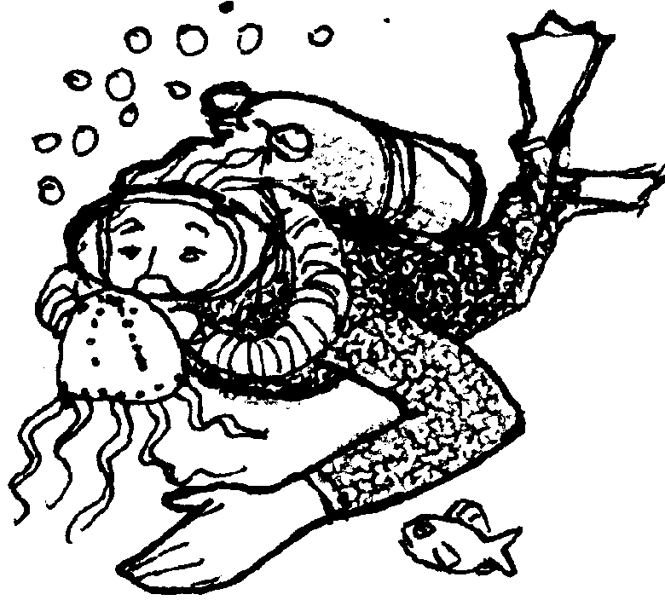
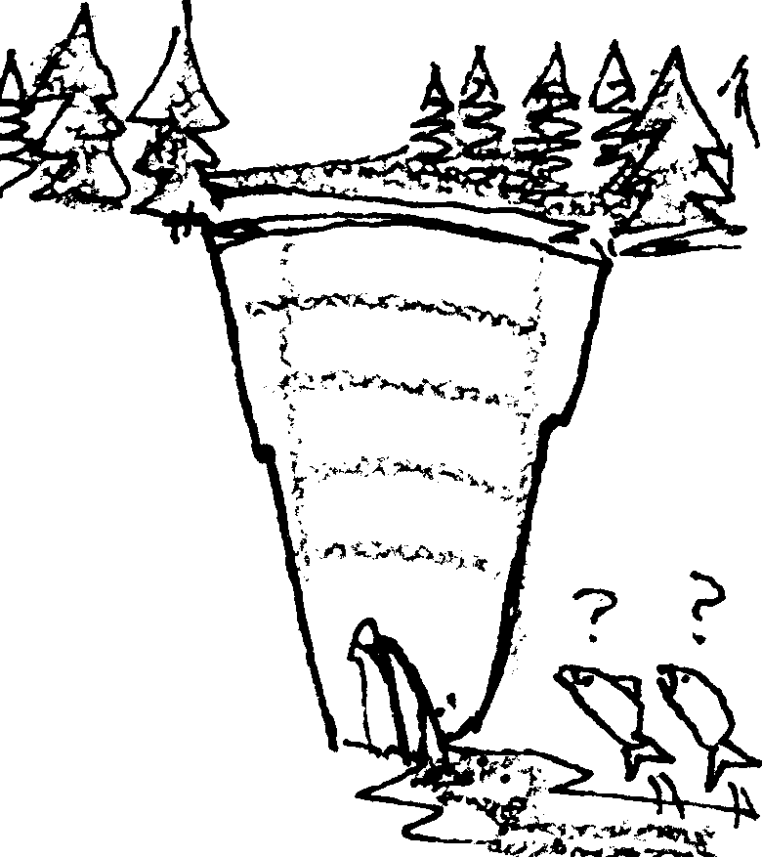
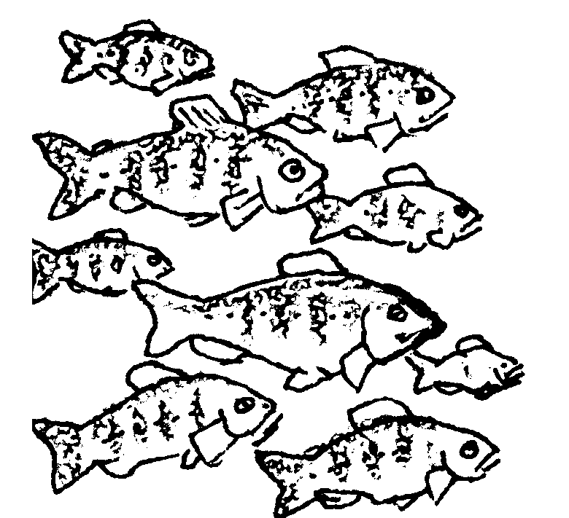

I work for a power company. We want to put a dam on the Makaw River. Right now all that water is just going to waste. It could be generating cheap power. People and businesses would move into the Bountiful Bay area. A few salmon runs might be hurt. But wouldn’t we rather have a strong economy?

(Have the class vote whether to dam the Makaw river. If the class votes yes, remove half the water from the Makaw River. Pour the water out into a sink or waste bucket. Reach into Bountiful Bay and remove two fish. If the class votes not to dam the Makaw, turn off one light in the classroom.)

I am chief biologist for a fish hatchery on the Jersey River. We hatch fish and raise them in water from the river. The fish are released into the river when they are big enough. If the water is too polluted, the fish won’t survive. Fewer fish will make it to Bountiful Bay.

(Take a water sample from the Jersey River. Compare it with the water quality standard. If it is darker than the standard, the fish will not survive. Pay 3 pieces of “money” and look for another job. If it is lighter, add two fish to Bountiful Bay.)

I live in Chicago. I love to scuba dive. I come to Bountiful Bay because it has such interesting underwater life. If the places I like to dive become too polluted, I won’t see as many interesting creatures. I’ll look for another place to dive.

(Use the secchi disk to test the water. Lower it in the water, and if you can’t see the edge of the circle 6 inches from the surface, you won’t be back to dive in the Bay any more.)

16.

17.

18.

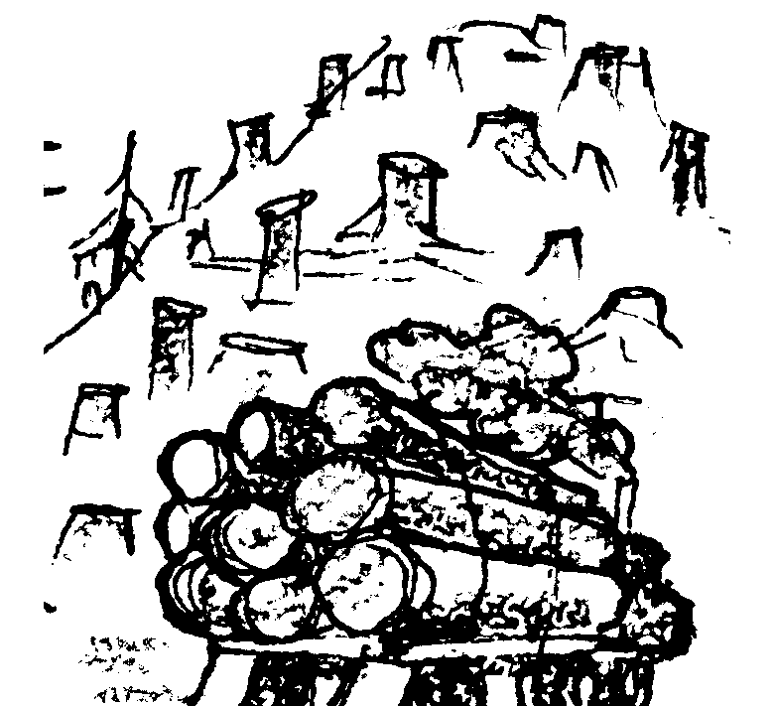
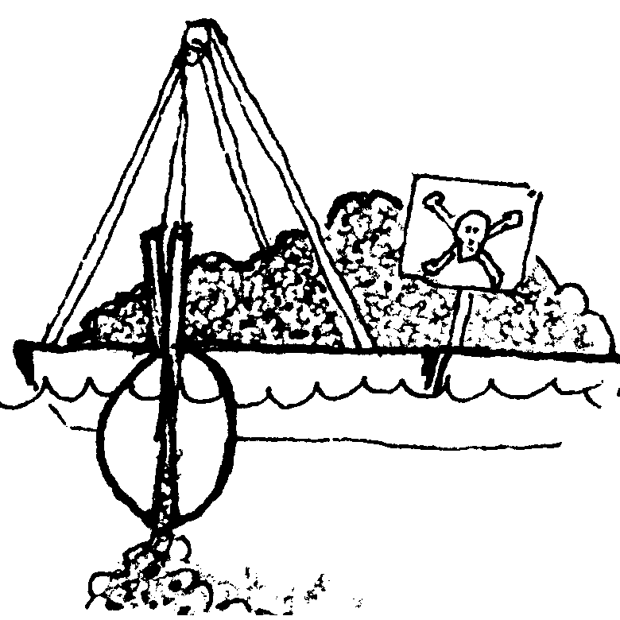
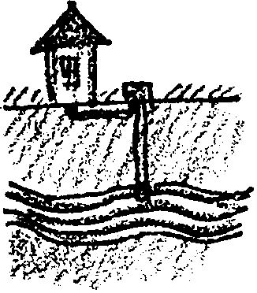

I work for a logging company. We have been harvesting timber in the Bountiful Bay area. We have been cutting on steep slopes. Sometimes we work too close to the streamside. The winter rains are here. Erosion and mud slides are carrying large amounts of silt into the river.

(Put 1 teaspoonful of dirt into the Andara and the Makaw Rivers. Add 4 teaspoonfuls of dirt to Bountiful Bay and stir gently.)

I am the manager of a harbor near Jefferson City. I want to dredge the harbor deeper. Then, bigger ships could use our docks. The trouble is, the mud that needs to be removed is contaminated with industrial wastes. We could ship it to a toxic waste disposal site. Then, it would be out of the water for good. It would cost us $1,000,000. If we did this we would need to charge ships a lot more money to stay in our harbor. I’m asking for permission get rid of it in a cheaper way. I want to put it back in Bountiful Bay somewhere else. This way more ships will use the harbor because they won’t need to pay as much. I’ll be able to create many new jobs for people in the area.

(Ask for a class vote. Decide whether you will be allowed to dump the toxic sediments back into Bountiful Bay. If the class votes yes, add 8 drops of color to Bountiful Bay -- and choose 5 classmates to receive high-paying jobs in the new shipyard. These people each receive 1 piece of “money” from the bank. If it votes no, you pay 5 pieces of “money” to dispose of the sediments more safely.)

I just bought a nice little place in the country. It’s alongside the Sabine River. I’ve decided to test the water in my well. I want to make sure it’s safe for my family.

(The water in the Sabine and your well are connected. Water can move slowly through the ground between them. Take a water sample from the Sabine River. Compare it with the water quality standard. If it’s darker than the standard, your water supply is polluted too. It’s going to cost you $1000 to connect with a city water supply. Pay 3 pieces of “money”.)
19.

20.

21.

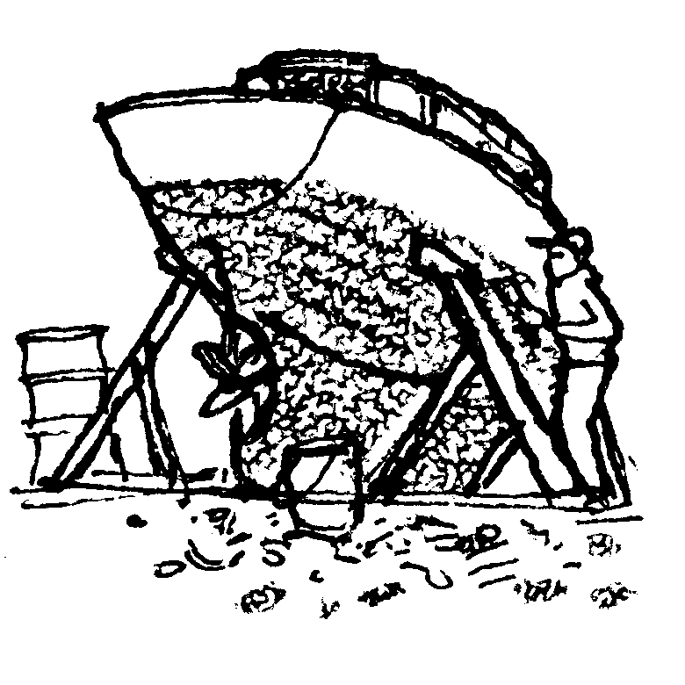
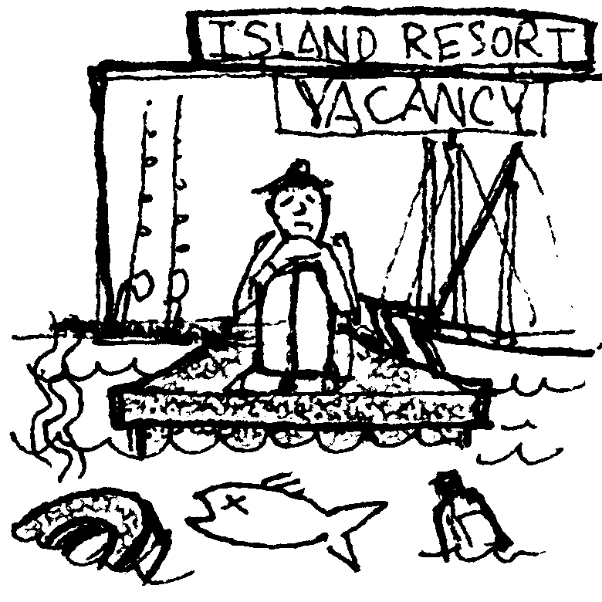
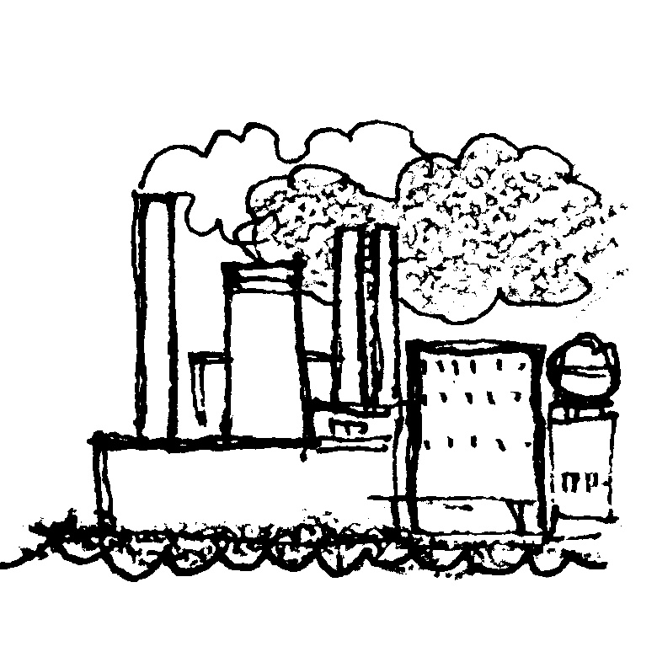

I just bought a sailboat. It needs some work. I need to have it hauled out so I can repaint the bottom. I will have to scrape all the old paint off. The paint has copper and other chemicals in it to keep barnacles from growing on the boat. When I scrape the old paint off, it falls on the ground. From the ground, it can just wash right back into the water. I could decide to catch all the old paint and dispose of it properly.

(Either pay one piece of money for a tarp to go under your boat, or add 1 teaspoon of clear contaminant to Bountiful Bay.)

I run a resort on Kittery Island. People come from all over the country to spend their vacations here. They sail, fish, and have a good time on the water. If the water is polluted, people will stop coming here. I’ll go out of business.

(Use the secchi disk to test the water. Lower it in the water. If you can’t see it 6 inches from the surface, turn in all your “money”. You go out of business!)

I manage a copper smelter near Cascadia. Our refining process is polluting the air and water of Bountiful Bay. To clean up our factory would cost us $1,000,000. If we have to pay that much, we will have to cut back our business. Two hundred and fifty people will lose their jobs. I have to choose. Should I stop polluting but put workers out of a job? Or should I continue to operate the way we have been.

(Either pay 5 pieces of “money” or add 3 teaspoons clear contaminant to Bountiful Bay.)

22.

23.

24.

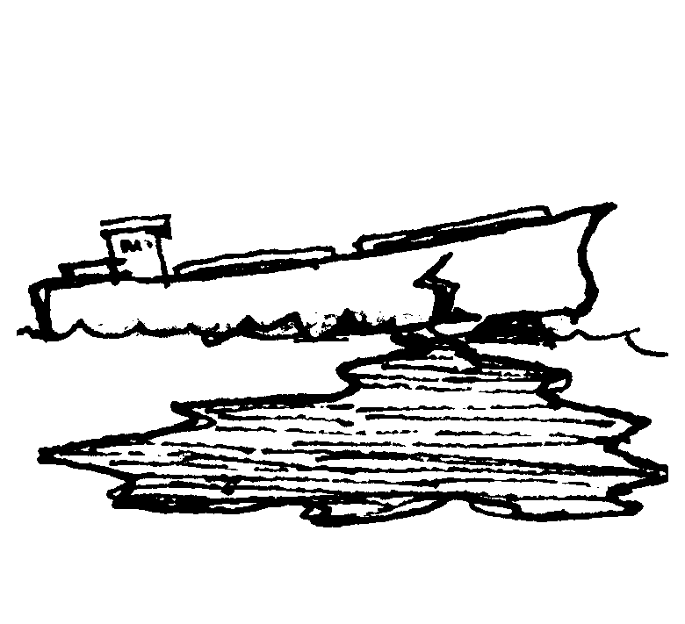
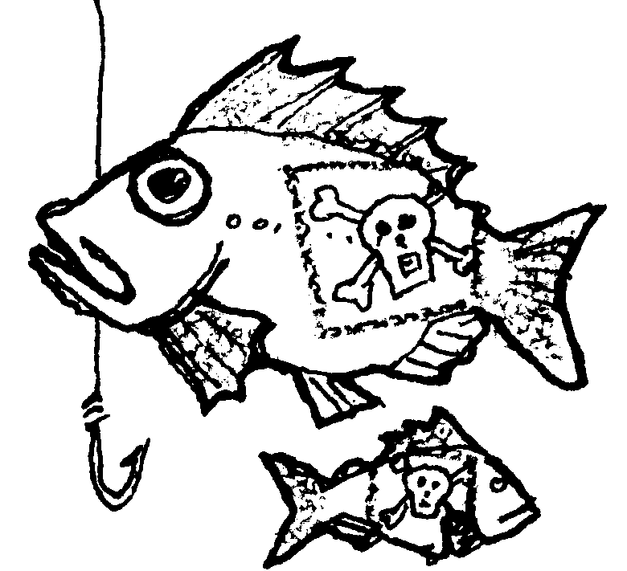
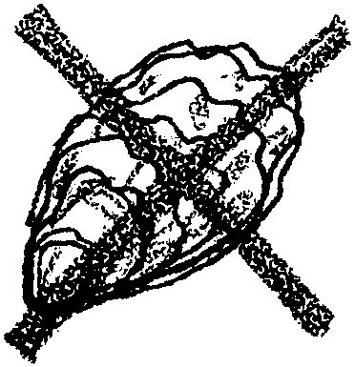

I am a commercial fisherman. I am trying to catch bottom fish near Strawberry Spit. I’m worried that the fish I catch may contain toxic materials higher than federal standards. If they do, I cannot sell them to the public. I will not be able to make my boat payments. I will have to go out of business.

(Take a water sample from Bountiful Bay. Compare it with the standard color. If it is darker than the standard, the fish are too contaminated to sell. Turn in all your “money” and go out of business. If the water is lighter than the standard, take one minute to try catching some fish.)

I am an executive for a shipping company. We ship crude oil to an oil refinery in Manchester. Some people say we should replace our old tankers with new ships. The new ships would have double hulls, with two layers of steel to hold the oil. They say this would prevent oil from escaping in case of an accident. It would cost us millions to make this change. Of course we would have to pass this cost on to our customers. Gas would cost more at the pump. We certainly aren’t going to do this unless we’re required to do it by law.

(Take a classroom vote. Would the people be willing to pay more to drive their cars in order to reduce the chance of a major oil spill in Bountiful Bay? If they agree, each person pays 1 piece of “money”. If they don’t, add 15 drops of color to Bountiful Bay.)

I raise oysters at the end of Sampa Lagoon. I sell my oysters to restaurants all around Bountiful Bay. If the water in my bay becomes too polluted, the Health Department will close the bay to shellfish harvest. If I cannot sell my oysters, I will go out of business.

(Take a water sample from Bountiful Bay. Use a litmus paper strip to test the water. If it tests 8 or higher on the color scale, your oysters are contaminated. Turn in all your “money” and go out of business.)

25.

26.

27.

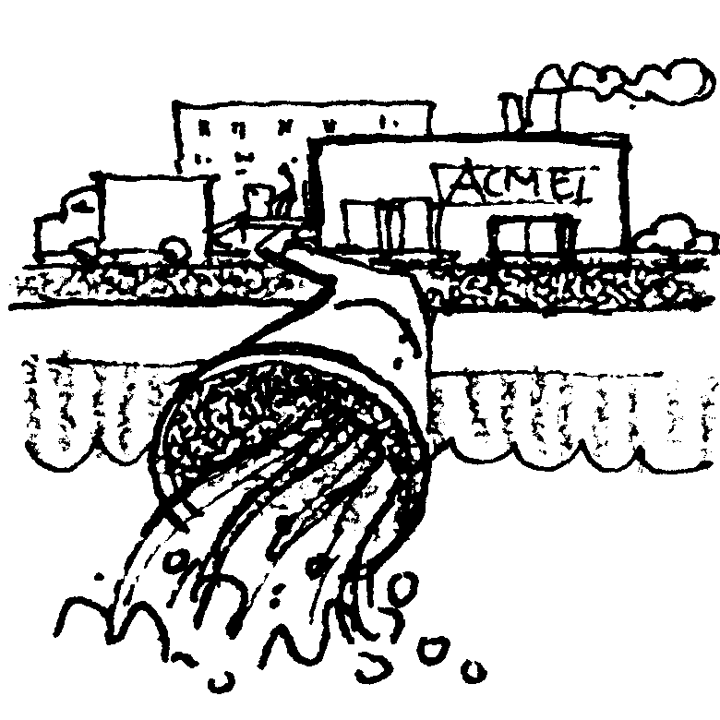
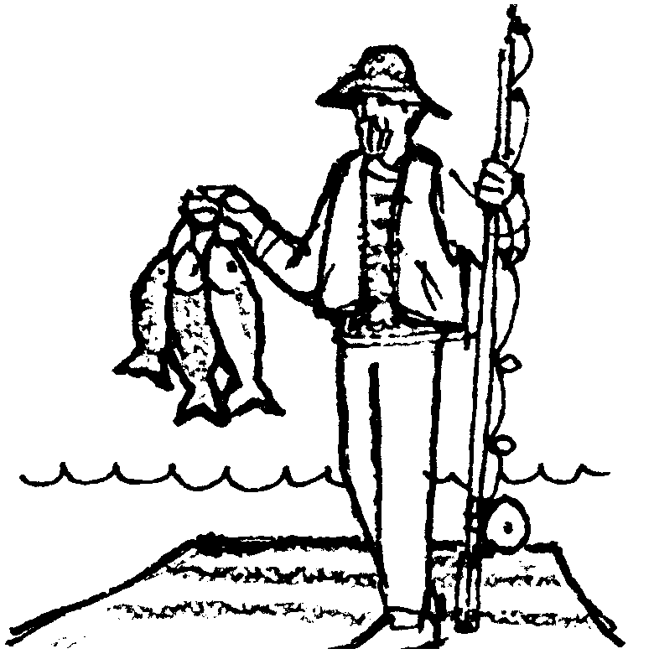
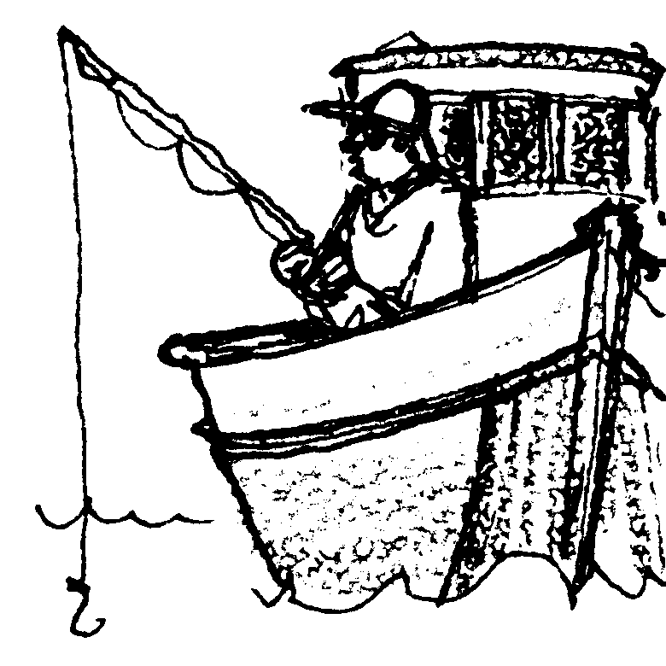

I live in Manchester. I can’t afford a car, but I love to go fishing. Each weekend I ride the bus down to the waterfront. I fish for flounder off the piers. I always take the fish I catch home to eat. Is the water so polluted that the fish I’m eating are contaminated?

(Take a water sample. Use a litmus paper strip to test the water. If the water tests less than 8 on the color scale, you are still healthy. But, if it tests 8 or higher on the color scale, you will get cancer from eating contaminated fish. Pay 10 pieces of “money” for your medical expenses and die!)

I have come from Boston to vacation in Bountiful Bay. I have paid for a charter boat to take me out fishing. I also spend money to stay in motels. I eat in restaurants while I’m in town. If the water is too polluted, I can’t catch any fish. I’ll just take my money and vacation somewhere else.

(Try to catch a fish. One minute will be allowed for fishing. If a fish is caught, everybody in the class receives one piece of “money”, because tourist dollars are flowing into the region.)

I represent a manufacturing company. We are located on the Jango River. We use 400,000 gallons of clean water from the river every day to make our products. Then we return the water to the river polluted. We could clean up our process so that we don’t pollute the water. But it will cost $1,000,000.

(If you continue to pollute the river, add 2 drops of color to the water in the river and 8 drops to Bountiful Bay. If you decide instead to “come clean”, pay 5 pieces of “money.”)

28.

29.

30.

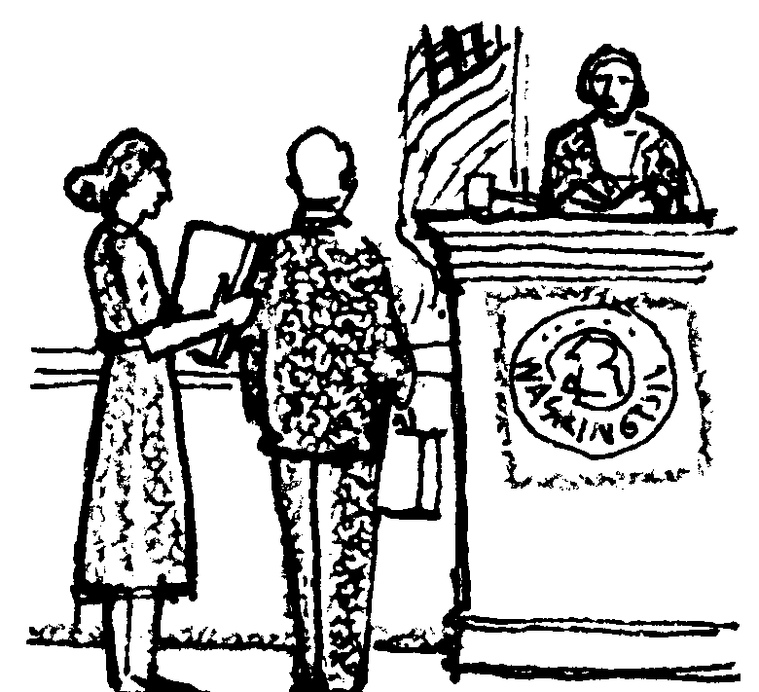
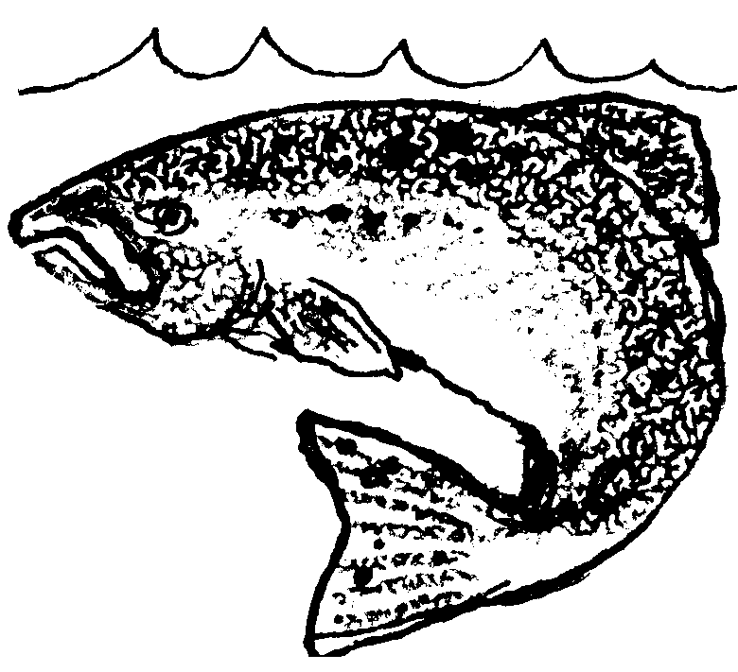

I am a pollution control agent. We do have laws to protect the environment. Sometimes they are violated. It takes people like me to enforce the law. We take violators to court. It takes tax money to pay my salary so I can do this work. But many people complain about taxes. Would you tax yourself so that there will be money to enforce clean water laws?

(Take a vote. If the class votes to tax themselves, everybody pays 1 piece of “money”. If the class voted to hire you, you may then issue a fine to up to 3 people in the room who polluted during the game. Charge these violators 1 piece of “money” each. Naturally, you won’t want to tell them this before they vote!)

I am a salmon living in Bountiful Bay. I share this watershed with you. If my habitat is polluted or destroyed, animals like me are in trouble. Will I be able to survive in this environment? Will you?

(Take a water sample. If it is darker than the standard, remove two fish from Bountiful Bay. If it is lighter, add two fish. There were six fish at the beginning of the game. How many fish are left?)
31.

32.

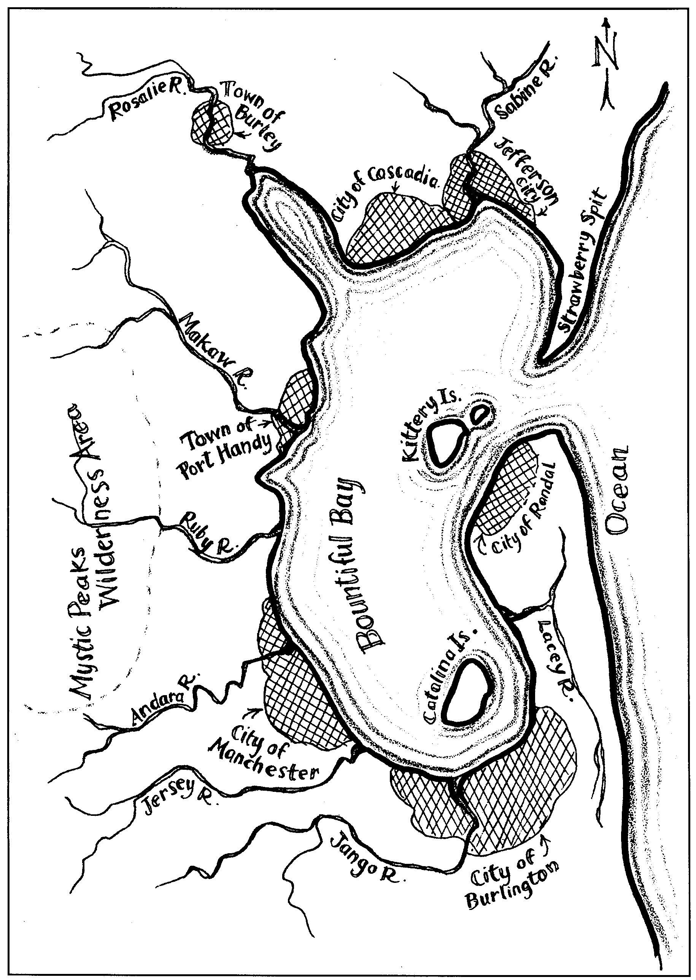

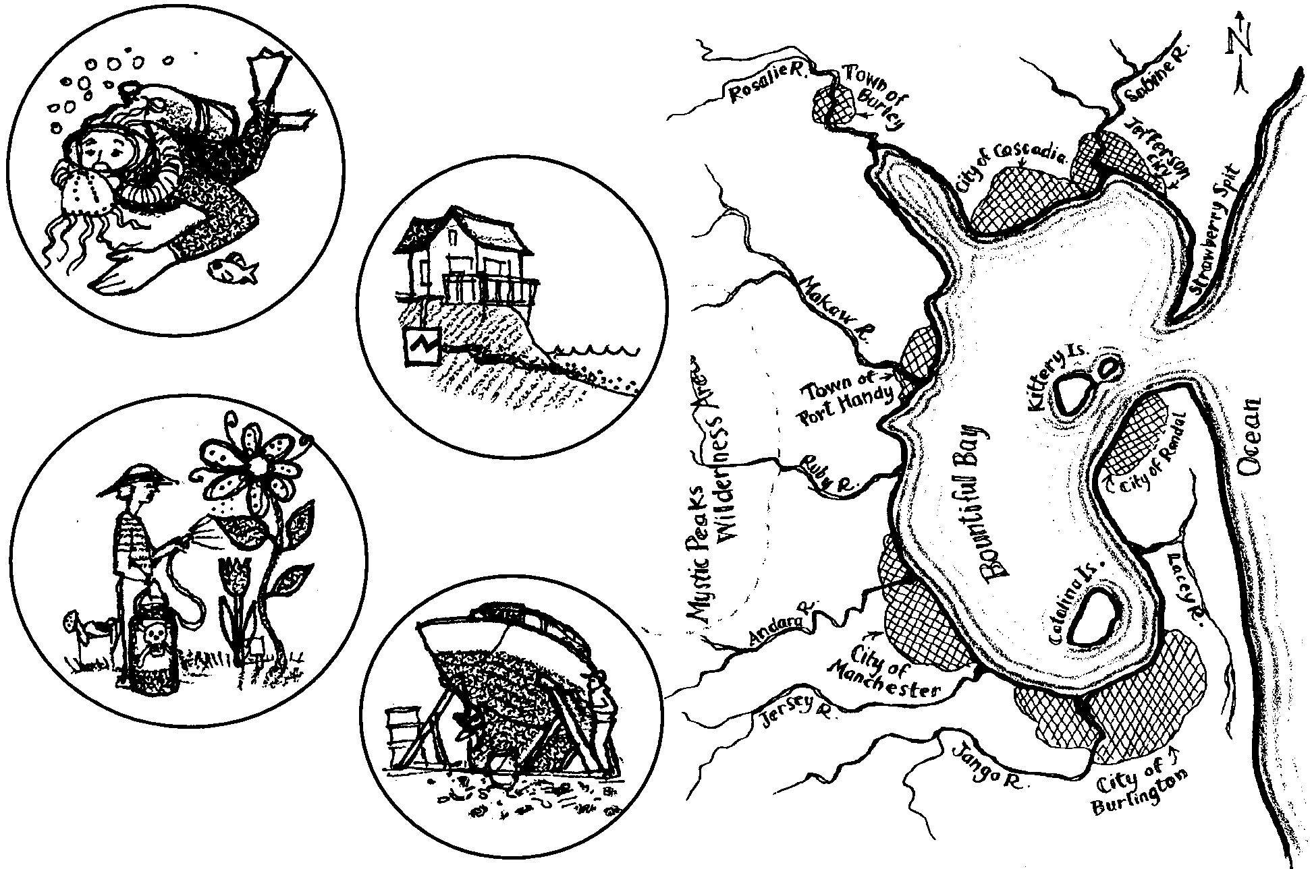
The Bountiful Bay Game: Use vs. Abuse

1. Why was it sometimes difficult for people to make decisions in favor of protecting the water quality in this game?

2. If players chose short term profits over protecting the environment, the water quality was likely to suffer. What were some long-term costs which individuals or society as a whole might end up paying for as a result of such decisions?

3. Pollution sources like the copper smelter in this game, which discharge large amounts of waste from a single point are called point sources of contaminants.

a. What is another example of a point source of pollution used in the Bountiful Bay Game?

b. What is an example of a point source of pollution in the area in which you live?

4. Non-point source is the term for sources of contamination which are hard to locate, because they come from many places. Often, they are caused by the behaviors of individuals. The backyard gardener is an example of a non-point source in this game.

a. What is another example of a non-point source of pollution used in the Bountiful Bay Game?

b. What is an example of a non-point source of pollution in the area in which you live?

5. In your opinion, what is the point, or message of the Bountiful Bay Game?

6. What is something you or your family could do to improve the water quality where you live?

