Marsh Models
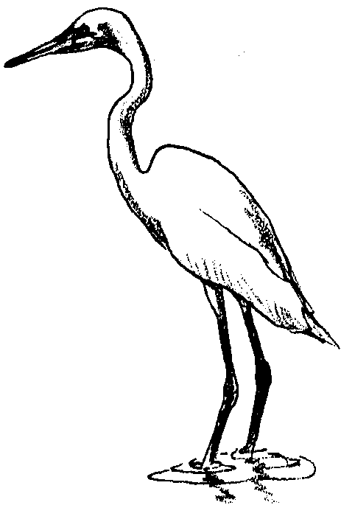

Key Concepts
1. Wetlands help filter silt and pollutants from water, help prevent soil erosion, and often reduce flood damage.
2. A simplified wetland model can help demonstrate some important wetland functions.

Background

Background for the “Marsh Models” is found in the preceding activity “Wetland Metaphors”.

Materials

For a class of 32 working in pairs:

• 16 small, rectangular or square aluminum cake pans

• modeling clay, preferably water resistant

• 4 large sponges cut into four pieces whose length equals the width of the cake pan

• a variety of building materials: toothpicks, cotton swabs, cardboard, pipe cleaners, natural materials such as pine needles, twigs, grass, etc.

• colored paper

• glue

• scissors

• colored pencils/pens

• water

• watering can

• container of muddy water

• 8 small containers for muddy water

• pictures of wetlands, field guides

Teaching Hints

It is hard to tell that wetlands have important functions by just looking. In this activity, students build a marsh model to help them understand some wetland functions.

Before you begin this activity with your students, make a demonstration model for yourself.

Although student directions are included, you may wish to guide your students through the construction procedure in a stepwise fashion. As always, choose the approach that works best for your students.

Procedure

1. Give each pair a pan, clay, sponge, and other materials. Note: the absolute size of the pan and sponge are not critical; it is critical, however, that the sponge piece extend from one side of the pan to the other.

2. Instruct each group to build a marsh model according to the following instructions:

a. Use the modeling clay to build a land form in half of the pan. (You can reduce the amount of clay required by providing cardboard or other materials from which a substrate can be made.) Spread a layer of modeling clay in half of the pan to represent land. The rest of the empty pan will represent a body of water. Shape the clay so that it gradually slopes downward toward the body of water. Smooth the clay edges along the sides of the pan to seal the edges. In the clay land, form meandering streams that lead down to the body of water.

b. Cut the sponge to completely fill the space along the edge of the clay across the width of the pan. You should still have empty space in the pan for the body of water. The sponge represents the wetland buffer between dry and open water. Here’s what your marsh model will look like in cross section:
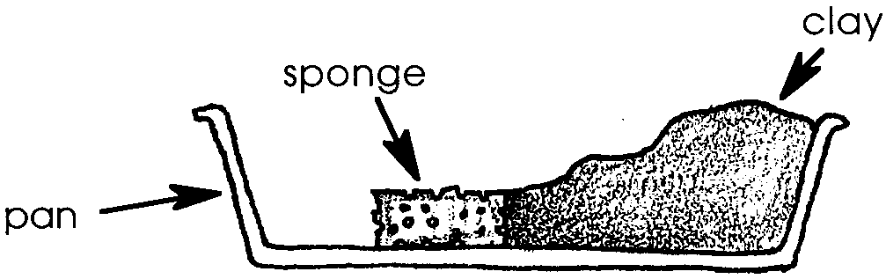

c. Have students add final touches to their models by attaching “plants” made from natural materials and “animals” which may be clay models or figures drawn on paper and glued to toothpicks. Cotton swabs painted green and brown make dandy cattails. Pine needles make great reeds. Trees can be made from construction paper or pieces of sponge attached to toothpicks. Have pictures and guides available for students to use for ideas.

3. Explain that wetlands, like all habitats, are very complicated natural systems and we are still learning about how they work. We do know that wetlands perform some very important functions, such as filtering pollutants, reducing flood damage, and preventing soil erosion, by soaking up excess water and releasing it slowly to streams, lakes, etc.

4. Tell students that you are going to simulate a rainstorm by slowly pouring water onto your model. Pour the water onto the clay land.

5. Have students pour their muddy water on their clay land and describe what happens. (The water should soak into the sponge “wetland” and slowly drain into the empty part of the pan-the “body of water”).

6. Look at the water draining into the “water body” of the model. Ask: “Has the clarity of the water changed? Discuss what is happening and the value of wetlands in water filtration and pollution reduction.

7. Ask students what would happen if the wetland wasn’t there. Have some students “excavate” their sponge “wetland” and repeat the experiment. What happens? (The water should fill the “body of water” much more quickly and it should be dirtier because the wetland buffer is gone.) Explain that most wetlands are shallow basins that collect water and slow its rate of flow. This slowing process helps reduce flooding and allows sediments to settle.

8. Ask students the following questions:

a. What would happen if the marsh was paved over and made into a parking lot? (The water couldn’t soak in.) What could happen to areas downstream? (Could result in increased flooding.)

b. Why are places like marshes important to us? (They can reduce flooding and help to clean our water.)

Key Words

buffer - something that lessens or absorbs the shock of an impact

meandering - following a winding and turning course

model - a small object, usually built to scale, that represents some existing object

wetland - a lowland area, such as a marsh or swamp, that is saturated with moisture; especially when thought of as the natural habitat of wildlife

Extensions

1. Have students change the size of the wetlands and have them note any changes in runoff patterns.

2. Have students cover the “wetland” surface with “pavement” and note any changes.

Answer Key

Text questions

3. Answers will vary according to experimental results. Generally, the water runs off the clay and is absorbed by the sponge.

4. Answers will vary according to experimental results.

5. a. Answers will vary according to experimental results. Generally, the clarity of the water improves.

b. The observations affirm that water is slowed and that solids are removed from the flowing water. These are both important wetland functions.

6. Answers will vary according to experimental results.

Analysis and Interpretation

1. a. If the marsh was paved over and made into a parking lot, the water could not soak in.

b. Downstream areas could experience increased flooding.

c. Places like marshes are important to us because they can reduce flooding and help to clean our water.

Adapted, with permission of National Wildlife Federation, from the Wading Into Wetlands issue of Naturescope, copyright 1992, and Discover Wetlands, Washington Department of Ecology.

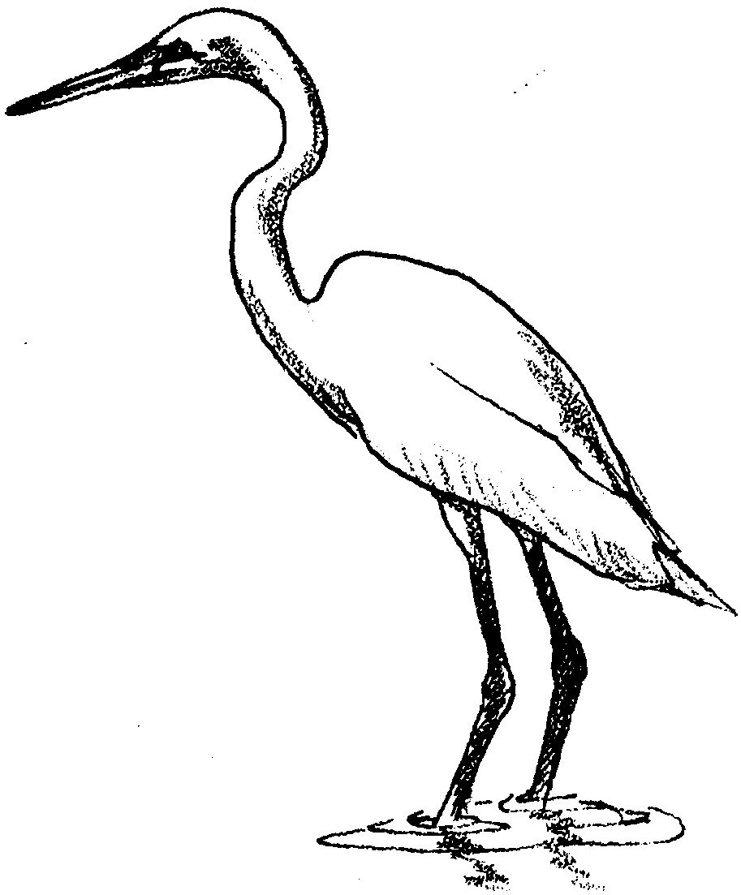
Marsh Models

Wetlands are important. They help filter silt and pollutants from water. They can help prevent soil erosion and reduce flood damage. It is hard to tell that wetlands have important functions by just looking. In this activity, you will build a marsh model to help you understand some wetland functions. Here’s what you’ll need:

Materials:
For each pair of students:
• aluminum cake pan
• modeling clay
• sponge
• “building materials”
• colored paper
• glue
• scissors
• colored pencils/pens
• water
• watering can
• container of muddy water
• small containers for muddy water
• pictures of wetlands, field guides
Here’s what to do:

Procedure

1. Obtain a pan, clay, and sponge.

2. Follow these steps:

a. Use the modeling clay to build a land form in half of the pan. (You can reduce the amount of clay required by making a rough form from cardboard.) Spread a layer of modeling clay in half of the pan to represent land. The rest of the empty pan will represent a body of water. Shape the clay so that it gradually slopes downward toward the body of water. Smooth the clay edges along the sides of the pan to seal the edges. In the clay land, form meandering streams that lead down to the body of water.

b. Cut the sponge to completely fill the space along the edge of the clay across the width of the pan. You should still have empty space in the pan for the body of water. The sponge represents the wetland buffer between dry and open water. Here’s what your marsh model will look like in cross section:

c. Add final touches to your model. Attach “plants” made from natural materials and “animals” which may be clay models or figures drawn on paper and glued to toothpicks. Cotton swabs painted green and brown make dandy cattails. Pine needles make great reeds. Trees can be made from construction paper or pieces of sponge attached to toothpicks. Use available pictures and field guides for ideas.

3. Wetlands, like all habitats, are very complicated natural systems. We are still learning about how they work. We do know that wetlands perform some very important functions. They filter pollutants. They reduce flood damage, and help prevent soil erosion by soaking up excess water and releasing it slowly to streams, lakes, etc. Simulate a rainstorm by slowly pouring water onto your model. Pour the water onto the clay land.

What happens to the water?

4. Pour your muddy water on their clay land.

Describe what happens.

5. Look at the water draining into the “water body” of the model.

a. Has the clarity of the water changed?

b. How do these observations help show the value of wetlands in water filtration and pollution reduction?

6. What would happen if the wetland wasn’t there? “Excavate” your sponge “wetland” and repeat the experiment.

What happens?

Analysis and Interpretation

1. a. What would happen if the marsh was paved over and made into a parking lot?

b. What could happen to areas downstream?

c. Why are places like marshes important to us?

