Why Do Fish Go to School?
Lesson by Linda Hagelin - Saratoga, CA
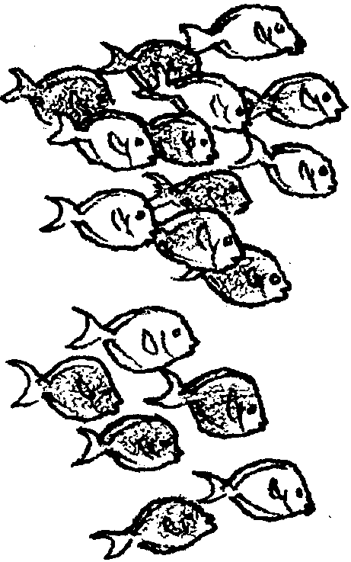

Key Concepts
1. Traveling in groups, or schools, provides many benefits for fish:
• greater protection from predators
• easier swimming
(riding the “draft” of a neighbor)
• readily available mates
• better chance of finding food

Background

Schooling is a means of survival for thousands of fish species. This activity gives your students a chance to experience being in a “school”. Many schools are large, containing hundreds or thousands of fish, but any number can compose a school from two fish to millions. Schools have no leaders. When the school reverses direction, the fish at the rear may find itself suddenly in the lead. Schools are formed according to species. Even as young fry, fish group themselves with their own species.

The members of the school move in the same direction, at the same speed, all evenly spaced from each other. In the presence of a predator, the school suddenly disperses and the fish scatter in all directions. They quickly re-group again. Studies have shown that predators tend to catch any fish that is not part of the group or is acting differently than the others.

How do fish communicate in schools? Studies done in the 1920s identified vision as the primary sense in schooling fish. When fish were put in a completely dark room, they wandered aimlessly in their tanks. When the tiniest ray of light was available, they immediately grouped into a school. The fish can sense light at a much lower level than needed for human vision.

In addition to vision, fish have a lateral line along their side that helps them to keep the regular spacing in a school. This lateral line is used to sense changes in water pressure and currents. These changes let fish know how close they are to their neighbors and help them sense a change in direction immediately.

All evidence indicates that it is beneficial for a fish to be a member of a school. Studies have shown that fish can swim for longer periods of time, consume less oxygen, more readily find mates, and are better protected from predators if they are in schools. The same fish swimming alone does not do as well as it does in a school. Each member of a school can be thought of as a “lookout” for danger. More eyes scanning for predators give each member of a school greater protection. For example, when a single coalfish was released into a tank with a predatory cod, it was eaten in 1/2 minute. When the same cod was presented with a school of 25 coalfish, it took the predator 2 1/2 minutes to capture a member of the school. Predators seem to be confused momentarily by the sudden dispersal of a school.

It is apparent that schooling is very useful for many fish. Schooling even helps conserve energy during swimming. Depending on the position in the school, a fish can coast along in the vortex or “draft” of a fish in front of it, using less energy. During the mating season, a school has mates readily available for any individual, and the number of eyes scanning the area increases chances of finding food, as well as avoiding predators.

Materials

For the class:

• 6 or 8 strips of sheeting for blindfolds

Teaching Hints

This activity provides a chance for your students to experience being in a school of “fish”. They also will explore the advantages of schooling and herding in other animal groups, including humans.

Procedure

1. Divide your class into groups of 3 or 4 students.

2. Each group discusses and lists their possible answers to the following question:

“How many advantages can you list for a fish traveling in a school?”

3. Groups share their ideas with the class. As they discuss their lists, encourage them to explain fully. For example, if they list “protection” as an advantage to schooling, ask for an explanation of HOW the school offers protection to a fish.

4. List the discussion points on the chalkboard and add information from the background section, above, as necessary.

5. At the end of the discussion, tell the class they now have a chance to see what it feels like to be in a “school”. Ask 6 or 8 students to come to the front of the room. Talk them through grouping themselves like a school of fish. They should face the same direction, space themselves evenly, move at the same speed, stay together. Refer to the background information above.

6. Ask the school to move around the classroom, maintaining that formation. What was the most important sense they used in forming the school? Try the same activity with blindfolded “fish”. (Vision is the primary sense used by schooling fish to group themselves.)

7. Ask the student groups to think of other kinds of animals that move in groups or schools (dolphins, whales, herding animals such as antelope, zebras). The students can compare the advantages discussed for schooling fish to the possible advantages of herding for these mammals.

8. Humans live in tribes and communities. What are the similarities to schooling and herding animals? What are the differences? Student groups discuss and share their ideas.

Extensions

1. Films or videos showing schooling fish can provide helpful visual information for this activity.

2. Discuss how schooling/herding might help predators such as tuna (swim fast in loose schools to cover maximum area searching for food; more eyes scanning for prey; and the same schooling advantages cited for smaller fish).

