Fish: Modeling the Inside
Lesson by Sheri Allen – Carpenteria, CA
Developed for NSF Monterey Bay Aquarium Teacher Institute
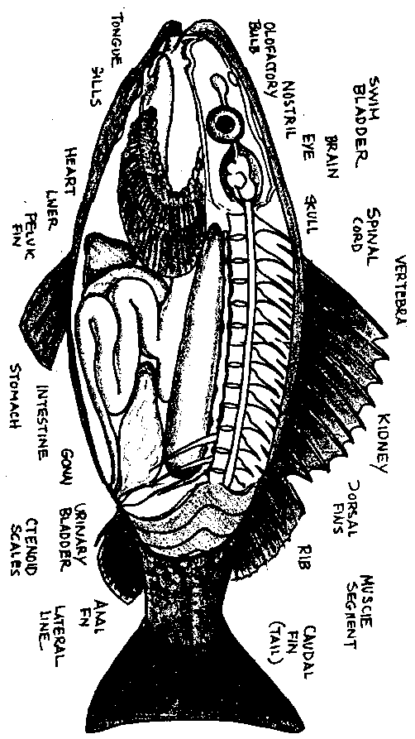

Key Concepts
1. Fish have most of the same internal organs as humans and other vertebrate animals.
2. Fish need oxygen just as terrestrial animals do.
3. Fish gills absorb oxygen that is dissolved in water.

Background
Fish share a body plan similar to that of humans and other vertebrate animals. The bony skeleton with its flexible vertebral column supports and protects the internal organs. Although similar, a few adaptations deserve comment:

Swim bladder - Thought to once have played a role in breathing, the swim bladder acts like a sophisticated balloon. The air-tight sac is lined with glands that selectively remove gases directly from the fish's blood. The gases are stored in the bladder and the amount is precisely regulated to adjust the buoyancy of the fish so that it is effectively neutrally buoyant. This means the fish can remain at a fixed depth in the water column with very little expenditure of energy.

Gills - Fish remove oxygen from the water they take in through their mouths. The water is passed through the gill chambers and expelled through openings on the side of the head. The gills function to transfer gases into and out of the blood, much like lungs in humans. The surface area of the gills is greatly increased by the folded gill filaments. At the base of the filaments are the gill rakers which serve to strain out most food particles and other solids in the water. Edible particles are swallowed; inedible ones are "coughed" up. The whole package is neatly stored beneath the boney gill cover or operculum.

Materials

For each student:

• fish anatomy sheets

• colored pencils

• fabric scraps, toothpicks to build a fish model

• scissors

• glue

Teaching Hints

It is possible to teach internal fish anatomy without the difficulties associated with having students cut open a fish. This activity is a chance for your students to build a model of the internal parts of a bony fish. They are asked to bring items from home that can be used in their models.

Procedure

Day 1

1. As a class, color and discuss each part of the fish on the "Fish Anatomy Sheet." A good source for information is Marine Biology Coloring Book by Thomas M. Niesen.

2. As you discuss, identify the internal structures on the diagram that are the same as those in humans: brain, spinal cord, nostril, tongue, heart, kidney, liver, stomach, intestine, etc.

3. Ask the class: "How does a fish breathe?" Students will say "With gills". Ask for a volunteer to explain how a gill works:

The fish opens its mouth and takes in water. As the mouth is closed, the water is forced over the gills. Gills have a lot of surface area (like our lungs). Where the gill surface is in contact with the water, gas exchange can occur. Dissolved oxygen can be taken into the fish's bloodstream; carbon dioxide can be passed into the water. All animals need oxygen, whether they live in the water or on land.

4. Spend 5-10 minutes closely observing the fish part diagram. Make a list of the internal organs and common household items that they resemble. (i.e. fish scales look a bit like sequins, bones somewhat like toothpicks).

5. For homework, have students collect any materials (toothpicks, fabric, dried noodles, etc.) they can find at home which can be glued to paper to construct a model of a fish.

Day 2

6. Use the fish outline provided or have students draw an outline of their fish on a piece of construction paper or cardboard. Have them cut out the outline.

7. Using the "Fish Anatomy Sheet" as a guide, have students construct each of the parts of their fish.

8. Remind students to make the model anatomically correct by arranging the parts according to the diagram.

9. Students then glue/tape the organs to their fish outline.

10. Finally, have students label each part with a letter or number, then write a key to their model.

Extensions

Complete the steps which follow to create a poster-puzzle teaching tool, highlighting bony fish anatomy, from the student page templates:

1. Make an overhead transparency using each of the templates.

2. Using an overhead projector, project the outline of the fish onto a piece of butcher paper and trace. (The model can be a large as you want to make it).

3. Project the "fish parts" template onto various pieces of colored construction paper and trace. When tracing the templates, be careful not to move the overhead. Movement can result in the outline being of a different scale than the pieces that fit inside.

4. Laminate the fish outline and pieces.

5. Cut out each laminated fish piece.

6. Place a piece of stick-on velcro on the back of each fish piece. Press the fish piece in its proper place on the fish outline. (This lines up the velcro halves).

Fish: Modeling the Inside
