Fish: What's on the Outside?
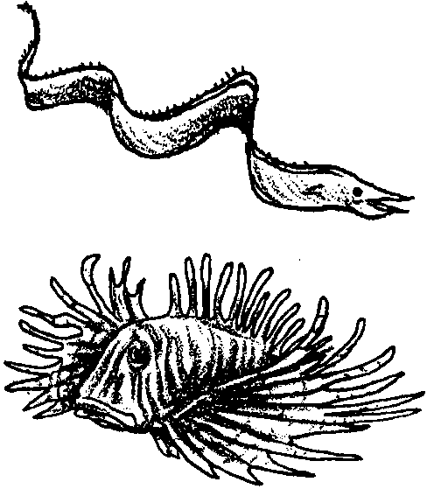
Lesson by Linda Hagelin Saratoga, CA

Key Concept
1. The external features of a fish can give many clues to its food preferences, habitat and lifestyle.

Background

It is possible to tell a lot about a fish just by studying the external anatomy. Fish body shape, mouth location, presence or absence of teeth, fin types and eye position are clues to its lifestyle. For example,

Body Shapes:

a. Flat shapes: hide on the bottom (flounder) or in tight spots (eel)

b. Torpedo shape: good swimmer (salmon, tuna)

c. Round body: often small, fit into tight spots (coral reef fish)

d. Long body: hide under rocks (wolf eel)

Pectoral Fin:

a. Long and pointed: fast swimmer (tuna)

b. Round: medium swimmer (snapper)

c. Flowing fins: slow swimmer (lionfish)

d. Round and stubby: quick turns, rests on bottom (sculpin)

Caudal (Tail) Fin:

a. Crescent or sickle shaped: fast swimmer (tuna)

b. No “v” in the tail: medium swimmer (snapper)

c. Fan shaped: slow swimmer (lionfish)

Mouth:

a. Big, wide mouth: predator that sits and waits for food (grouper)

b. Long skinny “nose”: prober that finds food in crevices (reef fish)

c. Mouth on underside of fish: bottom feeder (rays)

Eyes:

a. Eyes on the sides of the head: swims above the bottom most of the time (salmon, cod)

b. Eyes on top of head: stays on or near the bottom (skate)

c. Both eyes on one side of head: stays on or near the bottom (flounder)

Note that a fish’s eye lens is shaped like a clear BB. This gives it a wide field of vision, like a “fisheye lens” on a camera. The lens in our own eye is more like a “contact” lens: dish-shaped. We have forward-viewing binocular vision.

Materials

For each group of 4–5 students:

• whole fresh fish (Asian markets are a good source of whole fish). It is more interesting if each group has a different type of fish: flounder, rock cod, mackerel, etc.

• “Fish: What’s on the Outside? ” activity sheet

• compound microscope (optional) or magnifier lens

• newspaper on which to lay fish

• tweezers

Teaching Hints

In this activity, your students will examine several different types of fish from the market and compare the external anatomy. Students will infer the living habits of the fish by comparing these observations with the “Fish Shapes” information sheet included in the activity.

Have at least TWO types of fish available for this activity. To reduce out-of-pocket expenses, ask your fish market clerk to hold fish that are too “old” to sell for you. Markets will sometimes keep these fish in their freezer for you.

To reduce “fishy” odors, wash the fish with a little liquid detergent and cool water before class. Blot dry with paper towels.

Procedure:

1. Have students examine their fish using the worksheet as a guide. When they finish, ask them to look at another fish and compare it to theirs.

Extensions

1. This is a good time to use your fish for Fish Printing. See “Gyotaku - Japanese Fish Printing” in FOR SEA manual Grade 4.

2. Demonstrate the difference between a flatfish and a round fish by holding both with the dorsal fin up and ventral fin down towards the ground. The ground fish will be oriented just as it would be while swimming. The flatfish, however, is flattened laterally: one side of the flatfish has all the skin color and both eyes, while the other side is blind and usually white. In real life, the flatfish actually swims on its side with the blind side down against the sediment. Should you also have a skate, you can show that it is flattened dorsal-ventrally (back to belly) with both eyes on top of the head.

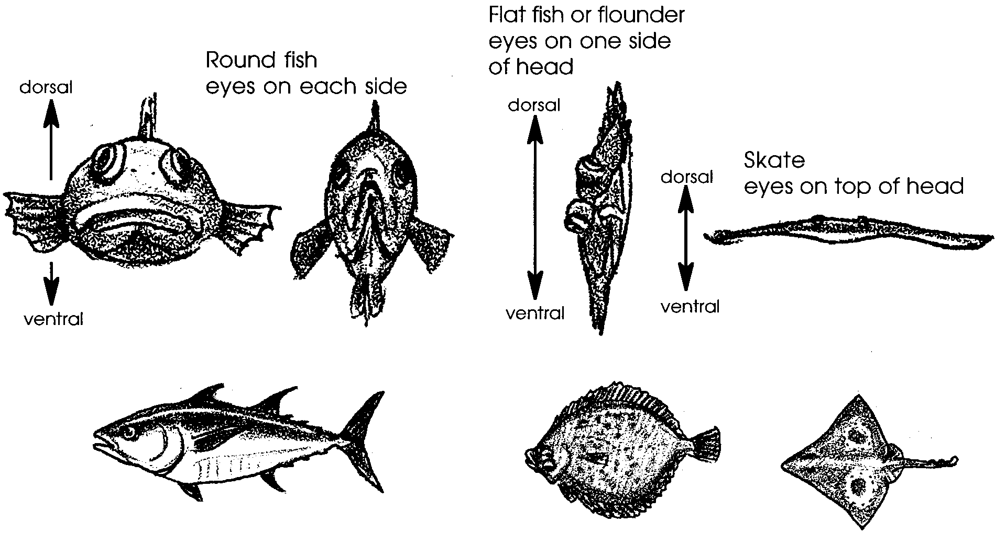

3. Have students investigate “right-handed” and “left-handed” flatfish. Some species of fish (like English sole in Puget Sound) are always right-handed which means they swim with the right side up. Others (like the summer flounder of the U.S. Atlantic coast) are left-handed, swimming with the left side up. Some others (like starry flounder in Puget Sound) may be either right- or left-handed. Students can tell if a fish is right- or left-handed by laying it on a table with the blind side against the table and the dorsal fin “up” (away from the students). If the head is on the right side, it is a right-handed fish; if the head is on the left side, it is a left-handed fish.

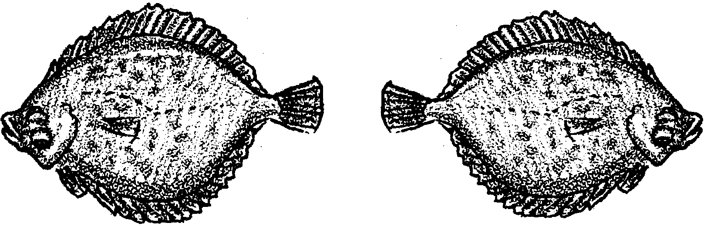

Left-handed Right -handed

Answer Key

1-6. Answers will vary depending on the fish species used.

Fish: What's on the Outside?
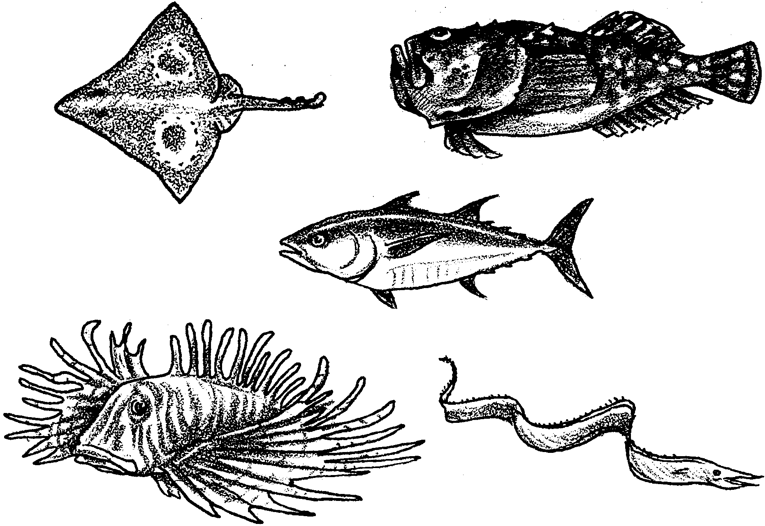

You can tell a lot about a fish’s lifestyle by examining its body shape and fins. Does your fish live near the bottom? Is it a fast swimmer? What does the lens from its eye look like? After you have observed your fish, look at another fish that is different from yours.

1. Look carefully at your fish. Draw it on the back of this sheet. Leave room for a written description of your fish under the drawing (Question #6).

2. Look inside your fish’s mouth. Does your fish have:

a tongue?

teeth? Draw the teeth here:

3. Lift the operculum (gill cover). Describe the gills:

4. How many fins on your fish? Put the number of each kind in the blank.

dorsal (on the back) caudal (tail)
pectoral (“arms”) pelvic (“legs”)
Any other fins?

Which fins are spiny?

5. Scales: Put a scale on a microscope slide in a drop of water. You can do this by using tweezers to remove a scale. Grasp a scale and pull toward the tail. Look at the scale with a compound microscope or magnifying lens. With a microscope, start at the lowest power (shortest lens). Make a drawing of the scale here:

6. Using the “Fish Shapes” sheet:

Describe the lifestyle of your fish. Support your statements with information about its body shape, fins and tail, mouth and eye position. Write your description on the back of this paper under your fish drawing.

