A Case Study in the Salmon Dilemma: To Be Or Not To Be?

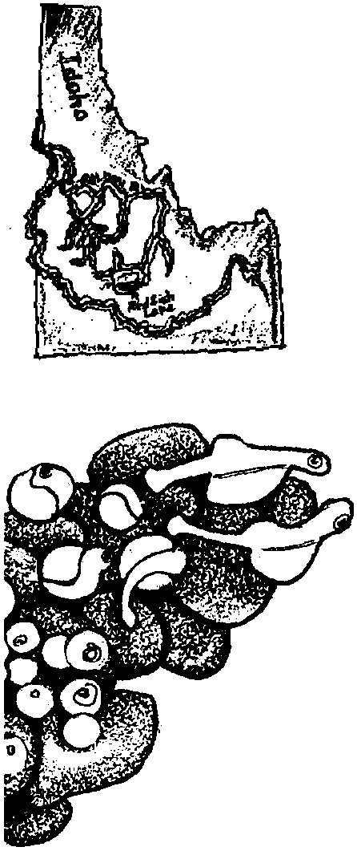
Key Concepts
1. Many salmon populations have declined in recent years as a result of human and naturally caused events.
2. Issues affecting salmon have local, regional, national, and international components.
3. Salmon populations present special management challenges because of the distance the fish travel and the wide variety of conditions or changes in habitats through which they travel.
4. Attempts have been made to improve salmon runs including limiting harvest, stocking programs, modifying dams, transporting smolt, and varying water releases from dams. These attempts have met with varying degrees of success.

Background

Early History of the Snake River Sockeye

Although at the very southern extreme of their range, sockeye salmon have been present in the Snake River drainage for thousands of years. For many centuries, the Shoshone and Bannock Indians caught sockeye salmon, using them for subsistence and in tribal ceremonies. When the miners and settlers moved into central Idaho, they also fished for sockeye salmon. Until the late 1800’s, the sockeye salmon traveled through at least four Idaho rivers: Payette River, Clearwater River, South Fork of the Salmon River, and upper Salmon River. The salmon spawned in Payette Lake near McCall; Lake Mervin and Warm Lake on the South Fork; and five lakes in the Stanley Basin: Redfish, Alturas, Stanley, Yellow Belly and Pettit Lakes. In many years fish were abundant; in other years few, if any, returned. One early day prospector reportedly harvested 2,600 pounds of sockeye out of Alturas Lake in 1881. But in 1896, a net set at the mouth of Alturas Lake from July to September caught no sockeye. As the following graph shows, the Snake River and Columbia River sockeye populations clearly showed the fluctuations expected of a species “living on the edge” (of its range).
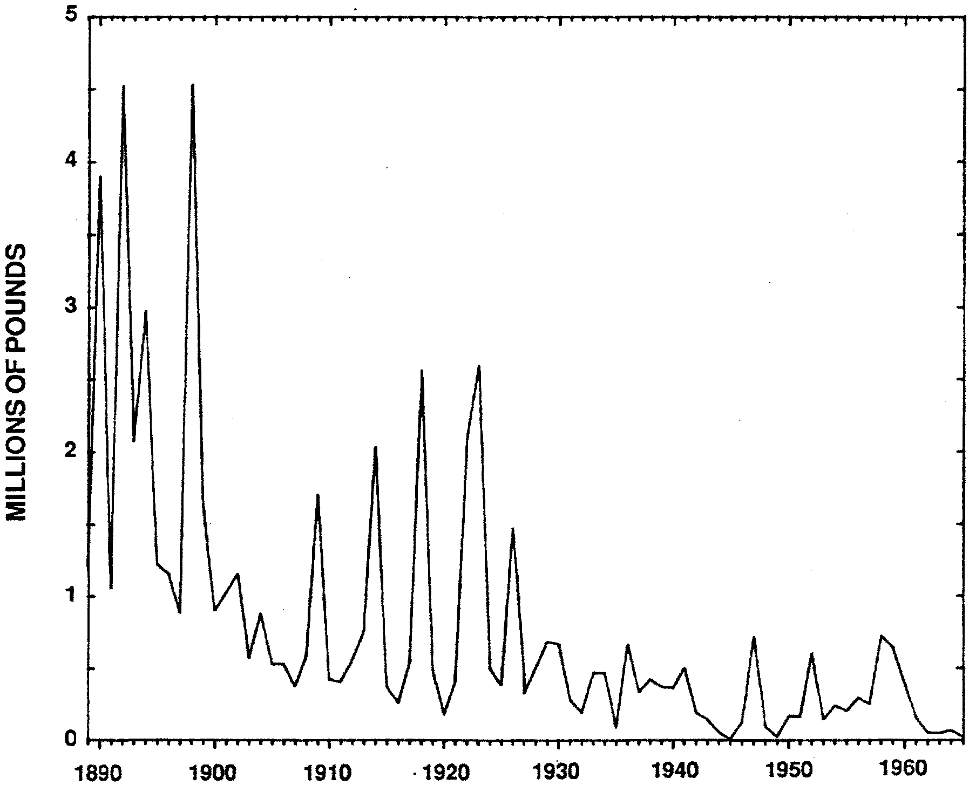

Commercial catches of blueback salmon in the Columbia River 1889 to 1965. Adapted from Craig and Hacker (1940) and Davidson (1966) by Pauley et.al (1989)

Extinction is a normal part of the natural world and results from a variety of physical and biological factors. In the fossil record there are hundreds of salmonid species that have flourished and gone extinct in the last 65 million years. However, in recent time, human-caused factors have contributed to the natural decline and extinction of many animal and plant species. This decline has become so precipitous that we may now be on the brink of the largest extinction episode in 65 million years.

There is reason to think that the natural fluctuations seen in the Snake River sockeye salmon population have been amplified by human activities. The construction of irrigation, flood control, and hydroelectric dams is often cited as a major contributor to the overall decline in Snake River sockeye numbers. Among the first irrigation and hydropower dams built were several that blocked access to much of Idaho’s spawning and rearing habitat. For example, in 1910 the Sunbeam Dam was built on the main fork of the Salmon River about 20 miles downstream from Redfish Lake. The dam was too high for the fish to get over by leaping and sockeye salmon migration to the Stanley Basin lakes was interrupted. A fish ladder was built on the Sunbeam in 1912, however, the ladder may not have functioned properly. In 1934, part of Sunbeam Dam was removed allowing sockeye to pass through to Stanley Lake. By 1942, 200 sockeye were seen spawning in Redfish Lake and by 1955, the number of salmon reached a high of 4,361.

By 1955, however, other dams were in place or being constructed on the lower Snake and Columbia rivers. McNary dam on the Columbia was completed in 1953, before Redfish Lake’s peak run in 1955. The Dalles dam was completed in 1957, followed by Ice Harbor in 1961, Lower Monumental in 1969, Little Goose in 1970, and Lower Granite in 1975. Sockeye runs began to decline drastically during this period of time. While it appears clear that the dams have played a role in the decline of the sockeye population, the picture is far from simple. For example, while only 55 spawning sockeye reached Redfish Lake in 1958 (before most of the Snake River dams were built), 102,397 sockeye passed through McNary Dam and 97,900 passed through Rock Island Dam in the same year.

In 1923, the Black Canyon dam on the Payette River eliminated sockeye salmon runs into the Payette Lake.

Current Population Trends

Today Idaho’s sockeye salmon face extinction. From 1989 to 1991 only 6 adult sockeye salmon returned to Redfish Lake (2 in 1989, 0 in 1990, and 4 in 1991). In 1990, the Shoshone-Bannock Indian tribes led efforts to develop a sockeye recovery plan. In 1991, the Snake River sockeye was listed as endangered under the Endangered Species Act. In 1992, one sockeye salmon returned to Redfish Lake.

What’s the Problem?

One of the most difficult tasks in salmon management is allocation: Who do the salmon belong to anyway? Today, the lower Columbia and Snake Rivers are a series of placid lakes formed by 15 dams constructed for power, barge navigation and irrigation (see following map). The Columbia river begins 80 miles north of the U.S. Border and winds about 1250 miles to the ocean. The Columbia River and its main tributaries, the Snake and Yakima Rivers, drain an area of approximately 260,000 square miles in Washington, Oregon, Idaho, Montana, Nevada, Utah, Wyoming, British Columbia, and Alberta. Redfish Lake, on the Salmon River, is part of the Snake River system which begins near the Idaho-Wyoming border.

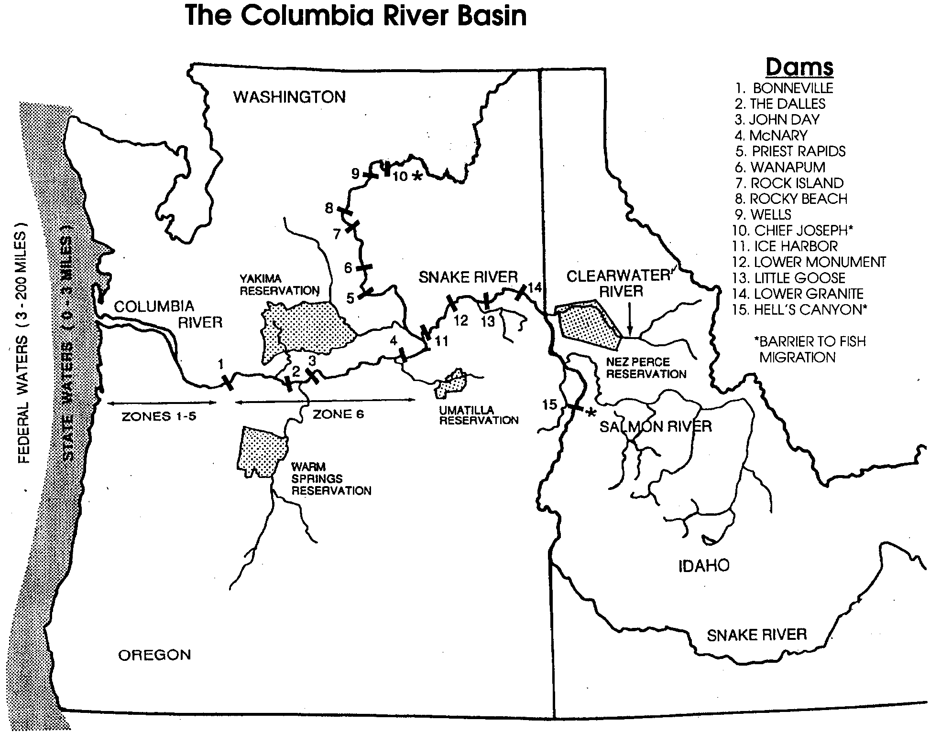

Once in the Pacific Ocean, the salmon recognize no political boundaries. Many stocks, wild and hatchery fish alike, mingle in the North Pacific. Fisherman from at least five countries, four states and many Indian tribes fish for the salmon in the ocean, bays, and rivers, under state and provincial jurisdictions. Because of the intermingling of salmon and the insistence of each of the various groups that it deserves a greater share, one of the most difficult tasks in salmon management is allocation.

The goal is simple, enough salmon must survive years at sea and then be allowed to escape commercial and sport fisherman by strictly controlling the fishing times. Achieving this goal, however, is difficult. The Pacific Salmon Commission is the group formed under the terms of the U.S.-Canada Pacific Salmon Treaty and is responsible for determining the number of salmon each country may harvest. Quota negotiations between the United States and Canada begin in early fall. The Pacific Fisheries Management Council is a regional group responsible for governing fisheries management from three to 200 miles off the coasts of California, Oregon, and Washington. The Council weighs recommendations from commercial, sport, and tribal fisherman in light of the Pacific Salmon Commission’s quotas. In Washington, the council must also ensure that half the harvestable salmon are allocated to 20 Indian tribes. Each major fishing area from California to Alaska is given a quota of salmon that may be caught. The weakest run in each system, called the “driver stock”, helps determine quotas. When the driver stock is present in an area, all fishing must cease because of the risk of wiping out the endangered run. For these and other reasons the salmon are difficult to manage.

Human and naturally occurring events have caused many salmon populations to decline in recent years. The following is a list of some of the major factors affecting salmon populations:

Predators: Several predators in the rivers and lakes eat salmon embryos and fry. Predators include: squawfish, bass, sculpin, and trout. One squawfish can eat 100 salmon smolt per day and the number of squawfish has increased a “thousand fold” in recent years. The survival rate from embryo through fry is estimated between 10-20% for Snake River sockeye salmon and is, in large part, dependent on the number and type of predators present. Sea gulls, harbor seals, sea lions, orcas and humans prey on salmon in the ocean. Non-native predators also pose a threat to salmon. For example, walleye, which feed on salmon, were deliberately introduced into Lake Roosevelt behind Grand Coolee Dam in the 1940’s and have spread down river.

Passage Mortality: Some smolts die as they pass through each dam. Accurate measurements are difficult to make. Mortality rates have been estimated at 10-20% of downstream migrants per dam and 5-10% of upstream migrants. The cumulative juvenile passage mortality for downstream migration has been estimated at 77-96% and cumulative adult upstream migration at 37-61%. Efforts to decrease passage mortality, including, barging smolts around dams, is decreasing these numbers. Some 50-80% of Snake River salmon are collected and transported around dams.

Harvest: Ocean fisheries have accounted for up to 73% of the Columbia River Basin sockeye harvested in some years. The Columbia River harvest ranges from 0-68% and tribal ceremonial and subsistence harvest ranges from 0 to 2%.

Dams: The 15 dams on the Columbia River and lower Snake River have changed the fast moving rivers into slack water pools. It once took smolts 10 days to migrate to the ocean. Now it takes 21 days or more. Smolts are forced to swim through slack water pools, causing additional stress and complicating their adjustment to sea water. In addition, an unnaturally long trip further increases stress on the fish. Within a few days of starting downstream to the ocean, salmon begin the physiological transformations necessary to live in salt water. If they are unable to reach saltwater within the “normal” time frame of these changes, they often die.

Ocean Conditions: Overall ocean conditions play an important role in the survival of salmon species. Changes in ocean temperature and circulation such as experienced during “El Nino” are thought to seriously affect survival.

During the upstream migration, adult fish face most of the same dangers the smolt do on their downstream migration. For example, adults must contend with disease, predation, and hydroelectric dams. In addition, they have to make their way past anglers. Most fish entering the Columbia River will not make it to the Idaho border.

Irrigation and diversion: Diversions of water along the migration corridors can cause problems by directing migrating salmon into fields and pastures, blocking adult fish migration, and through erosion, devastating stream beds. More water is being diverted each year for irrigation. About 7.6 million acres of farmland have been developed in the deserts of southern Idaho and eastern Washington. On the average, an additional 53,000 acres is irrigated annually . Water returned to the Columbia and Snake rivers from irrigated fields is warmer and may contain pesticides, phosphates, nitrates, sediments, increased salinity, and fecal coliform bacteria from animals. All of these may affect the survival of the migrating salmon.

Alturas Lake in the Stanley Basin suffered from a slightly different type of diversion. The lake was blocked to adult migrant sockeye and used for cattle watering. In this case, the fish were diverted!

Pollution and sedimentation: Silt deposits from logging, mining, road building, and overgrazing can clog salmon spawning gravel beds. Forest Service researchers found that from 50 to 75% of the original pools in streams are gone from areas of the forests that have been most intensively managed for timber production and grazing. This reduction of salmon spawning and rearing habitat poses a serious threat to sockeye survival.

Poisoning: Three lakes upstream from Redfish Lake were poisoned using Rotenone in the 1960’s to as recently as 1989 to get rid of unwanted squawfish, suckers, and kokanee (land-locked sockeye salmon). However, the Rotenone also destroyed all other fish. The lakes were blocked off from swimming migrants and stocked with trout. The poisoned lakes represented about 25% of the salmon spawning habitat in the Stanley Basin.
Decreased water flows: Drought and/or other water uses have decreased the amount of water flowing downstream. As the amount of water decreases in the rivers and streams along the migratory route, river flows slow down and the temperature of the water increases. As the temperature increases, the amount of dissolved oxygen available for the fish and other aquatic life decreases. Salmon and trout species are intolerant of warm water.

Hatchery Fish: Fifteen to thirty million hatchery raised salmon are released into the Stanley River Basin rivers and streams each year. Hatchery fish can spread disease among wild salmon populations and compete for food. Worst of all in the eye of some scientists, hatchery fish can interbreed with wild fish, diluting the wild gene pool and potentially spreading deficient characteristics. Hatchery fish may be adapted to concrete raceways, not necessarily to stream and river conditions.

The issues surrounding hatchery fish are many. About two billion hatchery fish are released into the northeast Pacific Ocean from North America. Another two and a half billion are released into the northwest Pacific Ocean from Japan and Russia. The potential for a serious impact on the ocean ecosystem seems great to many scientists.

Materials

For each student:

• “To Be Or Not To Be?” activity sheet

• game pieces

• dice

• balance sheet

For each group of 3–4 students:

• “To Be Or Not To Be?”game board

• game card

• calculator

Teaching Hints

“To Be or Not To Be” is the second activity in the “Salmon Dilemma”. The goal of this activity is to give students insight into some of the complex variables that affect salmon populations. Students play a game in which they try to maintain their own salmon population as it goes through its life cycle and migration. The game mimics some of the factors that affect real sockeye salmon populations. The game also reinforces computational skills as students track the total number of salmon in the population. Population changes are determined from information provided on the cards drawn by students during the course of the game. The object of the game is to maximize the number of fish spawning in Redfish Lake.

Procedure:

1. Use the game board masters to make enough game boards for a group size of 3 or 4. Finished game boards are 17" by 22". Notice that there are two different game board masters. Each master represents one half of the game board. For each game board, tape one copy of each master together.

2. Gather game pieces. Game pieces can be made out of anything that is small enough to fit on the game board.

3. Duplicate a set of game cards for each game board. Laminate the cards for longevity. Cut out the game cards by cutting across the star line and down the solid column lines.

4. Begin play with youngest student starting (note: youngest is an arbitrary attribute). Students advance by drawing condition cards that determine what happens to their population as it migrates to the ocean and back to Redfish Lake.

All the population changes noted on the “condition” cards are expressed as percentages. Students must therefore change percentages to decimals, then multiply their present population number by that decimal to calculate the number of the decrease in the salmon population. That number is subtracted from the previous population total to obtain the current population number. You may wish to share the following example with your students as they begin:

a. Let’s say your current salmon population numbers 1500 fish.

b. Imagine you draw a condition card that reads: “Squawfish predators have had a serious impact on the survival rate of your salmon eggs and have reduced the number of eggs by 55%”.

c. Here’s what you do:

• First, convert 55% to a decimal by moving the decimal point 2 places to the left. The decimal equivalent of 55% is .55.

• Then, multiply .55 times the current population number of 1500. .55 times 1500 fish equals 825 fish. This is the number of salmon eaten by squawfish.

• Finally, subtract 825 fish eaten from the 1500 in the original population to arrive at a new population of 625 salmon.
5. Play continues to the left until fish from all hatchery managers return or are decimated.
Key Words

fry - young salmon from the time they emerge from the eggs to about one year of age

parr - young salmon from about one year of age to the time they are ready to migrate downstream to the ocean

smolts - young salmon from the time they are ready to migrate downstream to the ocean until they reach adulthood

redds - salmon “nests”, dug in the gravel, where salmon eggs are laid

Extensions

1. Change the number of salmon eggs with which the managers start.

2. Use one die instead of two.

3. Have those players who have at least two salmon return to Redfish Lake, go through the migrations game again. For each pair that returns, the players get 2000 new eggs.

Answer Key

1. Five lakes in the Stanley Basin (Redfish, Alturas, Stanley, Yellow Belly and Pettit Lake) were home to spawning sockeye salmon. This question is included so that students will come to appreciate the magnitude of the sockeye decline.

2. Removing part of Sunbeam Dam caused an increase in the number of sockeye salmon in Redfish Lake.

3. This question calls for an opinion. The dams seem to be directly related to the decline of the salmon.

4. Salmon could successfully reproduce in 1989 and 1991 only. Make the point that one salmon (1992) could not successfully mate.

5. The different states and provinces have different priorities regarding use and preservation of the Columbia River and its resources. These differences make it difficult to reach an agreement on sockeye management.

6. This question calls for an opinion. Accept any reasonable, thoughtful answers. To fully protect fish from Redfish Lake, ocean fishing should be eliminated and replaced by fishing at the mouth of specific rivers, streams, and lakes.

7. This question calls for an opinion regarding a very difficult problem. Accept any reasonable, thoughtful answers. This question sets the stage for the activity which follows.

Dam Condition Card:
If you are a smolt, migrating downstream, you and your siblings are caught in the dam’s turbine. Your population decreases by 30%.

If you are an adult migrating upstream, you and the rest of your population are having problems getting up the dam’s ladder. 10% of you will not make it up stream

Dam Condition Card:
If you are a smolt, migrating downstream, you and your siblings are caught in the dam’s turbine. Your population decreases by 29%.

If you are an adult migrating upstream, you and the rest of your population are having problems getting up the dam’s ladder. 9% of you will not make it up stream

Dam Condition Card:
If you are a smolt, migrating downstream, you and your siblings are caught in the dam’s turbine. Your population decreases by 28%.

If you are an adult migrating upstream, you and the rest of your population are having problems getting up the dam’s ladder. 8% of you will not make it up stream

Dam Condition Card:
If you are a smolt, migrating downstream, you and your siblings are caught in the dam’s turbine. Your population decreases by 27%.

If you are an adult migrating upstream, you and the rest of your population are having problems getting up the dam’s ladder. 7% of you will not make it up stream

Dam Condition Card:
If you are a smolt, migrating downstream, you and your siblings are caught in the dam’s turbine. Your population decreases by 26%.

If you are an adult migrating upstream, you and the rest of your population are having problems getting up the dam’s ladder. 6% of you will not make it up stream

Dam Condition Card:
If you are a smolt, migrating downstream, you and your siblings are caught in the dam’s turbine. Your population decreases by 25%.

If you are an adult migrating upstream, you and the rest of your population are having problems getting up the dam’s ladder. 5% of you will not make it up stream.

Dam Condition Card:
If you are a smolt, migrating downstream, you and your siblings are caught in the dam’s turbine. Your population decreases by 24%.

If you are an adult migrating upstream, you and the rest of your population are having problems getting up the dam’s ladder. 10% of you will not make it up stream

Dam Condition Card:
If you are a smolt, migrating downstream, you and your siblings are caught in the dam’s turbine. Your population decreases by 23%.

If you are an adult migrating upstream, you and the rest of your population are having problems getting up the dam’s ladder. 9% of you will not make it up stream

Dam Condition Card:
If you are a smolt, migrating downstream, you and your siblings are caught in the dam’s turbine. Your population decreases by 22%.

If you are an adult migrating upstream, you and the rest of your population are having problems getting up the dam’s ladder. 8% of you will not make it up stream

Dam Condition Card:
If you are a smolt, migrating downstream, you and your siblings are caught in the dam’s turbine. Your population decreases by 21%.

If you are an adult migrating upstream, you and the rest of your population are having problems getting up the dam’s ladder. 7% of you will not make it up stream

Dam Condition Card:
If you are a smolt, migrating downstream, you and your siblings are caught in the dam’s turbine. Your population decreases by 20%.

If you are an adult migrating upstream, you and the rest of your population are having problems getting up the dam’s ladder. 6% of you will not make it up stream

Dam Condition Card:
If you are a smolt, migrating downstream, you and your siblings are caught in the dam’s turbine. Your population decreases by 19%.

If you are an adult migrating upstream, you and the rest of your population are having problems getting up the dam’s ladder. 5% of you will not make it up stream

Dam Condition Card:
If you are a smolt, migrating downstream, you and your siblings are caught in the dam’s turbine. Your population decreases by 18%.

If you are an adult migrating upstream, you and the rest of your population are having problems getting up the dam’s ladder. 4% of you will not make it up stream

Dam Condition Card:
If you are a smolt, migrating downstream, you and your siblings are caught in the dam’s turbine. Your population decreases by 17%.

If you are an adult migrating upstream, you and the rest of your population are having problems getting up the dam’s ladder. 10% of you will not make it up stream

Dam Condition Card:
If you are a smolt, migrating downstream, you and your siblings are caught in the dam’s turbine. Your population decreases by 16%.

If you are an adult migrating upstream, you and the rest of your population are having problems getting up the dam’s ladder. 9% of you will not make it up stream

Dam Condition Card:
If you are a smolt, migrating downstream, you and your siblings are caught in the dam’s turbine. Your population decreases by 15%.

If you are an adult migrating upstream, you and the rest of your population are having problems getting up the dam’s ladder. 8% of you will not make it up stream

Predation Card:
Your smolt population has met up with some very hungry squawfish. The squawfish eat 10% of your population.

Predation Card:
Your smolt population has met up with some very hungry catfish. The catfish eat 9% of your population.

Predation Card:
Your smolt population has met up with some very hungry walleye. The walleye eat 8% of your population.

Predation Card:
Your smolt population has met up with some very hungry squawfish. The squawfish eat 7% of your population.

Predation Card:
Your smolt population has met up with some hungry squawfish. The squawfish eat 6% of your population.

Predation Card:
Your smolt population has met up with some hungry squawfish. The squawfish eat 5% of your population.

Predation Card:
Your smolt population has met up with some hungry sculpin. The sculpin eat 4% of your population.

Predation Card:
Your smolt population has met up with a few hungry squawfish. The squawfish eat 3% of your population.

Predation Card:
Your smolt population has met up with a few hungry squawfish. The squawfish eat 2% of your population.

Predation Card:
Your smolt population has met up with one very hungry small mouth bass. The small mouth bass eats 1% of your population.

Mystery Card:
One of the local fish hatcheries releases some diseased salmon as your population passes by. 10% of your population catch the disease and die.

Mystery Card:
One of the towns along the river dumps toxic water into the river as your population passes by. 20% of your population catch the disease and die.

Mystery Card:
It has been a drought year and the water temperature climbs above 65° Celsius. 10% of your population suffer from lack of oxygen and die.

Mystery Card:
Accidently, someone introduced a new species into the river. 10% of your population die from starvation because the new species has eaten their food.

Mystery Card:
Accidently, someone introduced a new species into the river. 6% of your population die from starvation because the new species has eaten their food.

Mystery Card:
As your population migrates, they swim into a canal used to divert water into a field. 13% of your population can’t get back to the river and die.

Mystery Card:
One of the local fish hatcheries releases some diseased salmon as your population passes by. 5% of your population catch the disease and die.

Mystery Card:
As your population migrates, they swim into a canal used to divert water into a field. 7% of your population can’t get back to the river and die.

Mystery Card:
Fishing limits were set too high this year. 15% of your population is caught by sports fisherman.

Ocean Card:
An oil spill occurs in the area in which your population is feeding. 8% of your population die from contamination.

Ocean Card:
An oil spill occurs in the area in which your population is feeding. 8% of your population die from contamination.

Ocean Card:
Gillnet fisherman are in the same area in which your population is feeding. 2% of your population is caught.

Ocean Card:
An oil spill occurs in the area in which your population is feeding. 5% of your population die from contamination.

Ocean Card:
Gillnet fisherman are in the same area in which your population is feeding. 1% of your population is caught.

Ocean Card:
A larger school of fish is in the same area in which your population is feeding. 1% of your population is consumed by these larger fish.

Ocean Card:
A larger school of fish is in the same area in which your population is feeding. 2% of your population is consumed by these larger fish.

Ocean Card:
A passing ship dumps a large amount of trash off the coast. Your population encounters the trash and consumes some of it. 1% of your population die as a result.

Ocean Card:
A passing ship dumps a large amount of trash off the coast. Your population encounters the trash and consumes some of it. 2% of your population die as a result.

Ocean Card:
Too large a salmon harvest was allowed this year. 3% of your population is caught.

Ocean Card:
Too large a salmon harvest was allowed this year. 4% of your population is caught.

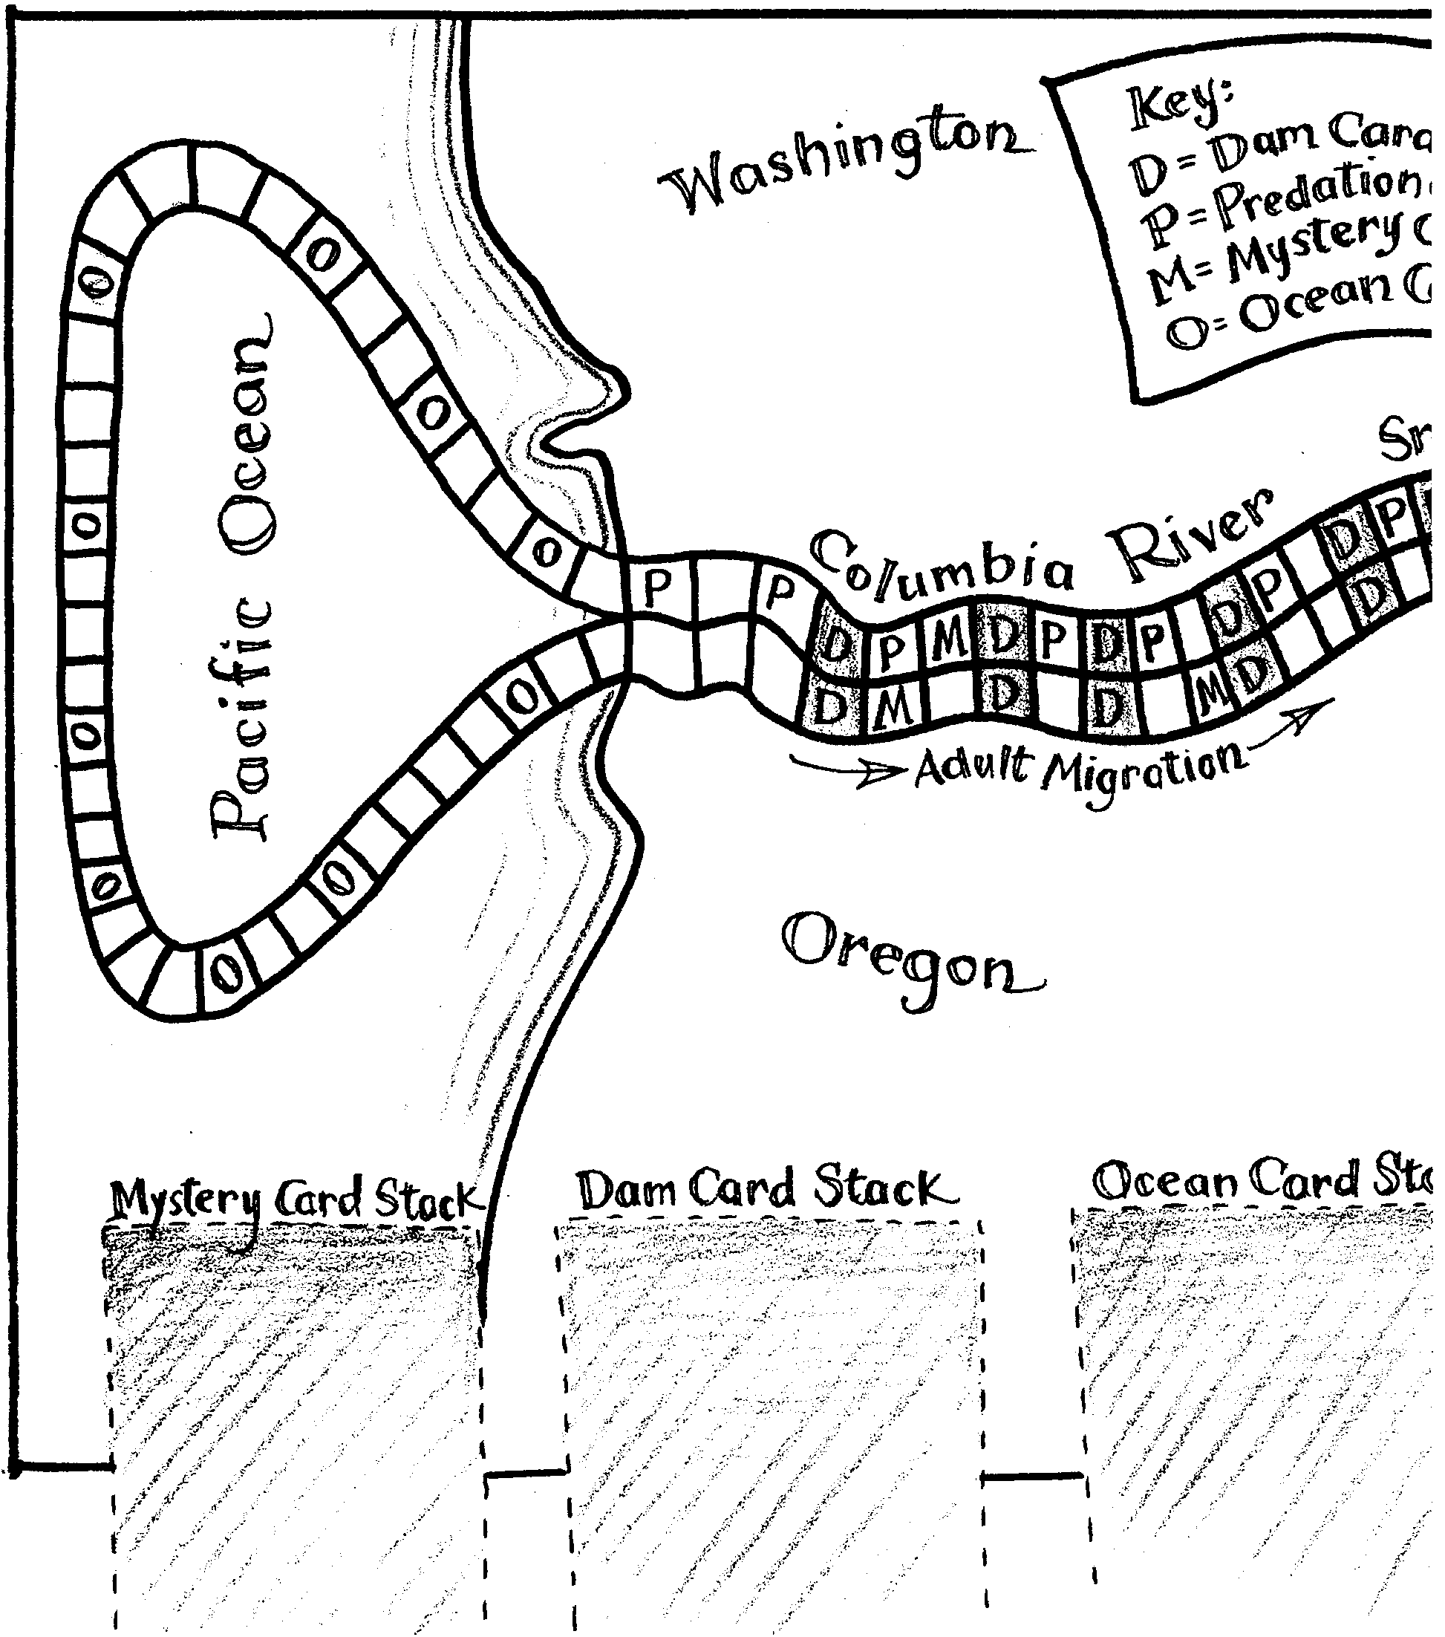
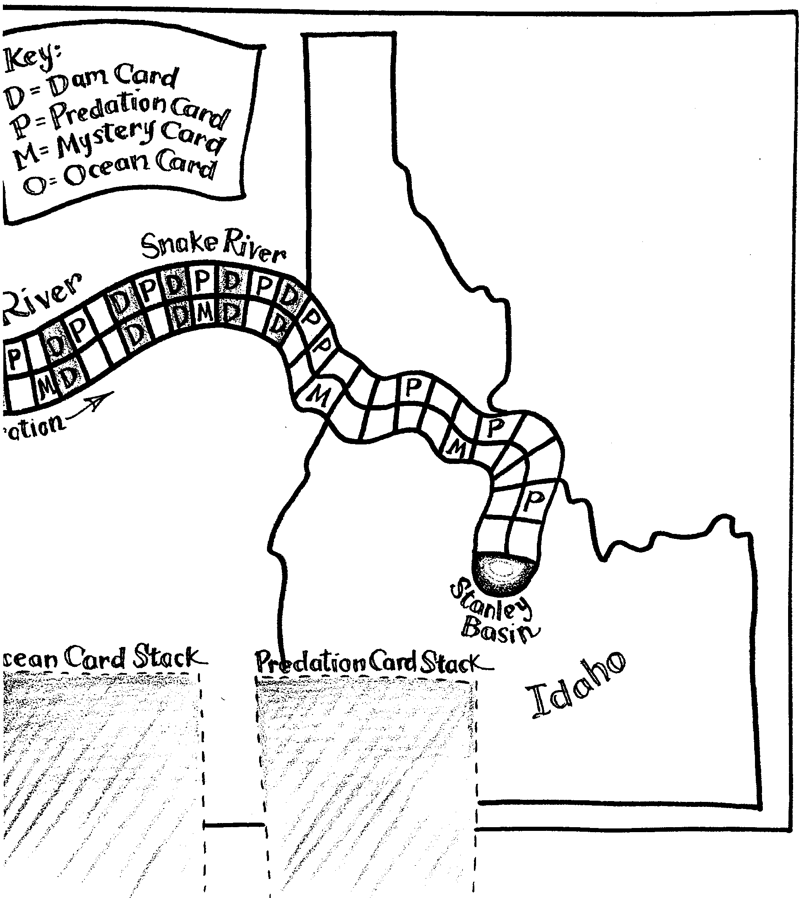

A Case Study in the Salmon Dilemma:

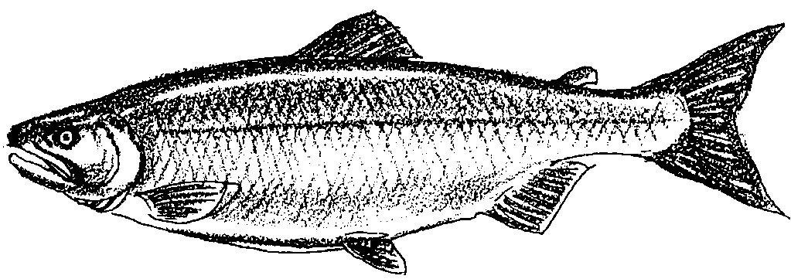
To Be or Not To Be?
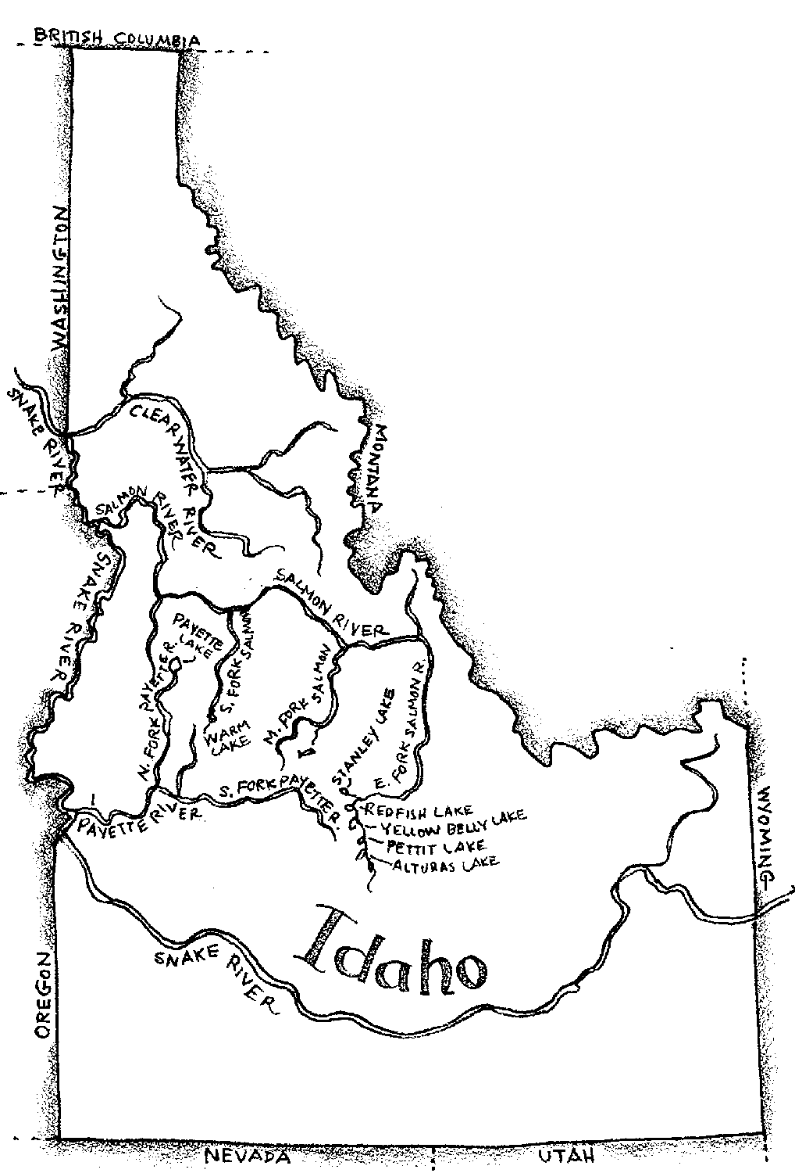

Early History of the Snake River Sockeye

Sockeye salmon have been present in the Snake River drainage for thousands of years. For many centuries, the Shoshone and Bannock Indians caught sockeye salmon. They ate the fish and also used them in tribal ceremonies. Later miners and settlers moved into central Idaho. They also fished for sockeye salmon.

Until the late 1800’s, the sockeye salmon traveled through four Idaho rivers: Payette River, Clearwater River, South Fork of the Salmon River, and upper Salmon River. The salmon spawned in Payette Lake near McCall; Lake Mervin and Warm Lake on the South Fork; and five lakes in the Stanley Basin: Redfish, Alturas, Stanley, Yellow Belly and Pettit Lakes.

In many years fish were abundant; in other years few, if any, returned. One early day prospector reportedly harvested 2,600 pounds of sockeye out of Alturas Lake in 1881. But in 1896, a net set at the mouth of Alturas Lake from July to September caught no sockeye. Why such changes? The Snake River is about as far south as sockeye salmon are found. It is also about as high in the mountains as sockeye salmon are found. The changes in the Snake River sockeye population are what is expected of a species “living on the edge” of its range.

1. How many Idaho lakes were home to spawning sockeye salmon?

There is reason to think that these natural changes are affected by human activities. For example, dams were built that blocked access to much of Idaho’s spawning and rearing habitat. In 1910, the Sunbeam Dam was built on the main fork of the Salmon River. This dam is about 20 miles down stream from Redfish Lake. The dam was too high for the fish to get over by leaping. The sockeye salmon migration to the Stanley Basin lakes was interrupted. A fish ladder was built on the Sunbeam in 1912, however, the ladder may not have worked very well. In 1934, part of Sunbeam Dam was removed. The removal allowed sockeye to pass through to all the Stanley Basin lakes. By 1942, 200 sockeye were seen spawning in Redfish Lake. By 1955, the number of salmon reached a high of 4,361.

2. What was the effect of removing part of Sunbeam Dam on the number of sockeye salmon in Redfish Lake?

While sockeye were increasing in number in Redfish Lakes, other dams were being constructed on the lower Snake and Columbia rivers. McNary Dam was built in 1953. The Dalles Dam was finished in 1957. Ice Harbor was built in 1961, Lower Monumental in 1969, Little Goose in 1970, and Lower Granite in 1975. Sockeye runs began to decline drastically during this period of time.

3. How do you think the dams are related to changes in the number of sockeye salmon?

Current Population Trends

Today Idaho’s sockeye salmon face extinction. From 1989 to 1991 only 6 adult sockeye salmon returned to Redfish Lake (2 in 1989, 0 in 1990, and 4 in 1991). In 1990, the Shoshone-Bannock Indian tribes led efforts to develop a sockeye recovery plan. In 1991, the Snake River sockeye was listed as endangered under the Endangered Species Act. In 1992, one sockeye salmon returned to Redfish Lake.

4. During which years from 1989 to 1992 could salmon successfully spawn in Redfish Lake?

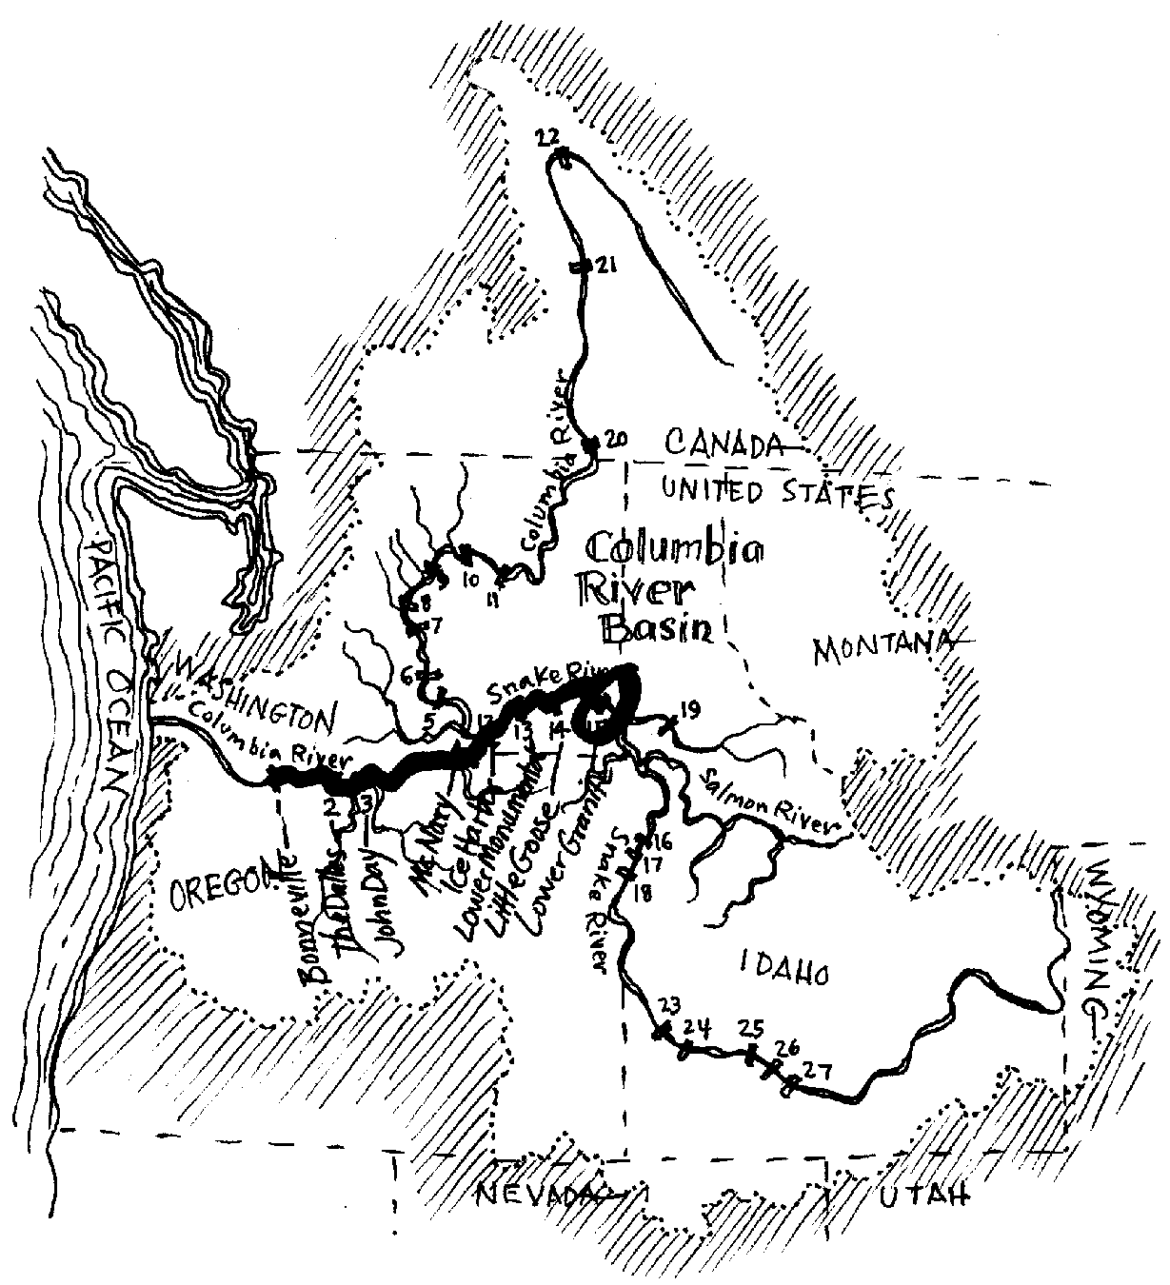
What’s the Problem?

One of the most difficult tasks in salmon management is allocation: Who do the salmon belong to anyway? Today, the 1250 mile long Columbia River is really a series of lakes. The lakes are formed by eight dams constructed for power, barge navigation and irrigation. The Columbia River system drains an area of approximately 260,000 square miles. Rivers and streams in Washington, Oregon, Idaho, Montana, Nevada, Utah, Wyoming, British Columbia, and Alberta flow into the Columbia.
5. Lots of states and provinces have a stake in the Columbia River. How might this complicate saving the sockeye salmon population?

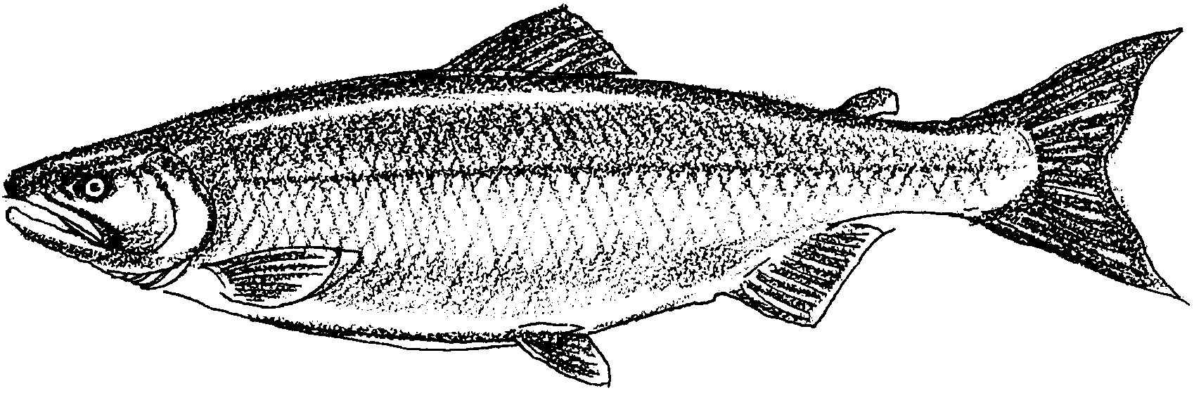

Once in the Pacific Ocean, the salmon recognize no state or national boundaries. Many stocks, wild and hatchery fish alike, mingle in the North Pacific. Fisherman from at least five countries, four states and many Indian tribes fish for the salmon. The fish in the ocean, bays, and rivers, are regulated by state and provincial governments. Each different group of fishers insist that it deserves a greater share. Managers try to protect salmon populations by strictly controlling the fishing times.

6. In the ocean, salmon from many different streams mix. As a manager, you want to protect fish from Redfish Lake. How would you regulate ocean fishing?

The goal is simple, enough salmon must survive years at sea and then be allowed to escape commercial and sport fisherman to reach the spawning grounds. Achieving this goal, however, is difficult.

7. How would you allocate salmon to the various fishers?

To Be Or Not To Be: You’re In Charge

As we have seen, both natural and human-made factors affect sockeye numbers. During the following activity you will take on the role of a fisheries manager. As a manager, you will examine some of the factors that affect salmon populations. The goal of this game is to have as many spawning salmon as possible return to Redfish Lake. Good Luck!

Materials

• “To Be Or Not To Be?” activity sheet
• game piece
• balance sheet

For each group:

• “To Be Or Not To Be?” game board
• game card
• calculator
• dice

Procedure:

1. You are a fisheries manager. Your job depends on the salmon that return to spawn. In other words, you want to end up with the most salmon returning to spawn.

2. You begin this year with 2000 sockeye salmon eggs. Your task is to keep tract of how many salmon you have throughout the salmon’s life cycle. You will do this by keeping a balance sheet on the population level.

3. Set up the salmon life cycle board. Place the appropriate environmental condition cards face down in the spaces provided.

4. Choose a salmon marker piece to represent your salmon population. Your marker will “migrate” from Redfish Lake to the ocean and return. Place your salmon marker in Redfish Lake in the Stanley Basin.

5. Anyone can begin. Roll the dice and move your salmon marker according to the number rolled. The manager to the left has the next turn.

6. If you land on a square with a letter M, O, or P, drawn an appropriate card: M = Mystery; O = Ocean; and, P = Predation. If you land on or pass a square with a letter D, draw a Dam card. Read the card aloud to the other managers. Apply the information on the card to your salmon population. Record the population changes on your “balance sheet”.
For example, “Squawfish predators have had a serious impact on the survival rate of your salmon eggs, reducing the number of eggs by 55%.” The player applies this condition card to his or her population by doing the following:

First, convert 55% to the decimal .55 by moving the decimal point 2 places to the left.

Next, multiply .55 times the current population number, 2000 in this case. the answer, 1100, is the number of salmon that have died.

Then, subtract 1100 from 2000 to get the new population number which is 900.

Finally, round the answer to the nearest whole salmon. Record this information on the “balance sheet” provided.

7. Migration continues by the next manager rolling the dice and drawing a condition card, if necessary. That manager applies the condition card to his or her salmon population.

8. If at any time you run out of condition cards, take the cards that have already been used, reshuffle them and place them back on the board.

9. Migration ends when all salmon populations return to Redfish Lake to spawn. The player with the largest number of salmon spawning at the end has had the most successful year.

10. After the migration is over, discuss and answer the following questions within your group:

Analysis and Interpretation

1. List five factors that affect salmon populations.

a.

b.

c.

d.

e.
2. Which factor(s) had the largest effect on the salmon?

3. a. What was the largest number of salmon returning to spawn?

b. Is this number considered large or small? Why?

4. Would managing the sockeye salmon populations be an easy or difficult job? Why?

5. a. Which aspects of the game seemed realistic? Which didn’t?

Realistic:

Unrealistic:

6. Discuss three possible ways to improve the numbers of salmon returning to spawn.

a.

b.

c.

Balance Sheet—Salmon Dilemma—Activity Two: To Be or Not To Be?
• Beginning Population: 2,000

% Decimal

Condition:

Amount the population decreased:

(Current population times decimal)

2,000
x
=
=
x

New population:

(Current population — amount decreased)

2,000

% Decimal

Condition:

Amount the population decreased:

(Previous "new" population times decimal)

x
=
=
x

New population:

(Previous "new" population — amount decreased)

% Decimal

Condition:

Amount the population decreased:

(Previous "new" population times decimal)

x
=
=
x

New population:

(Previous "new" population — amount decreased)

&%

Condition:

Amount the population decreased:
(Previous "new" population
times decimal)

x=

New population:
(previous "new" population
minus amount decreased)

–=

&%

Condition:

Amount the population decreased:
(Previous "new" population
times decimal)

x=

New population:
(previous "new" population
minus amount decreased)

–=

&%

Condition:

Amount the population decreased:
(Previous "new" population
times decimal)

x=

New population:
(previous "new" population
minus amount decreased)

–=

&%

Condition:

Amount the population decreased:
(Previous "new" population
times decimal)

x=

New population:
(previous "new" population
minus amount decreased)

–=

&%

Condition:

Amount the population decreased:
(Previous "new" population
times decimal)

x=

New population:
(previous "new" population
minus amount decreased)

–=

&%

Condition:

Amount the population decreased:
(Previous "new" population
times decimal)

x=

New population:
(previous "new" population
minus amount decreased)

–=

&%

Condition:

Amount the population decreased:
(Previous "new" population
times decimal)

x=

New population:
(previous "new" population
minus amount decreased)

–=

&%

Condition:

Amount the population decreased:
(Previous "new" population
times decimal)

x=

New population:
(previous "new" population
minus amount decreased)

–=

&%

Condition:

Amount the population decreased:
(Previous "new" population
times decimal)

x=

New population:
(previous "new" population
minus amount decreased)

–=

&%

Condition:

Amount the population decreased:
(Previous "new" population
times decimal)

x=

New population:
(previous "new" population
minus amount decreased)

–=

&%

Condition:

Amount the population decreased:
(Previous "new" population
times decimal)

x=

New population:
(previous "new" population
minus amount decreased)

–=

&%

Condition:

Amount the population decreased:
(Previous "new" population
times decimal)

x=

New population:
(previous "new" population
minus amount decreased)

–=

&%

Condition:

Amount the population decreased:
(Previous "new" population
times decimal)

x=

New population:
(previous "new" population
minus amount decreased)

–=

&%

Condition:

Amount the population decreased:
(Previous "new" population
times decimal)

x=

New population:
(previous "new" population
minus amount decreased)

–=

&%

Condition:

Amount the population decreased:
(Previous "new" population
times decimal)

x=

New population:
(previous "new" population
minus amount decreased)

–=

&%

Condition:

Amount the population decreased:
(Previous "new" population
times decimal)

x=

New population:
(previous "new" population
minus amount decreased)

–=

&%

Condition:

Amount the population decreased:
(Previous "new" population
times decimal)

x=

New population:
(previous "new" population
minus amount decreased)

–=

&%

Condition:

Amount the population decreased:
(Previous "new" population
times decimal)

x=

New population:
(previous "new" population
minus amount decreased)

–=

&%

Condition:

Amount the population decreased:
(Previous "new" population
times decimal)

x=

New population:
(previous "new" population
minus amount decreased)

–=

&%

Condition:

Amount the population decreased:
(Previous "new" population
times decimal)

x=

New population:
(previous "new" population
minus amount decreased)

–=

&%

Condition:

Amount the population decreased:
(Previous "new" population
times decimal)

x=

New population:
(previous "new" population
minus amount decreased)

–=

&%

Condition:

Amount the population decreased:
(Previous "new" population
times decimal)

x=

New population:
(previous "new" population
minus amount decreased)

–=

&%

Condition:

Amount the population decreased:
(Previous "new" population
times decimal)

x=

New population:
(previous "new" population
minus amount decreased)

–=

&%

Condition:

Amount the population decreased:
(Previous "new" population
times decimal)

x=

New population:
(previous "new" population
minus amount decreased)

–=

&%

Condition:

Amount the population decreased:
(Previous "new" population
times decimal)

x=

New population:
(previous "new" population
minus amount decreased)

–=

&%

Condition:

Amount the population decreased:
(Previous "new" population
times decimal)

x=

New population:
(previous "new" population
minus amount decreased)

–=

&%

Condition:

Amount the population decreased:
(Previous "new" population
times decimal)

x=

New population:
(previous "new" population
minus amount decreased)

–=

&%

Condition:

Amount the population decreased:
(Previous "new" population
times decimal)

x=

New population:
(previous "new" population
minus amount decreased)

–=

&%

Condition:

Amount the population decreased:
(Previous "new" population
times decimal)

x=

New population:
(previous "new" population
minus amount decreased)

–=

&%

Condition:

Amount the population decreased:
(Previous "new" population
times decimal)

x=

New population:
(previous "new" population
minus amount decreased)

–=

&%

Condition:

Amount the population decreased:
(Previous "new" population
times decimal)

x=

New population:
(previous "new" population
minus amount decreased)

–=

&%

Condition:

Amount the population decreased:
(Previous "new" population
times decimal)

x=

New population:
(previous "new" population
minus amount decreased)

–=

Final # of Salmon:

