A Case Study in the Salmon Dilemma: Sockeye Life History

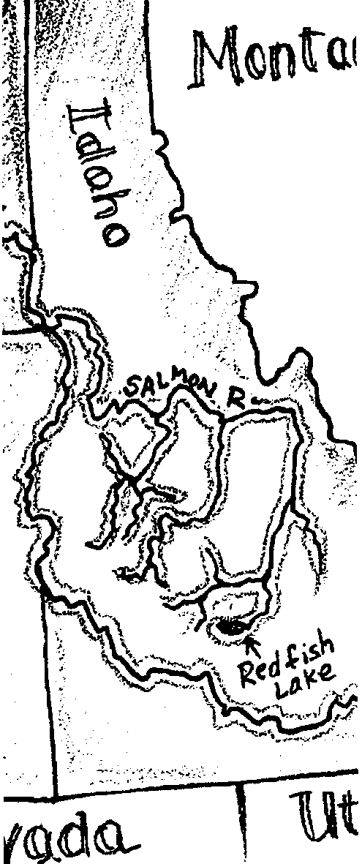
Key Concepts
1. Many salmon populations have declined in recent years as a result of human and naturally caused events.
2. Issues affecting salmon have local, regional, national, and international components.
3. Salmon populations present special management challenges because of the distance the fish travel and the wide variety of conditions or changes in habitats through which they travel.
4. Attempts have been made to improve salmon runs including limiting harvest, stocking programs, modifying dams, transporting smolt, and varying water releases from dams. These attempts have met with varying degrees of success.

Background

The ocean that covers two-thirds of our planet has a great impact on all of us. It influences the weather, our food supply, even the oxygen we breathe. Human activities both near and far from the coast can threaten the health and diversity of our ocean.

• Since almost all land drainage ultimately flows into rivers which finally flow into the sea, waste such as crankcase oil that is dumped in a storm drain many miles from the coast can reach the sea.

• Greenhouse gases released from burning fossil fuels in vehicles and manufacturing centers far from the coast may be altering the composition of our atmosphere.

• Fish populations are declining while technology is making more efficient fishing methods possible. Since 1800, 98% of resident cutthroat salmon in North America have gone extinct.

• Human activities can encourage the movement of plants and animals from their native habitat to new areas where they may change the existing predator-prey balance.
“A Case Study in the Salmon Dilemma” begins to introduce your students to these and other issues by giving them background information through hands-on activities.

Salmon populations follow natural cycles of high and low abundance. Today, some salmon populations have been declining to the extent that they are in danger of becoming extinct. While extinction is a natural part of the evolutionary process, human changes and activities that may cause extinctions should be avoided. Even populations which are presently healthy have been affected by the increase in the human population found in the watersheds used by salmon. Various agencies, scientists, groups and individuals have tried to increase populations with some or little success. The Endangered Species Act is now being employed in an effort to stem the decline of a number of salmon populations.

As can be seen from the national debate over the old growth forests and the spotted owl, the Endangered Species Act is a management tool with far-reaching consequences. Because of this, the declaration of a species as endangered is a complicated, multi-step process. For the purposes of the Act, “An endangered species is any species in danger of extinction throughout all or a significant portion of its range”. The determination of whether or not to list an organism as endangered must “be based solely on the best scientific and commercial data available, without reference to possible economic or other impacts of such determination”.

The process begins with a petition from an interested group requesting designation of the plant or animal as endangered. In the case of salmon species, the petition is directed to the National Marine Fisheries Service within the National Oceanic and Atmospheric Administration of the U.S. Department of Commerce. The petition usually presents substantial scientific information indicating that the listing may be warranted. The agency evaluates the petition through internal review and public input. If the petition has merit, a “proposed rule” is prepared and published in the Congressional Record requesting comments from all interested parties. Where appropriate, this information is incorporated into a “final rule” which is again published in the Congressional Record along with the date the rule becomes effective. The rule requires the agency in charge to develop a management plan for the species.

The first salmon species to be listed as endangered was the Snake River sockeye salmon. The process formally commenced in April of 1990 with a petition by the Shoshone-Bannock Tribes of the Fort Hall Indian Reservation in Idaho. The final rule went into effect on December 20, 1991. “A Case Study in the Salmon Dilemma” provides three activities that deal with the plight of the Snake River sockeye salmon. They provide students with the opportunity to learn about the life cycle of the sockeye salmon, what factors may be causing declines in salmon populations, and possible solutions for saving salmon.
Because of its precedent setting listing as endangered, the Snake River sockeye salmon was chosen for this case study. In some ways this is a problematical choice for such a study because:

• the species population is very small

• Snake River sockeye historically have been vulnerable to environmental change from natural causes because they are at the very southern extreme of the range, move further inland and to higher elevations than most sockeye populations, and depend upon a very tenuous and narrow life-line to the sea

• the continued existence or extinction of the Snake River sockeye salmon would likely have limited human impact.

In other ways, the choice is very appropriate:

• the problems affecting the sockeye are not, for the most part, unique;

• the preservation of genetic diversity is of critical importance, even if those genes are found in a small population; and,

• the use of the Endangered Species Act as a tool for preserving a salmon species is an important consideration.

As an example of this last point, the group “Pro-Salmon”, comprised of professional fishery workers, petitioned the National Marine Fisheries Service on March 11, 1994 to “list as threatened or endangered nine naturally spawning populations of salmon indigenous to Puget Sound in Washington State and to designate critical habitat for these stocks under the Endangered Species Act”. Although, as noted above, the continued existence or extinction of the Snake River sockeye salmon would likely have limited human impact, the listing of the Snake River sockeye or other species can have massive human impacts ranging from reductions in fishing to changes in energy availability from hydropower dams.

Background for “The Sockeye Salmon Life Cycle”

The first activity, “The Sockeye Salmon Life Cycle”, introduces the unique life cycle of the sockeye salmon. A basic understanding of the salmon’s life cycle is necessary in order to understand why the sockeye salmon and other salmon species are especially vulnerable to human influences.

Sockeye Salmon Life Cycle

Snake River sockeye salmon are the southern–most sockeye run in North America and travel farther on their migration to the ocean than most other North American salmon. Their life cycle exposes them to a variety of habitats and their attendant risks and resources.

Eggs: Snake River sockeye salmon start life as small red eggs laid in gravel-filled nests beneath Redfish Lake or the streams connected to the lake. The eggs are laid in October and five or six months later hatch in late March or April.

Fry: After they hatch, the salmon are called fry. The fry spend their first three to five weeks in the gravel, emerging April through May. It will be one or two years before the young salmon leave their freshwater spawning and rearing grounds. They feed on microscopic animals and insects. They must constantly avoid larger fish, birds, and other predators. Eighty to ninety percent of these fry will die during their first few months.

Parr: During the following winter, the young salmon are called parr. The parr seek shelter from predators and weather conditions in the spaces between the rocks on the lake bottom. The parr leave their shelter when the water warms up in the spring.

Smolts: After one to two years in Redfish Lake, the sockeye salmon begin their 897 mile trip through three states to the Pacific Ocean. When the fish leave, they are about four inches long, have turned a silvery color, and are called smolts.

To the Ocean: In late April or early May, the smolts leave Redfish Lake. The stream current helps as the fish swim downstream to the Salmon River. They follow the Salmon River to the Snake and Columbia rivers, staying close to the river banks and traveling mostly at night to avoid predators.

Ocean Life: Once the salmon reach the Pacific Ocean, they remain inshore or within their home river’s influence zone for the early summer. Later, they migrate through the northeast Pacific Ocean, perhaps in fairly rigid, genetically determined migration patterns. In the ocean, they feed voraciously on microscopic animals, small fish, and other marine life. They grow to 1.5 to 2 feet long and put on 3-6 pounds. While in the ocean, the fish must avoid predators and angler’s nets and hooks. Exactly where the sockeye migrate through the northeast Pacific ocean is not precisely known.

Returning Home: After two to five years in the Pacific Ocean, the sockeye have matured to adults and are ready for the return journey to Redfish Lake to spawn. In either June or July, the adult fish start upstream, moving approximately 13 miles per day, passing Bonneville Dam in late June and July. Once near the parent stream, the salmon smell differences in the water that lead them to within yards of their birthplace. Once the fish enters the river, they stop feeding and therefore must rely on fat reserves that accumulated in the ocean. Those salmon that avoid predators, dams and fishers will reach Redfish Lake sometime in late July and August.

Spawning: Once the salmon arrive, they wait until October before spawning. During this time the female’s belly swells with eggs. The males turn a darker color and their heads and snouts become hooked shape. Apparently using the changing day length and falling temperatures of October as clues, the female selects a spawning site where the temperature, pH, water velocity, and size of the gravel are just right. She digs out a depression or nest using her tail. The female releases 50 to 100 eggs and the male releases sperm to fertilize the eggs. After the eggs have been fertilized, the female covers her eggs, again using her tail. The female may lay a total of about 2000 eggs in her spawning area. The nest sites are known as “redds”. After spawning, the adults die within a few days to several weeks. The eggs will incubate in the redds until April or May when they emerge as fry to start this cycle again.

Materials

For each student:

• “A Case Study in the Salmon Dilemma: Sockeye Life History” activity sheets

• “Sockeye Salmon Life Cycle” activity sheet

Teaching Hints

Your students may already be familiar with the life cycle of salmon. You then may want to point out some of the differences between sockeye salmon and the salmon with which they are familiar.

Students can play a review game called “Numbered Heads Together”. This is how it is played:

1. The teacher divides the class into groups of 4.

2. Each person in the group is assigned a number 1-4.

3. Each group is assigned a number.

4. The teacher asks a review question and states how long the groups have to discuss the answer amongst themselves (use the questions the students are to answer as they read the article, but mix up the order). The harder the question, the more time the students should have to discuss and agree upon the answer within their groups during this time. However, once the teacher calls upon a student to answer, he or she cannot receive help from the group.

5. When the time is up the teacher randomly picks a number 1-4. This can be done by using dice and/or cards. If it is one, then the ones in each group need to stand up. Then the teacher randomly selects one of the groups to answer the question. The person standing up has to answer the question without help from the group. If the group answers correctly they get a point. If they do not answer correctly, another team is randomly chosen to answer the question.

6. The team with the most points at the end wins.

Key Words

fry - young salmon from the time they emerge from the eggs to about one year of age

parr - young salmon from about one year of age to the time they are ready to migrate downstream to the ocean

smolts - young salmon from the time they are ready to migrate downstream to the ocean until they reach adulthood

redds - salmon “nests”, dug in the gravel, where salmon eggs are laid

Extensions

1. An additional activity that allows students to graph four different salmon populations, illustrating the declines that have occurred over time is called “Where have all the salmon gone?” and appears in “Aquatic Project Wild” published by Western Association of Fish and Wildlife Agencies and the Western Regional Environmental Education Council. This activity would be a good follow-up to the “Salmon Dilemma” activities.

2. Additional information regarding the plight of salmon and of the special concerns of Snake River sockeye salmon may be found in the following:

Anon. 1987. The Saga of the Salmon. Seattle Times/Seattle Post Intelligencer. November 22, page A1.

Anon. 1993. Coho Fishing Ban Called a Bad Idea. Associated Press in Seattle Times, April 4.

Anon. 1993. Snake River Salmon National Treasure at Risk of Extinction. State of Idaho Office of the Governor, Boise, Idaho. 10pp.

Bjornn, T., D. Craddock, and D. Corley. 1968. Migration and Survival of the Redfish Lake, Idaho, Sockeye Salmon, Oncorhynchus nerka. Trans. Am. Fish. Soc., 97:360-373.

Dietrich, B. 1992. Fishy Quiz: Name Our No. 1 Upstream Migrant. Seattle Times, Aug. 7, page B8.

Dietrich, B. 1992. Plan to Restore Salmon Runs Touted as Worldwide Model. Seattle Times, Sept. 10, page D1.

Ely, T. 1991. In Sea of Trouble. Wilderness, 55(fall):18-26.

Gantenbien, D. 1991. Salmon on the Spot. Sierra, Jan./Feb.: 32-34.

Gibbs, A. 1991. Search for a Consensus Solution Has Yet to Bear Fruit. The Morning News Tribune, June 11, Page A9.

Hume, M. 1992. Enforcement Vacuum Blamed for Loss of Salmon. Vancouver Sun (Vancouver, B.C.), Nov. 17, page B8.

Judd, R. 1992. Alarming Coho Run May Prompt Fishing Ban. Seattle Times, Nov. 12, page A1.

Kohm, K. 1991. Balancing on the Brink of Extinction. Island Press. 318 pages.

Lewis, R. 1991. Can Salmon Make a Comeback? Bioscience 4(1):6-10.

Lowe, M. 1988. Salmon Ranching and Farming Net Growth Harvest. Worldwatch, Jan./Feb., pages 28-32.

Muckleston, K. 1990. Striking a Balance in the Pacific Northwest. Environment 32(1):10-35.

Palensky, J. 1991. The Downstream Dilemma. The Morning News Tribune, Tuesday, June 11, page A1.

Pauley, G.; R. Risher; and G. Thomas. 1989. Species Profiles: Life Histories and Environmental Requirements of Coastal Fishes and Invertebrates (Pacific Northwest): Sockeye Salmon. U.S. Fish and Wildlife Service, National Wetlands Research Center. Washington, D.C.

Pryne, E. 1992. Low Stream Flows Threatening Salmon. Seattle Times, Aug. 7, page A1.

Teton, G. and S. Broderick. 1990. Listing the Snake River Race Sockeye Salmon as Endangered. Shoshone-Bannock Tribes of the Fort Hall Indian Reservation in Idaho. 42 pp.

Waples, R., O. Johnson, and R. Jones. 1991. NOAA: Status Review for the Snake River Sockeye Salmon. National Marine Fisheries Service, Environmental and Technical Services Division, Portland, Oregon. 23pp.

Answer Key

1. Snake River sockeye salmon begin their lives as eggs, laid in the gravel of Redfish Lake.

2. Fry face hazards such as predators, suffocation from silt, starvation, and changes in water quality.

3. The dark, vertical lines (called “parr marks”) help the young salmon hide; they act as camouflage.

4. This question is designed to highlight the amazing feat these four inch wonders accomplish in swimming 897 miles. The problem is easily solved if set up in a step-wise fashion like this:

1 foot x 60 seconds x 60 minutes = 3600 feet/hour
second minute hour

3600 feet x 1 mile = .68 miles/hour
hour 5,280 feet

897 miles x 1hour = 1319 hours/migration
migration .68 miles

1319 hours x 1 day = 54 days
migration 24 hours

In discussing this problem, note that in addition to traversing the horizontal distance of 897 miles, the Snake River sockeye also climb some 6,500 vertical feet.
5. Dams, irrigation projects, fishers, and pollution are among the hazards faced by smolts swimming downstream. This question is included to start students thinking about hazards in the river.

6. Experiments, and hence answers, will vary.

7. This question requires students to recall the distance from Redfish Lake to the ocean, 897 miles.

1 day x 897 miles = 69 days per trip.
13 miles trip

8. For the salmon population to remain the same, two eggs out of the 3,700 laid would need to hatch, grow, and return to Redfish Lake. As an aside, the actual number of eggs laid varies between about 1,400 and 4,500 and is directly related to the size of the adult female. Use this question as a recap of the hazardous life of sockeye salmon.

A Case Study in the Salmon Dilemma:

Sockeye Life History
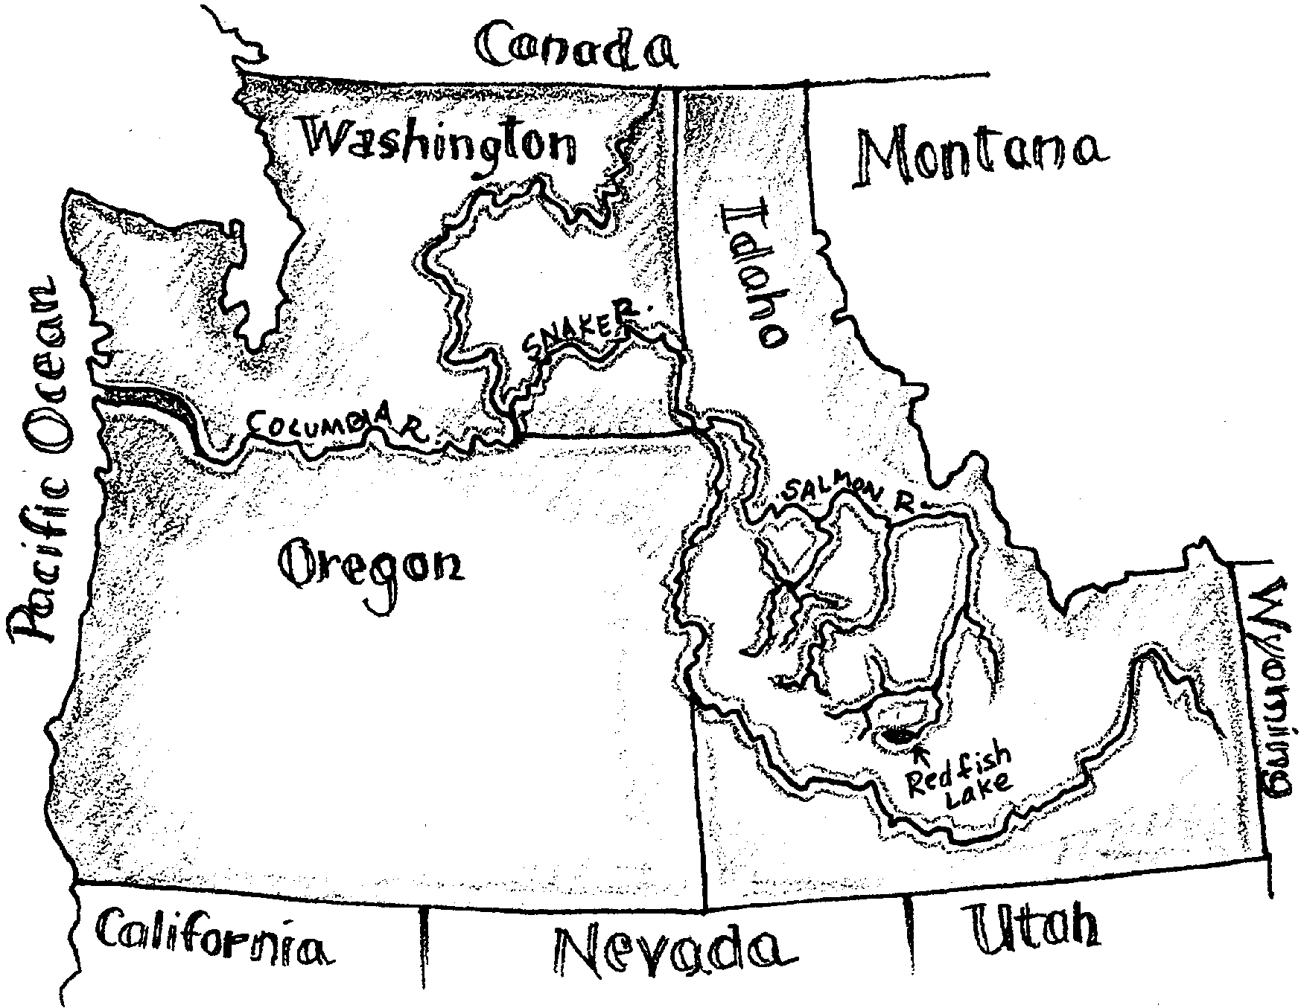

Some salmon populations are declining. Some are in danger of becoming extinct. Scientists have tried to increase populations with some or little success. To understand the issues behind these changes, we need to know something about the life cycle of these fish. All Pacific salmon species are born in freshwater and travel to the sea. Each species makes the trip in a different way. Let’s look at the life cycle of the Snake River sockeye salmon. As you look at this information, begin to think about these questions:

What factors affect the number of salmon?

What can be done to “save the salmon”?

Idaho’s sockeye salmon are the southern–most sockeye run in North America. These fish travel almost 900 miles on their migration to the ocean. Let’s look at that journey.

Sockeye Salmon Life Cycle
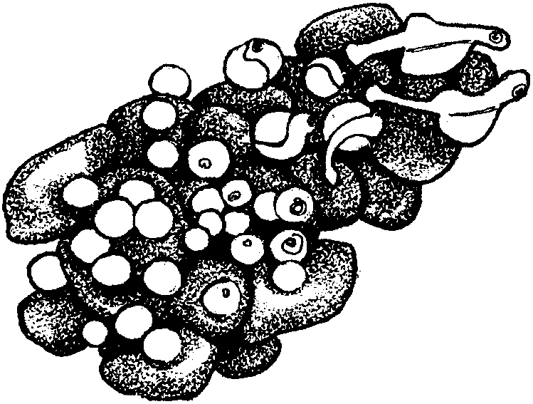

Eggs: Snake River sockeye salmon start as small red eggs. Most of the eggs are laid in gravel-filled nests beneath Redfish Lake. Laid in October, the eggs hatch five or six months later in March or April.

Fry: After they hatch, the salmon are called fry. The fry spend their first three to five weeks in the gravel. It will be one or two years before the young salmon leave their freshwater home. They feed on microscopic animals and insects. They must constantly avoid larger fish, birds, and other predators. Eighty to ninety percent of these fry will die during their first few months.

1. Where do Snake River sockeye salmon begin their life?

2. Being a salmon fry is risky business. What hardships do fry face?

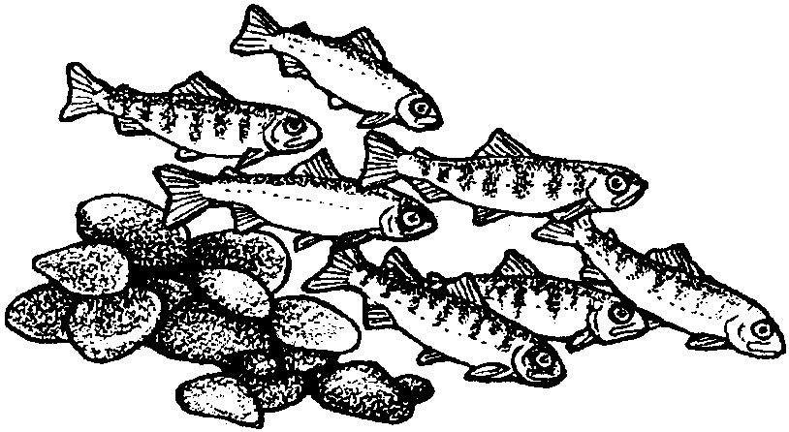
Parr: As the fry grow, they change. Dark, vertical lines on their sides help them hide. The are now called “parr”. They seek shelter from predators and weather conditions in the spaces between the rocks on the lake bottom. When the water warms up in the spring, the parr leave their shelter.

3. How might the dark, vertical lines help parr to survive?

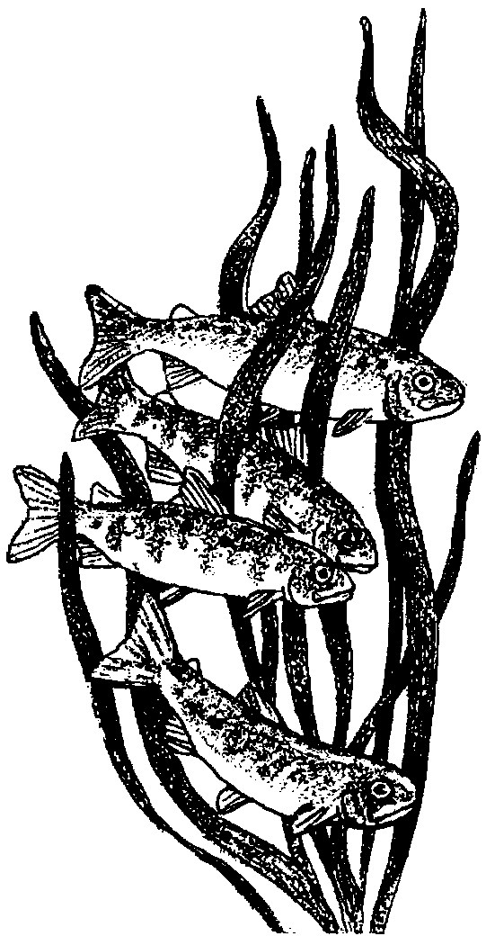
Smolts: After one to two years in Redfish Lake, the sockeye salmon are ready to leave their freshwater home. On their 897 mile downstream trip to the Pacific Ocean, they pass through three states. When the fish leave, they are about four inches long and have turned a silvery color. They are called smolts. Smolts are recognizable as small salmon.

4. Let’s say a smolt can swim and drift one foot in a second. Let’s also say a smolt travels day and night. How many days would it take for a smolt to reach the ocean? Please shown your work.
(Hint: There are 60 seconds in a minute, 60 minutes in an hour, and 24 hours in a day. There are 5280 feet in a mile.)

To the Ocean: The stream current helps as the fish swim downstream. They stay close to the river banks and travel mostly at night to avoid predators.

5. Predators are one hazard smolts face swimming downstream. What is another hazard?

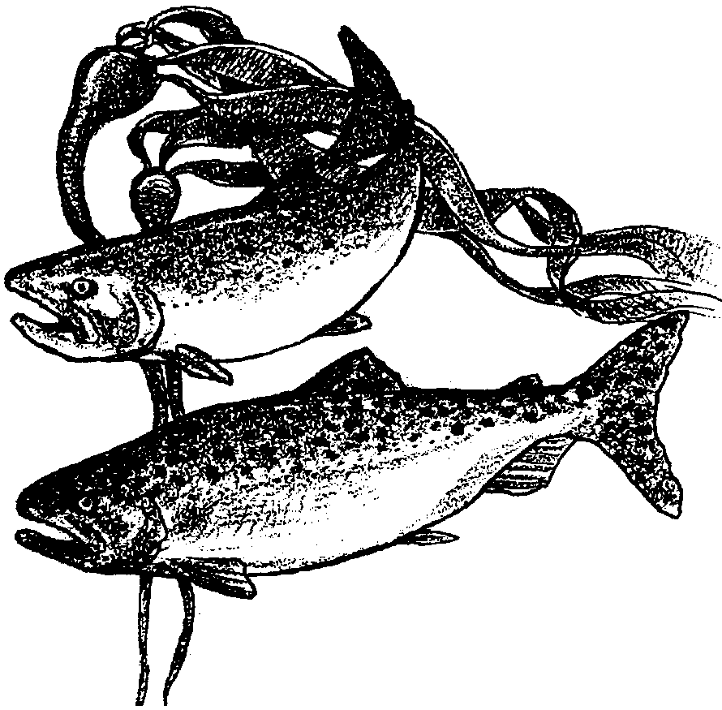
Ocean Life: In a month or so, the salmon reach the Pacific Ocean. They spend the early summer near the mouth of the Columbia River. Later, they travel further into the ocean. They eat large amounts of microscopic animals, small fish, and other marine life. They grow to 1.5 to 2 feet long and put on 3-6 pounds. While in the ocean, the fish must avoid predators and anglers’ nets and hooks.

6. Exactly where the sockeye migrate is not precisely known. Design an experiment that would help you discover where salmon go in the ocean. Describe your experiment.

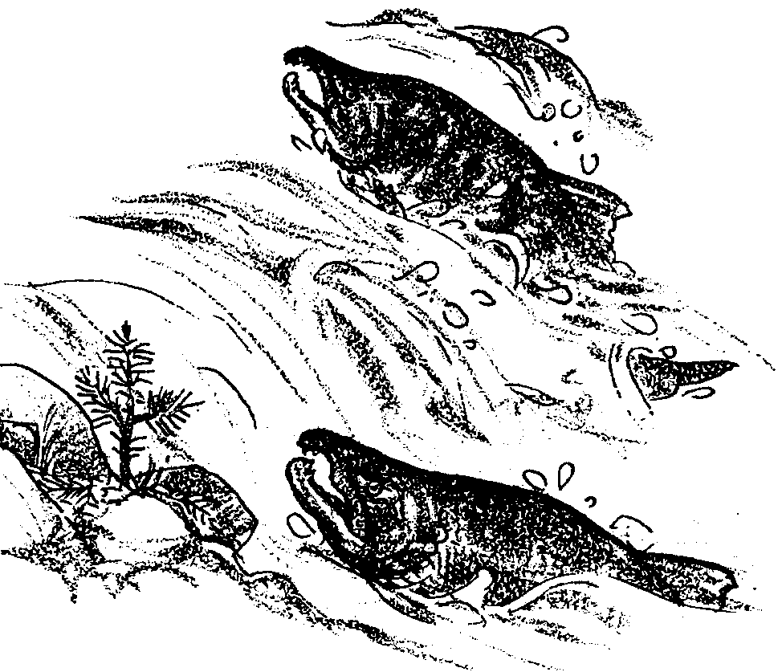

Returning Home: The sockeye stay in the ocean for two to five years. During that time, they mature. They are ready for the return journey to Redfish Lake to spawn. In June and July, the adult fish start upstream. They move approximately 13 miles per day. Once fish enter the river, they stop feeding. They must rely on fat reserves they accumulated in the ocean.
7. How many days will it take a sockeye to swim to Redfish Lake?
(Hint: How far do the smolts travel to the ocean?)

Once near the parent stream, the salmon smell differences in the water. These differences lead them to within yards of their birthplace. Those salmon that avoid predators, dams and fishers will reach Redfish Lake sometime in late July and August.

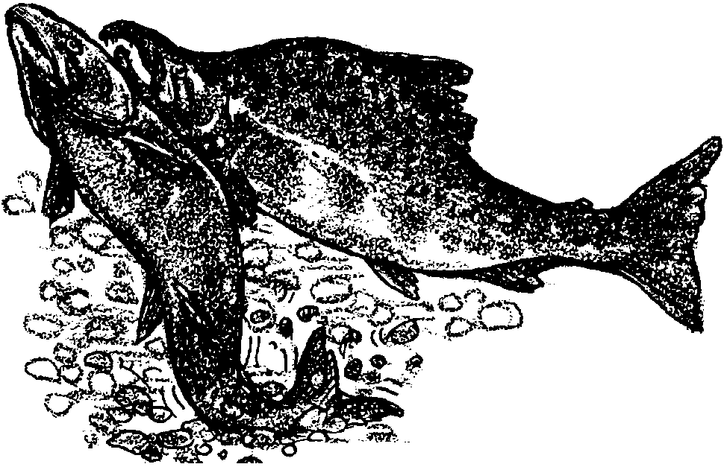
Spawning: Once the salmon arrive, they wait until October before spawning. During this time the female’s belly swells with eggs. The males turn a darker color. Their heads and snouts become hooked shape. The female selects a spawning site in the gravel. She digs out a depression or nest using her tail. The nest sites are known as “redds”.

The female lays 50 to 100 eggs. The male releases sperm to fertilize the eggs. Then the female covers her eggs, again using her tail. An average female lays about 3700 eggs in her spawning area. After spawning, the adults die within a few days to several weeks. The eggs will incubate in the redds. If the temperature, pH, water velocity, and size of the gravel are right, the eggs develop. In April or May, they emerge as fry to start this cycle again.

8. A female sockeye salmon lays about 3,700 eggs. For the salmon population to stay the same size, how many of these eggs have to hatch, grow, and return to Redfish Lake?

Salmon LIfe Cycle
