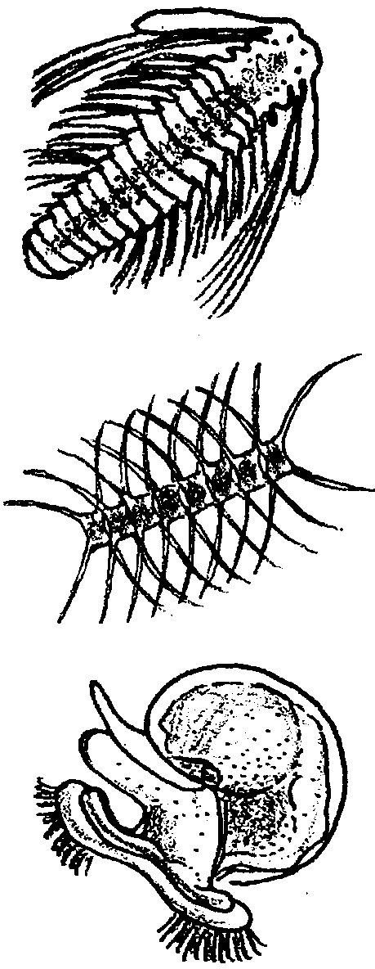
Where the Food Is: Plankton

Key Concepts
1. Plankton is at the base of the ocean food chain, the key to all life in the sea.
2. Plankton can be divided into two broad categories: plant plankton (phytoplankton), and animal plankton (zooplankton).
3. Planktonic plants and animals cannot swim against a current and are usually microscopic (but there are planktonic jellies).
4. As the drifters of the sea, the distribution and abundance of plankton are especially influenced by ocean currents.

Background

Microscopic plant plankton play a critical role as the basis of most marine food chains. While many plants and animals remain microscopic members of the plankton community all of their lives (e.g., diatoms, dinoflagellates, copepods), many other marine plants and animals go through a planktonic stage at sometime in their early development (e.g., sea stars, crabs, barnacles, clams, some fish). While “plankton” is Greek for “drifter”, most animal plankton (zooplankton) swim strongly enough to migrate toward the surface at night to dine, often on the plant plankton (phytoplankton) which remains in the upper lighted ocean waters. After feeding, they then sink to spend the daylight hours at greater depths, usually below levels where sunlight is sufficient for visual predators such as fish larvae. Although this is impressive swimming for microscopic animals, plankton are no match for ocean currents. As such, the distribution and abundance of plankton are especially influenced by ocean currents.

Although planktonic organisms have been known to science for many years, recently a new group of very tiny plankton has been found: nannoplankton. These plants and animals are so tiny (size range from 2 to 20 microns) that they slipped through conventional plankton nets. They have been discovered with new technologies made available in recent years such as satellite oceanography, remote sensing, scanning electron microscopy. The importance of these tiny creatures is just now being studied. One type of nannoplankton, called a coccolithophore, is a plant plankton that appears to be the dominant type in the open ocean. Coccolithophores may account for the vast majority of all photosynthetic activity in open ocean waters. There appear to be nanozooplankton that eat the tiny coccolithophores and other nanophytoplankton. Good source for more information about plankton:

Nybakken, James W. Marine Biology, an Ecological Approach Harper and Row, New York, 1988, 514 pages.

Materials

• plankton picture set

• plankton sample

• microscope

• dropper

• Petri dish

Teaching Hints

“Where the Food Is: Plankton” introduces plant and animal plankton through a grouping activity followed by plankton observation.

Preparation

Make an overhead transparency of plankton pictures student sheet. Cut out organisms so they can be moved around on the projector. Note the student sheet has the names omitted, while on the Answer Key sheet “P” denotes phytoplankton, “Z” denotes zooplankton.

Prepare a plankton pictures sheet for each group of 3 or 4 students:

• Laminate each or cover with clear contact paper.

• Cut out organisms and place in an envelope for each group.

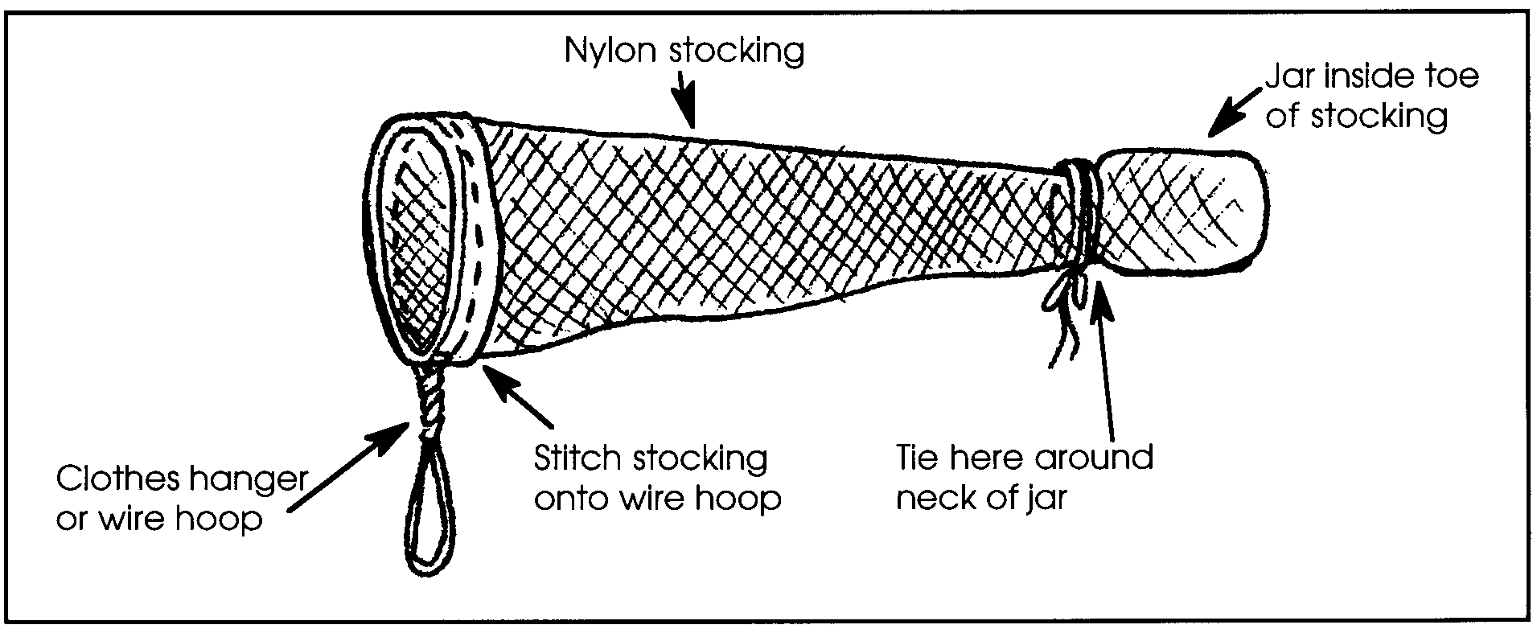
Collect a sample of live plankton from the sea or a pond. This is very easy to do with a commercial plankton net or with one you can make from a nylon stocking following the directions below. While preserved plankton is available from science supply houses, the live sample is much more exciting for your students. A jar of pond or creek water left in a sunny place for several days will yield many tiny creatures. Be sure to point out to your students that the plankton picture sheet depicts SALT WATER plankton.

Procedure

1. Ask the class to divide their plankton pictures into two groups: Plants and Animals.

2. Call on a volunteer group to come to the overhead projector and show the grouping they chose. Ask them to tell WHY they grouped the organisms as they did...what physical characteristics do the plants exhibit? the animals? Correctness of grouping is not important at this stage.

3. Group the overhead transparency organisms into plants and animals using your answer key.

4. Ask the class to find the single diatom among the pictures. Tell them that this tiny plant is shaped like a Petri dish: a top half and a bottom half that fit together. The outer covering of this diatom is made of silica, the same material as glass. Deposits of the glass coverings of diatoms form diatomaceous earth used in swimming pool filters and toothpaste.

5. Through photosynthesis, phytoplankton (plant plankton) produce over half of the oxygen in our atmosphere.

6. Point out to the class that many of the plants and animals have long projections on their bodies (copepod, diatom chains). These projections keep the organism from sinking too fast. Ask: Why would that be important? (The plants must stay near the sunlit surface waters, and the animals such as the copepod stay near their food source, the diatoms.) Long projections serve to increase surface area. Demonstrate this principle by dropping a whole, flat sheet of paper to the floor. It floats slowly down.

Now crumple the same paper and drop it. It drops rapidly. The flat sheet had a broader surface area to slow its fall. Planktonic organisms use the same principle of increased surface area to slow their sinking.

7. Ask the class to find the dinoflagellate. These plants move by whipping their tail-like projections. At certain times of the year, some organisms in this group cause the “red tides” which make clams and mussels unsafe to eat because of the toxins the dinoflagellates produce. (Remind the class that clams and mussels are filter-feeders and concentrate those toxins in their bodies.)

8. Ask: Which organism is the most abundant animal in the world? (copepod). It remains a member of the plankton community all its life...permanent plankton. Copepods eat diatoms. Since the copepods are permanent plankton, they are always at the mercy of the currents. Copepods eat plant plankton. Off the coast of South America, plant plankton depends on upwelling caused by the Peru Current. During El Niño, the Peru Current is pushed south and the plants quickly use up the nutrients. Ask: What happens to the copepods? (Copepods not moved by the currents, die.)

9. Find the crab larva. This is an example of temporary plankton. This organism is going to grow up and leave the plankton community to become a full grown crab. Ask: How might ocean currents be important in expanding the distribution of crabs?

10. Have students look at samples of live plankton and try to identify the various forms. If live plankton is not available at all, try substituting brine shrimp purchased from an aquarium pet store. Information on brine shrimp is readily available at your local library or the pet store.

Your students will want to know the names of the plants and animals they see in their sample. The following books are helpful for identification of plankton:

Smith, DeBoyd L. 1977. A Guide to Marine Coastal Plankton and Marine Invertebrate Larvae. Kendall/Hunt Publishing Co., Dubuque, Iowa. 161 pages.

Reid/Zim 1967. Pond Life. Golden Press, New York. 160 pages.

Key Words

current - large scale movement of ocean waters

micron - a unit of measure equal to one thousandth of a millimeter, or one millionth of a meter

nanoplankton - plankton with a size range from 2 to 20 microns (i.e., 500,000 nanoplankton could line up side by side on a meter stick)

phytoplankton - plant plankton

plankton - free floating plants and animals, usually (but not always) microscopic, that are at the mercy of currents in the ocean

zooplankton - animal plankton

Answer Key
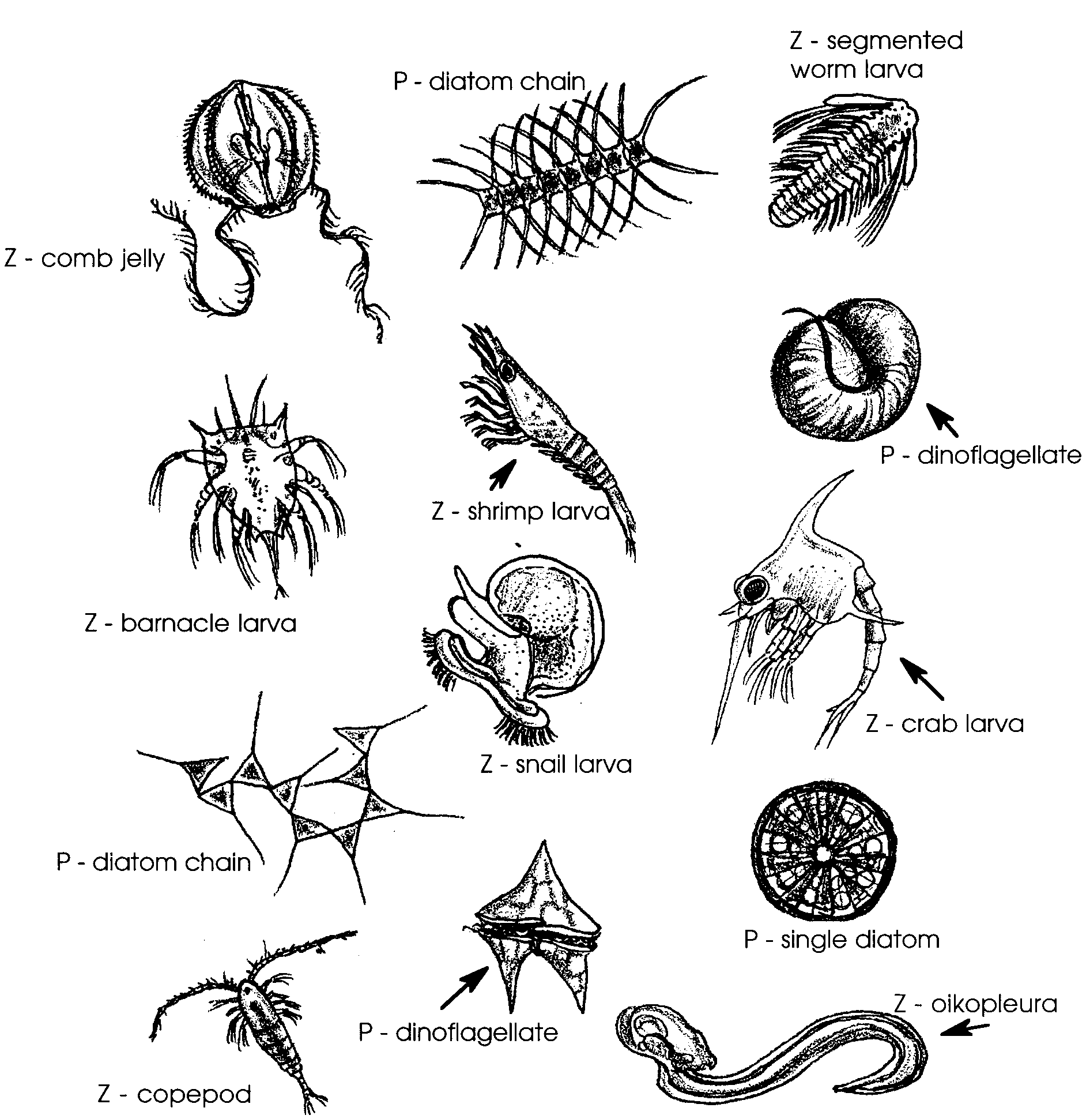

Where the Food Is: Plankton
