Ol' Sea Salt

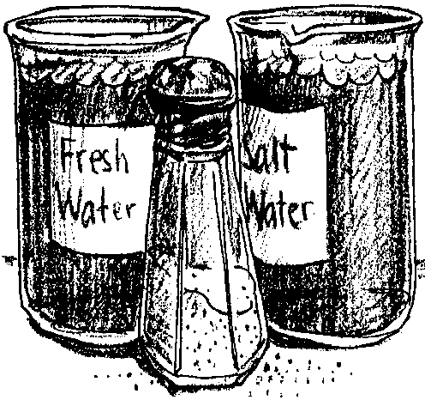
Key Concepts
1. Currents are large-scale water movements in the sea.
2. The three main causes of currents in the ocean are:
• wind
• earth’s rotation
• density differences in ocean waters.

Background

Background information for “Ol’ Sea Salt” is found in the preceding activities “Currents: Moving Water,” and “The Hydrometer.”

Materials

For the class:

• “standard water”

• 4% salt solution

For each pair of students:

• hand built hydrometer

• 100ml graduated cylinder

• 150ml Griffin beaker

Teaching Hints

Density differences due to temperature and salinity are discussed in “Currents: Moving Water” and provide the background necessary for “Ol’ Sea Salt”.

“Ol’ Sea Salt”, an activity dealing with the effect of salinity on the density of water, uses the hydrometers your students constructed in the activity “The Hydrometer.” These activities provide your students with some “hands-on” experiences with the factors which cause ocean currents. Again bear in mind that the “Analysis and Interpretation” sections endeavor to relate the activities to the situation in the oceans. It is often difficult for students to see that the forces which they observe on a small scale in the laboratory are sufficient to cause the vast movement of water seen in the oceans. As you work through and discuss the activities, stress that the forces are, indeed, the same.
Duplicate the activity pages. One set is recommended per student. “Ol’ Sea Salt” is a laboratory activity best performed in pairs or small groups. As with “Heating It Up,” a refresher in hydrometer calibration can serve as a fitting introduction to “Ol’ Sea Salt.” Distilled water serves as the “standard water” for calibration.

The 4% salt solution may be made by adding 40 grams of NaCl to 1000ml of distilled water.

As noted previously, it is possible to run “The Hydrometer”, “Heating It Up”, and “0l’ Sea Salt” activities on consecutive days with a general follow-up discussion after all three have been completed. Alternatively, discussions after the completion of each of the activities and before commencing the next activity helps insure that your students are “on the right track” before proceeding to the next activity. The abilities of your class will determine the strategy you employ.

Key Words

current - large-scale movement of ocean waters

density - mass per unit volume of a substance. More dense seawater tends to sink, less dense seawater tends to rise in the ocean.

hydrometer - instrument used to measure density or specific gravity of a liquid

salinity - measure of the quantity of dissolved salts in seawater

Answer Key

1. The data table will vary according to experimental results. Some approximate results follow:

SolutionDensity

4%1.028 g/ml

2%1.014 g/ml

1%1.006 g/ml

2. The plotted experimental results should resemble the graph below.
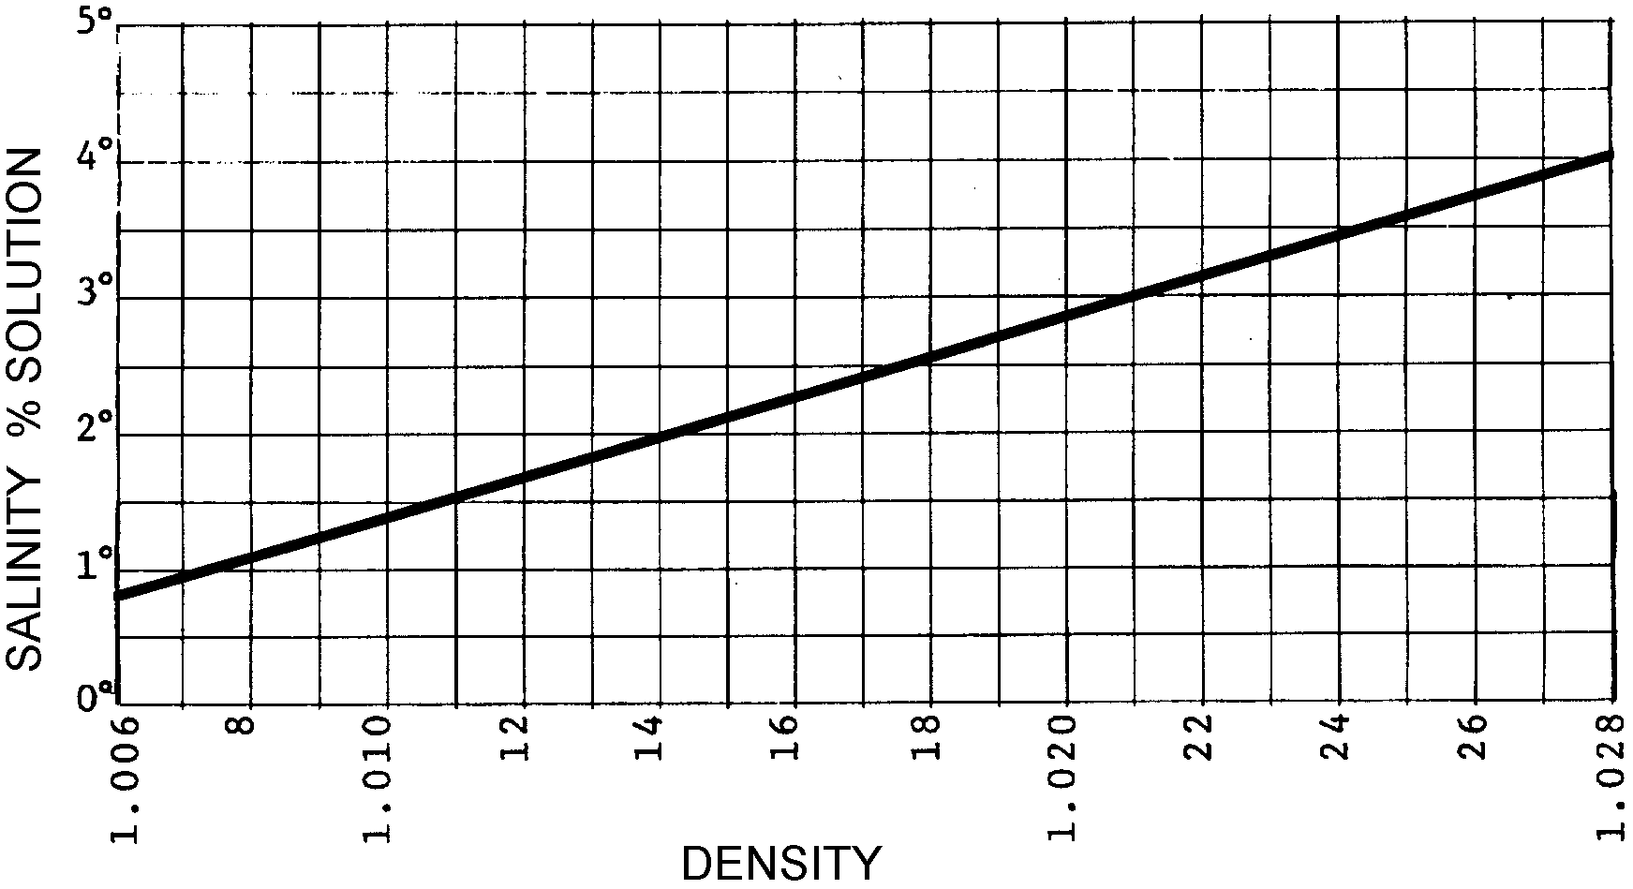

3. Following the line of reasoning developed in the procedure your students should be able to conclude that 50 ml of 1% solution plus 50 ml of water would yield a .5% solution. From the graph, the predicted salinity of the solution would be about 1.004 g/ml.

4. From the above graph, the density of a 3% solution would be about 1.021 g/ml.

5. From the graph, the average salinity of sea water with a density of 1.025 g/ml would be about 3.5%.

6. Because river water is fresh, it is less dense than the sea water and will float on top of the sea water.

7. Deep ocean water is saltier than surface water because salty, dense water sinks.

8. a. The waters with the lowest salinity would be found near the surface and in the warmest areas.

b. The waters with the highest salinity would be found in the cold deep oceans.

9. We call the movement of dense ocean waters to areas of less dense water “currents”.

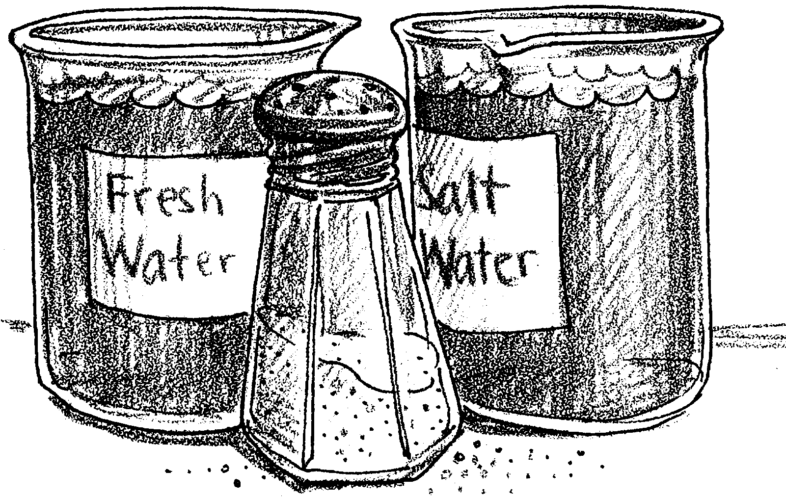
Ol' Sea Salt

We have seen that the temperature of ocean water differs in different parts of the ocean. The amount of salt dissolved in sea water also differs in different parts of the ocean. In places where there is little flow and a high rate of evaporation, the amount of salt in the water is high. In places where large rivers flow into the ocean, the amount of salt in the water is low. The amount of salt in the water is called salinity. Salinity affects the density of water. Just as differences in density due to temperature cause currents, differences in density due to salinity cause currents. Ocean currents are caused by a combination of differences in density due to temperature and salinity and to other factors. In the following activity you will investigate the effect of salinity on density.

Materials:
• hand built hydrometer
• 100ml graduated cylinder
• “standard water”
• 4% salt solution
• 150ml Griffin beaker
Procedure:

1. Check your hydrometer in standard water to see if it is still properly adjusted. If the water line is no longer at the second dark line, readjust your hydrometer. You may make small adjustments by tightening or loosening the stopper a tiny amount.

2. In a 100ml graduated cylinder, obtain 85ml of 4% salt solution. Measure the density of the 4% solution. Record the density of your data table.

3. Obtain a 150ml Griffin beaker. Make a 2% solution by pouring 50ml of the 4% solution into the beaker. Add 50ml of standard water to the beaker and find the density of the resulting 2% solution. Record the density in your data table.

4. Repeat the process with the 2% solution by mixing 50ml of 2% solution and 50ml of standard water. Find the density of the new 1% solution. Record the density in your data table.

Analysis and Interpretation:

DATA TABLE

Solution Density
4%
2%
1%

2. Obtain a piece of graph paper. Make a vertical line (axis) and a horizontal line (axis) near the lower right corner. Label the horizontal axis “Density”. Label the vertical axis “Salinity % Solution”. Divide each axis into convenient units. Your paper should look something like the graph on the next page:

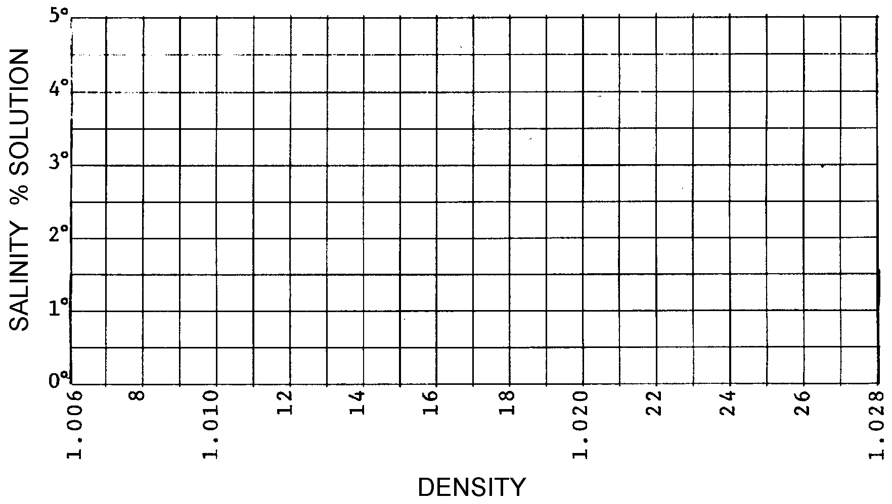

Plot your data on your graph paper and connect the points with a smooth line.

3. If 50ml of 1% solution were mixed with 50ml of water, what percent solution would be made? Use your graph to predict the density of such a solution.

4. Use your graph to find the density of a 3% solution.

5. Sea water has an average density of 1.025 g/ml. Use your graph to estimate what its average salinity would be.

6. What do you predict river water will do if it flows into the ocean and does not immediately mix with the sea water? (This is common for some large rivers).

7. From what you found out in this lab, explain why deep ocean water is saltier than surface water.

8. Where in the oceans would you expect to find:

a. the waters with the lowest salinity

b. the waters with the highest salinity.

9. What do we call the movement of dense ocean waters to areas of less dense water?

