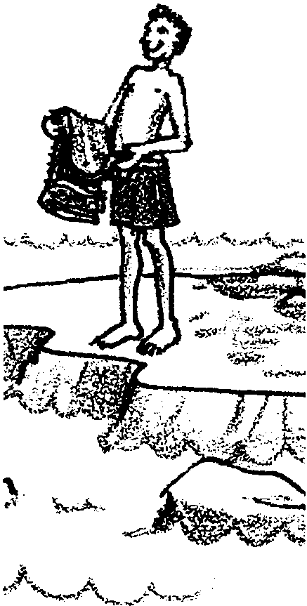
Heating It Up

Key Concepts
1. Currents are large-scale water movements in the sea.
2. The three main causes of currents in the ocean are:
• wind
• earth’s rotation
• density differences in ocean waters.

Background

Background information for “Heating It Up” is found in the preceding activities “Currents: Moving Water,” and “The Hydrometer.”

Materials

For the class:

• “standard water”

• sea water
For each pair of students:

• hand-built hydrometer

• 100ml graduated cylinder

• 600ml Griffin beaker

• tap water

• ring stand

• iron ring

• Bunsen burner or alcohol lamp

• wire gauze

• thermometer (-20° C to 110° C)

• watch or timer with second hand

• graph paper

Teaching Hints

Density differences due to temperature and salinity are discussed in “Currents: Moving Water” and provide the background necessary for “Heating It Up”.

“Heating It Up”, an activity dealing with the effect of temperature on the density of water, uses the hydrometers your students constructed in the activity “The Hydrometer.” These activities provide your students with some “hands-on” experiences with the factors which cause ocean currents. Again bear in mind that the “Analysis and Interpretation” sections endeavor to relate the activities to the situation in the oceans. It is often difficult for students to see that the forces which they observe on a small scale in the laboratory are sufficient to cause the vast movement of water seen in the oceans. As you work through and discuss the activities, stress that the forces are, indeed, the same.

Duplicate the activity pages. One set is recommended per student. “Heating It Up” is a laboratory activity best performed in pairs or small groups. A refresher in hydrometer calibration can serve as a fitting introduction to “Heating It Up.” Distilled water serves as the “standard water” for calibration. “Heating It Up” is a good time to review laboratory safety and fire extinguisher location.

As noted previously, it is possible to run “The Hydrometer”, “Heating It Up”, and “Ol’ Sea Salt” activities on consecutive days with a general follow-up discussion after all three have been completed. Alternatively, discussions after the completion of each of the activities and before commencing the next activity helps insure that your students are “on the right track” before proceeding to the next activity. The abilities of your class will determine the strategy you employ.

Key Words

current - large-scale movement of ocean waters
density - mass per unit volume of a substance. More dense seawater tends to sink, less dense seawater tends to rise in the ocean.
hydrometer - instrument used to measure density or specific gravity of a liquid
salinity - measure of the quantity of dissolved salts in seawater

Extensions

1. On a field trip to the tide pools, take a hydrometer to test several “pool” sites between the upper and lower tide zones. Have students predict where the more saline samples will be found.

2. Visit an estuary and test water found near the mouth of a river versus waters from elsewhere in the estuary.

Answer Key

1. The plotted experimental data should resemble the graph below:
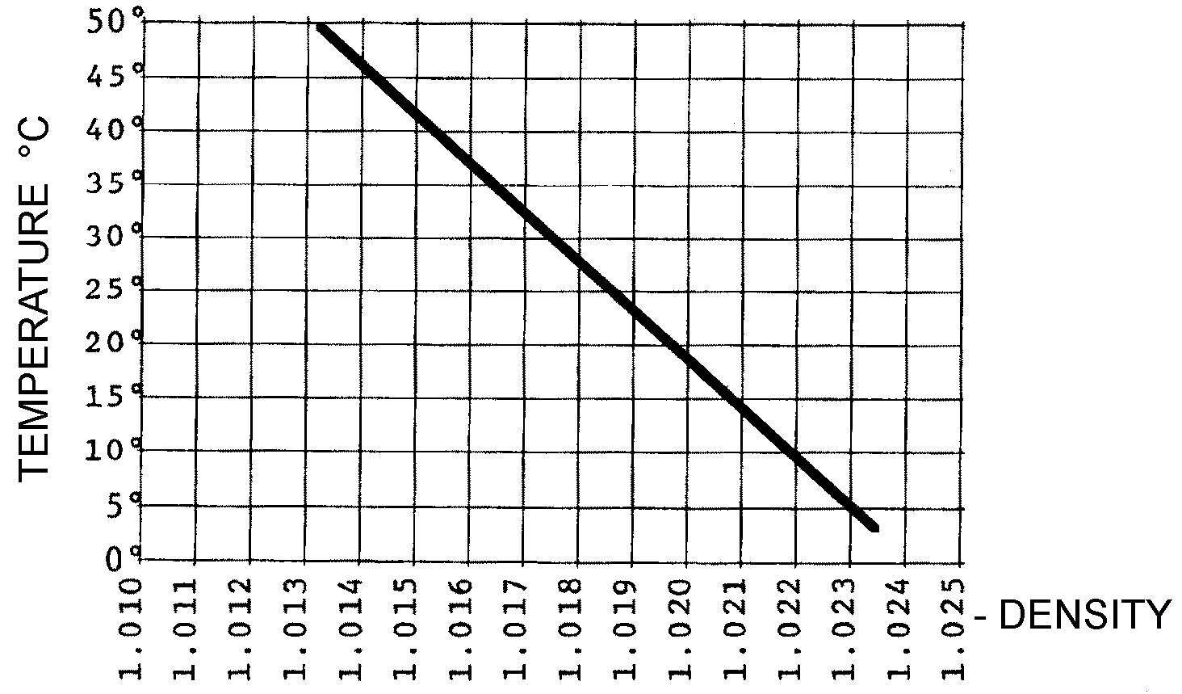

2. As sea water is warmed, the density decreases. As it is cooled, the density increases.

3. The warmest sea water would be found in the warmest areas, i.e. at the surface and near the equator. The coolest sea water would be found at the greatest depths in the ocean.

4. Considering temperature alone, the least dense sea water would be found at the surface, the most dense at the greatest depths.

5. Answers will vary depending upon the experimental results. Some approximations follow:
TemperatureDensity

25° C1.018-1.019
35° C1.016-1.017
45° C1.014-1.015

6. As fully loaded ships from Indonesia move toward Washington, they encounter colder, more dense water. Just as the hydrometer floats higher in more dense water, so will the ship. The ship behaves like a giant hydrometer.

Heating It Up
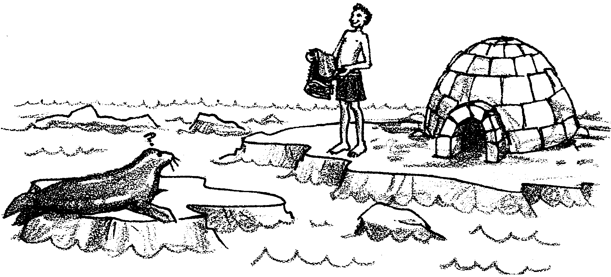

Most visitors to Hawaii spend at least some time swimming in the ocean waters. Very few visitors to Alaska go swimming in the ocean. Do only non-swimmers vacation in Alaska or is there some other reason few people swim in the Bering Sea or Gulf of Alaska? Did I hear you say the water is warmer in Hawaii? Exactly right. The temperature of the ocean is not the same everywhere. In general, the farther north or south you move from the equator, the cooler the ocean water tends to be. Water temperature also changes with depth. The deeper you dive, the colder the water tends to be. In the activity which follows you will have an opportunity to observe how these changes in temperature affect ocean waters.

Materials:
• hand-built hydrometer
• 100ml graduated cylinder
• “standard water”
• sea water
• 600ml Griffin beaker
• tap water
• ring stand
• iron ring
• Bunsen burner or alcohol lamp
• wire gauze
• thermometer (-20° C to 110° C)
• watch or timer with second hand
• graph paper
Procedure:

1. Check your hydrometer in standard solution to see if it is still properly adjusted. If the water line is no longer at the second dark line, readjust your hydrometer. You may make small adjustments by tightening or loosening the stopper a tiny amount.

2. Obtain a 100ml graduated cylinder. To your graduated cylinder add 85ml of sea water.

3. Obtain a 600ml beaker and fill it 2/3 full of cold tap water. This will become a water bath.

4. Obtain a ring stand, iron ring and wire gauze. Place the iron ring on the ring stand. Leave enough space beneath the ring for a Bunsen burner or alcohol lamp. Put the wire gauze on the iron ring.

5. Place the Bunsen burner or alcohol lamp under the wire gauze. Place the beaker of tap water on the wire gauze.

6. Stand (DO NOT POUR) the graduated cylinder of sea water in the beaker of water (water bath).

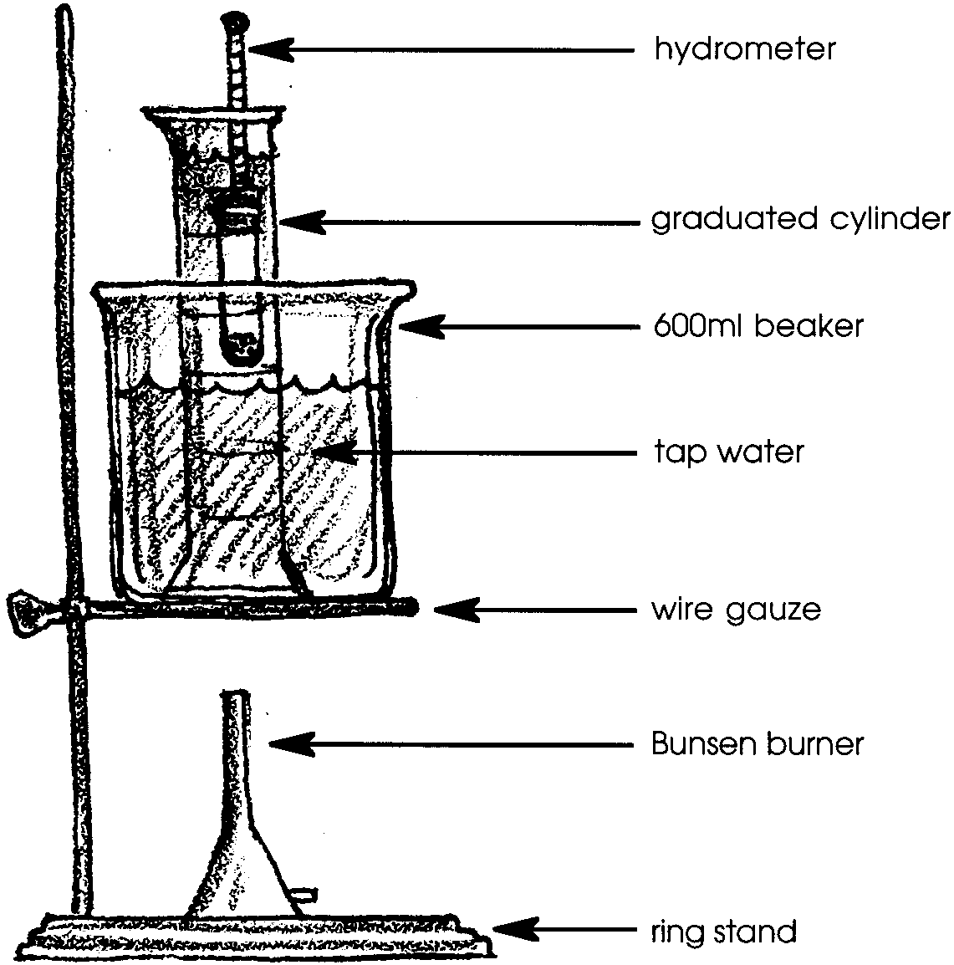
7. Obtain a thermometer. Put your hydrometer in the sea water and hold the thermometer in the water bath (the thermometer should be held so it does not touch the glass). Your set-up should look something like this:

8. On your data chart record the beginning temperature of the water bath and the density of the sea water.

9. Obtain a timer or watch with a second hand. Light the Bunsen burner or alcohol lamp. On your data chart record the temperature of the water bath and the density of the sea water every 1/2 minute while you gently heat the water.

10. Keep taking readings until the temperature of the water bath reaches 50° C.

11. Lift the graduated cylinder up every few seconds to keep the bottom from getting too hot.

Analysis and Interpretation:

1. Obtain a piece of graph paper. Make a vertical line (axis) and a horizontal line (axis) near the lower right corner. Label the horizontal axis “density”. Label the vertical axis “temperature”. Divide each axis into convenient units. Your paper should look some thing like this:
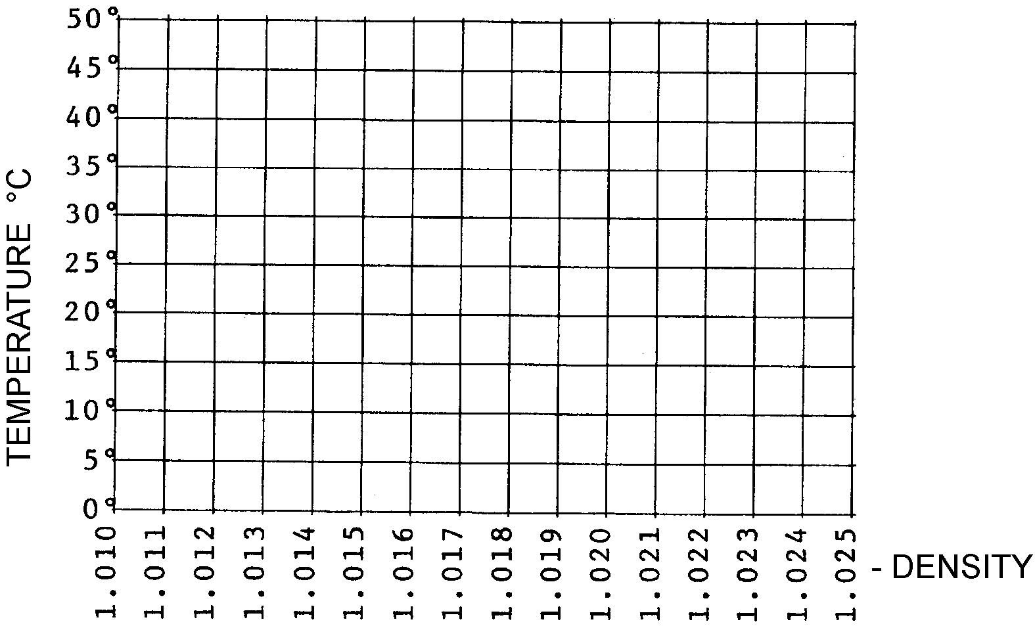

Plot your data on your graph paper and connect the points with a smooth line.

2. What happens to the density of sea water as it is warmed? Cooled?

3. Where would you expect to find the warmest sea water? Coolest sea water?

4. If all you had to consider was the temperature of the water, where would you expect to find the least dense sea water? The most dense sea water?

5. Use the graph to estimate the density of sea water at:
a. 25° C
b. 35° C
c. 45° C

6. Fully loaded ships from Indonesia (tropical climate) often float higher in the water as they travel northward toward Washington. Explain why.

Data Chart

Time (1/2 minutes) Temperature Density

(stop at 50°C)

