Hot Air: Wind-Driven Currents

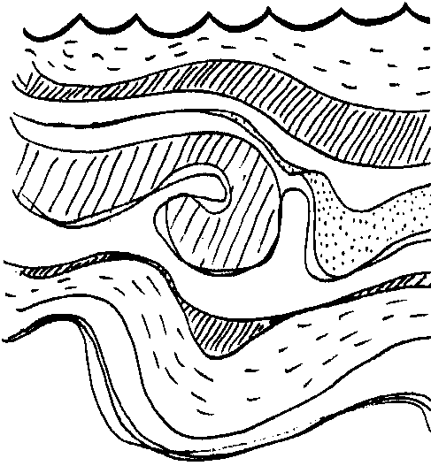
Key Concepts
1. Surface currents are created by wind.
2. Humans have for thousands of years used surface currents to aid in navigation.
3. Ocean circulation shapes climate and influences plant and animal populations on land as well as in the ocean.

Background

Since before the written word, currents have aided sailors. The currents that move down the coast of North America have been utilized by people of Asia and America. The currents that move down the coasts of Europe and West Africa were used by European and African sailors. More importantly, ocean circulation shapes climate and influences plant and animal populations on land as well as in the ocean. Additional background information is found in the preceding lesson “Currents: Moving Water”.

Materials

For each team of 2–4 students:
• copies of student worksheet, “Hot Air”

• glass baking dish, or similar shallow container

• food coloring

• tap water

• finger bowl

• petri dish

• hot air (a person blowing)

• an assortment of waterproof objects

Teaching Hints

In “Hot Air: Wind Driven Currents” students will observe the behavior of surface currents created by winds.

Procedure:

1. Distribute the student worksheets. This activity is best accomplished by pairs or small groups. Be aware that this activity can result in water spills so have plenty of paper towels available for your students.
2. Conclude the activity with a discussion of the questions in the “Analysis and Interpretation” section. During your discussion, emphasize the effect of currents on living organisms. Currents affect the availability of plankton by bringing or removing nutrients as well as moving groups of planktonic organisms. How can the presence or absence of plankton affect all other organisms?

Key Words

currents - movement of water

density - property of a substance defined as mass per unit volume. Salt water is more dense than fresh water because there are more heavy molecules (salt PLUS water) in a cup of salt water than there are in fresh water (water ONLY).

environment - total of living and non-living factors surrounding a group of organisms

equator - an imaginary line, equal distance from North and South Poles, dividing the Northern and Southern Hemispheres; 0 degrees latitude

generate - create

influence - have an effect

nutrient-rich - full of important compounds that influence growth of plant plankton.

salinity - measure of dissolved salts in seawater

submerged - below the surface of the water

upwelling - rising of water rich in nutrients toward the surface: usually the result of diverging surface currents.

Answer Key

Analysis and Interpretation - Part I

1. Generally, the drawings will be different. The surface currents move away from the wind while those at depth move back toward the source.

2. The currents move most rapidly at the source of the wind.

3. The current spreads out as it moves away from the wind source.

Analysis and Interpretation - Part II

1. The island causes the current to split and form two currents.

2. The current is stronger in front of the island. This is a good opportunity to introduce the concept of windward and lee sides of islands. As a nice example of relative motion, you may wish to point out that islands often create a “wake” in a current just as a boat creates a wake when moving through the water.

Analysis and Interpretation - Part III

1. The surface currents move across the submerged island with only a small amount of disturbance. The currents at depth are greatly affected by the presence of the island.

2. a. The chain of submerged islands in the Aleutians causes the ocean currents to become confused and turbulent. Chains of seamounts and submerged ridges affect currents especially at the deeper depths. The magnitude of the affect is related to how far the seamount projects into the current.

b. The gray whale is helped along in its migration when the currents flow in its direction of travel. It is hindered when it must swim against the currents to proceed.

Analysis and Interpretation - IV and Summary

1. The currents are more complex with odd shaped objects. Similarly, ocean currents are more complex when flowing near coasts. The dye movement clearly shows the places where moving waters collide.

2. The currents do not always move in the direction of the wind. Factors such as islands, land masses, and depth of water influence the direction of movement. In addition, the Coriolis effect due to the Earth’s rotation causes the currents to flow at an angle relative to the wind.

3. a. The bottom currents differ from the surface currents in their speed and often in the direction in which they move.

b. One possible source of the differences is the presence of islands or other land masses.

4. Aside from wind, two environmental factors mentioned earlier which can cause currents include:

a. the rotation of the earth

b. differences in density of ocean waters due to differences in temperature and/or salinity.

5. Two ways in which currents affect living organisms include:

a. aiding or hindering swimming

b. increasing or decreasing food supply and availability.

Hot Air: Wind-Driven Currents
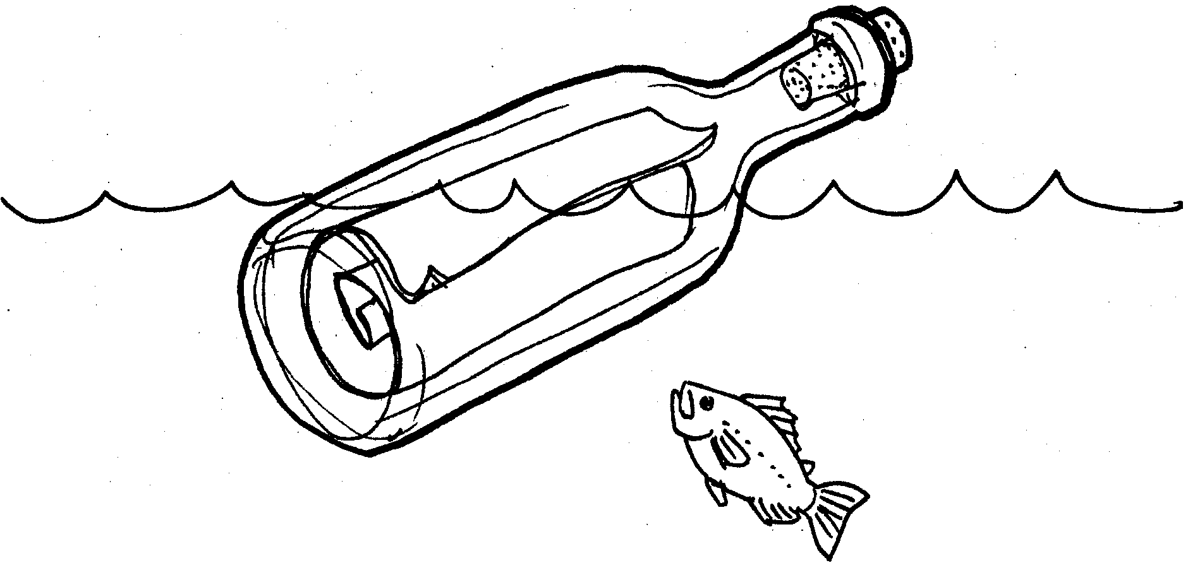

For thousands of years, people have used surface currents as an aid to travel. These same currents shape climate and influence plant and animal populations on land as well as in the ocean. We know that differences in the temperature and salinity of water can cause currents. So can other environmental factors. Winds blowing for very long periods of time also cause currents. In the following activity, you will have a chance to observe wind-caused currents.

Materials:
• glass baking dish or similar shallow container
• food coloring
• tap water
• finger bowl
• Petri dish
• hot air (a person blowing)
• assortment of waterproof objects

Part I

Procedure

1. Obtain a glass baking dish or similar shallow container. Fill the container with water. Let the water settle completely.

2. Place a drop of food coloring at one end and blow gently across the surface. In the space below, draw what happens at:

a. the surface

b. on the bottom

Analysis and Interpretation - Part I

1. Are your drawings different? If so how do they differ?

2. Where do the currents move most rapidly?

3. What happens to the current as it moves away from the wind sources?

Part II

Procedure

1. Place the finger bowl in the center of the container to represent an island.

2. Add a drop of food coloring and supply the necessary wind. In the space below, draw what happens to the food coloring in front and in back of the island.

Analysis and Interpretation - Part II

1. What effect does the island have on the current?

2. Is the current stronger in front of or behind the island? How can you tell?

Part III

Procedure

1. Remove the finger bowl. Place a submerged Petri dish in the center of the container to represent a submarine island.

2. Add a drop of food coloring and again supply the necessary wind. In the space below, draw what happens to the food coloring.

Analysis and Interpretation - Part III

1. How do these results differ from those obtained in Part II?

2. The Aleutian Islands chain has many submerged islands.

a. What effect do these islands have on the currents?

b. How might a California gray whale swimming in Aleutian waters be alternately helped, then hindered by currents?

Part IV

Procedure

1. Repeat the procedure in Part II with the following change: instead of a finger bowl, use a waterproof object with an irregular shape.

2. In the space below: draw what happens to the food coloring.

Analysis and Interpretation - Part IV and Summary

1. Were the currents more or less complex with your odd shaped object? Please explain.

2. Do the currents always move in the direction of the wind? If not, what factors might influence the direction of movement?

3. a. How do the bottom currents differ from the top currents?

b. What is one possible source of the differences?

4. Wind can cause currents. What are two other environmental factors that can cause currents?

a.

b.

5. What are two ways in which currents affect living organisms?

a.

b.

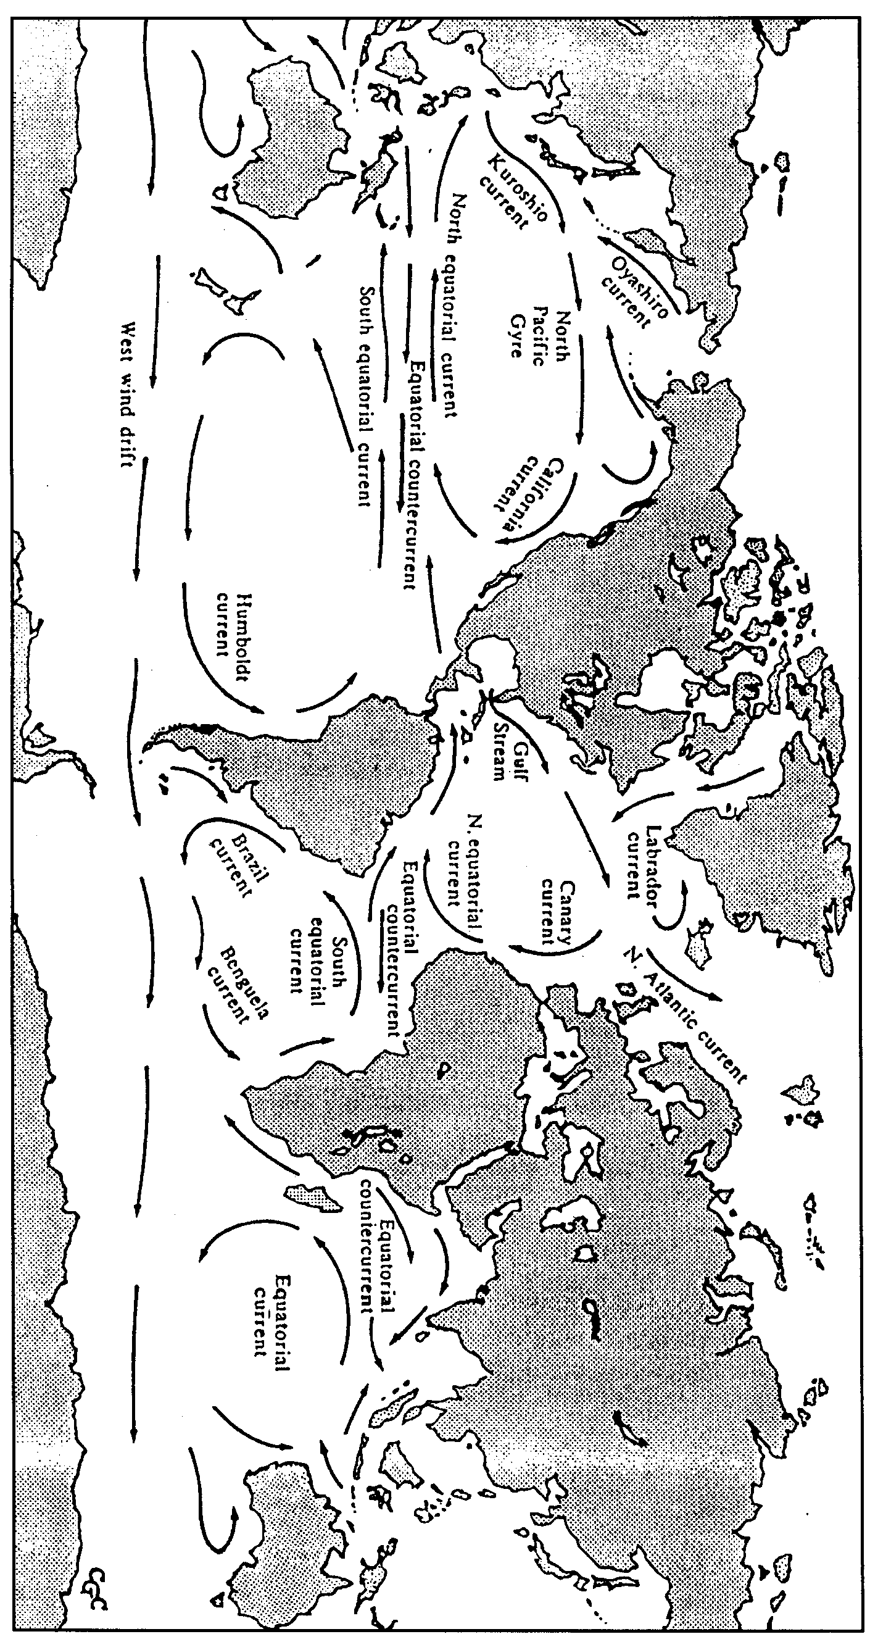

Major Surface Currents

