Moving Right Along: Density Currents
Edited by Gene Williamson, Manning, OR

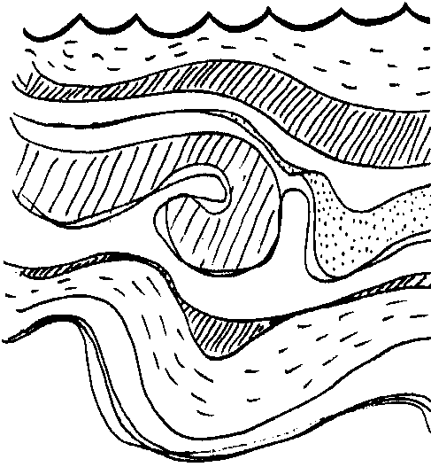
Key Concepts
1. Currents exist deep in the oceans which influence climates, and plant and animal populations.
2. Both salinity and temperature influence the differences in water density which cause deep water currents.

Background

Ocean currents have been used as an aid to navigation for thousands of years. Ocean currents affect climates and influence plant and animal populations on land, as well as in the oceans. How can currents have such an effect? Before we investigate that question, let’s look at what causes these influential currents.

Surface currents are largely driven by the earth’s winds. Deep currents of the world’s oceans are caused by other forces. Caused by differences in temperature and salinity, the varying densities of ocean waters are major forces in producing deep ocean currents.

Consider the water in an environment such as that deep under the ice around the antarctic. It is so cold that salt water is taken up to form ice. But, there is no room in the structure of the ice crystal for the atoms which make up salt. As a result, the salt is left behind in the water, and a very cold, salty water is formed. Because of its density, this water sinks.

In an entirely different part of the world, another phenomenon occurs. In the Mediterranean region, evaporation is so much greater than precipitation, the level of the Mediterranean is actually lower than the level of the Atlantic. This high rate of evaporation creates a constant and significant current flowing into the Mediterranean past the Rock of Gibraltar. German submarines made use of this current during World War II. The captains would submerge the U-boat a few feet below the surface, shut down the engines, and slide undetected into the Mediterranean.

The rapid evaporation of water from the surface of the Mediterranean leaves behind very salty water. Even though this very salty water is warm, the density is sufficient to cause it to sink to the bottom. This very salty, warm water is subsequently pushed along the bottom of the sea moving past the Rock of Gibraltar and into the Atlantic. The German U-boats, having completed a mission, would simply shut off the engines, drop down to that very dense current heading out to the Atlantic, and slide silently out to safety. Eventually, the allies installed huge submarine nets to prevent this maneuver.

Humans have, for thousands of years, used currents and surface currents to aid in navigation. The warm Japanese currents that swing down the coast of North America have been utilized by peoples of both Asia and America.

We are not the only hitchhikers, however. Consider the drifters, phytoplankton and zooplankton, or the 20-ton swimmers, the California gray whales, who catch the currents in their migrations. The huge volumes of moving water play a significant role in the life of the seas.

Materials

Activity 1: The Duwamish River

For the class:
• map of Washington (you may want to use a river in your area)

For each team:

• clear plastic shoe box, or similar container

• food coloring (any color but yellow)

• paper cup

• straight pin

• salt

• stirring stick

• measuring spoon

• tap water

• forceps

For each student:

• “The Duwamish River” activity sheet

Activity 2: That’s Cool!

For each team:

• clear plastic container

• food coloring (any color but yellow)

• paper cups

• straight pins

• thermometer (Celsius)

• tap water

• forceps

• ice cubes

For each student:

• “That’s Cool!” activity sheet

Activity 3: All Together Now

For class (demonstration) or for each group of 4 students:

• 10 gallon aquarium

• 2 or 3 density floats (available from science supply)

• submersible coil heaters (or 3 one-cup coffee heaters)

• 4 thermometers

• salt

• food coloring (any color but yellow)

• ice

• (2) 1000 ml beakers

• hot plate

• Pyrex beaker

For each student:

• “All Together Now” activity sheet

Teaching Hints

Activity 1: The Duwamish River

Students investigate the effects of salinity on the density of water.

Procedure:

Have students locate the Duwamish River that flows into the salt water of the Puget Sound at Seattle, Washington. Trace its flow and continue the flow to open ocean through the Straits of Juan De Fuca.

Ask students what they think happens when fresh water enters salt water. Divide students into teams and distribute the student worksheet for Activity 1, “The Duwamish River”.

Activity 2: That’s Cool!

Students investigate the effects of temperature on the density of water.

Procedure:

Divide students into teams and distribute the student worksheet, “That’s Cool!”.

Activity 3: All Together Now

Students observe that both salinity and temperature influence density. Density differences are one cause of deep water currents.

NOTE: This activity may be done by students, but given the complexity of the procedures and the use of electricity around water, it is probably better as a teacher demonstration.

Preparation:

1. Prepare the following water masses and set aside:

Antarctic water: 750 ml water + lots of salt + blue food color
cool to 0 degrees C.

Mediterranean water: 750 ml water + red food color
warm to 35 degrees C.

2. Fill the aquarium to within about two inches of the top with cool tap water. The temperature of this water is not critical, but you will need to know what it is (20 degrees C. is ideal). The water represents the Atlantic Ocean.

Let the students know this is fresh water. Explain that salt water is more corrosive and more dangerous around electricity.

3. Place three thermometers in the aquarium so that students can monitor the water temperature at the bottom, mid depth, and at the surface.

4. Place the submersible heaters at a convenient depth of about 3 to 5 inches below the surface. Remind students that heating by the sun produces a warm layer on top of the ocean, and that is what the heaters are doing in the aquarium.

Review with students why the heaters are only heating the upper layer. (Cold water is more dense, convection currents keep heated water near surface).

5. Place the density floats in the water. They should sit right at the surface, barely floating. Keep an eye on the density floats throughout the demonstration. They will move in response to currents and will generate many questions. The set up should look something like this:
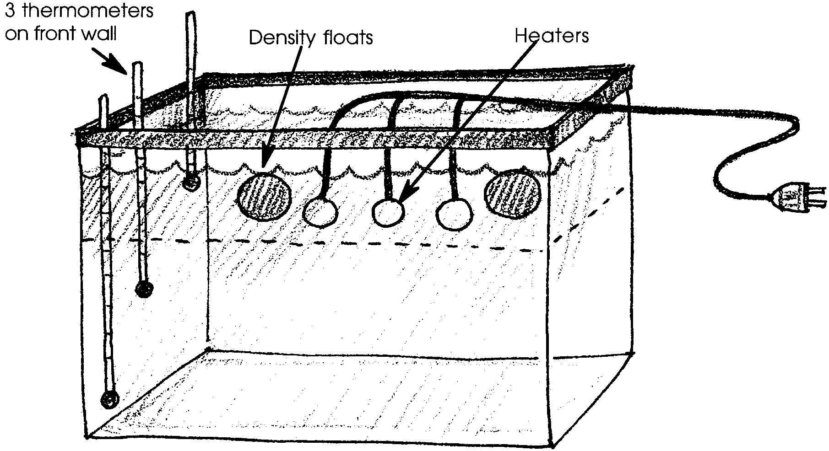

NOTE: If the density floats and/or aquarium glass are covered with gas bubbles, GENTLY remove. The bubbles on the density floats will prevent them from operating properly by keeping them down. To dispel this idea, use a stick to gently push to the bottom. When released, it will rise back to its new position atop the thermocline.

Procedures:

1. Distribute copies of the student worksheet, “All Together Now”.

2. Have students sketch the before picture in #1 on the worksheet.

3. Plug in the heaters. It will take about 15-20 minutes to raise the surface temperature to between 45-50 degrees C. This is warmer than any part of the ocean surface, but will serve to accentuate the effects of temperature.

Note what happens to the density floats as the surface water is heated. Explain that the boundary between the warm layer and the cold water below is called the thermocline.

IMPORTANT NOTE: When surface temperature reaches 45-50 degrees C., unplug and then remove the heaters from the water. DO NOT remove heaters before unplugging them.

Antarctic Water

4. Explain that near the Antarctic there is very cold, salty water formed under the ice cap. Have students predict how they think this water will behave when added to the aquarium. Have them record this prediction on #3 of the worksheet.

5. Slowly add the prepared “Antarctic water” to the system. Students should be encouraged to make observations and ask questions. It is often possible to observe an internal wave moving along the density boundary between the “Antarctic water” and the water above it.

6. Have students record observations on #4 of the worksheet and compare their observations to predictions.

Mediterranean Water

7. Explain that there is a lot of evaporation in the Mediterranean Sea and not much rainfall. The result is warm, salty water. As you might expect, this water sinks to the bottom of the warm Mediterranean because of the increased salt content. But how will this water behave when it enters the cold Atlantic Ocean? Have students record a prediction on #5 of the worksheet.

8. For this part of the demonstration, temperatures are critical. If everything is set up correctly, you should have cold, salty water on the bottom of the aquarium, cool (20 degrees C.) fresh water above that, and warm (45 degrees C.), fresh water on the top.

When the “Mediterranean water” is at 35 degrees C., you are ready. Gently pour the “Mediterranean water” into the aquarium. This water will probably sink first, then rise to the thermocline where it will knife in between the warm surface water and the colder layer underneath. Density dictates where it will reside.

This is exactly how Mediterranean intermediate water behaves in the Atlantic. The density of the water determined by temperature and salinity causes it to exit the Mediterranean and sink to an intermediate level in the Atlantic, where it can be traced as far away as South America.

9. Have students record their observations on #6 of the worksheet.

The four-layered structure in the aquarium will remain for some time before changing densities will destroy the layers.

Have students feel the outer surface of the aquarium. They may feel the thermocline where the “Mediterranean water” came to rest.
Key Words

density - the mass of a substance per unit of volume

density float - any object which will barely float in fresh, cold water; the density is roughly 1.0 g/ml. The object sinks as the water is warmed.

salinity - amount of salt in seawater usually expressed in parts per thousand ‰

thermocline - the temperature boundary between warm, surface waters and cold, deeper waters

Answer Key

Activity 1: The Duwamish River

Analysis and Interpretation:

1. a. The freshest water should be found near the surface.

b. The saltiest water should be found at the bottom.

2. Fresh water is less dense than salt water.

3. Fresh water will usually float over the top of the salt water when the two meet.

4. a. Fresh water will float on top of salt water.

b. The increased rainfall of the winter months would likely yield nearly fresh water at the surface near the mouth of the river.

Activity 2: That’s Cool!

Analysis and Interpretation

1. Most likely the cold water will sink toward the bottom when it enters the warm water.

2. Answers will vary, but in general the current will be deflected to the side, and perhaps back toward the surface. Again, this will be determined by the temperature gradient, residual turbulence, etc.

3. Cold water tends to sink when it meets warm water.

4. Fresh water tends to float when it meets salty water.

5. a. Activity 2: That’s Cool - differences in temperature.

b. (blank) - differences in temperature and salinity.

c. Activity 1: Duwamish River - differences in salinity.

6. The test for both salinity and temperature would require making changes in both the variables. Hopefully students recognize that it is density differences that cause deep water currents, and that both salinity and temperature influence density.

7. The movement of currents influence where the gray whale will find its food supplies. Gray whales are bottom feeding, baleen whales and will travel to where currents provide proper living conditions for food species.

Activity 3: All Together Now

1-6. Answers depend upon experimental results and student predictions.

7. Density, influenced by temperature and salinity, determines the level of a certain water type in the ocean.

8. Deep ocean currents are used by ocean plants for transportation and as a source of supply for food and nutrients.

Moving Right Along: Density Currents

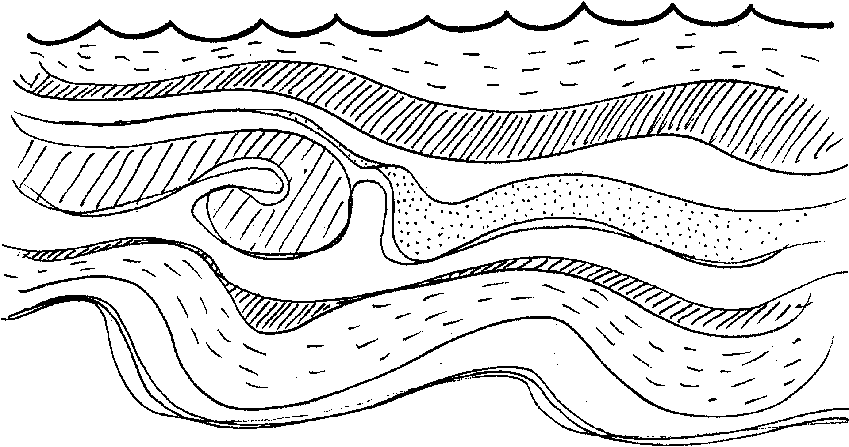

What causes the currents that sometimes help, sometimes hinder the California gray whale? What forces can move enough water to slow the progress of a twenty ton swimmer? In the following activities, you will observe some of the environmental factors which may cause movement of ocean waters. You will also have a chance to observe what happens when different ocean currents meet.

Activity 1: The Duwamish River
Materials:
• clear, plastic container
• food coloring
• paper cup
• straight pin
• salt
• stirring stick
• measuring spoon
• tap water
• forceps
Procedure:

The Duwamish River flows into the salt water of Puget Sound at Seattle. Puget Sound flows into the Pacific Ocean. This activity demonstrates what happens when fresh river water meets the sea.

1. Obtain one paper cup and a clear, plastic container. The paper cup will generate the river current. The plastic container will represent Puget Sound.

2. Place 5 drops of food coloring in the cup. Fill the cup right to the rim with cold tap water.

3. Obtain one straight pin. Stick the pin in the cup midway between the top and the bottom. LEAVE THE PIN IN THE CUP. Place the cup at one end of the container.

4. Place 4 teaspoons of salt in the plastic container. Fill the container with cold tap water to a depth about one inch below the top of the cup. Stir to dissolve the salt. Your setup should look something like the drawing below:
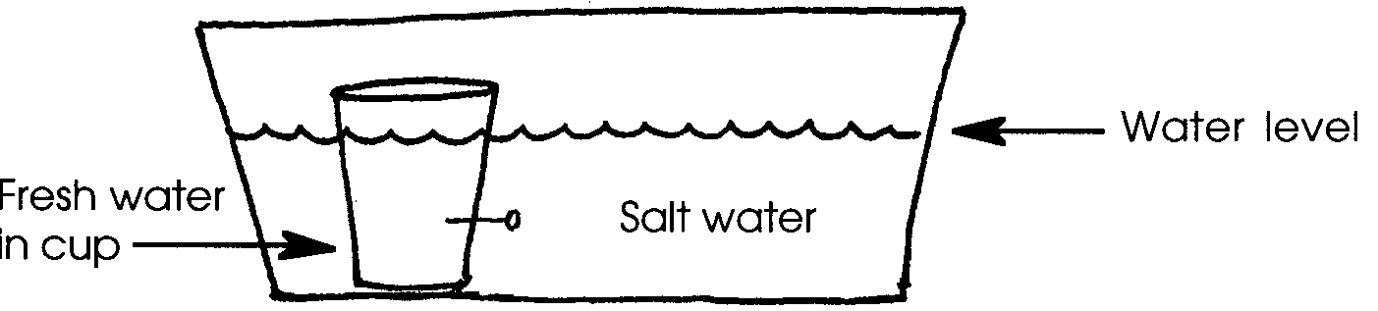

5. Wait until the water in the container has stopped moving. Wait at least 60 seconds. Then CAREFULLY pull out the pin with the forceps. DO NOT disturb the water more than necessary.

6. Observe the current that results.

7. After 6 minutes, record the location of the fresh water in the model.

Analysis and Interpretation

1. As a scientist studying the effects of pollution on ocean organisms, you want to take samples from the mouth of the Duwamish River as it enters Puget Sound.

a. Where would you expect to find the freshest water?

b. Where would you expect to find the saltiest water?

2. Is fresh water more dense or less dense than salt water?

3. Write one sentence which describes how fresh water will usually behave when it meets salt water.

4. During the winter, surface water taken from the mouth of the river is almost entirely fresh.

a. How do your experimental results help explain this observation?

b. What environmental factors might be responsible for this observation?

Activity 2: That’s Cool!

Ocean currents often differ in temperature. Some are very cold, others quite warm. In this part of the activity, you will investigate what may happen to a cold current when it meets a warmer current.

Materials:
• clear plastic container
• food coloring
• paper cup
• straight pin
• thermometer
• tap water
• forceps
• ice cubes

Procedure:

1. Obtain a paper cup and a clear, plastic container. The plastic container will represent a warm part of the Pacific Ocean. The cup will generate a cold current flowing into the warm ocean.

2. Use tap water to represent the ocean.

(The results will likely be the same if you used salt water. You can try the experiment with salt water, but remember that the saltiness of the water inside and outside the cup must be the same. Why? Remember what happened in Activity 1 when we had different amounts of salt inside and outside the cup?)

3. Put 2-3 ice cubes into the paper cup. Add 5 drops of food coloring. Fill the cup to the rim with cold, tap water. Stick one straight pin through the cup just at the surface of the “ocean”. LEAVE THE PIN IN THE CUP. Place the cup at one end of the container.

4. Fill the “Pacific Ocean” with warm (25-30 °C) water to a depth of about one inch below the top of the cup. Your setup should look something like this:
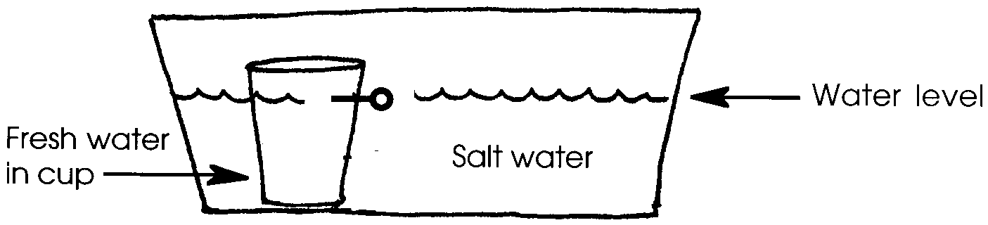

5. Wait until the water in the cup has cooled to 6 °C. Make certain all water movement has stopped. CAREFULLY pull the pin out of the cup using the forceps. Try not to disturb the water.

6. Observe the current that results.

Analysis and Interpretation

1. Where did the cold current go as it entered the warm water?

2. What happened to the cold current when it hit “land” (the side of the container in your model)?

3. Cold water tends to when it meets warm water.

4. Fresh water tends to when it meets salty water.

5. The three statements below are all true. The two activities you have performed give support to two of the statements, but it would take more experimenting to confirm the third statement. In the blank in front of the statements, write in the number of the activity that helped confirm each statement. (Activity 1: The Duwamish River, Activity 2: That’s Cool!)

Deep water currents are created by the difference in the density of water caused by:
a. - differences in temperature.
b. - differences in temperature and salinity.
c. - differences in salinity.

6. For the statement which is not supported by our experiments, describe an experiment you might do to confirm that it is true.

7. Both the temperature of the water and the amount of salt it contains affect the plankton that live in the water and the animals that inhabit the sea floor. We already know that currents can help or hinder the gray whale as it swims. What other effect might currents have on the life in the sea?

Activity 3: All Together Now

The gray whale’s world is not as simple as cold or warm and fresh or salty. The cold California current warms gradually as it moves toward the equator. Fresh water joins it, water evaporates from it, and other currents interfere with its progress. The ocean is a complex world where salinity and temperature differences work together to control water movement. This activity will demonstrate how salinity and temperature differences form currents.

Analysis and Interpretation

1. Sketch the ocean setup before the surface is heated. Then sketch a picture to show changes that took place when the surface water was heated.

Before After

2. How did the position of the floats change when the surface water was warmed? How would you explain this change?

3. Write your prediction for the behavior of the Antarctic water.

4. Describe how the Antarctic water behaved in the model ocean.

5. Write your prediction for the behavior of the Mediterranean water.

6. Describe how the Mediterranean water behaved in the model ocean.

7. What determines the level of a certain water type in the ocean?

8. How might deep ocean currents be used by ocean plants and animals?

