Stormy Weather: Wind Driven Currents

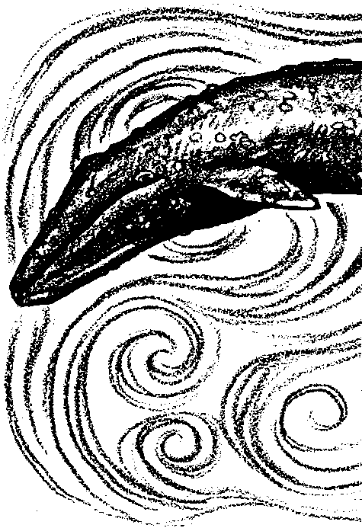
Key Concepts
1. Currents are large-scale water movements in the sea.
2. Currents affect living organisms by influencing food availability, migration, water temperature, and weather patterns.

Background

Currents are large-scale water movements that occur everywhere in the ocean. Surface currents are driven by winds. Ocean currents, winds, and weather patterns are closely linked. Currents affect living organisms by influencing food availability, water temperature, and weather patterns.

The ocean and atmosphere of the earth are heated unevenly by the sun. More heating takes place at the equator than at the poles. This difference in temperature at the equator and the poles causes warm air to rise along the equator, and cold air to sink at the poles. Rising and sinking air creates wind, as adjacent air masses move in response.
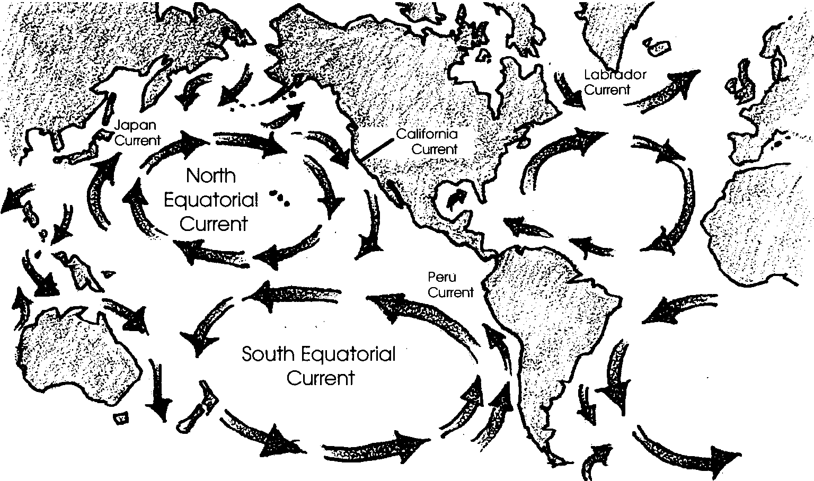

Wind blowing over long distances of ocean tends to drag surface water along with it. The rotation of the earth causes oceanic wind patterns to create large circular currents, or gyres. The “bending” caused by the earth’s rotation is called the Coriolis Effect. In the northern hemisphere the gyres flow clockwise, in the southern hemisphere gyres flow counterclockwise. These large wind-driven currents are year-around, constant patterns.
Additional background information for “Stormy Weather: Wind Driven Currents” is found in the preceding activity “Currents: Moving Water.”

Materials

For each student:
• “Stormy Weather: Wind Driven Currents” activity sheets

Teaching Hints

“Stormy Weather: Wind Driven Currents” begins with a look at a California gray whale dealing with various environmental factors during its southward migration. Your students are given a brief look at the breathing cycle, a look which may be expanded through the use of available films. Our whale also must deal with the currents faced in Umiak Pass and further south. The narrative provides a springboard for two activities dealing with currents: “Moving Right Along” and “Hot Air”. As you embark on these activities, stress the effect of the physical world (the currents) on the biological world (the gray whale and other organisms). Bulletin boards, films, records, etc. can help you tie these worlds together. The goal is to treat currents as they affect the life of the California gray whale and other marine organisms.

Duplicate the text pages. One set is recommended per student. This activity is best accomplished by individual students as homework or as an in-class assignment. Upon completion of “Stormy Weather: Wind Driven Currents”, plan to allow some time for a discussion of the narrative and to provide answers to the text questions.

Key Words

arctic - area surrounding the North Pole

breathing cycle - pattern of breathing and diving in whales

current - large-scale movement of seawater

exhales - releases air from lungs

flukes - the two horizontally flattened divisions of the tail of a whale

impede - interfere with

inhale - air intake into lungs

Answer Key

1 a. Our whale spent eight minutes completing the breathing cycle described.

b. She swam 7.5 cycles in one hour.

c. She swam one-half mile in the cycle described.

d. At this rate, she would swim 3.75 miles in one hour. (7.5 cycles x one-half mile.)

e. At this rate, she would swim 90 miles per day. (3.75 miles per hour x 24 hours.)

f. At this rate, she would have traveled 1260 miles since October 1st. (90 miles/day x 14 days.)

g. Our whale’s rate falls within the observed averages for distance covered per day.

2. Since the halibut breathe through gills, they are unaffected by the rough water which made breathing difficult for our whale. The purpose of this question is to emphasize the fact that whales are air breathers and must come to the surface to breathe regardless of the weather.

3. The south flowing California current makes swimming easier for our gray whale as she moves south. Technically, the gray whale would only encounter the California current well offshore of the west coast (100-200 miles). As she approached the shore, other southward flowing currents would influence her trip. These near shore currents reverse direction with seasonal winds. Timing of gray whale migration typically finds them migrating in the same direction as these currents.

Stormy Weather: Wind Driven Currents
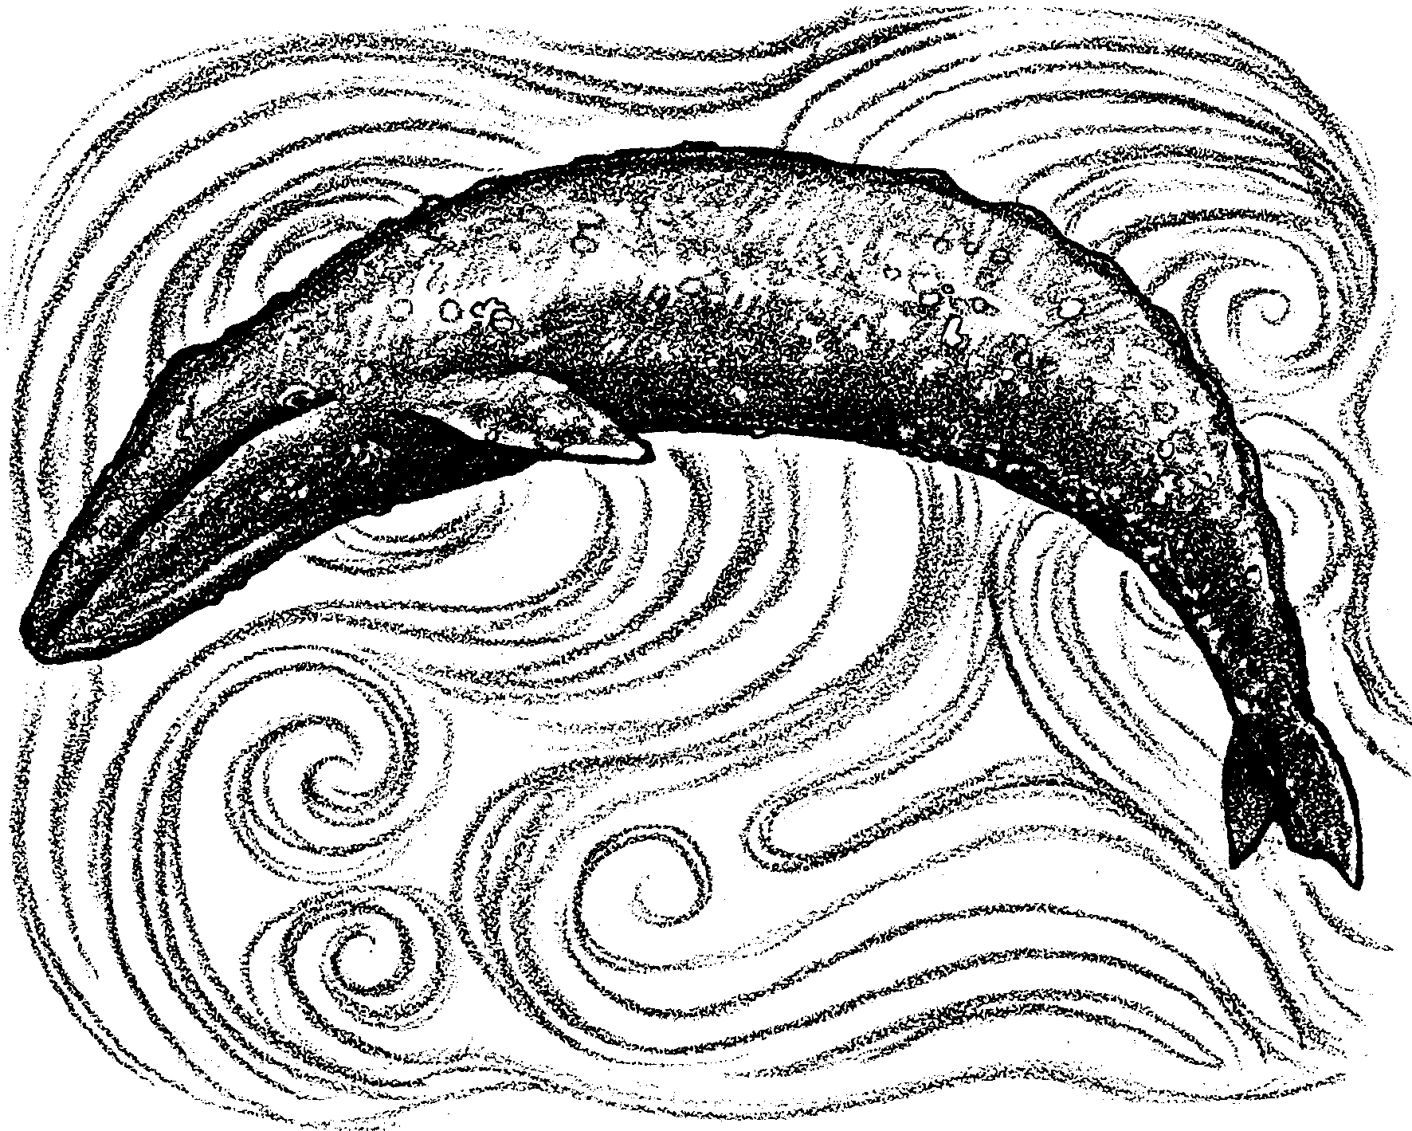

Currents affect life in the sea. Even creatures as large as a gray whale are affected by currents. Let’s look at a whale beginning her annual migration south from the arctic waters near Alaska to the warm waters of Baja California. Currents that she encounters along the way can help or impede her travel.

Swimming, breathing, swimming, breathing. Stroke after stroke the whale’s ten foot flukes push her 50 foot body through the cold Bering Sea.
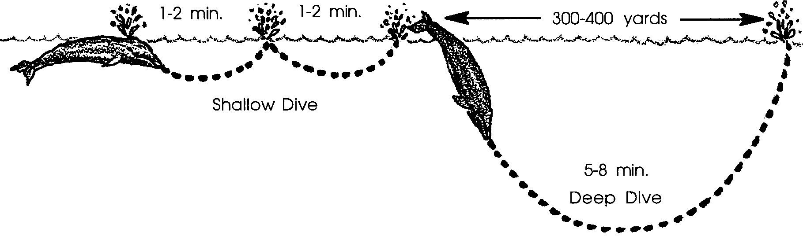

Her head breaks the water surface. Her blowholes open and a sudden rush of warm air escapes from her lungs. The expanding air cools into a cloud or fog called a spout. She inhales and shallowly dives disappearing beneath the surface for one minute.

She resurfaces, exhales, inhales, and dives shallowly again. After another minute, she again resurfaces, exhales and inhales.

She dives deeply, throwing her flukes out of the water to help propel her downward. She swims aggressively forward for six minutes before resurfacing and beginning the breathing cycle again. During this cycle of three breaths she has moved another half mile southward.

1. a. How much time did our whale spend in completing the breathing cycle described above?
minutes.

b. How many cycles did she swim in one hour(60 minutes)?
cycles.

c. How far did she swim during the cycle?
miles.

d. If she kept swimming at this rate how far would she swim in one hour (60 minutes)?
miles.

e. At this rate how far would she swim in one day (24 hours)?
miles.

f. At this rate how far has she traveled since October 1st?
miles.

g. Gray whales are known to swim 85-100 miles per day during the long swim. How is our whale doing compared to the average?

Swimming, breathing, swimming, breathing. Night and day for the next week, she moves southeastward toward Umiak Pass. Umiak Pass is the first break in the chain of Aleutian Islands. As she approaches the pass, our gray whale is joined by still more grays. Together they swim south and east.
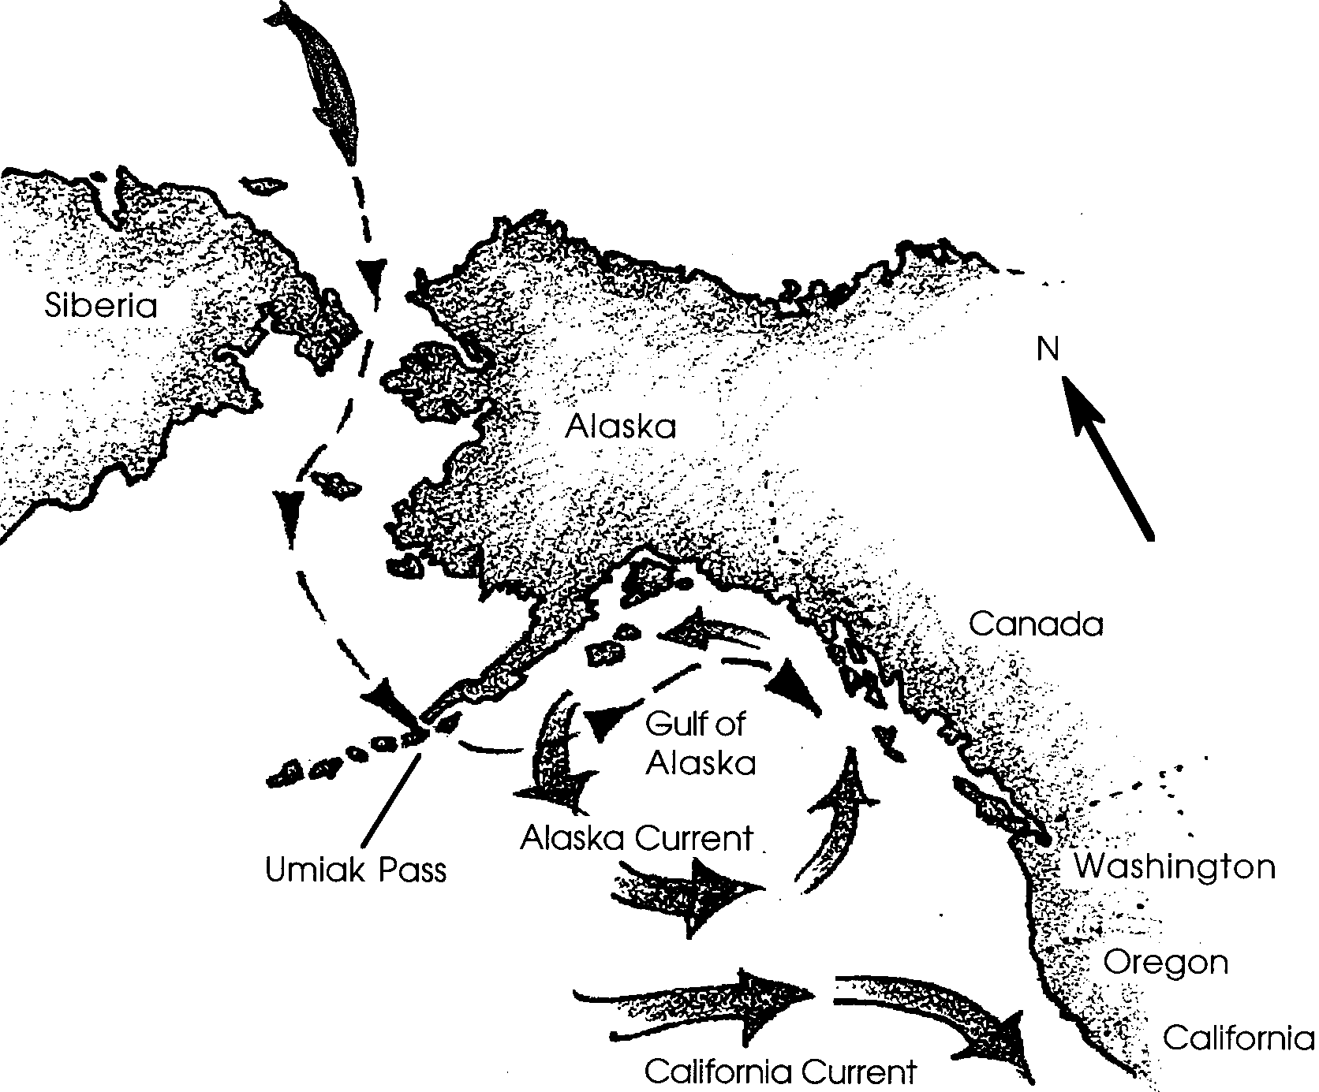

The wind and snow come more often. Winds from the north lash the waters of Umiak Pass. The churning water makes breathing difficult for our gray. Her powerful flukes drive her on. Strong currents run northerly through Umiak Pass. Swimming, breathing, swimming and breathing, she passes into the Gulf of Alaska. Here she is still swimming against the current. This time it is the Alaska Current.

2. Would the stormy water which made breathing difficult for our whale have an effect on the breathing of halibut fish in the pass?

For the next three weeks, she swims through strong currents. At times, the currents aid her progress south. At other times the strong currents impede her progress. The currents move vast quantities of water. Swimming and breathing she moves toward the south-flowing California Current. The California Current is part of a large, clockwise ocean circulation pattern north of the equator. The California Current carries cold water. This cold, wind-driven water influences life in the oceans and on the land.
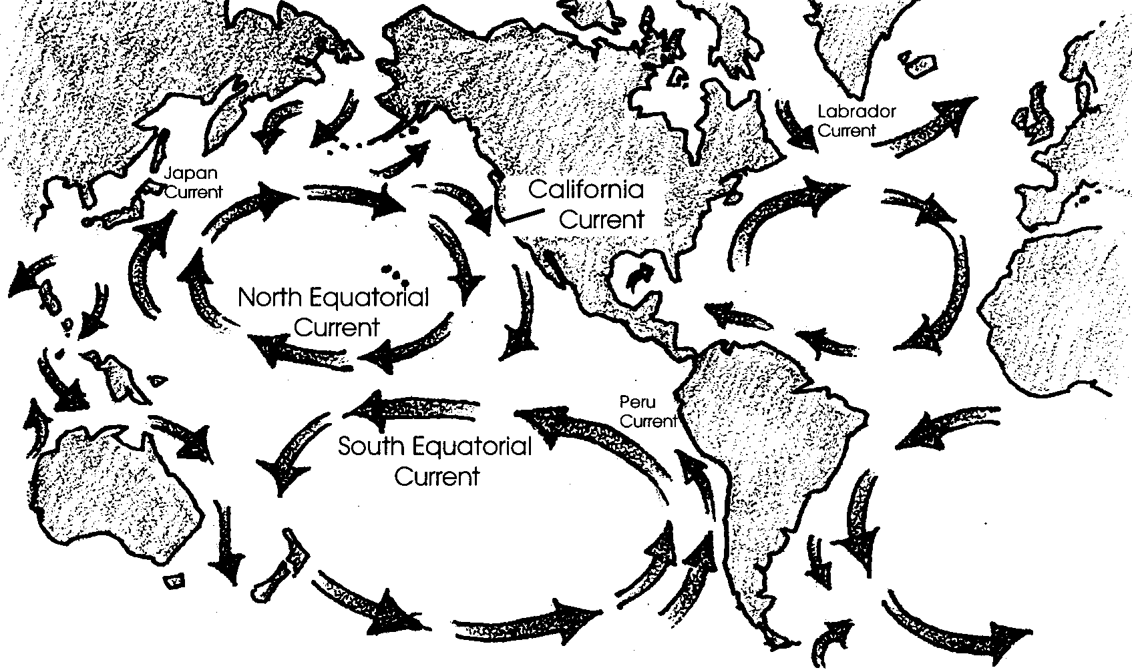

3. How might the California Current aid our whale in her southward swim?

