Currents: Moving Water

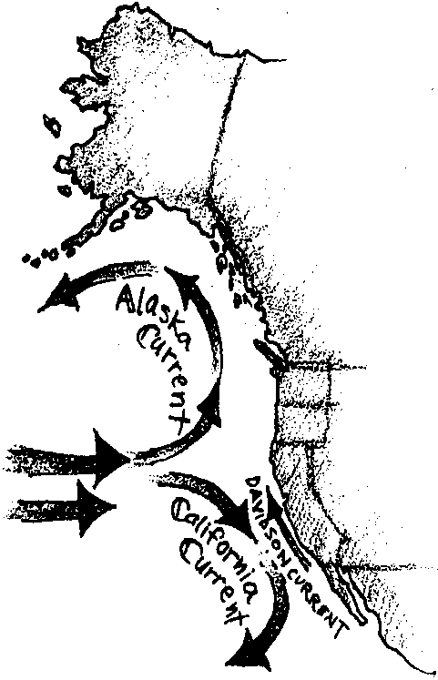
Key Concepts
1. Currents are large-scale water movements in the sea.
2. Currents affect living organisms by influencing food supply, water temperature and weather patterns.
3. The three main causes of currents in the ocean are:
• wind
• earth’s rotation
• density differences in ocean waters

Background

Currents are large-scale water movements that occur everywhere in the ocean. The surface currents are driven by winds, while deep subsurface currents are driven by density differences in the ocean water. Ocean currents transport heat from the equator toward the poles, thereby partially equalizing surface temperatures over the earth. Ocean currents, winds, and weather patterns are closely linked. Currents can affect the food chain by transporting nutrients and plankton from one area to another. Fish congregate in high plankton areas to feed, attracting larger predators such as tuna, birds and marine mammals (and humans!).

Wind Driven Currents

The ocean and atmosphere of the earth are heated unevenly by the sun. More heating takes place at the equator than at the poles. This difference in temperature at the equator and the poles causes warm air to rise along the equator, and cold air to sink at the poles. Rising and sinking air creates wind, as adjacent air masses move in response.

Wind blowing over long distances of ocean tends to drag surface water along with it. The rotation of the earth causes oceanic wind patterns to create large circular currents, or gyres. The “bending” caused by the earth’s rotation is called the Coriolis Effect. In the northern hemisphere the gyres flow clockwise, in the southern hemisphere gyres flow counterclockwise. These large wind-driven currents are year-around, constant patterns.

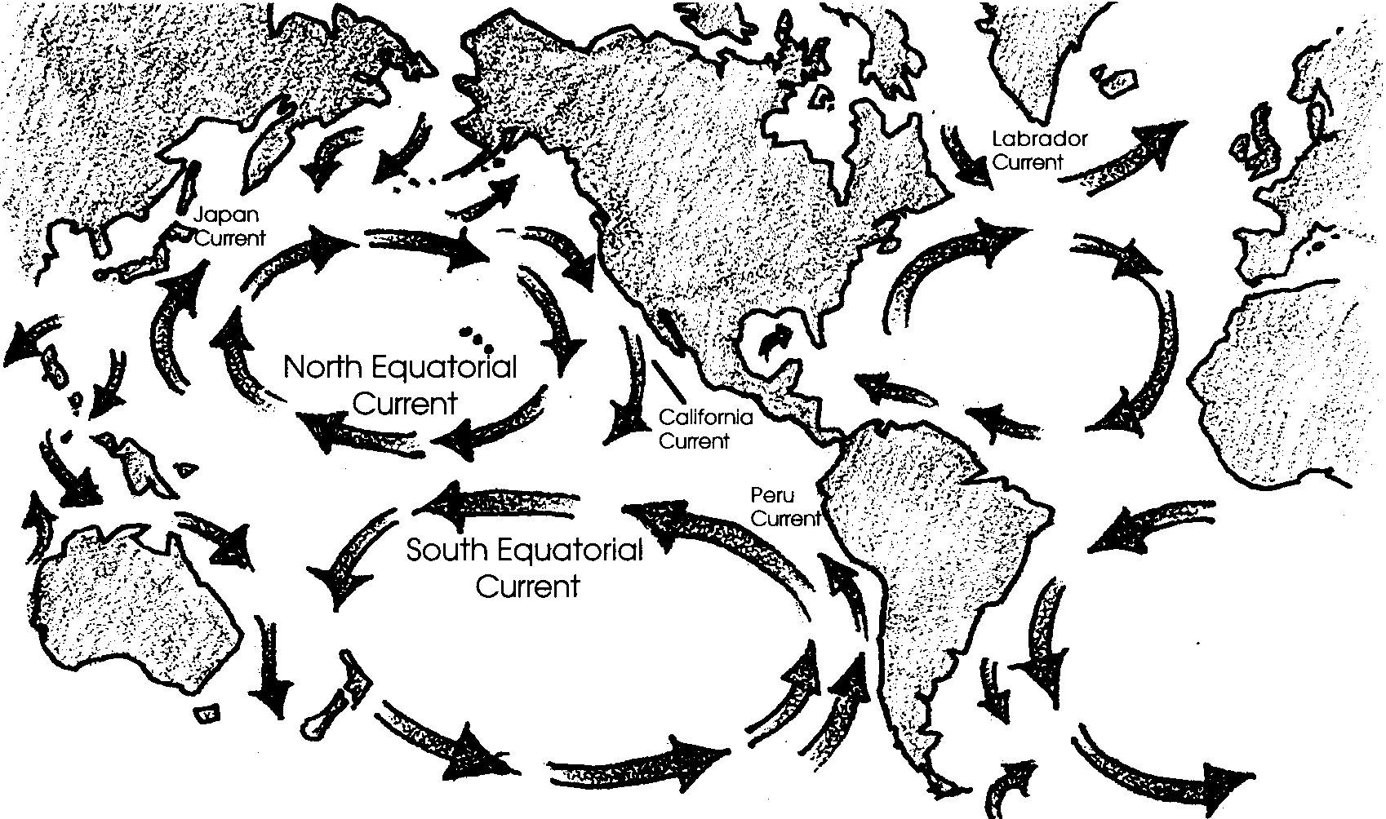

Density Currents

At the North and South Poles, ocean water is cooled by the polar ice caps and by the lack of sun. Very cold, dense water sinks and flows along the bottom of the ocean toward the equator. Antarctic bottom currents flow past the equator into the northern hemisphere. These polar bottom currents are very slow moving. It may take 600 years for Antarctic bottom water to reach into the northern hemisphere. This very cold water is full of oxygen and is the primary source of oxygen in the deep sea.

At the equator, waters warmed by the tropical sun rise, expand, and flow out away from the equator. Remember that the atmosphere is moving in much the same pattern, also due to unequal heating by the sun.

El Niño

Normal wind and current patterns in the Pacific ocean create a flow of water near the equator that moves from the coast of the Americas toward the west. Every few years this pattern of wind and currents changes. For reasons that are only beginning to be understood, the Trade Winds die down and become weak. The westward-flowing equatorial current slows and is pushed aside by the equatorial counter-current running in the opposite direction. This means that lots of warm, nutrient-poor water moves east along the equator from the western Pacific. This warmer water reaches the coast of South America, pushing the Peru current further south.

Many organisms cannot tolerate warmer water. Plankton die from lack of nutrients in the warm water. Fish, such as anchovies, that feed on plankton, scatter to find food somewhere else. The food chain is disrupted by this change in ocean currents.

Because this event often happens during the Christmas season, the people of South America have named it “El Niño”, or “the child”. El Niño is devastating to the fishing industry of coastal countries such as Peru. Environmental effects of El Niño including a rise in sea level and modified weather patterns can reach all the way to the United States.

Additional information about El Niño is found in the Background for the activity “El Niño: A Current Case Study”.

Teaching Hints

“Moving Water” serves as the introduction to several activities dealing with currents: “The Hydrometer”, “Heating It Up”, “0l’ Sea Salt”, and “El Niño: A Current Case Study”.

The idea of rivers of moving water within the oceans will be foreign to many of your students. The forces which set up the currents are likely to be even less familiar. “Moving Water” provides information relating to currents caused by differences in density, the earth’s rotation, and wind. The demonstrations outlined in the “Extension” section of this background help illustrate the forces which cause ocean currents.

Density differences due to temperature and salinity are discussed and provide the background necessary for “The Hydrometer”, “Heating It Up”, and “0l’ Sea Salt”.

Duplicate the activity pages. One set is recommended per student. “Moving Water” is best performed by individual students as an in-class or homework assignment. You may elect to have your students meet in small groups to discuss their answers before you provide the answers to the text questions during a general class discussion. As always, use the approach that will work best with your particular class.

Key Words

current - large-scale movement of ocean waters

density - mass per unit volume of a substance. More dense seawater tends to sink, less dense seawater tends to rise in the ocean.

El Niño - weather related change in oceanic wind and current patterns

gyres - large circular ocean currents caused by wind and rotation of the earth.

hydrometer - instrument used to measure density or specific gravity of a liquid.

nutrients - essential minerals for life: similar to “vitamins”

salinity - measure of the quantity of dissolved salts in seawater

upwelling - process by which water rises from a lower depth usually bringing nutrients with it.

veer - a tendency to bend in one direction

Extensions

1. Students need to see the ideas presented in the following activities at work in nature. Without this experience, the connection to the real world is a leap of faith. While just how you provide experiences in the natural world depends upon where you are, here are some suggestions. It is relatively straightforward to measure currents associated with the wind and to observe the tendency for nearshore currents to follow the beach by following drifting sticks thrown into the water. Measuring a temperature profile in a lake during late spring will show warmed water near the surface and winter-cooled water underneath; better yet, measure the same body of water in winter and then again in spring.

2. The following activities can be beneficially supplemented with audio-visual materials. An effective demonstration of the Coriolis effect can be done using a basketball and a piece of chalk. Explain to the class that the basketball represents the earth. Spin the basketball counterclockwise as you look down on the “North pole”. While spinning the “earth”, try to draw a straight line down from the North pole with the chalk. The chalk line will be deflected or bent because of the earth’s rotation. Ocean water is affected by winds that blow in the same direction. Winds “drag” the surface waters along with them. Emphasize that Coriolis effect is just ONE of the factors that affect currents in the ocean.

3. Several eye catching demonstrations may be used to introduce the concept of water density. For example, an effective demonstration of the manner in which very dense water is formed in oceans can be staged quite easily.

Use ink or food coloring to make some colored ice cubes. Place the cubes in a lukewarm “ocean” in an aquarium or other transparent tank and observe the movement of cold blue water from the melting ice down to, and along the bottom of, the “ocean”. The effect is most dramatic if the ice cubes are confined to one end of the tank by means of a wire strainer or cage.

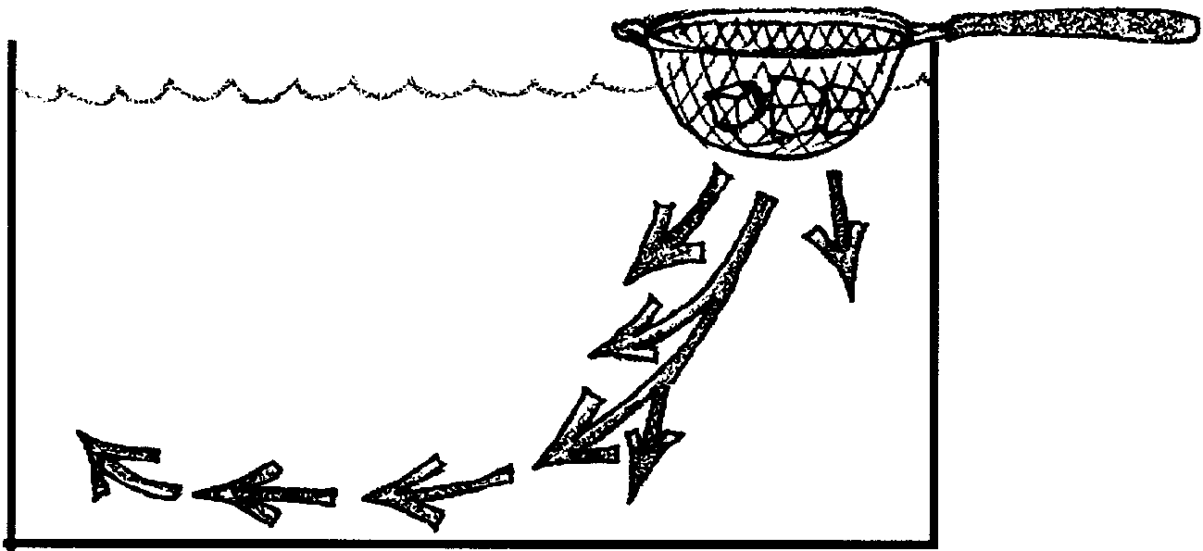

Ask the students what this demonstration represents in the “real world”. “Where on our earth is melting ice creating a dense cold current that is sinking to the floor of the ocean?” They may realize that this happens at the North and South poles. This very dense, very cold current runs along the ocean floor and is the major source of oxygen to the deep sea. Ask the students how creatures can live below the sunlit zone in the sea where there are no plants to form the base of the food chain. There are no plants to create oxygen for the animals in the dark waters. Where does the oxygen come from? This cold polar current delivers oxygen to the deep waters. Remind your students that cold water can carry more dissolved oxygen than warm water can. In your discussion point out that this represents an ideal situation. Within the actual basin there will be the effects of the topography and to some extent the Coriolis effect. Although the winds act only on the surface layer of water, they can indirectly set in motion large scale vertical and horizontal water motions.

4. A slightly different, but effective, demonstration may be done as follows: Fill a 5 or 10 gallon aquarium tank half full with clear tap water.

Have ready:

a) 400 ml beaker of ice water
add l tablespoon salt
blue color (stir until all salt is in suspension)

b) 400 ml beaker of HOT water
no salt
yellow color

The procedure is as follows:

1. Have one student pour dense, cold water into one end of the tank.

2. Have another student pour hot, less dense water into the other end of the tank.

3. Have students observe (from eye level, if possible).

If the pouring is done carefully a nice, three color tank is the result. Relate the results to the layering seen in the oceans and the movement of waters caused by different densities.

Answer Key

1. A “river” of water within the sea is called a current.

2. One force that moves ocean waters is the direct rays of the sun which provides more heat to the seas near the equator. Warm tropical seas expand, rise and move away from the equator.

3. This world map is correctly marked:
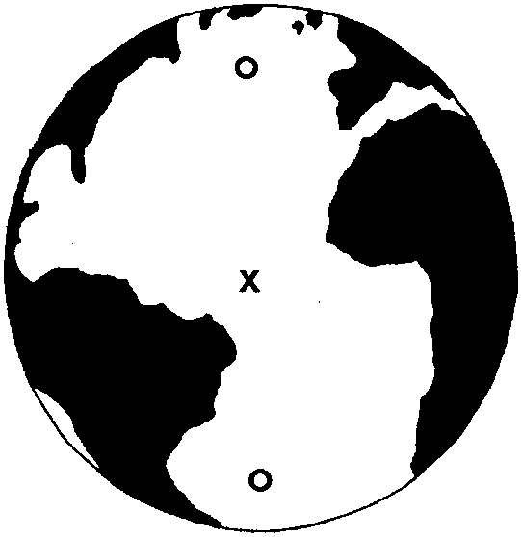

4. Saltwater/freshwater is more dense (“heavier”). The correct answer is in bold print.

5. The deepest water in the oceans is warm/cold and “light”/“heavy”. The correct answers are in bold print.

6. This map is correctly labeled:
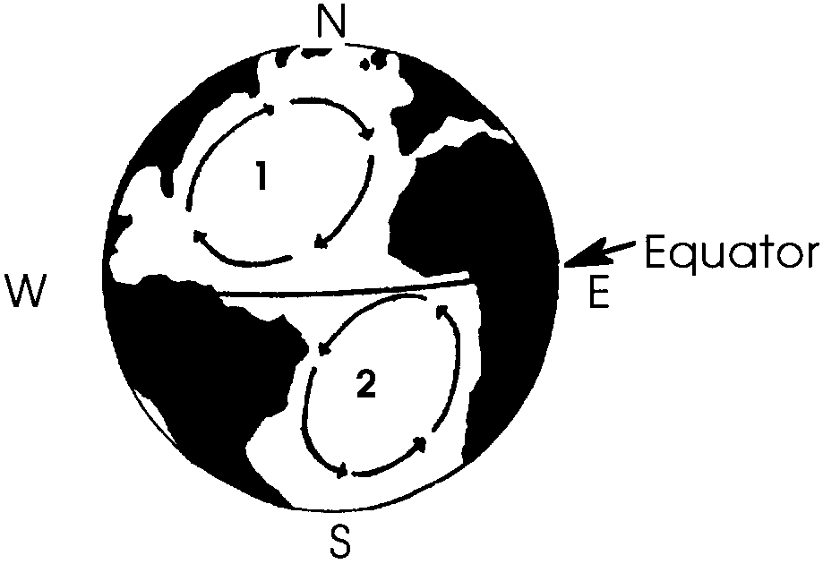

7. Three factors important in causing currents are:

a. differences in density of the water

b. the earth’s rotation

c. wind

8. Three ways in which currents affect living things may be chosen from the following:

a. hinder or facilitate movement

b.determine where plants and animals can live

c. determine the course of ships

d. affect the migration and settling of people

e. affect the climate of the land near which they pass.

Currents: Moving Water
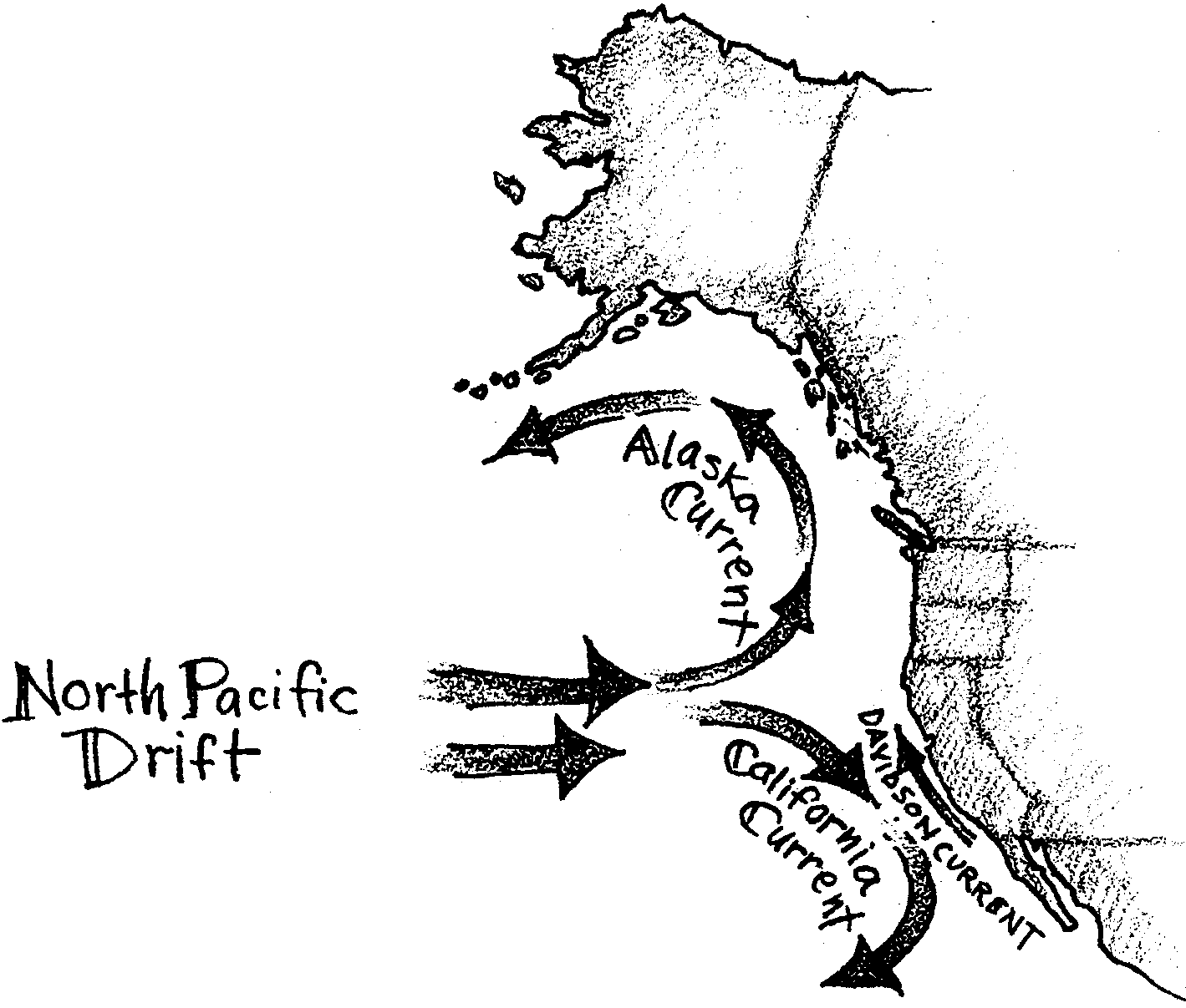

The waters of the sea are always going somewhere. Within the ocean, “rivers” of water flow in well known patterns. The water splashing off the back of a gray whale may have arrived in Alaska from the coast of Japan after a 5,000 mile trip in the Japan Current.

1. What do we call a “river” of water within the sea?

Several forces act to move ocean waters. As the earth moves through space it spins on its axis in such a way that the seas near the equator receive the direct rays of the sun. These direct rays provide more heat to the seas near the equator. Polar seas receive fewer warming rays. The warm tropical seas expand, rise, and flow away from the equator. Cold, heavy polar waters sink and flow toward the equator.

2. What is one force that moves ocean waters?

3. On the world map below, the white areas show water.
a. Place an X where the warmest waters would be found.
b. Place an O where the coldest waters would be found.
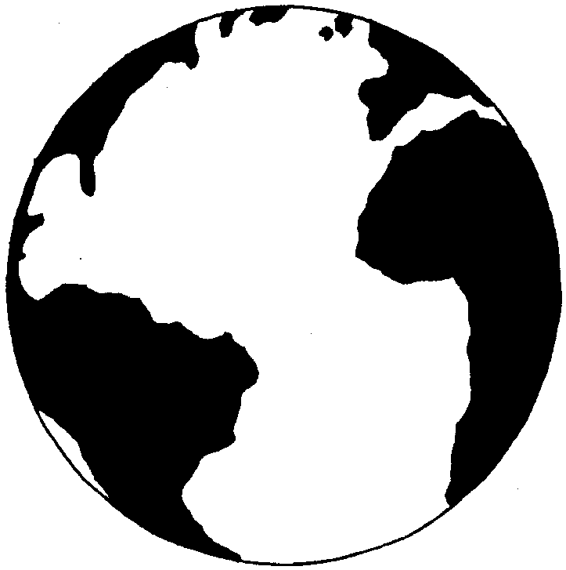

So, currents can be caused by differences in the density (“heaviness” or “lightness”) of water. We have seen that cold water is heavier (more dense) than warm and tends to sink. Salt, too, can make water heavy. Sea water contains salt. Usually the proportion of salt in the open sea stays close to 3.5 percent. This means that every 100 grams of sea water would contain about 3.5 grams of salt. There are, however, some exceptions to this rule. For example, near melting polar ice the seawater tends to be less salty because the ice that is melting is nearly fresh.

4. Saltwater/freshwater is more dense (“heavier”). Circle the correct answer.

Water that is near ice that is beginning to form has more than the average amount of salt. There is more salt because as the ice freezes, it leaves the salt behind in the water. (There is no room for salt in an ice crystal and it is slowly squeezed out as the sea ice “ages”). The extra salt around the ice makes this water more dense (heavy) and it sinks. (Can you make salt water freeze into ice cubes? Try it and see. What happens?)

5. The deepest water in the oceans is warm/cold and “light”/“heavy”. Circle the correct answers.

The rising of warm, less salty waters and the sinking of cold, more salty waters plays a major role in causing currents. These movements of water should tend to produce rivers of water in straight lines. A look at our current map shows that this isn’t the case. The major currents flow in circular patterns called gyres. These circular patterns are due to the spinning of the earth on its axis. The spinning causes the water to veer (move at an angle) slightly to the right in the northern half of the world. Spinning also causes the water to veer slightly to the left in the southern half of the world.
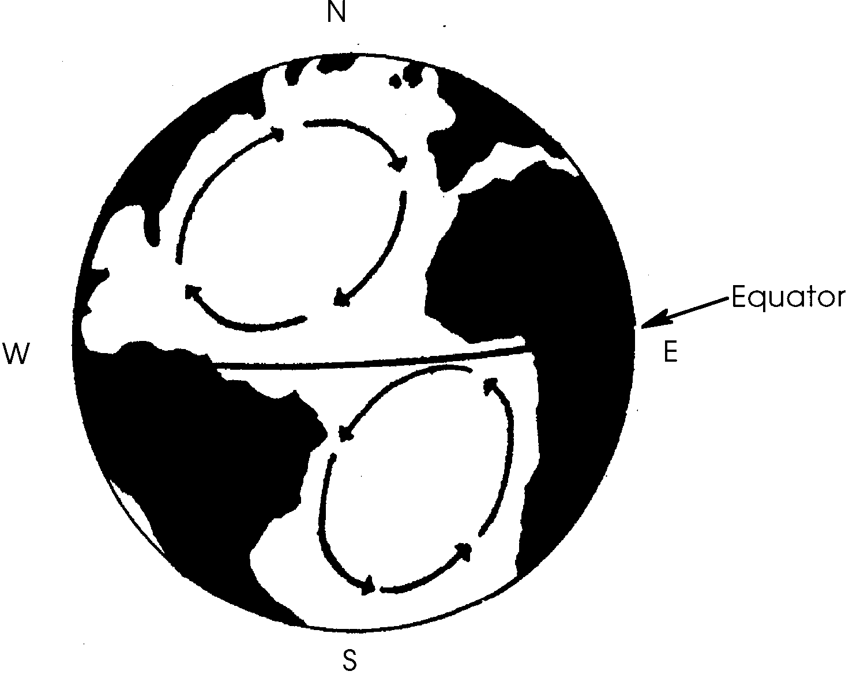
6. On the map above:

a. Place a number l on a gyre moving clockwise, north of the equator.

b. Place a number 2 on a gyre moving counterclockwise, south of the equator.

Another equally important factor that produces movement of the water is wind. The air at the equator, as we have seen, is warmer. The warm air expands, grows lighter, and rises. As it reaches the poles, it cools. the cool air then sinks back to the earth and the cycle begins again. As the earth rotates, the rising and sinking currents of air are “bent” in a clockwise direction north of the equator and in a counterclockwise direction south of the equator. These winds blowing across the ocean drag surface waters along with them, forming wind-driven currents or gyres.

The three factors that are most important in causing water movement are:
1. differences in density of the waters
2. the earth’s rotation
3. wind.

Ideally, the combined factors would produce currents like those shown below.
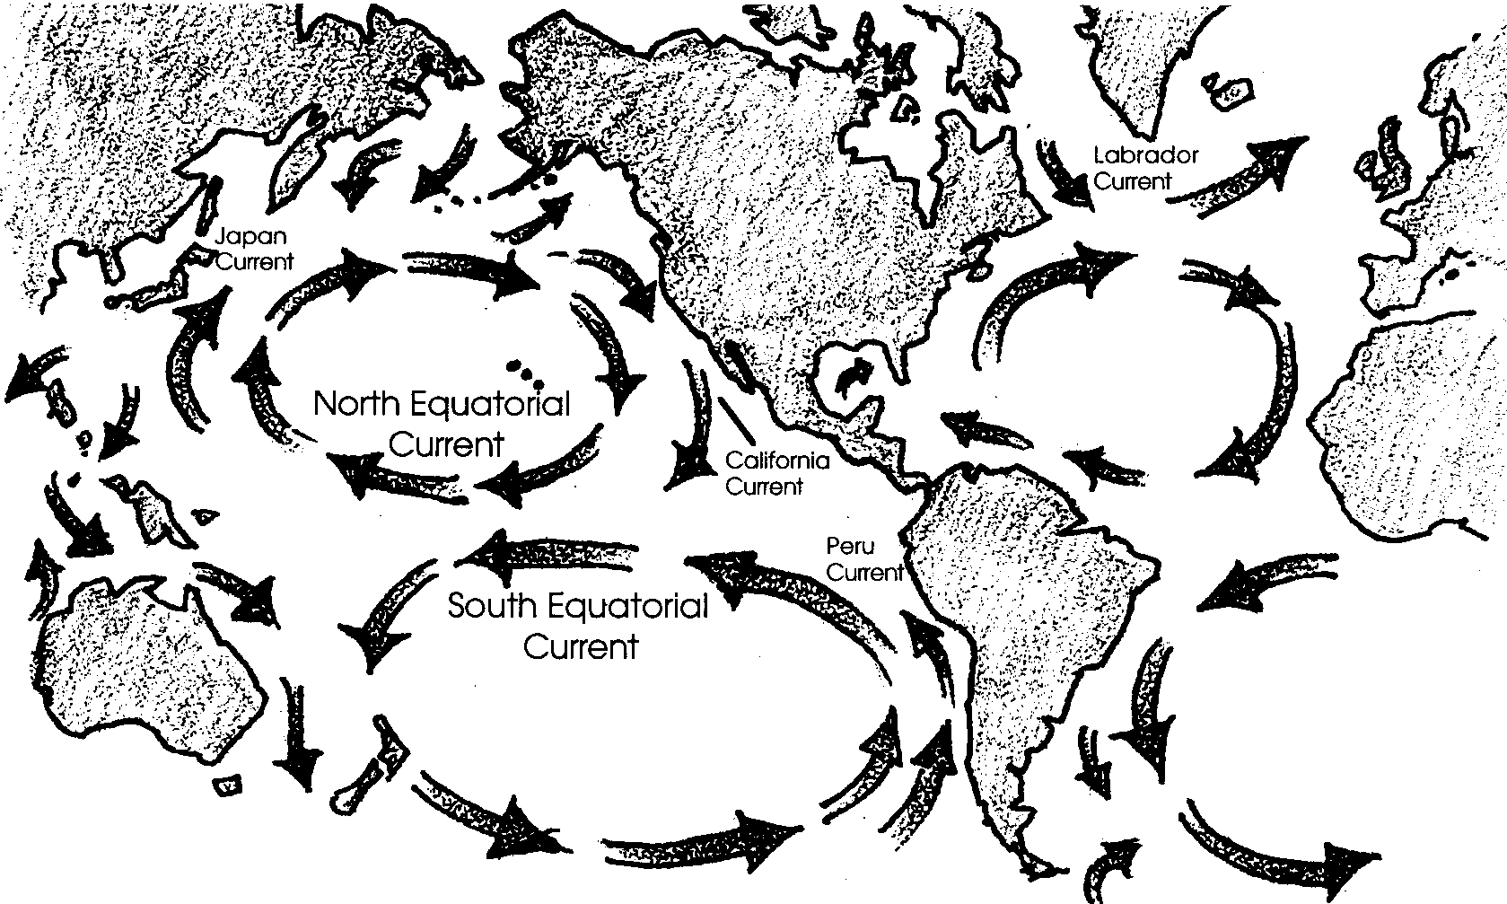

How do these currents influence living things? A gray whale could give us one answer. Currents can help or hinder the movement of animals. Plankton cannot swim against a current. So, the base of the ocean food chain is at the mercy of currents! Because they move water of different temperatures, currents also have an influence on where plants and animals can live. Currents help determine the course of ships. Ships save fuel and time by traveling with currents. In days past, currents affected where people could travel by sea. Because of this fact, currents affected the migration and settling of people. Finally, the speed and temperature of currents can affect the climate of the land near which they pass.

7. What are three factors important in causing currents?
a.
b.
c.

8. What are three ways in which currents affect living things?
a.
b.
c.

For an interesting view of how currents may have affected the migration and settling of people, read Kon-Tiki by Thor Heyerdahl.

In the following activities you will have an opportunity to examine some of the factors that cause ocean currents.

