View From Space
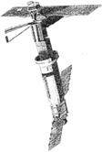
Lesson by Dr. Tom Howick, Gorham, Maine

Key Concepts
1. Satellites are tools that scientists use to monitor Earth’s physical, biological, chemical, and geological processes from space.
2. Satellite images provide a global view of the Earth, allowing scientists to track changes in atmosphere, ocean and land systems over time.

satellite photo courtesy of NASA
Background

Oceanography is no longer tethered to the sea. Satellite technology has now enabled scientists to place sensitive instruments in space, far above the sea surface, to take a new measure of the Ocean Planet. The huge amount of data collected from satellite observations has led to the construction of “models” of Earth systems using computer technology. These satellite sensors allow us to track changes in global patterns. The ability to track changes coupled with computer models may lead to an increased ability to predict global change in oceanic and atmospheric patterns.

Satellites now pass over a particular location several times a day, collecting hundreds of pieces of data in a fraction of the time it would take aboard ship. Satellites can collect information in 10 minutes that would take weeks to collect on board ship at the surface. The speed and volume of data collection is important because sometimes ocean conditions can change before data can be gathered by ship. At sea measurements still remain important to link (and verify) the surface data, collected by satellites from a thin (less than a few centimeters thick) veneer of the ocean, with data taken at depth from ships.

Since the launch in 1960 of “TIROS”, the first U.S. “remote sensing” satellite focusing on the oceans, the space program has had a significant impact on marine science and technology. “Remote sensing” of the Earth has proven to be a continuing success of the space program. Early satellites were used to collect data for modern weather forecasting and global land formations. Satellites from five different countries and the European Space Agency now study physical, biological, chemical, and geological processes from space.

Opertational Earth Observation Satellites

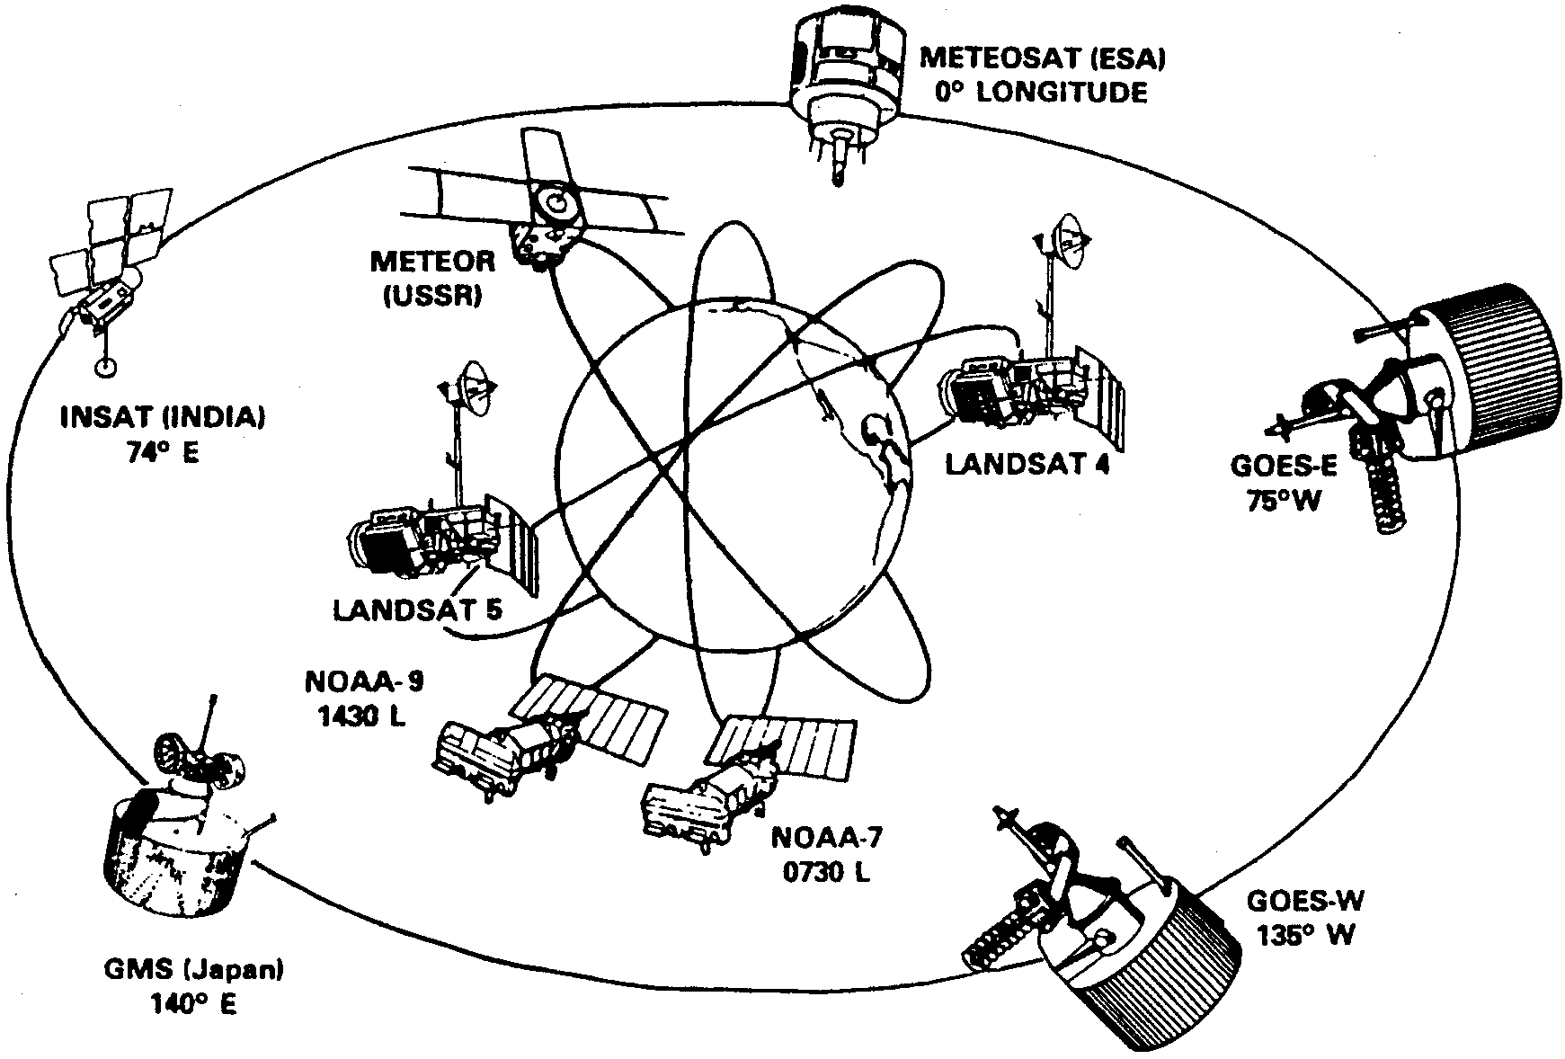

The current civilian operational satellite system includes satellites from five different countries and the European Space Agency. The geostationary satellites view the earth from a distance of 22,500 nautical miles; the polar-orbiting satellites are at a distance of about 520 miles. (The recently-launched French SPOT satellite is not shown.)

Seasat, launched by NASA in 1978, was the first dedicated ocean monitoring satellite. Since then, other oceanographic satellites have been deployed.

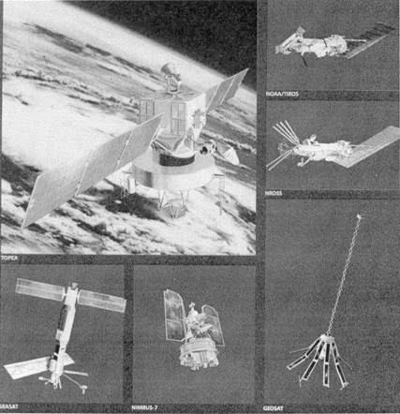
Oceanographic Satellites

Data from oceanographic satellites is best used to study features and patterns of regional and global scales. Today, satellites are equipped with a variety of sensors, including radar emitters and detectors, reflectors, altimeters, and cameras that detect visible light and infrared energy (heat). Data obtained from satellite instrumentation includes sea-surface temperature, surface-water turbidity, surface wind and wave conditions, sea-surface wave heights, ocean currents and tides, ocean-floor topography, and ocean productivity.

In a joint effort with France, NASA launched the TOPEX-POSEIDON satellite in the fall of 1993. The satellite measures sea-surface topography while circling the Earth every 112 minutes. The result will be global maps of the slight “hills and valleys” of the sea surface. From these maps scientists can calculate the speed and direction of ocean currents worldwide.

These worldwide patterns were difficult to map accurately before satellite technology made vast amounts of information available in a short time span. In ten days, TOPEX can make more (and more comprehensive) observations than made during the previous 100 years of shipboard measurements. As a result of these efforts, large scale pictures of ocean conditions are possible now. These global images make tracking changes in natural patterns more feasible.

For your reference, the following provides a listing of types of satellites:

Name Agency Measurements

Nimbus Series NASA -surface temperature
reflected back from Earth
-chlorophyll concentrations of
phytoplankton

Seasat NASA -global measurements of wind,
waves, and the shape of the
sea-surface and ice topography

NROSS NASA -global surface wind
observations, sea surface
temperature, and sea-ice
distribution

TOPEX NASA -ocean circulation (currents),
sea surface topography

TIROS - N NOAA -meteorological data

Landsat NOAA -land surface measurements
of radiation, vegetation
type, soil moisture, geology

SPOT France - global processes at the land
surface

Materials

• satellite images from FOR SEA CD-ROM

• detailed and comprehensive maps that show world and ocean features such as the following National Geographic Maps:

• December 1981, World Ocean Floor

• January 1990, World Ocean Floors: Exploring and Mapping the Sea Floor

• December 1988, page 910A, Vol. 174, No. 6: The World, Endangered Earth

Teaching Hints

In “View From Space” students use a mini-slide show to survey the kinds of information gathered by remote sensing satellites and to make inferences and draw conclusions from the information presented. The photo images are found on the FOR SEA CD ROM.

This activity lends itself to group work. A number of approaches are possible. You may choose to have students work in small groups at the computer screen, answering the questions posed about the satellite images. If you have the capability of projecting the computer screen image for the whole class, you may choose to project the images to the whole class while students work in small groups.

Before class, familiarize yourself with how to access the images and decide upon the strategy you will use to provide each student group with computer time. You may choose to conduct this activity simultaneously with “Where the Food Is” or “String For Your Supper.”

1. As background to the mini-slide show, provide time for students, in groups or individually, to investigate maps that show world and ocean features. The maps help provide supplementary perspectives about early techniques of collecting oceanographic data.

2. Introduce satellite imagery by asking the class:

“Suppose you were building a satellite to observe the Earth from space. What kinds of information do you think it would be important for the satellite to gather?”

3. Have students work in small groups to create their own lists, then share their lists through a class discussion. Ask the groups to defend their choices.
4. Provide each student with the “View From Space” activity pages and the class with the logistics for the strategy you’ve chosen for accessing the slides.

5. After groups have completed the questions, provide time for a class discussion of the activity.

Key Words

altimeter - an instrument that measures distance above sea level

abyssal plain - flat area on the deep-sea bottom

chlorophyll - green plant pigments essential for photosynthesis

estuary - partially enclosed body of water where fresh and seawater meet

infrared - in this activity, pertaining to images made by recording differences in heat (rather than differences in light as in conventional photography)

Landsat - abbreviation for “Land Satellite”, a remote sensing satellite operated by NOAA

latitude - distance, measured in degrees, north and south of the equator

longitude - distance, measured in degrees, east and west of the prime meridian (Greenwich, England)

NASA - National Aeronautical and Space Administration

NOAA - National Oceanic and Atmospheric Administration

plankton - organisms that drift or have weak swimming abilities and are moved by currents

phytoplankton - plant plankton: primary producers of the oceans

remote sensing - the science of gathering data from a considerable distance; in this activity, gathering data or making observations from a “space platform”, or satellite

Answer Key

1. a. Ships can gather data from a small area only. Many shipboard measurements are necessary to get the information that a satellite can gather in a matter of minutes.

b. Answers may vary since the question calls for an opinion. One might obtain a global view of current patterns in the sea from space.
2. a. Since the Earth is moving in relation to the satellite, each pass of the satellite moves over a different strip (“track”) of the planet. Combining the information from the different tracks gives a picture of the entire ocean.

b. The first satellites did not record continuously to conserve energy and preserve the useful life of the satellite.

3. a. The satellite is above the South Pacific and Australia.

b. Answers will vary. Two possibilities include the information is stored on board to be later sent to California; or other antennas are situated around the globe. Both of these strategies are employed.

4. a. The information from the satellite is transmitted to an earth-based antenna, is processed and saved on magnetic tapes which are shipped to Dr. Campbell and fed into a computer which sends them to her computer which produces the image at her desktop.

5. a. Answers may vary since the question calls for an opinion. The red spots are cities (i.e., Boston, and surrounding cities )

b. Explanations will vary but the cities show as red because they are warmer than the surrounding land.

c. This image was taken in the summer (June, actually). The answer comes from a recognition that the land is warmer than the ocean. In winter, the land is colder than the ocean.

6. a. Boston, MA; Concord NH; Portland, ME are the cities in the area shown.

b. This image, coupled with others of the same area taken over time, could help show changes in the condition of the ocean (temperature, plankton, sediments, etc.).

7. The images taken from season to season might show short term changes in vegetation, coastal erosion, and flood or storm damage.

b. Longer term change from the above as well as human activities such as development would also change vegetation patterns.

8. a. Fishers are interested in phytoplankton concentrations because fish follow the food (phytoplankton).

9. a. The highest levels of phytoplankton are found near the coastlines of land masses.

b. While answers will vary, the areas near the coastlines are the areas of upwelling which brings nutrients to the surface and also the areas where nutrients wash into the sea from the land. Phytoplankton need light and nutrients just as land plants do. The nutrients are the fertilizer for phytoplankton growth.

c. Answers will vary.

d. Since fish follow the food source and phytoplankton is the base of most ocean food chains, the best fishing areas in this part of the Atlantic are likely to be those with the highest phytoplankton concentrations.

10. a. The Gulf Stream flows north a bit offshore of the Atlantic seaboard.

11. a. At the “1”, the Gulf Stream is a warm current.

b. At this point, the Gulf Stream current flows close to the equator. Tropical sun heats the water and the ocean stays warm year round with little fluctuation in sea surface temperature.

c. The temperature of the Gulf Stream east of the North Carolina coast is decreasing (the color changes from red to orange). As the Gulf Stream bends to the northeast, it mixes (converges) with cooler water from the Virginia Current and other cooler ocean currents from the mid-Atlantic states. This mixing causes a decrease in the temperature of the Gulf Stream.

d. The temperature of the Gulf Stream continues to cool as it begins to reach the middle of the North Atlantic. In fact, it cools so much that its surface temperature can no longer be distinguished from that of surrounding waters.

12. a. The “S” shaped ridge is the Mid-Atlantic Ridge.

b. Provide help as required to assure students locate the features listed.

c. While answers will vary depending upon the maps on hand, the ocean floor map usually shows more detail.

d. The maps usually have more detail and information because such maps are constructed based on fifty or more years of data collected with instruments that oceanographers used while on many oceanographic research trips all over the world’s oceans. Satellites are still limited in what they monitor. In the future, satellites will likely have more data collecting capability.

e. Details such as fracture zones, continental shelves and other smaller features are not reflected in satellite images.

14. a. Answers will vary since the question calls for an opinion.

b. Surface measurements are still very necessary for two main reasons. First, they provide greater detail of a certain area; and second, they check the accuracy of satellite measurements. Both methods are vital to a complete picture of our Ocean Planet.

For More Information

Articles:

Baker, D.J. (Spring 1991). “Toward a Global Ocean Observing System” Oceanus 34 (1): 76-83.

Baker, D.J. & Wilson, W.S. (Winter, 1986/87). “Spaceborne Observations in Support of Earth Science” Oceanus 29 (4) : 76-85.

Huyghe, P. (December 1986). “Sea floor Mapping” Oceans 22-29.

“Oceanography from Space”. Fall 1981 Oceanus 24 (3).

Tippie, V.K. & Cawley, J.H. (Spring 1991). “Modernizing NOAA’S Ocean Services.” Oceanus 34 (1) 84-93.

Agencies:
UCAR Office for Interdisciplinary Earth Studies
PO Box 3000
Boulder, Colorado 80307-3000
(303) 497-1682

NOAA Office of Global Programs
Education Program Manager
1100 Wayne Ave, Suite 1225
Silver Springs, MD 20910

The Earth Observing System
Earth Science & Applications Division
NASA Headquarters (Code EE)
600 Independence Avenue SW
Washington, D.C. 20227 - 2028

NASA’s Mission to Planet Earth
NASA Public Affairs Officer
National Aeronautics and Space Administration
Washington, D.C. 20546
(202) 358-1547
Special thanks to Dr. Janet Campbell and Bigelow Laboratory for Ocean Sciences, Boothbay Harbor, Maine, and NASA for the use of their photos and satellite images.

NASA Ames Research Center
Teacher Resource CenterMail Stop TO25
Moffett Field, CA 94035
(415) 604-3574

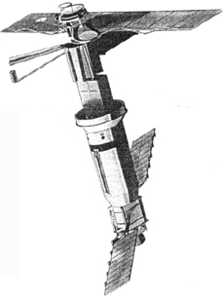
View From Space

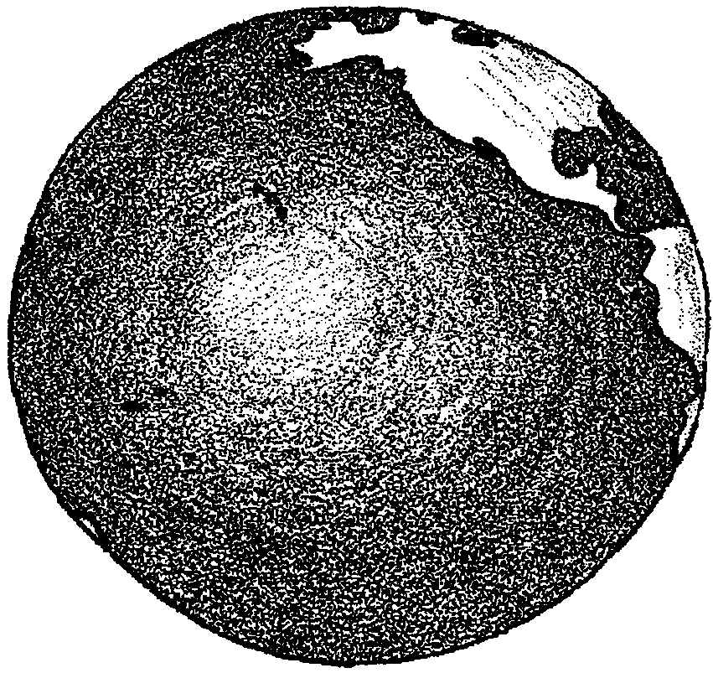

People have sought to learn about the oceans for centuries. Until recently, most of our information came from observations made on-board ships. The ocean is a big place. Think about making a map of the currents found in the north Atlantic. Many ocean voyages were necessary to gather enough observations to make such a map.

For the last 30 years, scientists have been using satellites to view the Earth from outer space. The information the satellites gather helps with weather forecasting. You can see satellite information about weather patterns every night on television news programs.

Oceanographers also use satellites to learn about the ocean. In 1978 NASA launched the Seasat satellite to monitor the ocean. (“Monitor” here means to watch closely or keep track of changes.) Seasat collected information about ocean wave heights and the shape of ice at the poles. Unlike ships, satellites can gather information about the whole globe in a matter of days. For instance, the TOPEX satellite orbits the Earth every 112 minutes. In 10 days it has measured the sea surface of all the oceans of the world.

In the following activity you will view a mini-slide show to learn more about satellite oceanography. With your group, read the information. Look at the satellite images and other photos. Then, answer the following questions about what you see.
Procedure:
1. Look at Slide 1. This satellite image shows the North Atlantic. The different colors show patterns of plant plankton (phytoplankton).

a. How is a satellite better than a ship for gathering this kind of information?

Cloud patterns are helpful in predicting weather. Imagine trying to take pictures of all the cloud patterns over your state. You can see only the pattern right above you at any one time. Even if you could be transported quickly all around your state, the clouds change before you can record all the patterns. There must be an easier way to get the pictures. Aha, you say. Perhaps an aerial view would be more accurate.

b. The ocean changes almost as fast as cloud patterns do. How might you get the whole picture of current patterns in the sea?

2. Look at Slide 2. This image shows the polar orbit of Seasat. The satellite was located 520 miles above the Earth’s surface. Polar-orbiting means that the satellite travels around the poles in a north-south orbit. Like any satellite, Seasat was held in orbit by the Earth’s gravity field.

a. The satellite ground track shows the width of the “picture of the Earth” the satellite can take. Compared to the size of the Earth, the track is pretty narrow. How could Seasat assemble a picture of the entire ocean? (Hint: What causes day and night on Earth?)

b. People on the ground could signal when to turn on cameras. The red squares show “regions observed.” Why do you think the first satellites did not record continuously?

3. Artificial satellites are complicated. They are “pieces of high tech. hardware” placed into space. Many of them orbit around the Earth. Making observations from a distance is called “remote sensing.” Satellites provide a great “platform” in space for “remote sensing.” The data gathered is sent back to Earth. Large receiving antennas collect the data. Look at Slide 3. This is a picture of an antenna in California.

a. Look at Slide 2, again. Seasat is at the tip of the arrow. What part of the world is the satellite above?

b. A satellite has to be able to “see” the antenna to send it data. How do you think information about this part of the world is sent to Earth?

4. Satellite data is collected by government agencies like NASA and NOAA. They process and save the data on magnetic tapes. Most scientists do not have their own receiving antennas. They use this stored data which is fed into a computer. Look at slide 4. This image shows Dr. Janet Campbell, satellite oceanographer, at Bigelow Laboratory for Ocean Sciences. She is feeding the data into a large computer. Look at slide 5. The computer displays the images on a color monitor. The oceanographer is then ready to analyze the information from the satellite.

a. Getting the information to Dr. Campbell involves a lot of steps. How does the image taken by the satellite get to her desktop?

5. Look at Slide 6. This image shows the Gulf of Maine and the New England Coast. Cape Cod, Massachusetts is in the lower left. Nova Scotia, Canada, is in the upper right. (Having trouble figuring out where you are? Look at a map of the ocean to help you.) The dashed line shows the satellite “track” or path. It took the satellite about 4 minutes to travel from top to bottom in this image.

This image looks a lot like one you might take with your camera at home. Actually, it’s quite different. Your camera records differences in light coming from the objects in the field of view. The camera that made this picture records differences in the heat coming from the objects. This is called an “infrared” image. Infrared energy is related to the temperature of the object viewed. A computer assigns different colors to the different levels of thermal (heat) energy recorded. In this image, blue shows the coldest objects, green is warmer, red is warmest. The water here is blue and the land is green. This image was taken by France’s SPOT satellite.

a. What do you think the red spots might be?

b. Please explain your answer.

c. What time of year was this image taken?
(Hint: When is the water warmer than the land? When is the land warmer than the water?)

6. Look at Slide 7. This image shows surface temperatures in the Gulf of Maine. It was taken on June 12, 1989. The lines on the picture show longitude and latitude. They form a grid used to pinpoint locations. Each location has a specific longitude and latitude coordinate.

a. Look at a map of North America. Find the location of this image. What cities are in this area?

b. A lot of people live in this area. How might such an image help scientists monitor the nearby ocean?

7. Look at Slide 8. Here is an example of a very detailed satellite image. It shows the coastal saltmarsh, estuary, and beach environment of Scarborough, Maine. This image was produced by NASA’s Landsat satellite. This satellite measures the amount of chlorophyll in land vegetation. Chlorophyll is what makes green plants green. It is important in the process plants use to make food (photosynthesis). The colors in the image show different things. RED shows different types of vegetation. LIGHT BLUE shows areas lacking vegetation such as beaches and rocks along the coast. BLACK shows bodies of water such as the estuary and the Gulf of Maine.

a. Landsat flies over this salt marsh all year long. How might the images taken change from season to season?

b. How might they change over the years?

8. Look at Slide 9. This image shows phytoplankton. Phytoplankton are minute, single-celled plants that float in surface waters. Like all ocean plants, they must have nutrients and light to survive. Light does not penetrate the ocean deeper than about 100 meters. Phytoplankton, the most abundant form of plant life over most of the oceans, need to remain in this lighted layer.

These tiny, important plants are carried by currents in the ocean. They are eaten by tiny animals, or zooplankton. Small fish and other animals eat zooplankton. Larger fish and other animals eat these small fish. Phytoplankton are important as the first link in most ocean food chains.

a. Why do you think fishers are interested in phytoplankton concentrations in the ocean?

9. Look at Slide 1, again. This image of the North Atlantic was taken by NASA’s Nimbus-7 satellite. This satellite monitors the concentration of chlorophyll in the phytoplankton. In this image, the reds and oranges show the highest levels of chlorophyll. The green, blues and pinks show gradually lower levels. Black areas show where no data was gathered. The image was taken in the fall of 1979.
a. Where are the highest levels of phytoplankton found? (Hint: Look carefully at your world maps and at the satellite image.)

b. What might explain why the highest levels of phytoplankton are found in these areas? (Hint: Think about what phytoplankton needs to grow.)

c. Where would the best fishing areas likely be in this part of the Atlantic?

d. Please explain your reasoning.

10. Some oceanographers go to sea to collect data. The satellite oceanographer uses data gathered by satellites to study the oceans while on land. Satellite imagery has changed our view of the oceans. Let’s see how. We’ll begin with the book Edge of the Sea, written by Rachel Carson in 1955. Look at Slide 10. This image shows the Gulf Stream as she described it. She thought of it as a warm river of water flowing in the Atlantic Ocean along the east coast of the U.S. From the information that was available, people thought the Gulf Stream was very orderly.

a. Which direction does the Gulf Stream flow?

11. Look at Slide 11. This is an infrared image of sea-surface temperature of the Gulf Stream. It was collected using a NOAA polar-orbiting satellite. In this image, the red colors are the warmest. Blue colors are the coldest.

Contrast Slide 11 with Slide 10. (Remember that the drawing in Slide 10 was made before the first satellite was launched). Notice how complex the Gulf Stream is in reality!

a. Find the “1” on the image. This shows the Gulf Stream at the tip of Florida. (The Gulf Stream appears red at Florida.) Is the Gulf Stream a warm or a cold current at this point?

b. What factors might account for this temperature of the Gulf Stream?

c. Find the “2” on the image. The number is located east of the North Carolina coast. The Gulf Stream is moving offshore. What is happening to the temperature of the Gulf Stream at this location?

d. Find the “3” and the “4” on the image. The Gulf Stream is flowing between these numbers. What happens to the temperature of the Gulf Stream as it begins to reach the middle of the North Atlantic?

12. We now know that the bottom of the ocean looks like the surface of the continents. The ocean floor has valleys, mountains, and plains. The shape of the ocean floor is called its topography. It turns out the surface of the ocean (the water) also has a topography. Look at Slide 12. This image shows the water surface of the ocean. It was taken in 1978 by measuring sea level with a tool called an altimeter. The altimeter was aboard Seasat. Just as we sound the ocean depths, the satellite’s altimeter sends radar pulses to measure the distance between the satellite and the ocean surface. The image shows obvious depressions and rises on the ocean’s surface. With special enhancement techniques, scientists use this surface information to detect the contours of the sea floor. In this image, blues indicate deep surfaces (e.g., abyssal plains). Yellows indicate high surfaces (e.g., ridges). Use a map of the ocean floor to help you identify some of the features.

a. Find the ridge between North America and Africa/Europe. (Hint: It looks like a stretched out “S”.) What is the name of this ridge?

b. Find the following features:
• Hawaiian Island Chain
• Tonga Trench
• Emperor Seamounts
• Aleutian Trench
• Sohm Abyssal Plain
• Ninety East Ridge

c. Compare the sea-surface topography image to your map of the ocean floor. Which has more detail and information?

d. Why do you suppose it has more detail and information?

e. What details shown on ocean floor maps are not reflected in satellite images?

13. Satellite technology has made more information available to scientists than ever before.

a. Do you think we should continue our shipboard and other measurements taken on the Earth’s surface?

b. Please explain your answer.

