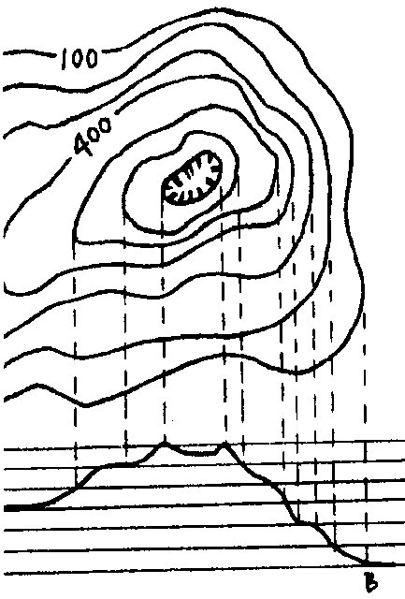
Contours

Key Concepts
1. Natural features on the earth, such as mountains and valleys, can be represented on a two-dimensional map.
2. Geologists and oceanographers use maps of the sea floor as tools to help explain tectonic processes such as plate movement.

Background

Background information for “Contours” is found in the preceding activity “Mountain Making.”

Teaching Hints

“Contours” takes the abstractions connected with sea floor topography a final step further. The progression of a profile transect to a series of profile transects in the stand-up models of “World’s Smallest Ocean” to contour maps is designed to give your students the skills and background necessary to feel and be successful in the use of bathymetric maps. “Contours” gives your students an introduction to the creation and utilization of topographic maps. The activity culminates with a “self-check” of sorts in which your students reverse the normal process and create a three-dimensional model from their two-dimensional bathymetric map. The maps your students construct will be simple but useful. Supplement their efforts with a display of bathymetric maps, topographic maps, and navigation charts (available from the National Ocean Service and the U.S. Geologic Survey, or through marine and sporting goods stores).

Duplicate the activity pages. One set is recommended per student. This activity is best accomplished by individual students as an in-class project or as homework after you introduce the topic. Caution your students to use care in the cutting of the cardboard sections in Part II. Be aware of potentially dangerous actions as you circulate through the classroom. Allow some time for the students to compare their finished products prior to your discussion of the activity. After your students become familiar with topographic mapping you may wish to have them create topographic maps of the stand-up ocean models they created in “World’s Smallest Ocean”.
Key Words

abyssal plain - flat sections of the ocean floor

bathymetric maps - maps showing the shape of the ocean floor, or depths

continental shelf - submerged margins of the continents

continental slope - steep slope separating the continental shelf from the deep ocean basin

contour line - line on a topographic map indicating a specific elevation along its entire length

contour interval - the difference in elevation between two succeeding contour lines

fathom - unit of length equal to six feet and used principally to specify ocean depths

sounding - measurement of depth of water beneath a ship

three dimensional (3-D) - having length, width, and depth

two dimensional (2-D)- having length and width

Answer Key

Part I

1. A correctly labeled bathymetric map is found below.

2. Steep slopes are represented by lines which are close together.

3. The most likely cause of the submarine canyon shown on the map is the scouring action of turbidity currents spawned by the outflow of the Columbia River.

4. Bathymetric contouring is important to the captain of the fishing vessel Reckoning in order to keep from running aground, and to keep gear from fouling on the bottom.

5. a. While the answer depends upon the class results, it is highly improbable that all of the maps are exactly the same.

b. The differences may be due to differences of interpretation (does the line go midway between the depths, closer to one than the other, etc.) or to errors (missed depths, connecting incorrect depths, etc.). A discussion of the difference between these two types of errors might be worthwhile.

6. Additional depth readings would help to increase the accuracy of this map. They would also increase the difficulty of the mapping.
Part II

1. a. Again, while the answer depends upon the class results, it is highly improbable that all of the maps are exactly the same. (If they are, you may wish to look into the well-developed information sharing system existing in your class!)

b. The same sources of differences seen in Part I apply here: differences due to interpretation and differences due to error.

2. The features labeled may be referenced from the correctly labeled bathymetric map found below.

3. The continental shelf becomes the continental slope at about 200 meters. It might be worthwhile, at this point, to mention that the names we apply to different regions (e.g. shelf, slope and abyss) are somewhat arbitrary since one blends into the next. The divisions are useful, nonetheless, in helping us understand bottom topography.

4. The continental slope becomes the abyssal plain at about 400 meters.

5. The question asks for student preference. As such, there is no right or wrong answer. Most students, however, will find visualization easier with the three dimensional representation.

6. Answers will vary, but most will find the 2-D contour map easier to construct than the 3-D map.

7. The 2-D bathymetric map is definitely easier to store than the 3-D cardboard model.

8. Oceanographers generally use charts because of:

a. the ease with which they may be stored

b. the ease with which they may be used

c. the relative ease with which they may be constructed.

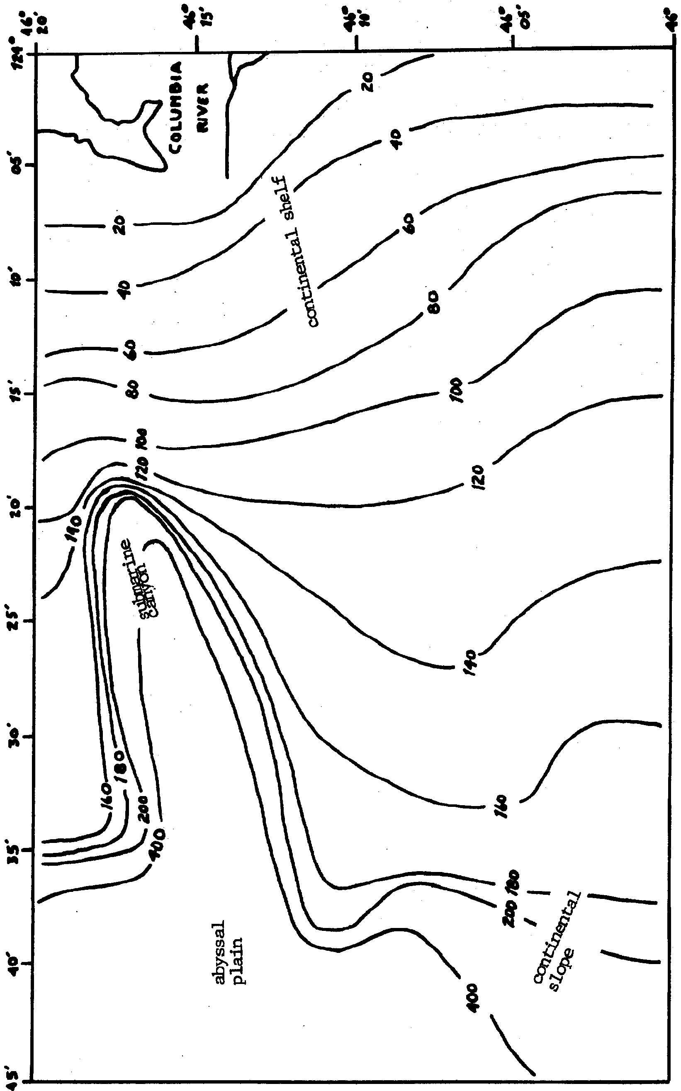

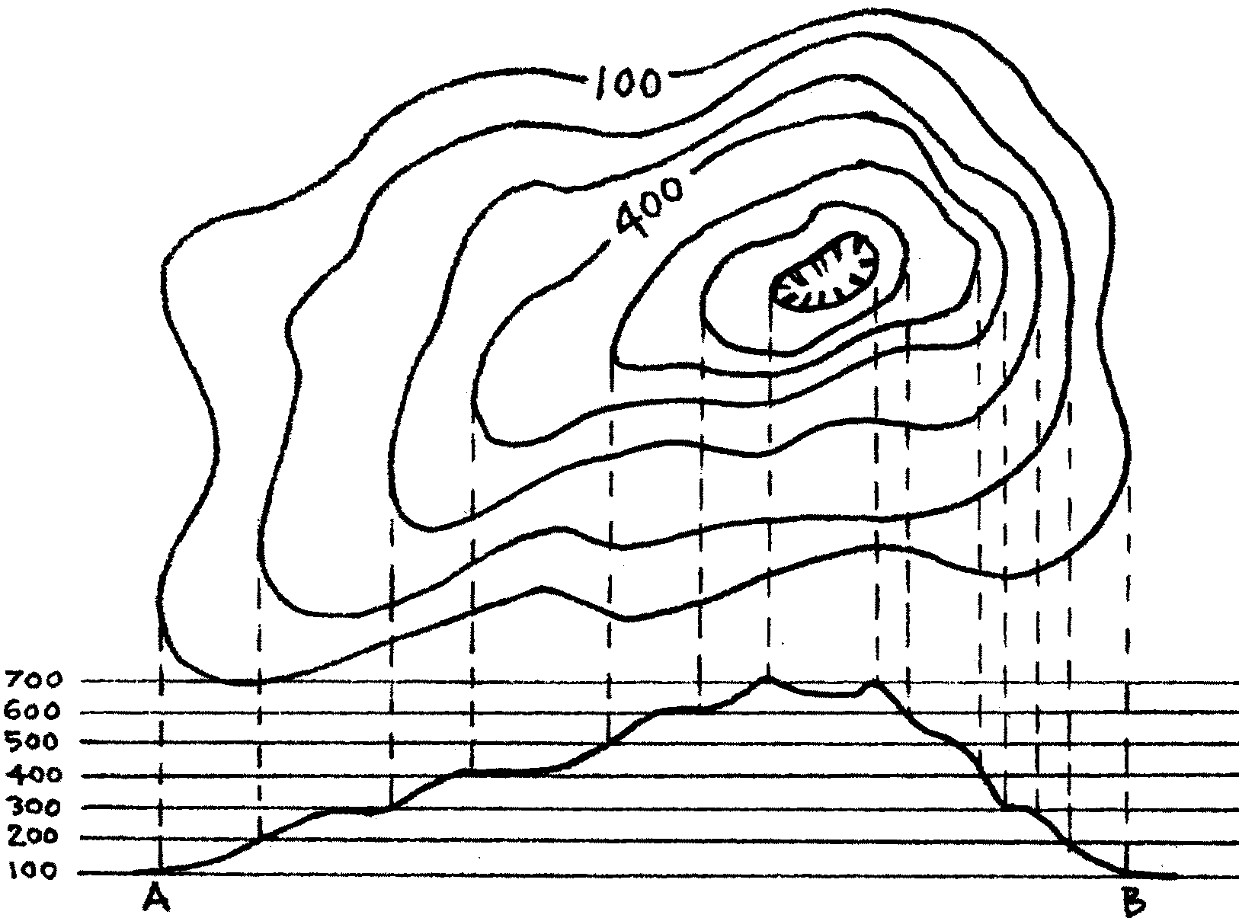
Contours

With echo sounders, oceanograghers have gathered large amounts of data about the ocean floor. How can they arrange this data in a form that is useful? We have seen one technique—the side view bottom profile—a series of profiles made into a stand-up model gives us a good picture of the bottom. However, the models take a long time to make. They also take up a lot of storage space. To overcome these problems, oceanographers make special contour maps. Contour maps show a three dimensional (length, width, height) surface on a two dimensional (length and width only) sheet of paper. These special contour maps are called bathymetric maps. The following exercise you will have a chance to make a bathymetric map. Look at the contour map above.

The map shows how a round hill is shown on a contour map. The bottom figure shows a profile of the same hill along a line from A to B. There are several rules that must be followed in making contour or bathymetric maps.

a. Contour lines are lines of equal height or depth. All points on a given contour line are the same height or depth.

b. Two contour lines may never cross each other.

c. A contour line never ends. Contour lines usually surround a given parcel of land and therefore form a continuous line.

d. If a line does not surround a parcel of land, it must disappear off the edge of the map.

Contour lines should not make sharp angles. They generally show smooth, regular changes. If one point shows a depth of 1 m and the next point shows a depth of 3 m, the contour line for the depth 2 m must occur between the two points.

Successive contour lines that are far apart on the map indicate a gentle slope. Lines that are close together indicate a steep slope. Lines that run together indicate a cliff. The figure below shows how contour lines express depth and form.
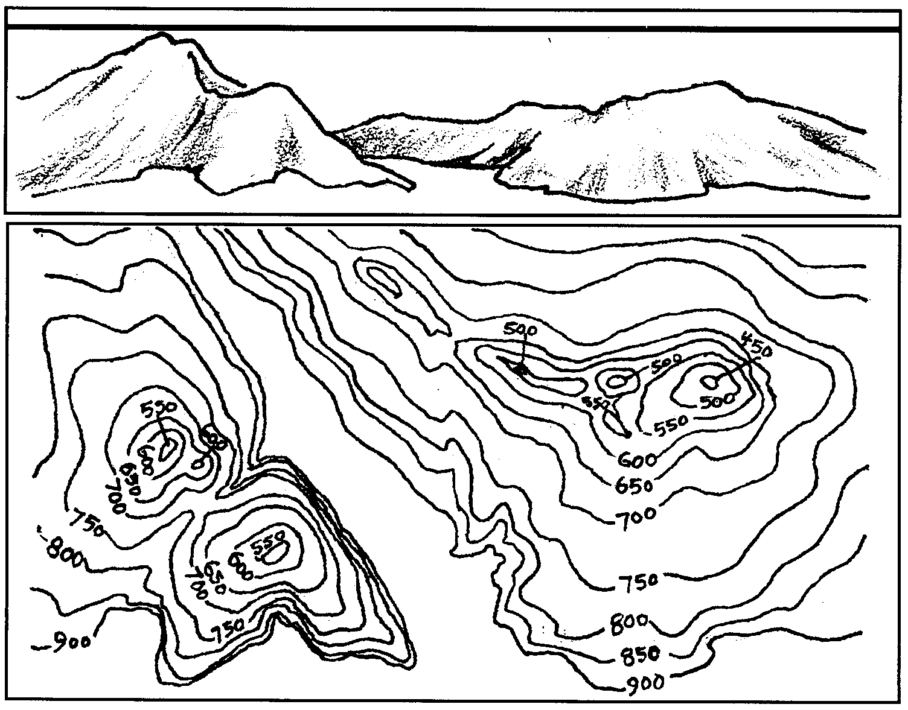
Sea Level

The sketch represents a submarine valley that lies between two hills. In the foreground is a submarine plain. The hill on the right is well rounded and has a ridge extending northwest. The hill on the left slopes steeply and has two peaks. On the map, each of these features is represented directly beneath its position in the sketch by contour lines. The contour lines are labeled as shown. Somewhere on the chart it should be stated whether the units used are feet, fathoms, or meters. A fathom is six feet.

In the following activity you will make a bathymetric map. You will then use the map to make a three dimensional model of a portion of the ocean bottom. The data was obtained near the mouth of the Columbia River.

Materials:
• sounding data
• pencil
• carbon paper
• cardboard or tag board
• scissors or utility knife
• glue

Part I
Procedure:

1. Obtain a sounding data sheet. All soundings on this data sheet are in meters.

2. Connect equal depth points with contour lines. Begin at a depth of 20 meters. Use a depth interval of 20 meters between contour lines.

3. Add the 400 meter contour line as a dashed line. The dashes show that the interval between the 200m line and the 400m line is different than the other intervals shown.

Analysis and Interpretation - Part I

1. Label the following features on your bathymetric map:
a) a submarine canyon
b) the continental shelf
c) the continental slope
d) the abyssal plain

2. How are steep slopes represented on your map?

3. What is the most likely cause of the submarine canyon shown on your map?

4. As captain of the fishing vessel Reckoning, you are bound for the mouth of the Columbia river to fish for bottom fish. What are two ways in which bathymetric contouring is important for your safety and success?

a.

b.

5. a. Compare your map with those of others in your class. Are all of the maps exactly the same?

b. How can you account for any differences you observe?

6. What additional data would help you increase the accuracy of this map?

Part II

By now you have an idea of what the floor of the ocean looks like near the mouth of the Columbia River. In this portion of the activity you will make a three dimensional model to see if your ideas are correct.

Procedure:

l. Obtain 4 or 5 pieces of cardboard or tag board and one piece of carbon paper.

2. Place the carbon paper face down on the cardboard.

3. Place the map you have drawn over the cardboard and trace the 400m contour.

4. Use your scissors to cut along the contour line. Keep the “shore-side piece” cardboard which represents the surface of the earth at a depth of 400m. Label the piece you save “400m” and set aside.

5. Repeat steps 3 and 4 for each of the other contour lines on your map. Be sure to keep the “shore-side” pieces and discard the “ocean-side” pieces.

6. Make a cardboard cutout of the land boundary.

7. Extend your contour lines about 1 cm past the top and bottom margins of your map. (By making your contour lines longer, you will be able to tell where to place your cardboard cut-outs).

8. Obtain a glue container.

9. Place the cut-out labeled “400m” over the 400m contour line. If all has gone well, the cut-out will follow the same line and hide all the rest of your map with the exception of the l cm extensions. It will look something like this:
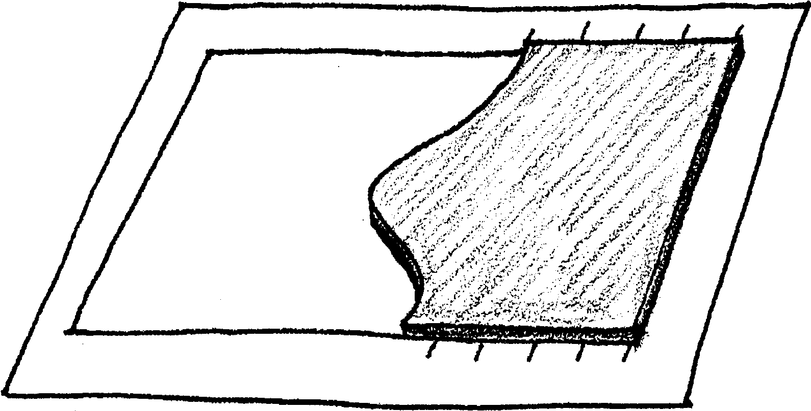

10. If your arrangement looks like the picture, glue the cardboard in place. Using your extended lines, place the 200m cut-out in its proper position. Glue it in place.

11. Follow the procedure in steps 9 and 10 until you have glued all of the cut-outs in their proper positions.

12. Use your model to answer the following questions.

Analysis and Interpretation: Part II

1. a. Compare your map with those of others in your class. Are all of the maps exactly the same?

b. What are two possible sources of the differences you see?

1)

2)

2. Label the following features on your three dimensional model:
a. submarine canyon
b. the continental shelf
c. the continental slope
d. the abyssal plain

3. At about what depth does the continental shelf become the continental slope?

4. At about what depth does the continental slope become the abyssal plain?

5. On which of the two representations of the bottom is it easier for you to see the bottom shape?

6. Which representation is easier to construct?

7. Which representation is easier to store?

8. What are two reasons that oceanographers generally use bathymetric maps instead of three dimensional models to show bottom contours?

a.

b.

