World's Smallest Ocean

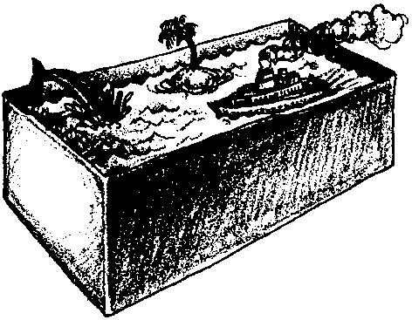
Key Concepts
1. The floor of the ocean is made up of hills, plains, ridges, trenches, and seamounts.
2. Oceanographers have developed methods for mapping the ocean floor, producing a picture of what cannot be seen.

Background

Oceanographers have discovered the shape of the ocean floor by measuring the depth of the ocean in many places. Early tools included lead weights, lowered on marked ropes or cables to the ocean floor. From such depth readings, scientists gradually built a picture of the ocean floor they could not see. These methods were very slow and eventually were replaced by sonar systems which bounced sound waves off the bottom.

Today, sophisticated side-scan sonar and satellite data are fed into computers that are giving us the most detailed pictures of the ocean floor ever obtained. All of the methods allow us to “see” the bottom of the ocean.

Every good model of the ocean floor shows all features as both taller and steeper than they actually are. This occurs for a very practical reason. If the model or sketch were prepared to exact scale, it would need to be very large. Vertical exaggeration is the price we pay to get the model down to a workable size.

Materials

Activity 1 - Constructing the World’s Smallest Ocean

For the class:
• ocean model, which has been cut to show cross section

• bathymetric map

For each pair of students:

• “Ocean Floor Features” sheet

• “Constructing the World’s Smallest Ocean” sheets

• shoebox with lid

• sheet of graph paper (one cm)

• old newspapers

(materials Activity 1 - cont.)

• cardboard, other assorted materials for ocean features

• flour paste or equivalent (flour paste can be made by mixing 500 ml flour with 500 ml salt; then add 250 ml water)

• compass point

• masking tape

Activity 2 - Probing the Model

• prepared ocean box (not student’s own)

• bamboo skewer (the variety used for barbecue works fine)

• permanent marker

• metric ruler

• pieces of one cm graph paper (master included)

• copies of Data Table #1

• transparent tape

• scissors

• a piece of stiff paper

Teaching Hints

While the previous activities have provided opportunities for constructing and studying bottom profiles, experience indicates that many students will still have considerable difficulty in visualizing the bottom from the plotted data. “World’s Smallest Ocean” provides an opportunity for a 3-D experience with ocean features.

Activity 1 - Constructing the World’s Smallest Ocean

In “Constructing the World’s Smallest Ocean”, students fabricate a sea floor model, demonstrating how oceanographers have mapped the ocean floor. Although this activity can be a bit messy, the rewards are worth the spilled flour and paper clippings on the floor. The activity is best accomplished by pairs, but the use of larger groups is possible. It is also possible for individual students to complete the activity.

Another option for model construction is to use cardboard, cups, spools, small boxes to form the ocean floor features. These items can be brought from home by the students and taped or glued into the box. Ask the class to think about what they could bring to build their ocean models.

It is helpful to have a bathymetric map available for the first activity. While bathymetric maps may be obtained at many marine stores, they are also available from a catalogue by writing:

National Ocean Service
1315 East West Highway
Silver Spring, Maryland 20910

(Map #5, “Topographic/Bathymetric, Bathymetric and Fishing Map”, is a good choice)

Make an ocean model similar to that which students will construct. See student worksheet, “Constructing the World’s Smallest Ocean”, for directions. When the model is dry, cut it to give a cross sectional view.

Activity 1 Procedure:

1. Distribute a copy of “Ocean Floor Features”, identifying some of the common ocean features and their attributes.

2. Introduce the idea of mapping the ocean floor by displaying a bathymetric map. Point out prominent ocean features. Have students make quick sketches showing how the features labeled on the “ocean features sheet” might look in cross section.

3. Show students your ocean model and cross section as an example of what they will be making. Be sure to identify the feature shown in cross section. Emphasize that the lid of the box represents the surface of the ocean. Remind students that many ocean features may be simulated by materials which might be classified as garbage in a less enlightened venue. Inverted egg cartons make fine guyots or, in series, a midocean ridge and rift valley. Two center rolls from paper towels, cut to fit the box, will also make a ridge and valley. Corrugated cardboard can be cut to fashion continental shelf, slope, or rise. Trenches are also easily formed from cardboard.

Again, this activity is best done in pairs.

4. Distribute student worksheet, caution students to keep their models simple, and let the world’s smallest oceans be created.

Activity 2 - Probing the Model

In “Probing the Model”, students gather data about the world’s smallest ocean bottom by measuring the depths in their ocean and recording that information for future interpretation. These second day activities provide the major learning experiences. The mechanics of the second day activities are simpler than the directions might seem to indicate. A brief introductory demonstration helps you minimize problems: display a stand-up ocean model like students will make in this activity. Circulate through the lab as your class performs this activity. Allow time for a discussion of the procedure and to provide answers to the questions posed in the activity. Arrange to display your students’ stand-up models. Be sure the models are labeled with student names and with the names of the ocean features shown.

Activity 2 Procedure:

1. Use the master provided to duplicate a supply of one cm graph paper. Fastened to the shoebox top, the graph paper provides the grid for holes which serve as data points. Choose a technique for punching holes which will not injure students or table tops. With careful use, a common compass produces holes of the proper diameter with ease.

2. Demonstrate how to make a “sounding” probe by marking a bamboo skewer at 1 cm intervals with a permanent marker. For ease of reading, every fifth mark may be a different color. Next, demonstrate how to measure the depth at a sample “station”. The depth of each “station” or data point is read to the nearest 0.5 cm. (NOTE: If the box top has become concave from the punching of holes, lay a ruler across the box to realign “sea level”).

You may wish to suggest that, since it is usually easier, students probe across the box rather than lengthwise. In any case, something systematic is recommended.

3. Have students trade boxes for completion of Activity 2.

4. Distribute “Probing the Model” worksheet for recording data. Partners can trade jobs, one probing and one recording the data. It is strongly recommended that two data sheets be maintained. (The student who has the only copy could be (will be?) absent the next day).

Answer Key

Analysis and Interpretation

Activity 2 “Probing the Model”

1. Answers will vary depending on individual results, but most students will see a definite similarity.

2. a. Most groups will have missed at least one feature.

b. Features which are small are most easily missed.

c. Oceanographers have exactly the same problem in dealing with the ocean floor. Very often accuracy must be sacrificed for speed. Recent technological advances are giving incredibly accurate results at high rates of speed.

3. a. A long stick calibrated in some convenient units could be used to measure the depth by simply poking the stick straight down until it reaches the bottom. The depth is read at the intersection of the water surface and the stick. Earliest soundings employed this technique. The technique was quickly modified by substituting a weighted line for the stick.

b. The major disadvantage of using a probe involves the length of the probe. A 5000 m long probe could be a bit unwieldy.

4. Accuracy might be improved by taking readings at shorter intervals. Some students will also suggest that more markings on the probe might give more accurate results. Actually this often leads to more mistakes, not less.

5. By using a hollow tip to penetrate the seafloor, a sample could be brought to the surface. A sticky substance could be used to pick up a sample. Students may suggest a variety of other techniques.

6. a. Oceanographers were delighted with the continuous and rapid collection of data by sonar.

b. The lead line was extremely slow and tedious. Only a few readings could be taken on a voyage. Few data points led to some serious misconceptions about the shape of the ocean floor. Sonar greatly increased the accuracy of ocean floor maps. Today, side-scan sonar and satellites utilizing laser beams are giving even more accurate pictures of the ocean floor.

Key Words

abyssal hills - low, rounded submarine hill less than 1000 m high

abyssal plains - flat sections of the deep ocean floor

atoll - seamount ringed with coral

bay - partly enclosed body of water open to the sea or a lake

continental shelf - submerged margin of the continents

continental slope - steep slope separating the continental shelf from the deep ocean basin

contour - line on a chart connecting the points of equal elevation

guyot - flat-topped volcanoes which have subsided beneath the water’s surface

island - relatively small land area surrounded by water

island arc - chain of volcanic islands formed when plates converge at a subduction zone

rift valley - trough formed by faulting where plates move apart, as in the mid-ocean ridge

seamount - underwater volcanoes which have not reached the water’s surface

sounding - measurement of depth of water beneath a ship

subduction zone - area where one crustal plate slips beneath another

submarine canyon - V-shaped underwater canyon in the continental slope

trench - long, narrow, deep depressions in the seafloor associated with subduction zones

The World's Smallest Ocean
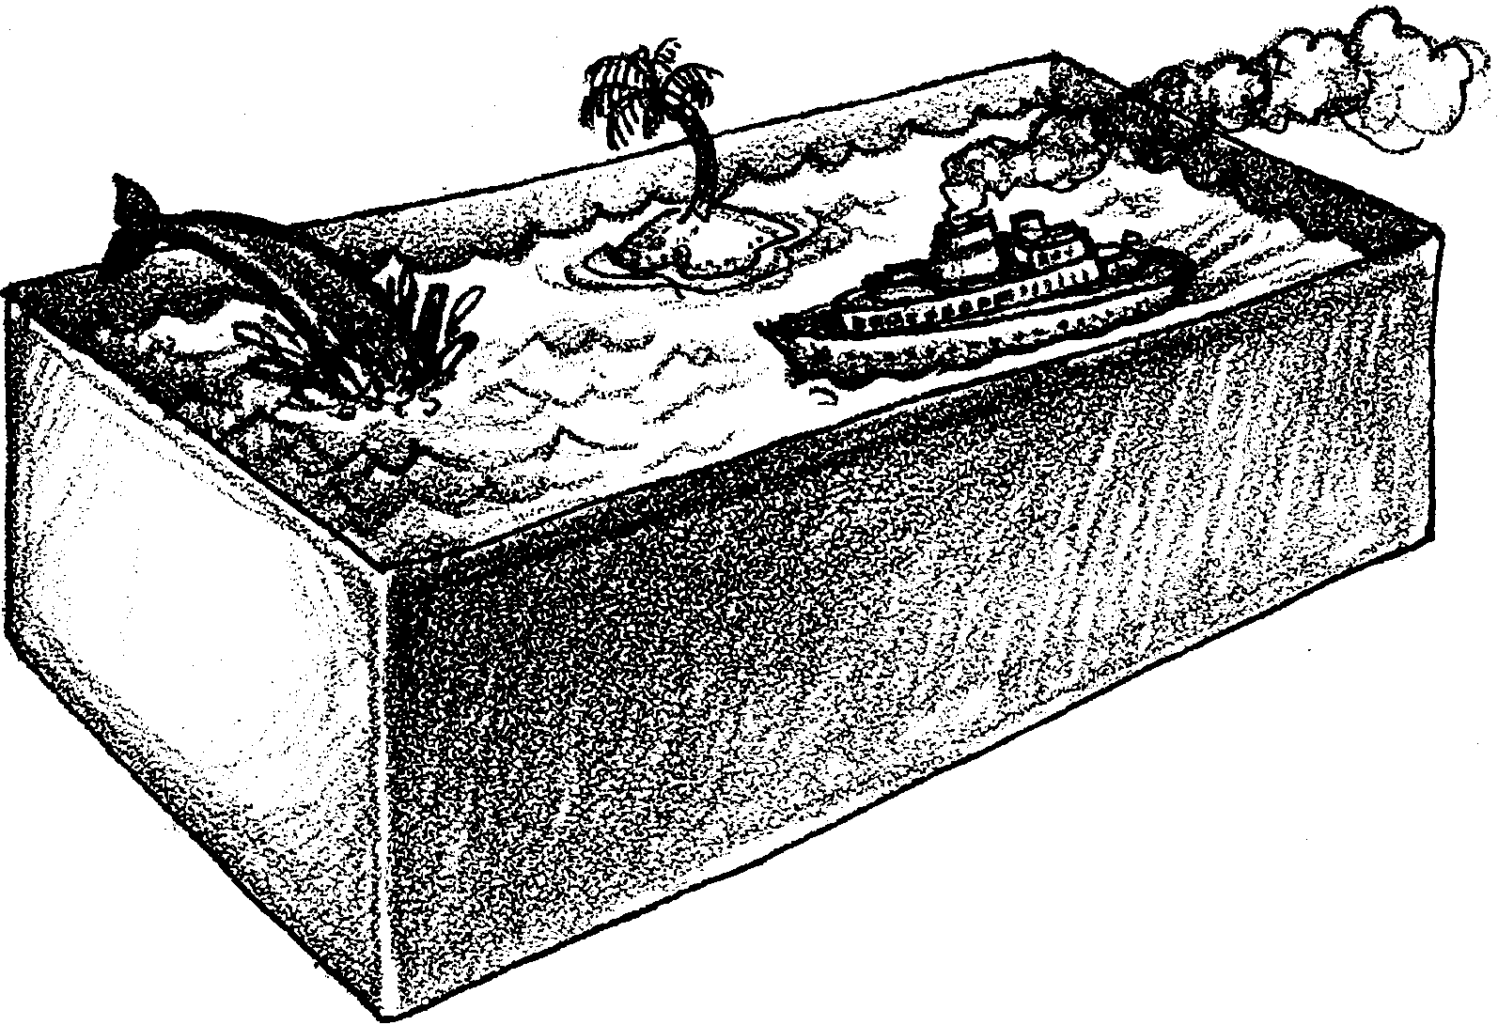

Activity 1: Constructing the World’s Smallest Ocean

Oceanographers have discovered the shape of the ocean floor by measuring the depths of the water. Because of the great depths, these oceanographers cannot see the bottom where they are working. They have to sense the bottom by “feel”. In the following activity you will make and exchange a shoebox ocean. Using a probe, you will then “sound” the depths of your unknown ocean, analyze the data collected, and make a bottom profile.

Here’s what you will need:
• shoebox with lid
• sheet of graph paper (one cm grid)
• old newspapers
• cardboard, other assorted materials for ocean features
• baker’s dough or equivalent (baker’s dough can be made by mixing 500 ml flour with 500 ml salt; then add 250 ml water)
• compass point
• masking tape
Procedures for building your model:

1. Sketch a drawing of how your model will look when it is finished. Try to include from 7-10 features in your model. Be sure that the placement of the features are realistic. For example, seamounts do not belong on continental shelves, and island arcs must have a trench on the ocean side of them.

2. When the plan has been approved by your teacher, begin to build your model. You may use papier mâché, plaster of paris, wood, cardboard, or any other materials you can find. Use your imagination, but remember two very important rules:

A. Your model must have a dry, hard surface when it is finished.

B. Any feature built into the model must be at least 2 cm across and 1 cm high.

Try to keep things in correct proportion. This will not always be possible, but you should avoid making seamounts which are bigger than the mid-ocean ridge.

3. When your model is completed, set it aside to dry in a warm place. A sunny window sill would be ideal. Be sure you put your name on the inside of the box and on the box top.

4. After the model is dry, prepare your boxtop by taping a sheet of 1 cm graph paper to the inside of the boxtop. Use a compass, or other sharp pointed object, to put a small hole through the boxtop at each intersection on the graph paper. BE CAREFUL!! Punch into thick cardboard or a wooden board.

5. When all the holes have been punched, remove the graph paper from the inside of the boxtop. Place the top on the box and tape it shut. Tape the graph paper to the top by realigning the punched paper with the holes in the boxtop.

Activity 2: Probing the Model

Materials:
• prepared ocean box (not your own)
• bamboo skewer
• permanent marker
• metric ruler
• piece of 1 cm graph paper
• copies of “World’s Smallest Ocean” Data Table
• transparent tape
• scissors
• a piece of stiff paper

Procedure:

1. Trade ocean boxes with another group.

2. Do not open your mini ocean! Remember, oceanographers cannot see the bottom of the ocean. To get the feel of how an oceanographer works, it is better if you do not see the bottom. When you are done with this activity, you will have a chance to see the inside of the box and to compare your results with the model in the box. Record the owner’s name and the number of the box you received on the data sheet. Be sure to use the same box each day.

3. Mark each grid line across the long edge of the box with a letter beginning with “A”. Mark each grid line along the short edge of the box with a number, starting with “1”. (See drawing below). The marked grid will be used to locate sample sites on the box. Your box should look something like this:
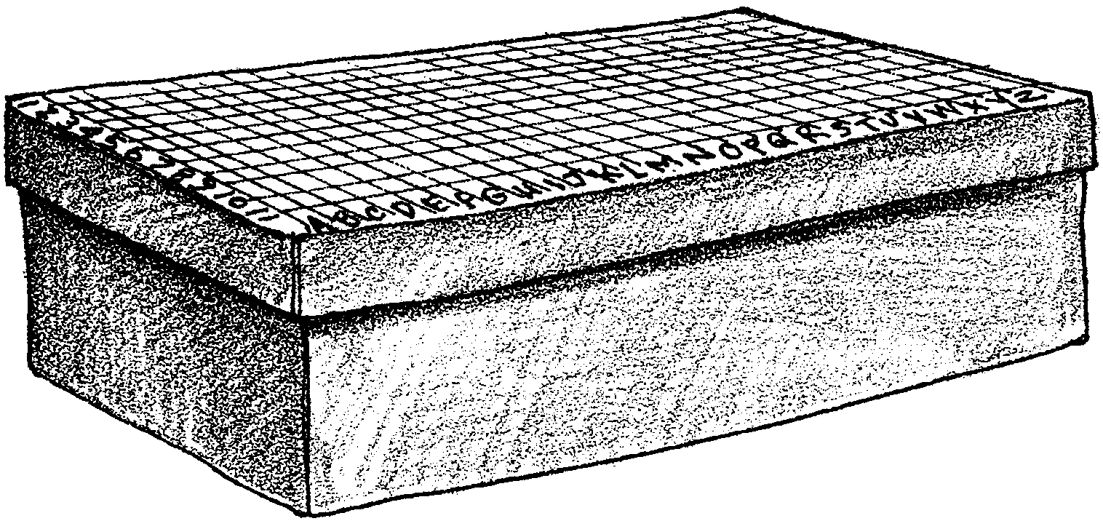

4. Each hole in the boxtop is now identified by a letter and a number. (i.e. A-1, C-2 etc.) Oceanographers call these data points “stations”. In the real ocean, stations are identified by latitude and longitude.

5. Use the ruler and a marker to mark the probe (bamboo skewer) at one cm intervals. You will find it useful to make the 5 cm and 10 cm marks a different color for quick counting.

6. Insert the probe straight down into hole A-1 until it just touches the bottom. Read the depth to the nearest 0.5 cm (estimate) and record the depth in the appropriate space on your data table.

NOTE: Make two (2) - that is TWO - copies of your depth readings. One is for you and one is for your partner. Be sure you each keep a copy. In this way, if one of you is absent, the other will not have to start over again from scratch.

7. Continue probing to determine the depth of the model at each station. Carefully record your data. You will probably find it easiest to probe across the letter rows (e.g. A-1, A-2, A-3, and so on).

8. On a piece of 1 cm graph paper, draw the apparent cross section of the ocean floor for row A. Remember:

A. Zero (0) on the graph corresponds to the depth at the top of the box.

B. The bottom line of the graph corresponds to the bottom of the empty box.

Add a one cm tab on the graph paper below the empty box line. (See below). Be sure to label the cross section with your box number and a big letter “A”.
Shade the portion of the graph that represents the seafloor.

9. Carefully cut out the cross section for row A, and fold the tab over at a 90 degree angle. NOTE: Don’t throw away the seafloor and keep the water. Your cross section should look something like this:
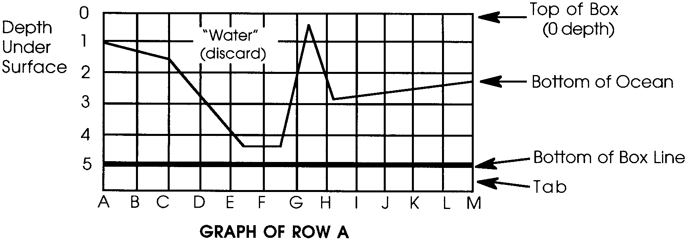

10. Use the same procedure to create cross sections for the remaining rows.

11. Arrange the cross sections in A,B,C order. Check your data sheet to see that the graphs are lined up exactly like your data.

12. Tape the tabs of each cross section to a stiff piece of paper. The tabs will allow the graphs to stand up, and they keep the graphs separated from each other by the correct distance. Your finished model should look something like this:

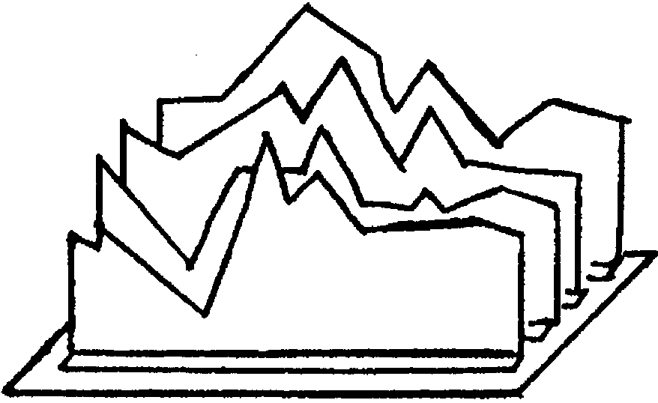

13. Label your stand up model with the names of ocean bottom features you think are shown.

14. Open the box and compare the mounted cross sections with the features in the box.

Analysis and Interpretation:

1. How do your cross sections compare with what is really present?

a. In what ways are they similar?

b. In what ways are they different?

2. a. Did you miss any features?

b. What kind of features are easiest to miss?

c. Do you think oceanographers have similar problems when investigating the ocean floor?

3. a. How could you use a probe to find the shape of the real ocean floor?

b. What would be one disadvantage of using a probe to measure the real ocean floor?

4. How could you have improved the accuracy of your results?

5. Suppose you wanted to know of what the bottom was made. How could you modify your probe to give you this information?

6. The techniques you used are essentially the same as those used by early navigators to chart the depths of the ocean. The “probe” was a lead weight on a rope or cable.

a. Based on your experience, why do you think oceanographers were very happy to see the development of sonar equipment for measuring ocean depths?

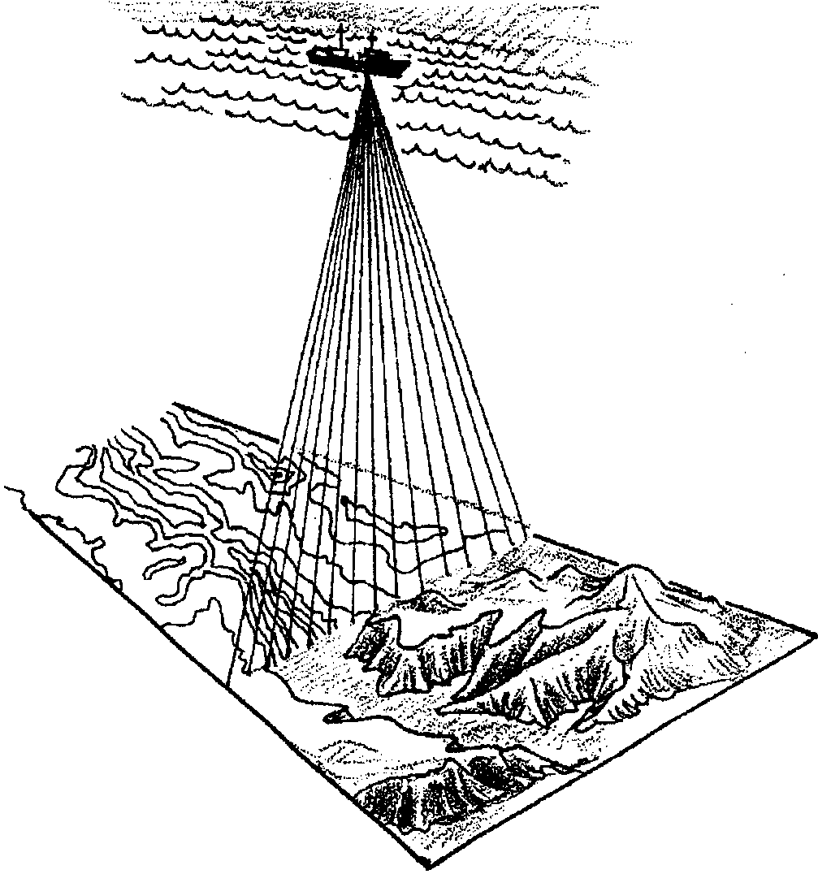

b. What do you think happened to the accuracy of ocean floor maps after sonar was introduced? Why?

Extra Credit:

Use your library or other research facility to find out how modern oceanographers are using satellites to measure ocean depths. It is a first class “science fiction” story of satellites, lasers, and computers. We have come a long way from the lead weight and rope.
Ocean Floor Features
