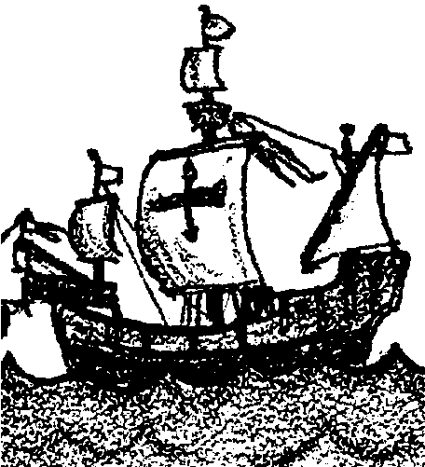
Retracing the Steps of Columbus

Key Concept
1. Information gathered from echo soundings can provide us with a picture of the ocean floor.

Background

“Deep Sounds” and “Sounds Good To Me” provided your students with an introduction to bottom topography and echo sounding. “Retracing the Steps of Columbus” provides the data necessary to construct a bottom profile of the Atlantic ocean basin from Cape Cod to Gibraltar. Although excessively exaggerated on the vertical scale, the profile reveals tectonic information and clearly shows the mid-Atlantic ridge, seamounts and other ocean features.

Materials

For each pair of students:
• data sheet

• graph paper

• pencil

• ruler or straight edge

• tape or glue

Teaching Hints

Duplicate the activity pages. One set is recommended per student. This activity is best accomplished in groups of two pairs. One pair plots the data from Cape Cod to mid-ocean while the second pair plots the data from mid-ocean to Gibraltar. It is imperative that both teams use the same horizontal and vertical scales. Demonstrate the technique and on the black board write the scales used (i.e. horizontal, one square = 100 kilometers; vertical one square = 300 meters). Have one member of each pair read off the data while the second member plots the points. In this manner, the plotter reduces the risk of mislocating points inherent in moving eyes from graph to data to graph etc. As always, provide your students with any assistance they may require during the activity. Allot time for a discussion of the activity and the questions in the “Analysis and Interpretation” section. Plan to post the finished bottom profiles on a classroom bulletin board so that the groups may have a chance to compare their results.

Key Words

bottom profile - one type of picture of the ocean floor

continental shelf - the submerged margin of the continent

echo sounding - method for locating objects by determining the time for a sound wave to travel to the object and for the echo to return

guyots - flat-topped volcanoes which have subsided beneath the water’s surface

mid-Atlantic ridge - underwater mountain range which runs the length of the Atlantic Ocean

seamounts - underwater volcanoes which have not reached the water’s surface

Extensions

1. Have students research the voyages of Columbus, then write a ship’s log outlining the highlights of the voyage.

2. Use bathymetric maps (National Geographic is a good source) to name the features seen in the completed bottom profiles.

Answer Key

1. See completed bottom profile included below. The North American side has a wider continental shelf.

2. a. See completed bottom profile.

b. The youngest rocks would be found at the mid-Atlantic ridge, about 3075-3090 kilometers from North America.

3. a. A volcanic island is found about 1010 km east of the mid Atlantic ridge.

b. A seamount is found about the same distance (1010 km) west of the mid-Atlantic ridge.

4. a. The difference in height from the lowest point (5100 m) to the highest point (500 m) is 5600 m.

b. The horizontal distance between the highest and lowest points is 660 km. Essentially the highest point descends without interruption to the lowest point.

5. a. See completed bottom profile.

b. The suspected cause of the flat top is the planing action of ocean waves which occurred when the seamount protruded above sea level.

6. The simplest way to obtain a more detailed profile of the bottom would be to obtain and/or plot more data points.
Completed Bottom Profile
Overlap these three pages, connecting them at the triangles, to get complete data sheet.

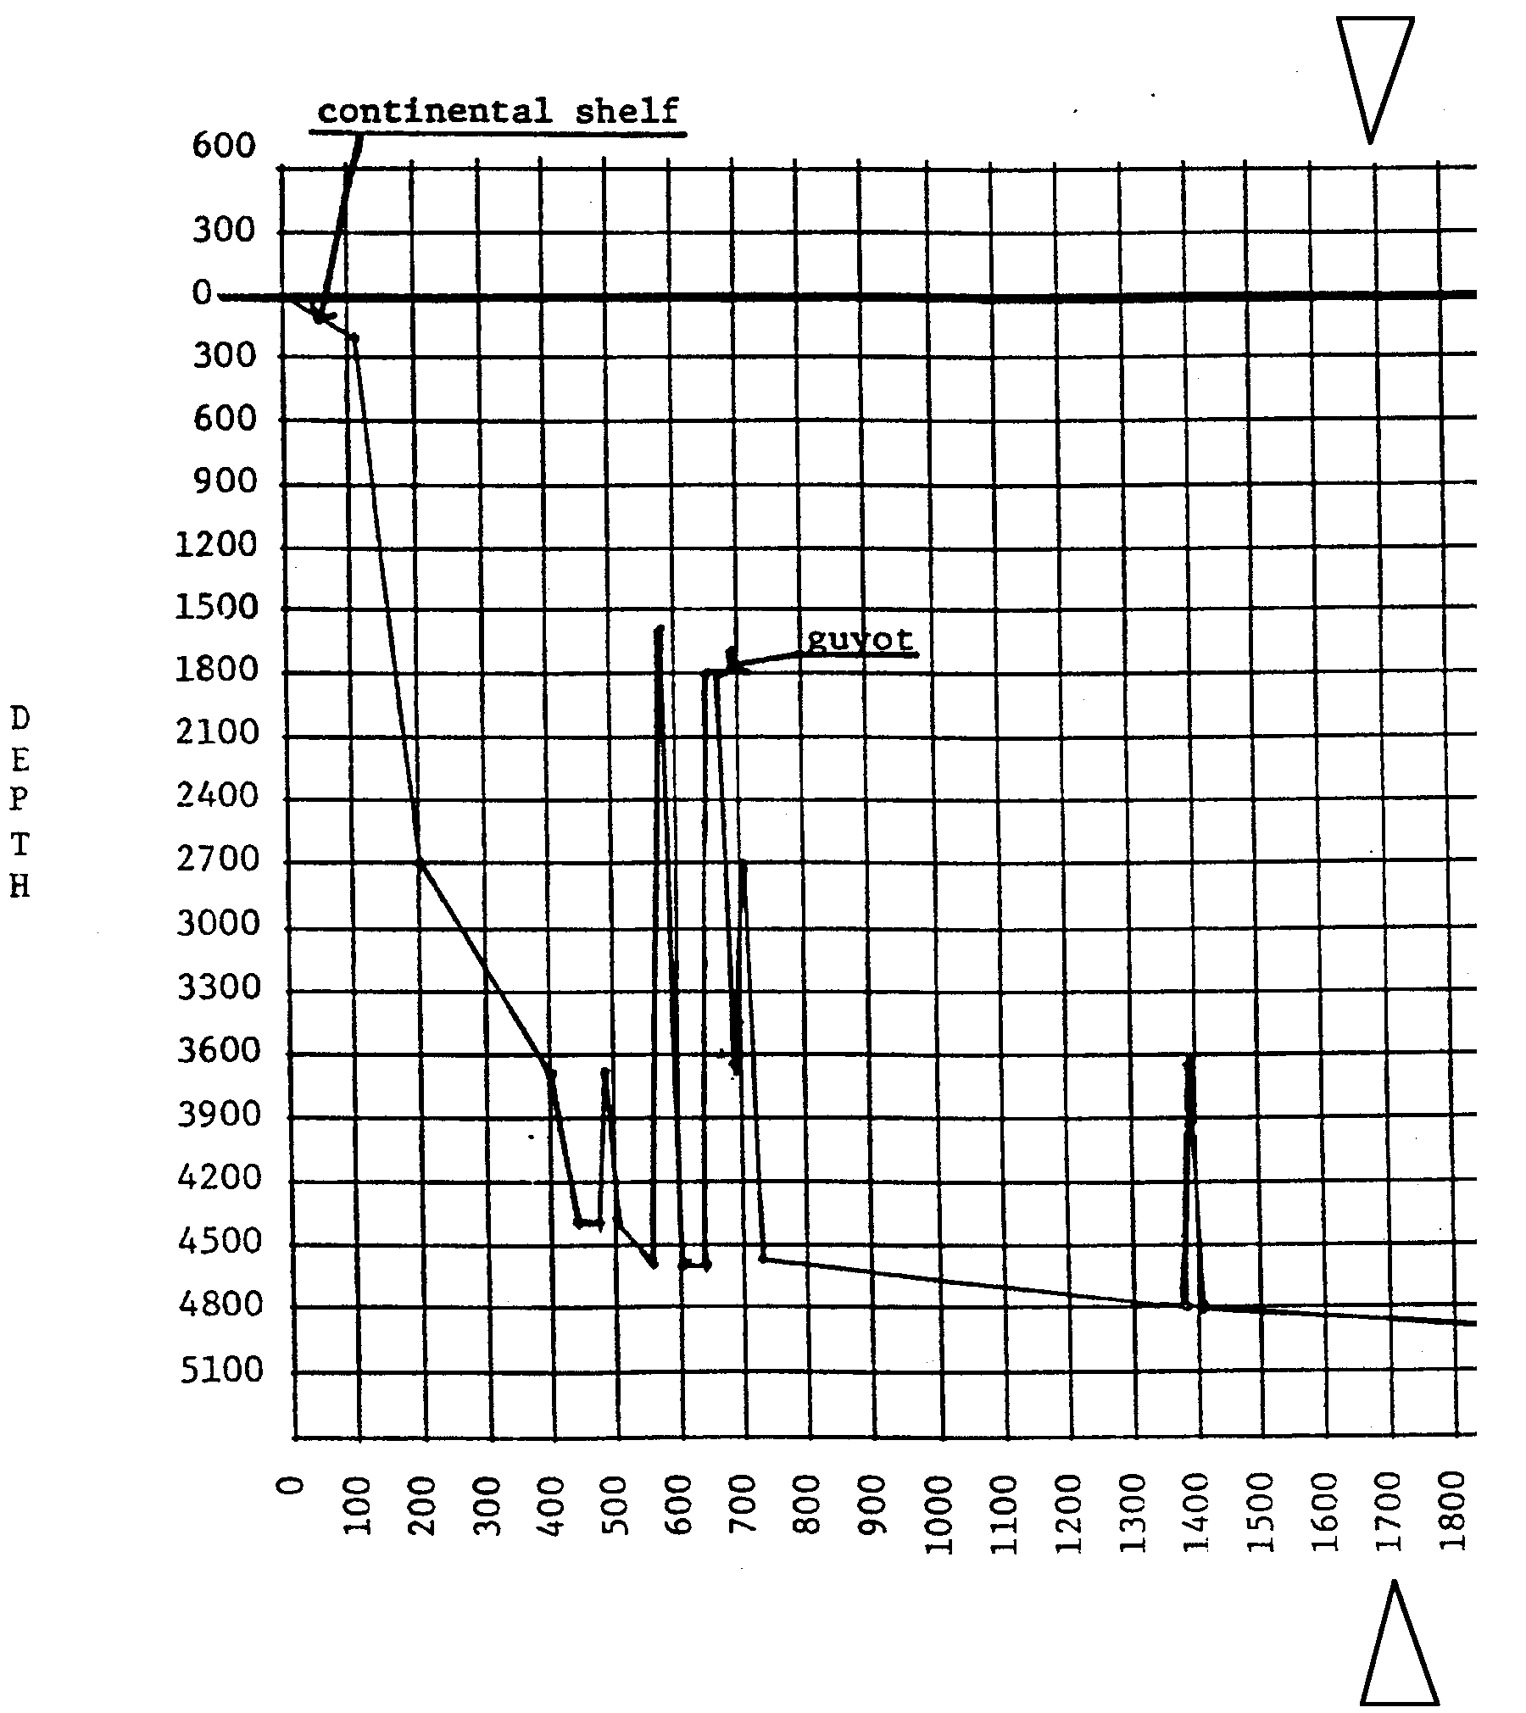

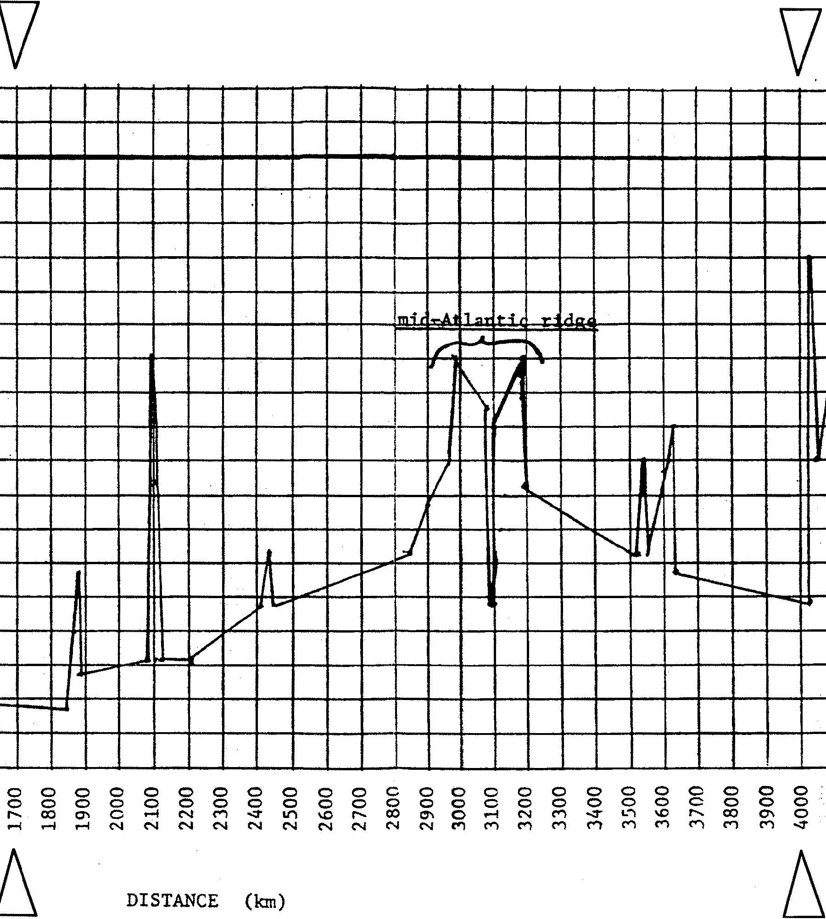

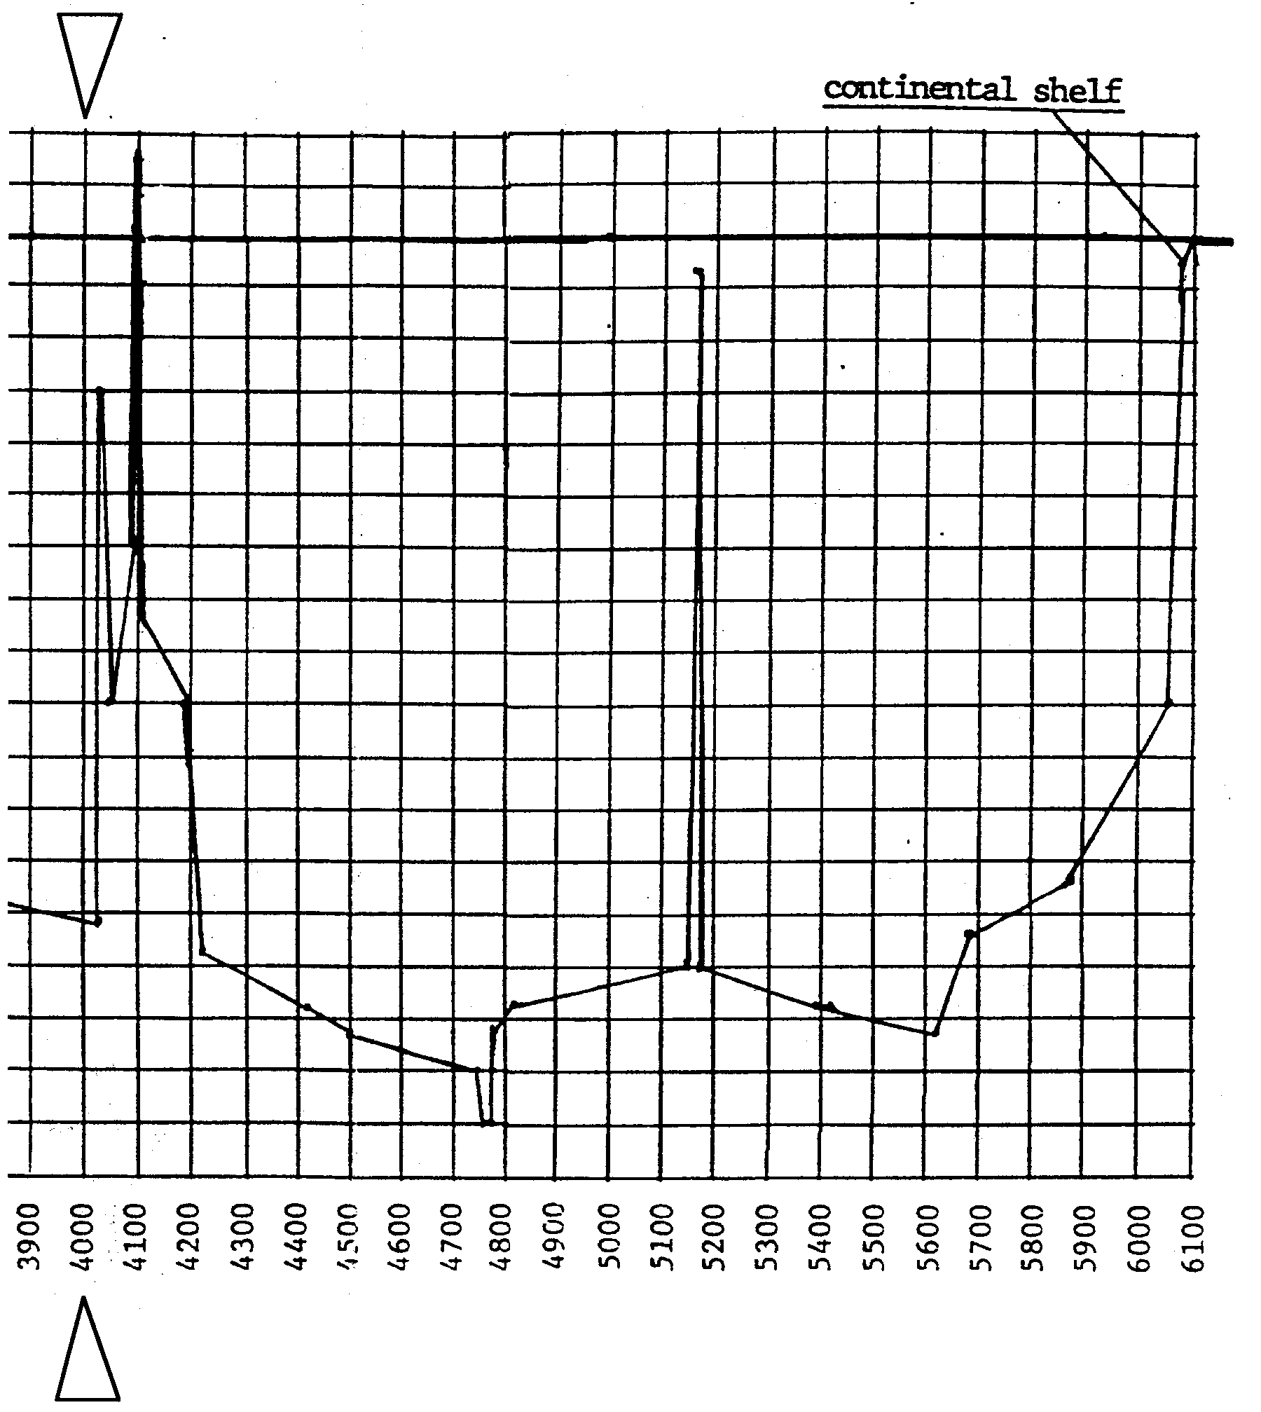

Retracing the Steps of Columbus

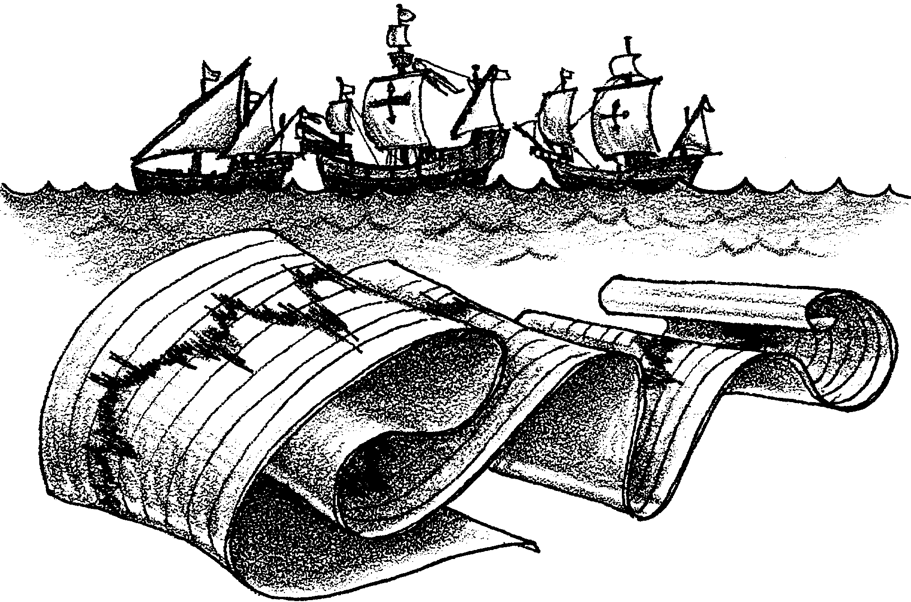

What kinds of information can we obtain from echo soundings? The locations of the continental shelves are revealed by soundings. Geologists searching for oil and minerals are interested in locating these deposits on the shelves. Other geologists studying the forces that have shaped the face of the earth also use echo soundings to provide information to test their theories.

In the following activity you will use sounding data to construct a bottom profile for the Atlantic Ocean. Using this profile you will be able to answer questions of interest to research geologists.

Materials:
• data sheet
• graph paper
• pencil
• ruler or straight edge
• tape or glue

Procedure:

1. For this activity you will be working in groups of four. Divide your group into two pairs. One pair of students from your group will chart profile A. The other pair of students will chart profile B.

2. Obtain either Profile A or Profile B data sheet. The 40 data points on your profile represent soundings from a ship as it traverses half of the Atlantic Ocean.

3. Pair A will chart Profile A while Pair B will chart Profile B. Both teams must use the same horizontal and vertical scales. For the horizontal scale, one square will equal 100 kilometers (km). One vertical square will equal 300 meters.

4. Label the horizontal axis “Distance (km)”. Pair A will label the vertical axis “Depth (m)” along the left paper margin. Pair B should label the vertical axis along the right paper margin.

5. Pair A will begin labeling the horizontal axis starting at 0 km and ending at 3300 km. Pair B begins at 2900 km and ends at 6l00 km.

6. Plot points for your profile and connect them with a solid line as you proceed. (Use your ruler or straight edge).

7. After both pairs are finished, use tape or glue to join the two halves at the section where they overlap. (Hint: The maps overlap from 2900 km to 3300 km.)

8. Use your completed bottom profile to answer the questions in the “Analysis and Interpretation” section which follows.

Analysis and Interpretation:

1. Label the continental shelves. Which side of the Atlantic has a wider continental shelf?

2. a. The mid-Atlantic ridge is thought to be the location where new ocean floor is formed. The two sides of the ridge are slowly moving away from each other. The ocean floor to the east of the ridge is a rough mirror image of the ocean floor to the west of the ridge. On your profile mark the mid-Atlantic ridge with an arrow and label it with its name.

b. At about what distance from North America would the youngest rocks be found on the ocean floor?

3. a. What geologic feature is found about 1010 km east of the mid-Atlantic ridge?

b. What geologic feature is about the same distance west of the ridge?

4. a. What is the difference in height from the lowest to the highest points shown on your profile?

b. What is the horizontal distance between the highest and lowest points?

5. a. A guyot (gee-oh) is a flat topped seamount. Label a guyot on your profile.

b. What is the suspected cause of the flat top?

6. What would be one way in which you could obtain a more detailed profile of the bottom of the Atlantic Ocean?

Profile A: Cape Cod to Mid-Atlantic

POINT DISTANCE (KM) DEPTH (M)

1 0 0

2 120 200

3 200 2700

4 400 3700

5 440 4400

6 480 4400

7 490 3700

8 500 4400

9 560 4600

10 580 1600

11 600 4600

12 640 4600

13 660 1800

14 680 1800

15 690 3700

16 700 2700

17 725 4600

18 1375 4800

19 1390 3700

20 1400 4800

Profile A: Cape Cod to Mid-Atlantic - continued

POINT DISTANCE (KM) DEPTH (M)

21 1850 4900

22 1875 3700

23 1890 4600

24 2075 4400

25 2090 1800

26 2100 4400

27 2210 4400

28 2420 4000

29 2440 3500

30 2450 4000

31 2850 3500

32 2900 3100

33 2960 2700

34 2975 1800

35 3060 2200

36 3075 4000

37 3090 4000

38 3100 2400

39 3190 1800

40 3200 2900

Profile B: Mid-Atlantic to Gibraltar

POINT DISTANCE (KM) DEPTH (M)

1 2900 3100

2 2960 2700

3 2975 1800

4 3060 2200

5 3075 4000

6 3090 4000

7 3100 2400

8 3190 1800

9 3200 2900

10 3525 3500

11 3540 2700

12 3550 3500

13 3625 2700

14 3630 2400

15 3640 3700

16 4025 4000

17 4035 900

18 4050 2700

19 4090 1800

20 4100 +500

Profile B: Mid-Atlantic to Gibraltar - continued

POINT DISTANCE (KM) DEPTH (M)

21 4110 2200

22 4190 2700

23 4225 4100

24 4425 4400

25 4500 4600

26 4750 4800

27 4760 5100

28 4770 5100

29 4780 4600

30 4825 4400

31 5150 4200

32 5160 200

33 5170 4200

34 5390 4400

35 5625 4600

36 5675 4000

37 5875 3700

38 6050 2700

39 6075 200

40 6100 0

