'Sounds Good to Me'

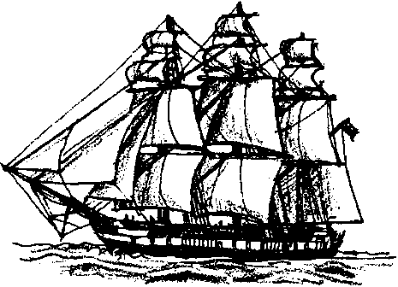
Key Concepts
1. Oceanographers use sound to “see” the ocean floor.
2. The speed of sound is used to calculate the depth of the water.

Background

Echo sounders, sonar, and similar devices have given oceanographers a window on the underwater bottom. The theory behind these devices is quite simple. If we know the speed of sound in water, we can determine the depth by measuring the time it takes for a sound wave to go from a ship to the bottom and back to the ship. While the theory is simple, the practice has become quite sophisticated. Not only can oceanographers obtain detailed pictures of the bottom profile, they can determine something about the composition of the bottom, stratification and thickness of bottom sediments, and they can detect schools of fish and even individual fish between the surface and the bottom. Although all of the calculations your students will be performing are now done within the echo sounder before the information is displayed, it is illustrative to have your students work through these calculations to help them understand the concept involved in echo sounding.

Materials

• R/V Nordic Maid sounding data

• graph paper

• pencil

• scratch paper

Teaching Hints

“Sounds Good To Me” provides your students with an opportunity to transform echo sounding data into a bottom profile. Duplicate the activity pages. One set is recommended per student. This activity may be accomplished by individual students working independently or by pairs. It may be wise to demonstrate the mechanics required to set-up the problems before your class begins to work independently. It is possible to assign the activity as homework although most classes benefit from having the instructor present as the students work through the data. Allow time for a group discussion of the results upon completion of the activity.

Key Words

abyssal plain - flat sections of the deep ocean floor

continental shelf - submerged margins of the continent

continental slope - steep slope separating the continental shelf from the deep ocean basin

echo sounding - method for locating objects by determining the time for a sound waver to travel to the object and for the echo to return

ocean feature - a geological feature of the ocean floor

sonar - a method for determining depth using sound waves

Extensions

1. Students could be encouraged to use calculators.

2. If possible, have students set up a spread sheet with the information and have the computer graph the data for comparison.

3. If possible, supplement this activity with posters, films and other visual aids which show bottom topography and the use of echo-sounding equipment.

Answer Key

1. Since the total time represents the time required for the sound wave to travel from the ship to the bottom and back from the bottom to the ship, the time must be divided by two to find the one-way travel time.

2. Depth = time down and back X 1460 m/sec. (speed of sound in water)
2

Depth = 10 seconds X 1460 m/sec.
2

Depth = 7300 meters

Procedure Questions

l. A completed data chart is included below.

Distance from Shore Travel Time Depth of Ocean

Station km sec m

1 5 0.07 51.20

2 10 0.14 102.20

3 20 0.28 204.40

4 25 0.35 255.5

5 30 0.42 306.6

6 35 1.40 1022.0

7 45 3.36 2452.8

8 60 5.88 4292.4

9 65 6.30 4599

10 70 6.76 4934.8

11 75 6.93 5058.9

12 80 7.00 5110

13 85 7.21 5263.3

14 90 7.42 5416.6

15 100 7.56 5518.8

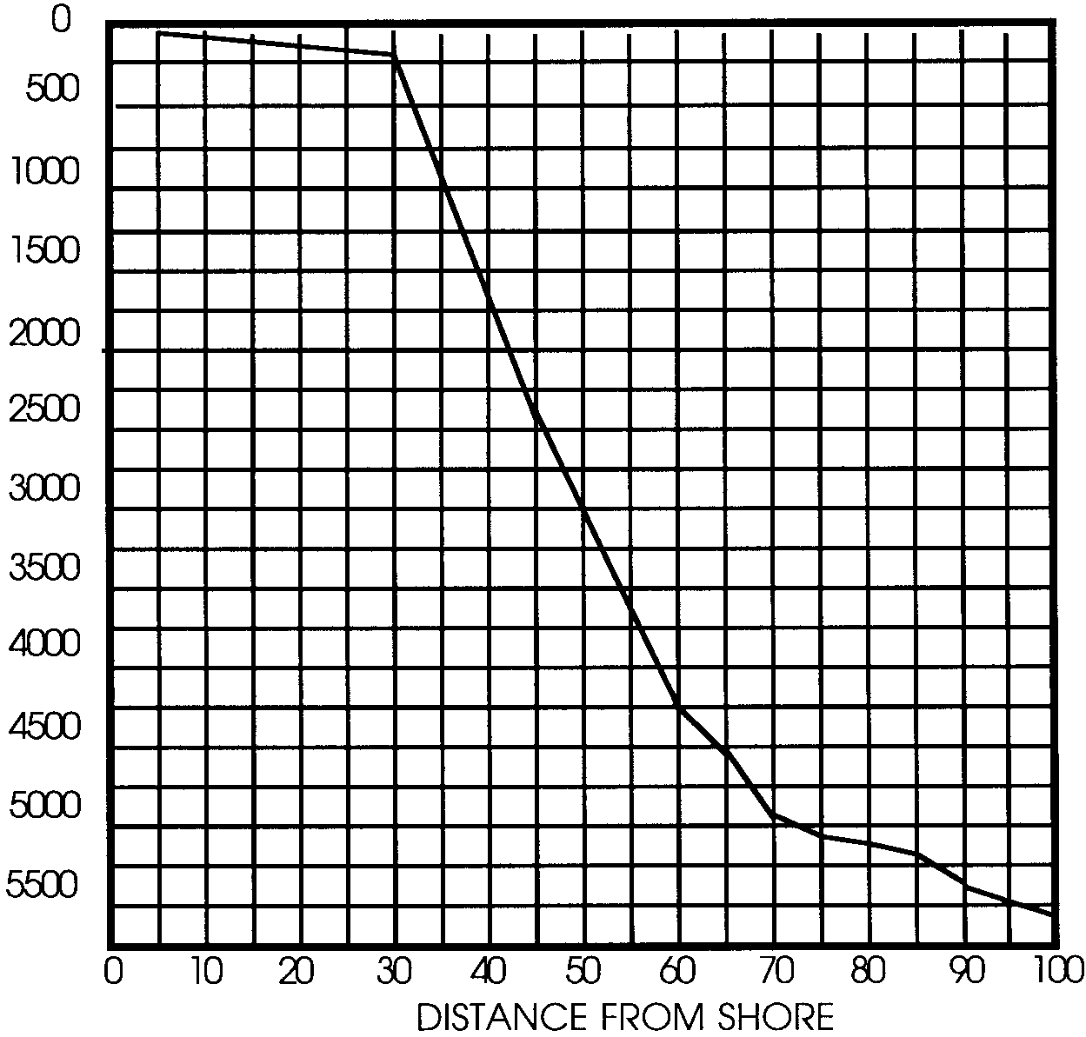
Ocean Depths
Along the Path of the R/V Nordic Maid

DEPTH (m)

Analysis and Interpretation Questions

1. The ocean feature seen at station 1 is the continental shelf.

2. The ocean feature seen at station 7 is the continental slope.

3. The ocean feature seen at station 14 is the deep-ocean basin or abyssal plain.

4. Fishers learn to recognize these false bottoms as schools of fish and set their gear accordingly. The use of electronic gear to sense the presence of schools of fish has increased tremendously the ability of the fisher to locate fish. It has also increased the likelihood of over-exploitation of certain fish stocks.

5. Two reasons fishers have echo sounding equipment on board their boats may include the following:

a. to keep from running aground.

b. to keep from fouling their nets and gear on underwater obstacles.

c. to aid in the location of fish.

d. to pinpoint, with the aid of charts, the vessel’s location.

6. a. Small scale ocean features (i.e. those less than 5 or 15 kilometers in size) are most likely to be missed using this procedure.

b. Oceanographers prefer to use equipment that gives a continuous sounding because it reduces the risk of missing small (but potentially important) sea floor features.

Virtually all of the echo sounding equipment now in use provides a continuous recording of the bottom profile. Using a continuous recording device reduces, but does not eliminate, the likelihood that small features will be missed. Resolution is dependent on several factors including sonar “footprint” (i.e., the area of the sea floor covered by the beam(s)), water depth, and seastate. Side-scanning and multibeam sonar now allow a single ship to map a swath instead of a line. Side-scan sonars portray the seafloor as maps of contrasting acoustic reflectivity, providing information about what the seafloor is composed of, e.g. sediment versus rock. Multibeam sonars provide bathymetric (i.e., depth) information. Both side-scan and multibeam sonars are “side-looking”.

'Sounds Good To Me'
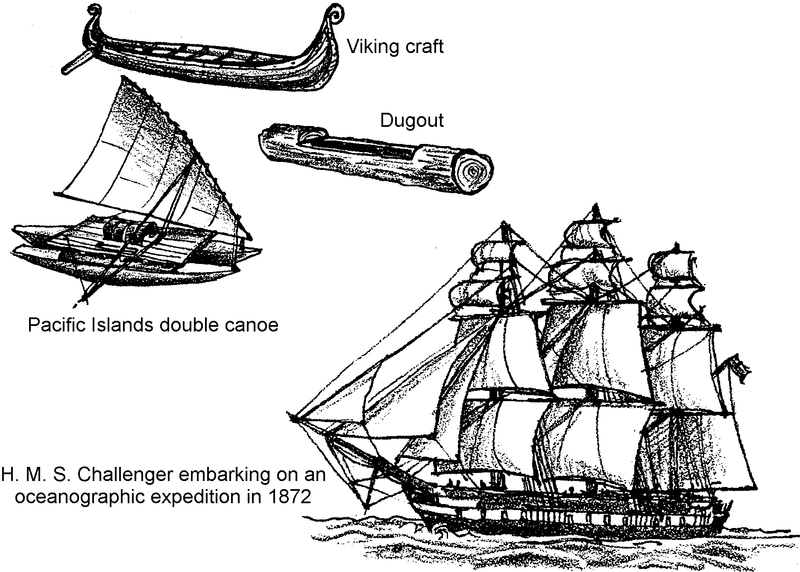
For centuries people have sailed the surface of the oceans. Sailors wondered about the shape of the bottom of the ocean. They could do little more than wonder. It has only been within the last few years that oceanographers have begun to discover the hidden secrets of the ocean floor.

Scientists use a technique called echo sounding to determine the depth of the ocean. Echo sounders bounce sound waves off of the bottom of the ocean. We know how fast sound travels in water. We can determine the depth by knowing how long it takes for sound to go from the ship to the bottom and back to the ship. By making continuous soundings as the ship moves along, oceanographers obtain many depth readings. From these readings a profile of the ocean bottom can be made.

Sound waves move through water at an average speed of 1460 meters per second (about 5000 feet per second). We can use this information to determine the depth when we know the time it takes for a sound wave to travel to the bottom and back to the ship.

Depth = time down and back x 1460 m/sec. (speed of sound in water)
2

1. Why do we divide the total time by 2 before we multiply by the speed of sound in water?

2. If the recorded time down and back is 10 seconds, what is the depth of the ocean?

In the following activity you will use data collected by the Research Vessel Nordic Maid. You will use the data to calculate depths and to plot a profile of the ocean bottom.

Materials:
• R/V Nordic Maid sounding data
• graph paper
• pencil
• scratch paper

Procedure:
The R/V Nordic Maid is cruising due north mapping the ocean bottom. The time required for a sound wave to travel from the boat to the bottom and back to the boat is given for each of 15 stations sampled.
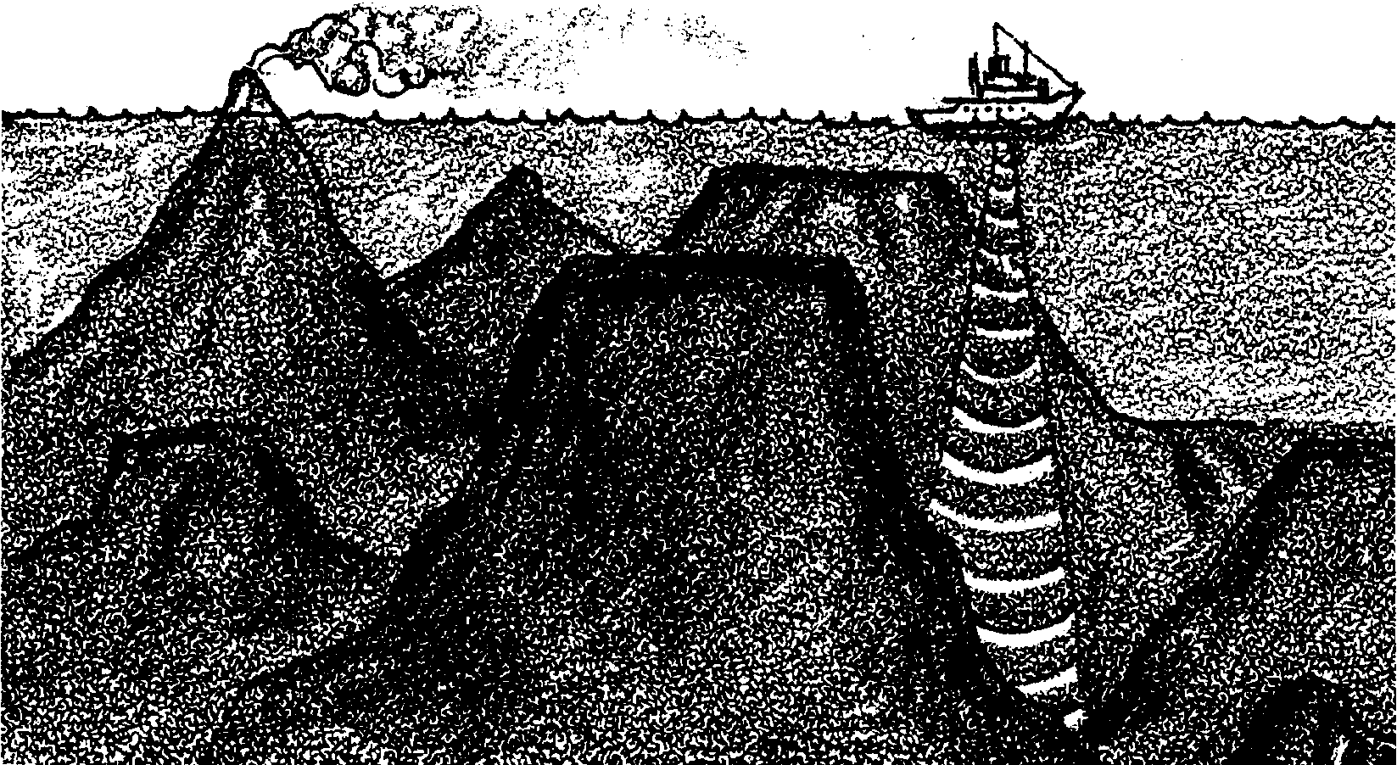

1. Use the data below to determine the depth of the ocean along the route. Make your calculations on scratch paper. Place the answers in the proper boxes.

Distance from Shore Travel Time Depth of Ocean

Station km sec m

1 5 0.07

2 10 0.14

3 20 0.28

4 25 0.35

5 30 0.42

6 35 1.40

7 45 3.36

8 60 5.88

9 65 6.30

10 70 6.76

11 75 6.93

12 80 7.00

13 85 7.21

14 90 7.42

15 100 7.56

2. Now you have some figures for depths. Plot these figures to see what a profile of the bottom would look like. The bottom of the graph (horizontal axis) should show the distance from shore. The left hand side of the graph (vertical axis) should give the ocean depth. Plot the depth at each station.

Ocean Depths Along the Path of the R/V Nordic Maid
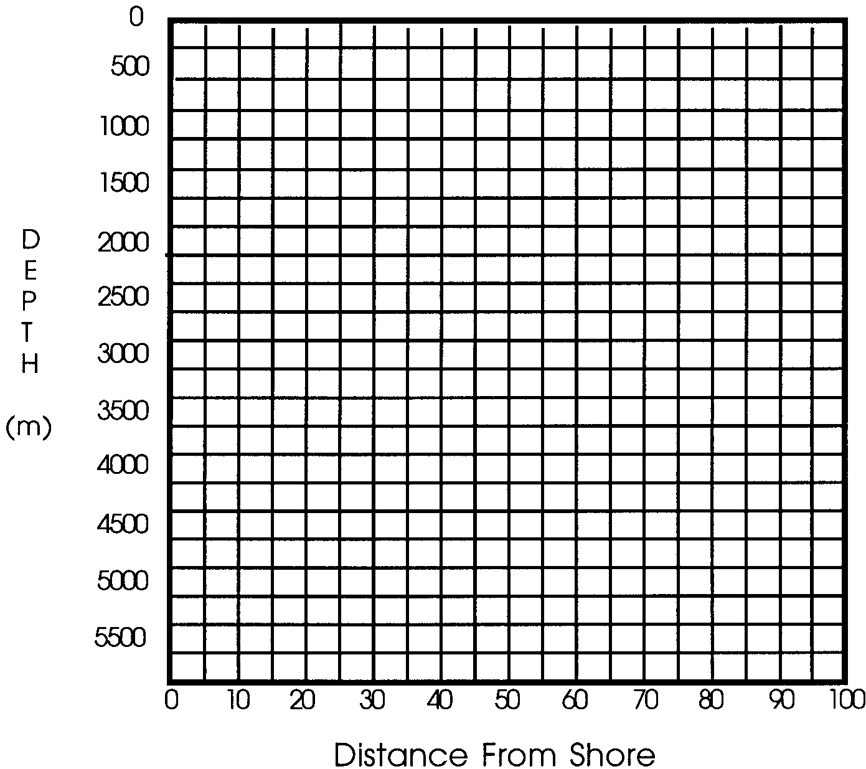

3. After you have plotted the depths connect the points (dots) with a smooth pencil line. This line reflects the shape of the ocean bottom along the path of the R/V Nordic Maid.

Analysis and Interpretation:

1. What is the ocean feature seen at station 1?

2. What is the ocean feature seen at station 7?

3. What is the ocean feature seen at station 14?

4. If a school of fish is present under the R/V Nordic Maid, the echo sounder will show a “false bottom” where the school of fish is located. How might this “false bottom” phenomenon be of use to fishers?

5. What are two reasons many fishermen have echo sounding equipment on board their boats?
a.

b.

6. Soundings were made every 5 to 15 kilometers.

a. What size ocean features might be missed using this procedure?

b. Why do oceanographers prefer to use equipment that gives a continuous sounding?

