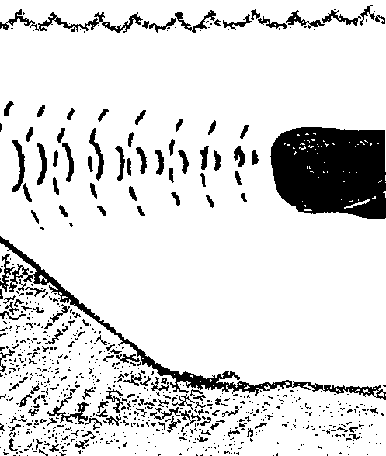
Deep Sounds

Key Concepts
1. Technological developments have made it possible for us to get an accurate picture of the ocean floor.
2. The ocean floor has features very similar to those of the land.

Background

While humans have been traversing the surface of the ocean for thousands of years, it has only been within the last half century that we have been able to say with any reasonable certainty how the bottom of the ocean looks. Submarines and submarine warfare fostered the development of echo-sounding and sonar equipment. After World War II this equipment became more widely available to oceanographers.

The first sonar devices produced a single beam of sound which could be used to trace a depth profile line across the bottom. While these devices were a vast improvement over mechanical sounding with a lead line, recently developed multibeam sonars which trace a swath across the bottom have truly revolutionized bathymetric mapping. These devices have permitted us to make continuous recordings of depth and thereby map the bottom with considerable ease and accuracy.

The information obtained provides important evidence in support of the theory of plate tectonics. It now appears that sea floor topography is, in fact, largely a result of the processes involved in plate movement. Bottom profiles have also provided information important to sea bed miners and oil drillers. “Deep Sounds” looks at some of the discoveries.

Materials

• student handout

Teaching Hints

“Deep Sounds” serves as an introduction to and preview for several activities dealing with the topography of the ocean floors. Duplicate the text pages. One set is recommended per student. This activity is best accomplished by individual students as homework or as an in-class assignment. There is merit in having the students meet in small groups after each individual has completed the assignment. The groups provide an opportunity to exchange and compare answers prior to a general class discussion of the material.

Key Words

abyss - the deep ocean

abyssal plain - flat sections of the deep ocean floor

atoll - seamount ringed with coral

continental shelf - submerged margins of the continent

continental slope - steep slope separating the continental shelf from the deep ocean basin

coral - calcareous skeleton-producing invertebrate; skeletons often form large reefs

guyots - flat-topped volcanoes which have subsided beneath the water’s surface

ridges - long narrow chain of underwater mountains

seamounts - underwater volcanoes which have not reached the water’s surface

silt - fine sand or clay carried by running water

sonar - a method for determining depth using sound waves

soundings - a method for determining depth using a weight and line

submarine canyons - “U”-shaped underwater canyons in the continental slope

trench - long, narrow, deep depressions in the sea floor associated with zones of subduction

turbidity currents - dense current of sediments moving along the slope and floor of the ocean

Extensions

1. This topic lends itself well to bulletin board displays. Supplement the text material with films and/or filmstrips. Encourage your students to bring in articles and other supplementary materials relating to the topics under consideration.

Answer Key

1. Fishers are interested in the bottom profile to keep from running aground and to keep from entangling and losing their gear. Since certain fish and/or shellfish are found at specific depths or over specific types of bottoms, fishers also use bottom profile information to tell them where to fish. The bottom profile reproduced in the text shows another reason fishers are interested in echo sounders. Schools of fish show up as shaded blips on the recorder. The ability to pin-point schools of fish has increased the fisher’s ability to locate and catch fish. New echo sounders can even detect individual fish. There is some reason for concern that this sophisticated gear may lead to over fishing and the extermination of some (or many) fish stocks.

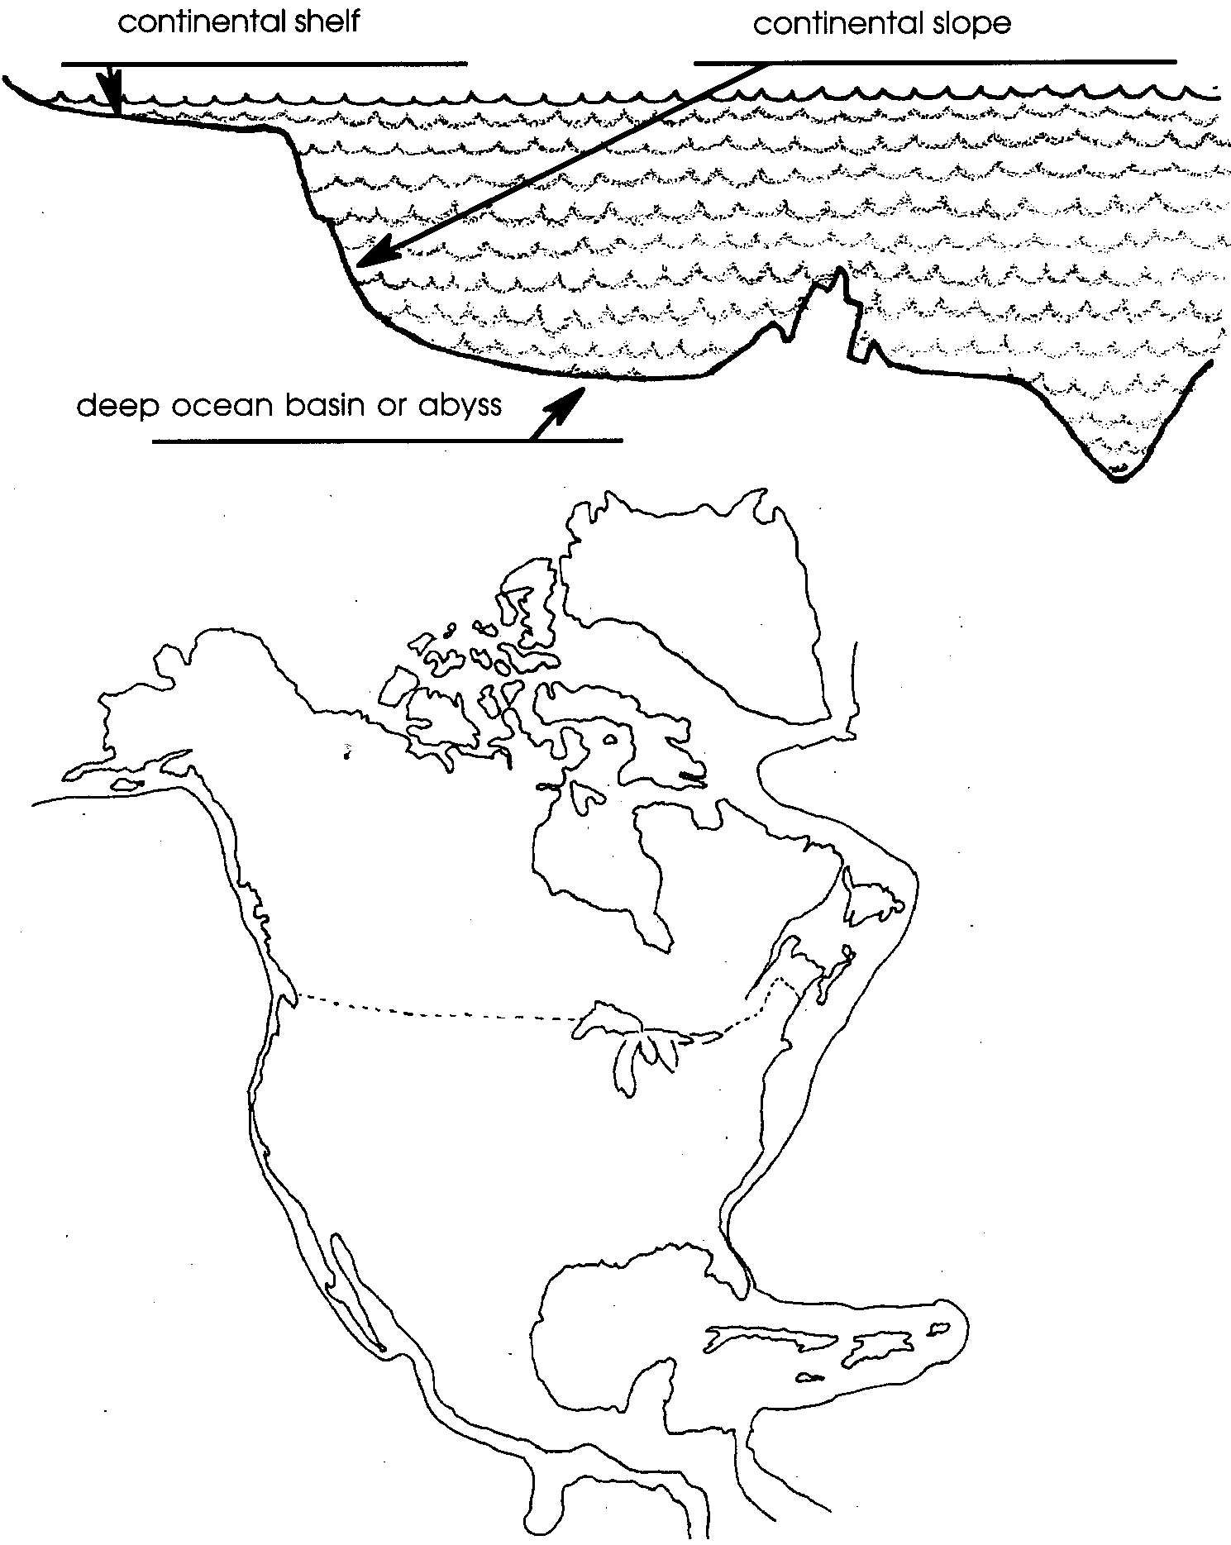
2.

3.

4. a. Turbidity currents are torrents of silt-laden water that flow down the continental slopes. Essentially they are underwater avalanches that flow because the currents are more dense than the surrounding sea water.

b. Turbidity currents shape the continental slope by scouring deep submarine canyons as they flow downward.

c. The most likely locations for turbidity currents are shown on the figure below:
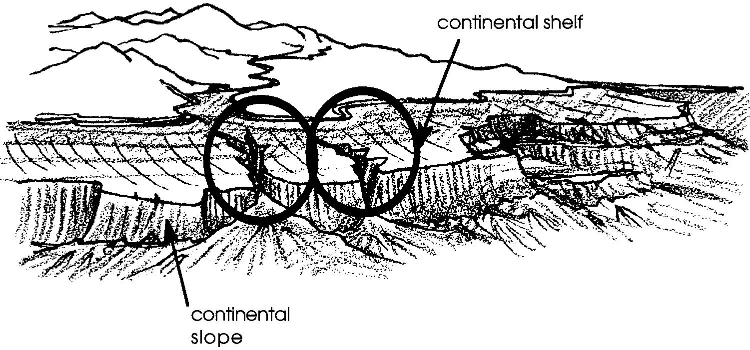

5. Submarine peaks, ridges and other features are preserved relatively unchanged because the forces of wind, rain and frost that wear away geologic features above the ocean’s surface do not act below the ocean’s surface.

6. A correctly labeled figure is shown below:
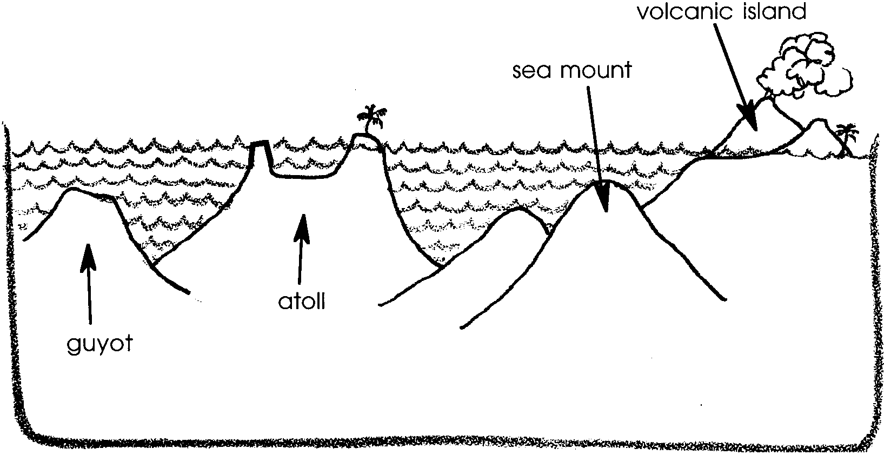

7. The echo-sounder and sonar are major research tools that have enabled oceanographers to “see” the ocean floor.

Name That Shape

“Name That Shape” serves as a vocabulary review for “Deep Sounds”. The correct answers are found below.

Scientists have measured the great depths of the ocean. They’ve found that the shape of the ocean floor, or topography, is very much like that of the land. Some of the underwater formations they found are listed below. Draw a line from each word to its correct definition.
A. a volcanic peak rising from the sea floor that is “flat-topped” because of earlier wave action.

B. the sea-bed along continents that forms a gentle slope. It is covered by shallow water ranging from a few to hundreds of kilometers wide.

C. a submarine volcanic peak.

D. a seamount with a ring of coral growing around it.

E. narrow, deep cuts with steep slopes.

F. a peak formed by lava rising above sea level.

G. a long, narrow rise in the sea floor with steep sides.

H. deep; covered with a thin layer of sediments.
1. abyssal plain

2. atoll

3. continental shelf

4. guyot or plateau

5. ridge

6. seamount

7. trench

8. volcanic island

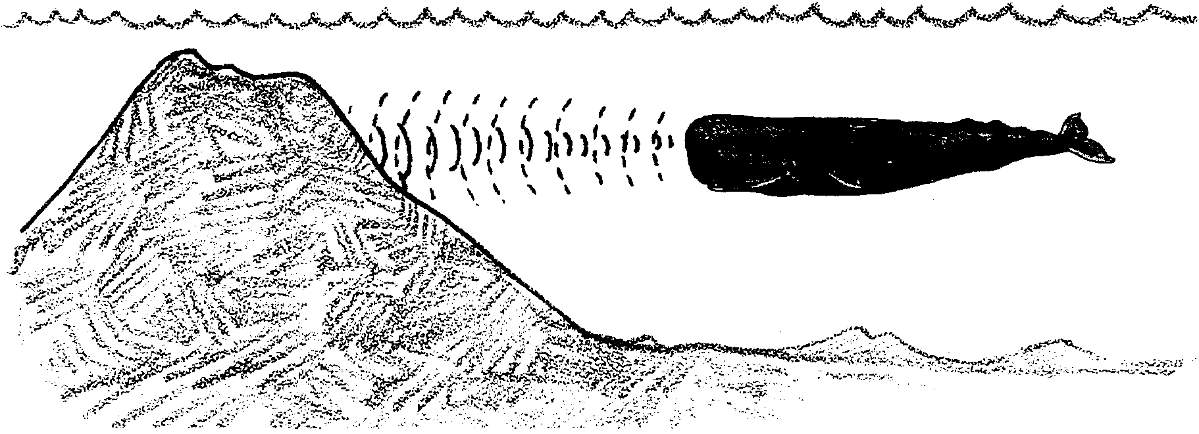
Deep Sounds

Nearly three quarters of the earth’s surface is under water. What shapes have the moving plates of the earth’s crust fashioned beneath the ocean’s surface? Gray whales and other marine mammals dive into the darkened depths of the seas. These animals depend upon a knowledge of the bottom shapes to keep from colliding with the ocean floor.

How do the whales sense the bottom? Scientists believe that whales orient themselves in space through some sort of sonar. The whale sends out a sound impulse. The impulse is reflected by the bottom and returns to the whale. The longer the time before the sound returns, the deeper the bottom. Using this sonar the whales can travel in the darkness without danger.

Until the 1920’s humans did not have anything like sonar. To chart the shape of the bottom we had to make soundings by dropping a marked, weighted line overboard. A measurement of the depth of the water is called a sounding. By the 1950’s sonar was available and being used by oceanographers to map the shape of the sea bottom. The ocean bottom began to give up its secrets. The bottom was more rugged than anyone had imagined.

1. Oceanographers are not the only people interested in the shape of the ocean floor. Why might a fisher be interested in the bottom profile?

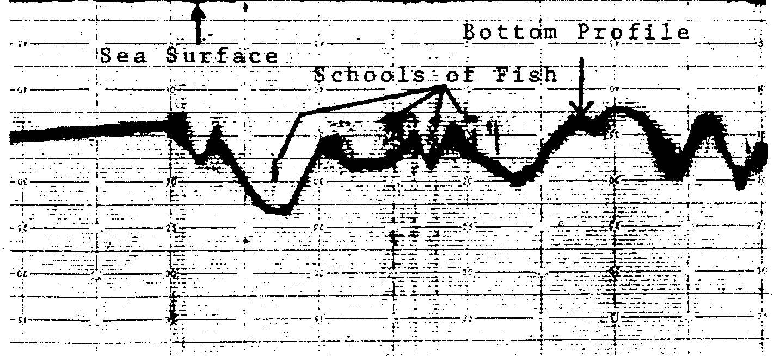
BOTTOM PROFILE REPRODUCED FROM A FATHOMETER TAPE

Beneath the flat surface of the sea lay mountains taller than Everest. Oceanographers discovered trenches deep enough to swallow half a dozen Grand Canyons. They also found steep cliffs long enough to stretch from New York to San Francisco.

The data has revealed that the floor of the ocean is divided into three great domains or regions. The first domain is the continental shelf. The shelves are the shallowly submerged edges of the continents. Marine life is abundant on the continental shelves. At the continental slope, the second domain, the sea floor plunges two miles to end at the deep-ocean basin. The deep-ocean basin or abyss forms the third great domain of the oceans.

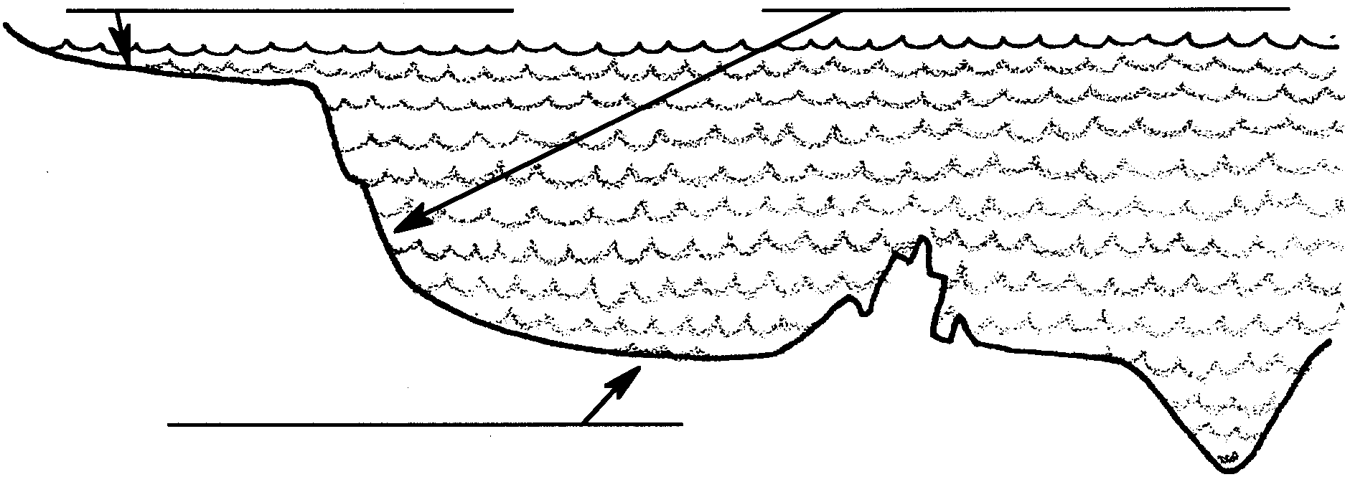
2. On the drawing below label the: a) continental shelf, b) continental slope, and c) the deep ocean basin or abyss.

Continental Shelf

The continental shelves are found on most of the earth’s coasts. They are the underwater extensions of the continents. Over time, sea level has changed due to various changes in the climate. Sometimes the continental shelves have been dry. Sometimes, like now, they have been covered with water. The continental shelves slope gently away from the shore to a depth of about 200 meters (650 feet). Off many coasts, especially on the Atlantic, the shelf is wide, projecting more than 100 miles into the sea. The widest shelf anywhere stretches 800 miles into the sea off the Arctic shore of Siberia. There is almost no shelf off southeastern Florida. Off Florida, the Gulf Stream runs like a swift underwater river. It sweeps the offshore sea bottom clean of shelf-building debris. Off mountainous shores like the Pacific coast of the American continents, there are few rivers to pile up much sediment. Consequently, the continental shelf is apt to be narrow or nonexistent.

3. Use the information above to draw the continental shelves on the map of North America.
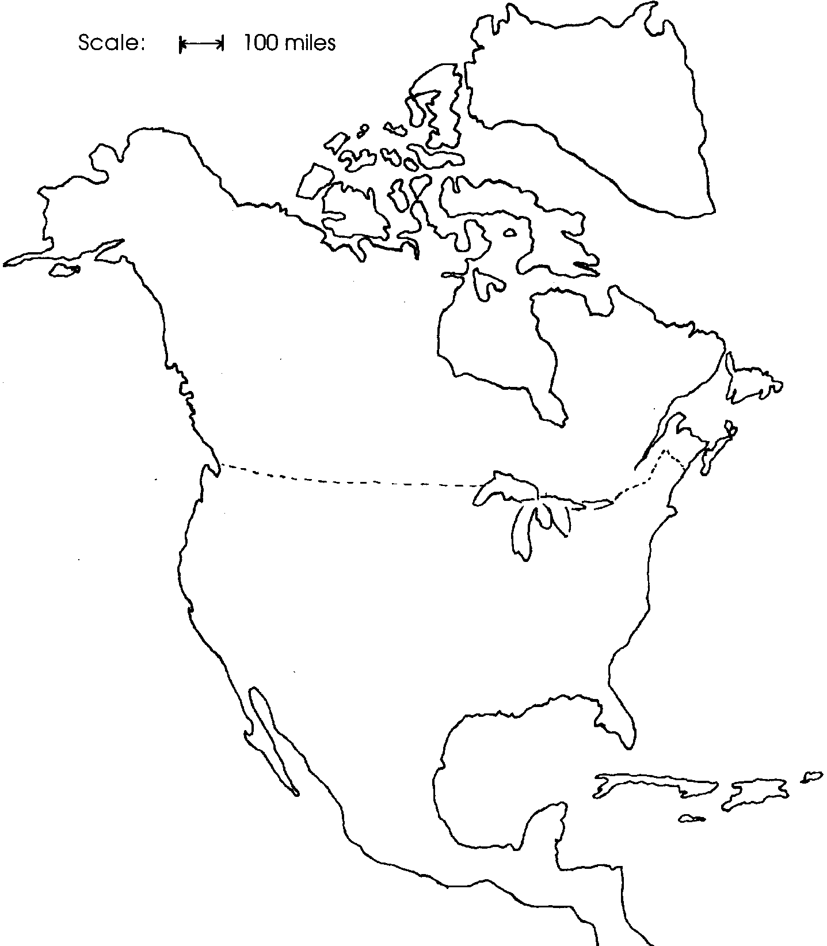

Continental Slope

At the outer edge of the continental shelves, the land plunges down. The slope sometimes falls unbroken for two to three miles. These continental slopes are among the most imposing features of the entire earth. They are the highest and longest walls in the world.

Nearly everywhere that oceanographers have probed the continental slope so far, they have found deep gorges and canyons cut into its face. The force that had carved them was a mystery. Many were too far off shore, and in water too deep, to be explained as drowned river beds. Earthquakes had clearly opened a few but not all of these gorges. Scientists now believe they were cut into the continental slopes by powerful underwater avalanches called turbidity currents. These are torrents of silt-laden water that flow down the slopes. The water flows downward because it is more dense (heavier) than surrounding sea water. An earthquake or load of sediment on the continental shelf can send silt rushing down the slope. The silt, flowing at express-train speed, gouges out a canyon as it goes. Turbidity currents can roll on for hundreds of miles. As they slow down, they spread out thick new layers of sediment. These layers of sediment form the abyssal plain.
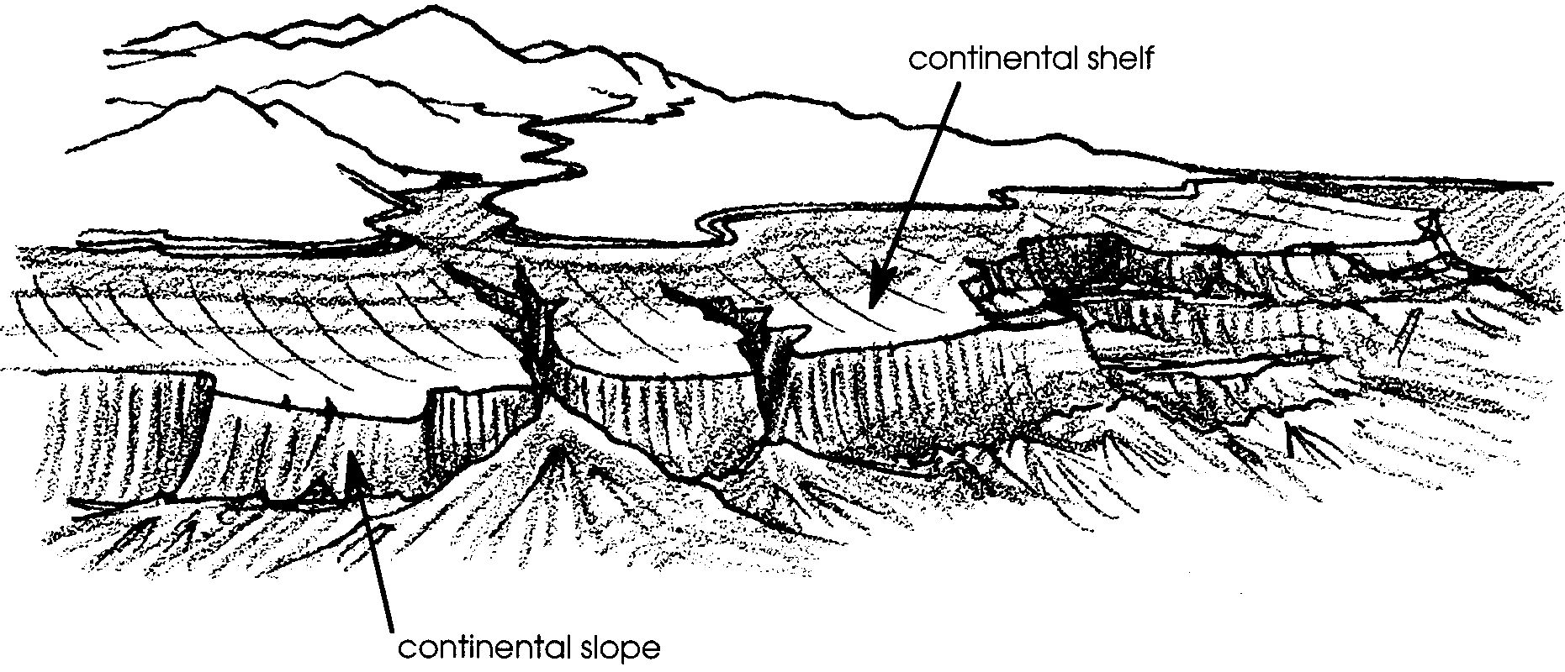

4. a. What is a turbidity current?

b. How do turbidity currents shape the continental slope?

c. On the picture of the continental slope found above, circle a place where turbidity currents are likely to have occurred.
The Deep-Ocean Basin or Floor

The deep-ocean floor begins at the foot (bottom) of the continental slope. It is the biggest of the ocean’s three geographic domains, comprising over 70% of the total sea area. In this domain of darkness, we humans have made our most startling discoveries about the earth’s hidden surfaces.

Amazingly enough, the peaks, cones, ridges and cliffs formed beneath the sea have been preserved largely unchanged. Beneath the sea there is no wind, rain and frost to wear away these features. On the Pacific floor, for example, there is a cliff half a mile to a mile high and 3,000 miles long. It is as sharp and jagged as if it had been wrenched from the sea bottom just yesterday. In spite of its appearances, in some places it is 70 million years old.

The flat sections of the deep-ocean floor turned out to be flatter than anything ever seen on land. Called abyssal plains these level expanses lie smooth and even as a dance floor. Core samples from these abyssal plains show that they were formed by sediments from turbidity currents. After carving canyons in the continental slope, the turbidity currents spread out when they reached the sea floor. Sediments carried by the currents gently filled every seabed crevice with sand and mud washed down from the coasts.

5. How are the submarine ridges and other features preserved unchanged?

Several other interesting features are found on the ocean floor. Seamounts are cone-shaped submarine volcanoes which rise from the floor. In some areas, the lava flow has caused the seamount to rise above the surface of the ocean. These seamounts then form volcanic islands. The Hawaiian Islands are examples of volcanoes rising from the ocean floor. Some of the seamounts have had their tops worn away by earlier wave action. These ”flat-topped“ volcanic peaks are called guyots (pronounced “gee oh”). Some seamounts close to the surface support the growth of coral animals. The coral can form a ring around the island or it can form a ring on top of a guyot. These ringed coral islands are called atolls.
6. On the diagram below label the following features:
a) atoll
b) seamount
c) guyot
d) volcanic island

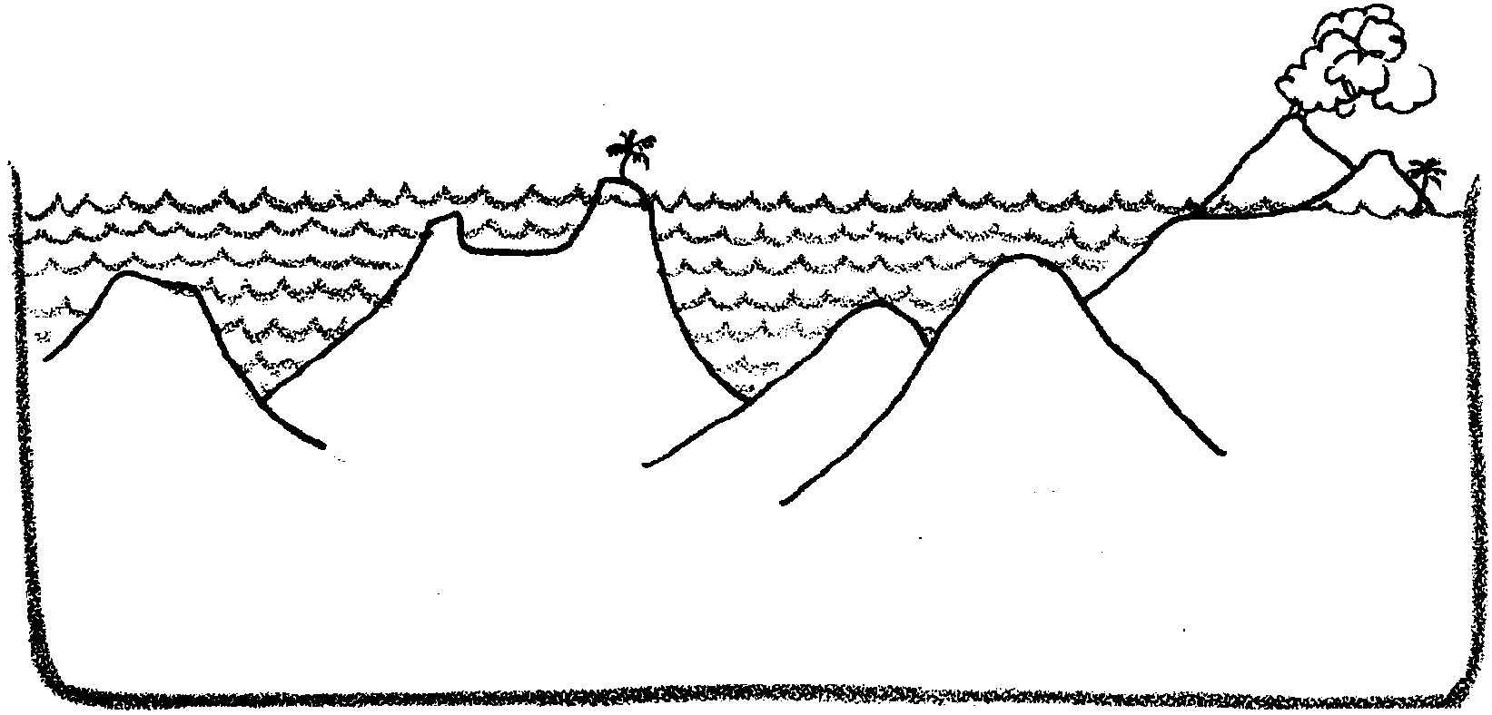

The ridges and trenches we associate with plate tectonics are also found in the deep ocean basin. The rises are thought to be areas in which the seafloor is spreading and growing. The deep trenches occur where one plate dives under another. These steep-sided canyons are deep enough to swallow many Grand Canyons.

We once thought the floor of the ocean was entirely smooth. The sediment covered abyssal plains are, indeed, very smooth. We have found, however, that other parts of the floor are anything but smooth. New research tools have let us explore the ocean bottom more fully than ever before. As new research tools are developed, other secrets are sure to be revealed.

7. What was the major research tool that enabled oceanographers to “see” the ocean floor?

Name That Shape

Scientists have measured the great depths of the ocean. They’ve found that the shape of the ocean floor, or topography, is very much like that of the land. Some of the underwater formations they found are listed below. Draw a line from each word to its correct definition.

1. abyssal plain A. a volcanic peak rising from the sea
floor that is “flattopped” because of
wave action.

2. atoll B. the sea-bed along continents that
forms a gentle slope. It is covered
by shallow water ranging from a few
to hundreds of kilometers wide.

3. continental shelf C. a submarine volcanic peak.

4. guyot or plateau D. a seamount with a ring of coral
growing around it

5. ridge E. narrow, deep cuts with steep slopes

F. a peak formed by lava rising above
6. seamount sea level.

G. a long, narrow rise in the sea floor
7. trench with steep sides

H. deep; covered with a thing layer of
8. volcanic island sediments

