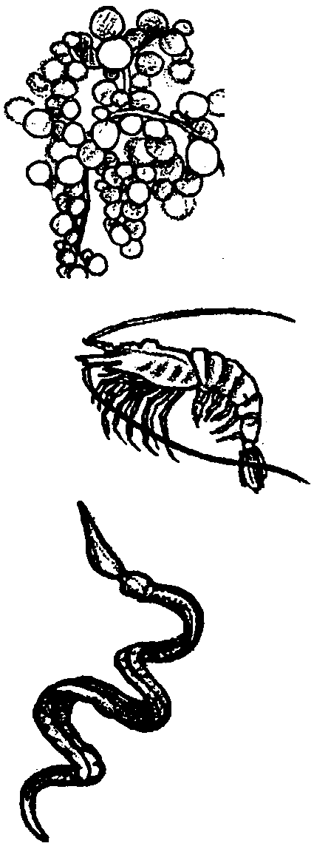
The Mating Game

Key Concepts
1. A complex community of living things survives at hydrothermal vents without sunlight.
2. The food producers of this community are chemosynthetic bacteria, many of which are endosymbionts.
3. The food structure of the hydrothermal vent community is similar to other oceanic and terrestrial food webs.

Background

In hydrothermal vent communities, chemosynthetic bacteria produce the food that sustains all other members of the community. There are three types of chemosynthetic bacteria in the vent community: plume bacteria, mat-forming bacteria, and symbiotic bacteria. These chemosynthetic bacteria are the producers for the entire hydrothermal vent community.

Plume bacteria live in the cloud of water rich in hydrogen sulfide (H₂S), which comes from the vents. Filter-feeding shrimp and other animals that swim along the plume, as well as microscopic zooplankton, consume the plume bacteria.

Mat-forming bacteria coat every surface of the vent area. Wherever H₂S occurs, mat-bacteria grow. Snails, shrimp, and worms graze on the white, rusty, and brown mats.

The third group of chemosynthetic bacteria are symbiotic bacteria which live in the tissues of the tube worms, white clams, and mussels. About 75% of all the chemosynthetic bacteria in the vent communities are symbiotic bacteria.

When examined, it was found that the tube worm, Riftia, was essentially a closed sac with no mouth and no digestive system. It had, instead, a trophosome (feeding body) in which colonies of bacteria lived. The bacteria altered the H₂S absorbed by the worm, combining it with CO₂ produced by the worm’s respiration, and made sugar. The sugar was food for the bacteria and the worm. The worm cleaned out the sulfate waste products formed as a result of the bacteria’s chemosynthetic process. Both species benefitted from this symbiotic relationship. Relationships such as this where one species lives wholly within another are called endosymbiotic. The bacteria are called endosymbionts.
The worm’s trophosome can be thought of as an internal factory. The worm provides the raw materials, H₂S (hydrogen sulfide), CO₂ (carbon dioxide), and carries away the waste products, SO₄-- (sulfates). The endosymbiotic bacteria manufactures the food for itself and its host.

The large white clam and mussel also depend on chemosynthetic endosymbionts which live in their gills.

The remaining inhabitants of the vent community do not have endosymbiotic bacteria and must obtain food by consuming mat or plume bacteria, eating particulate matter, scavenging, or preying upon one another.

The vents dot the tops of the spreading zones and are separated by great distances. Many empty vents have been found, surrounded by dead organisms. It is estimated that individual vents may be active for only 20-30 years.

Materials

• 1 set of hydrothermal vent animal picture cards for each student

Teaching Hints

1. This game is patterned after the television game show, “The Dating Game”. The purpose of the activity is for students to find an “appropriate mate.” But, you can change the emphasis so they try to find an “appropriate meal” or “symbiont”.

2. Choose four students for Round 1. Set up your classroom so that the four students face the class, with the “contestant” on one side of a barrier and the three “bachelor/bachelorettes” on the other side of the barrier.

3. Encourage the students to keep their “identities” a secret from the rest of the class. If they have a difficult time keeping this information to themselves, you may wish to have them study all the information and then give them their “identity” as they start the game.

4. When you select the “contestant” and the three “bachelor/bachelorettes” try to include some predators and prey, as well as a member of their own species, if possible.

5. The audience should know the “identities” of all the players. The teacher can act as the emcee for the initial round, then that role can be assigned to a student, if you wish.

Key Words

endosymbiont - a symbiont which lives entirely within the host

particulate matter - small pieces of animals, their waste products, etc. which float in the water

symbiosis - relationship involving organisms of different species living together, benefitting one or both organisms

trophosome- gut-like structure of the Riftia worm in which bacteria live

zooplankton - weakly swimming animals, usually microscopic, which flow with the currents

Answer Key

1. Plume bacteria, mat-forming bacteria, and symbiotic bacteria form the food that sustains the vent community.

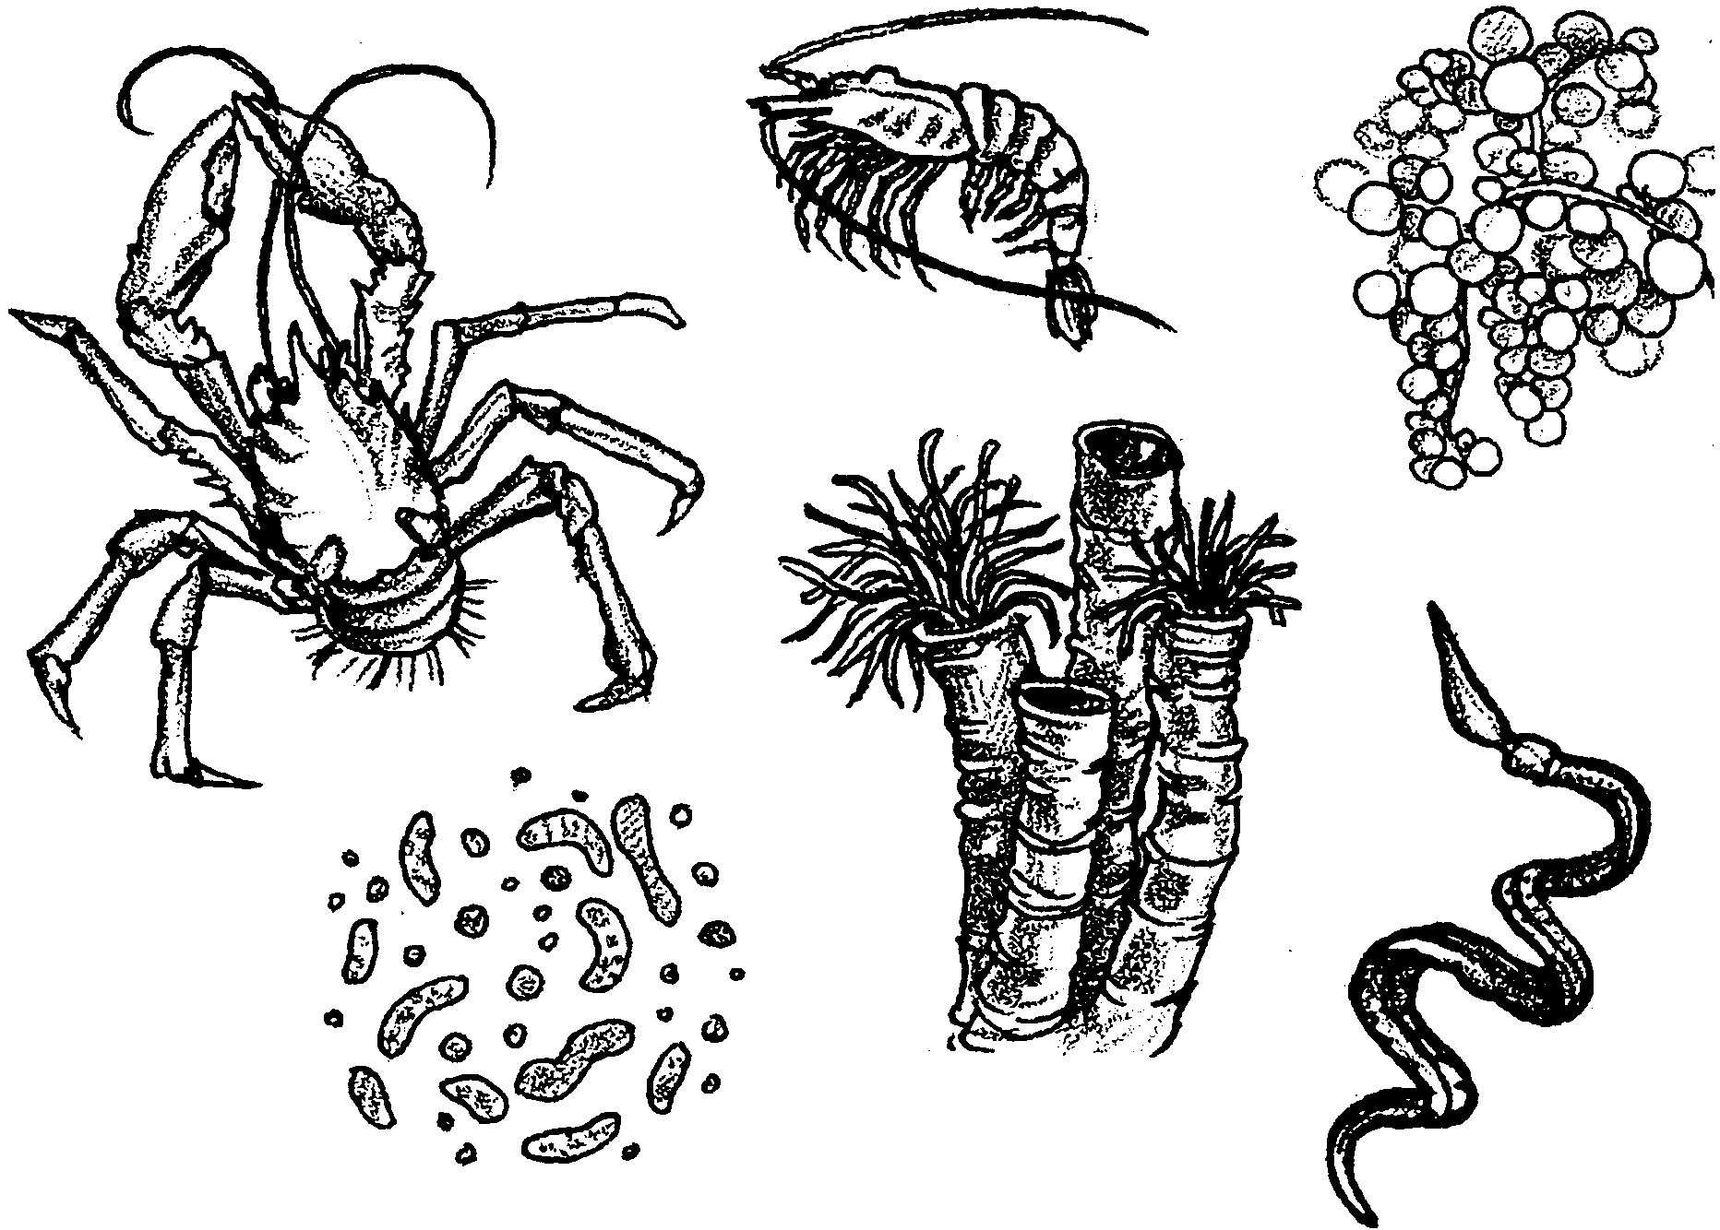
The Mating Game

In hydrothermal vent communities, chemosynthetic bacteria produce the food that sustains all other members of the community. There are three types of chemosynthetic bacteria in the vent community: plume bacteria, mat-forming bacteria, and symbiotic bacteria.

Plume bacteria live in the cloud of H2S-rich water which comes from the vents. Filter-feeding shrimp and other animals that swim along the plume, as well as microscopic zooplankton, consume the plume bacteria.

Mat-forming bacteria coat every surface of the vent area. Wherever H2S occurs, mat-bacteria grow. Snails, shrimp, and worms graze on the white, rusty, and brown mats.

The third group of chemosynthetic bacteria are symbiotic bacteria which live in the tissues of the tube worms, white clams, and mussels. About 75% of all the food producers in the vent communities are symbiotic bacteria.

The remaining inhabitants of the vent community obtain food by consuming mat or plume bacteria, scavenging other particulate matter, or preying upon one another.
1. What three groups of chemosynthetic bacteria produce the food that sustains vent communities?

Materials
• 1 set of hydrothermal vent animal picture cards

Procedure

1. Your teacher will assign you the role of an animal that lives in the hydrothermal vent community. Keep your “identity” a secret.

2. Carefully read the information on the animal picture cards to find out as much as you can about “yourself” and your relationship to the other animals in your community.

3. Your teacher will select 4 students from your class to play Round 1 of The Mating Game. You will be told whether you are the “contestant”, a “bachelor”, or a “bachelorette”.

4. The “contestant” will have the opportunity to ask 2 questions to each of the “bachelor/bachelorettes”. Those questions should be designed to obtain as much information as possible, but they cannot be direct questions. In other words, you cannot ask, “Will you eat me?”

5. At the conclusion of the questioning period, the “contestant” must select a “Mate”.

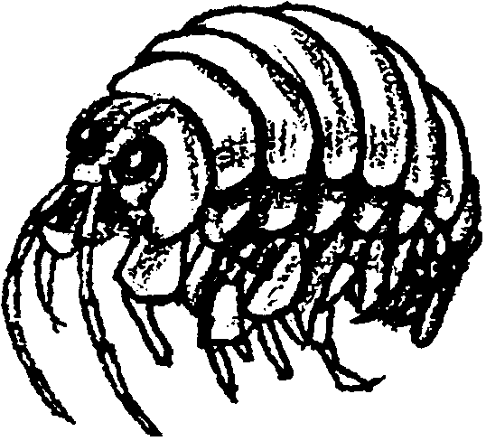
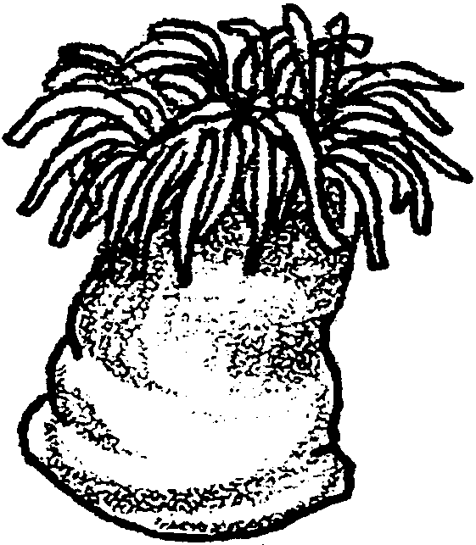
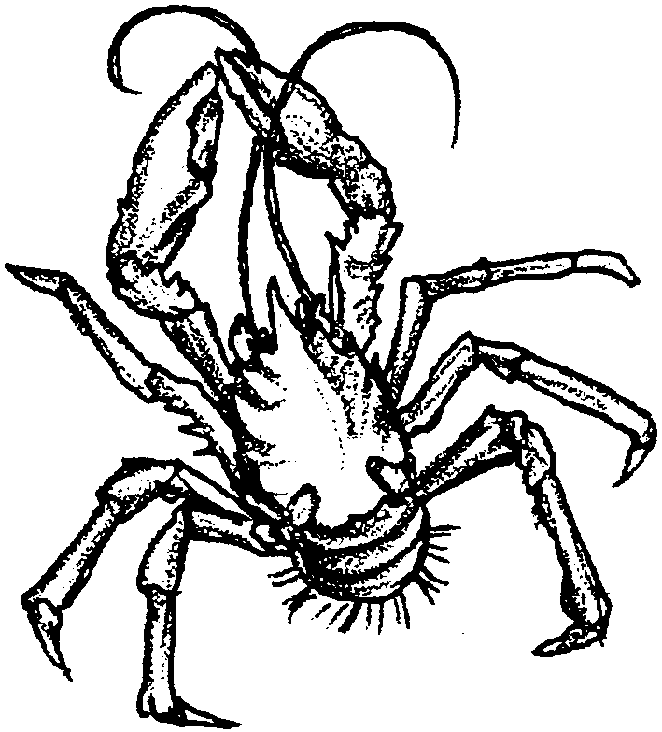
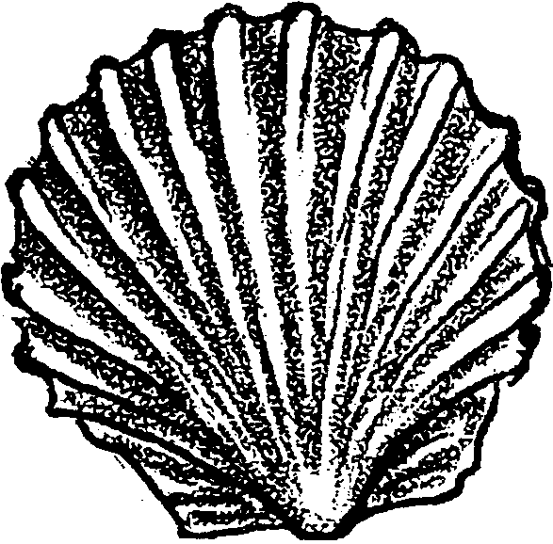

squat lobster
Found up to 50cm (20") wide, including its legs, this large, white, scavenging crab really does resemble a lobster. It is found throughout the vent community eating whatever it can find.

scallop
Hydrothermal vent scallops grow to about 3cm (about 1" )in length and are found in a variety of colors. Using their gills, they filter out particles of food floating in the water.

anemone
This white anemone can be seen attached to rocks at fringes of the hydrothermal vent community. As in the tidal and subtidal zones where anemones are common, this anemone also captures zooplankton with tentacles.

amphipod
The amphipod is a small crustacean which may feed on zooplankton. It grows to about 5 mm (about 1/4 ") in length and is gray in color. It is found crawling around in the mats.

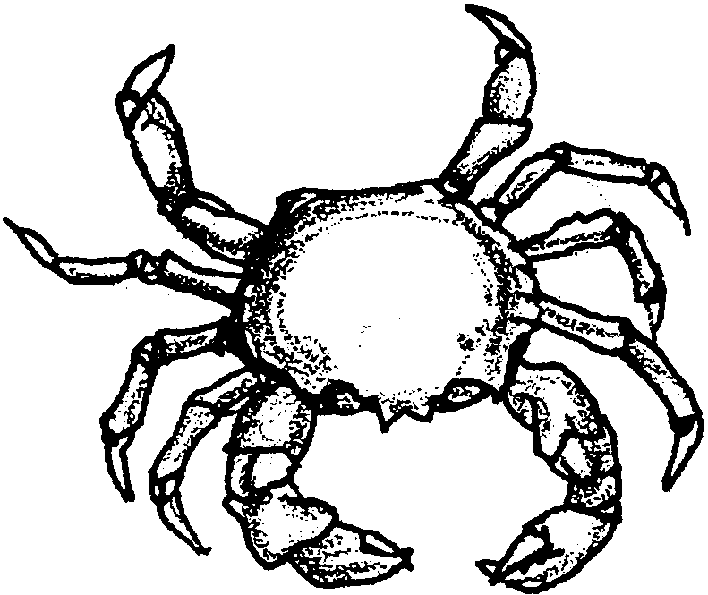
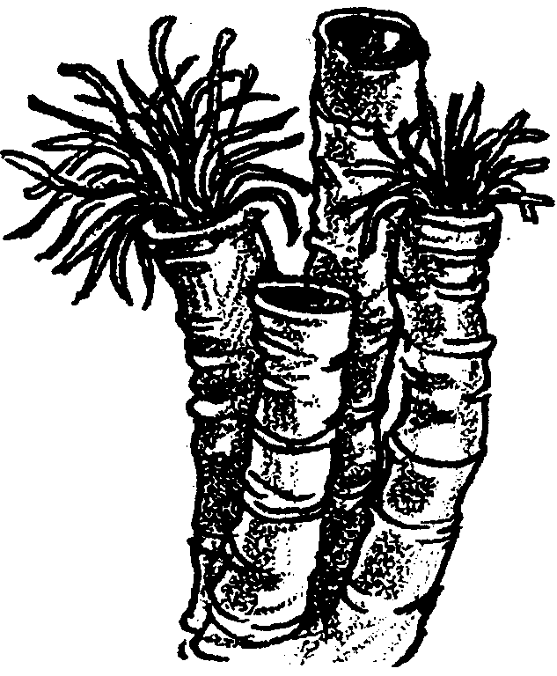
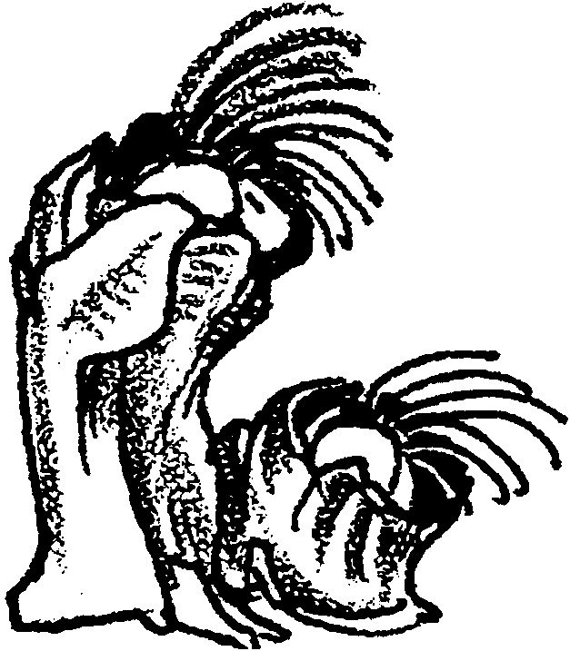
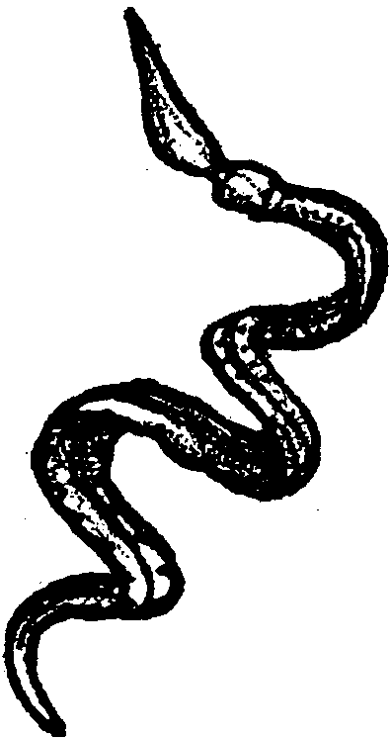

barnacles
These gray, filter-feeding relatives of the rocky shore barnacles live on rocks on the fringes of the vent community. They grow to about 2 cm (about 1") in diameter.

enteropneusts
It is easy to see why these worms are also called spaghetti worms. Growing to 30cm (12") in length, thin, and light-colored, they look just like spaghetti. The worm drapes itself over rocks while its head end drifts freely, filter-feeding on zooplankton.

serpulid worms
These tiny, 5mm (about 1/4"), worms live in tubes on the rocks of active hydrothermal vents. They are whitish in color and filter particulate matter out of the water for food.

brachyuran crab
The brachyuran crab is found throughout the vent community scavenging whatever it can find. Growing up to 20 cm (8") wide, the crab may become a predator on tubeworms and other animals.

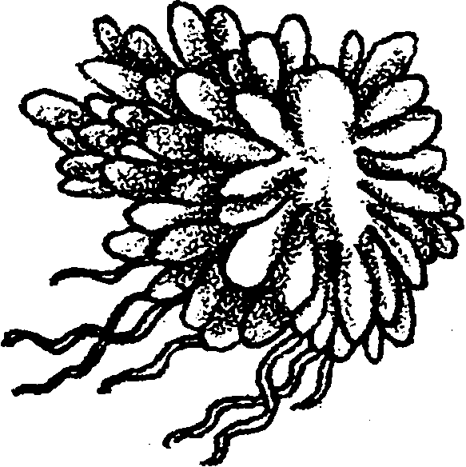
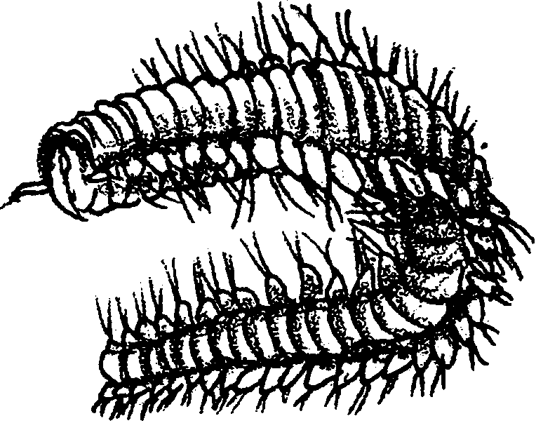
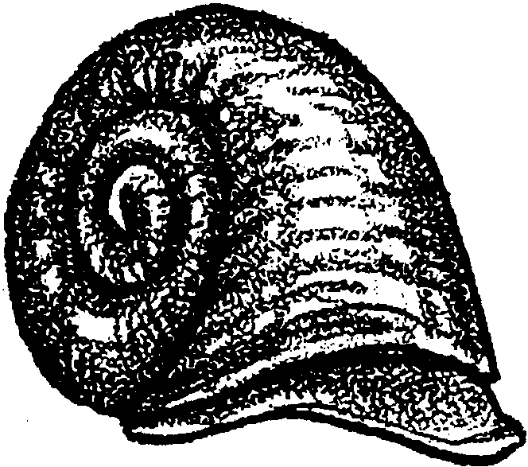
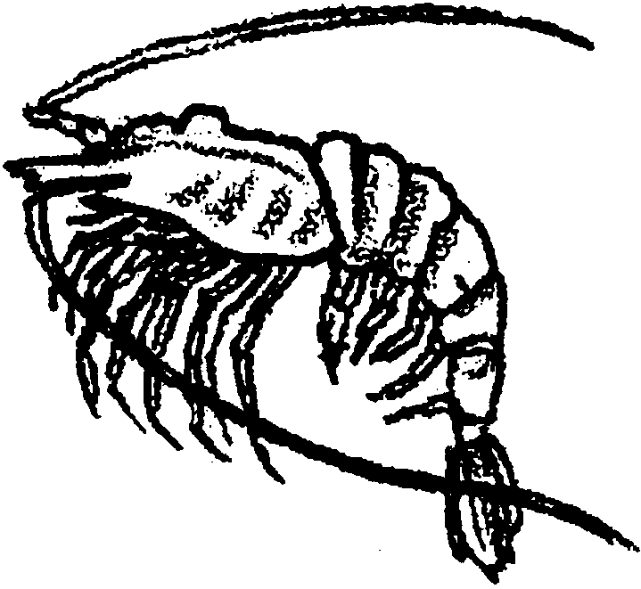

coiled snail
These coiled snails grow to about 2.5 cm (1") and are found in various colors. They cling to the rocks near the vent, where they scrape off the mat-forming bacteria with their radulas.

shrimp
These pink shrimp cluster around the vents, feeding mostly on mat-bacteria. Their size ranges from 5 to 12 cm (2" to 5") in length.

polychaete worm
These tiny worms grow to only 2mm (about 1/8") in length. They are segmented and have bristles on their segments. These red worms feed on mat bacteria.

siphonophore
This siphonophore is an unusual relative of the Portuguese man-of-war. It is actually a colony of individual organisms. When grown to its full size of 5cm (2"), it resembles a dandelion in color, shape, and size. The siphonophore uses its tentacles to catch zooplankton.

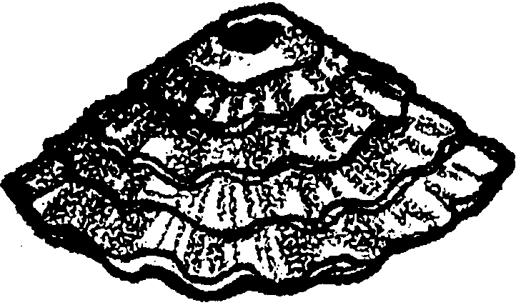
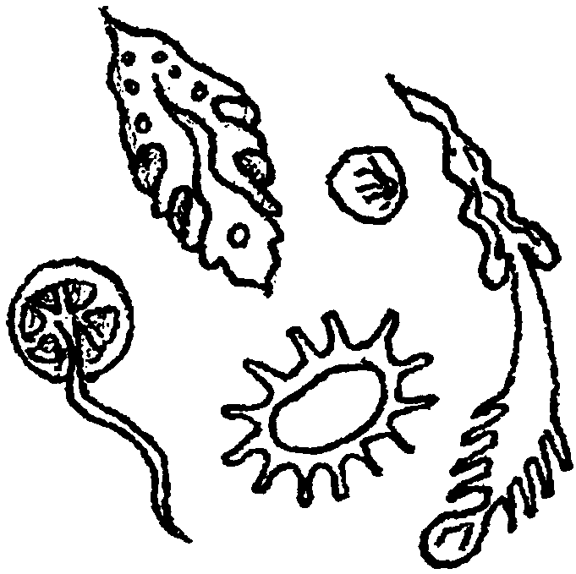
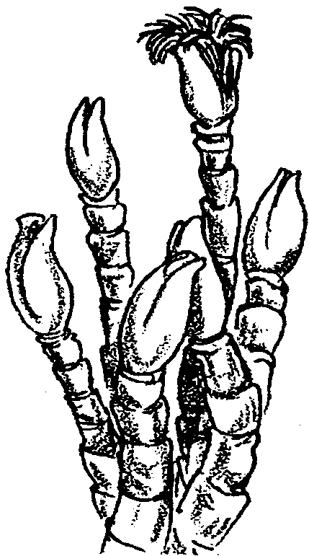
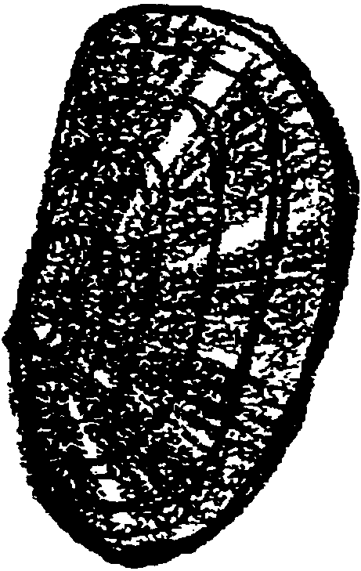

tube worms
These tube worms can grow up to an amazing 2 meters in length. Their bright red, soft bodies are supported by white tubes. These worms have no mouth, no gut, and no digestive system. They absorb H₂S from the vent waters to support the endosymbiotic bacteria living in their tissues.

mussels
These rust-colored mussels grow up to 19cm (8") in length. They grow rapidly in clusters around the vents. They feed on food produced by endosymbiotic bacteria living in their gills.

zooplankton
Microscopic zooplankton swim in the plume waters and feed on plume
bacteria or other zooplankton.

limpets
These limpets are quite similar to those found in the rocky intertidal. They grow to an average of 3cm (about 1") in diameter and cling to the rocks near the vents. Limpets graze on mat-forming bacteria.

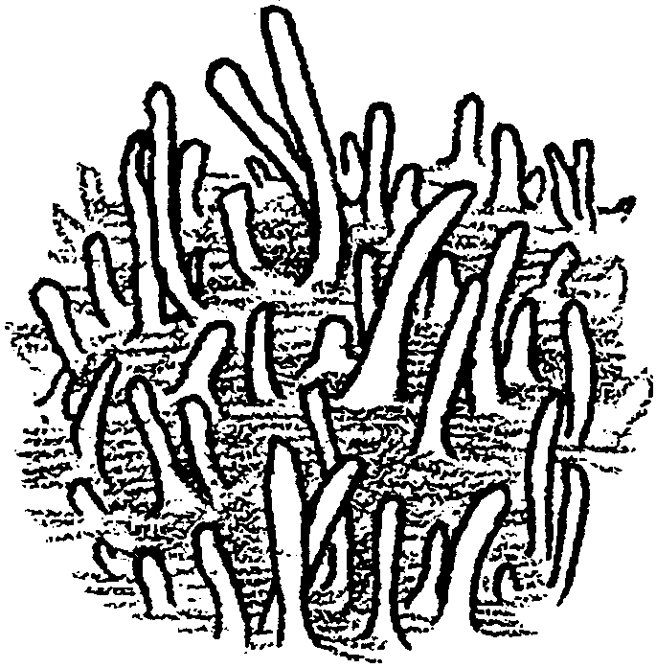
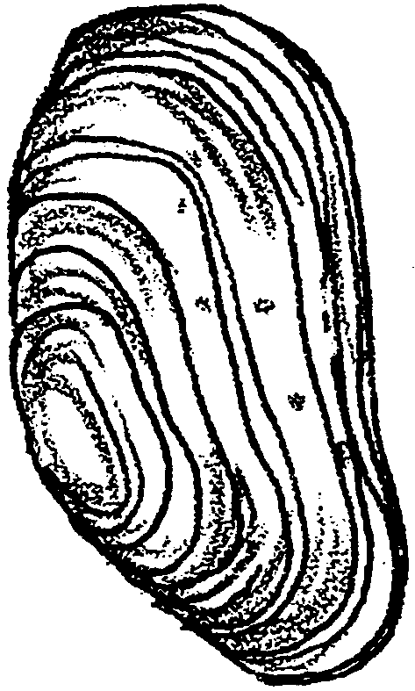
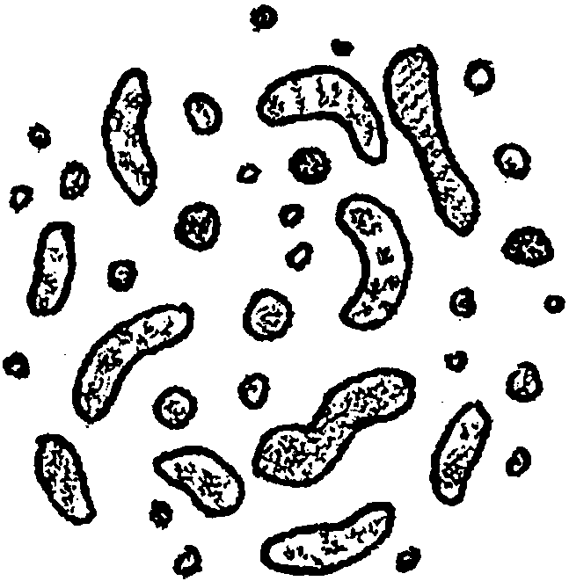
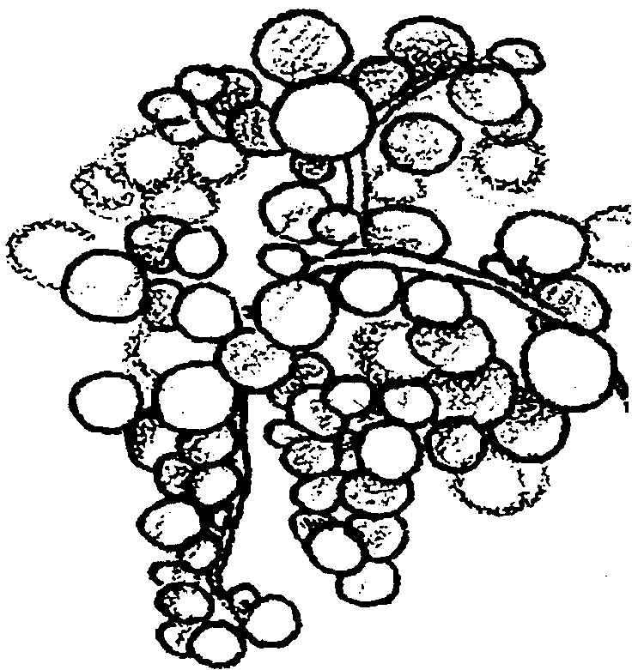

mat-forming bacteria
These bacteria form slimy mats on most surfaces around vents where there is H₂S. These bacteria grow in multi-celled filaments. They burn H₂S and use that energy to combine H with CO₂ to make food for themselves.

giant clam
This large white clam can grow up to 24 cm (10") in length. It grows quite rapidly and lives along cracks at vents. It feeds on food produced by endosymbiotic bacteria living in its gills.

plume bacteria
These peanut-shaped bacteria
live in the hot water plume which escapes from the vent. They burn H₂S and use that energy to combine H₂ with CO₂ to make food for themselves.

symbiotic bacteria
These ball-shaped bacteria live in tissues of tube worms, clams, and mussels. They burn H₂S and use that energy to combine H₂ with CO₂ to make food for themselves and host.

