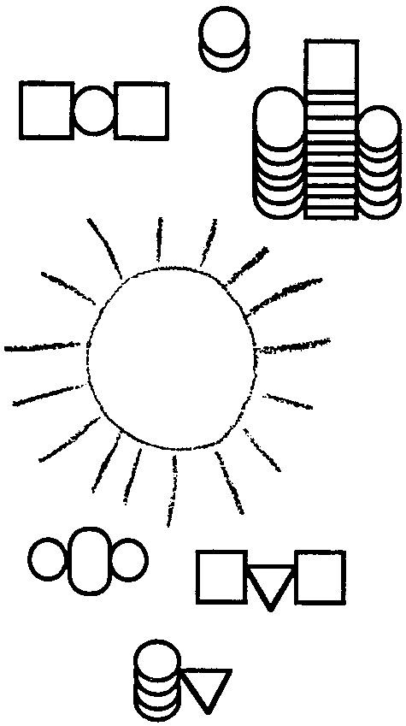
Chemicals or Light? - Chemosynthesis/Photosynthesis

Key Concepts
1. Chemosynthesis and photosynthesis are very similar.
2. The decomposition of H₂S releases the energy needed for chemosynthesis to occur.
3. Certain bacteria have an enzyme capable of reducing H₂S.

Background

Hydrothermal vents would appear to present a hostile environment for living things. Yet, even though flooded with poisonous hydrogen sulfide, in extremely hot waters, with no light and no apparent source of food, a community of organisms flourishes. In what should be a deep-sea desert, populated by occasional scavengers finding bits of detritus floating down from the distant surface, hydrothermal vent communities thrive. Hydrothermal vent organisms cluster near the vent. Masses of mussels, large white clams and blood-red tube worms cling to the outside edges. Surfaces on which to attach are scarce and competition for a “foothold” is as intense as in the intertidal zone. Mats of bacteria cover the shells of sessile animals and any open space. Limpets and snails graze on the bacteria mats. Crabs scavenge and prey upon tube worms and snails. Plume bacteria float in the nutrient rich water flowing through the vent opening. Microscopic zooplankton feed on the plume bacteria. How does this community survive?

Perhaps we can get an idea by looking at communities with which we are familiar on the earth’s surface. When we trace the energy source for these food chains and food webs, we can start with the higher order carnivores which eat the plant-eating herbivores. The plant-eaters get their food from the plants. The plants make their own food by using energy from the sun in a process called photosynthesis.

In photosynthesis, a water molecule is split apart in the presence of chlorophyll and sunlight. The energy released during that process powers the photosynthetic reaction which combines atoms from water and carbon dioxide to form sugar, the plant’s food; and oxygen, the plant’s waste product.

This process of photosynthesis produces ample food for the plant to use as it grows and reproduces. Plant eating animals then consume the plant or plant parts, and utilize, for the animals’ life processes, the food that the plant made for itself to carry out its own life processes. Higher order consumers then eat the plant-eaters, utilizing them as food to carry out their own life processes. Once the animals die and decompose, the minerals are returned to the soil where they can be recycled by the decomposers and reused by another generation of plants.

This basic food chain works very well on the surface of the earth, and even in the ocean down to about 100 meters, about as far as sunlight can penetrate. But photosynthesis cannot occur unless there is light, and there is no sunlight at the depths of the hydrothermal vents. Yet, life flourishes there.

So what is the source of energy that supports the food chain at the hydrothermal vents? It seems that the bacteria that populate the vent communities have evolved to carry out a process called chemosynthesis.

Vent community bacteria absorb the hydrogen sulfide into their cells where their enzyme system breaks the H₂S into SO₄--. They use the energy released from this reaction to power a chemosynthetic reaction. In chemosynthesis, the hydrogen from H2S combines with carbon dioxide to form sugar, the bacteria’s food; and sulfates, the bacteria’s waste product.

Both plants and bacteria use energy, hydrogen and CO₂ to make sugar. The main difference between photosynthesis and chemosynthesis is in were the energy comes from.

In chemosynthesis, energy is provided by splitting the hydrogen sulfide molecules which come from the vents in the ocean floor. Enzymes in the bacteria cause the reaction which releases the energy. The energy is used to combine the hydrogen from the H₂S with CO₂ to form sugar.

In photosynthesis, energy is provided by splitting the water molecules. The chlorophyll and sunlight cause the reaction which releases the energy. The energy is used to combine the hydrogen from the H₂O with CO₂ to make sugar.

Materials

• One copy of the photosynthesis/chemosynthesis worksheet per student

Teaching Hints

1. This activity should be used as a review after you have discussed the differences and similarities of chemosynthesis and photosynthesis in class.

2. Notice that there has been no attempt to balance the chemical equations.

Key Words

carnivore - an organism that eats meat

chemosynthesis - the process some bacteria use to make their own food using the energy from chemical reactions

enzyme - an organic chemical that acts as a catalyst to help chemical reactions occur

herbivore - an organism that eats plants

photosynthesis - the process plants use to make their own food using sunlight

Answer Key

Text Questions
1. The source of energy for the photosynthetic reaction is the energy released from the splitting apart of a water molecule in the presence of chlorophyll and sunlight.

2. The source of energy for the chemosynthetic reaction is the energy released from the splitting of hydrogen sulfide molecules by enzymes.

3. a. The waste product of photosynthesis is oxygen.

b. The waste products of chemosynthesis are sulfates.

Analysis and Interpretation

1. The discovery that some bacteria do exist that can withstand extreme temperatures and utilize chemicals considered poisonous to “all” living things gives us cause to consider the possibility that life may be found in other places that were previously considered too hostile.

Photosynthesis/Chemosynthesis worksheet key
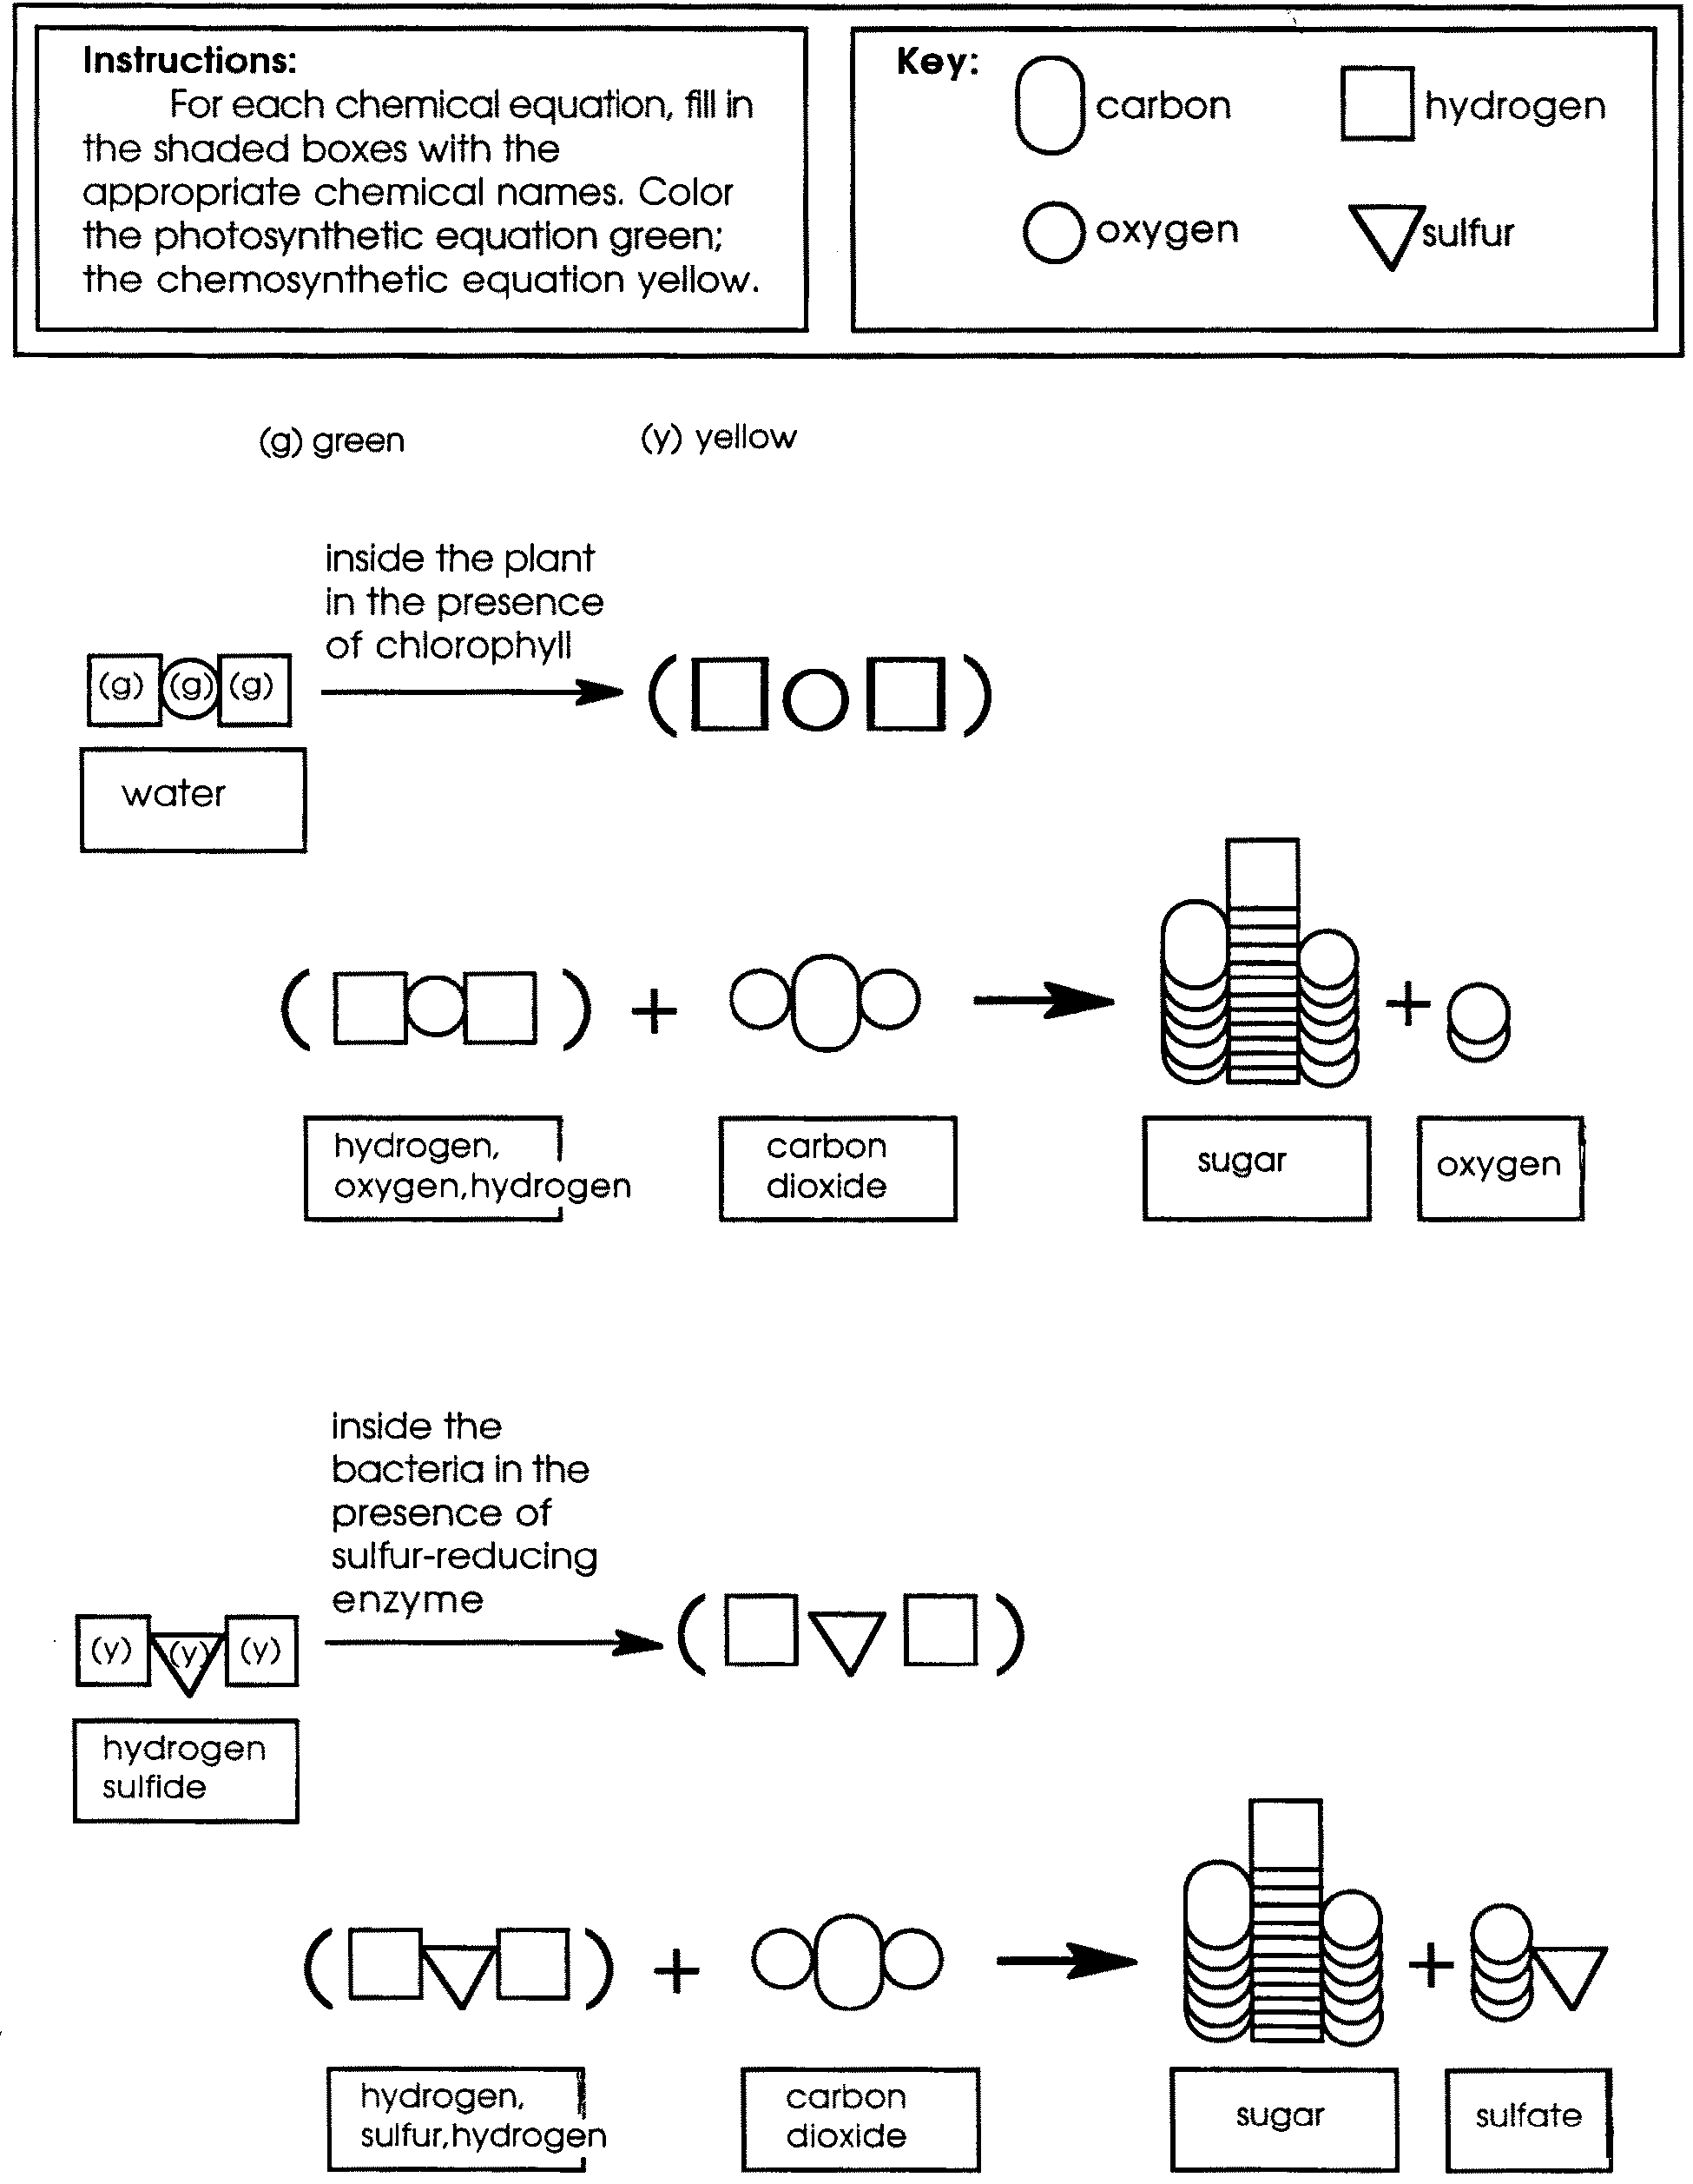

Chemicals or Light -

Chemosynthesis/Photosynthesis

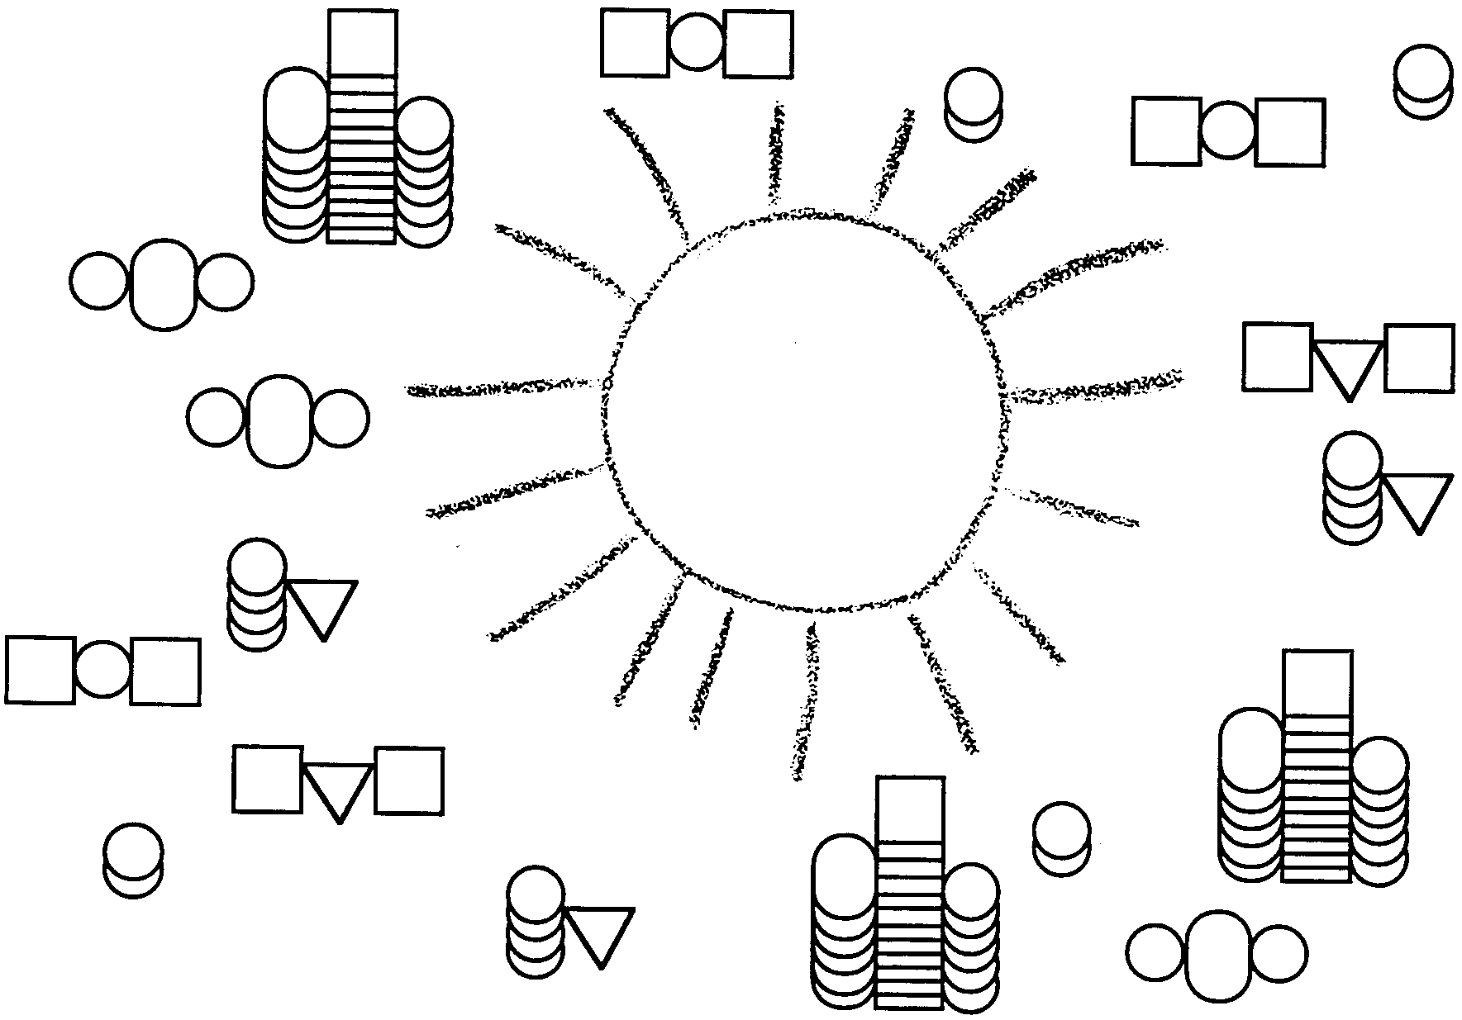
Life requires energy. Where does that energy come from? Let’s trace back the energy flow to the source for the food chains and food webs with which we are familiar on the earth’s surface. We can start with the higher order carnivores, like wolves. These animals eat plant-eating herbivores, like rabbits. The plant-eaters get their food directly from the plants. The plants in turn, make their own food by using energy from the sun in a process called photosynthesis. So in these food chains and food webs, the energy comes from the sun.

In photosynthesis, a water molecule is split apart in the presence of chlorophyll and sunlight. The energy released during that process powers what we call the photosynthetic reaction. This reaction combines atoms from water and carbon dioxide to form sugar, the plant’s food, and oxygen, the plant’s waste product.

1. What is the source of energy for the photosynthetic reaction?

Photosynthesis occurs only in the presence of sunlight. There is no sunlight at the depths of the hydrothermal vents. For this reason, scientists thought the vent areas would be deep sea deserts. They were very surprised to find thriving communities at many hydrothermal vent sites. So what is the source of energy that supports the food chain at the hydrothermal vents?

It seems that the bacteria that populate the vent communities have evolved to carry out a process called chemosynthesis. While hydrothermal vents do not get sunlight, they do get lots of normally toxic hydrogen sulfide. In chemosynthesis, energy is provided by splitting the hydrogen sulfide molecules which come from the vents in the ocean floor. Vent community bacteria absorb the hydrogen sulfide into their cells where their enzymes break down the H₂S molecules. The energy released during that process powers the chemosynthetic reaction which combines atoms from H₂S and carbon dioxide to form sugar, the bacteria’s food; and sulfates (SO₄--), the bacteria’s waste product.

2. What is the source of energy for the chemosynthetic reaction?

3. a. What is the waste product of photosynthesis?

b. What is the waste product of chemosynthesis?

Both plants and bacteria use energy, hydrogen and CO₂ to make sugar. The main difference between photosynthesis and chemosynthesis is the source of the energy.

Materials
• One copy of the photosynthesis/chemosynthesis worksheet

Procedure

1. For each chemical reaction, fill in the shaded boxes with the appropriate chemical names.

2. Color the photosynthetic reaction green. Color the chemosynthetic reaction yellow.
Discussion Questions

1. The environmental conditions at the hydrothermal vents were considered too hostile for life to survive. There is no light, the temperature changes are extreme. Yet, life flourishes at some hydrothermal vent sites. What does this imply about the possibility of living things surviving in other “hostile” environments?

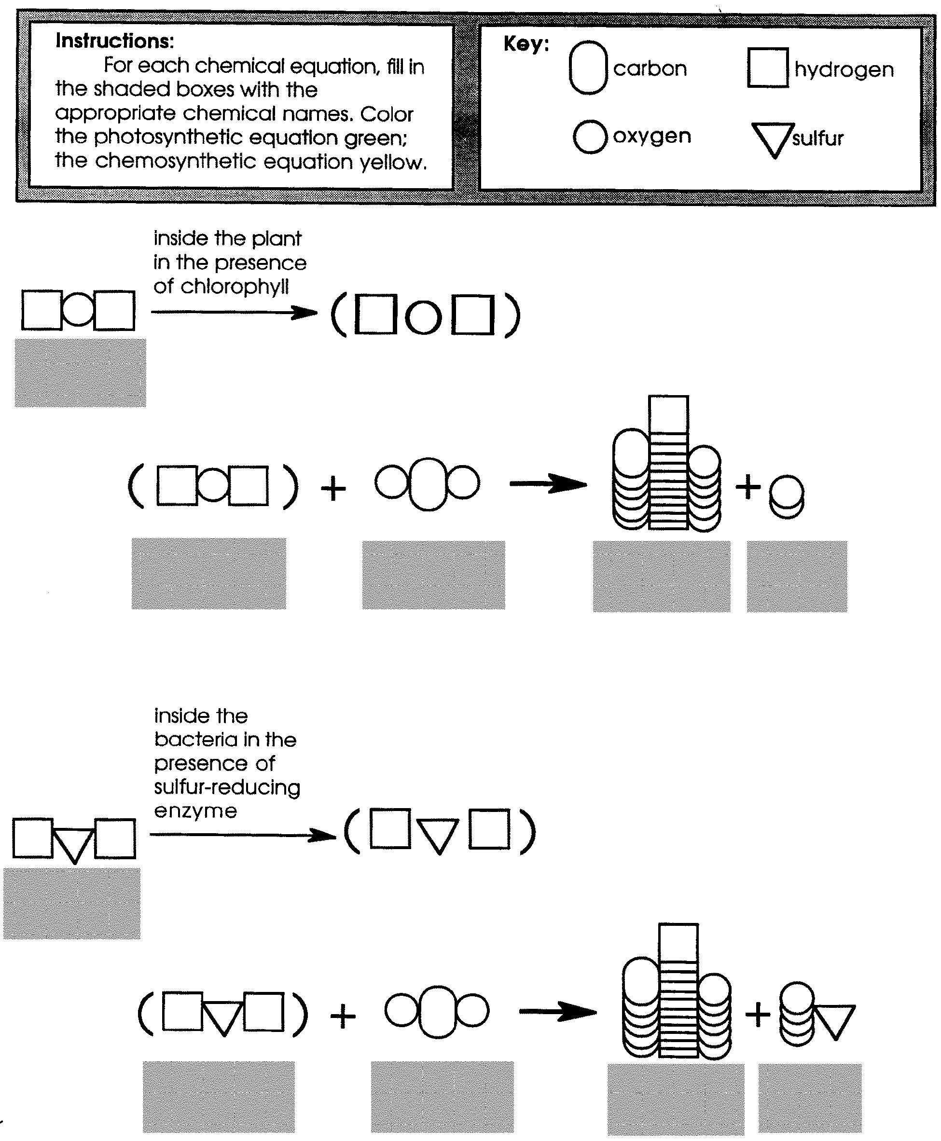
Photosynthesis/Chemosynthesis

